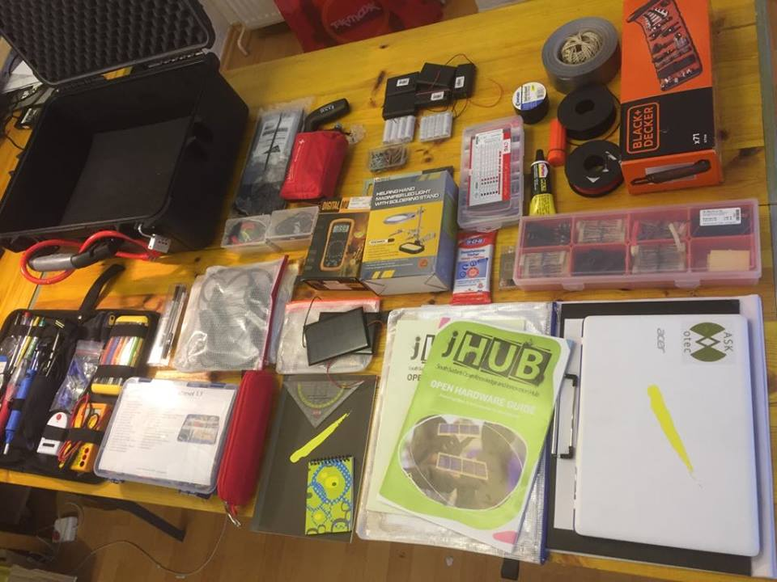
#ASKOTEC
Access o skills and knowledge: Open tech Emergency case.

INTRODUCTION:

When you want to create something with the minimal resources and not only create something but give excess to open knowledge to the world, then here it comes the #ASKotec) a kit designed to work as a mobile trainer‘ s set to tackle basic field challenges when it comes to Open Tech and Open Source Hardware innovation, education and repairing wherever needed. Providing Access to Skills and Knowledge as a multi-functional Open Tech Emergency Case gives rural and urban innovators a new point of entrance. ASKotec is very portable, strong and durable kit that is consisted of more than 40 items that helps to face hardest situations and fighting the challenges in the least resourceful areas. This smart kit helps to educate and innovate through minimum stuff. It is the access to the world of skills and development.
This kit consisted of lots of tools and material presented with the open guide to learn on your own and be creative and skillful.
The picture mentioned above will give you people a basic introduction and an insight about the stuff inside the kit. From a small needle to the big tools set everything that makes life easier and opens to knowledge is inside the kit.
CHALLENGES:
- What topics does the kit cover? (basic electronics, Arduino etc)
- What examples to the topics are realistic? (solar charger, LED Light, repair a bike/phone etc)
- Which scenarios are possible? (School training, Repair workshop, DEV Sprint etc)
- What are typical user profiles? (trainer, innovator, maker etc)
- How call all these above challenges be visualised?

BEST POSSIBLE EXAMPLES:

- May be using the things they can create solar charger. (Can take the help through the guide book).
- Can be creative to make their own customize phone stand.
- Can come up with LED light rechargeable.
- A broken bicycle can be repaired.
- A broken mobile parts can be replaced.
- Can make their own mini devices.

ASKOTEC CONTENT LIST:

A dust proof case with basic tools and materials to distribute knowledge and product development. As well as up-cycling old material to new #open innovation …anywhere!
The set contains
- basic electronics and connections
- soldering and cutting tools
- mechanical and measurement tools
- Guides and additional things (ex. adapters, first aid kit and additional things)
- (optional) A Linux computer and documentation content

