Open Hardware
_{Introduction}

Open Hardware (OH) or “Open Source Hardware (OSHW) is a term for tangible artifacts — machines, devices, or other physical things — whose design has been released to the public in such a way that anyone can make, modify, distribute, and use those things.”[1]
The general benefits of open source methods and open tech innovation are:
- Access to knowledge and product designs
- Fast and distributed exchange of skills and knowledge
- Accelerated innovation due to collaborative development
- Low development costs and more expertise
- Easy adaptation and customization

What do you need for Open Tech?
- Tools & Materials: depends on the technology
Always try local sourcing first!
- License Example: A proper license for the product design
  - for design-files, digital work: cc-by-sa (Creative Commons)[2]
  - for hardware, functionality: CERN OHL (OH License)[3]
- Open Source Software: Linux and platform independent if possible
  - Examples: see section →Resources

[1] www.oshwa.org/definition
[2] www.creativecommons.org/licenses/by-sa/4.0/
[3] www.ohwr.org/cernohl

ASKotek
Access to Skills and Knowledge – Open Tech Emergency Kit

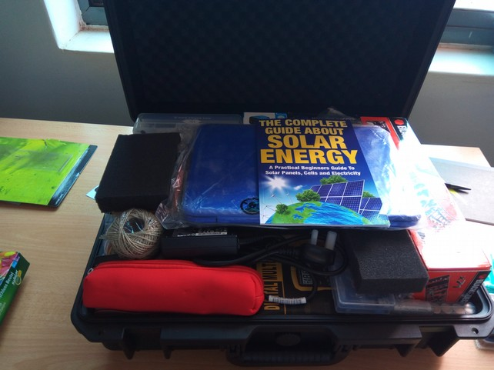
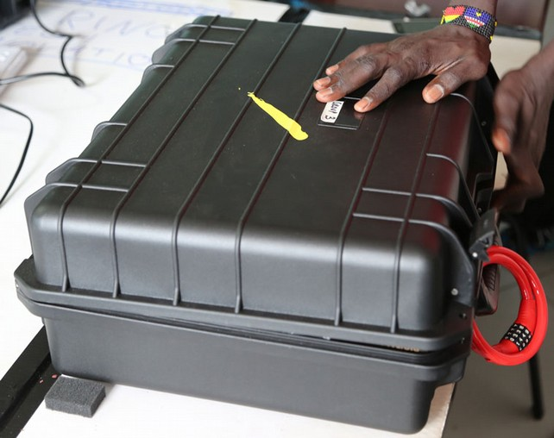
This basic Open Tech Kit provides all tools and materials to learn and distribute knowledge and product development.
The set contains:
- Basic electronics and connections
- Soldering and cutting tools
- Mechanical and measurement tools
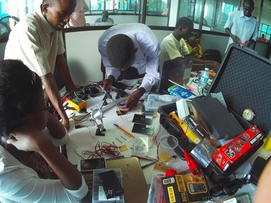
- A Linux computer and some adapters
- Guidelines and additional things to get creative and start innovation on the spot


The kit can be used on side, in the field and can function as a startup tool-set for building a co-working space, learning hub or any other innovation community setup.
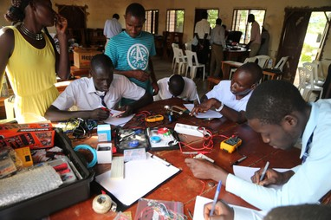
It is designed to be modular, mobile and adaptable to any location or situation to share knowledge and empower innovation.

Open Tech Skills
_{Training and Team}
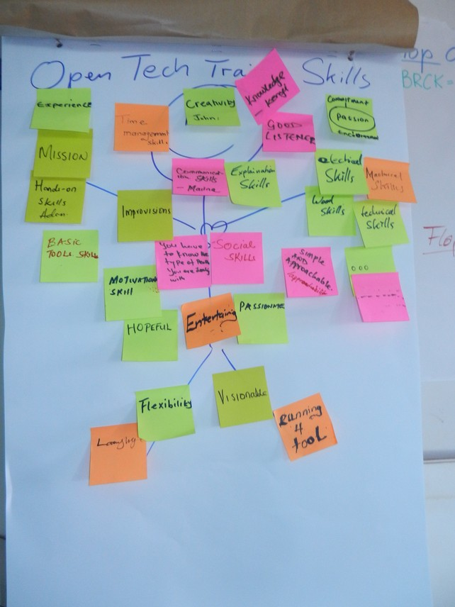

Resources

OPEN TECH, OPEN HARDWARE + ELECTRONICS

MOZILLA WEB LITERACY
https://learning.mozilla.org/en-US/web-literacy
Web literacy 21st Century Skills: Problem-Solving, Communication, Creativity, Collaboration. Share, design, code, compose, remix, navigate, connect, open practice, contribute.

OPEN! METHODS & TOOLS FOR COMMUNITY-BASED PRODUCT DEVELOPMENT
opensourcedesign.cc
Current practices of open source product development & concrete guidance to support design process efficiency of open source product development projects.

OPEN SOURCE HARDWARE ASSOCIATION
https://www.oshwa.org/
Open hardware community ensuring technological knowledge is accessible to everyone. Collaborative development of technology that serves education, environmental sustainability, and human welfare.

OPEN SOURCE EDUCATION
https://opensource.com/education/13/4/guide-open-source-education
A guide to free and open source education. Stories about creating, adopting, and sharing open source solutions.

AFRIMAKERS
http://www.afrimakers.org
Empowers makers in Africa to develop sustainable projects using rapid prototyping to solve local challenges.

APPROPEDIA
http://www.appropedia.org/Welcome_to_Appropedia
Sharing knowledge to build rich, sustainable lives.

IFIXIT
https://www.ifixit.com/
The free repair guide for everything, written by everyone.

INSTRUCTABLES
http://www.instructables.com/
Share what you make with the world, and tap into an ever-growing community of creative experts. Participate in make-a-thons through the platform. Add your own instructables.

OPEN SOURCE ECOLOGY
http://opensourceecology.org/
Open source industrial machines can be made for a fraction of commercial costs, designs shared online free, to create an open source economy which increases innovation by open collaboration.

WIKIFAB
http://wikifab.org/
Open source hardware documentation platform. Tutorials to make anything, written by everyone.

WIKI-HOW
http://www.wikihow.com/
“We're trying to help everyone on the planet learn how to do anything. Join us.”
-----
Open Tech Linux Software Installation
(on Ubuntu based OS)
Please run:
sudo apt update
sudo apt upgrade

sudo apt install gdebi software-properties-common libavcodec-extra ffmpeg redshift firefox libreoffice shutter vlc pinta pdfshuffler geogebra darktable gthumb trash-cli gimp inkscape openshot kazam audacity kdenlive freecad librecad fritzing kicad
-----

Open Hardware Process
_{Documentation Principals}

One key instrument of Open Hardware is clear documentation. In order to stay on track while developing or adapting a product, it is highly recommended to document the process to create an easy pattern to follow: → Open Hardware Guide. This saves time and prototyping iterations.
Therefore good sketches and pictures of the steps are needed, that trace the development process clearly and simply in the order that it happens. The following template might help as you take important notes along the way:
Project: Name and Team | Date and Step/Workday
CC-BY-SA (digital) CERN OHL (hardware) | Open Process Documentation (OPD) – Nr #

Steps: Notes:

Flops: | Tops:
Open Questions: marked as solved:
[ ]
[ ]
[ ]
. . .

Steps: Follow all working procedures & note the process step-by-step in the order it happens. Keep it clear and simple, note additional tips or details.
Flops & Tops: What went wrong and should be avoided?
What went right and is noted as best practice?

Open Questions: What challenges, problems still need to be solved?
(NB: This section is key to make progress and help others to participate in the process and get on board the project)

Open Hardware Guide
_{Documentation Principals}

Using your Open Process Documentation (OPD) the next part is to create a clean and visualized Open Tech Guide for the current version.
This Guide is key to empower further development and innovation.
The following template is given as a best practice reference:

Project: Name and Team | Date of release
CC-BY-SA (digital) CERN OHL (hardware) | Open Hardware Guide | Version Nr. #

Steps:  - ... | Tools:
Steps:  - ... | Materials
Steps:  - ... | Tips and Usage
Possible Improvements | Open Questions

+ References (weblinks) if available

Solar Charger
_{Open Hardware Guide}

Project: Solar Charger | Date: 26th November 2016
CC-BY-SA (digital) CERN OHL (hardware) | Open Hardware Guide

[Pictures] + Diagram SolarCharger
Steps:  - Draw diagram of the charger for easy understanding (optional)  - Open your ASKotek kit for tools  - Get circuit board and solder the diode and LED in place  - Solder the resistor in the front of the LED  - Connect to the LED lights to the negative side  - Solder the capacitors with long side connected to the outer regulator legs  - Fix regulator with black side facing you and connect between diode and resistor  - Connect the other side of the regulator to the capacitor (long side connected)  - Connect all the negatives sides together  - Cross the middle pin to the negative with side to LED  - Behind the diode (1. option) or to the right capacitor connect the positive wire from solar panel  - And the other negative to the negative side  - Connect female USB. Positive on red and negative on black  - Test the Solar Charger in the sun | Tools:  - Color-coded wire (red and black)  - Soldering iron  - Soldering grease  - Soldering Sucker  - Helping hand (magnifier & clamps)  - Soldering wires
Materials
- Solar panel 8V +/- 250mA
- Resistor 1200 Ohm (1. option)
Resistor 600 Ohm (2. option)
- 1 Diode
- Capacitor one 10 µF
- Capacitor two 100 µF
- Female USB
- 5V Regulator
- Circuit board
- LED light (red one)
Tips and Usage
1. Can be used for charging phones
2. Environmentally friendly
3. Saves money
4. Test with mobile phone or LED light
Open for improvements
- Build a casing
Open Questions:
- How to find + and – wires on female USB (if not red and black)?
- What if somebody is surrounded with no material, how to use old electronics?

LED Light
_{Open Hardware Guide}

Project: LED light (rechargeable) | Date: 26th November 2016
CC-BY-SA (digital) CERN OHL (hardware) | Open Hardware Guide

[Pictures] + Diagram LED

Steps:  - Measure battery voltage  - Calculate and sort out resistors  - Measure and cut circuit board  - Identify the negative and positive lines  - Start to solder the resistors (solder on board)  - Solder the big LED lamp  - Connect the batteries and LED to the switch  - Solder charging red LED  - Light up the big LED | Tools:  - Breadboard (test circuit board) + wires  - Helping hand (magnifier & clamps)  - Multimeter  - Soldering iron plus support  - Soldering wire
Materials
- Resistors (600, 25, 10 Ohm)
- USB (male)
- Red LED 2V
- Big white LED 3V
- Switch
- Diode
Tips and Usage
- Draw your own electrical current diagram
- Take safety measures while handling soldering iron
- Always test on a breadboard before soldering
Possible Improvements  - Show red LED only when charging  - Build a casing | Open Questions  - How to prevent the battery from discharging too much over time with simple electronics?

Phone Stand
_{Open Hardware Guide}

Project: Phone Stand | Date: 26th November 2016
CC-BY-SA (digital) CERN OHL (hardware) | Open Hardware Guide

[Pictures]
Steps:  - preparation of working space  - get the cardboard and place on the table  - measure the length and thickness of the phone and chose outside measure  - start cutting the back of the phone holder  - measure the phone holder part if not done already and cut the phone stand.  - cut the side flips and glue them together, depending on the phone size  - cover it with duct/gaffer tape (optional)  - Insert the phone in the back of the phone holder  - join the top flap with stand using paper clips. | Tools:  - scissors  - ruler  - cutter  - flat space mobile phone  - marker pen
Materials
- cardboards
- liquid glue
- paper clips
- tape (optional)
Tips and Usage
- keep away from water
- portable, flexible and easy to maintain

Possible Improvements  - make some extra holes on phone holder in order to charge your phone directly.  - make extra holes for the headset  - make holes to support the volume side | Open Questions  - What other materials are possible?

Title page – OPEN HARDWARE GUIDE

jHUB Kampala, 2016

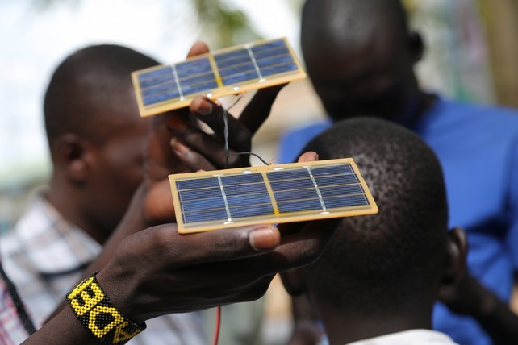

PARTNER INFO / CREDITS
PARTNER ORGANISATIONS

KAPITAL is a Juba based grass-roots video and sound production, ICT and community training organisation. Running what it called a 'Virtual Academy' KAPITAL operated as an independent peer-to-peer collective of young designers, filmmakers, IT professionals and artists working to train each other in viable media oriented skills. Tapping the hopes, aspirations and dedication to create a new future beyond conflict its members have come together to address the acute post- independence social, political, educational and environmental challenges arising from decades of civil war. With an urgent need to pro-actively strengthen and amplify the voice of youth seeking to eradicate the senseless violence that has gripped the country from within, KAPITAL established jHUB in late 2015.

icebauhaus is the German partner in the international icehubs-network of green-tech & social innovation hubs, geared towards a bottom-up strategy that combines both local and international trends with state-of-the-art technological developments. icebauhaus’ work is primarily project-based and community oriented. The members are experts in various academic disciplines, entrepreneurs and generalists with a great deal of background experience in international cooperation. Main expertise and experiences: ICT in agriculture [ICT4ag], experimental building & low-cost housing, techhubs, maker spaces and innovation networks.

r0g_agency for open culture and critical transformation focuses on model social innovation and peacebuilding projects embedded primarily in communities experiencing post-conflict development. Its network aims to influence policy from the ground up, to inform and create better policy outcomes, extend networks and support – bringing together arts, culture, open development, civil society and transparence of action. r0g_agency’s work taps into the power and breadth of contemporary free and public domain resources including open educational resources [OERs], free open source software [FOSS], open hardware, open data and open knowledge repositories.

Let's Go jHUB (#LGJ) is funded by the German Federal Ministry of Economic Cooperation and Development (BMZ) through its programme of “Support for Media, Access to Information and Freedom of Expression”.

ABOUT jHUB

jHUB creates an open knowledge and innovation space for South Sudanese youth to connect and collaborate, while providing an accessible resource centre for creative learning and exploration. It seeks to adopt an ‘open system’ approach, nurturing togetherness, socialisation, collaborative enterprise using hands-on, virtual, and e-learning digital environments as a means to understand South Sudan’s diverse culture.
jHUB’s capacity building and development elements are oriented towards using the advantages of a wide range and freely accessible of open source tools, platforms and methodologies including the extensive use and promotion of “Open Education Resources” (OERs). jHUB also forms a part of the Global Innovation Gathering (GIG), a network which helped host a number of jHUB activities in neighbouring countries in 2016.

http://jubahub.org

The Open Tech Guide is an outcome of "Step Juba Media Lab", a collaboration with Kapital Movie and the new jHUB community in South Sudan, produced with partners icebauhaus and r0g_agency for open culture and critical transformation in Berlin. This first edition of the Open Tech Guide is an outcome of training in the framework of the 'Let's Go jHUB' project, funded by the German Federal Ministry of International Cooperation and Development (BMZ) through its programme of “Support for Media, Access to Information and Freedom of Expression” in 2016.

