Open Hardware
Introduction

Open Hardware (OH) or “Open Source Hardware (OSHW) is a term for tangible artifacts — machines, devices, or other physical things — whose design has been released to the public in such a way that anyone can make, modify, distribute, and use those things.”
The general benefits of open source methods and open tech innovation are:
- Access to knowledge and product designs
- Fast and distributed exchange of skills and knowledge
- Accelerated innovation due to collaborative development
- Low development costs and more expertise
- Easy adaptation and customization
What do you need for Open Tech Innovation?
- Tools & Materials: depends on the technology
Always try local sourcing first!
- License Example: A proper license for the product design
  - for design-files, digital work: cc-by-sa (Creative Commons)
  - for hardware, functionality: CERN OHL (OH License)
- Open Source Software: Linux and platform independent if possible
  - Examples: see section →Resources

Open Tech Skills
Training and Team

Open Tech Training Skills
List for text version of the post-it note image

Experience
Creativity
Knowledge
Good Listening
Time Management Skills
Mission
Hands-on Skills
Improvisations
Basic Tool Skills
Motivational Skill
Hopeful
Entertaining
Passionate
Social Skills
Explanation Skills
Word Skills
Technical Skills
Commitment
Approachability
Flexibility
Visionable

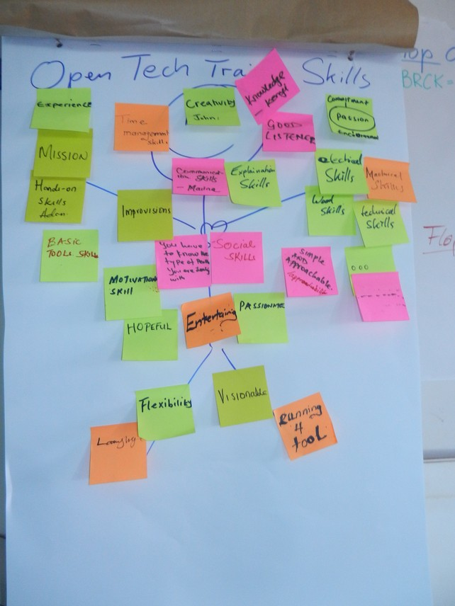

Open Tech Linux Software Installation
(on Ubuntu based OS)
Please run:
sudo apt update
sudo apt upgrade

sudo apt install gdebi software-properties-common libavcodec-extra ffmpeg redshift firefox libreoffice shutter vlc pinta pdfshuffler geogebra darktable gthumb trash-cli gimp inkscape openshot kazam audacity kdenlive freecad librecad fritzing kicad

#ASKotek
Access to Skills and Knowledge – Open Tech Emergency Kit
Freely shareable and collaboration based Open Technologies are a form of Open Source that can also act as accelerators for peace and empowerment.

A versatile, robust and mobile trainer’s kit with 40 items designed to tackle a range of basic education, innovation and self-training challenges #ASKotek enables ‘Access to Skills & Development’ in the field ... anywhere!

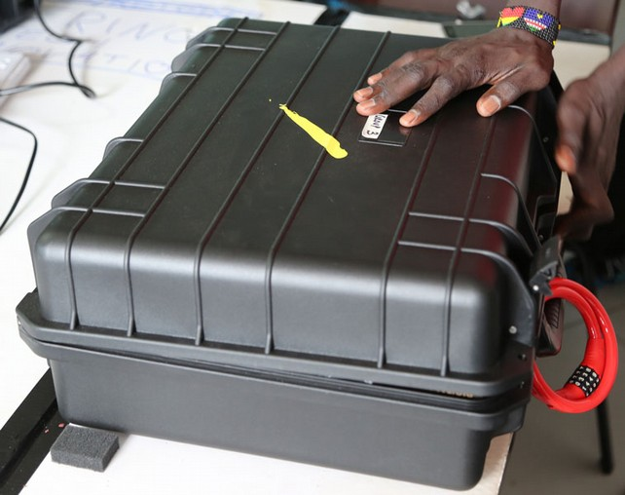
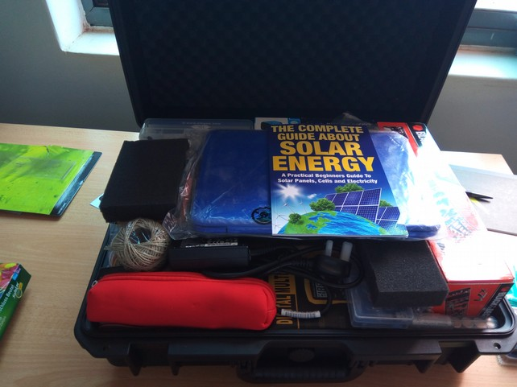
This basic Open Tech Kit provides tools and materials to learn and distribute knowledge and product development.
The set contains:
- Basic electronics and connections
- Soldering and cutting tools
- Mechanical and measurement tools
- A Linux computer and some adapters
- Guidelines and additional things to get creative and start innovation on the spot
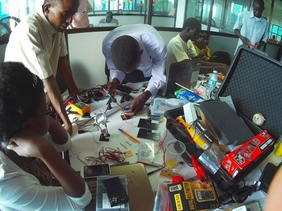
The kit can be used on site, in the field and can function as a startup tool-set for building a co-working space, learning hub or any other innovation community setup.
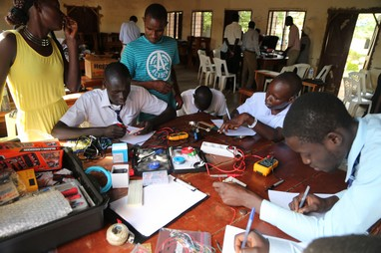
It is designed to be modular, mobile and adaptable to any location or situation to share knowledge and empower innovation.
#ASKotek was created by the participants of the Let’s Go jHUB project.

#ASKotec Content List:

Access to Skills and Knowledge - open tech emergency kit

- books (1 jHUB booklet, 1 solar book, 1 Open Learning Guide)
- 1 small trainers notepad
- 1 blue HP notebook (Linux Elementary OS installed)
- 1 clipboard with paper
- 1 protractor / square rule
- 1 pencil pouch (pen, pencil, ruler, cutter, 9V battery w/ wire connection, USB current meter, small Post-It Notes, highlighter, pencil sharpener, saw blades, small brush, 16GB USB memory stick)
- twine
- 1 pair of scissors
- 1 'helping hand' tool with magnifying glass
- 1 travel plug adapter
- 1 upgrade electronics kit
- 1 little electronics box (incl. solar charger pieces)
- 1 first aid kit incl. burn ointment
- 3 circuit boards
- 2 bread boards
- 4 x 4V solar panels
- 12V solar panel with adapter (in box)
- foam padding for PC
- small multimeter
- crocodile clips, jumper wires, twin wires
- 2 packets of 4 rechargeable AA batteries (2000 mAh)
- 3 x AA battery cases with switch
- 1 bag of switches
- 1 big multimeter
- 1 soldering kit (3 extra wires, 2 rolls of solder, 1 sucker, 1 solder iron + stand, 1 pack of extra tips, soldering grease and solder remover)
- 1 wire stripper
- 1 universal mobile phone repair tool set
- assorted heat shrink tubes
- 1 pack of 4 USB plugs
- 2 sizes zip ties (black - short, colour - long)
- 1 small hacksaw
- 1 pair chopsticks
- 1 mechanical tool set (Black and Decker)
- disposable cleaning pads
- 2 sizes of small zip-lock bags (150 and 380 ml)
- 1 LED light strip
- 1 ASKotek table of contents + packing / unpacking guide
- 1 small combination padlock (for locking case itself)
- 1 coloured combination chain lock (for locking case to something secure)
- 1 black dustproof / waterproof hard case 520 x 415 x 195 mm

Open Hardware Process
Documentation Principals

One key instrument of Open Hardware is clear documentation. In order to stay on track while developing or adapting a product, it is highly recommended to document the process to create an easy pattern to follow: → Open Hardware Guide. This saves time and prototyping iterations.
Therefore good sketches and pictures of the steps are needed, that trace the development process clearly and simply in the order that it happens. The following template might help as you take important notes along the way:
Project: Name and Team | Date and Step/Workday
CC-BY-SA (digital) CERN OHL (hardware) | Open Process Documentation (OPD) – Nr #

Steps: Notes:

Flops: | Tops:
Open Questions: marked as solved:
[ ]
[ ]
[ ]
. . .

Steps: Follow all working procedures & note the process step-by-step in the order it happens. Keep it clear and simple, note additional tips or details.
Flops & Tops: What went wrong and should be avoided?
What went right and is noted as best practice?

Open Questions: What challenges, problems still need to be solved?

Open Hardware Guide
Open Process Documentation

Using your Open Process Documentation (OPD) the next part is to create a clean and visualized Open Tech Guide for the current version.
This Guide is key to empower further development and innovation.
The following template is given as a best practice reference:

Project: Name and Team | Date of release
CC-BY-SA (digital) CERN OHL (hardware) | Open Hardware Guide | Version Nr. #

Steps:  - ... | Tools:
Steps:  - ... | Materials
Steps:  - ... | Tips and Usage
Possible Improvements | Open Questions

+ References (add web URL links) if available

Resources
OPEN TECH, OPEN HARDWARE + ELECTRONICS

MOZILLA WEB LITERACY
https://learning.mozilla.org/en-US/web-literacy
Web literacy 21st Century Skills: Problem-Solving, Communication, Creativity, Collaboration. Share, design, code, compose, remix, navigate, connect, open practice, contribute.

OPEN! METHODS & TOOLS FOR COMMUNITY-BASED PRODUCT DEVELOPMENT
https://opensourcedesign.cc/
Current practices of open source product development & concrete guidance to support design process efficiency of open source product development projects.

OPEN SOURCE HARDWARE ASSOCIATION
https://www.oshwa.org/
Open hardware community ensuring technological knowledge is accessible to everyone. Collaborative development of technology that serves education, environmental sustainability, and human welfare.

OPEN SOURCE EDUCATION
https://opensource.com/education/13/4/guide-open-source-education
A guide to free and open source education. Stories about creating, adopting, and sharing open source solutions.

AFRIMAKERS
http://www.afrimakers.org
Empowers makers in Africa to develop sustainable projects using rapid prototyping to solve local challenges.

APPROPEDIA
http://www.appropedia.org/Welcome_to_Appropedia
Sharing knowledge to build rich, sustainable lives.

IFIXIT
https://www.ifixit.com/
The free repair guide for everything, written by everyone.

INSTRUCTABLES
http://www.instructables.com/
Share what you make with the world, and tap into an ever-growing community of creative experts. Participate in make-a-thons through the platform. Add your own instructables.

OPEN SOURCE ECOLOGY
http://opensourceecology.org/
Open source industrial machines can be made for a fraction of commercial costs, designs shared online free, to create an open source economy which increases innovation by open collaboration.

WIKIFAB
http://wikifab.org/
Open source hardware documentation platform. Tutorials to make anything, written by everyone.

WIKI-HOW
http://www.wikihow.com/
“We're trying to help everyone on the planet learn how to do anything. Join us.”
-----

www.oshwa.org/definition
www.creativecommons.org/licenses/by-sa/4.0/
www.ohwr.org/cernohl

