RELAZIONE PROGETTO OPEN DATA
STUDENTE MICHELE MARESCA W82000079

Inserimento di Eventi e Locations

Dopo aver inserito gli eventi su un Google Sheet era necessario organizzare i dati, in modo tale da essere utilizzato per poi essere renderizzati su schermo. I dati a me assegnati sono stati gli Eventi e le Locations
Generazione di Eventi

Event Ontology

Per la modellazione degli eventi si è utilizzata l’Event Ontology sviluppata dall’Università di Londra.

L’ontologia è basata sulla nozione di evento visto come agenti cognitivi che classificano regioni spazio/tempo.

Questa ontologia è stata utilizzata in molti contesti, grazie alla sua flessibilità e usabilità.

I Namespace XML usati per l’ontologia sono i seguenti:

Prefissi | XML Namespace | Descrizione
event | http://purl.org/NET/c4dm /event.owl# | The Event Ontology
time | http://www.w3.org/2006/time# | OWL-Time The
geo | http://www.w3.org/2003/01 /geo/wgs84_pos# | Geo Positioning Ontology

Il Modello Event
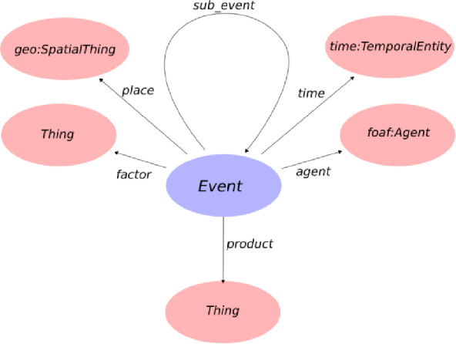

Esempio di un evento: performance di un musicista e di uno strumento (il santur) a Londra il 15/10/2007, a Mezzogiorno e dalla durata di un’ora

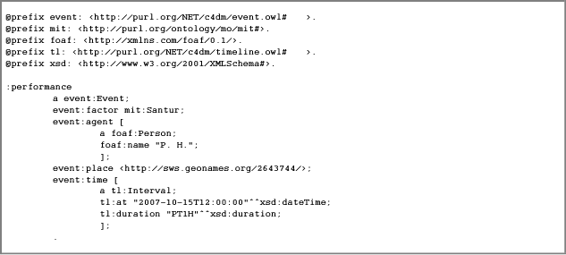
Per maggiori informazioni sull'Event Ontology: http://motools.sourceforge.net/event/event.html
Il codice in PHP qui sotto serve per modellare gli Eventi dell'Agenda Libera:

<?php
/**
* Generate an RDF/XML representation of an event.
*
* Copyright 2016 Michele Maresca
*
* This program is free software: you can redistribute it and/or modify
* it under the terms of the GNU Lesser General Public License as published by
* the Free Software Foundation, either version 3 of the License, or
* (at your option) any later version.
*
* This program is distributed in the hope that it will be useful,
* but WITHOUT ANY WARRANTY; without even the implied warranty of
* MERCHANTABILITY or FITNESS FOR A PARTICULAR PURPOSE. See the
* GNU Lesser General Public License for more details.
*
* You should have received a copy of the GNU Lesser General Public License
* along with this program. If not, see <http://www.gnu.org/licenses/>.
*
* @author Michele Maresca
*/
/**
* Include classes: Location e RDFLocnGenerator
*
* @author Michele Maresca
*/
//include("./RDFLocnGenerator.php");
/**
* Define the output file
*
* @author Michele Maresca
*/
if(basename(__FILE__) == basename($argv[0]))
define('XML_FILE', 'events.xml');
define('DATATYPE_ATTRIBUTE', 'rdf:datatype');
/**
* Define RDF attribute rdf:About
*
* @author Michele Maresca
*/
define('RDF_ATTRIBUTE', 'rdf:about');
/**
* Define RDF DATATYPE
*
* @author Michele Maresca
*/
define('RDF_DATATYPE', "http://www.w3.org/2001/XMLSchema#dateTime");
/**
* Define Ontology attribute
*
* @author Michele Maresca
*/
define('ONTOLOGY_VALUE', 'http://www.dmi.unict.it/~longo/opendatatour');
/**
* Define RDF Attributes value
*
* @author Michele Maresca
*/
/**
* Define URI
*
* @author Michele Maresca
*/
define('URI', 'http://opendatahacklab.org/agendaunica/');
/**
* Attribute for the RDF node parent
*
* @author Michele Maresca
*/
define('BASE_VALUE', 'http://example.org');
define('DC_VALUE', 'http://purl.org/dc/elements/1.1/');
define('GEO_VALUE', 'http://www.w3.org/2003/01/geo/wgs84_pos#');
define('FOAF_VALUE', 'http://xmlns.com/foaf/0.1/');
define('ORG_VALUE', 'ttp://www.w3.org/ns/org#');
define('LOCN_VALUE', 'http://www.w3.org/ns/locn#/');
define('DCTERMS_VALUE', 'http://purl.org/dc/terms/');
define('RDFS_VALUE', 'http://www.w3.org/2000/01/rdf-schema#');
define('OWL_VALUE', 'http://www.w3.org/2002/07/owl#');
define('XSD_VALUE', 'http://www.w3.org/2001/XMLSchema#');
define('EVENT_VALUE', 'http://purl.org/NET/c4dm/event.owl#');
define('RDF_VALUE', 'http://purl.org/NET/c4dm/event.owl#');
define('TIME_VALUE', 'http://www.w3.org/2006/time#');
define('SIOC_VALUE', '&sioc;');
/**
* Create a Event RDFnode to insert in the XML file
*
* @param $event An Event Object generated from the Class AgensaSheetParser
*
* @author Michele Maresca
*/
class RDFEventsGenerator
{
private $event;
public function __construct($event)
{
$this->event = $event;
}
/**
* Get the namespaces which are expected to be set (aside with respective
* abbreviation prefixes) in the destination ontology. excluding the default ones
* rdf, rdfs and owl-
*
* @return a map prefix -> namespace
*/
public static function getRequiredNamespaces(){
return array('event'=>'http://purl.org/NET/c4dm/event.owl#',
'time'=>'http://www.w3.org/2006/time#', 'dcterms'=>DCTERMS_VALUE);
}
/**
* Get the set of vocabulary iris to be imported in the target ontology
*/
public static function getRequiredVocabularies(){
return array('http://motools.sf.net/event/event.n3');
}
public function generateEvent($xml, $rdfParent, $uri)
{
//Contain the event URI
$eventURI = "";
//Create the Node for the RDFEvent
$eventRDF = $xml->createElement("event:Event");
$eventAttribute = $xml->createAttribute(RDF_ATTRIBUTE);
$eventRDF->appendChild($eventAttribute);
$eventName = $xml->createElement("rdfs:label");
if ($this->event->description!=null && strlen($this->event->description))
$this->addEventDescriptionElement($xml, $eventRDF, $this->event->description);
if ($this->event->creationTime!=null)
$this->addEventModificationTime($xml, $eventRDF, $this->event->creationTime);
$eventTime = $xml->createElement("event:time");
$timeInterval = $xml->createElement("time:Interval");
$rdfTimeAttribute = $xml->createAttribute(RDF_ATTRIBUTE);
$timeInterval->appendChild($rdfTimeAttribute);
$timeHasBeginning = $xml->createElement("time:hasBeginning");
$timeInstant = $xml->createElement("time:Instant");
$rdfInstantAttribute = $xml->createAttribute(RDF_ATTRIBUTE);
$timeXSDDataTime = $xml->createElement("time:inXSDDateTime");
$eventName->appendChild($xml->createTextNode($this->event->name));
if($this->event->locationId)
{
$eventPlace = $xml->createElement("event:place");
$eventPlaceAttribute = $xml->createAttribute("rdf:resource");
$eventPlaceAttribute->value = RDFLocnGenerator::getLocationURI($uri, $this->event->locationId);
$eventPlace->appendChild($eventPlaceAttribute);
$eventRDF->appendChild($eventPlace);
}
//If the Event Date is valid, the information will be saved in $date
if($this->event->start)
$date = $xml->createTextNode(date("c", $this->event->start->getTimestamp()));
else
$date = $xml->createComment("Data non valida!");
$formatInstant = $this->setDateAttribute($date);
//Generate Event URI from formatInstant
$eventURI = $this->generateURIEvent($formatInstant[0], $uri);
$rdfInstantAttribute ->value = $eventURI."time/begin";
$timeInstant->appendChild($rdfInstantAttribute);
$timeXSDDataTime->appendChild($date);
$rdfXSDAttribute = $xml->createAttribute(DATATYPE_ATTRIBUTE);
$rdfXSDAttribute->value = RDF_DATATYPE;
$timeXSDDataTime->appendChild($rdfXSDAttribute);
$rdfTimeAttribute->value = $eventURI."time";
$timeInstant->appendChild($timeXSDDataTime);
$timeHasBeginning->appendChild($timeInstant);
$timeInterval->appendChild($timeHasBeginning);
$eventTime->appendChild($timeInterval);
$eventRDF->appendChild($eventTime);
$eventAttribute->value = $eventURI;
$eventRDF->appendChild($eventName);
//Append RDFNode to the RDF Parent
$rdfParent->appendChild($eventRDF);
}
/**
* Add descrption as rdfs:comment to an individual representing an event
*
* @param unknown $xml the xml document
* @param unknown $eventElement
* @param unknown $descrpition
*/
private function addEventDescriptionElement($xml, $eventElement, $descrpition){
$textEl=$xml->createTextNode($descrpition);
$commentEl=$xml->createElement("rdfs:comment");
$eventElement->appendChild($commentEl);
$commentEl->appendChild($textEl);
}
/**
* Add dcterm:modified to an event.
*
* @param unknown $xml
* @param unknown $eventElement the xml element representing the event
* @param unknown $creationTime a DateTime object
*/
private function addEventModificationTime($xml, $eventElement, $creationTime){
$modifiedElement=$xml->createElement('dcterms:modified');
$eventElement->appendChild($modifiedElement);
$timeTextNode=$xml->createTextNode(date("c", $creationTime->getTimestamp()));
$modifiedElement->appendChild($timeTextNode);
$rdfXSDAttribute = $xml->createAttribute(DATATYPE_ATTRIBUTE);
$rdfXSDAttribute->value = RDF_DATATYPE;
$modifiedElement->appendChild($rdfXSDAttribute);
}
/**
* Format the date in the formate "YYYYMMDDHHMM"
*
* @param $date is Date Object
*
* @author Michele Maresca
*/
private function setDateAttribute($date)
{
$text = $tmp = [];
$str1 = $str2 = "";
//Split the date and the time of the Event
$text = explode("T",$date->wholeText);
//Here obtaine the date
$str1 = join(explode("-", $text[0]));
//Here the time
$tmp = explode("\+", $text[1]);
$tmp = join(explode(":", $tmp[0]));
$str2 = substr($tmp, 0, 4);
return [$str1, $str2];
}
/*
* TODO make it static and add comments
*/
private function generateURIEvent($data, $uri)
{
//Extract date from event following the format "YYYYMMDDHHMM"
//Strings who compose the URI of Event Object
$stringURI = "";
$timeURI = "";
$nameURI = "";
//Create timeURI and nameURI
$timeURI = substr($data, 0, 8);
$nameURI = urlencode($this->event->name);
$stringURI .= $uri.$timeURI."/".$nameURI."/";
return (string) $stringURI;
}
}
Generazione Locations
ISA Programme Location Core Vocabulary

L' ISA Programme Location Core Vocabulary fornisce un insieme di classi e proprietà per descrivere ogni posto in termini di nome, indirizzo o geometria. I dati sono stati progettati in modo tale che la pubblicazione di questi ultimi siano compatibili con l'EU INSPIRE Directive.

Namespace

L' URI per questo vocabulario è
http://www.w3.org/ns/locn#
Quando si abbrevia si utilizza il prefisso locn
Ogni classe o proprietà del vocabolario ha un URI costruito semplicemente accodando il nome del termine all'URI del vocabolario. Per esempio:
http://www.w3.org/ns/locn#Address
The ISA Programme Location Core Vocabulary includes terms defined in the following namespaces:

Ll'ISA Programme Location Core Vocabulary include i termini nei seguenti namespace:
- http://purl.org/dc/terms/
- http://www.w3.org/2000/01/rdf-schema

Descrizione del vocabolario locn

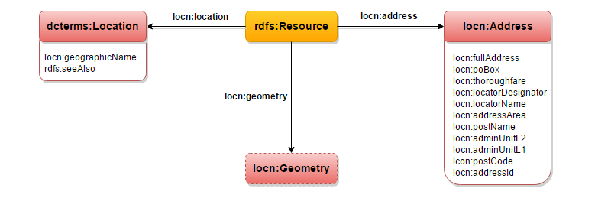
Per ogni altra informazione controllate su: https://www.w3.org/ns/locn
Di seguito vi riporto il codice in PHP utilizzato per creare un oggetto di tipo Location seguendo le regole del vocabolario descritto sopra:

Codice Descrizione Location
<?php
/**
*
* Basic representation of a Location, as defined in the LOCN vocabulary
*
* Copyright 2016 Michele Maresca and Cristiano Longo
*
* This program is free software: you can redistribute it and/or modify
* it under the terms of the GNU Lesser General Public License as published by
* the Free Software Foundation, either version 3 of the License, or
* (at your option) any later version.
*
* This program is distributed in the hope that it will be useful,
* but WITHOUT ANY WARRANTY; without even the implied warranty of
* MERCHANTABILITY or FITNESS FOR A PARTICULAR PURPOSE. See the
* GNU Lesser General Public License for more details.
*
* You should have received a copy of the GNU Lesser General Public License
* along with this program. If not, see <http://www.gnu.org/licenses/>.
*
* @author Michele Maresca
* @author Cristiano Longo
*/
class LocnLocation {
public $name;
public $city;
public $address;
public $houseNumber;
public $lat;
public $long;
public $id;
/**
*
* @param String $name
* not null, used to identify the location
* @param String $city
* @param String $address
* @param String $houseNumber
* @param double $lat
* @param double $long
*/
public function __construct($name, $city, $address, $houseNumber, $lat, $long) {
$this->name = $name;
$this->city = $city;
$this->address = $address;
$this->houseNumber = $houseNumber;
$this->lat = $lat;
$this->long = $long;
$this->id = $this->generateId($name, $city, $address, $houseNumber);
}
/**
* Create a unique identifier for this location
*/
private function generateId($name, $city, $address, $houseNumber){
if ($name!=null && strlen($name)>0)
return $name;
$city=$city==null ? '' : $city;
$address=$address==null ? '' : $address;
$houseNumber=$houseNumber==null ? '' : $houseNumber;
return "$city-$address-$houseNumber";
}
}
?>

Generazione di una Location in formado RDF/XML
<?php
/**
*
* Generate an RDF/XML representation of a location.
*
* Copyright 2016 Michele Maresca
*
* This program is free software: you can redistribute it and/or modify
* it under the terms of the GNU Lesser General Public License as published by
* the Free Software Foundation, either version 3 of the License, or
* (at your option) any later version.
*
* This program is distributed in the hope that it will be useful,
* but WITHOUT ANY WARRANTY; without even the implied warranty of
* MERCHANTABILITY or FITNESS FOR A PARTICULAR PURPOSE. See the
* GNU Lesser General Public License for more details.
*
* You should have received a copy of the GNU Lesser General Public License
* along with this program. If not, see <http://www.gnu.org/licenses/>.
*
* @author Michele Maresca
*/
/**
* Define adminUnitL1 value
*
* @author Michele Maresca
*
*/
define ( 'ADMIN_UNIT', 'IT' );
/**
* Create a Locn RDFnode
*
* @author Michele Maresca
*/
class RDFLocnGenerator {
private $location;
public function __construct($location) {
$this->location = $location;
}
public function generateLocation($xml, $rdfParent, $prefix) {
$locationId=
$uri=RDFLocnGenerator::getLocationURI($prefix,$this->location->id);
// Create RDF Node for location
$locnRDF = $xml->createElement ( "locn:Location" );
$locnRDFAttribute = $xml->createAttribute ( 'rdf:about' );
$locnRDFAttribute->value = $uri;
$locnRDF->appendChild ( $locnRDFAttribute );
if ($this->location->name!=null && strlen($this->location->name)>0){
$locationNameElement = $xml->createElement('rdfs:label');
$locnRDF->appendChild($locationNameElement);
$locationNameElement->appendChild($xml->createTextNode($this->location->name));
}
// Create NODE locn:address
$parentLocnAddress = $xml->createElement ( "locn:address" );
// Create NODE locn:Address
$locnAddress = $xml->createElement ( "locn:Address" );
$locnAddressAttribute = $xml->createAttribute ( 'rdf:about' );
$locnAddressAttribute->value = $uri. "/address";
$locnAddress->appendChild ( $locnAddressAttribute );
// Create node rdfs:label
$rdfLabel = $xml->createElement ( "rdfs:label" );
$rdfLabel->appendChild ( $xml->createTextNode ( $this->formatLabel () ) );
// Create node locn:fullAddress
$fullAddress = $xml->createElement ( "locn:fullAddress" );
$fullAddress->appendChild ( $xml->createTextNode ( $this->formatLabel () ) );
$locnAddress->appendChild ( $fullAddress );
// Create node locn:throughfare
if (isset($this->location->address) && $this->location->address!=null){
$locnThroughfare = $xml->createElement ( "locn:throughfare" );
$locnThroughfare->appendChild ( $xml->createTextNode ( $this->location->address ) );
$locnAddress->appendChild ( $locnThroughfare );
}
// Create node locn:locatorDesignator
if (isset($this->location->houseNumber) && $this->location->houseNumber!=null){
$locnDesignator = $xml->createElement ( "locn:locatorDesignator" );
$locnDesignator->appendChild ( $xml->createTextNode ( $this->location->houseNumber ) );
$locnAddress->appendChild ( $locnDesignator );
}
// Create node locn:locatorPostname
$locnPostName = $xml->createElement ( "locn:postName" );
$locnPostName->appendChild ( $xml->createTextNode ( $this->location->city ) );
// Create node locn:adminUnitL1
$locnAdminUnitL1 = $xml->createElement ( "locn:adminUnitL1" );
$locnAdminUnitL1->appendChild ( $xml->createTextNode ( ADMIN_UNIT ) );
// Insert node in locn:Address
$locnAddress->appendChild ( $rdfLabel );
$locnAddress->appendChild ( $locnPostName );
$locnAddress->appendChild ( $locnAdminUnitL1 );
$parentLocnAddress->appendChild ( $locnAddress );
// Create locn:geometry
if (isset ( $this->location->lat ) && strlen ( $this->location->lat ) > 0 && isset ( $this->location->long ) && strlen ( $this->location->long ) > 0) {
$parentGeometry = $xml->createElement ( "locn:geometry" );
// Create NODE locn:Geometry
$geoLocnGeometry = $xml->createElement ( "locn:Geometry" );
$geoAttribute = $xml->createAttribute ( "rdf:about" );
$geoAttribute->value = $uri . "/geometry";
$geoLocnGeometry->appendChild ( $geoAttribute );
// Create node geo:lat
$geoLat = $xml->createElement ( "geo:lat" );
$geoLat->appendChild ( $xml->createTextNode ( $this->location->lat ) );
// Create node geo:long
$geoLong = $xml->createElement ( "geo:long" );
$geoLong->appendChild ( $xml->createTextNode ( $this->location->long ) );
$geoLocnGeometry->appendChild ( $geoLat );
$geoLocnGeometry->appendChild ( $geoLong );
$parentGeometry->appendChild ( $geoLocnGeometry );
$locnRDF->appendChild ( $parentGeometry );
}
$locnRDF->appendChild ( $parentLocnAddress );
$rdfParent->appendChild ( $locnRDF );
}
/**
* Get the namespaces which are expected to be set (aside with respective
* abbreviation prefixes) in the destination ontology.
* excluding the default ones
* rdf, rdfs and owl-
*
* @return a map prefix -> namespace
*/
public static function getRequiredNamespaces() {
return array (
'geo' => 'http://www.w3.org/2003/01/geo/wgs84_pos#',
'locn' => 'http://www.w3.org/ns/locn#'
);
}
/**
* Get the set of vocabulary iris to be imported in the target ontology
*/
public static function getRequiredVocabularies() {
return array (
'http://www.w3.org/ns/locn',
'https://www.w3.org/2003/01/geo/wgs84_pos'
);
}
public static function getLocationURI($prefix, $name) {
return ( string ) $prefix . urlencode ( $name );
}
private function formatLabel() {
$label="Italy";
if (isset($this->location->city) && $this->location->city!=null && count($this->location->city)>0)
$label=$this->location->city.', '.$label;
if (isset($this->location->address) && $this->location->address!=null && count($this->location->address)>0)
$label=$this->location->address.', '.$label;
if (isset($this->location->houseNumber) && $this->location->houseNumber!=null && count($this->location->houseNumber)>0)
$label=$this->location->houseNumber.', '.$label;
return $label;
}
}

Tutti i codici sono disponibile presso il Github del progetto FreeAgenda presso l'URL: https://github.com/opendatahacklab/free-agenda/

