Table of Contents

Post-Code-Freeze Gatekeeper — Design Document
A time-gated, bot-only merge enforcement system for GitHub repositories.

Table of Contents
- 1. Problem Statement
- 2. Architecture Overview
- 3. GitHub App Setup
- 4. Ruleset Specification
- 5. Workflow Design
- 6. Configuration Schema
- 7. Deployment Guide
- 8. Edge Cases
- 9. Security Analysis
- 10. Appendix: Quick Reference

1. Problem Statement

Requirements
# | Requirement | Constraint
R1 | Block manual pushes to given branches of a given repo for a given time period | Time-configurable, per-repo, per-branch
R2 | GitHub workflow decides whether current time is in the restricted period and checks prerequisites | Time evaluation + CI status + labels + approvals
R3 | All changes via PRs only, merged exclusively by a GitHub App bot from the workflow | Bot is the sole merge authority
R4 | Nobody else can merge, even with full admin access | No human bypass — not even org owners

Why This is Hard
GitHub does not natively support time-based merge restrictions. Repository Rulesets can block pushes and require status checks, but they have no concept of “only during these hours.” The solution must combine static rulesets with dynamic workflow logic.
The hardest constraint is R4 — ensuring no human can merge. GitHub rulesets use an explicit bypass list. If we simply leave humans off the list, they cannot merge even outside freeze windows. We need the bot to be the ONLY entity that ever merges, and the bot itself must be controlled by time-aware logic.

2. Architecture Overview

Three-Layer Defense-in-Depth
The solution uses three complementary layers. Each layer independently prevents unauthorized merges, and all three must be satisfied for a merge to succeed.
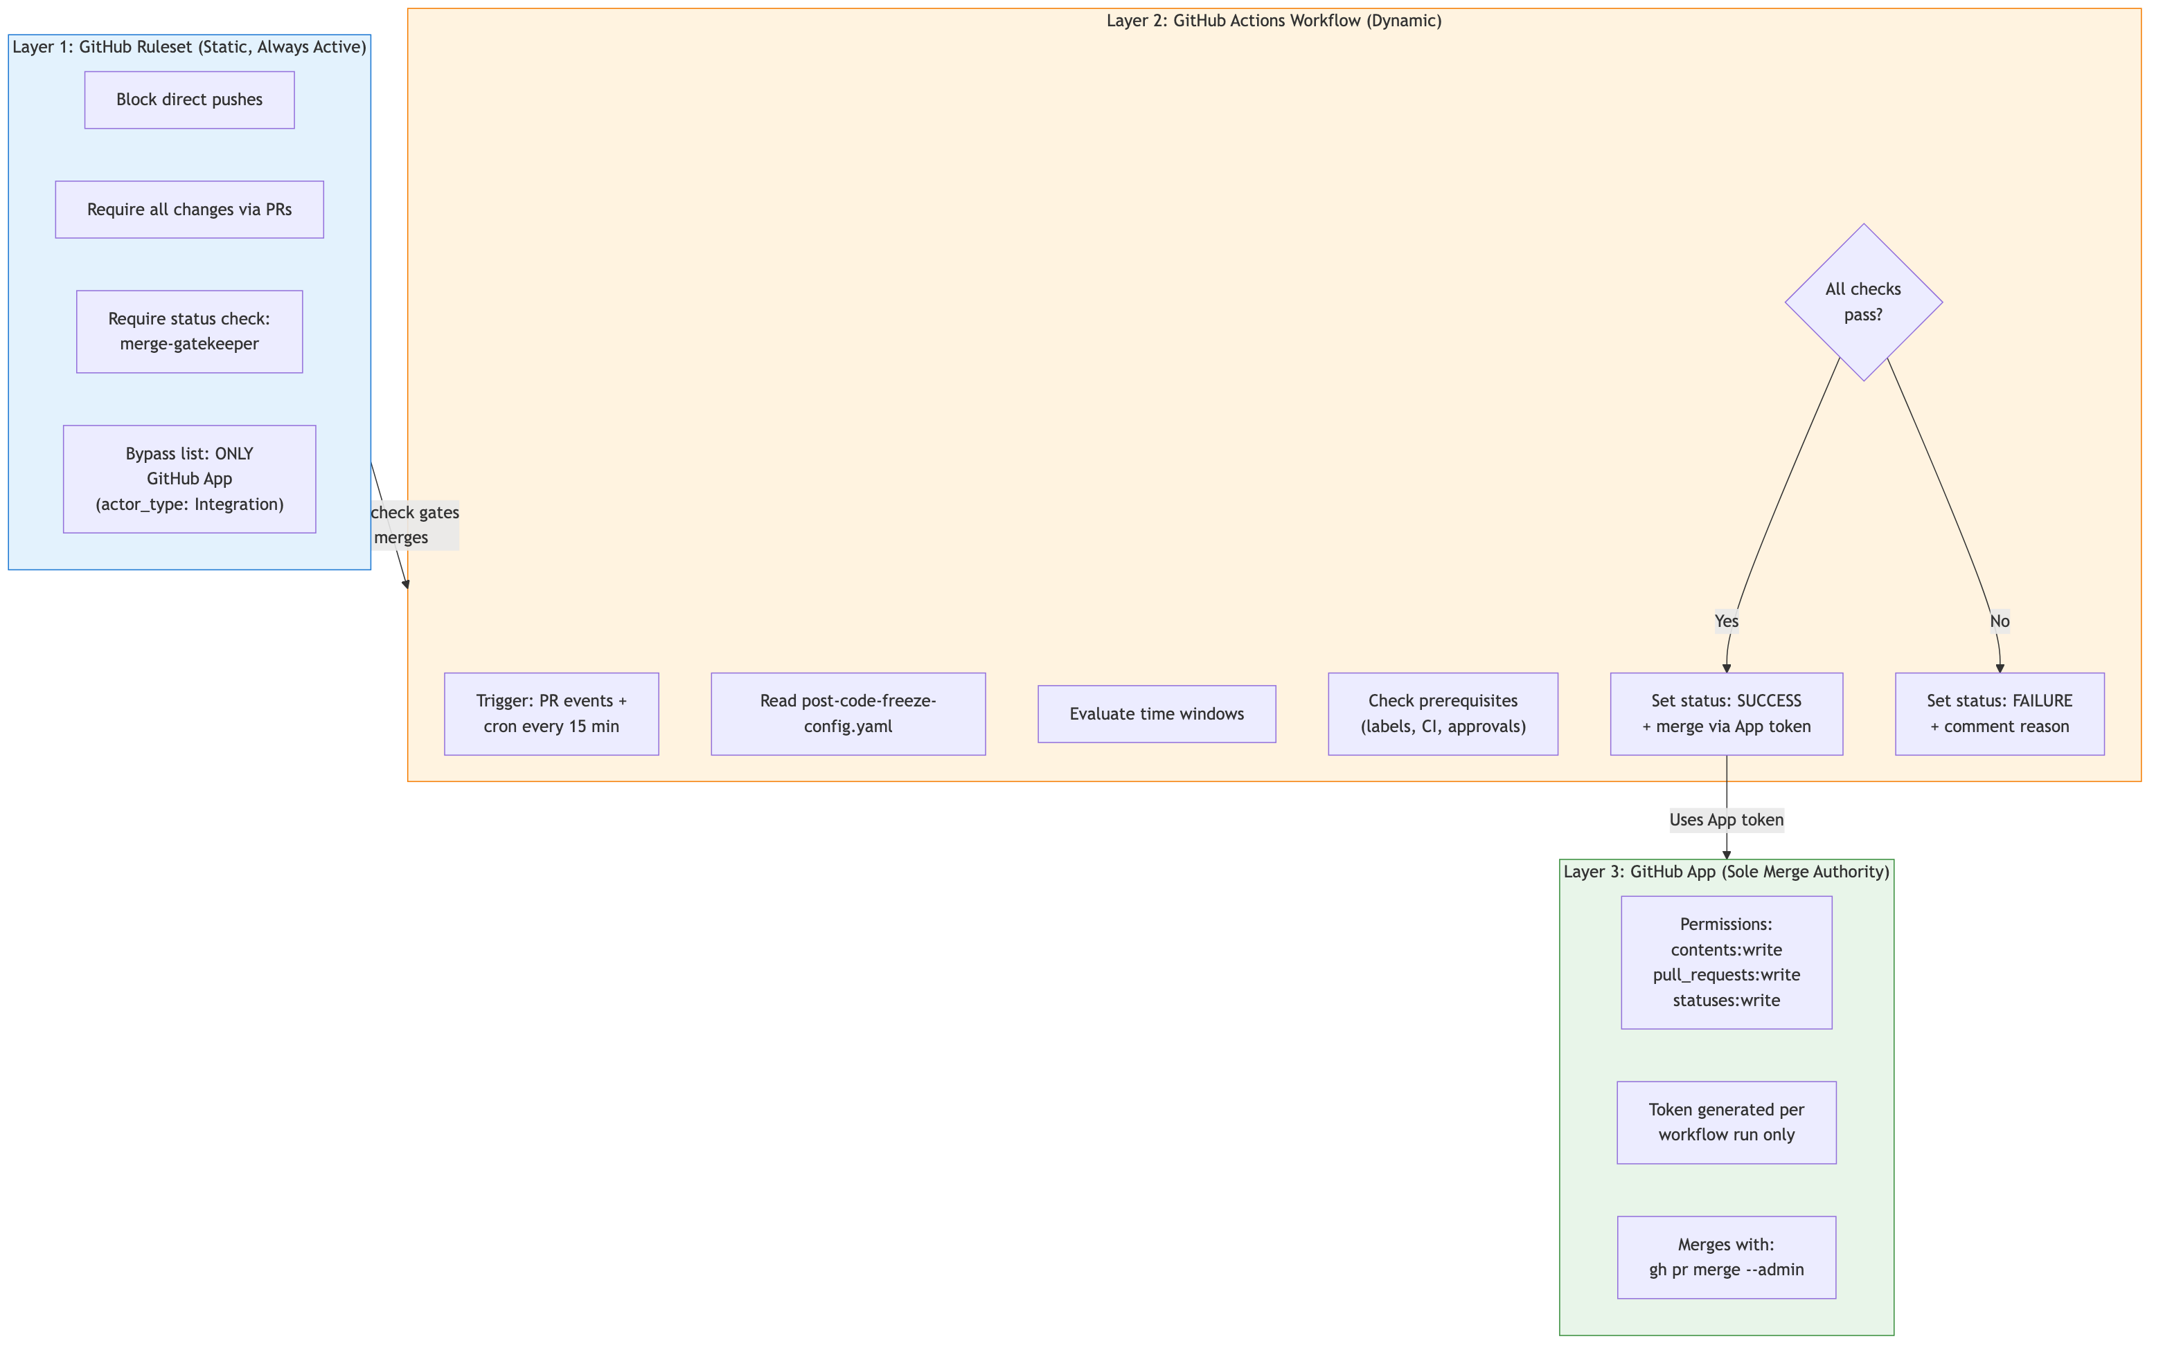
Three-Layer Defense-in-Depth Architecture

How the Layers Interact
- The Ruleset ensures that no human can push or merge. The merge button is disabled for everyone because the required merge-gatekeeper status check is controlled by the App.
- The Workflow evaluates time windows and prerequisites, then reports the status check result. During freeze, it reports failure — during open windows with passing prereqs, it reports success.
- The App is the only entity on the ruleset’s bypass list. It merges only when the workflow explicitly instructs it to. No human possesses the App’s token.
Key Insight: The time-gating happens in Layer 2 (the workflow), not Layer 1 (the ruleset). The ruleset is static and always active. The workflow dynamically controls whether the status check passes, which in turn controls whether the App will merge.

3. GitHub App Setup

Using the Existing App
The existing ODH_DEVOPS_APP (used by odh-konflux-onboarder.yml and odh-early-gate-onboarder.yml) can be reused.

Required Permissions
Permission | Level | Purpose
contents | write | Merge PRs (push to protected branch)
pull_requests | write | Comment on PRs, read PR metadata
statuses | write | Create/update the merge-gatekeeper commit status
checks | write | Optional: richer check run details

Token Generation Pattern
From the existing odh-konflux-onboarder.yml:113-118:
- name: Generate GitHub App token
id: app-token
uses: getsentry/action-github-app-token@v2
with:
app_id: ${{ secrets.ODH_DEVOPS_APP_ID }}
private_key: ${{ secrets.ODH_DEVOPS_APP_PRIVATE_KEY }}
Tokens are generated fresh per workflow run and expire after 1 hour. The private key is stored only in GitHub Actions secrets — no human should retain a copy outside the vault.

Security Constraints
Constraint | Rationale
Private key stored only in GitHub secrets | Prevents humans from generating tokens outside workflows
App installed only on target repos | Limits blast radius
No personal access tokens used | PATs are tied to humans who could bypass the system
Fork PRs cannot access secrets | pull_request events from forks use read-only GITHUB_TOKEN

4. Ruleset Specification
A single ruleset applied to each target repository. The ruleset is static — it never needs to be modified for freeze windows.

Complete Ruleset JSON
Source file: post-code-freeze/ruleset.json
Replace <GITHUB_APP_INSTALLATION_ID> with the actual App installation ID before applying.

Field-by-Field Rationale
Field | Value | Why
bypass_actors | App only, bypass_mode: "always" | App must bypass its own status check to merge (avoids chicken-and-egg). Safe because App only acts when workflow instructs it.
creation | enabled | Prevents creating new branches matching the pattern (e.g., no one can create release-* without the App)
deletion | enabled | Prevents branch deletion
non_fast_forward | enabled | Prevents force pushes
pull_request | required_approving_review_count: 1 | Ensures human review before the bot merges
required_status_checks | merge-gatekeeper | The workflow-controlled gate. No human can set this status — only the App’s token can.
strict_status_checks_policy | true | Branch must be up-to-date with target before merge
Why not bypass_mode: "pull_request"? With "pull_request" mode, the App would still need to satisfy the merge-gatekeeper status check when merging. Since the App is the entity that sets the check, and the workflow has already verified all conditions, this creates a timing dependency. "always" mode is safe because the App never acts without the workflow’s instruction.

5. Workflow Design

Workflow Trigger & Flow
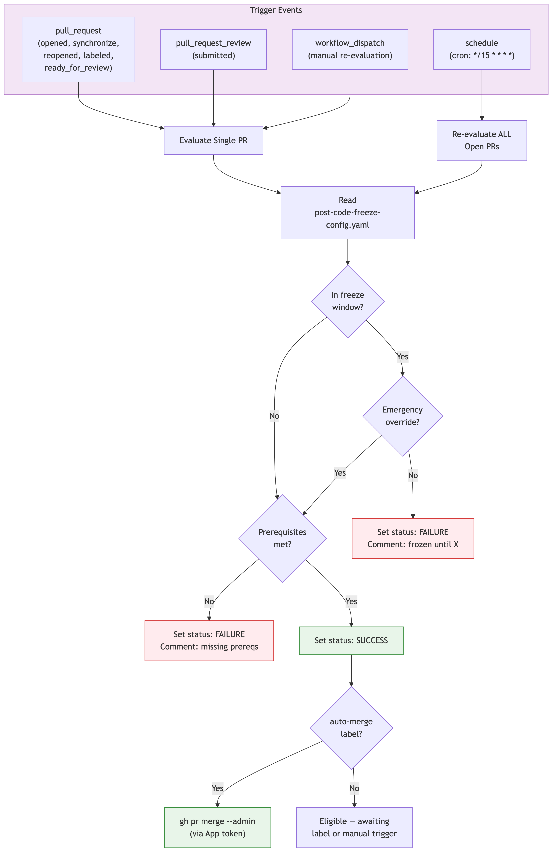
Workflow Trigger and Flow

Workflow Files
File | Purpose | Deploy To
post-code-freeze/workflows/reusable-merge-gatekeeper.yml | Reusable workflow with all evaluation logic | odh-konflux-central/.github/workflows/
post-code-freeze/workflows/merge-gatekeeper.yml | Caller workflow (lightweight, per-repo) | Each target repo’s .github/workflows/
The reusable workflow handles: freeze window evaluation, prerequisite checks (labels, CI, approvals, draft status), emergency override verification, status check reporting, auto-merge execution, and PR comment updates.
The caller workflow triggers on pull_request, pull_request_review, schedule (cron every 15 min), and workflow_dispatch.

PR Lifecycle with Merge Gatekeeper
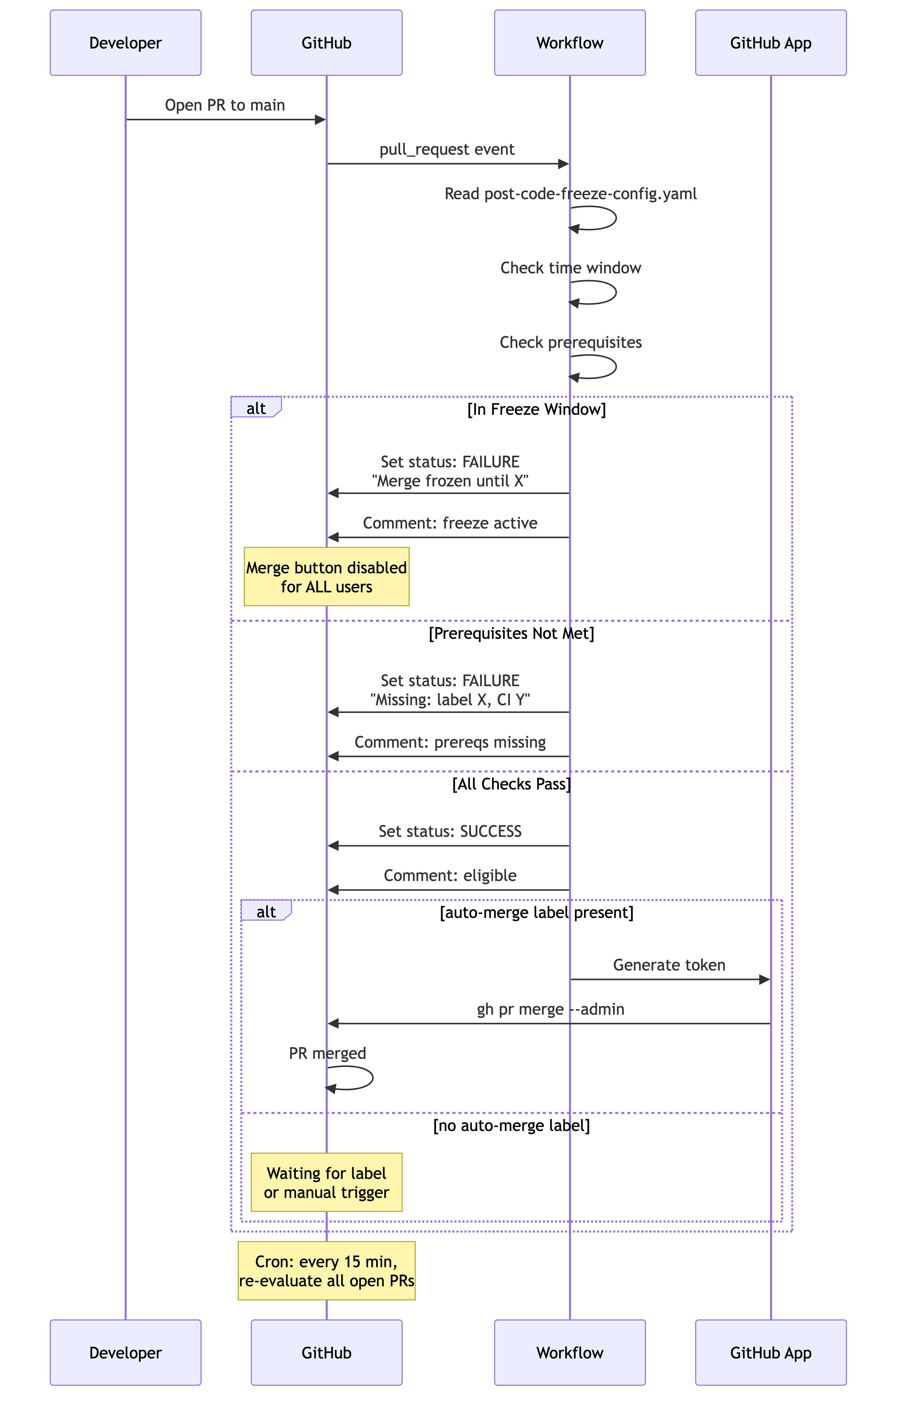
PR Lifecycle with Merge Gatekeeper

6. Configuration Schema
The configuration lives at config/post-code-freeze-config.yaml in odh-konflux-central, following the pattern of config/early-gate-config.yaml.

Full Configuration Example
Source file: post-code-freeze/config/post-code-freeze-config.yaml
Deploy to: config/post-code-freeze-config.yaml in odh-konflux-central
The configuration supports: - defaults — global freeze windows and prerequisites (apply to all repos unless overridden) - emergency_override — label name and list of authorized users who can bypass freezes - repos.<name>.branches.<pattern> — per-repo, per-branch freeze windows and prerequisites - Branch matching: exact match first, then wildcard "*" - Freeze window types: absolute (date range) and recurring (day-of-week + time range)

Freeze Window Evaluation Logic
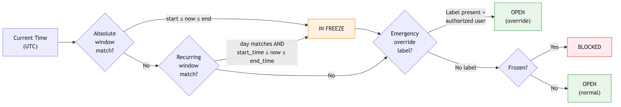
Freeze Window Evaluation Logic

7. Deployment Guide

Step 1: Verify App Permissions
Ensure the ODH_DEVOPS_APP has statuses:write. Check at: https://github.com/organizations/<org>/settings/apps/<app-slug>/permissions

Step 2: Get the App’s Installation ID
gh api "/repos/<org>/<repo>/installation" --jq '.id'

Step 3: Apply the Ruleset
# Replace <INSTALL_ID> with the value from Step 2
gh api "/repos/<org>/<repo>/rulesets" \
--method POST \
--input ruleset.json

Step 4: Add the Caller Workflow
Copy post-code-freeze/workflows/merge-gatekeeper.yml to .github/workflows/merge-gatekeeper.yml in the target repository.

Step 5: Add Required Secrets
Ensure these secrets are available in the target repo (already available org-wide): - ODH_DEVOPS_APP_ID - ODH_DEVOPS_APP_PRIVATE_KEY

Step 6: Test
- Open a PR to a protected branch
- Verify the merge-gatekeeper status check appears
- Verify the merge button is disabled for humans
- Add auto-merge label and verify the bot merges (outside freeze)
- Test during a simulated freeze window

Deployment Automation Workflow
A one-click workflow for applying rulesets across repos:
Source file: post-code-freeze/workflows/deploy-post-code-freeze-ruleset.yml
Deploy to: odh-konflux-central/.github/workflows/
Accepts inputs: target_repo, action (create/update/delete), and branch_patterns. Automatically fetches the App installation ID and applies the ruleset via the GitHub API.

8. Edge Cases
Scenario | What Happens | Resolution
Freeze starts while PR is mid-review | Next cron run (within 15 min) flips merge-gatekeeper to failure. Merge button disables. Comment updated. | PR waits until freeze ends.
Freeze ends with queued PRs | Next cron run sets status to success for eligible PRs. PRs with auto-merge label are merged sequentially. | If strict_status_checks_policy is true, only one merges at a time (others need rebase). Next cycle handles the rest.
Emergency during freeze | Authorized user adds emergency-override label. Workflow verifies the labeler is in authorized_users list. Freeze is bypassed for that PR only. | All other prerequisites still apply. Audit comment posted.
Multiple PRs labeled auto-merge simultaneously | Workflow processes them sequentially in the cron job. First merge succeeds; others become stale (need rebase if strict mode). | Next cron cycle re-evaluates and merges the next eligible one.
Renovate auto-merge during freeze | Renovate is NOT on the bypass list. Its PRs are subject to the same freeze. merge-gatekeeper blocks them. | Renovate PRs accumulate and are merged when freeze ends. To exempt Renovate, add its App ID to bypass_actors.
Someone removes the merge-gatekeeper status | Only the App’s token can set this status (tied to integration_id). Humans can’t spoof it. Even if deleted, the ruleset requires it — absent = failure. | Self-healing on next workflow run.
App token expires mid-merge | Tokens last 1 hour; entire workflow takes < 2 min. | Not a realistic risk.
Race between status check and human clicking merge | Human cannot merge — they are not on the bypass list. Even with green status, the ruleset blocks human merges. | The merge button literally does not work for humans.
Conflict with existing branch protection | Rulesets and branch protection rules coexist. Most restrictive wins. | Review and migrate existing rules before deploying.

9. Security Analysis

Threat Model
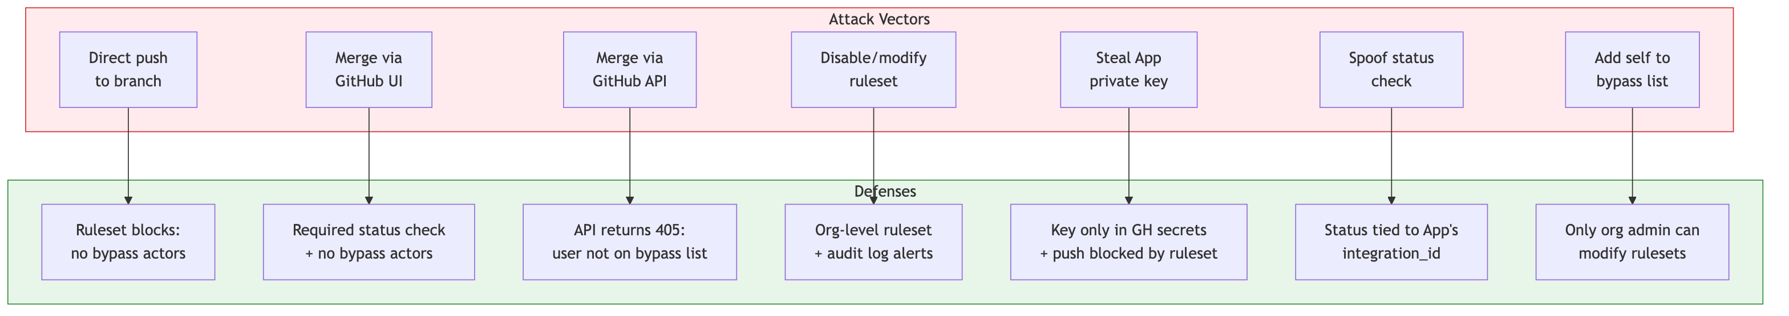
Threat Model

Proof by Exhaustion
# | Attack Vector | Blocked By | Residual Risk
1 | Direct push to branch | Ruleset creation, deletion, non_fast_forward rules. User not on bypass list. | None — GitHub rejects the push.
2 | Merge via GitHub UI | merge-gatekeeper status is failure during freeze. Even if success, user is not on bypass list — merge button is inoperable. | None — button is disabled or non-functional.
3 | Merge via GitHub API (PUT /repos/.../pulls/.../merge) | Returns 405: authenticated user not on bypass list. Admin scope on PAT doesn’t override rulesets. | None — API rejects the request.
4 | Org admin disables ruleset | This is the one real threat. Org admin navigates to Settings > Rules > Rulesets and deletes it. | Mitigations: (a) Use org-level ruleset (only org owners can modify). (b) Enable audit log alerts on ruleset changes. (c) Scheduled workflow detects and restores tampered rulesets.
5 | Steal App private key | Key stored only in GitHub encrypted secrets. Exfiltration requires pushing a modified workflow — blocked by the ruleset. Fork PRs don’t have access to secrets. | None — circular dependency prevents exfiltration.
6 | Spoof the status check | Status checks are tied to the App’s integration_id. Only tokens generated from the App’s private key can set the merge-gatekeeper context. | None — GitHub enforces integration_id matching.
7 | Add self to bypass list | Only org admins can modify rulesets. Same as vector 4. | Same mitigation as vector 4.

Residual Risk Summary
The only genuine bypass path is an org admin modifying the ruleset. This is intentional — GitHub does not allow completely locking out org owners. Mitigations:
- Use an org-level ruleset instead of repo-level (repo admins cannot modify org-level rulesets)
- Audit log monitoring — alert on repository_ruleset.update and repository_ruleset.destroy events
- Automated restoration — a scheduled workflow checks ruleset integrity and restores if tampered

10. Appendix: Quick Reference
┌─────────────────────────────────────────────────────────────────┐
│ POST-CODE-FREEZE GATEKEEPER — QUICK REFERENCE │
├─────────────────────────────────────────────────────────────────┤
│ │
│ ARCHITECTURE: Three-layer defense-in-depth │
│ Layer 1: GitHub Ruleset (static, always active) │
│ Layer 2: GitHub Actions Workflow (dynamic, time-aware) │
│ Layer 3: GitHub App (sole merge authority) │
│ │
│ RULESET: │
│ - No direct pushes, require PRs, require status check │
│ - ONLY GitHub App on bypass list (mode: always) │
│ - No humans, no admins on bypass list │
│ │
│ WORKFLOW TRIGGERS: │
│ - pull_request (opened, sync, labeled, etc.) │
│ - pull_request_review (submitted) │
│ - schedule (cron: */15 * * * *) │
│ - workflow_dispatch (manual) │
│ │
│ FREEZE WINDOW TYPES: │
│ - absolute: start_date / end_date (release freezes) │
│ - recurring: days_of_week + time range (weekly patterns) │
│ │
│ MERGE FLOW: │
│ 1. Developer opens PR │
│ 2. Workflow evaluates time + prerequisites │
│ 3. Sets merge-gatekeeper status (success/failure) │
│ 4. If success + auto-merge label → bot merges │
│ │
│ EMERGENCY OVERRIDE: │
│ 1. Authorized user adds emergency-override label │
│ 2. Workflow verifies user is in authorized_users list │
│ 3. Freeze bypassed for that PR only │
│ │
│ CONFIG: config/post-code-freeze-config.yaml │
│ DEPLOY: .github/workflows/deploy-post-code-freeze-ruleset.yml │
│ │
│ KEY CONSTRAINT: │
│ No human can merge — not even org admins. │
│ Only risk: org admin modifies the ruleset itself. │
│ Mitigation: org-level ruleset + audit log alerts. │
│ │
└─────────────────────────────────────────────────────────────────┘

GitHub API Reference
Operation | Method | Endpoint
List rulesets | GET | /repos/{owner}/{repo}/rulesets
Create ruleset | POST | /repos/{owner}/{repo}/rulesets
Update ruleset | PUT | /repos/{owner}/{repo}/rulesets/{id}
Delete ruleset | DELETE | /repos/{owner}/{repo}/rulesets/{id}
Set commit status | POST | /repos/{owner}/{repo}/statuses/{sha}
List PR reviews | GET | /repos/{owner}/{repo}/pulls/{number}/reviews
Merge PR | PUT | /repos/{owner}/{repo}/pulls/{number}/merge

