Physics Experience

Have you taken a class in Electricity & Magnetism before?

- No, never
- Yes, here (8.02)
- Yes, here (8.02 TEAL)
- Yes, other college
- Yes, high school (regular)
- Yes, high school (AP)
Math Background
What is the highest level of mathematics you have credit for? Please choose
only one option below.

- Credit for 18.01 in any form
- Halfway through 18.02a
(finishing this spring)
- Credit for 18.02 in any form
- Credit for 18.03 in any form
- Beyond 18.03
Math Background

Are you familiar with these concepts from vector calculus?

- I’ve never seen them before, and I am not so comfortable with math
- I’ve never seen them before, but I pick up new math concepts quickly
- I’ve seen them before, but definitely need some review
- I am comfortable with vector calculus
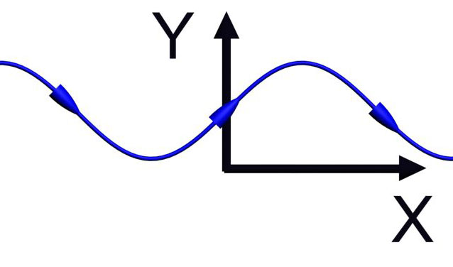

The field line above corresponds to the vector field:

1. 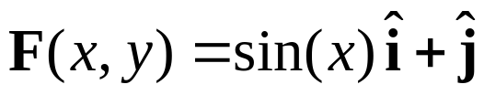
2. 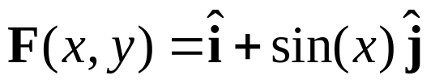
3. 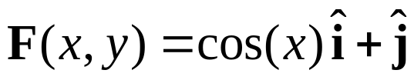
4. 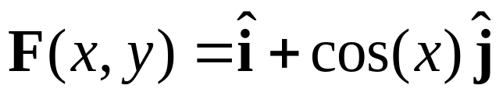
5. I don’t know

Answer: (4)

The curve above has a slope of 1 at the origin, and only (3) or (4) has this property. Moreover, the tangent to the curve above has a y-component changes sign as x changes and an x-component that is always positive, so the answer must be (4).
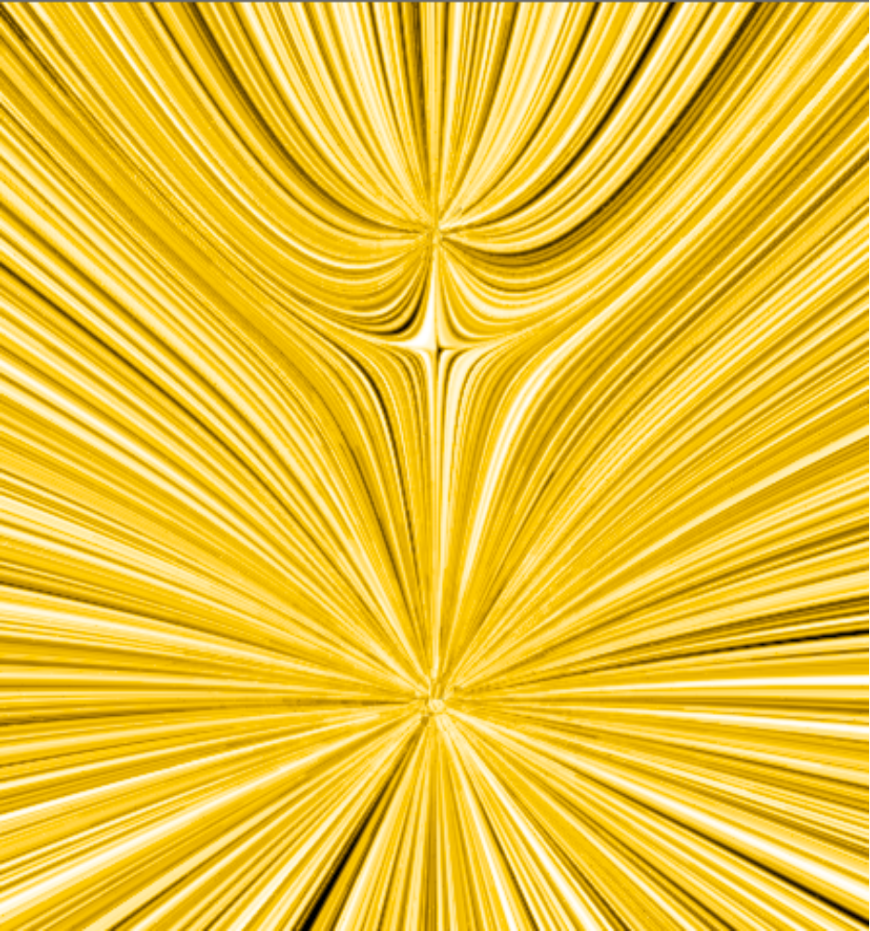

The above vector field is created by:

1. Two sources (equal strength)
2. Two sources (top stronger)
3. Two sources (bottom stronger)
4. Source & Sink (equal strength)
5. Source & Sink (top stronger)
6. Source & Sink (bottom stronger)
7. I don’t know

(3) Two sources, bottom stronger

Both sources because lines leaving one don’t enter the other.
Bottom is stronger because it “pushes” further
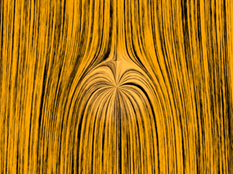

Here there is an initial downward flow.

1. The point is a source
2. The point is a sink
3. I don’t know

(1) Source (Animation)

It’s a source, because otherwise the downward flow would flow right into it.

NOTE: If the background were upward, then it would be just flowing right into it, so it would be a sink.
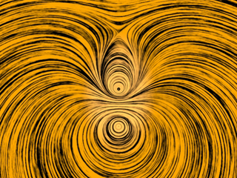

These two circulations are in:

1. The same direction
(e.g. both clockwise)
2. Opposite directions
(e.g. one clockwise, one ccw)
3. I don’t know

(2) Opposite directions (Animation)

You can tell by looking in between. Both circulations push the flow in the same direction, so they must be circulating counter to each other.

Animation with same direction

The “grass seeds” field plot above is a representation of the vector field:
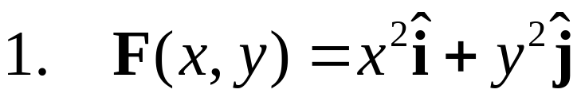
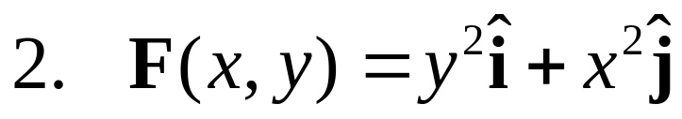
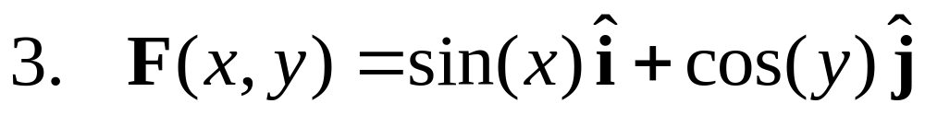
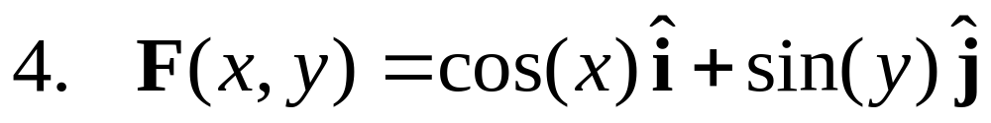
5. NOT SURE

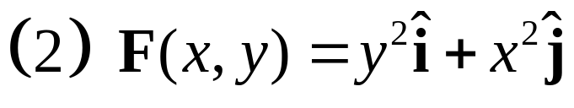

Look along the positive x-axis. Along this axis the grass seed textures are vertical. This means F has only a y component when y is zero and x is non-zero. Only consistent with (2).
Two opposite charges are placed on a line as shown below. The charge on the right is three times larger than the charge on the left. Other than at infinity, where is the electric field zero?

q_{L}
q_{R}

1. Between the two charges
2. To the right of the charge on the right
3. To the left of the charge on the left
4. The electric field is nowhere zero
5. Not enough information – need to know which charge is positive
q_{L}
(3) Zero is left of q_{L}.
q_{R}

Between field goes from source to sink.
On right, field is dominated by q_{R} (bigger & closer).
On left, because q_{L} is weaker, its “push” left will somewhere be balanced by q_{R}’s “pull” to the right

