Official city desk crawler
Mark Sobolev

28. July 2019

Project description

The aim of the project is to create a crawler, which downloads documents published on official boards of individual cities of the Czech Republic.

Proposed solution

In the first step, the program obtains links to official city pages using the list of Czech cities https://cs.wikipedia.org/wiki/Seznam_m%C4%9Bst_v_%C4%8Cesku. Subsequently, the links to the official boards of individual cities are extracted. In the last step, the program downloads files from individual official boards.

Implementation

The project is programmed in Python3 using the Scrapy framework, which simplifies the documents extraction.

2 scripts are used to download documents:
- download_desks.py extracts the municipal websites URLs. Extracted URLs are stored in JSON format. For each web page the file contains the name of the city, its website URL and domain.
- download_documents.py downloads documents from individual official websites using extracted URLs. Documents are divided into folders - one for each city.

Downloaded documents should be prepared for categorization - it is necessary to eliminate duplicates and assign filenames corresponding to the content of the documents.

2 scripts are used to prepare documents:

- remove_duplicates.sh removes documents which appear in folder more than once (Website may have several links to the same document, so the same document may be downloaded more than once)
- extract_names.py extracts the text from the first line of the PDF file and uses it as the new name for the file.

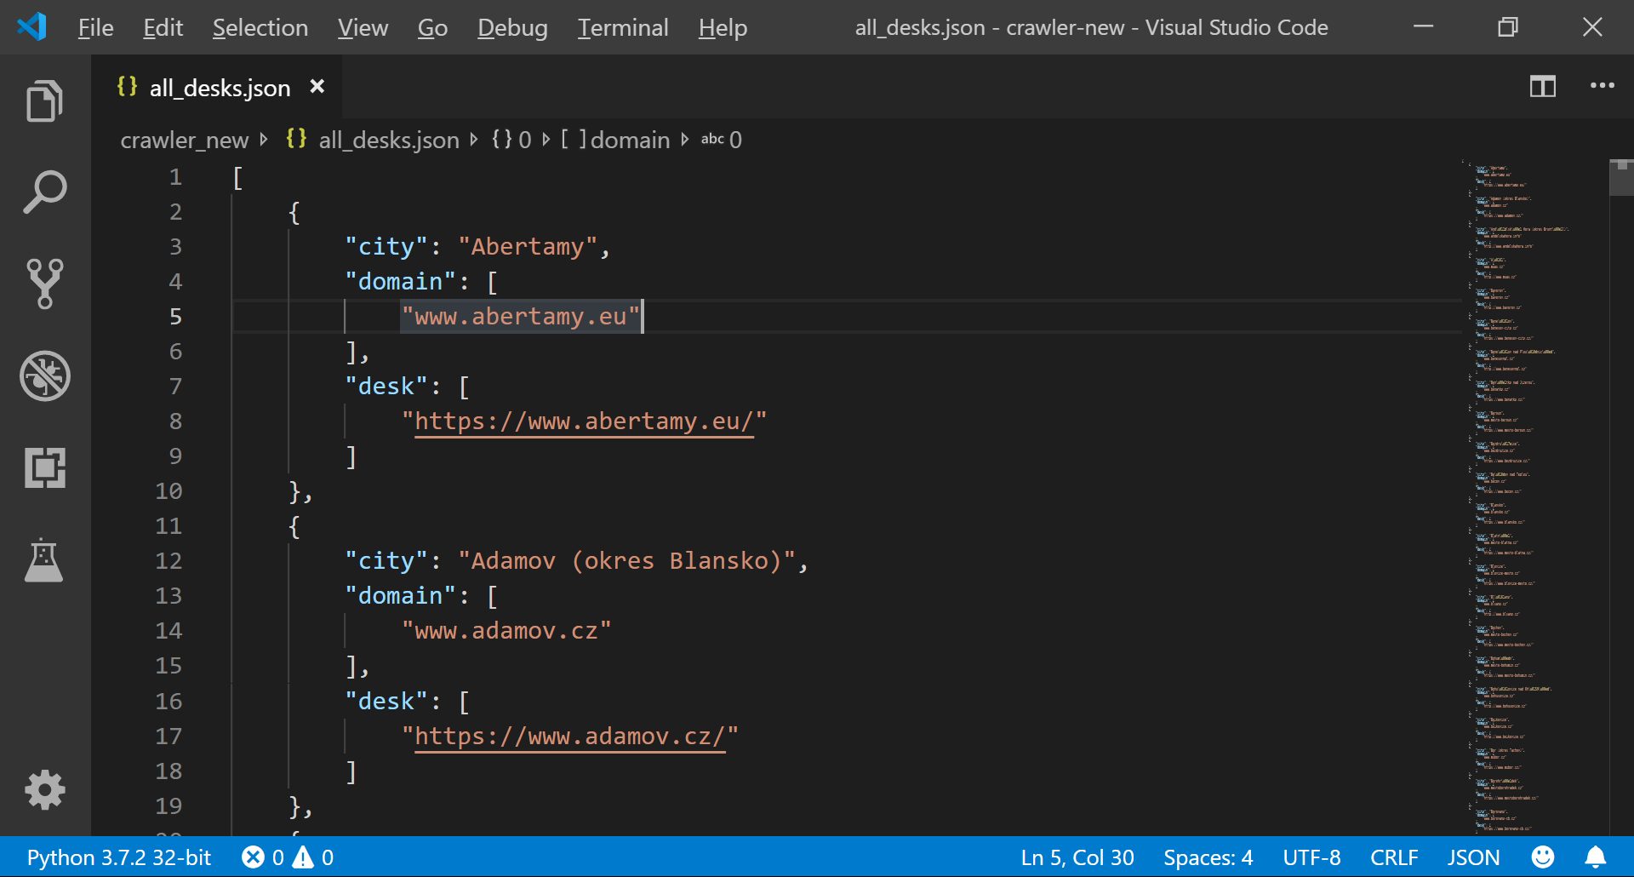
Fig 1. List of official municipal webpages in JSON format

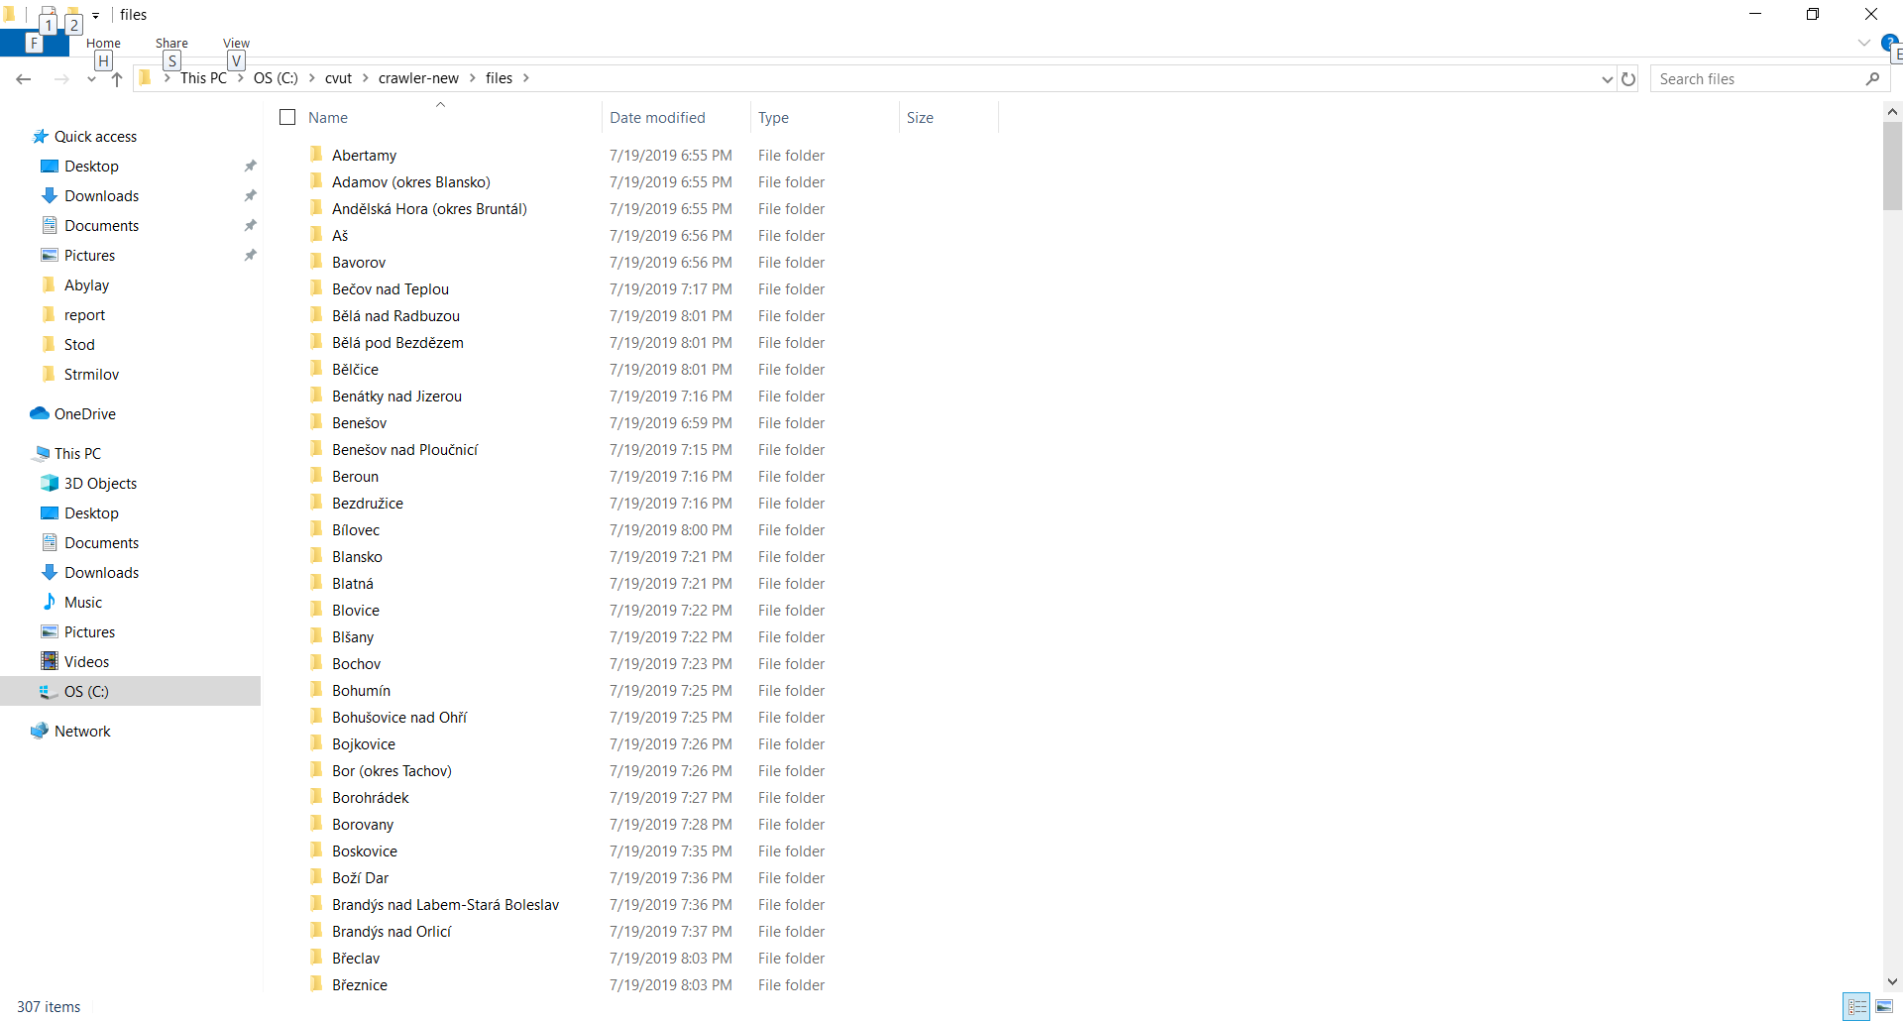

Fig 2. Folders with downloaded documents

How to use scripts

To work with scripts for downloading documents, one needs to install the Scrapy tool, which can be downloaded using the pip install scrapy command.
First run python download_desks.py to extract the municipal websites URLs. Then run python download_documents.py with appropriate arguments to download documents from individual official websites using extracted URLs.
Examples of valid argument combinations:

python download_documents.py --file all_desks.json --cities adamov bavorov downloads documents for Adamov and Bavorov

python download_documents.py --file all_desks.json --begin adamov --end bavorov downloads documents for cities starting with Adamov and ending with Bavorov. Cities in the list should be sorted lexicographically.

python download_documents.py --file all_desks.json --begin adamov --count 5

downloads documents for 5 cities starting with Adamov.

python download_documents.py --file all_desks.json --begin adamov downloads documents for all cities in the list starting with Adamov.

python download_documents.py --file all_desks.json downloads documents for all cities in the list.

Arguments for download_documents.py
Argument | Description | Example | Note
--file | Name of the file with the URLs which is used for downloading documents. | --file all_desks.json | Required. Should be the first argument.
--cities | Names of the cities to download documents for. | --cities adamov bavorov | Optional. Can not be combined with --begin. Case insensitive.
--begin | Name of the city to start with. | --begin adamov | Optional. Can not be combined with --cities. Case insensitive. If --count and  --end are not used, documents will be downloaded for all cities in the list
--count | Number of cities to download documents for. | --count 5 | Optional. Must be preceded by --begin. Case insensitive.
--end | Name of the last city to download documents for.e | --end bavorov | Optional. Must be preceded by --begin. Case insensitive.

Then you can run remove_duplicates.sh and extract_names.py to prepare documents for categorization. Both scripts should be placed in one folder with folders containing downloaded documents. remove_duplicates.sh removes duplicates from all folders in the same directory and extract_names.py extracts names from all folders in the same directory.
extract_names.py requires Pillow (Python Imaging Library), pdf2 (wrapper around the pdftoppm and pdftocairo command line tools to convert PDF to a PIL Image list) and pytesseract (python wrapper for Google's Tesseract-OCR).

Results

During testing, the task was to download documents for 307 cities. As a result, documents for 291 cities were downloaded (95% success rate). Downloaded documents were than renamed using extract_names.py. As seen on Figure 4 not all the names extracted correspond to the actual titles of the documents.

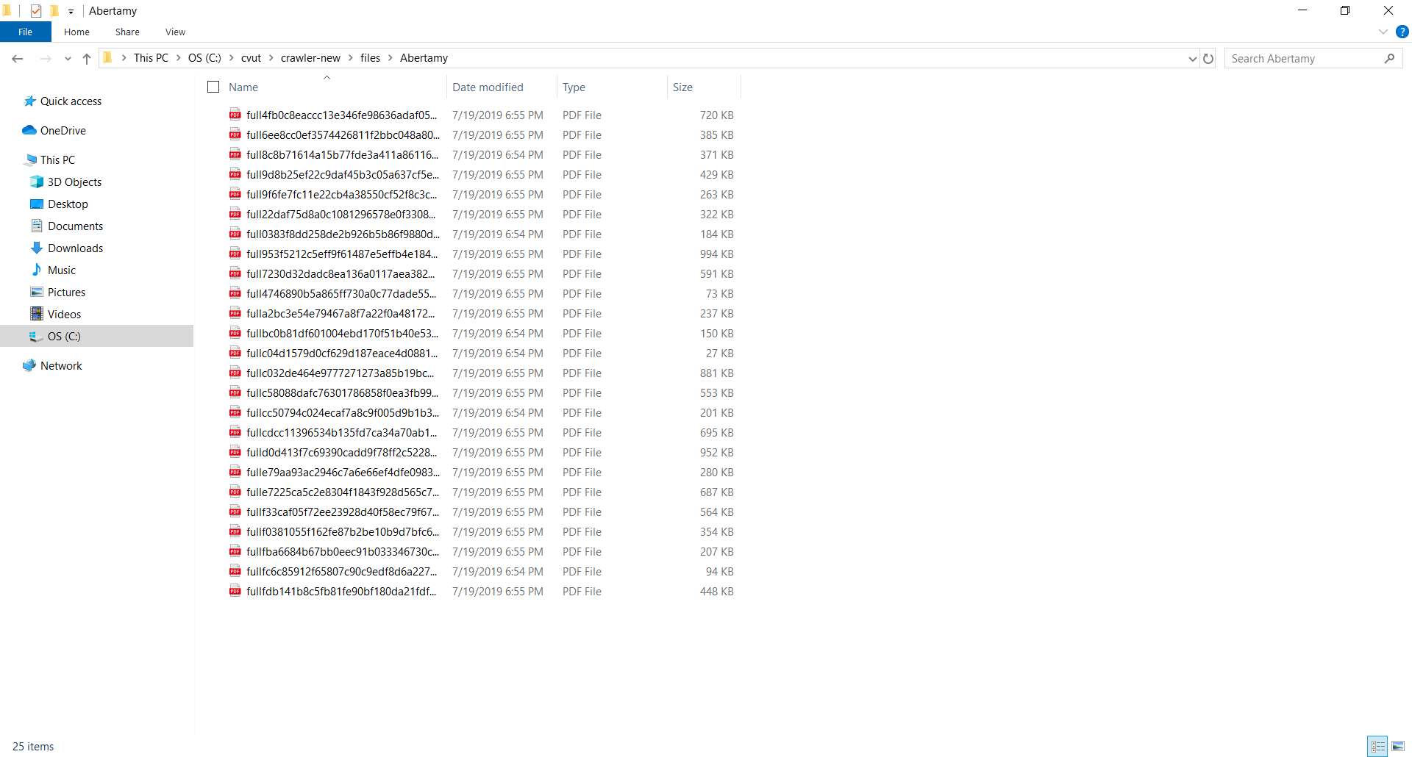
Fig 3. Downloaded documents

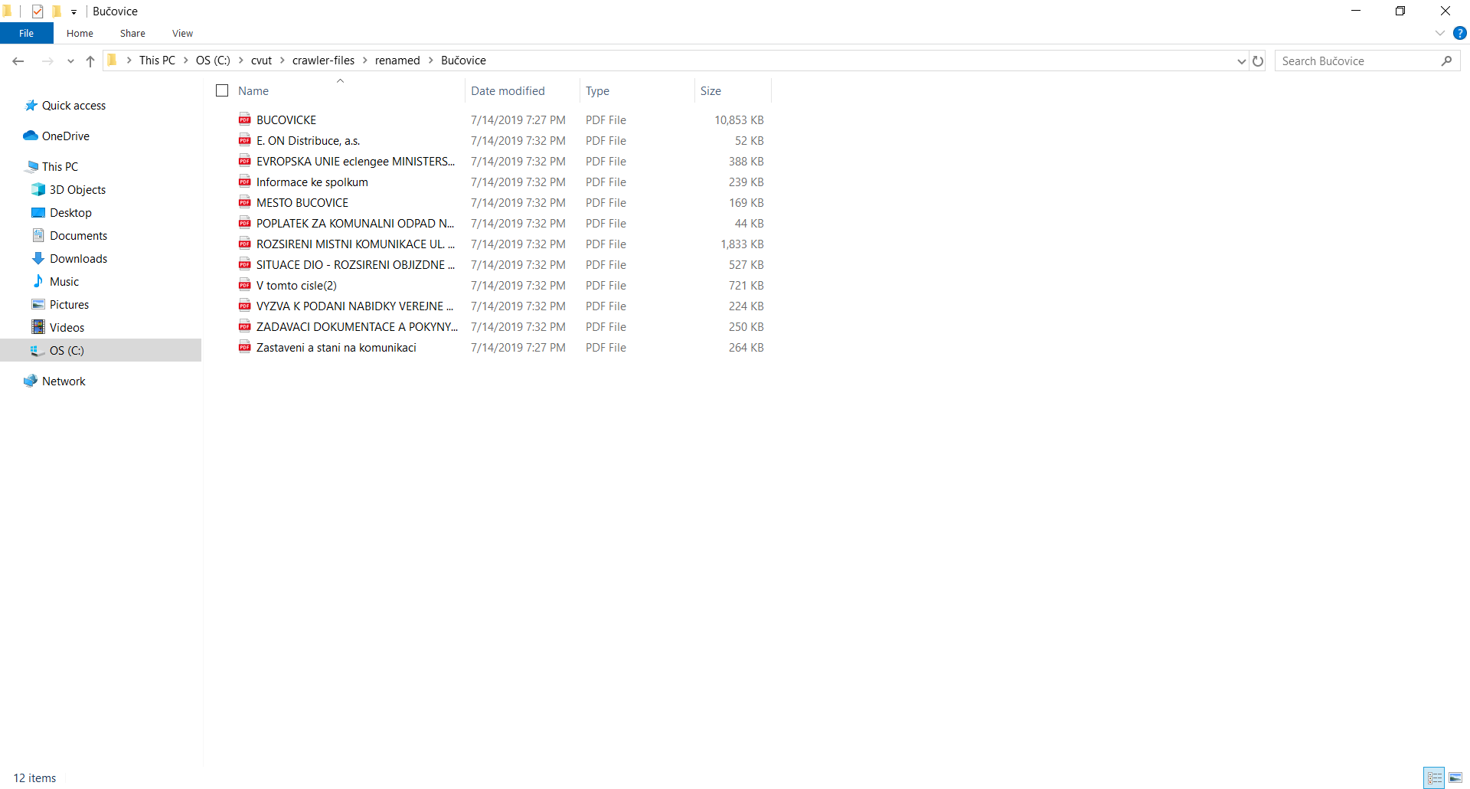
Fig 4. Renamed documents

Conclusion

The proposed solution has high success rate for downloading documents, but is insufficient to extract document names for further categorization of documents. It is assumed that the reason is too primitive method of determining the titles, based on the fact that the title text should be the first line of the text of the document. It is proposed to use PDF metadata extraction or pattern recognition to get better success rate for title extraction.

