Dipartimento di Ingegneria e Scienza dell’Informazione
- KnowDive Group -

Schema Matching and Etype Management for ODR Attribute Alignment Phase

Document data: | Reference persons:
26.01.15.v01.r01 | Ivan Tankoyeu

Table of Content

Introduction.................................................................. 3
Use Cases...................................................................... 3
Schema Matching Architecture .................................... 5
Evaluation of Schema Matching Component............... 8

1. Introduction
This document describes Schema Matching Architecture and Etype management within the scope of Attribute Alignment phase of ODR importing pipeline. The main aim of the Attribute Alignment phase in semantification pipeline is to define appropriate schema (Etype) for the source data set and provide correct mapping between elements of the data set and Attribute Definitions (AD) of the Etype. Thus, the problem we tackle in this document is a classical schema matching problem. We approach the problem in a semi-automatic way aiming to minimize user involvement.
From the user perspective Attribute Alignment step can be separated on two sub-steps: (i) defining of Etype for the data set and (ii) mapping ADs (source attributes) with schema elements of a source data set (target attributes) e.g. column headers of input table.
The document considers a set of different use cases described by activity diagrams. The report continues with a general architecture of the schema matching component initially proposed in [1] and extend it with description of training component. Moreover, the document describes the current approaches for automatic Etype detection of the ODR resource. Finally, preliminary results for the proposed approaches are provided in this report.

2.Use cases
This section describes two use cases that corresponds to sub-steps of Attribute Aligment phase in ODR semantification pipeline. First use case describes schema defining step, while the second aims to describe the process of attribute mapping.

2.1 Schema defining
Number | 1.1
Use Case | Choose Etype
Description | User choses appropriate Etype for the source data set (see illustration 1).
Actor | ODR User
Basic flow | The user choses Etype for the source dataset from the given by ODR list of ranked Etypes. The list is provided by ODR consist from five proposed Etypes and ranked according to the relevance of Etypes for source data set.
Alternative flow 1 | If the user does not find appropriate Etype among the proposed list she uses search. User enters the name of desirable Etype in ODR search box and the system recommends most relevant Etypes. Etypes with the most similar to input names are proposed to the user.
Alternative flow 2 | If search results does not contain required Etype then the user has to create a new one. In this case she is redirected to KOS (Knowledge Operation System) where a new Etype can be created. Then the user come back to ODR and acts accordingly to Alternative flow 1.
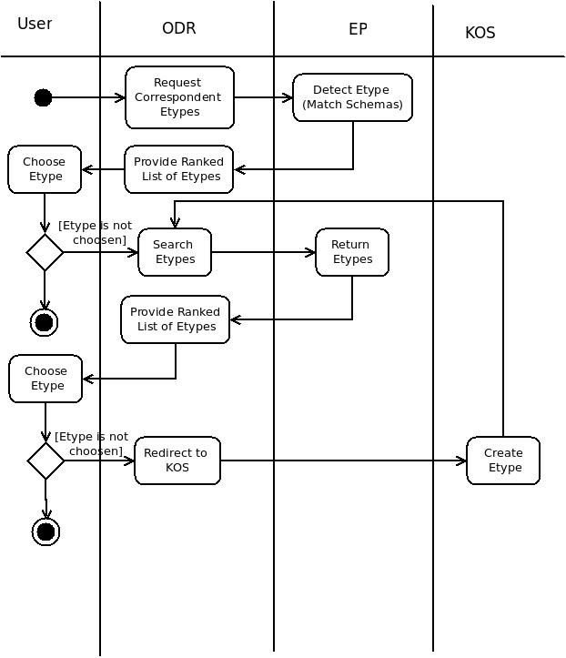Illustration 1: Activity Diagram for the Etype Defining sub-step

2.2 Attribute alignment

Number | 1.2
Use Case | Attribute alignment
Description | User choses appropriate attribute definition for each element of the source data set (see illustration 2).
Actor | ODR User
Basic flow | ODR correctly maps attribute definitions (target attribute) for each attribute of the source data set and the user verifies all of them by moving to the next phase.
Alternative flow 1 | If one or more target attributes are wrongly mapped by ODR to data set attributes then user involvement is required. In this case the user choses a proper attribute definition for each incorrectly mapped source attribute.
Alternative flow 2 | If Etype does not contain a suitable AD and the source attribute is specific to only the source data set the user creates a new free attribute through the means of ODR tool.
Alternative flow 3 | If Etype does not contain appropriate attribute definition (AD) for a source attribute and user is sure that the Etype is required to have it, then user has to extend Etype with a new attribute definition. Thus, he is redirected to KOS, where a new attribute definition can be created.

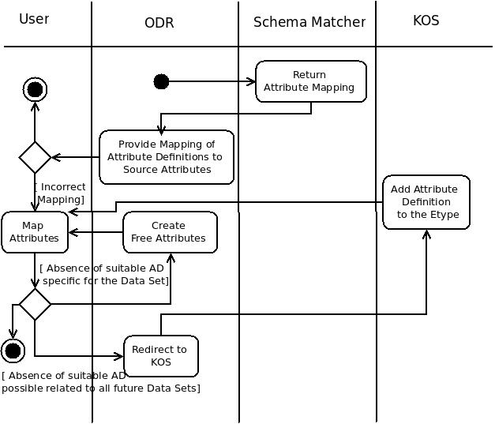Illustration 2: Activity Diagram for the Attribute Mapping sub-step

3. Schema Matching Architecture
In this section the current architecture of schema matching component is presented. The architecture was initially described in [1]. The proposed architecture for ODR schema matcher has a component-based design. The underlying idea of the architecture depicted on Figure 3 is to provide a modular structure of the component. Different modules can be plugged to schema matching component independently. Below we describe each module in detail.
Schema Import module aims to convert different schema formats to the internal schema model of the matcher. Currently it is able to extract schema from ODR Resource, Etype and Comma Separated Value (csv) formats. The module contains a translator for each of the mentioned formats to the internal schema model. It can be easily extended for supporting other formats e.g. XML, JSON.
Schema Feature Extraction and Normalization module is intended to extract and normalize information from an input schema elements for further analysis.
In the current approach schema features are presented by concepts, data types and edit distance. In order to extract concept and data types from a given source schema elements we employ column concept recognizer [2] and data type detector. The recognizer extracts concepts from schema elements and content.
The first phase of normalization process aims to provide LCA (Least Common Ancestor) distances [5] between all extracted source concepts and all target concepts provided by Attribute Definitions. Similarly, we compute edit distances between attribute names of source and target schema elements employing Levenstein distances [6]. Finally, two numeric matrices of concept and edit distances are created. On the second phase of normalization process the numbers from both matrices are converted to scores, having a number from 0 to 1.
Schema Matching module provides an infrastructure for different matching approaches. Currently, two techniques for schema matching are provided: Simple Schema Matcher and Hungarian Allocation Matcher.
Simple Schema Matcher is a brute-force way approach. A single attribute-to-attribute matching consists of comparing the result of attribute level recognition described in detail in [1]. The highest score for a source attribute in the result matrix points to the most appropriate attribute definition. In this approach two or more source attributes can corresponds to one attribute definition.
Hungarian allocation approach relies on the combinatorial optimization algorithm that solves the assignment problem in polynomial time. It employs the similar scoring input as a previous approach, however it compare target and source attribute in a different way. In contrast to the previous technique the correspondence between target and source attribute has “one to one” relationship.

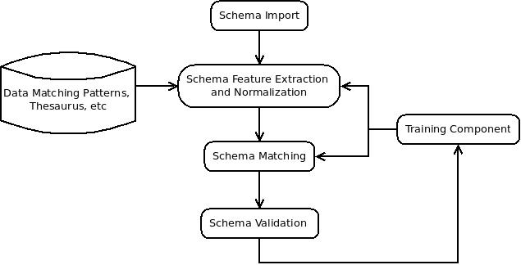Illustration 3: Proposed architecture for ODR Schema Matching Component

Finally, Schema Validation unit through the user interface means allows a user to accept or correct the schema matching results. All the feedback collected from a user is exploited further for re-training models required by machine learning-based approaches of Schema Feature Extraction and Schema Matching components. An architecture of Training component is proposed in the next sub-section.

3.1 Training component
Training component aims to re-train existing models used by machine learning techniques in order to improve accuracy of Schema Feature Extraction and Schema Matching modules.
It is difficult to estimate the time needed for learning process. It depends mostly on the amount of correcting feedback from a user and overall data that is used for the training e.g. number of Attributes Definitions and Etypes. Therefore, the main requirement for the component is to be running independently from ODR semantification pipeline i.e. in asynchronous mode and provide re-trained models as soon as they will be ready. The figure below shows the interaction between ODR, Schema Matching and Training component.

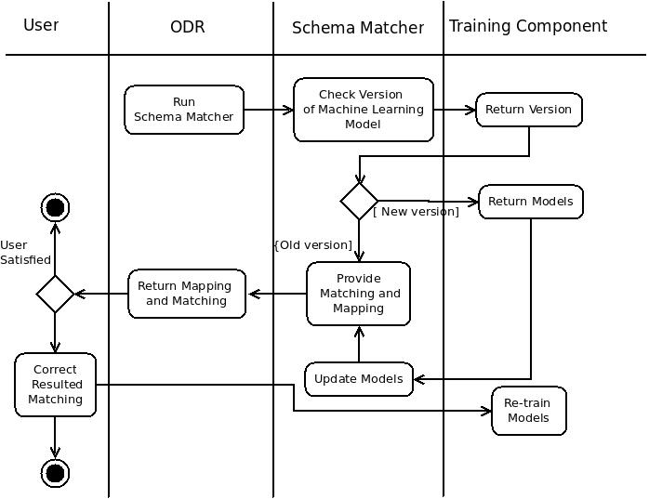Illustration 4: Activity diagram for training process
In order to support the asynchronous communication between aforementioned components an event-driven architecture is proposed. Because event-driven systems are more normalized to asynchronous environments [3].
In our system we have two events. The first event triggers as soon as training component finishes the training process. As the result of the first event training component provides new models for machine learning techniques. The second event triggers while importing entities (last step of the pipeline). The results of the second event consist of the aggregated user feedback. In case of the retraining process training component should not stop and restart it, but should buffer the feedback and restart training with it after the finishing the already started process.
Thus, we analyzed possible approaches to support this architecture and come up with RxJava [4]. RxJava (Reactive Extension Java) is a library that supports implementation of the asynchronous and event-based programs by using observable sequences. It supports sequences of data/events and adds operators that allows to compose sequences together declaratively while abstracting away concerns about things like low-level threading and synchronization.
The component can be either developed as a web service with API that supports HTTP calls or as a Java component integrated with schema matcher and ODR. The further discussion on the component is required.

4. Evaluation of Schema Matching Component

4.1 Data set
In order to evaluate proposed approaches we selected and manually annotated several source data sets. During the selection process we met the following two main requirements: (I) a source data set should have a corresponded Etype and (ii) the data set should be available in *.csv format. Moreover, we avoided statistical data sets that contains only numerical content. Thus, we selected 11 source data sets which have in total more than 100 attributes (columns).
We manually assigned for each source data set an appropriate target Etype. Similarly, we create a mapping of attributes for each pair of correspondent source and target schema. However, some attributes of source data set did not have appropriate attribute definition for mapping. Here are some of the discarded from the final mapping attributes:
N_bagni_in_stanze, Classificazione_punteggio_tabella_2, COD_ASL, etc. Thus, the resulted ground truth consist of 11 sourced data set matched to Etypes and 78 pairs of mapped attributes.

4.2 Experimental Results
For the attribute level mapping we run a simple experiment that compare concept and edit distance-based approaches. The results are presented in the Table 1.

 | Concept Distance Based |  | Edit Distance Based
Correctness | 0.33 | 0.38 | 0.58 | 0.49
Table 1. Experimental results on attribute mapping.

As can be seen from the table edit distance based approach outperforms concept distance-based one. This unexpected result can be explained by the process of Etype creation: attribute names from the source data sets were widely adopted for Attribute Definitions names.
On schema level matching we evaluated Simple Matching and Hungarian Allocation approaches. The results were computed in a two-fold manner:
- The Etype corresponded to source data set was on the top place among all resulted Etypes.
- The Etype corresponded to source data set was among the top five results among all resulted Etypes.
We also calculated time performance in milliseconds for each approach (number in brackets).
As can be seen from the Table 2 the results of the evaluation varies and requires further analysis and discussion.

 | Concept Distance Based |  | Edit Distance Based
Approach: | Top place | Within top 5 | Top place | Within top 5
Simple Matcher | 0.27 | 0.63 (5983ms) | 0.18 | 0.81 (255ms)
Hungarian Allocation | 0.09 | 0.91 (5682ms) | 0.18 | 0.81 (192ms)
Table 2. Experimental results on schema matching approaches.

References

[1] “Schema Matching in ODR” v0.1 12.07.2014. G. Bella, I. Tankoyeu.
[2] “Column Recognizer” 10.03.2014 Simon Anderson.
[3] Jeff Hanson, Event-driven services in SOA, Javaworld, January 31, 2005
[4] https://github.com/ReactiveX/RxJava
[5] http://en.wikipedia.org/wiki/Lowest_common_ancestor
[6] http://en.wikipedia.org/wiki/Levenshtein_distance

