OPENDCS 6

LRGS (9.0)
(Local Readout Ground System)
User’s & Administrator’s Guide

Document Revision 8
May, 2017

This Document is part of the OpenDCS Software Suite for environmental data acquisition and processing. The project home is: https://github.com/opendcs/opendcs
See INTENT.md at the project home for information on licensing.

Table of Contents
1. Introduction 1
1.1 Change Log 1
2. GOES Data Collection System Overview 2
2.1 The NOAA/NESDIS Data Collection System 2
2.2 The Role of the LRGS 4
2.3 DCP Message Content 5
2.3.1 Failure Code 5
2.3.2 Signal Strength 6
2.3.3 Frequency Offset 6
2.3.4 Modulation Index 6
2.3.5 Data Quality 6
2.4 DCP Message Types 7
2.5 The DOMSAT Re-Broadcast 7
3. LRGS Software Overview 9
4. Starting and Stopping the LRGS Server Daemon 10
5. LRGS Configuration 11
5.1 DDS Users and Server Security 17
5.1.1 Is DDS Secure? 17
5.1.2 How to Create DDS User Accounts Manually 18
5.1.3 How to Maintain DDS User Accounts from the Status GUI 19
5.2 Configuring the DDS Receiver Connections 21
5.2.1 Use Network Lists to Only Pull Data of Interest 22
5.3 Configuring DRGS Connections 24
5.3.1 Configure your DRGS Interfaces 24
5.3.2 DRGS Message Validation 26
5.3.3 DAMS-NT Compliance 26
5.4 Configuring Alarms and Actions 27
5.5 LRGS Event Log Messages 29
5.5.1 Log File Rotation 29
5.5.2 Writing Events to SQL Database 30
5.6 Message Files 31
5.7 The Quality Log File 32
5.8 The Merge Filter 33
6. Monitoring LRGS Status 34
6.1 Web-Accessible Status Page 34
6.2 LRGS Real Time Status GUI 35
6.3 Changing Your Password 37
6.4 Managing DDS Account 37
6.5 LRGS Configuration 38
6.6 Network List Maintenance 43
6.7 Integrate RTSTAT with Web LRGS Monitor 44
7. DDS Implementation 45
7.1 DCP Data User Directories 45
7.2 Password-Authenticated Connections 45
7.3 DCP Names and Network Lists 45
7.3.1 Network List File Format 45
7.4 Order of Data Retrieval 46
7.5 DDS Client Log 46
7.6 Allowing Connections Only from Known IP Addresses 46
7.7 Limiting Real-Time Clients to a Maximum Number of DCPs 46
8. How to Retrieve DCP Messages 48
8.1 The ‘getDcpMessages’ Utility 49
8.2 The Message Browser 50
8.2.1 The Search Criteria Editor Screen 52
8.2.2 The Message Output Screen 53
8.3 Search Criteria File Format 54
8.3.1 Allowable Time Formats for a Search Criteria File 55
8.3.2 Network Lists Referenced in a Search Criteria File 55
9. Synchronize a Group of Cooperating LRGS Systems 56
9.1 Set up the LRGS-Synchronization Configuration File 56
9.2 Set up SSH, SCP, and RSYNC 56
9.3 Test the Synchronization Script 58
9.4 Changing Masters 58
10. Ingesting EDL Files into LRGS Archive 59

Introduction
LRGS stands for Local Readout Ground Station. LRGS is a universal store-and-forward device for GOES-DCP data. It can receive data via several satellite links and the internet. It stores the raw DCP data efficiently for a month or more, automatically deleting the oldest data when pre-set storage limits are reached. It provides the DDS network service to distribute data efficiently to client processes, such as DECODES.
From 1999 through 2007, ILEX Engineering, Inc. built the LRGS open-source code through a series of government contracts with:
- U.S. Geological Survey (USGS), Water Resources Division,
- U.S. Army Corps of Engineers (USACE), and
- National Oceanic and Atmospheric Administration (NOAA).

By funding the LRGS development, these three agencies have done a great service for the entire DCS user community.
Cove Software, LLC now provides commercial support for the LRGS that includes:
- Turnkey system installations,
- Software subscription, maintenance, and technical support contracts,
- Maintaining this document

Change Log
- Revision 7: Added write up for “source=name” notation in DDS Receive in section 5.2.1.
- Revision 8:
  - Addition of properties: ddsMinHourly, lritMinHourly, edlMinHourly, and drgsMinHourly. See additions to table of configuration parameters in section 5.
  - Addition to configuration dialogs to set the xxxMinHourly properties mentioned above.
  - Added section 5.5.2 on writing INFO and higher-priority events to a SQL database.

GOES Data Collection System Overview
The LRGS is a proven system that provides many federal, state, local, and private organizations with the ability to collect remote environmental data in real-time. The LRGS provides local storage of raw DCP data limited only by your disk capacity.
With the LRGS you can receive and archive data from any combinations of input interfaces: DOMSAT, LRIT (DAMS-NT), GOES-DRGS, Internet-DDS, or NOAAPORT. Platform messages are merged according to a user-settable priority scheme for ultra-reliable data collection.
The LRGS provides the de-facto standard DDS (DCP Data Service) for distributing raw data to your processing applications. Your data-processing applications can run on the same machine as the LRGS, or over the network.
The latest release of the LRGS is written in almost 100% Java. (The only ‘native’ code is a small amount of driver code for the high-speed DOMSAT serial card.) Consequently, the LRGS will run on any modern computing platform (Linux, Macintosh, Windows, Solaris, AIX).

The NOAA/NESDIS Data Collection System
The National Environmental Satellite, Data, and Information Service (NESDIS) operates the U.S. Geostationary Operational Environmental Satellite (GOES) system. The GOES system's primary mission is to continuously observe changing weather phenomena from satellite-based sensors situated approximately 23,000 miles from Earth. As a collateral duty, the GOES system supports a radio relay or Data Collection System (DCS). The DCS enables a large variety of environmental data to be relayed from point sources through GOES and back to Earth, from where these data are disseminated to the various system users. These point sources are called Data Collection Platforms (DCP), and can be are land, sea or mobile-based.
Figure 2-1 depicts the GOES DCS. Starting on the left, data is transmitted from over 30,000 DCPs throughout the western hemisphere. Each platform is equipped with a recorder, power source, transmitter, antenna, and an array of environmental sensors. Each DCP is programmed to collect sensor data and then transmit it in a ‘message’ during specified time-slots on specified GOES channels.
Users with a GOES DRGS (Direct Readout Ground Station) can receive the DCP messages directly from GOES. For other users, NOAA provides other services through the DCS Automated Processing System (DAPS). DAPS is a large dual-computer based system located at the NOAA Command and Data Acquisition (CDA) facility in Wallops, Virginia. It continually monitors all GOES RF channels for incoming DCP messages. DAPS can support the receipt and archival of messages from up to 100,000 platforms, redistributing them to up to 5,000 users.
DAPS supports the distribution of DCP messages to the user-organizations via a domestic communications satellite (DOMSAT). DAPS continuously broadcasts all incoming DCP messages over DOMSAT using a single high-speed channel. Thus for a fraction of the cost of a DRGS, users can receive the entire DCS data stream via DOMSAT.
NOAA also supports the direct transmission of DCP data to users via internet. This uses a TCP socket protocol called DDS (DCP Data Service). DDS allows users to specify data of interest by DCP address, channel, or time range. Users can retrieve historical data or a real-time stream.
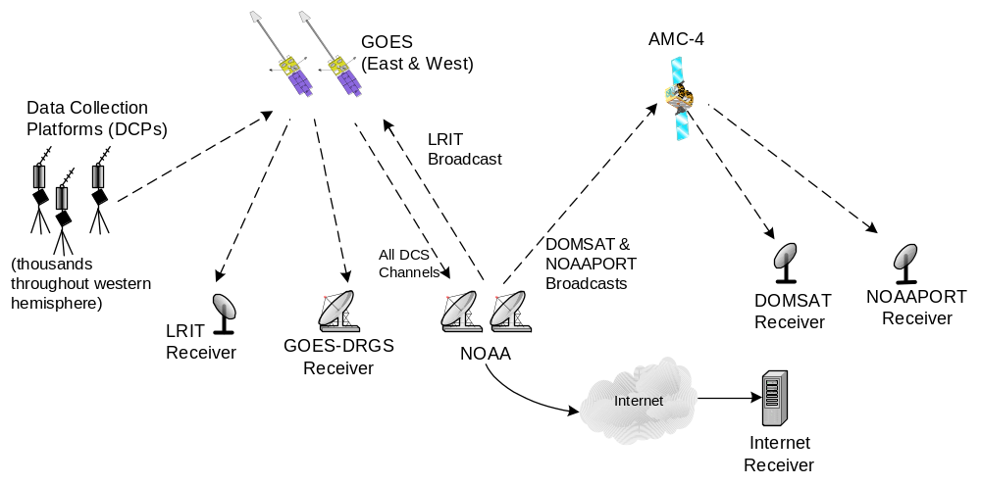Figure 2-1: GOES DCS Overview.

In 2004, NOAA started a new service called LRIT (Low Rate Information Transfer). This service combines low resolution WEFAX images and all DCS data. It operates on a separate frequency on both GOES East and West Satellites.
Finally, the NOAAPORT data stream is similar to DOMSAT in that it operates on a separate domestic satellite. It differs from DOMSAT in the following ways:
- NOAAPORT contains imagery data, weather bulletins and other products, in addition to DCP messages.
- Only DCP messages processed by the National Weather Service are transmitted over NOAAPORT.
- There can be a several minute delay in retrieving DCP data via NOAAPORT. DOMSAT is almost instantaneous.

The Role of the LRGS
The LRGS can retrieve data via any of the input interfaces mentioned above, as shown in Figure 2-2. The LRGS can be configured with multiple interfaces. It can merge data simultaneously from any or all of the interfaces shown at the left. The LRGS acts as a store-and-forward device. It archives any amount of historical data (limited only by available disk space) and provides network interfaces to a variety of programs shown at the right.
The core of the LRGS software was written by ILEX Engineering, Inc., under contract to the federal government. As such it is freely available. Cove Software, LLC now maintains the software and provides support to the user community.

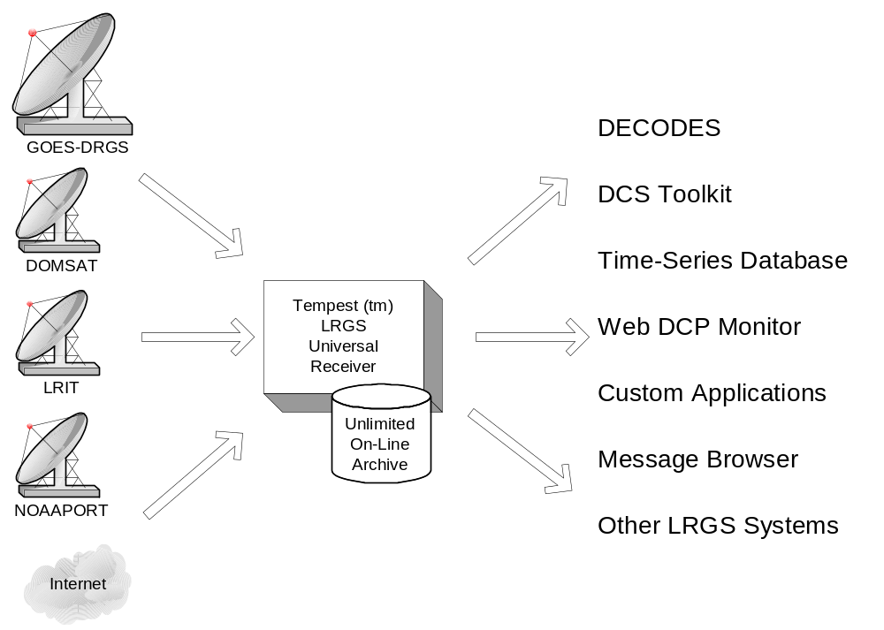
Figure 2-2: The Role of the LRGS.

DCP Message Content
Each DCP message will have header fields followed by a message body. Regardless of which interface a DCP message was received from, the LRGS internally formats the header into a 37-byte character string with the following fields:
- 8 hex digit DCP Address
- YYDDDHHMMSS – Time the message arrived at the Wallops receive station. The day is represented as a three digit day of the year (julian day).
- 1 character failure code
- 2 decimal digit signal strength
- 2 decimal digit frequency offset
- 1 character modulation index
- 1 character data quality indicator
- 3 decimal digit GOES receive channel
- 1 character GOES spacecraft indicator (‘E’ or ‘W’)
- 2 hex digit uplink carrier status
- 5 decimal digit message data length
Following the header will be the message body, with a variable number of characters. The format of the message body varies widely depending on the manufacturer of the transmitter, data logger, sensors, and the technician who programmed the DCP. The body can be simple ASCII, sometime with parameter codes and time-stamps embedded, sometimes not. The body can also be in ‘Pseudo-Binary’ which is character encoding of binary data that uses 6 bits of every byte and guarantees that all characters are printable.
The message body must be processed by a program like DECODES to convert the data into time-tagged engineering units. From there it is typically ingested into a time-series database.
The following subsections detail the meaning of various header fields.

Failure Code
The single character labeled 'Failure Code' in the DCP message header indicates whether the message originated from a DCP or whether it is a DAPS-generated status message. Real DCP messages have a failure code of 'G' for good message, or '?' if the message contained parity errors when received by DAPS.
If the failure code is anything other than '?' or 'G', the message is generated by DAPS. These status messages have the DCP address of the pertinent platform and are typically sent immediately after the real DCP message from that platform. The body of the message will be a brief text message explaining the event.
Possible failure codes are as follows:
Real DCP Messages:
G Good DCP Message
? DCP Message with Parity Error
DAPS Status Messages:
W Previous DCP message was Received on the wrong channel
D Previous DCP message was duplicated (i.e. received on multiple channels)
A Previous DCP message contained a correctable address error
B Previous DCP message contained a bad (unknown) address
T Previous DCP message was received outside its proper time slice (early/late)
U Previous DCP message was unexpected
M The DCP message for the referenced platform was missing (not received in its proper time slice)
I Previous DCP message had an invalid address
N The referenced platform has a non-complete entry in the DAPS Platform Description Table (PDT)
Q Previous DCP message had bad quality measurements

Signal Strength
Signal Strength will be two ASCII digits and will be in the range of 32 to 57. Signal strength is the implied EIRP, assuming the pilot is a +47 dBm reference.

Frequency Offset
Frequency Offset will be two ASCII characters. The first will be a plus or minus sign. The second will be on ASCII digit 0 through 9, or the capital letter 'A'. The sign indicates that the DCP is transmitting above or below (plus or minus, respectively) the channel center frequency. The digit indicates the amount of the offset in increments of 50 Hz. The character 'A' represents 500 Hz, which is the worst case frequency error that DAPS can acquire.

Modulation Index
Modulation Index will be one of the following three characters:
N Normal: (60° ± 5°)
L Low: (≤ 50°)
H High: (≥ 70°)

Data Quality
Data Quality will be one of the following three characters:
N Normal: Error rate better than 10-6
F Fair: Error rate between 10-4 and 10-6
P Poor: Error rate worse than 10-4

DCP Message Types
There are several types of DCP messages:
Self-Timed DCP Messages are generated by a platform according to an internal schedule. NOAA assigns time-slices and GOES channel numbers.
- Random DCP Messages are generated by a platform in response to some environmental trigger. These are sent over a separate ‘random’ channel. Since there is a possibility of collision, the DCP will typically send 3 copies of the message at random time intervals.
- Retransmitted DCP messages: If you are receiving data from one of the DAPS-rebroadcasts (DOMSAT, NOAAPORT, LRIT, DDS) you may see historical messages. These are sent from time to time in response to a user’s request.
DADDS-generated status messages: In many cases, DADDS will generate a separate status message transmitted immediately after the normal DCP message to indicate some type of failure (e.g. a message received on an unexpected channel). The header will contain the DCP address and the message body will explain the error condition. See the above discussion on ‘Failure Code’ for a list of possible codes.

The DOMSAT Re-Broadcast
NOAA provides a re-broadcast of all DCS data over a domestic communications satellite (DOMSAT). The service has moved to different satellites since its inception in 1991. Currently it uses the SES-1 Satellite, with a downlink frequency of 11,997.525 MHz. As shown in Figure 2-3, the service is roughly aimed at the continental United States. However it can be received in the outlying areas with larger antennas.
More information can be found on the web at:
http://www.ses-americom.com/satellites/amc-4.html

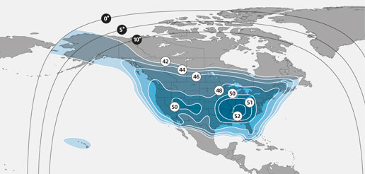
Figure 2-3: DOMSAT (AMC-4) Footprint and Frequency Plan

Figure 2-4 depicts hardware components necessary for DOMSAT. The antenna collects the Ku-band DOMSAT signal and directs it to the LNB at the antenna focus. The LNB down-converts the signal to L-band and transmits it via coaxial cable to a receiver. The receiver demodulates the signal and sends synchronous X.25 blocks to a high-speed serial board in the PC. The LRGS software decodes the X.25 packets and constructs complete DOMSAT messages.
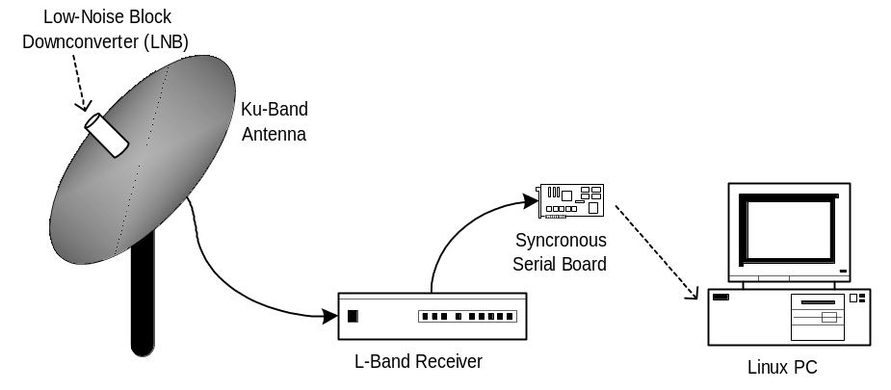
Figure 2-4: DOMSAT Hardware Components.

LRGS Software Overview
The LRGS is a single Java application designed to run in the background on a real-time server. The application has many modules, some of which represent separate threads of execution. Figure 3-5 shows how data flows through the system
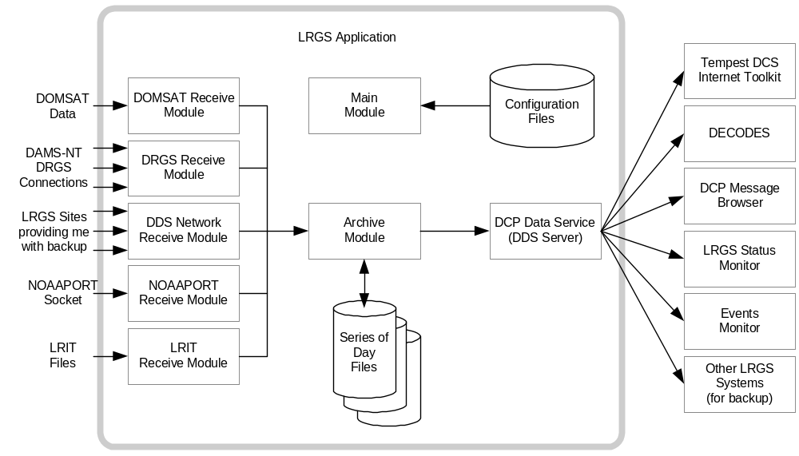
Figure 3-5: LRGS Software Data Flow.
Major modules include:
- The Main Module controls start-up, shutdown, configuration, and status gathering.
- The Archive Module manages a series of day-files, along with corresponding index files. By default, a system is configured to store 30 days worth of data. This can be increased, limited only by available disk capacity.
- The DOMSAT Receive Module handles data reception from DOMSAT using special purpose HDLC hardware. This is the only LRGS module that is not 100% Java because it contains a small amount of C-Language code to interface with the hardware drivers.
- The DRGS Receive Module handles data reception from any number of DAMS-NT connections. You can mix and match demodulator systems from different vendors as long as they support DAMS-NT.
- DDS (DCP Data Service) Network Receive Module handles data reception from other LRGS systems over the network. This is typically used for backup. If your satellite link fails, you will still get real-time data over the network.
- NOAAPORT Receive Module handles data reception from a variety of NOAAPORT receivers, using the real-time socket interface that they provide.
- The LRIT DAMS-NT Receive Module receives data from LRIT receivers that support the DAMS-NT protocol.
- The DDS Server handles client connections to serve up DCP data, status, and events.

Starting and Stopping the LRGS Server Daemon
We recommend that you set an environment variable LRGSHOME pointing to the OPENDCS installation directory. Then you should add the LRGS’s bin directory to your path. On a unix or linux system, modify your startup script (e.g. “.bash_profile” if you are using bash) with the lines:
LRGSHOME=The Directory where you installed OPENDCS
export LRGSHOME
PATH=$LRGSHOME/bin:$PATH
After installation, you will find a script in the $LRGSHOME/bin directory called “startLRGS” (for Windows, “startLRGS.bat”). Run this script either from the command line, or a GUI shortcut, to start the LRGS.
The LRGS creates a lock file in the $LRGSHOME directory called “lrgs.lock”. While it is running, it periodically updates the last-access-time on this file. The purpose of this file is two-fold:
  - It prevents multiple instances of the LRGS from running at the same time.
  - It provides an easy way to shut down the LRGS: simply delete the lock file.
Hence, to stop the LRGS on a Linux/Unix system, type the following. The LRGS will shutdown within 10 seconds.
cd $LRGSHOME
rm lrgs.lock

The ‘startLRGS’ script can take the following arguments:
-f configFile Sets the name of the LRGS configuration file. The default is $LRGSHOME/lrgs.conf
-l logFileName Sets the base name of the LRGS log file. The default is $LRGSHOME/lrgslog
-d debugLevel Sets the verbosity for log messages. Default=0 (meaning no debug messages). You can enter 1 … 3. (3 is most verbose).
-S maxLogSize Sets the maximum size of a log file. Default=20000000 (20 million bytes). When the file reaches this size, the logs are rotated.
-N numOldLogs Sets the number of old log files to keep. Default=5. Old logs are given a numeric extension 1 (most recent) … N (oldest).

LRGS Configuration
After the initial installation, the LRGS comes with an administrative user account named “lrgsadmin” with password “lrgsadmin”.
You are strongly encouraged to change this password after first starting the LRGS.
After starting the LRGS server as described above, start the real-time status display on the same machine with the command:
rtstat

Along the top, type “localhost” for hostname and “lrgsadmin” for user name. Also check the box and type the password for lrgsadmin.
If this is your first time connecting, Hit File – Set Password from the menu in the upper left. Then reconnect with the new password.
You can now select File – LRGS Configuration from the menu at the upper left. As shown in Figure 5-6, you will be presented with a multi-tabbed configuration GUI in which you can modify all of the LRGS configuration parameters by category.
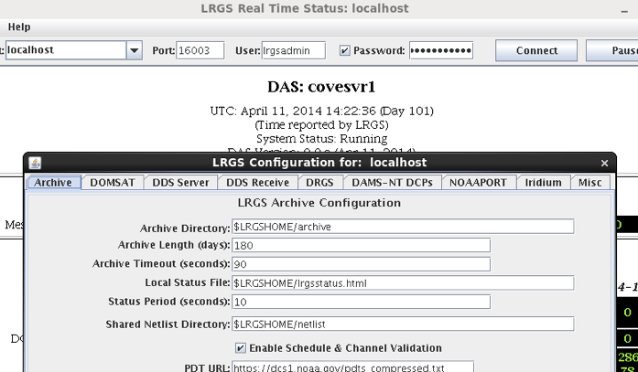
Figure 5-6: LRGS Configuration Menu.

The LRGS Configuration is stored in three files in the $LRGSHOME directory:
- lrgs.conf is a series of ‘name=value’ pairs, one per line. You can modify the file with any standard text editor.
- ddsrecv.conf is an XML file containing an XML record for each remote LRGS server that you want to use for backup.
- drgsconf.xml is an XML file for each DAMS-NT DRGS that you are receiving data from.
The LRGS process checks the configuration files once per minute for modifications. If it detects that a file has changed it is re-loaded.
For the main “lrgs.conf” file, Table 5-1 contains a list of accepted properties. Some of the properties may not be changed on-the-fly. The right-most column indicates whether the property can be modified on the file. If this is ‘No’ then you must restart the LRGS in order for the change to take effect.
You may put comments in the file by placing a ‘#’ character at the beginning of the line.

Property Name | Value Type | Default | Description | Can  Modify
acceptDomsatARMs | true/false | false | Normally, an LRGS does its own schedule checking based on NOAA’s PDT. If you want to rely on ARMs (Abnormal Response Messages) from a remote LRGS, set this to true. | Yes
archiveDir | directory name | $LRGSHOME/archive | The name of the directory containing the archive day-files. | No
channelMapLocalFile | Filename | $LRGSHOME/cdt | Name of file in which to store cached channel map | Yes
channelMapUrl | URL | https://dcs1.noaa.gov/chans_by_baud.txt | URL for downloading the channel descriptions from Wallops. This tells the LRGS which channel numbers are valid and what baud rates each can handle | Yes
ddsAllowAdmin | true/false | false | Set to true if you want administrative functions to be available through DDS. If enabled, administrative functions will only be allowed for authenticated connections. | Yes
ddsBindAddr | IP Addr | (empty) | For systems with multiple network interfaces. If you only want to enable the DDS server on a specific NIC, specify the IP Address. | No
ddsListenPort | Integer | 16003 | TCP Port on which to listen for incoming DDS client connections. | No
ddsMaxClients | Integer | 100 | Maximum number of simultaneous DDS clients that can be supported on this LRGS. | No
ddsMinHourly | Integer | 0 | If set to positive number, then issue a warning message if the number of messages received in an hour is less than this value. Also, this will enable the check for number of messages in a given hour being less than half the number of messages in the previous hour. | Yes
ddsNetlistDir | directory name | $LRGSHOME/netlist | Any network list files (ending in “.nl”) placed in this directory will be available to all DDS clients for specifying DCP addresses and DCP names. | No
ddsRecvConfig | file name | $LRGSHOME/ddsrecv.conf | Name of configuration file for the DDS Receiver Software. This contains a list of server names to connect to, and other parameters. | No
ddsRequireAuth | true/false | false | Set to true if you want to require all DDS clients to authenticate themselves via hash/password. See discussion below. | No
ddsUsageLog | file name | $LRGSHOME/dds-log | DDS connection information is periodically logged. This specifies the file name. | No
ddsUserRootDir | Directory name | $LRGSHOME/users | The name of the directory containing a sub-directory for every DDS users | No
ddsUserRootDirLocal | Directory name | $LRGSHOME/users.local | The name of the directory containing a sub-directory for every local DDS users | No
domsatClass | Class Name | lrgs.domsatrecv.DomsatSangoma | Class name for the hardware interface. DOMSAT also supports the old Franklin ICP188 card by setting this to lrgs.domsatrecv.DomsatFranklin | No
domsatTimeout | # seconds | 60 | Number of seconds after which a timeout is declared if there is no activity on the DOMSAT link. | Yes
dpcHost | Host or IP Addr | none | If you receive data from a DOMSAT Protocol Converter, enter the host name here | No
dpcPort | Integer | 9000 | If you receive data from a DOMSAT Protocol Converter, enter the port number here | No
doPdtValidation | Boolean | false | Set to true to have this local LRGS do GOES message validation based on the downloaded PDT | No.
dqmSerialPort | String | “COM1” | Serial port for sending sequence messages to DAPS. | No
drgsRecvConfig | file name | $LRGSHOME/drgsrecv.conf | Name of configuration file for the DRGS Receiver Software. This contains a list of server names to connect to, and other parameters. | No
drgsMinHourly | Integer | 0 | If set to positive number, then issue a warning message if the number of messages received in an hour is less than this value. Also, this will enable the check for number of messages in a given hour being less than half the number of messages in the previous hour. | Yes
edlIngestEnabled | Boolean | false | Set to true to enable ingest of EDL files by scanning a hot directory. | No
edlIngestDirectory | Directory Name | $LRGSHOME/edl-incoming | Name of hot directory to search for incoming EDL files. If ‘edlIngestRecursive’ is set, then subdirectories are recursively searched also. | Yes
edlIngestRecursive | Boolean | false | If true, then edlIngestDirectory is taken as the top of a tree that is searched recursively for incoming files. | Yes
edlFilenameSuffix | String | none | If set, then only files with a matching filename suffix are processed. All other files in the directory (or directory tree) are ignored. | Yes
edlDoneDirectory | Directory Name | none | If set, then incoming EDL files will be moved here after ingest. If not set, then the files will be deleted. | Yes
edlMinHourly | Integer | 0 | If set to positive number, then issue a warning message if the number of messages received in an hour is less than this value. Also, this will enable the check for number of messages in a given hour being less than half the number of messages in the previous hour. | Yes
enableDdsRecv | true/false | False | Set to true to enable reception of data over the network from other LRGS systems. | Yes
enableDomsatRecv | true/false | False | Set to true if you have a DOMSAT interface. | Yes
enableDrgsRecv | true/false | False | Set to true to enable reception of data over the network from DRGS (DAMS-NT) systems | Yes
enableLritRecv | true/false | False | Set to true to enable the LRIT file ingest module. | Yes
htmlStatusFile | file name | $LRGSHOME/lrgsstatus.html | File in which to save periodic HTML snapshots of the LRGS status. | Yes
htmlStatusSeconds | Integer | 30 | Number of seconds between HTML status snapshots | Yes
iridiumEnable | Boolean | false | Set to true to enable the Iridium SBD Listener | No
iridiumCaptureFile | Filename | none | If specified, iridium SBD raw data will be captured here. | Yes
iridiumPort | Integer | 10800 | Port number to listen for incoming Iridium SBD messages | No
loadDecodes | Boolean | False | Load the DECODES Database at start up. This gives LRGS access to DECODES network lists. | No
loadDomsat | Boolean | True | Loads the DOMSAT native interface. | No
localAdminOnly | Boolean | false | Set to true if this LRGS synchronizes user accounts from another LRGS and you only want local users to be able to administer this system | No
lrgsHostName | String | (empty) | Host name or IP address of the remote DAMS-NT LRIT unit. | No
lritDamsNtStartPattern | Hex Number | 534D0D0A | Start pattern for DAMS-NT protocol | Yes
lritMinHourly | Integer | 0 | If set to positive number, then issue a warning message if the number of messages received in an hour is less than this value. Also, this will enable the check for number of messages in a given hour being less than half the number of messages in the previous hour. | Yes
lritPort | Integer | 17010 | Port number on which the DAMS/NT LRIT Receiver is listening | No
lritReceiverType | String | (empty) | OPENDCS LRGS only supports dams-nt | No
lritSrcCode | 2-chars | LR | This is inserted into the 37-byte GOES header as the source field | Yes
lritTimeout | # seconds | 120 | Assert a timeout if no LRIT files are received in this many seconds | Yes
lritMaxAgeSec | # seconds | 7200 | Discard messages arriving on the LRIT DAMS-NT link that are older than this. | Yes
maxDownlinks | Integer | 32 | Each process that supplies data to the LRGS is considered a “downlink”. For example if you specify 3 DRGS connections, DOMSAT, and 4 DDS Receive Connections, your system will use 8 downlinks. | No
maxLogSize | Integer |  | Maximum size of the “lrgslog” file before it is rotated. | No
mergePref1 | Name | None | Specifies the first (highest) preference for the merge filter. Can be one of “DDS”, “DRGS”, “LRIT”, “DOMSAT”, or “NOAAPORT”. | No
mergePref2 | Name | None | Specifies the second highest preference for the merge filter. | No
mergePref3 | Name | None | Specifies the third highest preference for the merge filter. | No
mergePref4 | Name | None | Specifies the fourth highest preference for the merge filter. | No
noaaportCaptureFile | String | (empty) | If supplied, LRGS will archive every NOAAPORT message received by adding a date/time extension to the filename. | No
noaaportEnabled | true/false | false | Enables the NOAAPORT Interface | No
noaaportHostname | host or IP addr | none | Required if noaaportReceiverType is “unisys”. In this case the LRGS connects to an external server. | No
noaaportPort | Integer | N/A | Port number to either listen on, or connect to, depending on the type of NOAAPORT receiver | No
noaaportReceiverType | String | Can be “marta”, “unisys”, or “PDI” | Determines the protocol used to communicate with the NOAAPORT receiver | No
numDayFiles | Integer | 30 | Number of day files to maintain. Files older than this are deleted. | No
numOldLogs | Integer | 5 | Number of old log files. Old log files are given a numeric suffix from 1 (most recent) to N (oldest) | No
onStartupCmd | Command | None | Command to be executed by LRGS when it starts up. The command line should be an executable command in whatever operating system is used. | No
pdtLocalFile | File name | $LRGSHOME/pdt | File in which to store cached version of downloaded PDT. | Yes.
pdtUrl | URL | https://dcs1.noaa.gov/pdts_compressed.txt | URL for downloading PDT from Wallops | Yes
recoverOutages | true/false | False | If true, then the DDS-Receive module will attempt to recover data from discrete outages. If false (default) then DDS-Receive will retrieve a real-time stream. | No
timeoutSeconds | Integer | 90 | If no data is received in this amount of time, the LRGS asserts a timeout condition. | Yes
writeDacqEvents | Boolean | false | If set to true AND if loadDecodes is also true AND you are using SQL for the DECODES Database, then INFO and higher priority events are also written to the DACQ_EVENT table in the SQL database. | No
Table 5-1: LRGS Configuration Variables.

DDS Users and Server Security
Clients will connect to your system using DDS Protocol. DDS offers the following operations:
- Retrieve DCP messages.
- Retrieve recent status and event information.
- Change your own password (but only if you connected with a password).

The first two functions are inherently read-only. No one can harm your system using these functions.
By default, DDS allows un-authenticated connections for the first two functions. This means that the client must supply a valid user name, but no password. However, for a more secure system, you can restrict access to authorized clients to whom you have supplied a password. To do this, set the “ddsRequireAuth” variable to true.
Additionally, if you connect to the server with a password and you are defined on the server as an administrator, you will have the following capabilities.
- Add/Delete/Edit user accounts (names, passwords, permissions)
- Other Administrative functions (not yet implemented).
DDS insists that these functions (Administrative) are only accessible to authenticated clients who have been granted the “admin” role (see below). You cannot change this behavior.
Any attempt by a non-authorized client to perform administrative functions will cause the connection to be immediately disconnected.

Is DDS Secure?
Yes when used with passwords, for the following reasons:
- Passwords are never transmitted over the network. Rather, a one-way-hash of the password, user name, and current time are transmitted. Thus a network-sniffer could not intercept a login sequence to steal a password.
- ‘Replay’ attacks are prevented by the inclusion of the time in the hash. The server requires that the time provided be reasonably current (within a few minutes).
- A side effect is that if the client and server machines have internal clocks that differ by too-large an amount, the connection will be rejected.
- The server stores a hash of the user’s password in a protected file. Permissions are set so that only ‘lrgs’ has read priviledges.
- Administrative functions are only available to users who have been granted ‘admin’ privileges on the server.
- Any sensitive information in admin messages in encrypted with DES.

How to Create DDS User Accounts Manually
You must create the first account manually.
All users require a ‘sandbox’ directory where temporary files are stored. These are sub-directories under the directory $LRGSHOME/users. So, for example, to create a user with name “groucho”, issue the following commands:
cd ~/users
mkdir groucho

LRGS stores passwords in a secure file called “.lrgs.passwd” in the $LRGSHOME directory. This file stores user names, roles, and a hash of the password. You should keep this file hidden so that only you can modify it. On a Linux or Unix system, create the file as follows:
cd ~
touch .lrgs.passwd
chmod 600 .lrgs.passwd
Now run the utility for adding, removing, and modifying LRGS administrative users. A simple command-line utility called “editPasswd” (for Edit LRGS Passwords) has been supplied for this. Start the utility by typing:
editPasswd
Type ‘help’ and hit ENTER for a list of supported commands. For example, to add a user named ‘groucho’ with both DDS and Administrative privileges, type:
adduser groucho
...(type the password as you are prompted)
addrole groucho dds
addrole groucho admin
write
quit
Currently the following roles are recognized:
- “dds” allows the user to access read-only functions like pulling messages and status.
- “admin” allows the user to access all administrative functions.
The editPasswd program also allows you to set ‘properties’ on each user. These are used to control features such as the IP address restriction (see section 7.6) and the Real-Time Stream DCP Limit (7.7).

How to Maintain DDS User Accounts from the Status GUI
Use the Real-Time status GUI to connect to your LRGS. Use a user name that has ‘admin’ privilege and connect using a password. Select ‘File’ – ‘User Administration’ from the menus at the top left. Figure 5-7 shows the user administration screen.
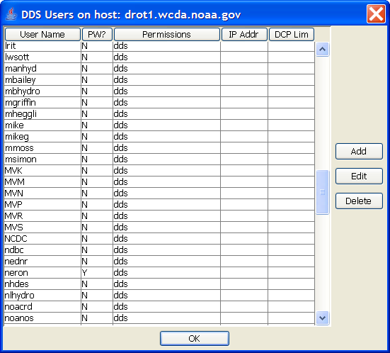
Figure 5-7: User Administration Screen.
By pressing the ‘Add’ button, or by selecting a user and pressing ‘Edit’ you will see the dialog shown in Figure 5-8. You are strongly urged to define a password even if your server doesn’t require one. We anticipate that authenticated connections will be the norm in the near future.
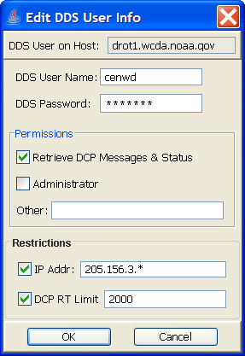
Figure 5-8: Edit DDS User Dialog.
You can edit the following information about each user:
- DDS User Name – each user’s name must be unique and is case sensitive.
- DDS Password – May be left blank if this user only uses unauthenticated access.
- Permissions or ‘roles’. Currently only two are recognized:
- Ability to retrieve DCP messages and status
- Administrative privileges
- An optional IP address restriction. If set, this user is only allowed to connect from the specified IP address or range.
- To allow a range, the address may contain the wildcard ‘*’ as shown in the example.
- To list addresses or ranges individually, separate with a semicolon:
- Example: 205.156.3.*;192.168.5.23
- An optional DCP real-time stream limit. If set, this user is not allowed to pull a real-time stream of data for more than the specified number of DCPs.

Configuring the DDS Receiver Connections
The LRGS can receive data in real-time from other LRGS systems. Your LRGS will act as a client to the remote LRGS. You can specify up to 16 systems from which to pull data.
The configuration for the DDS receiver is stored in a separated XML-format file. The file name, by default, is “$LRGSHOME/ddsrecv.conf”, but it can be changed by specifying a different value in the “lrgs.conf” file for the “ddsRecvConfig” property, as described above.
The “ddsrecv.conf” file is an XML file. Figure 5-9 shows an example of this file with two connections to the public servers operated by NOAA/NESDIS. Note the hierarchical nature of the file.
<!--
This file holds the DDS Receiver Configuration.
-->
<ddsrecvconf>
<networkList>usace-mvd</networkList>
<networkList>usace-nwd</networkList>
<timeout>90</timeout>
<connection number="1" host="drot.wcda.noaa.gov">
<name>DROT</name>
<port>16003</port>
<enabled>true</enabled>
<username>ilex</username>
<authenticate>false</authenticate>
<hasDomsatSeqNums>true</hasDomsatSeqNums>
</connection>
<connection number="2" host="cdadata.wcda.noaa.gov">
<name>CDADATA</name>
<port>16003</port>
<enabled>true</enabled>
<username>ilex</username>
<authenticate>false</authenticate>
<hasDomsatSeqNums>false</hasDomsatSeqNums>
</connection>
</ddsrecvconf>
Figure 5-9: DDS Receive Configuration File Example.
The following rules must be followed in the DDS Receiver Configuration File:
- The top-level element in the file must be “ddsrecvconf”
- There may be any number of “networkList” elements. See section 5.2.1 below.
- This element may contain up to 32 “connection” elements.
- Every “connection” element must have unique number and host attributes. The host may be either a host name or an IP address.
- The “name” element is used for displaying status. It should be descriptive, short, and unique.
- The “port” element is used to specify a port number. If not supplied the default is 16003.
- The “enabled” element may be used to disable a connection without removing it from the file.
- The “username” element tells the receiver what username should be used when connecting to the remote server. The remote DDS server will require a valid user name.
- The “authenticate” element defaults to “false” if not supplied. If set to “true”, it causes your LRGS to connect to the server using the secure hash-password method. In order to use this, add an entry in your password file (see above). You do not need to specify a roles since you are using this entry to access external systems only.
- The “hasDomsatSeqNums” element defaults to false. If your system is a DOMSAT system and you want to recover DOMSAT Transient Sequence Number Outages, then you need to tell the DDS Recv module which connections have DOMSAT sequence numbers, by setting this value to true.
- The “timeout” element specifies the number of seconds, after which, if no messages have been received from the server, that we will hang-up from this server and try the next one.

Use Network Lists to Only Pull Data of Interest
The purpose of this feature is to reduce network traffic by only retrieving data from the platforms you are interested in.
In the DDS Receive Configuration File you may put any number of “networkList” elements. Each one contains the name of a network list that you maintain. A network list is simply a list of DCPs, identified by the NESDIS DCP-Address. There are two types supported by LRGS:
- Network Lists stored in a DECODES database. LRGS will look for this type first, but only if you have DECODES installed on this machine.
- Flat file Network Lists in the format described in section 7.3.1.
The example in Figure 5-9 shows two lists called “usace-mvd” and “usace-nwd”. These represent the DCPs for two different Corps of Engineers Divisions.
Again, if DECODES is installed on this machine, and LRGS can successfully find and open the DECODES database, and the named list exists in the database, then LRGS will use the DECODES network list. Else, LRGS will look for a flat file network list in the $LRGSHOME/netlist directory. In either case, you do not need to include the “.nl” extension on the list name.
When your LRGS makes a connection to some remote LRGS, it will send the lists and then reference them in a search criteria file. Subsequently, when you pull data, you will only get data for the platforms in the lists.
In summary, to use this feature, do the following:
- Build one or more network lists containing the platform addresses of interest.
- If you’re using DECODES, build the list in the “dbedit” database editor.
- If you use DECODES, but on another machine, build the list with “dbedit” and then export it by using the nl2lrgs utility. See section 4.6.2 in the DECODES User Guide for details.
- If you’re not using DECODES, you can prepare a flat file in the format described in section 7.3.1.
- Place these lists in the $LRGSHOME/netlist directory. (That is, the “netlist” subdirectory under your LRGS installation).
- Add one or more “networkList” elements to the XML configuration file, as shown in Figure 5-9.
- That’s It! You do not need to restart LRGS. The DDS Receiver will notice that the configuration has changed and automatically reload it.
One final wrinkle: The remote LRGS may be configured to impose limits on the number of DCPs for which you can pull data. (See section 7.7 for how to impose these limits on your LRGS.)
IF a limit is imposed on the remote system for your user name, AND IF the total number of DCP in all of your lists is over that limit, THEN the remote LRGS will return a special error code after you establish the connection. When this happens, your LRGS will try a different LRGS connection.

New Feature added in OpenDCS 6.2 RC12:
Network Lists added to either the primary or secondary group can be of the form:
source=source-name
Where source-name is one of:
- NETDCP – Network DCPs a.k.a. Electronic Data Logger messages, usually received via polling or manual file-drop.
- IRIDIUM – Iridium Messages
A good use for this feature is in the secondary group. Specify an LRGS in the group that is receiving network DCPs, then specify “source=netdcp” as a network list for the group. Then you will receive all network DCP messages from that LRGS without having to specify the medium ID (EDL Name) for each one.

Configuring DRGS Connections
The LRGS can receive data from any GOES demodulator systems that supports the NOAA-published DAMS-NT (Data Acquisition and Monitoring System - New Technology) ICD can supply data to an LRGS. The LRGS supports up to 64 simultaneous DAMS-NT connections.
To receive data from a DRGS, first make sure that the “enableDrgsRecv” variable is set to true in the “lrgs.conf” file, and that the “drgsRecvConfig” is set to the name of the DRGS connection configuration file. By default this will be $LRGSHOME/drgsconf.xml.

Configure your DRGS Interfaces
Next you need to edit the file ‘drgsconf.xml’ found in the $LRGSHOME directory. This is an XML file. A sample file with two DRGS connections is shown below:
<?xml version="1.0"?>
<drgsconf>
<validate enable="true"
pdturl="http://dcs.noaa.gov/ftp_daily/pdts_compressed.txt"
cdturl="http://dcs.noaa.gov/ftp_daily/chans_by_baud.txt"/>
<connection number="0" host="drgs-e.mydomain.gov">
<name>EAST-DRGS</name>
<enabled>true</enabled>
<msgport>17010</msgport>
<evtport>17011</evtport>
<evtenabled>false</evtenabled>
<startpattern>534D0D0A</startpattern>
<cfgfile>$LRGSHOME/EAST-DRGS.cfg</cfgfile>
<sourceCode>DE</sourceCode>
</connection>
<connection number="1" host="drgs-w.mydomain.gov">
<name>WEST-DRGS</name>
<enabled>false</enabled>
<msgport>17010</msgport>
<evtport>17011</evtport>
<evtenabled>false</evtenabled>
<startpattern>534D0D0A</startpattern>
<cfgfile>$LRGSHOME/WEST-DRGS.cfg</cfgfile >
<sourceCode>DW</sourceCode>
</connection>
</drgsconf>
Figure 5-10: DRGS Configuration File Example.
You can include up to 64 “connection” records, each with a unique “number” argument from 0…63. The host argument is required and may be a host name or IP address.
As shown in the sample, you can include options inside the connection records:
- <name> specifies the name to show on the real-time status page, and in log messages.
- <enabled> defaults to ‘true’. You may set it to false to temporarily disable receiving messages from a particular DRGS.
- <msgport> defaults to 17010 as per the NOAA DAMS-NT ICD. Only change it if your DRGS uses a non-standard port number.
- <evtport> defaults to 17011 as per the NOAA DAMS-NT ICD.
- <evtenabled> defaults to ‘true’. Set it to false to disable event reporting from a particular DRGS. Events from the DRGS are turned into LRGS log messages.
- <startpattern> defaults to the value shown in the sample. This is equivalent to the pattern “SM\r\n”, SM stands for Start Message. Enter the 8-hex-digits appropriate for your DRGS.
- <cfgfile> contains the name of a file with configuration statements. It defaults to a file in the $LRGSHOME directory with the same name as the connection and an extension of “.cfg”.
- <sourceCode> contains a two-character code that is inserted into every message received from this DRGS link. The code is inserted into the unused IFPD status bytes in the DOMSAT header. Using unique codes for each DRGS will allow you to positively identify the source of each message in your archive.

DRGS Message Validation
Note the ‘validate’ entry in the configuration file with three attributes:
- enable: set to “true” or “false”. Set to true for validation to be enabled.
- pdturl: set to a URL from which to download the daily PDT dump.
- cdturl: set to a URL from which to download the daily channel table dump.
Message validation ensures that each message was received on the proper channel and in the proper time-slice. If any anomalies are detected, the code generates the same ‘status messages’ which are currently generated by the DAPS system. These are described above in section 2.3.1. Specifically Table 5-2 lists which checks are done.
Status Msg Type | Conditions Causing the Message
‘A’ - correctable addr error | DRGS reports that an address was corrected.
‘I’ – invalid address | DCP address not found in the PDT.
‘W’ – wrong channel | Self-timed or random message was received on wrong channel, as defined in PDT for each message type.
‘T’ – time slice | Self-timed message was received partially out of its time-window (either starts too early or finishes too late).
‘M’ – Missing | Self-timed window expires and no message was received.
‘U’ – Unexpected | Self-timed message was received completely out of its time-window.
‘D’ – Duplicate | Message received on more than one channel.
Table 5-2: DRGS Message Validation Results and Conditions.
To disable this type of validation, either delete the ‘validate’ element from the configuration file, or set the enabled attribute to “false”.
The pdturl attribute tells the software where to get the periodic dump of the Platform Description Table. NOAA currently provides this on their Wallops web site. The URL for this is the setting shown in the example.
Likewise, the cdturl attribute tells the software where to get the periodic dump of the channel table.
The CDT and PDT URLs can be set to an empty string. This will prevent the software from attempting the download. The latest disk copy will be used in this case.
The DRGS configuration file is a series of commands that would normally be sent to the DRGS configuration port. Consult the DAMS-NT specification or your DRGS documentation for a complete list of commands. The LRGS looks for ‘assign’ statements in this file this list to determine which channels are ‘covered’ on each connection. Only channels that are covered will cause ‘M’ (missing) status messages to be generated. Assign statements look like this:
assign slot channel spacecraft baud

DAMS-NT Compliance
The LRGS complies with DAMS-NT Version 8.1. In this specification, the DAMS-NT unit may optionally include carrier stop/end times to millisecond-resolution. The code automatically detects if carrier times are being used. You do not need to change configuration to enable this.

Configuring Alarms and Actions
The LRGS generates a stream of event messages. These are visible at the bottom of the LRGS Real-Time Status Screen and are saved in the file “lrgslog”. Some of these event messages can be alarm messages. Messages which can be treated as alarms have the form:
Priority Date/Time Module:EventNum Message ...

… where priority can be “INFO”, “WARNING”, or “FAILURE”. The distinguishing feature is that the message must have a module name and an event number.
For any alarm message you can associate a process to be executed. To do this, create a file “alarm.conf” in the $LRGSHOME directory. You can add to this file lines of the form:
Module:EventNum Command ...

… where “Command” is the name of the external program to be executed, and “…” are arguments passed to the command.
As a convention, several of the LRGS software modules generate a WARNING or FAILURE alarm with a positive event number when an alarm condition is asserted. Later when the alarm condition has been rectified, an INFO alarm is generated with the corresponding negative number.
For example, if the DOMSAT Hardware times-out – meaning that no data has been seen in more than 60 seconds, you will see an alarm with even number 5, that looks like this:
WARNING YYYY-MM-DD/HH:MM:SS DomsatRecv:5 No data in more than 60 seconds.

Later, suppose that data starts flowing again. You will see an alarm with the number -5:
INFO YYYY-MM-DD/HH:MM:SS DomsatRecv:-5 DOMSAT Link Recovered.

You could associate different commands with events 5 and -5.
Table 5-3 contains a list of module names and event numbers, along with an explanation of each alarm.

Module | Event Num | Meaning
DomsatRecv | 1 | DOMSAT Hardware Initialization Failed. This is a non-recoverable alarm. It typically means that the DOMSAT hardware interface is not working or the driver is incorrectly installed.
DomsatRecv | 5 | DOMSAT Link Timeout. No data seen in more than 60 seconds.
DomsatRecv | -5 | DOMSAT Link Recovery – cancels the timeout event.
DrgsRecv | 1 | Connection to a DRGS server failed. This can be due to the server not running, the configuration has the wrong port number, or perhaps the connection is being blocked by a firewall.
DrgsRecv | -1 | Connection to a DRGS server succeeded.
DrgsRecv | 2 | DRGS Connection Timeout. More than 20 seconds has elapsed with no activity seen on the port. The connection will be discarded and a new connection will be attempted.
DrgsRecv | 3 | IO Error on DRGS Connection, meaning that the connection was terminated by the server. Perhaps the server was shutdown, or an intervening firewall was reconfigured to disallow the connection.
DrgsRecv | 4 | Bad message header. Is this DRGS 100% DAMS-NT compliant?
DdsRecv | 1 | No connections are configured. No data will be received by the DDS network module.
DdsRecv | 2 | Connection failed. If a backup connection has been configured, it will be attempted.
DdsRecv | 3 | Bad Configuration. Either the configuration file doesn’t exist or could not be parsed.
LrgsMain | 2 | Master configuration was changed.
LritRecv | 1 | Cannot move an LRIT file after processing. This usually indicates disk full or a permissions problem.
LritRecv | 2 | Cannot delete an LRIT file after processing. Check permissions on the directory where LRIT files are being read-from.
LritRecv | 3 | Timeout – No files seen in more than 120 seconds.
LritRecv | -3 | Timeout Recovery – New data seen after timeout was asserted.
Table 5-3: LRGS Alarm Module and Event Numbers.

LRGS Event Log Messages
The LRGS maintains a log file of event messages in the $LRGSHOME directory called “lrgslog”. The file grows to a pre-determined size (default = 10MB). When this limit is reached, it is closed and renamed with a numeric extension. A new log is then created.
Each log message is on a separate line of the file. Each has three fields followed by a free-format text message. The left-most field is the message priority. This will be one of the following:
- DBG3 – low-level voluminous debug info
- DBG2 – mid-level fairly voluminous debug info
- DBG1 – high-level not-so-voluminous debug info
- INFO – Normal processing, not an error.
- WARNING – abnormal but recoverable condition
- FAILURE – a requested operation could not be performed
- FATAL – a fatal error occurred in an LRGS process (the process subsequently aborted).
The LRGS normally only logs messages with a priority of INFO or higher. However, the “startLRGS” script can be given a debug flag (-d1, -d2, or –d3). When started in this way, increasing levels of verbosity can be seen in debug messages.
After the priority is a time stamp in the format: YYYY-MM-DD/HH:MM:SS. These times are always in UTC (GMT) time zone.
After the time stamp is name of the software module that generated the event.
On Linux or Unix systems, a good way to view the log file in real-time is with the command:
tail –f lrgslog

Log File Rotation
Previous version of LRGS allowed only two historical logs. As of version 6, logs are rotated in a manner similar to the log files in UNIX:
- “lrgslog” is the current log
- “lrgslog.1” is the previous log
- “lrgslog.2” is the log before that …
- “lrgslog.N is the oldest log.

Command line arguments allow you to control the number of historical logs and the maximum log size.
For LINUX Systems, you can also rotate the log by sending SIGHUP to the executing Java process. First determine the process ID and then use:
kill –s SIGHUP PID

This feature is not available in other operating systems.

Writing Events to SQL Database
As of OpenDCS 6.4, the LRGS can write its INFO and higher priority events to the DACQ_EVENT table of the DECODES SQL database. To enable this:
- On the “Misc” configuration tab, set loadDecodes = true.
- On the “Misc” tab, set writeDacqEvents = true
- Restart LRGS.
In order for this to work you must have a DECODES SQL database with a Database Version of 15 or higher. That is:
select * from decodesdatabaseversion;
The VERSION_NUM column should be 15 or higher.
You should also create an LRGS process record so that events can be properly associated with the LRGS process. From the OpenDCS Launcher, select Processes. If there is no process currently named LRGS, click the “New”button and add one. Name the process LRGS (required). and set the process type to “lrgs”.

When this is enabled, you can then use the DECODES “eventmon” utility to view recent LRGS events.

Message Files
The LRGS saves each day’s worth of data in a separate file in the “archive” subdirectory. For each day, three files are saved:
- arch-YYYYMMDD.msg – The actual message data.
- arch-YYYYMMDD.idx – An index file used for sequential time-range searching.
- arch-YYYYMMDD.min – A ‘minute-index’ used to optimize large searches.

The Quality Log File
The LRGS monitors the number of message received on each data source. Once per minute, it saves an line of text to a file called “quality.log” in the $LRGSHOME directory. Each line has the following fields:
- Date/Time stamp in the format YYYY/MM/DD-HH:MM:SS
- Number of Good Quality messages received on DOMSAT
- Number of Parity-Error messages received on DOMSAT
- Average DOMSAT Bit Error Rate observed in the minute (or a hyphen if no observations)
- Maximum DOMSAT Bit Error Rate observed in the minute (or a hyphen if no observations)
- Number of Good Quality messages received on DRGS
- Number of Parity-Error messages received on DRGS
- Number of Good Quality messages received on DDS Network Links
- Number of Parity-Error messages received on DDS Network Links
- Number of Good Quality messages received on NOAAPORT
- Number of Parity-Error messages received on NOAAPORT
- Number of Good Quality messages received on LRIT
- Number of Parity-Error messages received on LRIT
- Number of Good Quality messages received over legacy network backup links
- Number of Parity-Error messages received over legacy network backup links
- Total number of Good Quality messages archived
- Total number of Parity-Error messages archived

The “quality.log” file is allowed to grow to about 10 day’s worth of measurements. At that time it will be renamed to “quality.log.old”, and a new “quality.log” will be started. Thus at any given time you should have at least 10 days of quality history.

The Merge Filter
The LRGS can receive data simultaneously from several satellite links and from the internet. Thus it may receive several copies of the same message. It uses a built-in ‘Merge Filter’ to save the best copy of each message.
When the LRGS receives a message, it searches backward through the archive to find a message from the same DCP on the same channel that was received within 2 minutes of the message being processed. LRGS assumes that these are copies of the same message. Then the following rules apply:
- If one is good (failure code ‘G’) and the other has errors (failure code ‘?’), LRGS saves only the good copy.
- ELSE If both are good, and one is significantly (i.e. more than one byte) longer than the other, keep the longer copy.
- ELSE If both are bad …
  - If a preference order is provided, keep the one from the preferred downlink (see below)
  - Else, If no preference is specified, keep the one that arrived first.
Refer back to Table 5-1 and notice the variables called mergePref1, mergePref2, mergePref3, and mergePref4. Set these variables to one of DOMSAT, DRGS, DDS, NOAAPORT, or LRIT.
For example, if you trust your DRGS more than you do DDS (which receives data over the network, possibly from somebody else’s DRGS), then specify:
- mergePref1=DRGS
- mergePref2=DDS

Monitoring LRGS Status
LRGS provides several ways to monitor the status of your LRGS.

Web-Accessible Status Page
Every 10 seconds, the LRGS rewrites an HTML status page in the $LRGSHOME directory called “lrgsstatus.html”. You can view this page in any web browser, as shown in Figure 6-11. The page has an HTML header field that causes the browser to refresh the content every 10 seconds.
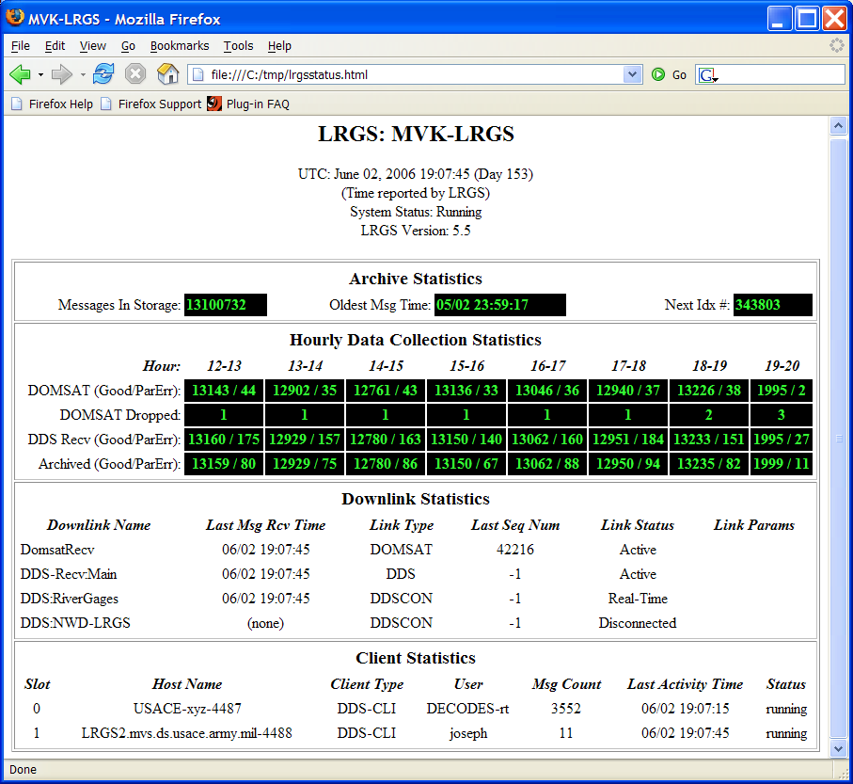
Figure 6-11: LRGS Status Web Page.

LRGS Real Time Status GUI
The ‘rtstat’ command brings up the real-time status GUI. This program can be used to monitor the status of your LRGS.
rtstat options

Options include:
-h hostname The host name to connect to initially. The last used username and port number will be used. The connection will be made immediately rather than waiting for the user to push the ‘Connect’ button.
-u username The name of the DDS user account to use when connecting.
-H headerfile The name of the HTML header file to insert into the displayed report. You can use this option to modify the header appearance, add an agency logo, etc.
-s scan-period Period at which to refresh the screen. The default is 2 seconds.

A snapshot of the screen is shown in Figure 6-12. As you can see, the display is identical to the web page. The differences are:
- This screen updates approximately once every two seconds.
- This s a Java GUI rather than a web browser. Notice the controls along the top for connecting to a particular host.
- This screen uses the same DDS connection (16003) used to distributed messages, so no additional setup is required to make status available on a network.
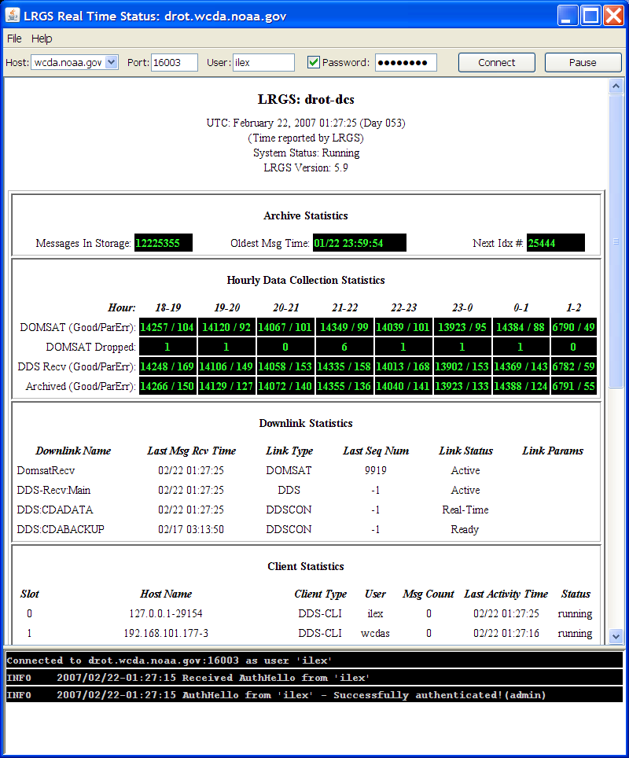
Figure 6-12: LRGS Real Time Status Screen.

Changing Your Password
You can change your password by selecting File – Set Password. This shows the dialog as in Figure 6-13. You can only do this is you have connected to the LRGS with your old password. If you do not currently have a password, contact your LRGS administrator to set one for you.
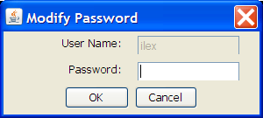
Figure 6-13: Set Password Dialog.

Managing DDS Account
To access this feature you must connect with a password, and you must be defined as an administrator on this LRGS. Select File – User Administration to bring up the dialogs shown in Figure 6-14. The first dialog shows a list of users. You may sort the list in various ways by clicking the column headers.
The second list is the result of selecting a user and pressing the ‘Edit’ button. Here you see and can change the details about this user account.
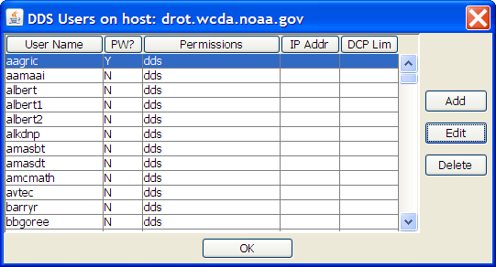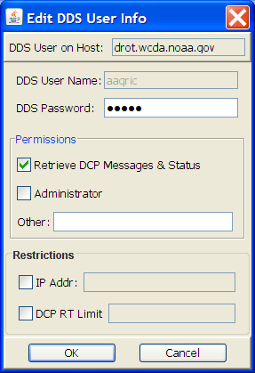
Figure 6-14: User Administration Dialog.

LRGS Configuration
To access this feature you must connect with a password, and you must be defined as an administrator on this LRGS. Select File – LRGS Configuration to bring up the multi-tabbed GUI shown in Figure 6-15 through Figure 6-20. These screens provide an easy way to edit the files described in section 4.
Also, you can use these screens to edit the configuration of a remote LRGS (provided you are an administrator). When you bring up the dialog, it fetches all of the configuration information from the LRGS. When you click the OK or Apply button, the configurations are sent back to the server.
The OK button will send any information that has changed to the server and close the dialog. The Apply button will force-send all configuration information regardless of whether it has changed.
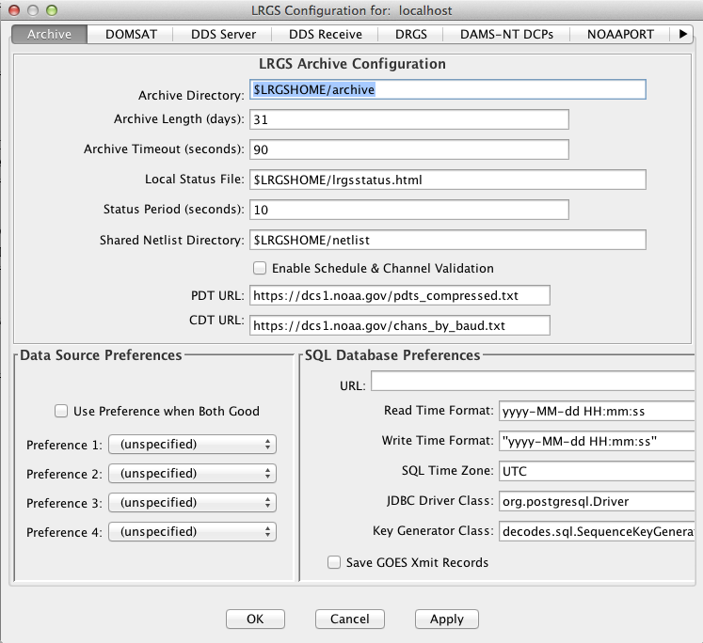
Figure 6-15: LRGS Configuration - Archive Tab.
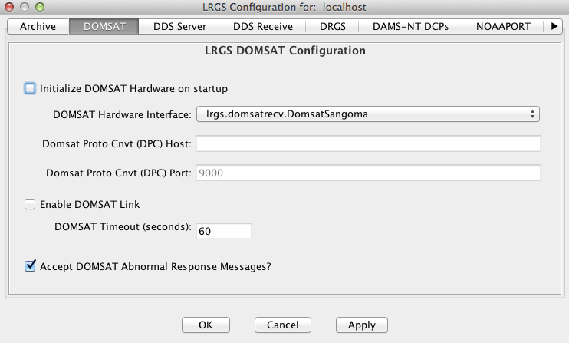
Figure 6-16: LRGS Configuration - DOMSAT Tab.
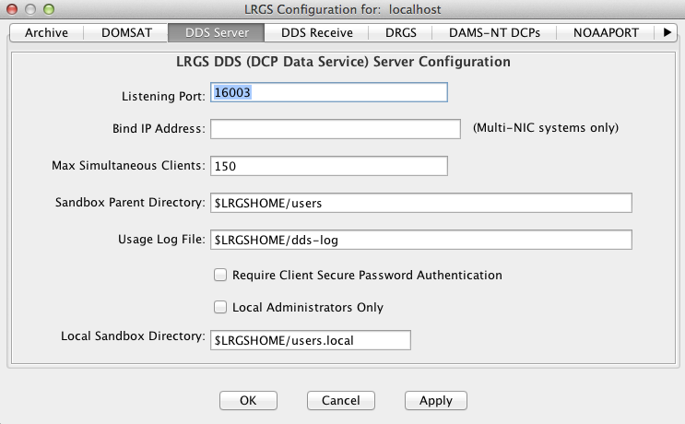
Figure 6-17: LRGS Configuration - DDS Server Configuration Tab.
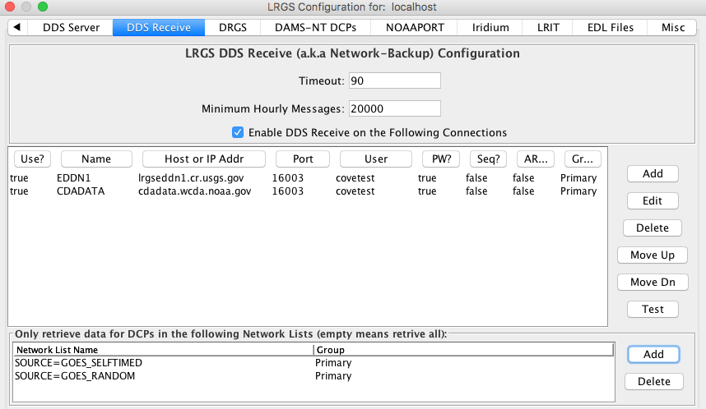
Figure 6-18: LRGS Configuration - DDS Receive Tab.

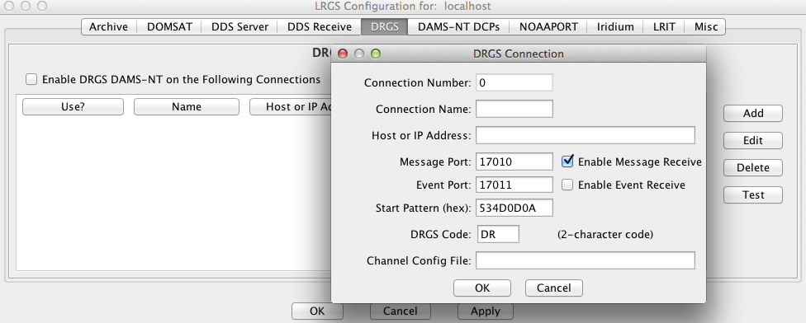
Figure 6-19: LRGS Configuration - DRGS DAMS-NT Tab.
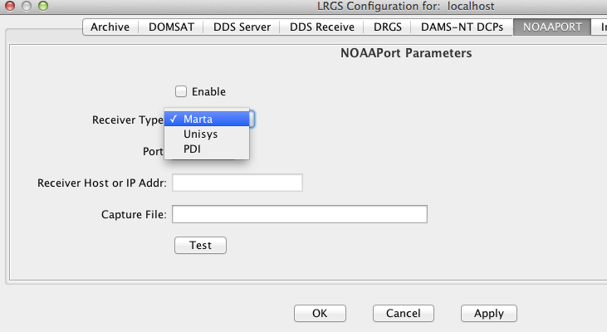
Figure 6-20: LRGS Configuration - NOAAPORT Parameters Tab.

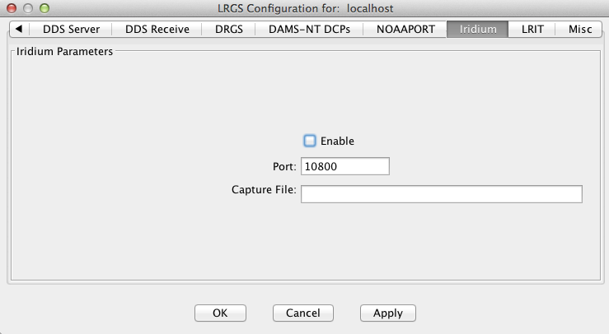
Figure 6-21: LRGS Configuration - Iridium Parameters Tab.

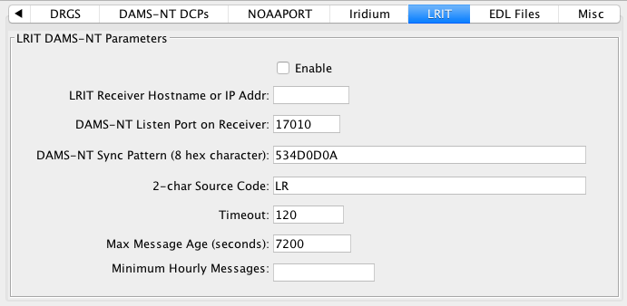
Figure 6-22: LRGS Configuration - LRIT Parameters Tab.

Network List Maintenance
To access this feature you must connect with a password, and you must be defined as an administrator on this LRGS. Select File – Network Lists to bring up the dialog shown in Figure 6-23.
This dialog allows you to maintain which network lists are stored in the shared (netlist) directory on the server.
The left-side list shows lists on the server. The button below the list allows you to delete a list from the server. The right-side list shows local copies. The button below allows you to delete a local list.
The middle buttons allow you move ‘refresh’ the left-side server-list, ‘retrieve’ a copy of a list on the server by copying it to your local disk, and ‘install’ a copy of your local list to the server.
The right-side buttons allow you to create and edit local copies of network lists. When this is done, the selected list is brought up in the network list editor shown in Figure 6-24.
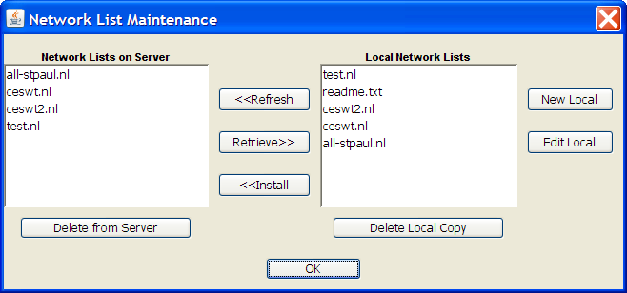
Figure 6-23: Network List Maintenance Dialog.
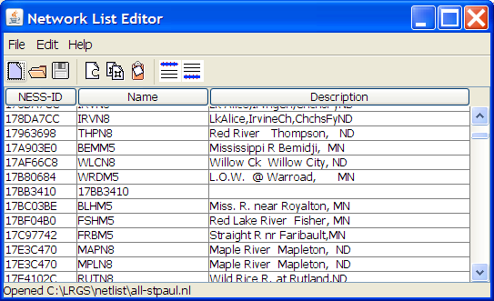
Figure 6-24: Network List Editor GUI.

Integrate RTSTAT with Web LRGS Monitor
The LRGS provides a summary status display that can work with the LRGS Monitor Web Application to give you a summary of your LRGS systems, and then the capability to ‘drill-down’ to individual systems for detailed status and administration.
For information on setting up the LRGS Monitor Web Application, see the DECODES Web Applications User Guide. Chapter three in that document is devoted to setting up the LRGS monitor.
Type the command:
rtsum [-M url-to-LRGS-Mon]

This will start the display shown in Figure 6-25. If you don’t supply an initial URL, the field at the top is blank and you must type it there.
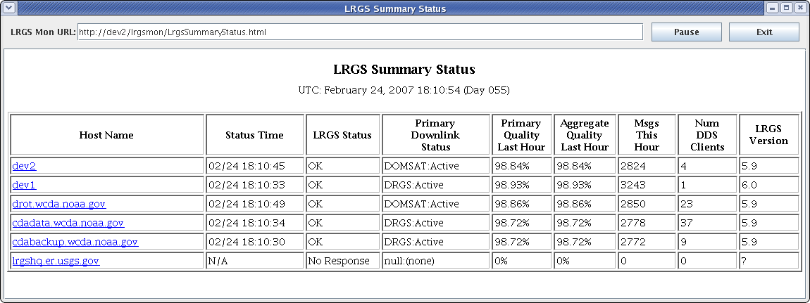
Figure 6-25: LRGS Summary Status Display.
The display shows the following columns:
- Host Name of the remote LRGS. This is a hyper-link. Click on the host name to bring up a Real-Time Status GUI on that system.
- Status Time: This is the system time as reported by the remote system. All of your LRGS server times should be reasonably close.
- LRGS Status: “OK” means that the system is receiving current data from one of its interfaces.
- Primary Downlink Status: States the name of the primary downlink (e.g. DOMSAT or DRGS) and the status on that link.
- Primary Quality Last Hour: This is a measure of good vs. parity error messages.
- Aggregate Quality Last Hour: This is also a measure of good vs. parity errors, but aggregated for all available downlinks.
- Num DDS Clients: Current number of clients connected.
- LRGS Version: Version of the LRGS software running on the remote server.

DDS Implementation
DDS (DCP Data Service) is the LRGS’s link to the outside world. The DDS server is built into the LRGS.
DDS is a standard protocol. Please contact info@covesw.com if you would like a copy of the interface definition. This chapter discusses the specific implementation of DDS that is built into the LRGS.

DCP Data User Directories
Each DCP Data User must have a sandbox-directory for local storage of network list and search criteria files. The Configuration File specifies the root directory where these are stored. See section for instructions on creating DDS user accounts on your server.

Password-Authenticated Connections
The LRGS DDS implementation supports password-authenticated connections. See section for instructions on setting this up.
The password file is called “.lrgs.passwd” and should be stored in the $LRGSHOME directory. It should be protected so that only user ‘lrgs’ can read or write the file. In Unix/Linux, we create the file with the commands:
cd ~lrgs
touch .lrgs.passwd
chmod 600 .lrgspasswd

You then use the ‘editPasswd’ utility to modify the file, as described in section 5.1.2.
Each line in the password file will have the following format:
username:role1,role2,…:authenticator:propname=value,…

DCP Names and Network Lists
For the purpose of searching, the LRGS uses network lists to map names to DCP addresses. When a name is referenced in a search criteria file, the LRGS looks for a matching name in a network list file. It examines network list files in the user’s sandbox directory first. If no match is found, then it examines network list files in the $LRGSHOME/netlist directory.
Thus any network list placed in $LRGSHOME/netlist is available to all connections for mapping names.

Network List File Format
Network List Files are ASCII text files that contain a series of DCP addresses, one per line. By convention, they should have a “.nl” extension.
The only mandatory restriction on the format of the file is that each line should begin with a hex DCP address (8 chars long). However, several utilities in the LRGS software suite can accept an enhanced format that allows you to associate names and comments with each DCP address:
Address:Name Comment

- The line should begin with the hex DCP address followed by a single colon.
- The first blank-delimited word following the colon is taken to be the DCP name.
- Any additional text following the name is a free-form comment.
For example:
CE123456:BLUE_RIV Blue river at west fork – stage, temp

- The DCP address is CE123456
- The DCP Name is “BLUE_RIV”. This name can be used for a variety of purposes within the LRGS.
- The comment is “Blue river at west fork – stage, temp”

Order of Data Retrieval
The LRGS uses two algorithms for retrieving data, depending on the circumstances:
  - Forward-Index-Search: is used when no DCP address (or name) has been requested, or a network list with a very large number of DCPs. It’s also used for all real-time retrievals (i.e. retrievals with no ‘until’ time.)
    - Data will be returned in ascending time order.
  - Reverse-Pointer-Search: is used when a small number of DCP addresses has been requested.
    - Data will be returned by DCP in reverse time order.

DDS Client Log
The DDS server maintains a file called “dds-log” to track the activity of all its clients. Each minute, the server appends a line to the log file for each client currently connected. The line has the following fields:
currentTime ID hostname numMsgs lastActivityTime
The times are in the format YYYY-MM-DD/HH:MM:SS. The ID is a unique runtime ID assigned to each client.

Allowing Connections Only from Known IP Addresses
You can limit the IP address that each user is allowed to connect from. This is especially useful as a security feature if you are allowing unauthenticated access. It prevents any arbitrary user from connecting just because they know (or can guess) a valid user name.
To use this feature, see Figure 5-8 in section 5.1.3. Check the box labeled “IP Addr” and type in the IP address in the field provided.
The IP address may contain a wildcard. For example, to allow any machine that starts with the address “205.156.3” to connect, enter: 205.156.3.*.
As an alternative to the GUI, you can use the text-mode editPasswd program described in section 5.1.2. Simply add a property to the user called “ipaddr”. The value of the property is the IP address as described above.

Limiting Real-Time Clients to a Maximum Number of DCPs
If you have network bandwidth issues, and you potentially have a large number of remote LRGS systems that will be pulling a real-time stream of data from you for backup purposes, then you might want to impose a limit on the total number of DCPs on a client-by-client basis.
This will prevent remote LRGS systems from pulling a complete real-time stream from your LRGS if they are using a restricted user-name.
To activate this feature, see section 5.1.3. When you edit a DDS User, check the box labeled “DCP RT Limit” and type in the desired DCP limit.
Alternately, you can use the text-mode editPasswd program described in section 5.1.2. Simply add a property to the user called “maxdcps”. The value of the property is the integer limit.

How to Retrieve DCP Messages
The LRGS supports any DDS client. Known DDS clients include:
- The “getDcpMessages” Utility (see below)
- LRGS Message Browser (see below)
- DECODES Routing Spec
- USGS SATIN (Satellite Input) Program
- National Interagency Fire Center “ASCADS” Program

This chapter will discuss the first two client programs in the list, which are included in the LRGS release.

The ‘getDcpMessages’ Utility
A command line program called getDcpMessages is included in the LRGS release. You can use this program to retrieve DCP messages from any DDS server. We provide a script in the bin directory called ‘getDcpMessages’ (for Windows, ‘getDcpMessages.bat’) to start the program.
Run the program as follows
getDcpMessages –u username options...

The only required argument is “-u username”. Supply a valid user name on the server you are connecting to.
Options can be any of the following:
- -p port Numeric TCP Port. Default is 16003.
- -h host Supply a host name or IP address. Default is “localhost”.
- -f searchcrit The name of the search criteria file to send to the server. If this argument is omitted, no search criteria file will be sent, this causes the server to send all messages currently in storage, which is probably not what you want.
- -b before Specifies a string to be output before each message
- -a after Specifies a string to be output after each message
- -n Causes a newline to be output after each message
- -v (Verbose) – Cuases various status information to be printed while running.
- -d level Sets the debug level: 0 (no debug messages), 1, 2, or 3 (most verbose)
- -l logfile Name of log file where debug messages are sent (default=stderr)
- -t seconds Timeout value: Number of seconds to wait for a message from the server before exiting.
- -s (single) Use this option to force the client to retrieve messages from the server one-at-a-time. By default, if the server is protocol version 4 or higher, the client will attempt to retrieve DCP messages in 80KB blocks. (This is much more efficient.) Hence, only use this argument in trouble-shooting scenarios.
The before and after strings can contain control and binary characters by using Unix-style escape sequences.
The search criteria file format is described below.

The Message Browser
To start the GUI message browser, use the ‘msgaccess’ (for Windows ‘msgaccess.bat’) script provided with the LRGS release.
The Message Browser screen is shown in Figure 8-26.
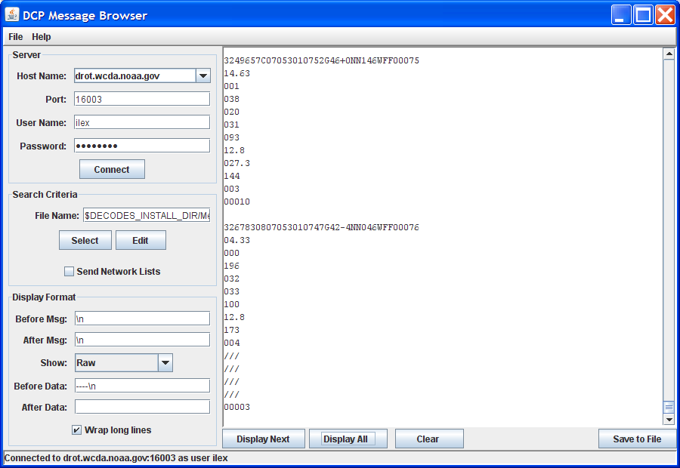
Figure 8-26: Message Browser Screen.

In the upper left quadrant you specify connection information:
- Host Name is either a fully-qualified domain name, an alias, or an IP address specifying the LRGS host you want to connect to.
- Port is a numeric TCP port number. The LRGS DCP data server uses port 16003 by default.
- User Name specifies your ID for connecting to the host.
- The Password field is for authenticated connections to a DDS server. Leave the password field blank for a standard (unauthenticated) connection.
The middle-left section of the screen is where you specify search criteria. You can specify the name of a search criteria file. This file will be downloaded when you first try to display a message.
The "Select" button brings up a file-selection dialog for you to navigate to, and select a file. Once selected, you can press the "Edit" button to bring up the Search Criteria Editor screen, as shown in Figure 8-27.
The check-box labeled "Send Network Lists" allows you to specify how network lists are handled. Recall that a search criteria file can specify network lists to be used. These lists might already reside on the LRGS in your user directory, or in one of the LRGS directories. If this is the case, leave this box un-checked.
Conversely, you may be using a new network list that only resides on your client machine. If this is the case, check the box. The network lists will be downloaded to the LRGS before the search criteria file is transferred.
When the server encounters a network list name in a search criteria file, it looks in directories in the following order:
- The user's sandbox directory – user-specific lists that you upload through the browser.
- $LRGSHOME/netlist – system-wide lists maintained on the server.
The lower-left area controls the Display Format for each DCP message. The 'Prefix' string is printed before the message. The 'Suffix' string is printed after the message. When the 'Wrap Long Lines' check box is checked, the horizontal scroll-bar will disappear. Long lines will be wrapped. When un-checked, lines of data will not be wrapped. Rather, a horizontal scroll bar will appear allowing you to view the entire message.
The 'Before Data' string is printed after the message but before the decoded data. The 'After Data' string is printed after the decoded data.
The ‘Show’ combo box lets you determine what information gets shown on the screen (or saved to the file). The choices are: Raw DCP Message Only, Raw and Decoded Message, and Decoded Data Only.
In order to successfully decode a message, you must have DECODES installed on your system. If decoding is successful, you will see the decoded data. If not, you will see an error message explaining the problem.
Please see the DECODES User Guide for more information on setting up a database of platform meta-data to facilitate decoding your DCP data.

The Search Criteria Editor Screen
The search criteria editor screen is shown in Figure 8-27. There are several valid formats for entering timer ranges, as explained in section 8.3. A commonly used technique is to specify times relative to “now”, as shown in the figure.
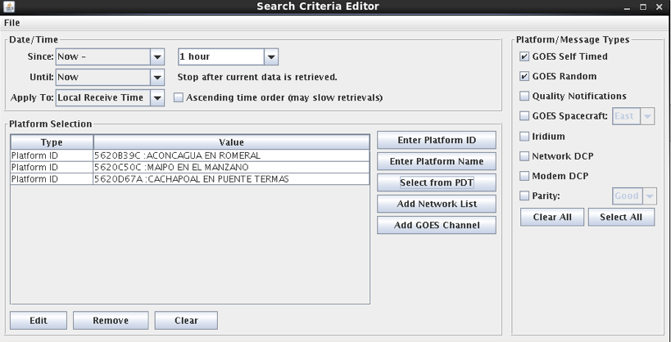
Figure 8-27: Search Criteria Editor.

The Message Output Screen
If you press “Save To File” from the Message Browser screen, The Message Output Screen is displayed, as depicted in Figure 8-28.
In this window you specify an output file to receive the data specified by your search criteria. The radio buttons along the left allow you to specify what to do if the file already exists.
Press 'Run' to start saving data to the file. The DCP address, time-stamp, and message count will be displayed in the screen along the right.
You can pause output by pressing the 'Pause' button. Press 'Run' to continue.
If you want the window to automatically close when the specified 'UNTIL' time is reached, check the box labeled 'Close When Done'.
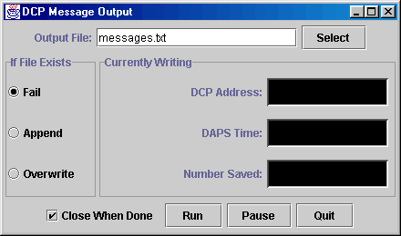
Figure 8-28: The Message Output Screen.

Search Criteria File Format
A search criteria file is a text file containing a series of keyword-value pairs, one per line. By convention, search criteria files should have a “.sc” extension. Each keyword signifies a particular criterion that DCP messages must pass in order to be returned.
Each line begins with a keyword, followed by a colon, followed by a string value. Here are the available keywords:
DRS_SINCE Only retrieve messages that were received after the specified time. See allowable time formats below.
LRGS_SINCE Synonym for DRS_SINCE.
DRS_UNTIL Only retrieve messages that were received before the specified time. See allowable time formats below.
LRGS_UNTIL Synonym for DRS_UNTIL.
DAPS_SINCE Only retrieve messages with a DAPS time-stamp after the specified time. See allowable time formats below.
DAPS_UNTIL Only retrieve messages with a DAPS time-stamp before the specified time. See allowable time formats below.
NETWORK_LIST The value following this keyword is a network list file. Only retrieve messages whose DCP address is contained in the list. For multiple lists, put multiple lines in the search criteria file, each beginning with the NETWORK_LIST keyword.
DCP_ADDRESS Only retrieve messages with the specified DCP address. To specify multiple addresses, put multiple lines in the search criteria file, each beginning with the DCP_ADDRESS keyword.
DCP_NAME Only retrieve messages with the specified DCP name. Names are mapped to DCP addresses in network list files.
CHANNEL Only retrieve messages that were transmitted on the specified GOES channel. The value is a number only. The GOES spacecraft identifier (‘E’ or ‘W’) is not necessary.
SOURCE Specifies that the client only wants to retrieve data that was received from the named source. Possible arguments are DOMSAT, NETBACK, DRGS, NOAAPORT, LRIT, or OTHER. For multiple sources, put multiple lines starting with ‘SOURCE:’, each with a single argument.

Allowable Time Formats for a Search Criteria File
The SINCE and UNTIL values can take one several time formats.
Relative formats start with the keyword “now” and then add or subtract increments. For example:
now – 20 minutes
now – 1 day
now – 1 week 3 days 20 minutes 10 seconds
now

You can specify an absolute GMT value in one of the following formats.
YYYY/DDD HH:MM:SS complete specification
YYYY/DDD HH:MM seconds assumed to be 00
DDD HH:MM:SS assume current year
DDD HH:MM seconds assumed to be 00
HH:MM:SS assume current day
HH:MM seconds assumed to be 00
You can specify that output should start with the last message you retrieved from a previous session. This is a special value that can only appear in the LRGS_SINCE field. Simply type the word:
last

The “last” keyword provides an easy way to connect periodically and processes all messages that have arrived since your last session. Simply connect periodically and use the time range:
LRGS_SINCE: last
LRGS_UNTIL: now

The server tracks the last message received by each user. So if you plan to use “last”, make sure that no one else is using your DDS account.

Network Lists Referenced in a Search Criteria File
See section 7.3.1 for an explanation of the format of a network list file.
On an LRGS, Network List Files can be in two places:
- A DDS User’s sandbox directory: Lists here are only accessible to this DDS user.
- In the “$LRGSHOME/netlist” directory: Lists here are accessible to all DDS users.
When the LRGS receives a search-criteria file from a DDS client that contains a NETWORK_LIST reference, it will look for a matching file name in these two locations, in the order listed above. Hence if the same list exists in both places, the specific DDS User’s version will be used.
Be convention, your network list files should end with the “.nl” extension. As of version 5.9, you do not need to put the “.nl” in the search-criteria reference. The LRGS will find the file whether or not it follows the convention.

Synchronize a Group of Cooperating LRGS Systems
Version 6 of the LRGS contains scripts to facilitate a group of cooperating LRGS systems. You would like to synchronize the following files among group members:
- DDS User Information: names, permissions, passwords, and sand-box directories.
- Network Lists
We will set up a configuration file defining the members of the group. The file also designates one system as the ‘master’ of the group. Periodically, the master will run a script that pushes its user information and network lists out to each group member. We will use secure Unix utilities to accomplish the file transfers: namely RSYNC, SSH, and SCP.

Set up the LRGS-Synchronization Configuration File
A sample configuration file is depicted in
lrgs hqlrgs9.er.usgs.gov /home/lrgs
satin hqnwisdev8.er.usgs.gov /usr/opt/LRGS
lrgs sfdrgs1.wr.usgs.gov /usr/opt/LRGS MASTER
lrgs sfdrgs2.wr.usgs.gov /usr/opt/LRGS
admin 155.98.222.105 /u01/home/users/lrgs
Figure 9-29: Sample LRGS-Syncronization Configuration File.
For each LRGS in the group you must specify three parameters:
- The Unix user name that owns the LRGS installation.
- The host name or IP address
- Where LRGS is installed on that system. That is, the $LRGSHOME directory.
Also, one line will have an additional argument, the word ‘MASTER’. This designates that system as the group master. In the example above, the master is the LRGS owned by ‘lrgs’ running on the host ‘sfdrgs1.wr.usgs.gov’.

Set up SSH, SCP, and RSYNC
SSH, SCP, and RSYNC are widely available for Linux and Solaris. You must have these utilities installed on every machine that is to participate in the group.
As we stated above, the ‘master’ of the group will be doing all the work by overwriting or deleting files on the subordinates. Therefore each system must be set up to grant SSH access to the master using a public/private RSA key pair. This section will describe how to accomplish this.
First, you must generate a key-pair on the master. Login as the LRGS-owner (‘lrgs’ in our example). Then type:
ssh-keygen –t rsa

You are prompted for a location in which to store the keys. Hit ENTER to accept the default. You are then prompted for a pass-phrase. It is important to just hit ENTER here. We do not want a pass-phrase because we will run the synchronization script in the background. It must be able to use the keys without a human to type the pass-phrase.
The default location for the keys is in the “.ssh” directory under your HOME directory. This directory will be created so that only you have access to it. CD to this directory and you will find two new files:
- id_rsa: This is your PRIVATE key. It should never leave this machine. Its permissions should always be -rw-------, or 600, meaning that only the owner can access it in any way.
- id_rsa.pub: This is your PUBLIC key. You need to send a copy of this file to all of the subordinate machines.
Now, you can send the keys to the LRGS owner accounts on each of the subordinate machines. In our examples, we would send it to the first machine as follows:
scp ~/.ssh/id_rsa.pub lrgs@hqlrgs9.er.usgs.gov:/tmp/master-key

You will need to enter the password for ‘lrgs’ on that machine.
Finally, login to that machine as the designated user, and add this key to the end of the file that designates authorization. Again in our example, we just sent the file as user ‘lrgs’ to the machine ‘hqlrgs9.er.usgs.gov’:
ssh lrgs@hqlrgs9.er.usgs.gov (enter password)
mkdir .ssh (Only if it doesn’t already exist)
chmod 700 .ssh (Restrict access to this directory)
cd .ssh
cat /tmp/master-key >>authorized_keys2
chmod 600 authorized_keys2
exit

The final ‘exit’ command terminates the remote session. Now test by once again typing the ssh command:
ssh lrgs@hqlrgs9.er.usgs.gov

If everything is right, you will be granted access to the system without a password.
Do this for every computer in the group. If you are setting it up so that more than one system can act as a master (at different times of course), then each subordinate system must have every potential master’s key installed in this manner.

Test the Synchronization Script
At this point we assume that you have a configuration file on the master and you have set up all the subordinates to grant access by the master.
We recommend that you call the configuration file “lrgs-sync.conf” and store it in the $LRGSHOME directory on the master.
Test the script by typing:
lrgs-sync.sh config-file-name

This will push all user information and network lists on the master out to the subordinates. This will overwrite user and network list information on the subordinates.
If everything works, you can now place this command in your crontab to have it run on a schedule.
If it fails and asks you for a password check the following:
- The permissions on your home directory should be 755 or 750.
- The permissions on the .ssh directory must be 700.
- The permissions on the authorized_keys2 file must be 700.

Changing Masters
The script will do nothing unless it is running on the system designated as the MASTER. That is: The output of the ‘hostname’ command must match the hostname of the system designated as the MASTER in the configuration file.
This approach makes it easy to change masters: you need to modify the configuration file and designate a new master. You need to distribute this file to the new and the old master.

Ingesting EDL Files into LRGS Archive
OpenDCS Version 6.1 LRGS has the capability to scan a directory for incoming EDL (Electronic Data Logger) files. When a file is found, its header is parsed (see required header format below) and the message is stored in the LRGS archive.
The benefit is that EDL data may now be shared, distributed, and processed in the same way as GOES or Iridium data.
To configure your LRGS for EDL file ingest, connect to your LRGS using the Real Time Status (rtstat) display. Connect as an administrator with a password. Then click File – LRGS Configuration. Click on the EDL Files Tab:
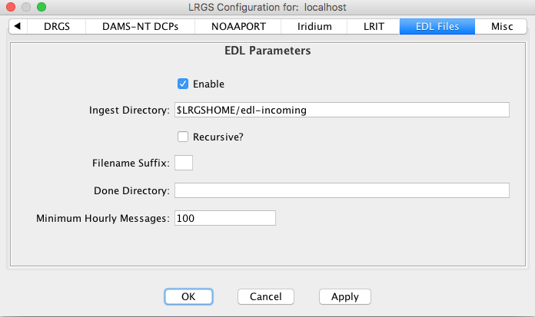
The configuration items are:
- Enable: This must be checked to enable the module. After enabling, you will have to restart the LRGS daemon in order for the module to be loaded
- Ingest Directory: LRGS will ingest EDL files from this directory.
- Recursive: If checked, then the Ingest Directory and all subdirectories are searched. If unchecked, then only the named directory is searched.
- Filename Suffix: If specified, only files with the specified suffix are ingested. You can use this to prevent LRGS from ingesting files as they are being built. For example, Build the file with a “.tmp” extension and then rename it with a “.dat” extension after it is complete.
- Done Directory: If specified, files are moved here after ingest. If not specified, files are deleted after ingest.
- Minimum Hourly Messages: A WARNING is generated in the log if, after 3 hours of operation, the number of hourly messages falls below this expected amount.
EDL Header Format
EDL Files should have a formatted header containing a number of variables. Each header line begins with two forward-slash characters. The header ends with the first line that does not start with two slashes. The following is a typical header:

//STATION RBOWBANF
//SOURCE fts
//DEVICE END TIME 160517 150751 +0000
//POLL START 160517 150751 +0000
//POLL STOP 160517 150804 +0000
Accepted variables include:
- STATION – This should be followed by a unique station identifier. When decoding, this identifier is used to link to a DECODES platform.
- SOURCE – This is used to select station types for the purposes of a polling protocol. It is not necessary for decoding.
- DEVICE END TIME – This should be followed by a date time in the format YYMMDD HHMMSS, and then optionally followed by a time zone offset. This is taken as the message time for purposes of message retrievals. It can also be used by DECODES for automatic time tagging, as is typically done for GOES messages. (Note: more typically, EDL files contain date/time stamps for each value parsed).
- POLL START – followed by a date/time in the same format as described for DEVICE END TIME. For polled DCPs this provides annotation as to when the polling session began.
- POLL STOP – followed by a date/time in the same format as described for DEVICE END TIME. For polled DCPs this specifies when the polling session ended. It is also used to message time stamp.
Retrieving EDL Data
Within the search criteria screens in the message browser and DECODES, you can select EDL data in multiple ways. To retrieve all EDL data, you can check the Network/Modem DCP check box at the right of the screen:
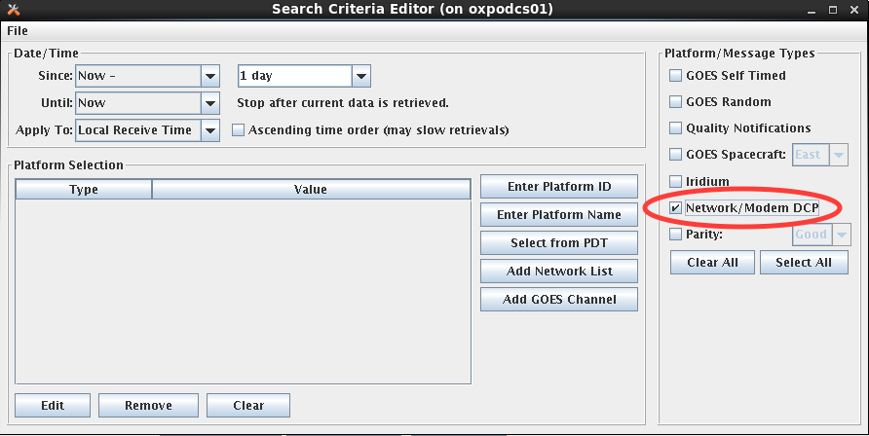

Alternately, to retrieve data from a specific station, click Enter Platform ID and enter a string matching the STATION identifier in the header.
Finally, you could create a network list of EDL station identifiers and then retrieve by network list.
See the Platform Decoding Guide for assistance with decoding EDL messages.

- Glossary
API Application Program Interface
DAPS DCS Automated Processing System – This is a large computer system operated by NESDIS in Wallops, VA. A primary function is to receive data from all platforms and rebroadcast via DOMSAT and an NMC X.25 link. NESDIS has plans to renovate DAPS in the near future.
DCS Data Collection System – This is the name for the large organization of user agencies, NOAA/NESDIS, and vendors that operate and have a vested interest in environmental monitoring via GOES.
DECODES DEvice COnversion and DElivery System – This is a legacy software package developed by USGS/WRD.
DOMSAT Domestic Satellite – This is used as a high-speed broadcast of data from all platforms in the DCS.
DROT DOMSAT Receive Only Terminal – Public domain prototype system developed for NOAA/NESDIS.
DRS DOMSAT Receive Station – This is a proprietary system for receiving DOMSAT data. Also see LRGS
EMIT Environmental Message Interpreter Translator – A proprietary software package in wide use within USACE.
GFE Government Furnished Equipment
GOES Geostationary Operational Environmental Satellite – In addition to the primary imaging function, the GOES spacecraft also support a multi-channel data relay which is used by the DCS to facilitate remote environmental monitoring.
GUI Graphical User Interface
HTML Hypertext Markup Language – the language of web pages
HTTP Hypertext Transfer Protocol – The protocol used between browsers and web servers.
JDK Java Development Kit – A suite of tools provided by Sun Microsystems for Java development.
JRE Java Runtime Environment – A free download from Sun Microsystems enabling you to run Java programs.
LRGS Local Readout Ground Station – This is a freely available, open-source system for receiving environmental data via DOMSAT.
NESDIS National Environmental Satellite Data Information Service – This is the division of NOAA that operates the GOES spacecraft and its relay functions.
NMC National Meteorological Center
NOAA National Oceanic Atmospheric Administration – An agency under the U.S. Department of Commerce
NOAAPORT A satellite rebroadcast of several NOAA data products including imagery, bulletins, and DCP message data. Currently this service is leased on the AMC-4 satellite and uses a C-band transponder.
NWS National Weather Service
SATIN Satellite Input – A USGS application for ingesting DCP data into a database.
SSL Secure Socket Layer – A method of encryption and authentication employed by secure web services.
STIWG Satellite Telemetry Interagency Working Group
TWG Technical Working Group – A small group of people overseeing this development effort.
UML Unified Modeling Language – defines modeling tools that will be used as an aid in extracting requirements and system design.
USACE U. S. Army Corps of Engineers
USGS/WRD U. S. Geological Survey, Water Resources Division
XML Extensible Markup Language – More flexible than HTML, XML can be used to describe any kind of data.

