KMM Pongsak

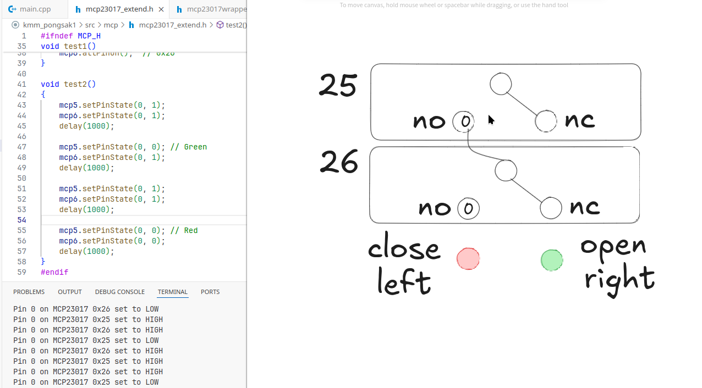

pump1 0x26 PB2 Active Low
pump2 0x26 PB3 Active Low

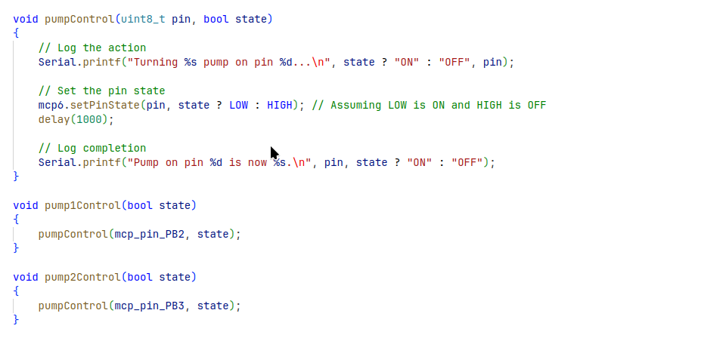

Function Test
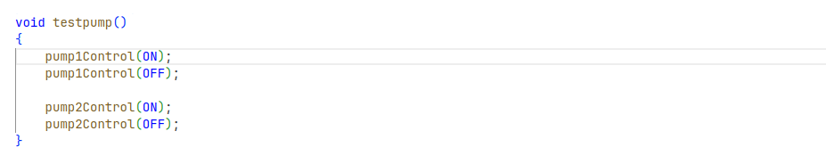

Sensor Weather



