This is an Austrian project, sponsored by an Australian wine company called De Bortoli Wines. Thank you!
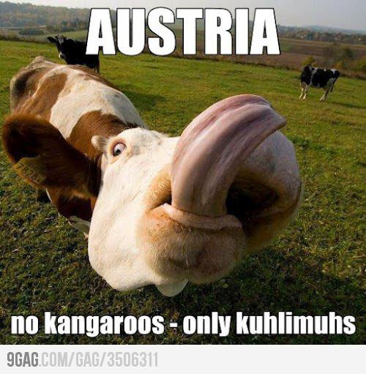
More information reader.tomtasche.at.

Important
This document shows you a little demo of what OpenDocument Reader is able to do. Additionally, you're going to find out what we're working on and when you will be able to edit your documents (hint: never ever).

You can use one of the following apps to open documents:
- Dropbox
- Gmail
- File Expert
- ASTRO File Manager
- Android Browser
- EStrongs File Explorer
- Box.net
- many more we don't know about...


Features
- zoom
- copy text
- formatting
- open password-protected documents
- fast as hell
- image support
- spreadsheet support
- ads! More on that later...

Support for presentations is on the way but editting documents won't happen anytime soon. Sorry.

But... OpenDocument Reader is open source. Open sauce? No, open source! That means everybody's able modify it, improve it and help us make it even better. If you think you can do that drop us a mail.

Ads
If you don't want to see ads in this app you have plenty of options: remove them by purchasing a little love package (available in the menu) or just bear with them. Please keep in mind that you help us keep this project alive by purchasing our stuff / bearing with ads. Thank you! <3

By the way, you can support us via PayPal too. Or just download our donation app from the Google Play Store. Other, cheaper ways of supporting us include rating this app on the Google Play Store and telling your friends about this app.

We would love to hear your feedback! Mail us!

Thanks for your attention!
Have a very nice, open-sourcy day. :)

In love,
Your developers,
Andi, who's responsible for the tough part (e.g. „understanding“ your documents), and Tom, who's responsible for everything else.

