APPENDIX D
MEDICAL PLAN
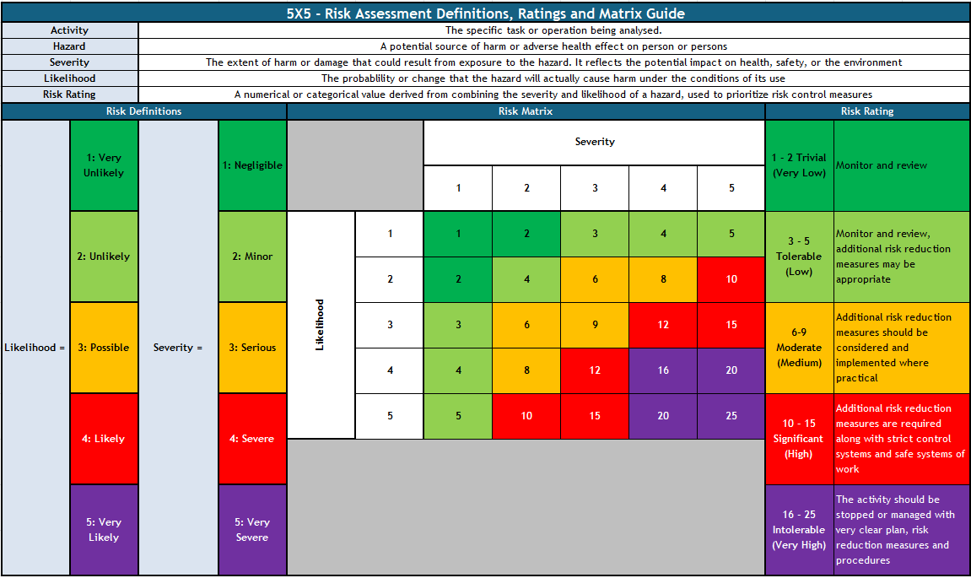

<Content Select="./C1[1]" Optional="true"/>

<Content Select="./C2[1]" Optional="true"/>
<Content Select="./C3[1]" Optional="true"/>
<Conditional Select="C4b[1]" Match="true"/>
<Content Select="./C5[1]" Optional="true"/>
<EndConditional/>
<Conditional Select="C4b[1]" NotMatch="true"/>
<Content Select="./C7[1]" Optional="true"/> - <Content Select="./C8[1]" Optional="true"/>
<EndConditional/>

