**Drought Hackathon - Indices**

Meteorology – Precipitation and Evaporation 2

SPI - Standardized Precipitation Index 2

SPEI - Standardised Precipitation-Evapotranspiration 4

Runoff 5

SRI – Standardized Runoff Index 5

Discharge anomaly 7

Vegetation 8

VCI – Vegetation Condition Index 8

NDVI – Normalized Difference Vegetation Index Description of index 8

EVI – Enhanced Vegetation Index 9

Agriculture 10

Agriculture Stress Index (ASI) 10

Soil Moisture 11

SMAI - Soil Moisture Anomaly Index 11

SMADI – Soil Moisture Agricultural Drought Index (incomplete) 11

Groundwater 12

Groundwater Table Declining Trend 12

# Meteorology – Precipitation and Evaporation

## SPI - Standardized Precipitation Index

### Description of index

* SPI quantifies observed precipitation as a standardized departure from a selected probability distribution function (usually Gamma distribution) that models the raw precipitation data[1]

SPI values can be interpreted as the number of standard deviations by which the observed anomaly deviates from the long-term mean. Typically, periods of 1,3 or 6 months are used and respectively noted as SPI 1,3, or 6.

The further the values differentiate from 0, the lower is the probability of the precipitation. Low SPI values indicate low precipitation and hence a higher chance for drought.

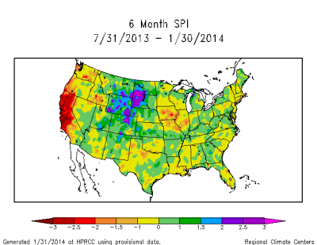

### Available info / user guides

https://climatedataguide.ucar.edu/climate-data/standardized-precipitation-index-spi

https://library.wmo.int/doc_num.php?explnum_id=7768

https://edo.jrc.ec.europa.eu/documents/factsheets/factsheet_spi.pdf

https://drought.unl.edu/droughtmonitoring/SPI/MapInterpretation.aspx

### Examples / literature

Visualization (interactive):

<https://noaa.maps.arcgis.com/apps/Cascade/index.html?appid=aec0b8fc5b504a449f99ba162af904fd>

http://citeseerx.ist.psu.edu/viewdoc/download;jsessionid=E783ADEE2F1EB3E4495ABA2ACD69CCCA?doi=10.1.1.462.4342&rep=rep1&type=pdf

### Data required

precipitation, preferably sub-monthly scale

precipitation data:

e.g. CHIRPS or ERA5 (see data overview)

Implementation (scripts or dataset)

P:\droughthack\DataSets\SPI_ERA5_2004_2020

P:\droughthack\DroughtIndicatorScripts\calculate_spi.py (based on monthly grids of P, ncdf)

(R) <https://cran.r-project.org/web/packages/SCI/SCI.pdf>

## SPEI - Standardised Precipitation-Evapotranspiration

### Description of index

Considers difference between precipitation and potential evaporation (monthly):

Di = Pi - PETi

afterwards normalization similar to SPI

### Available info / user guides:

<https://spei.csic.es/home.html>

### Examples / literature

Previous studies:

https://rmets.onlinelibrary.wiley.com/doi/full/10.1002/joc.3887

for probability distribution:

https://rmets.onlinelibrary.wiley.com/doi/full/10.1002/joc.4267

### Data required

precipitation & potential evapotranspiration

precipitation data:

e.g. CHIRPS or ERA5 (see data overview)

potential evapotranspiration:  
GLDAS, ERA5

### Scripts or index datasets

<https://cran.r-project.org/web/packages/SPEI/SPEI.pdf>

<https://cran.r-project.org/web/packages/ClimInd/ClimInd.pdf>

<https://cran.r-project.org/web/packages/SCI/SCI.pdf>

# Runoff

## SRI – Standardized Runoff Index

### Description of index

The SRI quantifies the deviation of runoff over a certain time (e.g. 1 or 3 months) from mean runoff, based on a probability distribution of occurring discharges (usually historic records). The probability function to use depends on the region or respective historic records.

“The procedure for calculating the SRI includes the following steps:

(1) A retrospective time series of runoff is obtained by simulation, and a probability distribution is fit to the sample represented by the time series values.

(2) The distribution is used to estimate the cumulative probability of the runoff value of interest (either the current accumulation or one from a retrospective date).

(3) The cumulative probability is converted to a standard normal deviate (with zero mean and unit variance), which can either be calculated from a numerical approximation to the normal cumulative distribution function (CDF)”

### Examples / literature

https://agupubs.onlinelibrary.wiley.com/doi/10.1029/2007GL032487

<https://www.cpc.ncep.noaa.gov/products/Drought/Monitoring/sri3.shtml> (viewer)

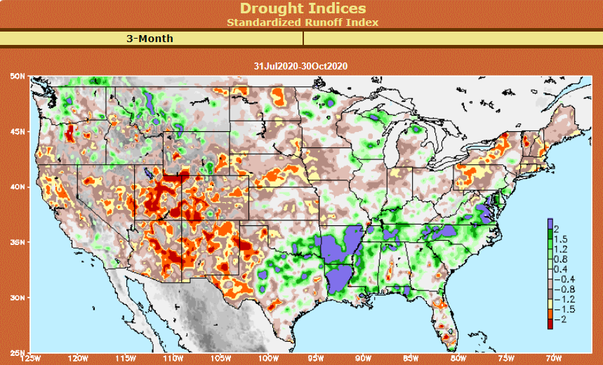

### Data required

monthly streamflow

Recorded streamflow (point-data):

GRDC: <https://www.bafg.de/GRDC/EN/Home/homepage_node.html>

Modelled streamflow (raster):

PCRGLOBWB with input from ERA5, CRUCIAL:

p:\droughthack\DataSets\Discharge_ERA5_PCRGLOBWB_CRUCIAL (netcdf)

P:\droughthack\DataSets\TIFF_converted\Discharge_ERA5_PCRGLOBWB_CRUCIAL (GeoTIFF)

Simulations for Mali:

P:\droughthack\DataSets\Mali_simulated discharge

### Scripts or index datasets

(R) <https://cran.r-project.org/web/packages/SCI/SCI.pdf>

*adaptable from SPI scripts*

## Discharge anomaly

### Description of index

The discharge anomaly is calculated on a monthly time-scale and indicates whether the discharge for the given calendar month is below (negative) or above (positive) the long-term average for the given month. This is quantified as the percentage difference from the long-term mean monthly climatology.

### Literature / examples

p:\droughthack\CRUCIAL reports - global drought forecast and secnarios\C3S422Lot1.WEnR.DS4d_ AlgorithmTheoreticalBasis_ERA5_AHW_v1.2.docx

p:\droughthack\CRUCIAL reports - global drought forecast and secnarios\technical memo Global_seasonal_drought_risk_forecast_2020 Deltares.docx

### Data required

monthly streamflow

Recorded streamflow (point-data):

GRDC: <https://www.bafg.de/GRDC/EN/Home/homepage_node.html>

Modelled streamflow (raster):

PCRGLOBWB with input from ERA5, CRUCIAL:

p:\droughthack\DataSets\Discharge_ERA5_PCRGLOBWB_CRUCIAL (netcdf)

P:\droughthack\DataSets\TIFF_converted\Discharge_ERA5_PCRGLOBWB_CRUCIAL (GeoTIFF)

Simulations for Mali:

P:\droughthack\DataSets\Mali_simulated discharge

### Scripts or index dataset available

The discharge anomaly is calculated from the discharges simulated with PCR-GLOBWB. First the daily time-series are aggregated to a monthly time-step. Than the long-term average monthly means are calculated, i.e. the monthly climatology. Finally, the deviation of the monthly time-series from the long-term mean is assessed and expressed as percentage deviation.

The calculation of agro-hydrological indicators is based on the ERA5Land dataset. The ERA5Land data was downloaded at the same resolution as the PCRGLOBWB model resolution (5min = 0.0833). Therefore, the ERA5Land data is interpolated to the model grid using closest distance interpolation.

P:\droughthack\DroughtIndicatorScripts\SMDI_ETDI_Qanomaly.py

# Vegetation

## VCI – Vegetation Condition Index

The vegetation conditions index is a spatially normalized version of the NDVI index and describes the “health” of vegetation (see NDVI below).

### Description of index

formula

normalized NDVI on pixel-by-pixel basis

The normalization serves to emphasize relative changes in the local NDVI signal through time while reducing the influence of spatial variability in NDVI phenology between different land cover types and climatic conditions.

### Literature / examples

**<https://hess.copernicus.org/articles/19/4581/2015/hess-19-4581-2015.pdf>**

## NDVI – Normalized Difference Vegetation Index Description of index

“based on the difference between the maximum absorption of radiation in *R* as a result of chlorophyll pigments and the maximum reflectance in NIR spectral region as a result of leaf cellular structure)”

https://core.ac.uk/download/pdf/42872724.pdf

formula where *ρ* is reflectance in the respective spectral bands

High values indicate healthy vegetation (max value: 1), but depend on vegetation type

### Examples /literature

Use of NDVI for Drought Assessment: https://journals.ametsoc.org/jcli/article/23/3/618/32790

Data required:

Reflection in NIR and RED wave lengths

### Scripts or index datasets

https://developers.google.com/earth-engine/datasets/catalog/MODIS_006_MOD13A2

<https://developers.google.com/earth-engine/datasets/catalog/NOAA_VIIRS_001_VNP13A1>

## EVI – Enhanced Vegetation Index

### Description of index

The enhanced vegetation index is an approved version of the NDVI and corrects for some atmospheric conditions and canopy background noise and is more sensitive in areas with dense vegetation.

It seems to be used less than NDVI but should be more powerful.

### Literature / examples

https://www.usgs.gov/core-science-systems/nli/landsat/landsat-enhanced-vegetation-index

### Data required

**usually available as complete product (see data overview)**

### Scripts or index dataset

https://developers.google.com/earth-engine/datasets/catalog/MODIS_006_MOD13A2

https://developers.google.com/earth-engine/datasets/catalog/NOAA_VIIRS_001_VNP13A1

# Agriculture

## Agriculture Stress Index (ASI) (incomplete)

### Indicator description

Agriculture Stress Index (ASI) is an FAO indicator that highlights anomalous vegetation growth and potential drought in arable land during a given cropping season

### Literature / examples

<http://www.fao.org/giews/earthobservation/asis/index_1.jsp?lang=en>

<http://www.fao.org/3/a-i4251e.pdf>

Data required  
Access to available product over WMS

https://io.apps.fao.org/geoserver/wms/ASIS/ASI_D/v1

# Soil Moisture

## SMAI - Soil Moisture Anomaly Index

### Description index

Can use weekly or monthly precipitation and potential evapotranspiration values in a simple water balance equation. It is intended to reflect the degree of dryness or saturation of the soil compared with normal conditions and to show how soil moisture stress influences crop production around the world.

### Literature / examples

<https://www.droughtmanagement.info/soil-moisture-anomaly-sma/>

p:\droughthack\CRUCIAL reports - global drought forecast and secnarios\C3S422Lot1.WEnR.DS4d_ AlgorithmTheoreticalBasis_ERA5_AHW_v1.2.docx

p:\droughthack\CRUCIAL reports - global drought forecast and secnarios\technical memo Global_seasonal_drought_risk_forecast_2020 Deltares.docx

### Data required

Volumetric soil moisture content



Scripts or datasets available

P:\droughthack\DroughtIndicatorScripts\SMDI_ETDI_Qanomaly.py

## SMADI – Soil Moisture Agricultural Drought Index (incomplete)

https://www.mdpi.com/2072-4292/8/4/287

# Groundwater

## Groundwater Table Declining Trend

### Description of indicator

This indicator represents the linear change of the groundwater head in a period of 10 years in m/year per aquifer. It is calculated by fitting a first order regression line to the monthly groundwater heads simulated by the MODFLOW GGM within a period of 10 years. The indicator has been calculated for several windows of 10 years: 1995-2004, 2015-2024, 2025-2034, 2035-2044, and 2045-2054. The groundwater table results corresponding to cells located in sedimentary basins are averaged per aquifer as defined in the WHYMAP map <http://www.whymap.org/whymap/EN/Home/whymap_node.html>).

Averaging the GTDT per aquifer results in masking some of the most extreme values which are often found in cities where the abstraction of groundwater takes place in concentrated areas and high discharges. However, providing 5arc min resolution results would not be appropriate as the used model is global and does not represent the heads correctly everywhere.

### Example / literature

* More information: p:\droughthack\CRUCIAL reports - global drought forecast and secnarios\C3S422Lot1.WEnR.DS4c_AlgorithmTheoreticalBasis_future_climate_change_v1.3.docx
* WRI Aqueduct

https://www.wri.org/applications/aqueduct/water-risk-atlas/#/?advanced=false&basemap=hydro&indicator=gtd_cat&lat=30&lng=-80&mapMode=view&month=1&opacity=0.5&ponderation=DEF&predefined=false&projection=absolute&scenario=optimistic&scope=baseline&timeScale=annual&year=baseline&zoom=3

### Data required

Timeseries of groundwater heads.

Scripts or datasets available:

Datasets from CRUCIAL project (NetCDF files)

p:\droughthack\DataSets\GTDT_CRUCIAL\

monthly groundwater recharge also as GeoTIFF

p:\droughthack\DataSets\TIFF_converted\GTDT_CRUCIAL_monthly

1. https://climatedataguide.ucar.edu/climate-data/standardized-precipitation-index-spi