**NTW2CONFIL**

Author: Daniel Tollenaar

Email: [daniel.tollenaar@deltares.nl](mailto:daniel.tollenaar@deltares.nl)

Version: 12 August 2014

Assumed Sobek version: 2.13.002

Assumed RIBASIM version: 7.01.10

Assumed python version: any standard-version will do (only relies on string-library)

***General description:***

This script converts a network.ntw file used in Sobek to a confil.ntw file used in RIBASIM. Current version translates rivers, inflows, terminals, reservoirs, diversions and runoff-rivers. A conversion can be made in two steps:

1. Re-import your Sobek-network using custom-node types (in ntrpluv.obj)
2. Convert your network.ntw file to a confil.ntw file using ntw2confil.py and open it in Ribasim

***Procedure***

1. Open the existing SOBEK-schematisation you would like to convert in Netter (Edit Model). See Figure 1 (Yeşilirmak) as an example.
2. Go to File -> Export -> GIS-file -> Reaches to export your reach layer.
3. Close Netter and save as a new case (e.g. “ForRibasim”)
4. Select 1DWAD in settings
5. Double-click on schematization evoking the schematization popup menu
6. Copy NTRPLUV.OBJ to the work-folder of your sobek-model and open Netter (Edit Model)
7. Delete your entire network
8. Import the reach layer you exported at 2 by choosing File -> Import. Choose the settings in Figure 2 for the popup window.
9. Click on the Advanced… button, select the Node types tab and choose (see Figure 3)

* Boundary in 67 Inflow
* Boundary out 66 Terminal
* Confluence 68 Confluence
* Diversion 69 Diversion
* Calculation point 16 Flow – Calculation Point

1. Copy the network.ntw file to the same folder as ntw2confil.py and run the python-script. It should create a confil.ntw file
2. Open Ribasim, add a basin, make a new case, select scenario’s, specify simulation control data and double-click on edit network, evoking the edit data popup menu
3. Copy the generated confil.ntw file to the work-directory of your Ribasim basin, overwriting the old one
4. Open Netter (Edit network and object data) from the edit data popup menu in Ribasim. Your converted model should appear similar to Figure 4

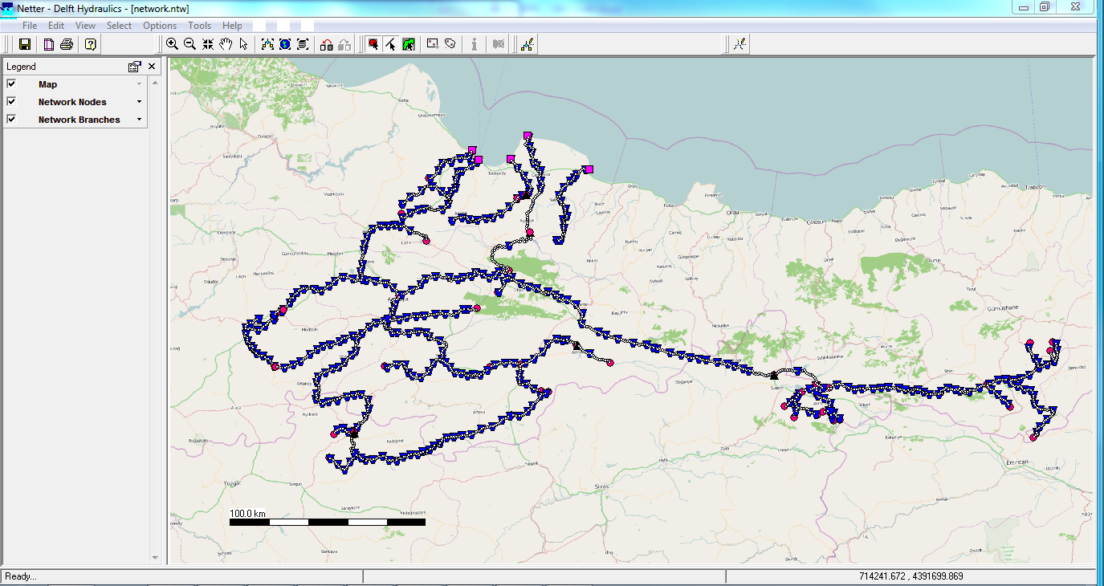

Figure 1 – Existing Sobek-schematisation

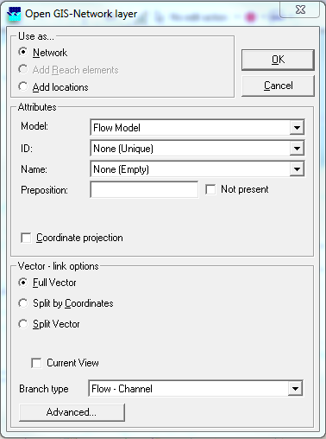

Figure 2 – Open GIS-Network layer window

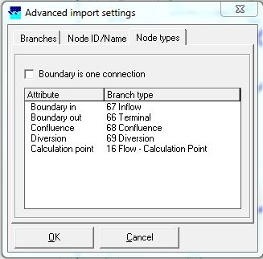

Figure 3 – Node types tab

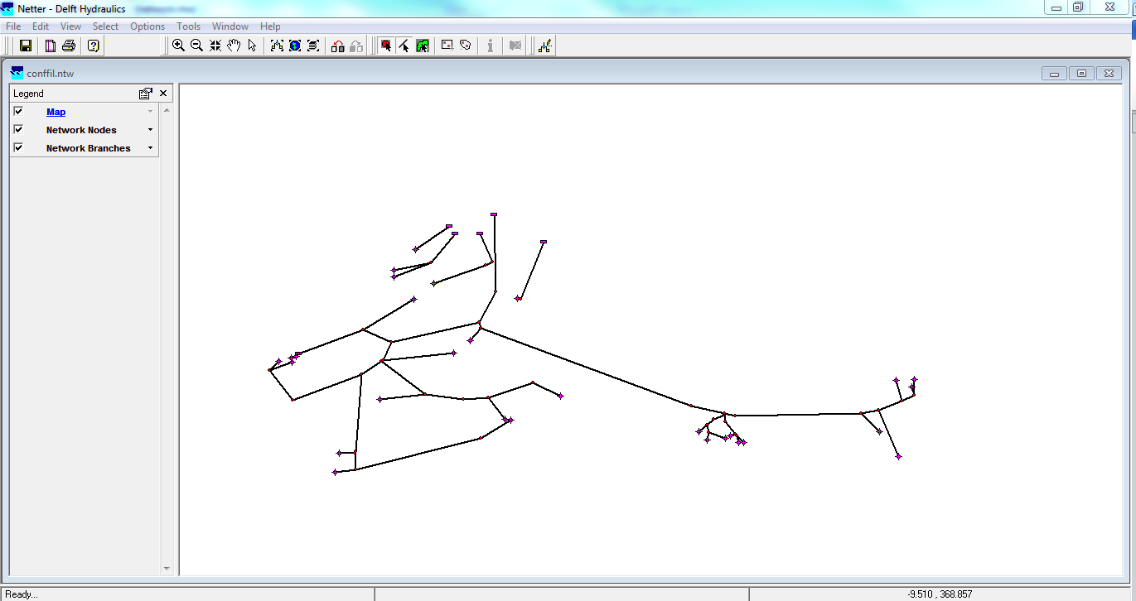

Figure 4 – Ribasim schematisation from Sobek model