# Installation manual

This installation manual provides the required steps to install the eeFEX (Earth Engine Feature EXtraction) Python toolbox on a Windows 64 bit machine.

1. Install the [Python(x,y)](http://python-xy.github.io/downloads.html) Python 2.7 64 bit distribution. Use the default settings during installation.
2. Open the windows command line (search for cmd) and install the following Python packages using the command lines:

*pip install simplekml*

*pip install pyproj*

hit enter after each line to execute that line.

1. Clone the eeFEX package from the [OpenEarth repository](https://svn.oss.deltares.nl/repos/openearthtools/trunk/python/applications/eeFex) to a folder on your local machine (referred to as localfolder).
2. Become a Google Earth Engine developer by linking your Google account to Earth Engine: <https://signup.earthengine.google.com/#/>
3. Install the Python Google Earth Engine packages via the command line using:

*pip install google-api-python-client*

*pip install earthengine-api*

1. Authorize Python to use your Google Earth Engine developer account. This can only be done after Google confirmed your Earth Engine account with a subscription email. Run the following lines in command line to authorize Python:

*python -c "from oauth2client import crypt"*

*python -c "import ee; ee.Initialize()"*

follow the onscreen instructions (for convenience they are listed below):

*earthengine authenticate*

login using your authorized Google account in the browser

paste the authorization token back to the command line.

1. To launch the eeFEX toolbox double click on the file *main.py* or start the toolbox via command line:

*python localfolder/main.py*

where localfolder refers to the folder used for cloning the eeFex repository.

# User manual

This manual explains the basic steps to manually extract features from satellite imagery using the eeFEX toolbox. Two basic steps are: 1) Image download, 2) Feature extraction.

## Image download

The first step is to download a selection of satellite images from the Earth Engine server to a local project folder. These images will be used in a later stage as a layer on which features can be detected manually. All options can be found under the Image download tab (Figure 2.1).

Figure 2.1 Image Download tab displaying the Sand Motor area of interest as a black polygon.

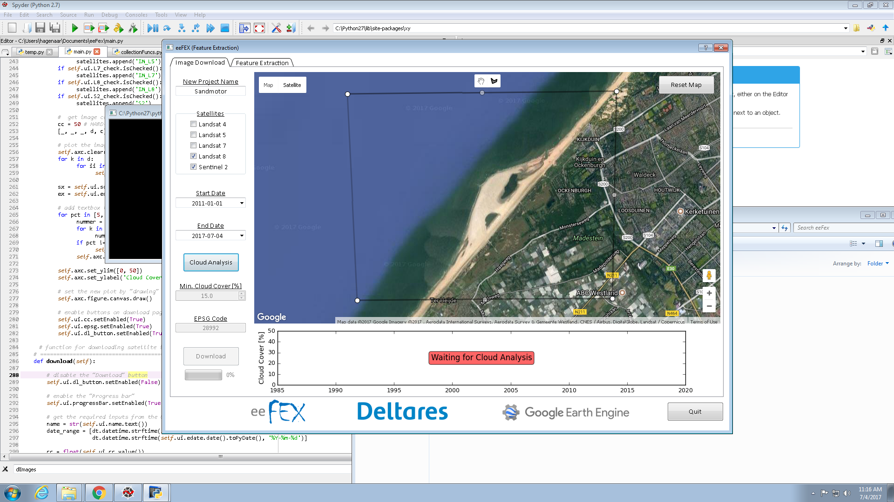

1. Enter a project name (e.g. Sandmotor).
2. Select the satellite missions where you would like to download the images from. The availability of satellite images depends on the satellite mission (Table 1) and your project site.
3. Select an analysis period by defining a start and end date. Take note of the available date ranges as described in Table 1.
4. Define a region of interest by drawing a polygon on the map using the polygon drawing tool in the top panel of the map. All images will be cropped to this polygon.

Table 1 Overview of specifications per satellite mission

|  |  |  |
| --- | --- | --- |
| Satellite mission | Available date range | Spatial resolution visible light |
| NASA Landsat 4 | Aug 1982 – Dec 1993 | 30 x 30 m |
| NASA Landsat 5 | Jan 1984 – May 2012 | 30 x 30 m |
| NASA Landsat 7* | Jan 1999 – present | 30 x 30 m** |
| NASA Landsat 8 | Apr 2013 – present | 30 x 30 m** |
| ESA Sentinel 2 | June 2015 – present | 10 x 10 m |
| *\* Please note that the SLC error of 2003 causes data gabs on the image* | | |
| *\*\* Landsat 7 and 8 are pansharped, which increases the resolution to ~15 x 15 m* | | |

1. Click on the Cloud Analysis button to obtain information on the cloud cover of the available satellite images within the analysis period and region of interest. Please note that the cloud cover information is based on the metadata, which is based on the cloud cover of the entire satellite image. This is not necessarily the cloud cover within the region of interest.
2. After the Cloud Analysis succeeded, a time series is plotted in the panel below the map (Figure 2.2). The time series contains the time instances of the available satellite images and the cloud cover percentage of those images according to the metadata. On the right y-axis the amount of images (*N*) is plotted that are available below a cloud cover percentage of 5%, 10%, 15%, 25% and 50%.

Figure 2.2 Time series of cloud cover percentage per satellite image.

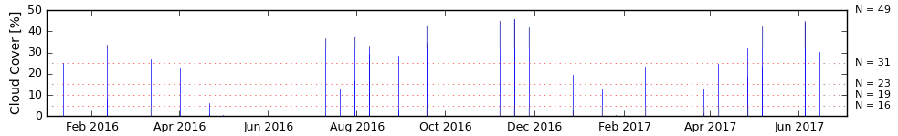

1. Select a Minimum Cloud Cover [%] value. Only images with a cloud cover percentage below this value will be downloaded.
2. Enter an EPSG Code of the desired coordinate projection to work in. Example EPSG codes are:

28992 RijksDriehoeks coordinates (RD), default.

4326 WGS84 (LatLon)

1. Click on Download. This will start downloading the images to a local project folder in the folder ~PROJECTS. Depending on the amount of images to download this might take some time.
2. The images are now ready for manual feature detection, which can be found under the ‘Feature Extraction’ tab.

## Feature extraction

Features can extracted manually once the selected satellite images are downloaded to the local project folder. Click on the tab Feature Extraction (Figure 2.3).

Figure 2.3 Feature Extraction tab with manual extracted shoreline for the Sand Motor project area.

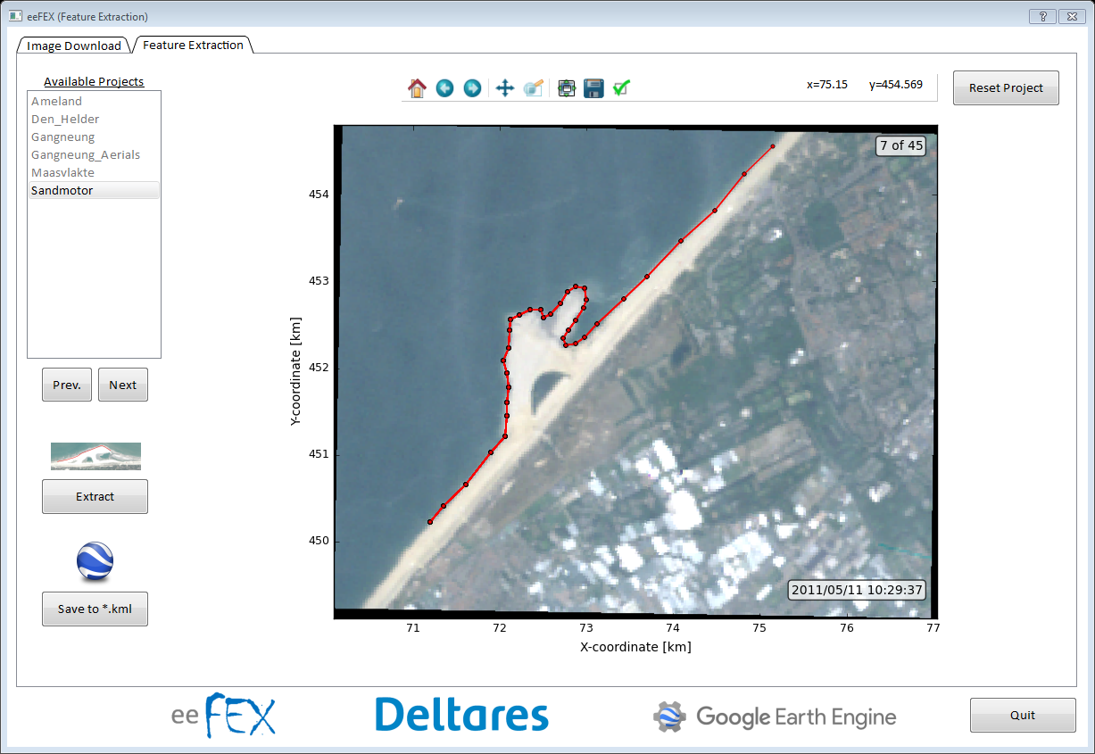

1. Select an available project name from the list and click Next.
2. The first available image will be displayed in the main panel. Switch between images by clicking Prev. (previous image) and Next (next image). Click Reset Project (top right) to select a different project.
3. Using the image toolbox (top panel) it is possible to zoom and pan on the image. By clicking on the ‘Reset original view’ (Home), the original zoom level will be restored.
4. Click on Extract to start extracting features (polygons) from the image. A feature can be extracted by clicking with the wheel mouse button on the image, after which a polygon coordinate is added to the feature.
5. When the feature is defined, click the right mouse button to store the feature as a *.ldb (ASCII) file and a snapshot of the feature on the image in the local project folder.
6. The feature can be overwritten and redefined by clicking on Extract again. A single feature per image can be extracted.
7. After the feature is extracted and stored locally, click Next or Prev. to load a new image.
8. When features are extracted from all images, click Save to *.kml to store all features in the project folder as a *.kml file. This *.kml file can be opened in for example Google Earth.