Q: How to solve a conflict in Subversion?

- “To prevent is better then to cure” (Dutch say)
  - Update your local copy often, so the differences between your code and the code on the repository server remain small.
- Nevertheless, a repository is meant for collaborating on the same code, so conflicts are bound to occur, they are part of the game.

- Look in the log who made the last change to the file you’ve got a conflict with.
- Give the person who caused the conflict a call or send an email, and discuss what about the best approach to tackle the conflict.

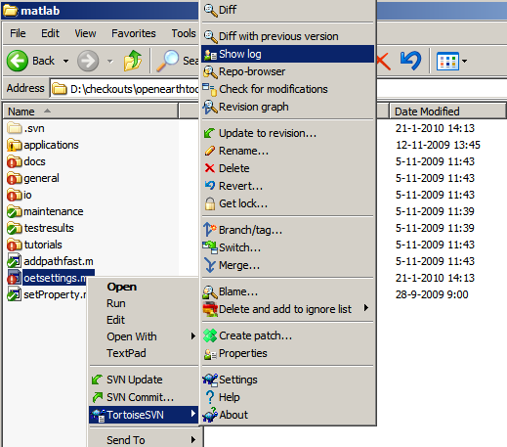

- Subversion has a tool to edit conflicts, here for example in oetsettings.m

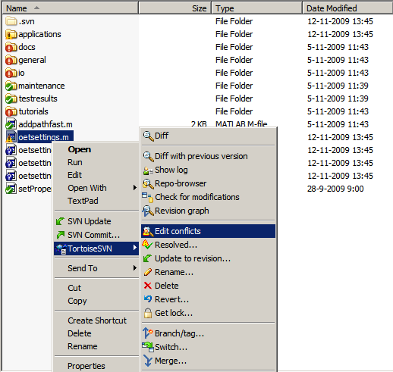

- Per conflict in a file you can choose code from the two versions.

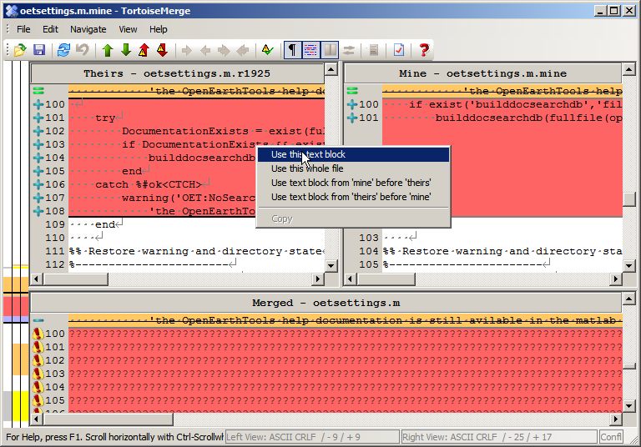

- When you’ve dealt with all conflicts, mark this file as resolved.

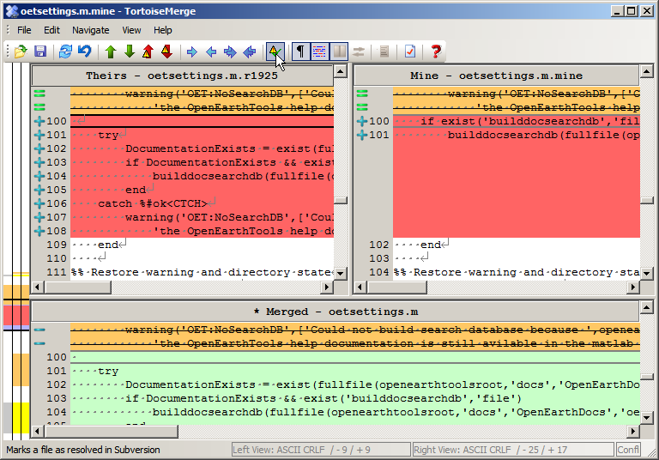

- Any remaining changes in oetsettings.m now appear as a modification and not as a conflict any more. You can submit these as a regular modification.

