Case 1: Basic probabilistic example

This case deals with the very basic probabilistic case of estimating the probability that the load (or solicitation) S exceeds the strength (or resistance) R. Both R and S are assumed to be normally distributed (Figure 1). The calculation will be carried out both with the Crude Monte Carlo and the FORM method.
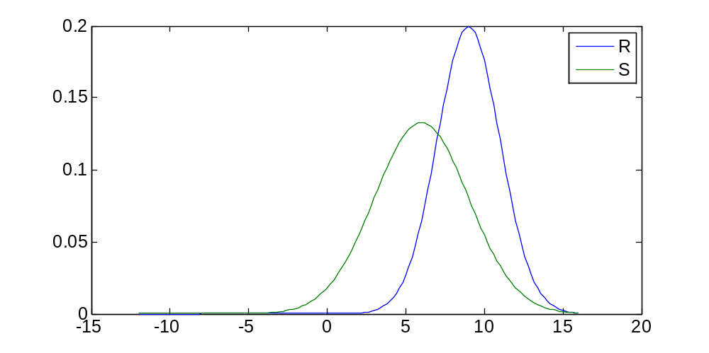
Figure 1 Distributions of the stochastic variables

The unfavorable situation or failure is described by:
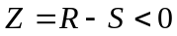

Step-by-step description
The required code to run this example is already available (case1.m). The steps taken to come to this code are described below:

- Define the stochastic variables. In this example we use two normal distributions with means and standard deviations as specified in the table:

Variable name | Distribution | Mean | Standard deviation
R | Normal | 9 | 2
S | Normal | 6 | 4

- Create an M-file (case1.m) to define the necessary stochastic variable structure. It has the following layout:

stochast =

1x2 struct array with fields:
Name
Distr
Params

And can be created as follows:

stochast = struct();

% resistance
stochast(1).Name = 'R';
stochast(1).Distr = @norm_inv;
stochast(1).Params = {9 2};

% solicitation
stochast(2).Name = 'S';
stochast(2).Distr = @norm_inv;
stochast(2).Params = {6 3};

- We will use the default limit state function available in the OpenEarth toolbox. Normally, you will need a more advanced function and possibly create your own, which will be explained in the next few cases. The default limit state function has the following layout:

function z = x2z(varargin)
%X2Z Basic x2z function

%% read options
OPT = struct( ...
'R', 0, ... % resistance value
'S', 0 ... % solicitation value
);

OPT = setproperty(OPT, varargin{:});

%% compute z-values
z = OPT.R - OPT.S;

The variable OPT contains the random samples of the stochastic variables you defined in the previous step. So, it will not contain the entire stochast structure just created, but only a set of numbers (random samples in case of MC and iteration steps in case of FORM). You can access the sample for the R, for example, as follows:

OPT.R

Be aware that it is possible that this variable will be a vector containing several samples at once. Your code should be able to process these vectors item-by-item. Therefore, use dot-operators (.* and ./ etc.) in your formulations, if applicable.

- Add a call to the FORM routine in case1.m specifying both the newly created stochastic variable structure and the z-function handle. For example:

F = FORM( ...
'x2zFunction', @x2z, ...
'stochast', stochast);

- Do the same using the MC routine. Choose a sensible number of samples. For example:

M = MC( ...
'x2zFunction', @x2z, ...
'NrSamples', 1e4, ...
'stochast', stochast);

- Execute your script and visualize your results using the plotFORMresult, plotMCResult and hist functions. For example:

plotFORMresult(F);
plotMCresult(M);

Additional questions
You should be able be to run case1.m. After running this script, several figures pop up on your screen, and among others the variables M and F appear in your workspace. Explore these variables and pay special attention to the Output field to answer the following questions:

- Has the FORM computation converged? What is the probability of failure according to the FORM and the Monte Carlo method?

- What is the value of beta? What would be de probability of failure in case beta was 2?

- In the scatter plot of the Monte Carlo result, a divide between the failure and non-failure area is visible. This is the limit state function Z, which should be a 1:1 line, since R = S. Is it?

- Modify the standard deviation of stochastic variable R to 3. Run again the script case1.m. What is the difference between the two runs? What causes the difference?

