

APCHMP WL | DELFT HYDRAULICS

WES Scientific Document

Version V7

Date: 19/06/01

Mr. Deepak Vatvani
Dr. AVR.Krishna Rao
Ms.P.Daizy Namratha
Dr. Sarah Goodchild

1. Introduction 1
2. Manipulation with the background wind (NWP-data) 2
2.1.1 Removal of the cyclone features 2
2.1.2 Interpolation of the background field on to FLOW grid 3
3. Synthesising the cyclone winds 4
3.1 Brief description of Holland’s model 4
3.2 The approach in WES 5
3.2.1 Method A: computing A and B from V_{m}, R₃₅, R₅₀ and R₁₀₀ 6
3.2.2 Method B: computing A and B from V_{m} and p_{d} 7
3.3 Further improvements in the original model 8
3.3.1 The use of Spider-web grid 8
3.3.2 Merging the cyclone wind field with NWP-wind field 8
3.3.3 Conversion Factor 9
4. Results; comparisons with observations 10
4.1 Comparison of Radius of Maximum wind and Max. wind speed 10
4.2 Comparison of Wind speed and direction with satellite data 12
4.2.1 QUICKSCAT winds 12
4.2.2 ERS winds 15
4.2.3 Comparison of WES Winds with measured ground data 20
5. Conclusions 21
6. References 22
Appendix A Modelling cyclone wind in Delft3D-FLOW 23
A.1 General considerations 23
A.2 Implementation in Delft3D-FLOW 24
A.3 Time interpolation of cyclone wind and pressure 24
A.4 Interpolation of wind and pressure to FLOW grid 24
A.5 Superimposing the cyclone wind to background data 25
A.6 The result (example) 25
A.7 Generating the Spider-web file with WES-module 25
A.8 Use of WES generated winds in the Delft3D flow (Storm Surge Model) 26
Appendix B Gust Factor and conversion factor 27

Introduction
Accurate depiction of the inundation requires the accurate computation of the Storm Surge, that again depends on the accuracy of the inputs it receives. The primary function of WES is to enhance the wind and pressure fields that have been forecast by Numerical Weather Prediction (NWP) models for more accurate modelling of storm surge and flooding.

Cyclone or cyclone induced winds usually are accounted for in the NWP-data. The grid resolution used in these models is however usually not sufficient to accurately generate the winds on finer grid that is required by the hydrodynamic model. Furthermore, the deficiencies in the parameterisation of Cumulus Convection in NWP models does not bring out the cyclone features in their true intensity and size. Hence, the wind and pressure in the cyclone that are predicted by these models are generally underestimated. To overcome this difficulty, all meteorological agencies resort to supply some bogus data to bring out the cyclone in the analysis. The methods used to generate winds are by Rankine Vortex or by generating some synthetic vortex or by the technique suggested by G.J. Holland (1980).

In this report, a Wind Enhancement Scheme (WES) following Holland has been devised to generate wind field around a given cyclone centre and specified intensity. The scheme was initially developed by the UK Met Office. Further improvements to the method have been applied to make the program more robust and yield more reliable and consistent results. To make the scheme more flexible towards the parameterisation method selected, the cyclone winds and pressure fields are generated on a separate polar-coordinate grid the so-called spider-web grid. Through this feature, future extension of the scheme to incorporate other parameterisation method can be performed in a straightforward manner. Furthermore, adjustments were made to couple the output with the Delft Hydraulics storm surge model, Delft3D-FLOW.

Therefore, WES carries out the following steps;
- it removes the less accurate cyclone feature in the NWP-field resulting in a data containing the so-called background wind field
- it then interpolates the background wind field data from the generally more coarser NWP-grid to the more finer storm surge model grid
- it synthesises a cyclone wind field following a parameterised approach.

In the storm surge model these 2 separate wind-forcing data are then merged for each and every integration time step of the hydrodynamic model.

The removal of the cyclone feature from the NWP-data and the interpolation of the results to the storm surge grid are explained in Chapter 2. In chapter 3 the approach to synthesise the cyclone wind and pressure fields is described. Finally the results are presented and discussed in Chapter 4 of this report.

A detailed description of the program is given in the WES User Manual (2001).

Manipulation of the NWP wind-data

Removal of the cyclone features
The global (background) wind data from NWP model, usually available from meteorological agencies, are read. This data contains analysed and predicted wind and pressure fields at every grid point of the Global Model. The use of this data set is optional and not crucial for the Storm Surge Model (SSM).
The main step in WES is to remove the cyclone from the global model data before superimposing them with the synthesised cyclone winds later on in Delft3D. Without this removal step the merging will result in an unrealistic double cyclone feature unless the location of the cyclone centre coincides with the centre predicted by the global model.
Another advantage is that this removal and later merging of synthesised cyclone wind back again, allows the use of arbitrary track predictions other than that contained in the global forecast data itself. The effect of such a removal is illustrated by means of pressure field contour pictures shown below.
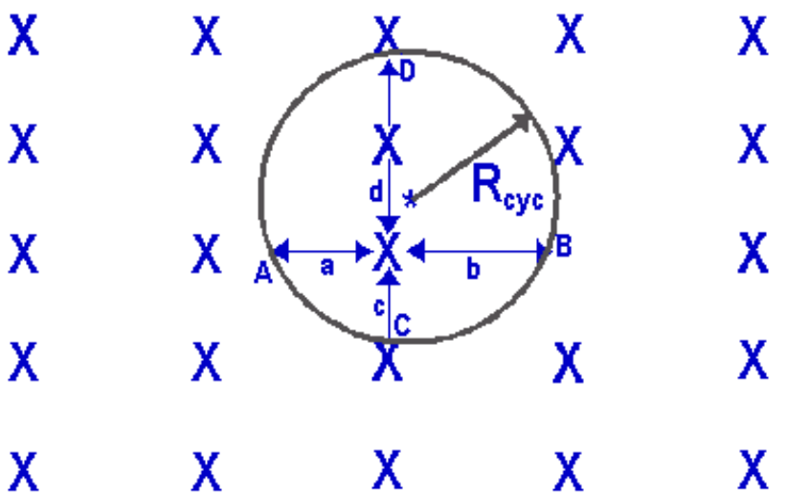
In order to remove the cyclone, from Global Model Data a maximum radius is to be specified by the user. From our experience a value of 600km for the radius of cyclones in the Bay of Bengal seems suitable. The pressures and wind components (East-West or U- and North-South or V-components) at all grid points within this radius are bilinearly interpolated as illustrated below.
Figure 2-1Bilinear Interpolation

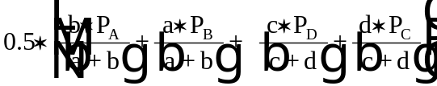For a cyclone centred at (φ_{c} , λ_{c} ) and a maximum radius of R_{cyc} the pressure at a point y is given by

(1)

where P_{A} is the pressure at point A, and a the distance between A and y.

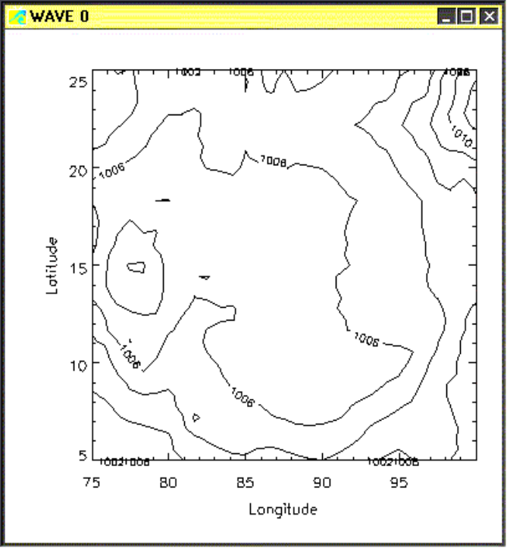
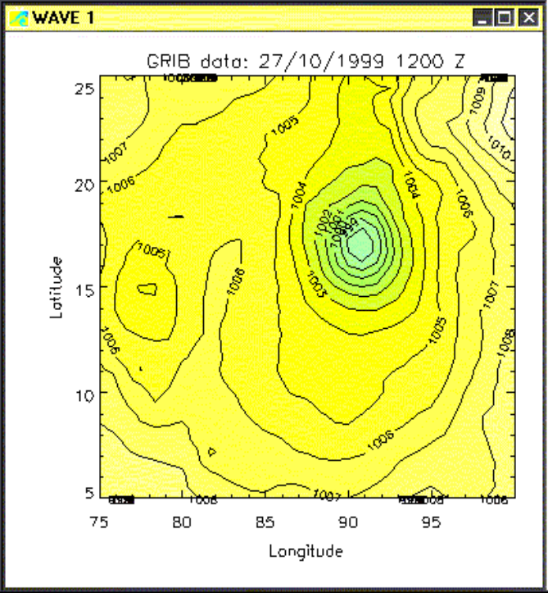
Figure 2-2Pressure contour before and after removal of the cyclone feature from the background pressure field

Interpolation of the background field on to FLOW grid
Provision is made to receive Global Model Data from any meteorological agency. However, in the present version of the program, arrangements are made to receive only the NWP-fields from UKMO in the form of a GRIB-file and from arbitrary source in ASCII-format (provided the file fulfils the format – see WES User Manual for a detail description of the file).
After reading the file, the background wind and pressure fields are interpolated on the FLOW grid and subsequently written to a file known as Space Varying Wind and Pressure file (see WES User Manual the User Manual of Delft3D-FLOW for a detail description of the file).
Optionally, it is also possible to write the output to a so-called MALAWI format that comprises of three ASCII output files (see WES User Manual the User Manual of Delft3D-FLOW for a detail description of these files).
The Delft3D-FLOW storm surge model can read the data generated from either of the above formats.

Synthesising the cyclone winds
As mentioned earlier, wind fields are generated around the given centres of the cyclone (the initial & predicted), following Holland’s method in order to obtain the wind and pressure fields on a high-resolution grid. The winds are computed as if all the points under considerations lie at sea. A more thorough description of the approach will be described in the following section.
The parametric model that has been adopted in WES is based upon G.J. Holland (1980), but has been improved by introducing asymmetry. This asymmetry is brought about by applying the translation speed of the cyclone centre displacement as steering current and by introducing rotation of wind speed due to friction.
This model has basically five parameters:
- the location of the cyclone centre,
- the radius of maximum wind,
- the maximum wind speed,
- the central pressure and
- the current motion vector of the vortex.

Brief description of Holland’s model
Following Holland, the gradient wind speed V_{g} at a distance r from the centre of the cyclone is expressed as:
V_{g} (r) = [ AB(p_{n}-p_{c})exp(-A/r^{B}) / ρr^{B} + r²f² / 4 ] ^{0.5} –rf / 2 (2)
Where
f = Coriolis parameter,
ρ = density of air (assumed to be constant at 1.10 kgm⁻³ from “Handbook of Aviation Meteorology” - 1971),
p_{c} = central pressure, and
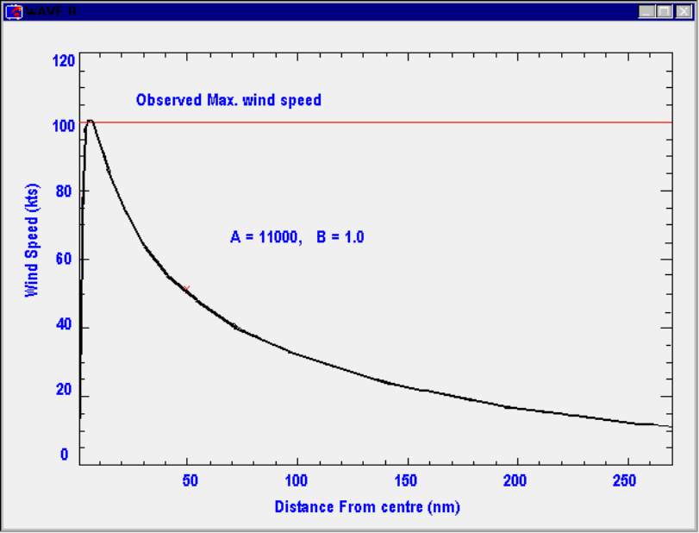
p_{n} = ambient pressure (theoretically at infinite radius, however for the purposes of this model the average pressure over the model domain is used).
Figure 3-1Example of curve fittings for A and B
Parameters A and B are determined empirically. Physically parameter A determines the relation of the pressure or wind profile relative to the origin, and parameter B defines the shape of the profile (Fig.3-1 which is shown above). Holland states that for plausible ranges of central and ambient pressures and radii of maximum wind speeds B is constrained to be between 1 and 2.5.
In the region of maximum winds the Coriolis force is small in comparison to the pressure gradient and centrifugal forces, and therefore the air is in cyclostrophic balance. The cyclostrophic wind V_{c} at a distance r in this region is given by:
V_{c} (r) = [ AB(p_{d})exp(-A/r^{B}) / ρr^{B} ] ^{0.5} (3)
For simplicity reason we have introduced a pressure drop term, p_{d}, equal to p_{n} – p_{c}. By setting d V_{c} / dr = 0, the radius of maximum winds (RMW) can be obtained and is given as follows:
R_{w}=A^{1/B} (4)
The RMW is independent of the relative values of ambient and central pressure and it is defined entirely by the scaling parameters A and B. Substituting (4) back into (3) yields an expression for the maximum wind speed as follows:
V_{m} = [ B p_{d} / ρe] ^{0.5} (5)
Where e = 2.71828182846 (base of the natural logarithm).
Parameters A and B can now be expressed as functions of measurable quantities as follows:
A = R_{w}^{B} (6a)
B = V_{m}² ρe / p_{d} (6b)
And the central pressure drop is given by:
p_{d} = ρe V_{m}² / B (7)
By substituting Eqs. (6a) and (6b) into Eq.(1) we can also express the geostrophic wind V_{g} as function of R_{w}:
V_{g} (r)= [(R_{w}/ r) ^{B} V_{m}² exp(1-(R_{w}/r)^{B}) + r²f² / 4 ] ^{0.5} –rf / 2 (8)
The equations above are valid for geostrophic winds. Before deriving A and B the wind speed and pressure values are now scaled to their geostrophic values. For wind speed this involves a division by a factor represented by preduce, and for pressure drop by preduce². Preduce is currently set to 0.7, the appropriate value over water.

The approach in WES
To enable the use of Holland’s model in an operational storm surge forecast we need to produce cyclone winds and pressure field based on (measured/observed/forecast) physical quantities that are reported in the cyclone advisories. The idea is that the winds will be synthesised assuming that the values of parameters A and B can be determined based on these quantities.
Unfortunately cyclone advisories originating from different meteorological agencies do not contain identical information for which a standard procedure can be developed. Below we summarise the contents of some of the advisories:
- Cyclone advisories from UK Met Office contains the present and 72 hours forecast of the cyclone positions accompanied by a qualitative description of the changes in the cyclone strength (intensifying, weakening etc.).
- JTWC Guam advisories contains the present and 48 hours forecast of the cyclone positions accompanied by a quantitative description of the cyclone strength with the help of 4 parameters:
- Maximum sustainable winds (V_{m}) at present positions,
- Radius of 35 knots wind (R₃₅) at present and future positions,
- Radius of 50 knots wind (R₅₀) at present and future positions and
- Radius of 100 knots wind (R₁₀₀) at present and future positions.
- IMD advisories contains the present and 36 hours forecast positions of the cyclone and a qualitative description of the changes in the cyclone strength (intensifying, weakening etc.)
- In all advisories the present cyclone translation speed and its direction are mentioned.
It is clear that that a single method for determining A and B can not be devised in case WES has to be applied in an operational system. Assuming at least an advisory from one source is received we have adopted a twofold computation method.

Method A: computing A and B from V_{m}, R₃₅, R₅₀ and R₁₀₀
To determine A and B an attempt to fit the solution from equation 1 to the observed values is carried out by varying the values of R_{w} and B.
First a set of possible B values are set as follows: B_{i} = 1 + (i-1)/2501.For each of this B_{i} value a set of possible radii of maximum wind values is defined as: R_{j} = j * 500; with j =1,2500. For each of this R_{j} value the wind speed associated with R35, R50 and R100 are subsequently computed using Eq. (8) as follows:
V_{g}^{ij} (R_{xx}) = [(Rj/R_{xx})^{B}i V_{m}² exp(1-(Rj/R_{xx})^{B}i) + r²f² / 4 ] ^{0.5} – rf / 2 (9)
Where R_{xx} stands for radius of 35, 50 and 100 knots winds respectively. For each of the wind speed value V_{g}^{ij} (R_{xx}) the error with the observed wind speed (35, 50 and 100 knots respectively) is determined:
Error^{ij} = (V_{g}^{ij}(R₃₅)–V_{g}(R₃₅))² + (V_{g}^{ij}(R₃₅)–V_{g}(R₃₅))² + (V_{g}^{ij}(R₃₅)–V_{g}(R₃₅))² (10)
The value of R_{w} and B is determined by finding the i and j values that yields the minimum error as given in Eq. (10). This method of computation may be applied when the required input data, namely V_{m}, and at least one of the following radii values R₃₅, R₅₀ and R₁₀₀ are known. Furthermore, a fake observation of 5 m/s at 500 km from centre has been assumed. This was found to be necessary to ensure that the winds decayed appropriately with distance from the cyclone centre.
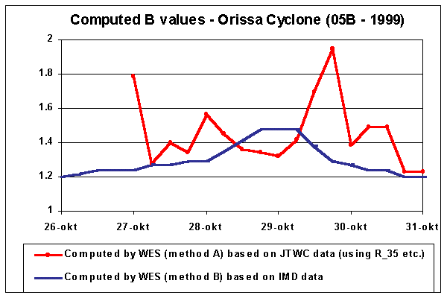
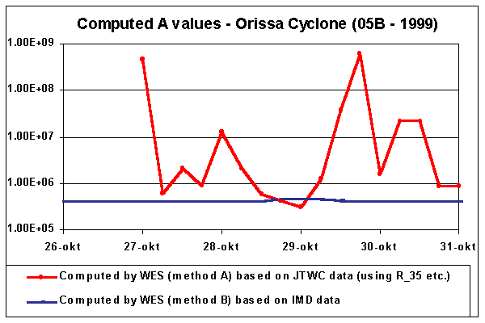
The method described here has been tested on a number of cyclones in India and Vietnam. As an example the figure below shows the results in one of the case tested namely the Orissa Cyclone (05B) – 1999. The method is found to produce consistent result when all the radii values R₃₅, R₅₀ and R₁₀₀ are available (i.e. strong cyclone). Otherwise the method is less dependable.
Figure 3-2A and B value computed using two different methods

Method B: computing A and B from V_{m} and p_{d}
In the case that R₃₅, R₅₀ and R₁₀₀ are unavailable then the following empirical method to determine A and B is adopted. This method has been devised after investigating a number of cyclones in the Bay of Bengal and after arriving at the conclusion that the proposed Method A occasionally fails to produce a reliable result.
The hindcast data from IMD contains both the maximum sustained wind V_{m} and the pressure drop p_{d} at regular intervals during the cyclone period. However IMD uses a constant value to relate the maximum sustained wind speed with the pressure drop as it can be clearly seen in Fig. 3-3.
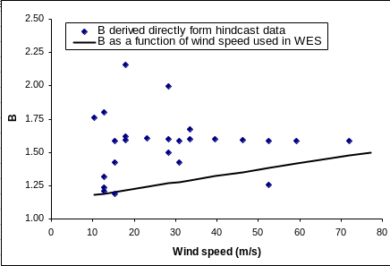
Application of this relation for determining the value of B will yield cyclones with fixed RMW. Therefore through experiments that were carried out an empirical relation has been determined that fits the cyclone data for the cyclones mentioned above. This relation is described by a linear function where B is set equal to 1.18 for 20 knot winds or below and ends at 1.55 for wind speed value of 150 knots (see Fig. 3-3).
Figure 3-3B as a function of Max. wind speed (Vmax)
To compute A we first set of possible A values as follows: A_{i} = 400000 + (i-1)*2.5 10⁶. Subsequently, for each of A_{i} value, a set of possible radii of maximum wind values is defined as: R_{j} = 6000 + j * 1000; with j =1,1000.
Lower bounds have been set for A_{i} and R_{j} to prevent the radius of maximum wind for the cyclone to be found will be less than 6 km. For each of this R_{j} value the maximum sustained wind speed is computed using Eq. (8) as follows:
R_{w}^{i} = A_{i}^{1/B} (11)
V_{g}^{ij} (R_{w}^{i}) = [(Rj/ R_{w}^{i})^{B}i V_{m}^{ij2} exp(1-(Rj/ R_{w}^{i})^{B}i) + r²f² / 4 ] ^{0.5} – rf / 2 (12)
For each of the wind speed value V_{g}^{ij} (R_{xx}) compute the difference with the specified maximum sustained wind V_{m} is determined:
ERROR^{ij} = (V_{g}^{ij}(R_{w}^{i})–V_{m})² (13)
The value of Rw and A is determined by finding the i and j that yields the minimum value for the expression given by Eq. (13). Furthermore, a constant value of 5 m/s at 500 km from centre has been assumed. This was found to be necessary to ensure that the winds decayed appropriately with distance from the cyclone centre. An example of the result is shown in Fig. 3-2 for the Orissa Cyclone (05B) – 1999 test case.

Further improvements in the original model
After determining the values of parameter A and B the wind as A, the cyclone winds as a function of distance r and direction θ on a spider-web like grid can be computed. The computed winds are then adjusted to account for the asymmetry introduced by the interaction of the cyclone with the steering flow (Chan and Gray 1982) by adding the translatory movement of the cyclone to the existing wind field. This vectorial addition increases the winds on the right hand side (RHS) of the direction of the cyclone movement and reduces the winds on the left hand side (LHS), thus bringing about an asymmetry in the wind field generated. The wind direction is rotated 20⁰ in the anti clock-wise (cyclonic) direction so that the wind spirals in towards the centre (Shea and Gray 1973) to account for the frictional effects. Also for the same reason a reduction factor of 0.7 is applied for the geostrophic wind to generate winds at 10 meters above MSL.

The use of Spider-web grid
In order to minimise data storage, an elegant technique has been adopted requiring data on a polar co-ordinate grid centred on the cyclone centre (Stelling, 1999). On this, the so-called spider-web, grid the cyclone wind and pressure field are generated. With the help of this grid the cyclone winds can be derived elegantly and stored in a compact file format. The effectiveness of this grid is demonstrated in the storm surge model and in the wind damage model. For a detailed description on how the grid is used we refer you to Appendix A of this report.
J = 4 3 2 1 …. etc.
I = 1
2
3
6
Figure 3-4Definition of the spider-web grid

Merging the cyclone wind field with NWP-wind field
Once the parametric cyclone wind speed and pressure have been derived a method of merging them with the global model fields is required. The merging of the winds generated by WES with the ‘cyclone free’ background wind is then carried out as follows.
If we assume:
- the radius of the cyclone is known (input parameter) and it is denoted by R_{cyc}
- superposition of the data is carried out on a grid and the grid indices are given by (M,N)
- Ws = Wind speed; Wd = Wind direction; P = Atmospheric pressure
- Subscript backg(round) is used to denote the background field and cyc(lone) to use the cyclone wind field and pressure
Then the superposition is the carried out as follows:
Ws (M,N) = F * Ws_{backg} (M,N) + (1 - F) * Ws_{cyc} (M,N) (14a)
Wd (M,N) = F * Wd_{backg} (M,N) + (1 - F) * Wd_{cyc} (M,N) (14b)
P (M,N) = F * P_{backg} (M,N) + (1 - F) * {P_{backg} (M,N) - p_{d} (M,N)} (14c)
Where F is the so-called merge factor that depends on the value of the distance Rd from Eq.(4) and its value is determined as:
F = 1.0 for R_{CYC} ≤ Rd
F = 2 Rd/R_{CYC} – 1 for 0.5*R_{CYC} < Rd < R_{CYC}
F = 0.0 for 0 < Rd ≤0.5*R_{CYC}
So upto 0.5 * R_{cyc} full weightage is given to the cyclone winds and then it is gradually decreased till R_{cyc} while at the same time the weightage to the NWP winds gradually increase from this distance towards R_{cyc}.
XXXXXXXXXXX

Background wind
XXXXXXXXXXX

XXXXXXXXXXX

XXXXXXXXXXX

XXXXXXXXXXX

0.5 * R_{CYC}
R_{CYC}
R_{d}
Superposition of cyclone
& background wind
Figure 4-1Superposition of cyclone and NWP wind and pressure field in WES

Conversion Factor
Any wind speed that is mentioned in the advisories and or computed by the NWP models is defined as wind speed that prevails after averaging them over a certain period of time. For example, JTWC (Guam) advisory mentions wind speeds that are based on 1-minute average while the IMD uses the wind speed on the basis of 3-minutes average. Because in WES the cyclone wind speed and the background wind speed data may originate from two different sources and in order to enable WES to compute wind speed in consistent manner two conversion factors have been introduced:
- Conversion factor for the background wind speed to convert the values from the averaging period used in the input file to the required, x-minute, average by the user.
- Conversion factor for the cyclone wind speed to convert the values from the averaging period used in the cyclone advisories to the required, x-minute, average by the user.
These factors can be found by determining the inverse ratio of the Gust factor for these periods respectively. For a detailed overview and treatment of the Gust factor and the conversion factor we refer you to Appendix B of this document.

Results; comparisons with observations
For comparison purpose of WES computation results, i.e. the synthesised cyclone wind and pressure fields, with the observations (or derived parameters from observations) the following cyclones and parameters have been selected.

Cyclone |  |  |  | Parameter(s) compared
Name | Id | Year | Month | Radius of Max. wind and Max. Wind speed | Wind speed & direction profile (QUICKSCAT data) | Ground observation (wind speed & direction) | Wind speed & direction (statistic – ERS data)
Visakhapatnam (Vizag) | 05B | 1994 | Nov | √
Kakinada | 05B | 1996 | Nov | √
Orissa | 05B | 1999 | Oct | √ | √ | √ | √
Cuddalore | 03B | 2000 | Nov |  | √ |  | √

When comparing the WES derived winds with observations we have to bear in minds that the computed winds at a certain point in space depend highly on the specified position of the cyclone centre in the WES input. The positions are given in latitude and longitude up to a tenth of a degree. So due to round off error the actual positions may actually lie ± 5 km (maximum) from the specified point. This might introduce discrepancies in the results when compared to the observed values, especially in the region where the wind gradients are high.

Comparison of Radius of Maximum wind and Max. wind speed
For comparison of the computed radius of maximum winds and the maximum wind speed two sets of data have been taken as input. One set of data originates from JTWC (Hawaii) cyclone bulletins containing maximum wind speed and radii of winds for 35, 50 and 100 knots winds (if and when available). Subsequently, actual reported positions from IMD RSMC report were used and the wind field and pressure field for every 6 hours were synthesised (i.e. method A). Another set of data consisting of cyclone tracks, maximum wind speed and pressure drop was obtained from IMD RSMC report. Method B was subsequently adopted to synthesise the cyclone winds. The resulting wind speed was then compared with the specified input data.
One of the parameters that is derived in WES is the radius of maximum wind (RMW) and reports this in the diagnostic/log file. This value can be verified against the radius of maximum reflectivity (RMR) which is given by the Radar observation when the cyclone comes in its view (RMR is a measure of RMW).
The JTWC (Hawaii) derives and two numbers for each of the specified radii of 35, 50 and 100 knots winds in their bulletin. One number represents the value for the north-eastern semicircle and the other one for other areas. In the computation either an average of these two values have been used. Furthermore the bulletins are issued every 12 hours. To compute the wind field for every 6 hours interpolation of these values have been applied.
Figures 5-1(a) to 5-1(c) depict the plots of radius of maximum wind and the maximum wind speed during the life cycle of the cyclone from the Vizag-1998, Kakinada-1996 and Orissa-1999 cyclones respectively.

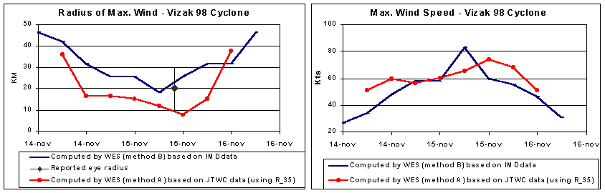
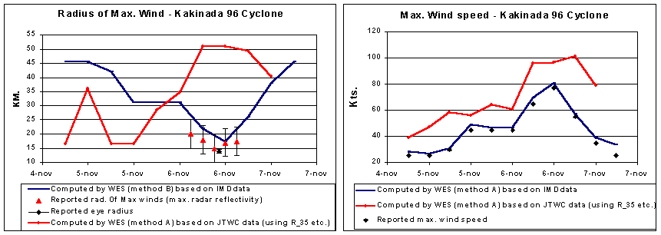
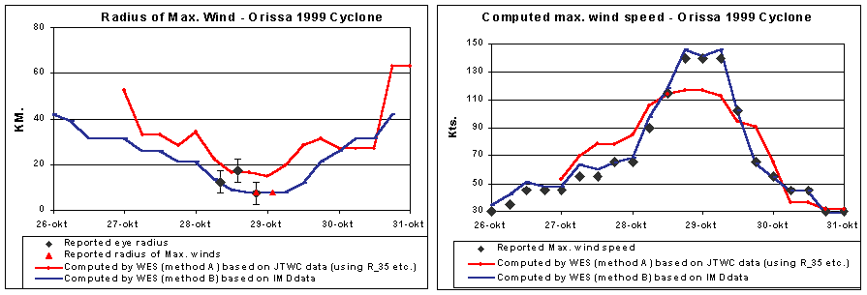
In Fig. 5-1(c), the Orissa Cyclone case, the radius of maximum wind (RMW) gradually decreased from a value of 42 km on the 26th October to a value of 7.5 km on the 29th October when the cyclone reached its peak intensity. The radius of maximum wind started increasing there after when the cyclone started decreasing in intensity after it landfall. The triangles shown in the diagram represents the RMR values measured by the radar at Paradip and the squares in the diagram represents 0.5 the eye diameter (radius of the eye). The reported accuracy of the observed data is represented in the figures by an error bar. The agreement with RMR and RMW in this case is remarkably good. Similar holds for the maximum wind speed computed. This is especially true for the computation using method A. Figures 5-1(a) and 5-1(b) represent the diagrams for Vizag and Kakinada cyclones. Similar is true for the Vizag cyclone case. The RMW values in the Kakinada cyclone case however, are slightly larger than the reported RMR value.
Figure 5-1(a) to 5-1(c) (from top to bottom) Comparison between the observed and computed Radius of Maximum Wind and maximum wind speed for Vizag, Kakinada, and Orissa Cyclones

Comparison of Wind speed and direction with satellite data
As long as the cyclone is in the ocean comparison of model result with observations has to rely on winds derived from the satellite data, as conventional observations are hardly available over the oceans. Fortunately, ERS satellite and more recently Quick Scat derives wind data from scatterometer data, despite some limitations. The accuracy of the winds is claimed to be 1.4 m/s up to the speeds of 20 m/s and an accuracy of 10% beyond that. The maximum measurable speeds with the scatterometer are 50kts. Hence, at higher wind speeds comparison cannot be made. This Quickscat data from the year 1999 onwards is available at the site http://manati.wwb.noaa.gov/cgi-bin/qscat_day-1.pl.

QUICKSCAT winds
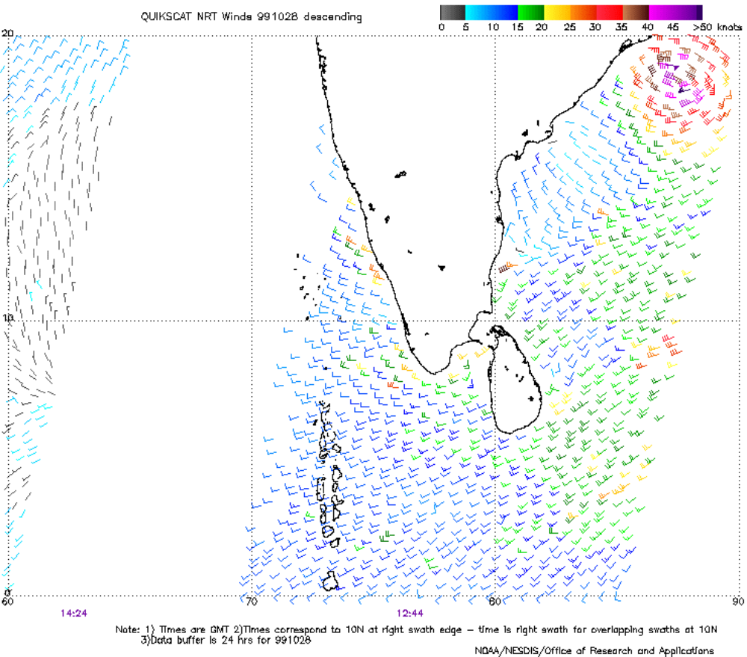
Comparison of WES computed winds with Quickscat data has been made for the Orissa cyclone (26th -30th Oct, 1999) and Cuddalore Cyclone (27-29 Nov, 2000). The comparison is made by printing out the graphs that have been downloaded from the above referred internet site and reading the wind speed and direction visually. Despite the fact that this method of comparison is imperfect and very error prone, it is nevertheless useful to check the main characteristics of the wind fields produced. An example plot of Quickscat observed data is depicted below for the Orissa Cyclone case.
Figure 5-2QuickScat winds measured from satellite using scatterometer at 28-10-1999 (Orissa Cyclone - 05B). Black coloured wind barbs indicates rain contaminated data.

The following figures depicts 4 out of the 8 main cross-sections of the wind derived with WES (in the WES User Manual all 8 cross-sections are shown). The wind speeds and direction of the winds from Quick Scat data are shown in each diagram at the appropriate points. Figures 5-3 and 5-4 shows the wind speed and direction at 28th October,1999-12UTC (Orissa Cyclone) and 28th November, 2000-12UTC (Cuddalore Cyclone). There is a very good agreement for wind speeds and wind directions in most of the cross-sections while in the other, the deviations are more but within the tolerable limits. Keeping in mind the crude method of comparisons, the results are very encouraging indeed.
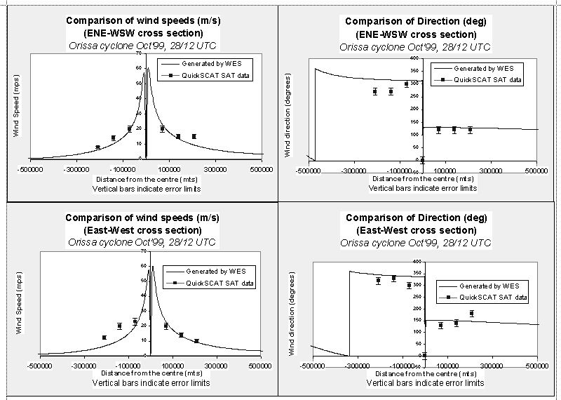
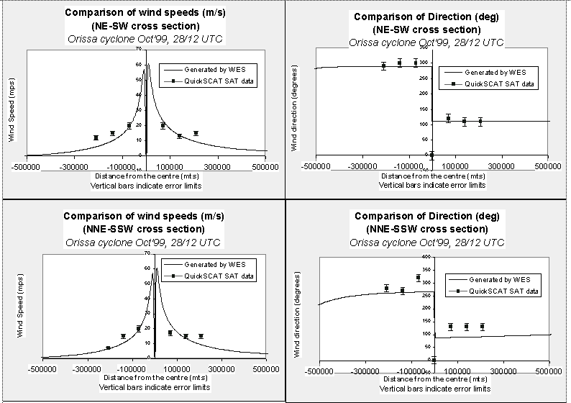

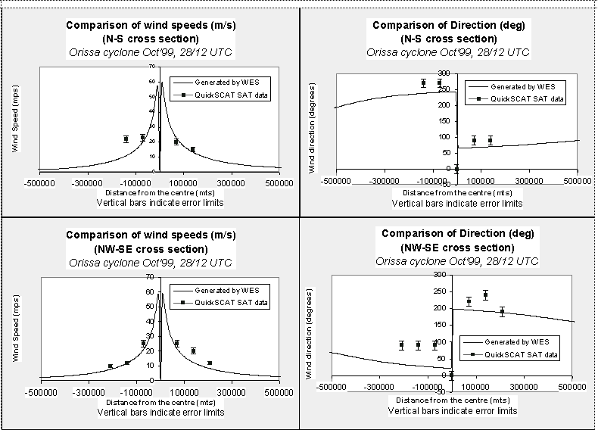

Figure 5-3 Comparison of WES winds and direction with derived winds from Quick Scat satellite for 4 different sectors (Orissa Cyclone)

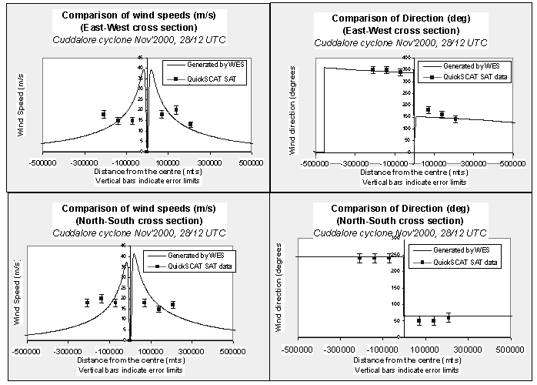
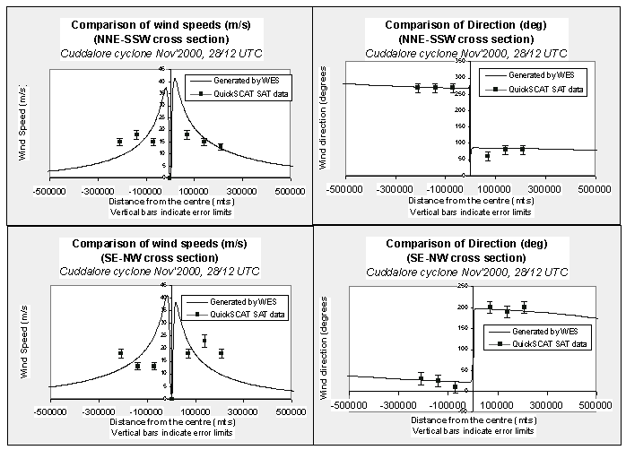
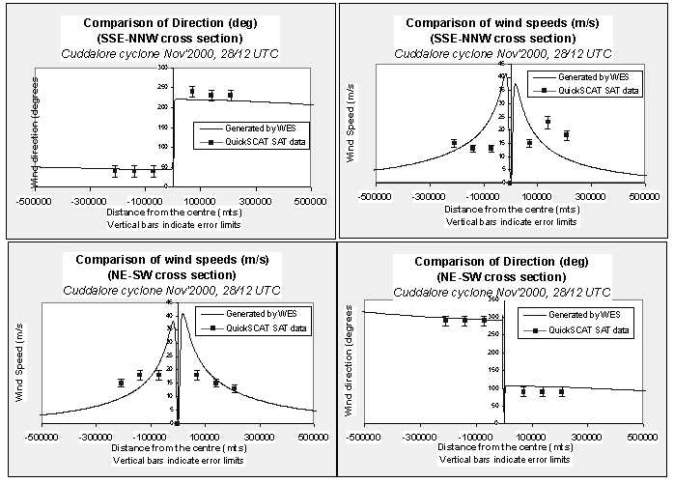

Figure 5-4 Comparison of WES winds and direction with derived winds from Quick Scat satellite for 4 different sectors (Cuddalore Cyclone)

The results of WES, especially the wind speed in the Orissa case and the wind direction in the Cuddalore case show good agreements with the satellite observations. Especially when we bear in mind that the comparison has been done by estimating the wind speed and direction visually from a printed graph and the fact in some occasion the wind measured was contaminated due to rainfall.

ERS winds
Comparison with ERS winds are carried out in a different manner as we had direct access to the data (provided by the UK Met. Office). Therefore we could compare the computed results with observation points at the exact locations. Furthermore, statistical computations were possible. In the following figures and tables the comparison of the WES results, both using method A and B, with the observed ERS derived winds are presented. When interpreting the figures and tables below please note that the maximum measurable speeds with the ERS are 50 kts (≈ 25 m/s). Hence, winds at higher speeds could not be compared at all.

Orissa case – Method A (using JTWC Hawaii advisories containing R_35, R_50 and R_100)
A = 6.5e6 B = 1.46
Vmax = 39 m/s Pdrop = 31.2 hPa RMW = 46.5 km

Number of observation points | Max distance from cyclone centre (km) | Mean wind speed error (m/s) | RMS wind speed error (m/s) | Mean wind direction error (degrees) | RMS wind direction error (degrees)
0 | 100 | 0 | 0 | 0 | 0
26 | 200 | -3.3032 | 3.4498 | 8.4202 | 10.8345
108 | 300 | -0.945 | 2.1533 | 6.9905 | 9.8197
245 | 400 | 0.696 | 2.5343 | 4.5498 | 10.2488
389 | 500 | 1.2626 | 2.6822 | 2.005 | 13.1879

Orissa case – Method B (using IMD data; Vmax and Pd)
A = 4.04E+06 B = 1.33
Vmax = 41.5 m/s Pdrop = 38.7 hPa RMW = 16.5 km

Number of observation points | Max distance from cyclone centre (km) | Mean wind speed error (m/s) | RMS wind speed error (m/s) | Mean wind direction error (degrees) | RMS wind direction error (degrees)
0 | 100 | 0.00 | 0.00 | 0.00 | 0.00
26 | 200 | -5.93 | 6.06 | 7.95 | 11.14
107 | 300 | -2.99 | 3.73 | 5.58 | 8.79
243 | 400 | -1.00 | 2.92 | 3.75 | 9.97
381 | 500 | -0.17 | 2.69 | 1.79 | 13.18
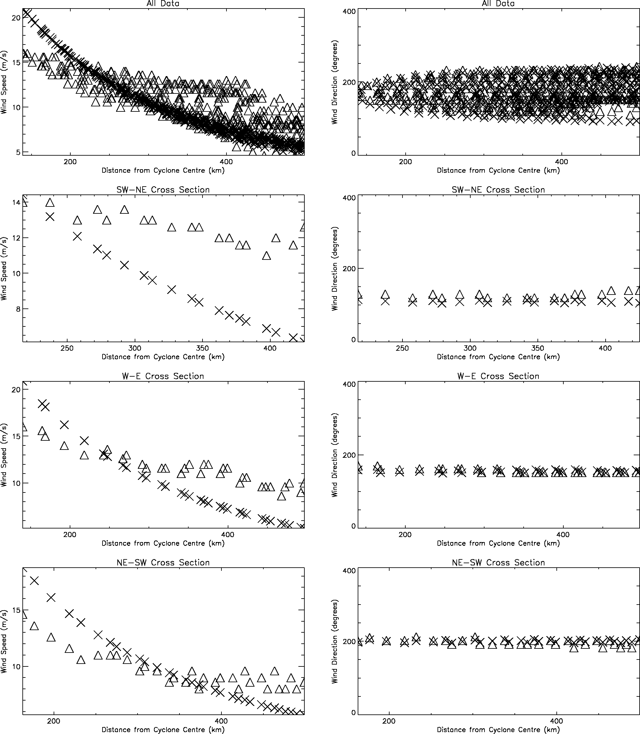
Figure 5-5 Comparison of ERS and parametric wind speeds and directions (Method A) on four radial cross sections on 28/10/1999 at 0400 Z. Triangles represent ERS data, crosses model data
SE-NW Cross section SE - NW Cross section

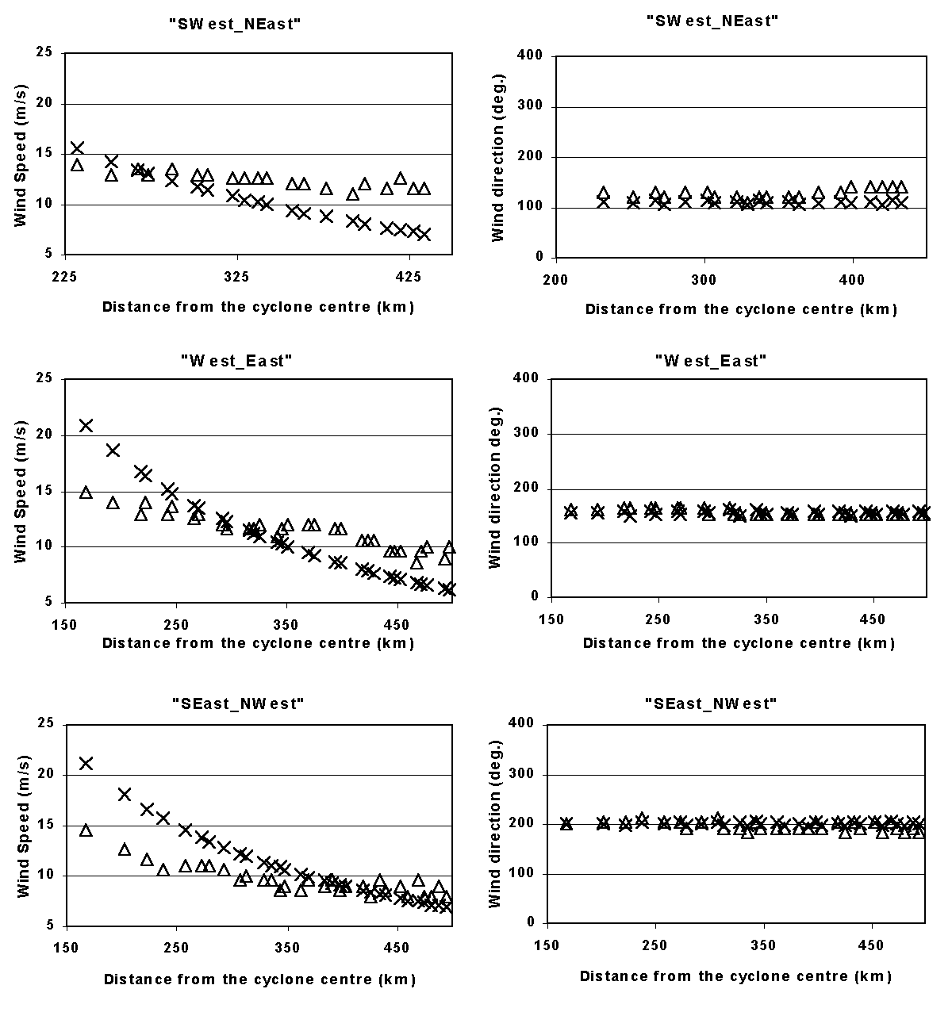
Figure 5-6 Comparison of ERS and parametric wind speeds and directions (Method B) on four radial cross sections on 28/10/1999 at 0400 Z. Triangles represent ERS data, crosses model data

Cuddalore case – Method A (using JTWC Hawaii advisories containing R_35, R_50 and R_100)
Figure 5-1 Comparison of ERS and parametric wind speeds and directions (Method B) on four radial cross sections on 28/10/1999 at 0400 Z. Triangles represent ERS data, crosses model data
A = 6.47e6 B = 1.44
Vmax = 26.0 m/s Pdrop = 14.0 hPa RMW = 54.5 km

Number of observation points | Max distance from cyclone centre (km) | Mean wind speed error (m/s) | RMS wind speed error (m/s) | Mean wind direction error (degrees) | RMS wind direction error (degrees)
28 | 100 | -5.1043 | 7.7524 | 9.6597 | 34.9876
106 | 200 | -1.6102 | 4.2264 | 11.7438 | 23.7
234 | 300 | 0.1976 | 3.2852 | 8.9879 | 18.092
409 | 400 | 1.2197 | 3.1091 | 6.2995 | 16.9551
627 | 500 | 1.8009 | 3.1167 | 4.9857 | 16.411

Cuddalore case – Method B (using IMD data; Vmax and Pd)
A = 4.23E+06 B = 1.37
Vmax = 50.4 m/s Pdrop = 55.4 hPa RMW = 12.5 km

Number of observation points | Max distance from cyclone centre (km) | Mean wind speed error (m/s) | RMS wind speed error (m/s) | Mean wind direction error (degrees) | RMS wind direction error (degrees)
33 | 100 | -7.60 | 9.08 | -2.27 | 54.71
118 | 200 | -2.83 | 4.96 | 5.33 | 34.14
253 | 300 | -0.98 | 3.55 | 4.45 | 25.22
439 | 400 | 0.04 | 2.94 | 2.77 | 22.25
643 | 500 | 0.62 | 2.73 | 2.47 | 20.38
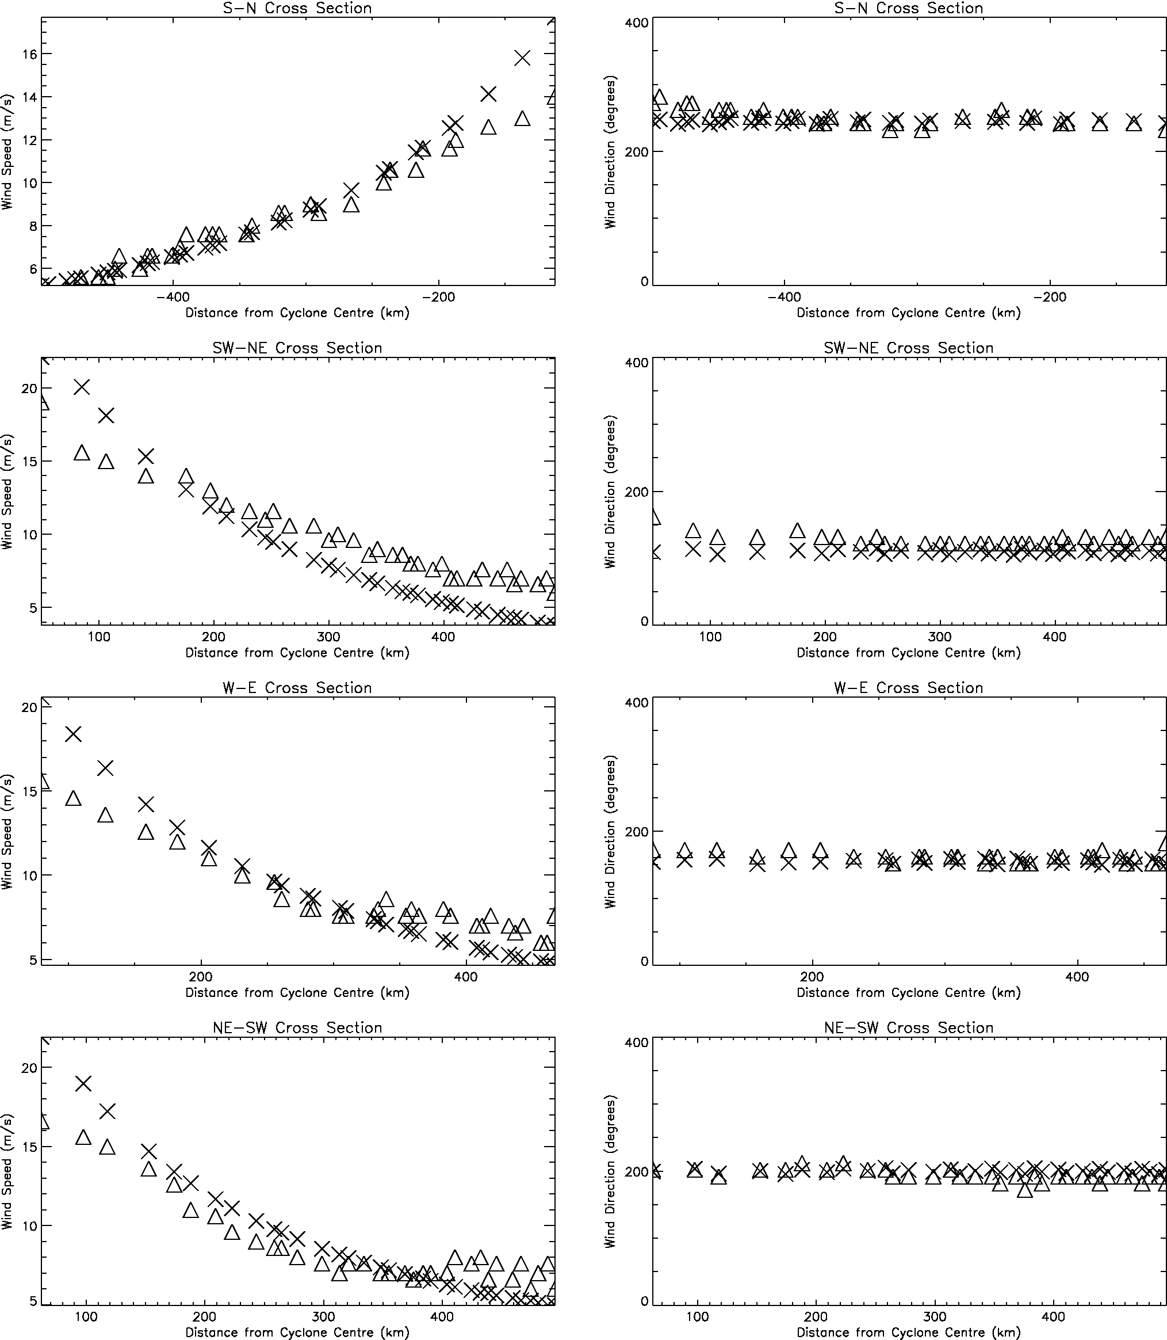
SE-NW Cross section SE - NW Cross section
Figure 5-7 Comparison of ERS and parametric wind speeds and directions (Method A) on four radial cross sections on 28/11/2000 at 0400 Z. Triangles represent ERS data, crosses model data

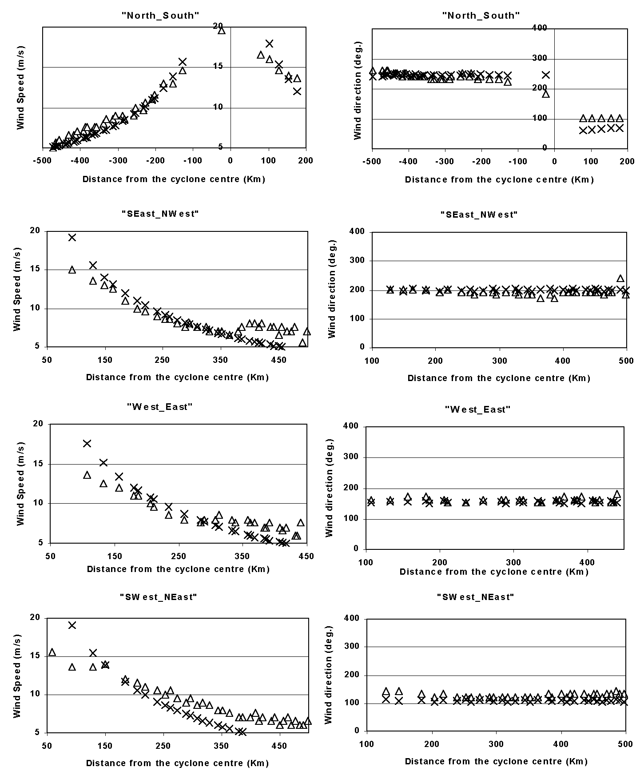
Figure 5-8 Comparison of ERS and parametric wind speeds and directions (Method B) on four radial cross sections on 28/11/2000 at 0400 Z. Triangles represent ERS data, crosses model data

Based on the figures above one might conclude that both the methods used by WES to derive the cyclone winds are comparable. A slightly better results were obtained by applying Method B. The agreement between the derived wind directions with the observed data is strikingly accurate.
The derived wind speed is quite accurate up to approximately 12 m/s. Deviations along some cross-sections then increase up to 7 m/s on average for the wind speed values between 12 and 25 m/s. Similar to the QuickScat case we were not able to determine the rain contamination in the measured data.

Comparison of WES Winds with measured ground data
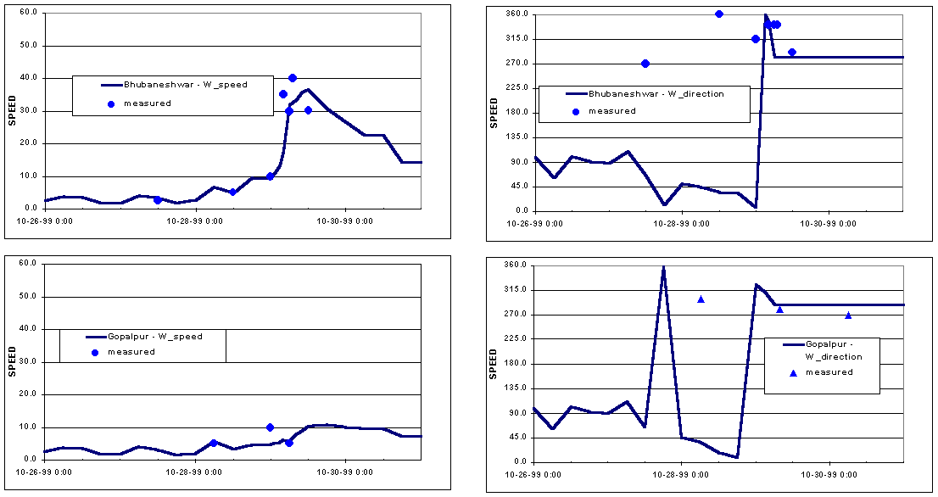
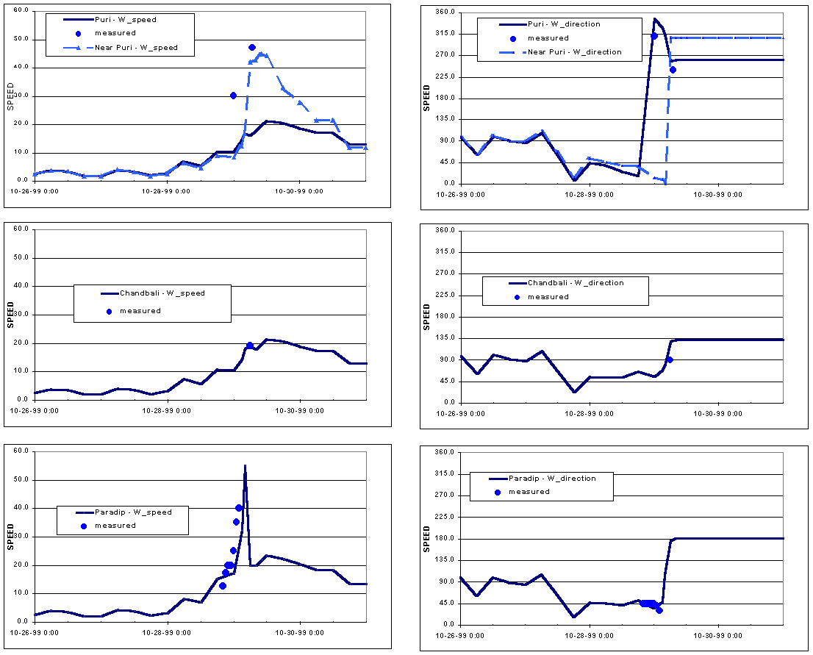
Some surface wind speeds during Orissa cyclone (05B) 1999 originating from ground observations has been collected from IMD Hyderabad Met. Office for comparison purposes. The results are shown below. From the figures it is clear that the WES winds are able to reproduce the surface wind measurements with sufficient degree of accuracy. One exception forms the results at Puri. However when a location slightly North of Puri is selected then the results are again quite good.

Figure 5-9 Comparison of WES generated wind speed and direction with ground observation

Conclusions
Based on the results above we can conclude that WES is able to reproduce the observed wind speed and direction with high degree of accuracy. On the lower end of the wind speed spectrum deviations in some sectors of approximately 7 m/s (on average) were found for the wind speed between 12 – 25 m/s. However, the observed data were contaminated by rainfall. We therefore suspect that even for these values the wind speed derived might be as accurate as well. This is supported by the results of comparisons with observations from ground stations where wind speed up to 40 m/s has been measured.

The agreement in the derived wind directions is very good indeed.

Comparison between Method A and B indicates that slightly better results were obtained for the wind speed derived by Method B. This is certainly true when the computed radii of maximum winds are compared with the measured data. This comparison clearly shows that Method B is by far superior to Method A.

References
Chan, J.C.L., and Gray, W.M. (1982): Tropical cyclone movement and surrounding flow relationships. Mon. Wea. Rev, 110 1354-1374.
Delft3D-FLOW User Manual, Version 3.05, WL|Delft Hydraulics, September 1999
G.S. STELLING, 1999 Delft Hydraulics internal notes on Cyclone modelling
Holland, G.J, 1980: An Analytical Model of the Wind and Pressure Profiles in Hurricanes. Mon. Wea. Rev, 108, 1212-1218.
Shea, D.J. and W.M. Gray 1973: The Hurricane’s Inner Core Region I. Symmetric and Asymmetric Structure. J. Atmos. Sci,30, 1544-1564.
WES User Manual, APCHMP Project Document, June 2001
Appendix A Modelling cyclone wind in Delft3D-FLOW
A.1 General considerations
Cyclone (typhoon or hurricane) generated wind data generally originates from Numerical Weather Prediction (NWP) models. Results from NWP models, i.e. the forecast wind and pressure fields, are usually only available at every six hours, whilst the storm surge model runs with a time-step of the order of minutes. The strong gradients in the wind associated with the cyclone do not allow for straightforward temporal interpolation, as is clearly shown in the figures below.
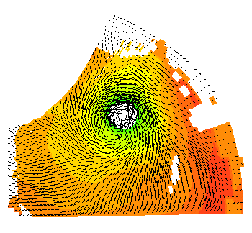
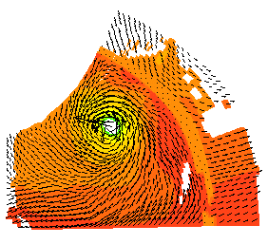
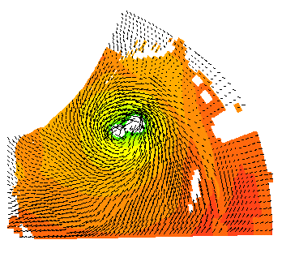
T = 0 hrs
T = 6 hrs
Interpolated values

T+0 hrs
T + 6 hrs
Linearly interpolated Intermediary values
Figure A-1 Effect of straightforward temporal interpolation of Cyclone winds on curvilinear grid
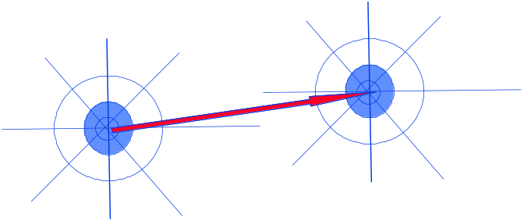
Therefore, either the synthesised wind and pressure fields must be prescribed at very short time intervals, or a more sophisticated method of temporal interpolation within the storm surge model is required. Since the former option is not practicable, the second option is to be resorted to. In order to minimise data storage, an elegant technique has been adopted requiring data on a polar co-ordinate grid centred on the cyclone centre (Stelling, 1999). The approach requires that the overall background wind and pressure fields and the cyclone wind and pressure be generated separately and on different grids. The background field is defined on the model grid points and the cyclone wind on the so-called spider-web.
Left: Definition of the spider-web grid
Right:Movement of the spider-web grid that follows the displacement of the cyclone

J = 4 3 2 1 …. etc.
I = 1
2
3
6
Figure A-2 Spider-web definition (left) and displacement in time (right)

A.2 Implementation in Delft3D-FLOW
The values of the cyclone wind field are subsequently defined at each point (I,J) on the spider-web above, the centre of the web being the centre or “eye” of the cyclone.
The temporal interpolation then follows the following steps:
- read the specified cyclone wind data that has been defined on the spider-web grid for two consecutive times
- allow the web to move, and interpolate intermediary values on the spider-web grid
- interpolate in space the wind from the spider-web grid points to the FLOW grid, and
- superimpose (merge) the wind temporally interpolated data on the background wind
A.3 Time interpolation of cyclone wind and pressure
To determine the intermediary values of the cyclone centre (X0_{EYE},Y0_{EYE}), the wind speed (Ws_{web}), the wind direction (Wd_{web}) and the pressure drop (dP_{web}) at a certain simulation time (t1+Δt) that lies between two specified input data t1 and t2, they are interpolated on the spider-web grid by letting the centre position (‘eye’) of the cyclone to travel a distance that is proportional to the integration time step Δt:
X0_{EYE} (t1+Δt) = X0_{EYE} (t1) + Δt / (t2 - t1) * {X0_{EYE} (t2) - X0_{EYE} (t1)} (1a)
Y0_{EYE} (t1+Δt) = Y0_{EYE} (t1) + Δt / (t2 - t1) * {Y0_{EYE} (t2) - Y0_{EYE} (t1)} (1b)
Ws_{web} (I,J) (t1+Δt) = Ws_{web} (I,J) (t1) + Δt / (t2 - t1) * {Ws_{web} (I,J) (t2) - Ws_{web} (I,J) (t1)} (A.1c)
Wd_{web} (I,J) (t1+Δt) = Wd_{web} (I,J) (t1) + Δt / (t2 - t1) * {Wd_{web} (I,J) (t2)- Wd_{web} (I,J) (t1)} (A.1d)
dP_{web} (I,J) (t1+Δt) = dP_{web} (I,J) (t1 + Δt / (t2 - t1) * {dP_{web} (I,J) (t2)- dP_{web} (I,J) (t1)} (A.1e)

A.4 Interpolation of wind and pressure to FLOW grid
First the ‘standard’ spider-web grid is constructed following identical definitions that are used in WES. Assuming:
- the number of points I in the angular direction equals MAXPHI and
- the number of points J in the radial direction equals MAXRAD
- the radius of the spider-web equals R_{CYC} (actual values of MAXRAD and MAXPHI are read from the spider-web file)
then the co-ordinates R_{web ,}φ_{web} are set as follows:
φ_{web} (I,J) = (I - 1) / MAXPHI * 2 π with I =1, 2,….MAXPHI (A.2)
R_{web} (I,J) = J / MAXRAD * R_{CYC} with J =1, 2,….MAXRAD (A.3)
Subsequently, the distance between each (M,N) point in the FLOW grid to the cyclone centre is determined. On a spherical grid this distance, R_{d}, is determined using the following non-Euclidean geometrical formulae that is valid on spheres:
R_{d} = SIN^{–1} [Min (1,√ SIN² (d λ) + COS (λ _{i}, φ _{i}) * COS (λ _{c}, φ _{c}) * SIN² (d φ))] (A.4)
Where: (λ _{M}, φ _{N}) = co-ordinates (lat, long) of the point (M,N) on FLOW grid
(λ_{c} , φ _{c}) = co-ordinates (lat, long) of the eye of the cyclone
= (X0_{EYE}t, Y0_{EYE}t)
d λ = λ _{c} – λ _{i}
d φ = φ _{c} – φ _{i}
Subsequently through standard bilinear interpolation the values of the cyclone wind speed Ws_{cyc} (M,N), wind direction Wd_{cyc} (M,N) and pressure drop dP_{cyc} (M,N) at each (M,N) point of the FLOW grid is determined.
A.5 Superimposing the cyclone wind to background data
After determining the wind speed, wind direction and pressure drop on the actual FLOW grid the cyclone wind is then merged at each grid point (M,N) of the FLOW grid with the background wind and pressure as follows:
Ws (M,N) = F * Ws_{backg} (M,N) + (1 - F) * Ws_{cyc} (M,N) (A.5a)
Wd (M,N) = F * Wd_{backg} (M,N) + (1 - F) * Wd_{cyc} (M,N) (A.5b)
P (M,N) = F * P_{backg} (M,N) + (1 - F) * {P_{backg} (M,N) - dP_{cyc} (M,N)} (A.5c)
Where F is the so-called merge factor that depends on the value of the distance Rd from Eq.(4) and its value is determined as:

F = 1.0 for R_{CYC} < Rd
F = 2 Rd/R_{CYC} – 1 for 0.5*R_{CYC} < Rd < R_{CYC}
F = 0.0 for 0 < Rd < 0.5*R_{CYC}
A.6 The result (example)
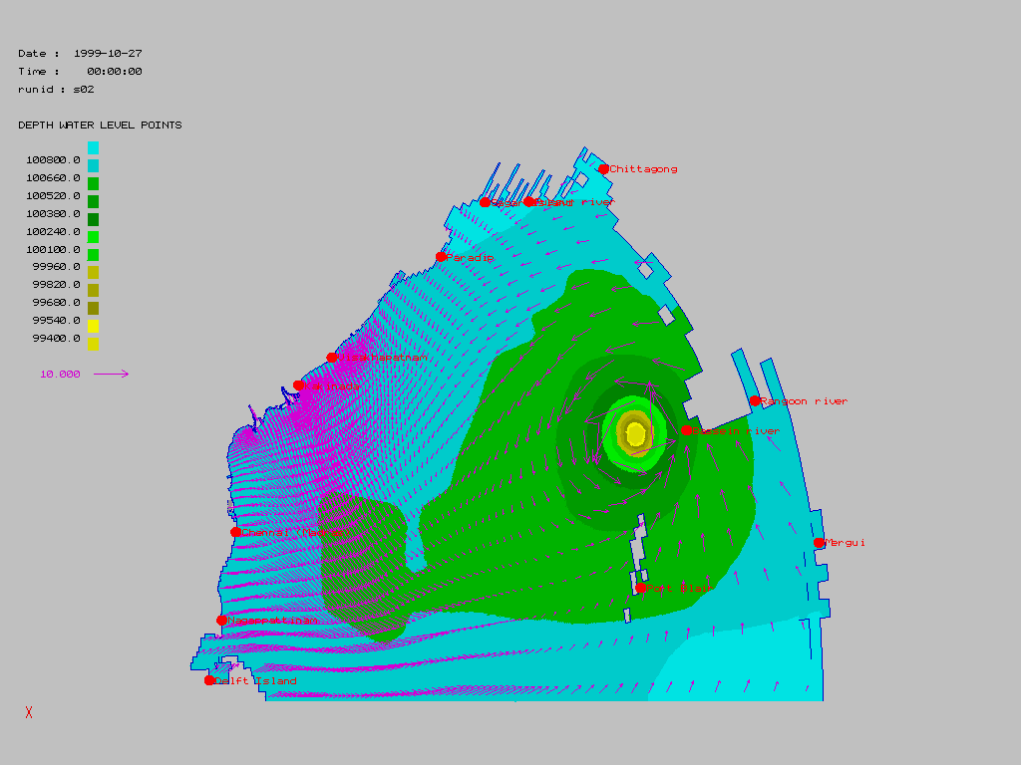
The pictures below depict an example of the merged background wind with the computed cyclone wind that prevailed in the Bay of Bengal.
Figure A-3 The merged background and cyclone wind for Orissa Cyclone (05B) 1999
A.7 Generating the Spider-web file with WES-module
The cyclone wind and pressure (drop) on the spider-web grid may be generated by an arbitrary program or by the so-called local Wind Enhanced Scheme (WES) module that is available within the Delft3D system.

A.8 Use of WES generated winds in the Delft3D flow (Storm Surge Model)
In order to use the output winds generated through WES (which is available in the form of Spider-web) they have to be interpolated to the Delft3D flow grid along with the background wind to be useful for Storm Surge Model (Background wind: wind data from NWP predictions). The removal operation is taken care by the programme edit_mdf.exe in the RTS. This is an automatic process.
In case the background is not received one can also apply a uniform background wind.

In offline mode, this operation is carried out manually by changing the attribute files in the mdf file namely
Filweb= #filename#
Where filename = name of the file that contains the cyclone wind on the spider-web grid.
Filewnd= #filename#
Where filename = name of the file that contains the background wind.

You have to ensure that the space varying wind and pressure data contains only the background wind and pressure values where the wind and pressure associated with cyclone has been removed completely from the data. For a more detailed specification of these additional records in the MD-file we refer you to the Delft3D-FLOW User Manual.

Appendix B Gust Factor and conversion factor
Different Meteorological agencies use different averaging period to measure the surface wind. Subsequently, all the wind speed data they use are converted to these averaging period in order to allow them to compare their data with the observations. Some of the agencies may use one-minute average while others uses 3 min and 10 min averages. To compare the data from one agency to those from the other agency then corrections must be applied by multiplying one set of the wind speeds with an appropriate factor.
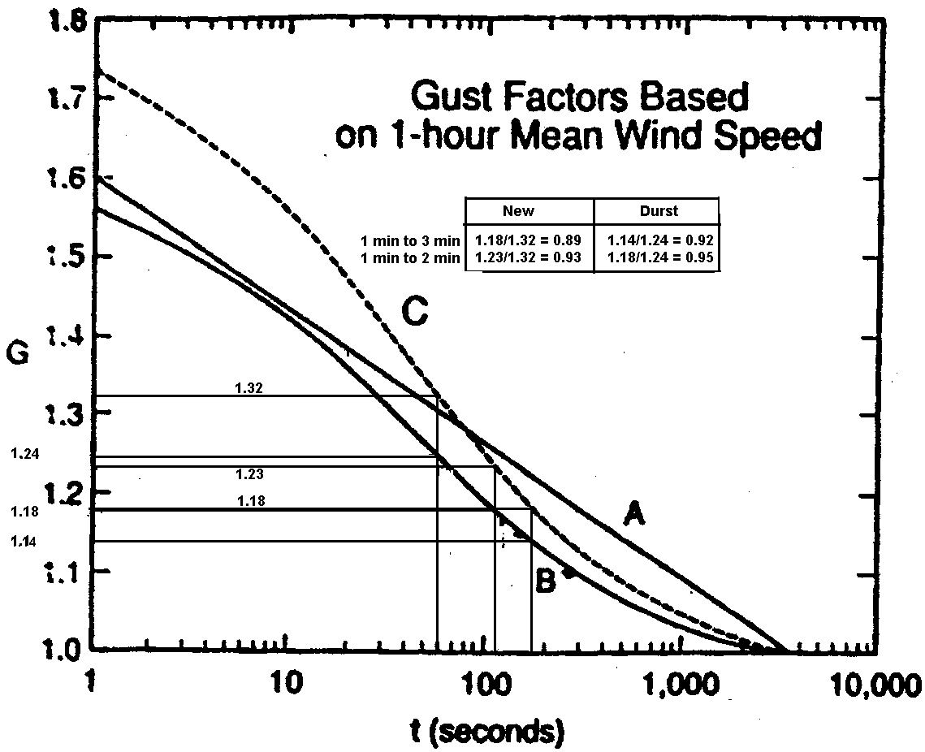
Figure B-1 Gust factors for hurricane wind speed (Curve C) as a function of time (From Gust Factors Applied to Hurricane Winds, Bulletin American Met. Society, Vol. 73, No. 5, May 1992)

The graph above depicts the gust factors as a function of time. Gust factor is given along the Y-axis and the time along the X-axis. A, B, C are the curves depicting various relations for the gust factors that has been reported by different scientist in the past. If we stick to Curve C for example and we want to find the conversion factor to convert one minute average wind speed to a three minute averaged wind speed then the factor can be determined as follows:
C^{f}₁₋₃ = gust factor for 3 minutes average/geust factor for 1 minutes average
= 1.18/1.32 = 0.894
In the Indian project we have applied a correction factor C^{f}₁₋₃ = 0.88 that has been used by IMD. Because this value does not differ much from the value found above and to be consistent with IMD we have applied their factor in WES when the maximum wind speed reported by JTWC (Hawaii) bulletin is used as input data.

