


WES USER MANUAL

Version: 1.41

Contents Page. No

1. A Guide to the manual 1
2. Introduction, what is WES 2
2.1 Functions and data flow of WES 2
Overview of the input files 3
2.3 Overview of the output files 4
3. How to use WES, Getting Started 5
3.1 Computer Configuration 5
3.2 Software configuration (environment variables) 5
3.3 Defining the WES-icon on your desktop 5
3.4 Defining the working directory 6
3.5 How to run WES 6
3.5.1 WES in RTS mode 8
4. Files description 9
4.1 The Master Input file (*.lmf file) 9
4.1.1 Options for WES Operation 9
4.1.2 Definition of different Grid system in WES 9
4.1.3 Conversion Factors 10
4.2 Creating a track file (*.trk) 10
4.2.1 Possible input parameters with respect to the cyclone intensity 11
4.3 File containing background wind and pressure field 12
4.4 The diagnostic or log file 12
5. Visualisation and checking of data in WES 13
5.1 Input file 13
5.1.1 Visualising and checking the track 13
5.1.2 Visualising the results 13
5.2 Quality checks of winds 14
5.2.1 Comparing QuickScat data with WES generated winds 14
6. References 17
7. Glossary of terms 18

Appendix A Description of the main input file for WES (*.lmf) 20
Appendix B Description of the cyclone parameters in the track file (*.trk) 23
Appendix C Description of ASCII input file containing background wind data 25
Appendix D Specification of GRIB input file containing background wind data 27
Appendix E Description of METEO output file containing wind data (SVWP OUTPUT TYPE record in main input file = SVWP) 28
Appendix F Spider-web file for cyclone wind and pressure 30
Appendix G Conversion Factors for wind speed 32
Appendix H Selection criteria of input parameter values that are accepted by WES 33
Appendix I Common Errors and Suggested Solutions in WES 34
Appendix J Some additional and specific information for the Indian Project 39
J.1 Quality checks of winds 39
J.2 How to obtain the winds? 39
J.3 Procedure to obtain data sets for comparison 39

A Guide to the manual
This user manual provides detailed information on running of WES program, version 1.4. To make this manual more accessible we will briefly describe the contents of each chapter and appendices.
Chapter 2: Introduction, provides an overview of the WES functions, area of applications and the software and hardware configurations of WES.
Chapter 3: Getting Started, gives a brief overview of the input files required, data flow within the program, the output files of the program and finally, the steps executed by WES.
Chapter 4: Preparing the files, provides practical information of the model input files
Chapter 5: Running WES, Discusses how to execute WES.
Chapter 6: Visualising the results, explains briefly how to visualise the results from WES.
Chapter 7: Conceptual Description, Describes the Physics in modelling WES. However, because the description contains a large amount of information it was decided to create a separate document named WES Scientific and Technical Reference Document.
Chapter 8: References, provides a list of publications referenced by this manual.
Chapter 9: Glossary of terms, contains a list of terms and abbreviations used in this manual and their explanations.
Appendices: Gives a description of all the files that can be used in WES. This information is required for generating some files manually or by other means of other utility programs. For the users of APCHMP project in India a special appendix (Appendix J) has been written that contain specific project related information that need to be consulted.

Introduction, what is WES
Wind Enhanced Scheme (WES) program computes surface winds and pressure around the specified location of a cyclone centre. The track prediction given by any Meteorological Agency can be taken for this purpose . However, JTWC, Hawaii is the only agency that predicts sustained maximum winds at regular intervals.
The program also calculates the radius of the maximum winds offering a possibility to compare it with Radius of Maximum winds derived from Radar and Satellite observations. Furthermore, it generates a background wind from the forecast NWP-field of which the cyclone features in the data has been removed.
The output of WES is suitable as input for the storm surge model Delft3D-FLOW, the wind hazard model and the cyclone processor.
Basically any parameterisation for cyclone winds can be used but the approach that has been implemented is based on the technique developed by G.J. Holland [1980]. The winds generated with this approach are geostrophic in nature. Asymmetry, which is usually encountered in the observed wind field, is brought out by vectorial addition of the translatory movement of the cyclone. For the detailed description of this scheme we refer you to the “WES Scientific Document” (2001).

Functions and data flow of WES
The main functions and data flow of WES are depicted in Figures 2-1 and 2-2.
Remove ‘weak’ cyclone / typhoon winds from the forecast wind and pressure file
Synthesize the cyclone wind and pressure drop on a ‘web’ type grid
Interpolate wind and pressure field to a grid
Wind Enhanced Scheme (WES)
Figure 2-1Main function of WES
A
C
Merge Background wind file with cyclone winds
D
B

Cyclone/typhoon track parameters
A
NWP global forecast
C
Cyclone wind & pressure in ASCII format on the spider-web grid file
B
Background wind & pressure on FLOW grid in Delft3D-flow file format
Master input file (*.lmf)
D
Figure 2-2Data flow of WES
Background wind & pressure merged with Cyclone winds on FLOW grid in Delft3D-flow file format
Grid file

Overview of the input files
Background wiind & pressure on FLOW grid in Delft3d-flow file format
The following input files are needed to run WES.
- *.lmf file: This is the so-called Master definition file (or the main input file) for WES. The files contain information regarding input and output files (name, location, type etc), grid information and WES run options.
- *.trk file: This file contains the cyclone information and is either created manually (by editing it) or is prepared by the Cyclone Processor
- *.wnd (optional): Containing (background) wind data originating from NWP model for WES. It may be given in the specific GRIB format (from UKMO – specially made for the Indian project) or in ASCII format.
- *.xyz or *.grd: Either of these files contain (Delft3D) grid definition. The use of either of these files in WES is optional. If not used then the grid definition of the output data must be specified in *.lmf file.
‘*’ sign above represents arbitrary filename.
Under RTS however, a name containing date and time stamp is devised for all the files. The files themselves are generated automatically.

Overview of the output files
WES produces the following output files.
- *.spw file: A file containing the synthesised cyclone wind speed and pressure (drop) on a polar-coordinate grid or the spider-web grid (see detailed description in Appendix F).
- *_out.wnd file: (OPTIONAL) This file contains the background wind & pressure fields interpolated to the user specified grid with the cyclone features removed. Furthermore, the data that originally was defined on the NWP-grid is transferred to the output grid (which has finer grid resolution then the NWP-grid). This file has the same format as space varying wind and pressure file for Delft3D (see detailed description in Appendix E).
- *_outmerge.wnd file: (OPTIONAL) This file contains the combined cyclone wind and pressure data from the spider-web and the (background) wind and pressure data originating from NWP model. However, there are two differences:
- the data are now given on a higher resolution grid and
- the cyclone winds, that were computed by the NWP model has now been replaced with winds that has been synthesised and therefore are more accurately determined.
This file also has the same format as space varying wind and pressure file for Delft3D (see detailed description in Appendix E).
- *.dia file: A diagnostic or the log file containing the steps carried out by WES + some intermediary results. It may also contain ERROR and WARNING messages from the program in case they occurred, so that appropriate actions may be taken to correct them.
‘*’ sign above represents the filename that is identical to the input file name in *.lmf.

How to use WES, Getting Started

Computer Configuration
Because WES is a FORTRAN based program it can run on any arbitrary platform. Until now the program however has only been tested and run on PC platforms under Windows 95, 98, NT and Windows 2000 only. The following configuration is advised to run WES.
Configuration | Minimal
Processor Speed | 166 Mhz
Internal Memory | 32 Mb
Swap Space | 1.5 * internal memory
Hard disk | 2 to10 Gb
Monitor | Any
CD-ROM | Any
Printer | Any

Software configuration (environment variables)
WES, being a FORTRAN executable, can be installed on any directory and requires no further configuration prior to its running. However, WES can be run in two separate, mutually exclusive, modes: as a part of the Real Time System (RTS) that has been specially designed for Delft Hydraulics’ projects in Vietnam and India or in a stand-alone mode.
Under the RTS mode two system environment variables must be set (see RTS User Manual):
- RTS_MODEL : directory name defining the location where the software has been installed
- RTS_DATA : directory name defining where the scenario file of RTS can be found
The exact location of the executable file in this case is: RTS_MODEL/w32/wes/bin/wes.exe.
In order to interrogate the environment variable’s settings you can issue a DOS-command: SET. For details of the environment variables see your Operating System documentation.
In case you want to run WES in the stand-alone mode the setting of the environment variable RTS_ MODEL has to be removed completely (or for temporary use you may temporarily rename the directory name where RTS_ MODEL is pointing to a different name).

Defining the WES-icon on your desktop
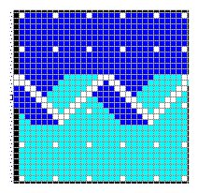
To run WES you can double click on the WES.exe file (from the Explorer or any other Explorer like tools). However, you may want to create a shortcut to WES.exe on your desktop and invoke the program by double clicking on the WES icon (see figure below).
Figure 3-1 Standard icon of WES (included in the ".exe" file)

Defining the working directory
To define the working directory right click the WES icon and select the properties option. The screen that you will see is depicted here below. Now set the path to the working directory where the *.lmf file resides, in the “Start in” field. After completing the entry in the start in field, click OK. This procedure must be repeated if you store your files in a different directory.
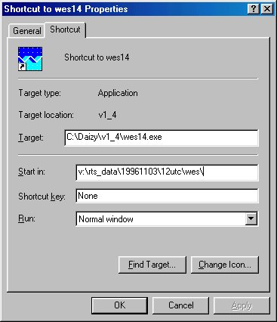
Figure 3-2 Screen shot of properties when WES clicked

How to run WES
In stand-alone mode the user must specify the input files manually. Please ensure that the hardware environment variable RTS_DATA does not point to an active directory in your system.
After ensuring that the input files are present, Invoke WES by clicking the icon on your desktop. When invoked you will be asked to specify the (main) input file for WES which acts as a command file (see figure below). This will determine which functions of WES are going to be activated.
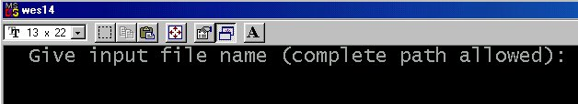
Figure 3-3 Screen shot from WES for defining the main input file

Type the *.lmf file name as indicated in Figure below.
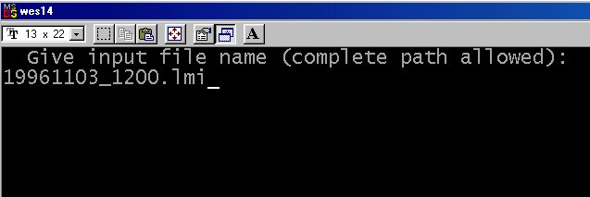
Figure 3-4 Screen shot from WES for writing the main input file

Once the input file is given, the details of the input files are read and processed.
The screen shots of WES when running is given below.

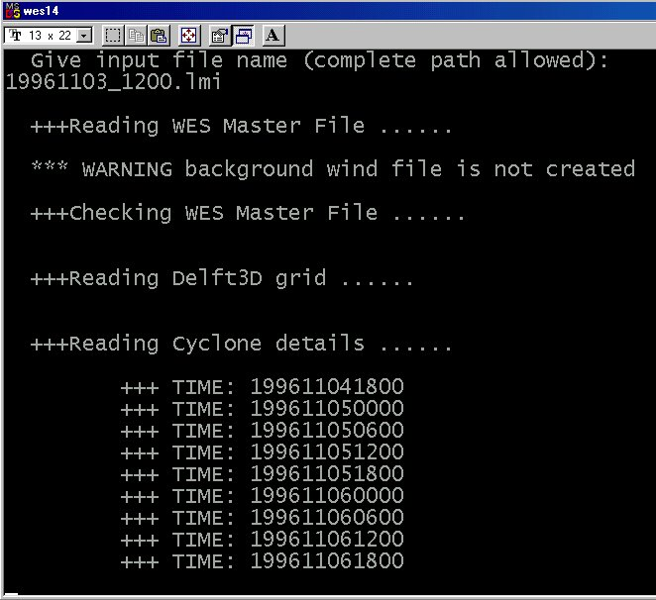
Figure 3-5 Screen shot from WES while processing

The detailed information regarding the processed input can also be seen in one of the output files of WES (*.dia).
If there are any errors in the input file WES will stop and it will generate the message “Abnormal end of the program” (see Figure below).

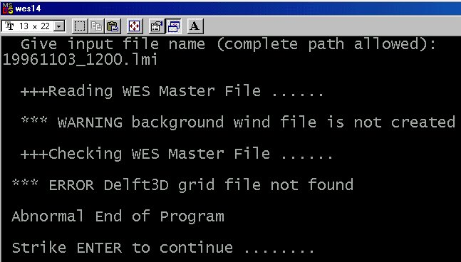
Figure 3-6 Screen shot from WES showing error in running WES

If no error is encountered, WES will produce the following output files: *.dia file, *.Wnd, *_outmrg.wnd and *. Spw.
When the background wind file is absent, WES gives an informative message about the absence of this file: “Background wind is absent”. This message is not caused by an error and the program will continue. One of the output files, namely *_out.wnd, in the output wind field the background winds would remain ‘zero’. The detailed description of different possible errors that can occur and the remedial actions to be taken in WES are given in Appendix I. Choosing the option “Ctrl C” from the keyboard would terminate the program before completion.

WES in RTS mode
In RTS mode, the system takes care of all the input files and runs WES automatically. Intervention from the user is not required. Please ensure that the environment variable settings (e.g hardware environment variable RTS_DATA) of the machine have been properly set (see section 3.2) to enable the program to run correctly.

Files description

The Master Input file (*.lmf file)
If not run under RTS, the Master definition file must be created manually. The file should contain the options for running WES, information about the model domain, the details about the spider-web grid size, the simulation period and other details about the location of the required files. In the following section description of various grid types that are used by WES that need to be described in the *.lmf file will be given. For a detailed description of all the parameters in the *.lmf file, Appendix A may be referred to.

Options for WES Operation
The WES program can be run with the following different options:
- With or without background wind and pressure (winds from NWP model output),
- Choice from two types of background wind file,
- Either or not include cyclone wind file (here WES will function only as file converter for the background wind),
- Define the output either on a specific (curvilinear) grid defined in a Cartesian co-ordinate system or on a regular grid in geographical co-ordinate system,
- Merge the synthesised cyclone winds and pressure with the background winds and pressure and create a merged file
- Get an extensive output report on how WES has interpreted the input data and produce some intermediary results (among which Radius of max. winds) or get only a brief log-file containing the steps carried out the by WES.

Definition of different Grid system in WES
The different types of grids used in WES are:
- Spider-web grid: In order to be flexible and independent from the method of parameterisation applied for synthesising the cyclone wind, an elegant technique has been adopted requiring data on a polar co-ordinate grid centred on the cyclone centre (Stelling, 1999). On this, the so-called spider-web, grid the cyclone wind and pressure fields are generated. The number of grid points in the spider-web both in the radial and in the tangential direction is user specifiable. The radius of the cyclone is user specifiable. If the radius is changed, the grid size will vary according to number of grids specified
J = 4 3 2 1 …. etc.
I = 1
2
3
6
Figure 4-1Definition of the spider-web grid
- Numerical Weather Prediction (NWP)-grid: This is the grid on which the background winds that are generated by NWP-model are specified. The files are written either in GRIB (GRID based Binary) format or in ASCII format. In case GRIB file is prescribed then the grid definition is contained within this file. If ASCII file is prescribed then the grid (in geographical co-ordinates) associated with this data must be specified separately as well. For a detailed description of these files refer to Appendices C and D.
- Output grids: that can be either
- Delft3D grid: This is the grid that is used by Delft3D-FLOW on which the output of WES may be produced. The grid is defined in the files that has extensions: *.grd or *.xyz. For a detailed description of these grids refer Delft3D flow manual or
- Arbitrary grid in geographical co-ordinates: This is the output grid when ASCII type of input file for the NWP wind has been specified and output type is of the type MALAWI. In this case the output grid ≡ input grid.

Conversion Factors
Any wind speed that is mentioned in the advisories and or computed by the NWP models is defined as wind speed that has been averaged over a certain period of time. For example, JTWC (Hawaii) advisory mentions wind speeds that are based on 1-minute average while the IMD uses the wind speed based on 3-minutes average. Because in WES the cyclone wind speed and the background wind speed data may originate from two different sources and in order to enable WES to compute wind speed in consistent manner, two conversion factors have been introduced:
- Conversion factor for the background wind speed to convert the values from the averaging period used in the input file to the required, x-minute, average by the user.
- Conversion factor for the cyclone wind speed to convert the values from the averaging period used in the cyclone advisories to the required, x-minute, average by the user.
These factors can be found by determining the inverse ratio of the Gust factor for these periods respectively. For a detailed overview and treatment of the Gust factor and the conversion factor we refer you to Appendix G.

Creating a track file (*.trk)
This file comes from the Cyclone Processor or can be edited manually. This file contains the main information on the cyclone parameters:
- the initial and predicted positions of the cyclone centre (in geographical co-ordinates),
- the direction and speed of movement of the cyclone centre during the previous 6 hrs,
- the intensity of the storm in terms of associated maximum winds and the corresponding pressure drop in Pascal.

Possible input parameters with respect to the cyclone intensity
V_{max} The maximum sustained winds in the cyclone (kts). This parameter is compulsory. It is estimated from satellite data.
Pdrop Represents the difference between the ambient and central pressures (HPa). This parameter is estimated from satellite intensities, or may be computed using the following relation Vmax=C√(Pdrop) (see: WES Scientific Document). In some cases P_{drop} and V_{max} will be the only pieces of data available.
Radius of 35, 50 & 100 kt winds
These parameters are estimated from satellite pictures and are reported in JTWC (Hawaii) bulletins.
B This parameter determines the shape of the wind and pressure profile as a function of distance from the cyclone centre. In some regions B has been determined from climatological data and you may wish to use this value. In the modified form, B value is calculated from V_{max}, which can vary from day to day in a given cyclone. Hence B value is not kept constant in the initial and predicted intensities of cyclone.
A This parameter along with B determines the radius at which maximum wind speeds occur. It is very unlikely that you will know the value of this parameter.

These information may be obtained from cyclone advisories from JTWC (Hawaii), UKMO, IMD, JMA or any other Meteorological institutes in the world. In all advisories, the present and forecast positions of the cyclones are given. The cyclone intensity parameter however is only specified in the JTWC (Hawaii) advisory in the form of prevailing and forecast maximum winds or in the IMD cyclone bulletins as prevailing cyclone intensity (specified in T-number). Specifying the positions, the prevailing and the expected wind speeds and pressure drops information are sufficient to synthesise the cyclone winds. In this case certain assumptions have to be made about the model parameters (see the Technical and Scientific report of WES).
In addition to this information, JTWC (Hawaii) advisory also contains information on the present and expected radius of 100 knots wind (R_100), 50 knots wind (R_50), and 35 knots wind (R_35) as a function of position (c.q. time). In this case the assumptions mentioned earlier are not required and WES can use the above radii in order to find an optimal fitting of the synthesised winds to the observed values. When not available or not used the related columns for these parameters in the “trk” file must be filled with the “Missing Index” value (= 1e30).
Therefore, the “trk’ file allows the user to specify these radii values making the program very robust and versatile. A detailed description of the *.trk file is shown in Appendix B.
Also of importance is the explanation on how WES will treat the parameters when redundant information is specified in this file. For the description on how WES will treat in this situation we refer you to Appendix H of this manual.

File containing background wind and pressure field
The initial and forecast wind and pressure fields are produced and available regularly from various meteorological agencies. This wind field is known as the background wind field. This information, commonly produced by the global NWP-models they use, could have served as input for the operation of the storm surge model as well as Wind Damage Model. However, because the resolution of the global model is usually very coarse, this data is not directly suitable to drive the storm surge model and produce accurate results. Therefore a wind and pressure data on a finer resolution grid is required.
After testing of the storm surge model and wind damage model it is concluded that the availability and the usage of the background wind in most cases is not strictly required. In the areas close to (100 to 200 km from) the cyclone centre, the cyclone wind is predominant. Though the usage of the background wind is not essential, provision has been made to make use of the data whenever they are available.
The formats of the file that can be accessed by the program are GRIB-format (e.g. data from UKMO) or ASCII (e.g. data from IMD). Depending upon the type the appropriate option is to be specified in the definition of the "Background Wind" in the ”lmf”-file. For detailed description of this file Appendices C and D may be referred.

The diagnostic or log file
The diagnostic file or *.dia file: In the *.lmf file, the option “EXTENDED_REPORT = “ enables the user in the input file to specify whether an extended diagnostics are to be produced or not (filename = input file name + extension “. dia”). Extended diagnostics include process-logging, extensive error and warning messages, etc. Compact diagnostic will only contain process-logging and main error messages. If the user mentions “YES” for EXTENDED_REPORT, extended diagnostics will be produced else compact diagnostics will be produced.
In the extended mode the following information can be viewed.
- The details of the master definition file (*.lmf) file.
- The details of cyclone *.trk file read including the computed constants and parameters such as A, B, and the pressure drop for different time step.
- Details of theDelft3D grid used.
Summary of data in the spider-web file for Delft3D, which consists of date and time of the cyclone position, maximum wind speed in Kts, its direction and radius of the maximum winds and direction in which it occurs.

Visualisation and checking of data in WES

Input file

Visualising and checking the track
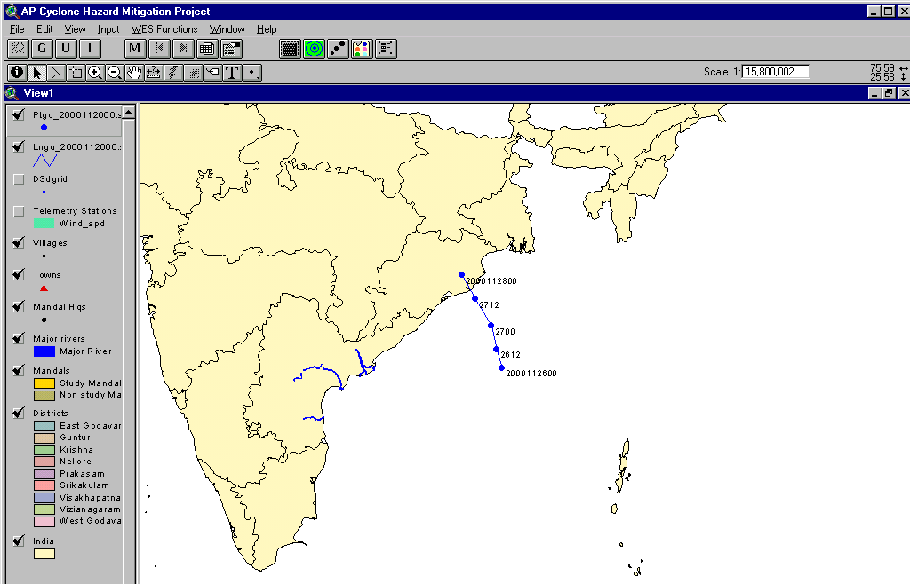
To inspect the cyclone track you may use the Cyclone Processor program (for a detailed description we refer you to the Cyclone Processor User Manual).
Figure 5-1 Tracks shown by the Cyclone processor

Visualising the results
Using Cyclone Processor the following output files of WES can be visualised
- Background wind, with or without the synthesised cyclone winds superimposed on it, on the Delft3D-FLOW grid, the so called SVWP type file
- Cyclone winds on the spider-web grid (file).
The figures are shown below as example. The top figure depicts the winds on Delft3D grid and the lower figure depicts the same on the spider-web grid. For the operational details on how to inspect the result we refer you to Cyclone Processor User Manual.

Quality checks of winds
The derived winds from WES can be compared with observations from the Satellites or from the surface winds reported by coastal observatories. For comparison with the winds derived from scatterometer data from Quick Scat Satellite one can download the data from the web-site: http://manati.wwb.noaa.gov/cgi-bin/qscat_day-1.pl .
Figure 5-2 Wind fields on Delft3D grid
However, there are some limitations to this data set. The accuracy of the winds is claimed to be 1.4 m/s upto the speeds of 20 m/s and an accuracy of 10% beyond that. The maximum measurable speeds with the scatterometer are 50kts. Hence, with this method higher wind speeds cannot be compared with observations.

Comparing QuickScat data with WES generated winds
Graphical comparison is made in the case of Orissa cyclone (28th October 1999, 12 UTC comparison date) and Cuddalore Cyclone (27-29 November 2000). Figures 7.2(a1) to 7.2 (h2) are the plots of wind direction and wind speed in different cross-sections across the cyclone. The wind speeds and direction of the winds from Quick Scat data are shown in each diagram at the appropriate points. There is a very good agreement for wind speeds and wind directions in most of the cross-sections while in the other, the deviations are more but within the tolerable limits.

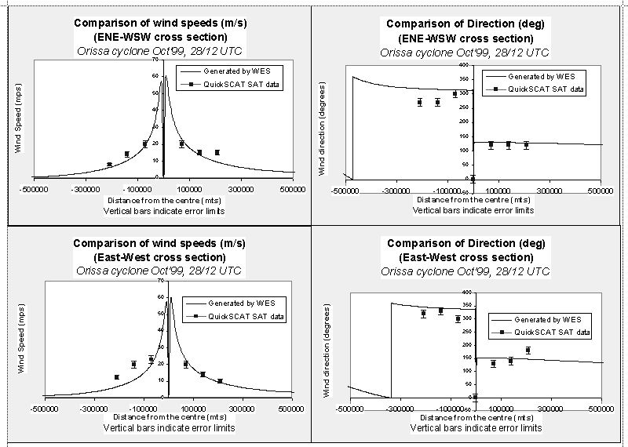
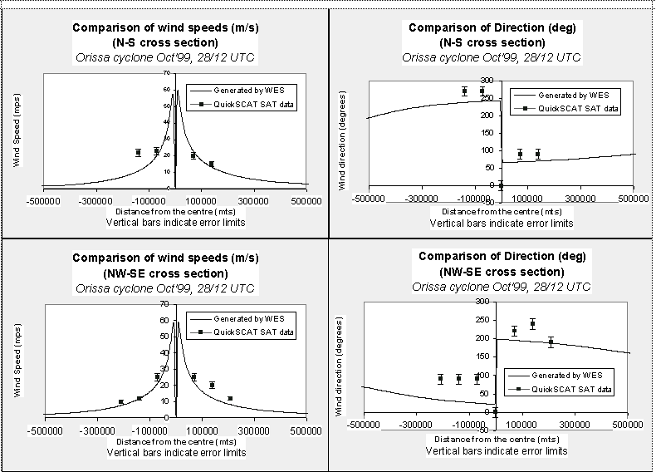

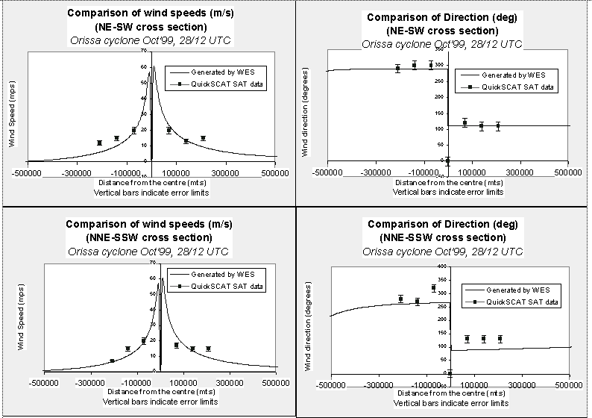
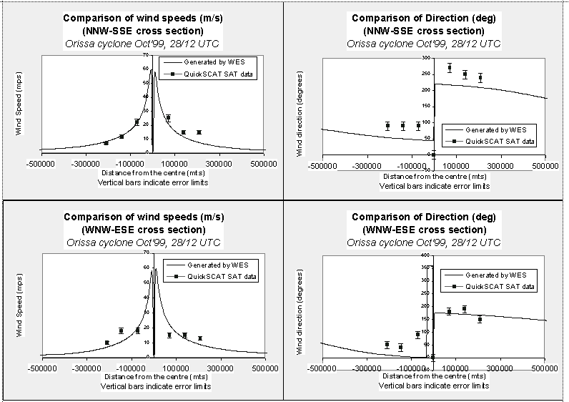
Figure 5-3 Comparison of WES winds and direction with derived winds from Quick Scat satellite for 16 different wind directions

References
Cyclone Processor User Manual, APCHMP Project Document, 2001
Delft3D-FLOW User Manual, Version 3.05, WL|Delft Hydraulics, September 1999
G.S. STELLING, 1999 Delft Hydraulics internal notes on Cyclone modelling
Holland, G.J, 1980: An Analytical Model of the Wind and Pressure Profiles in Hurricanes. Monthly Weather Review 108, 1212-1218.
JOHN D. STACKPOLE, A Guide to GRIB (Edition 1), The WMO Format for the Storage of Weather Product Information and The Exchange of Weather Product Messages in Gridded Binary Form
Real Time System User Manual, APCHMP Project Document, March 2001
KRISHNA RAO.A.V.R., DEEPAK VATVANI, P.DAIZY NAMRATHA and S.GOODCHILD, 2001: WES Scientific Document, APCHMP Project Document, pp 27
W.R. KRAYER and R.D. MARSHALL, Gust Factors Applied to Hurricane Winds, Bulletin American Met. Society, Vol. 73, No. 5, May 1992

Glossary of terms

APCHMP – Andhra Pradesh Cyclone Hazard Mitigation Project

Cyclone Processor - Graphical user Interface program to view and edit cyclone paths

dia - Standard file name extension used for WES Diagnostic file

DOS - Disk Operating System

Delft3D-FLOW - Storm Surge Modelling System

FORTRAN - Programming language

GRIB - Gridded Binary

grib or Ascii - Standard file name extension used for WES background wind fields

GRID - Delft3D grid

IMD - India Meteorological Department

JTWC - Joint Typhoon Warning Center

JMA – Japanese Meteorological Agency

Kts (Knots) - unit to measure winds

lmf - Standard file name extension used for WES Master definition file

MALAWI - A certain type of ASCII output file from WES

NWP - Numerical Weather Prediction

(Hecto-) Pascal - unit to measure Pressure

PC - Personal Computer

Quick Scat – A polar orbitting Satellite carrying a scaterometer the data from which can
be used to compute winds using microwave frequency

RTS_MODEL - directory name defining the location where the software has been
installed
RTS_DATA - directory name defining where the scenario file of RTS can be found

RTS - Real Time System

spw - Standard file name extension used for WES Spider-web

SVWP - Space Varying Wind and Pressure Fields

trk - Standard file name extension used for WES Track file

UKMO - United Kingdom Meteorological Office

WES – Wind Enhancement Scheme

wnd - Standard file name extension used for WES wind file

xyz or grd - Standard file name extension used for WES Delft3D grids

Appendix A Description of the main input file for WES (*.lmf)
Sample Input file for WES (‘Filename’.LMF).
Position of the 1st column in the file

1. COMMENT = WES run with cyclone and UKMO-file (GRIB)
COMMENT = This file is created on 200009281600UTC
COMMENT = Grid Delft3D file 259 by 129
2. BACKGROUND_WIND = YES
LAT, LON_LEFT_DOWN = 5.00 75.00
LAT, LON_TOP_RIGHT = 25.00 100.00
RESOLUTION_(DEGREE) = 0.40 0.40
3. FILE_TYPE = GRIB
GRIB_FILE_NAME = d:\WES\199910271200.grib
4. CYCLONE_DATA = YES
CYCLONE_PAR._FILE = d:\WES\Orissa_cyclone.trk
5. SPIDERS_WEB_DIMENS. = 400 16
RADIUS_OF_CYCLONE = 600000.000
6. WIND CONVERSION FAC = 1.12
WIND CONV. FAC (TRK)= 1.00
7. D3D_START_DATE = 19991027 1200 UTC
D3D_SIM._PERIOD = 2880.000 MINUTES
8. D3D_GRID_FILE_TYPE = XYZ
D3D_GRID_FILE_NAME = d:\WES\latlon9h_at_centre.xyz
D3D_GRID_DIMENSION = 259 135
D3D_COORDINATES = CURVILINEAR
9. NO._OF_OBS._DATA = 0
OBS._DATA_FILE_NAME =
10.SVWP OUTPUT TYPE = SVWP
11.MERGE_WINDS_&_PRES. = NO
12.EXTENDED_REPORT = YES

- The first NN lines are comments and should be filled in as information for yourself. All lines proceeded by the keyword COMMENT will be treated as comments. There can be any number of comments.
- BACKGROUND WIND Option is to be specified (Yes/No). If the type (see 3) is set to ASCII then the grid characteristics are to be specified here as well, otherwise they will be discarded. When background wind is not specified the program will only generate a spider-web file and the merge option will be discarded. Background wind usually originates from a numerical weather prediction (NWP) model.
- The type of background wind (NWP) input file e.g. GRIB, ASCII (containing wind and pressure). The path of the existing file may be included otherwise the current working directory will be assumed. WES may be run without the background wind. If WES is run without the background wind then the file-type need not be specified.

- Cyclone flag is to be specified. In case no cyclone is to be accounted for the program will only generate the output file for Delft3D containing the background wind and pressure field and the merge option will be discarded. Otherwise, the file name containing the track parameters must be specified next. Advised extension for the file name: “trk”. The path of the existing file may be included otherwise the current working directory will be assumed.
- The dimension of the spider-web grid is to be specified here as well as the maximum radius of the cyclone. The grid resolution in the radial direction (i.e. ratio of cyclone radius/number of points) must be sufficient to resolve the expected wind gradients. From our experience, the following values may be prescribed for the dimensions and cyclone radius (R_{cyc}): 400 by 16 points and 600,000 meters respectively. The resolution in the radial direction is then equal to 1500 meters. A resolution between 1000 – 2000 meters is required especially when dealing with compact cyclones with high wind gradients.
The radius also determines the domain of influence of the cyclone parametric model. Measured from the cyclone centre all background wind within the specified radius will be replaced by the values generated by the parametric model. A smooth transition is ensured by interpolating the values from the parametric model towards the NWP-values from 0.5 R_{cyc}.
- When wind force is measured, small (temporal) scale fluctuations are removed by averaging the measured wind during a certain period. However, each country defines its own standard and defines a different averaging period. To produce a consistent output and to allow you to use input data from different sources, separate conversion factors for the background wind and cyclone wind parameters have been defined.
- WIND CONVERSION FAC: is the conversion factor for the background wind to convert the values from the averaging period used in the input file to the, required, x-minute average by the user.
- WIND CONV. FAC (TRK): is the conversion factor for the cyclone/typhoon wind (specified in the track file or TRK-file) to convert the values from the averaging period used in the cyclone advisories to the, required, x-minute average by the user.

For example, cyclone wind data from JTWC (Hawaii) is usually based on 1 minute average. If the output is to be based on 3 minutes average as per IMD convection, then a multiplication factor equal to 0.9 to the cyclone parameters (WIND CONV. FAC (TRK)) should be specified. In this case the other conversion factor which is used is one.
- D3D_START_DATE is the Date & time of the Delft3D simulation.
D3D_SIMPERIOD is the total simulation time (e.g. 3 days = 4320.00 minutes, etc).
- Type of Grid file to be used. The format of the Grid file is the same as being used in Delft3D-FLOW (either ‘GRD’ type or ‘XYZ’ type). Subsequently, the path of this file, dimensions of the GRID and the co-ordinate type (Spherical, Curvilinear / Rectilinear) must be specified.
- 9.Number of observed data points and path to the file containing observed values (not yet active).
- Type of output file (SVWP or MALAWI) – see Delft3D User Manual. The project in India is fixed to SVWP.
- Specify whether a merged file is required or not. (Only available if output file type equals SVWP; see also other conditions above). This output file type is temporary and may be removed altogether in future.
- This option enables you to specify whether extended diagnostics are to be produced or not (filename = input file name + extension “. dia”). Extended diagnostics include e.g. process-logging, extensive error and warning messages, etc. Compact diagnostic will only contain process-logging and main error messages.
Appendix B Description of the cyclone parameters in the track file (*.trk)
File contents: Description of observed features of the cyclone and predicted future positions and characteristics.

File Format: ASCII free formatted data.

Record description:
record 1-N : A text header (comments) defining the file and the content of the following records (to be superseded by an asterisk in the first column).
record N+1 : Year (integer), month (integer), day (integer), and hour of prediction (integer),
Latitude of centre in decimal degrees (real), longitude of centre in decimal degrees (real),
Direction of movement over past 6 hrs in degrees (real), speed over past 6 hrs in kts (real),
Maximum sustained velocity in kts (real),
Radius of 100, 50 and 35 Kt winds in Nautical miles (real),
Constants B (real) and A, as defined in Holland (1980)
Central pressure drop (background pressure - central pressure) in Pa (real).
record N+2 : Year (integer), month (integer), day (integer), and hour of prediction (integer),
Latitude of centre in decimal degrees (real), longitude of centre in decimal degrees (real),
Maximum sustained velocity in kts (real),
Radius of 100, 50 and 35 Kt winds in Nautical miles (real),
Constants B (real) and A, as defined in Holland (1980)
Central pressure drop (background pressure - central pressure) in Pa (real).

Record N+2 is repeated PTIME times.

Restrictions: The dates and times of the typhoon positions should correspond to the validity times of the Background wind field (NWP) data.
Any undefined values should be indicated using the missing data value 1.0e+30.

Example: Cyclone track for 13 positions:

* EXAMPLE file for typhoon tracks that is required by WES
* A and B are constants required by the Holland’s parametric model.
* Setting Pdrop to PMDI (Parameter missing data Index = 1.e30) is to be used with caution
* Pressure drop is in Pascal.
*yyyy mm dd hh lat long Dm Vm MaxW R100 R50 R35 B A Pdrop
* (UTC) deg. (kts) (kts) (nm) (nm) (nm) (Pa)
2000 11 26 06 9.8 90.5 280 28 25 1e30 1e30 1e30 1e30 1e30 275
2000 11 26 12 10.1 89 25 1e30 1e30 1e30 1e30 1e30 275
2000 11 26 18 10.4 89 25 1e30 1e30 1e30 1e30 1e30 275
2000 11 27 00 10.8 88 25 1e30 1e30 1e30 1e30 1e30 275
2000 11 27 06 11.1 86.8 30 1e30 1e30 1e30 1e30 1e30 450
2000 11 27 12 11.3 85.8 45 1e30 1e30 1e30 1e30 1e30 1000
2000 11 27 18 11.4 85.2 45 1e30 1e30 1e30 1e30 1e30 1000
2000 11 28 00 11.6 83.8 55 1e30 1e30 1e30 1e30 1e30 1500
2000 11 28 06 11.6 83 65 1e30 1e30 1e30 1e30 1e30 2090
2000 11 28 12 11.6 82.2 77 1e30 1e30 1e30 1e30 1e30 2940
2000 11 28 18 11.6 81.4 102 1e30 1e30 1e30 1e30 1e30 6560
2000 11 29 00 11.6 80.8 90 1e30 1e30 1e30 1e30 1e30 4020
2000 11 29 06 11.6 80.1 66 1e30 1e30 1e30 1e30 1e30 2090

Appendix C Description of ASCII input file containing background wind data

File contents: forecast wind and surface pressure (Wx,Wy,PMSL)

File Format: ASCII free formatted data

File name: yyyymmddhhmm.nwp (example)

File contents : The file contains the following records:
record 1 : A constant (averaged value; averaged over the entire model) atmospheric pressure value in N/m**2 (= Pascal) and a pressure correction at the boundary (y or n; here always: y).
record 2 : Calendar Date and time in yyyymmdd hhmm
record 3 : NMAX records for MMAX values of the wind component in the East-West direction in m/s. Positive value is associated with wind directed towards East. Start with most southern row
record 3+NMAX : NMAX records for MMAX values of the wind component in the North-South direction in m/s. Positive value is associated with wind directed towards North. Start with most southern row
record 3+2*NMAX : NMAX records for MMAX values of the atmospheric pressure values in N/m**2.
Start with most southern row
records 2 to 3+2*NMAX are repeated for every date-time group.

File type : FREE FORMATTED / UNFORMATTED

Restrictions : Date time groups conforming to track advisory timing.

Example : For a model containing 27*29 points in the horizontal, and average pressure 101300 Pa, the related space varying wind and pressure file will contain the following parameters and matrices (MMAX = 27 by NMAX = 29) (only first four time blocks are shown):

101300.0 y Av. pressure in the model + corr.
20000908 0600 UTC Date Time (1st block; -06)
27 values for the wind component in the EAST-dir. NMAX = 29 records
27 values for the wind component in the NORTH-dir. NMAX = 29 records
27 values for the atmospheric pressure NMAX = 29 records
20000909 0000 UTC Date Time (2nd block; 00)
27 values for the wind component in the EAST-dir. NMAX = 29 records
27 values for the wind component in the NORTH-dir. NMAX = 29 records
27 values for the atmospheric pressure NMAX = 29 records
20000909 0600 UTC Date Time (3rd block; +06)
27 values for the wind component in the EAST-dir. NMAX = 29 records
27 values for the wind component in the NORTH-dir. NMAX = 29 records
27 values for the atmospheric pressure NMAX = 29 records
20000909 1200 UTC Date Time (4th block; +12)
27 values for the wind component in the EAST-dir. NMAX = 29 records
27 values for the wind component in the NORTH-dir. NMAX = 29 records
27 values for the atmospheric pressure NMAX = 29 records
(………………)
20000911 1800 UTC Date Time (13th block; +72)
27 values for the wind component in the EAST-dir. NMAX = 29 records
27 values for the wind component in the NORTH-dir. NMAX = 29 records
27 values for the atmospheric pressure NMAX = 29 records
Appendix D Specification of GRIB input file containing background wind data

File contents: forecast wind and surface pressure (Wx,Wy,PMSL)

File Format: GRIB format

File name: yyyymmddhhmm.nwp (example)

File contents : The file contains the following records:

This file is stored in the following format (brief description is given here due to the complex nature of the GRIB-format. For a more detailed description of this file refer to “A Guide to GRIB by John D.Stackpole”).

Data record 1 MSLP at time 0.
Data record 2 U component of wind (+ve if wind is blowing from South to North) at time 0
Data record 3 V component of wind (+ve if wind is blowing from West to East) at time 0
Data record 4 MSLP at time 1
Data record 5 U component of wind (+ve if wind is blowing from South to North) at time 1
Data record 6 V component of wind (+ve if wind is blowing from West to East) at time 1

Appendix E Description of METEO output file containing wind data (SVWP OUTPUT TYPE record in main input file = SVWP)

File contents: Time series for wind speed, wind direction and atmospheric pressure for a space varying wind and pressure (data group Processes - Wind).
File format: Free formatted.
File name: <name>.wnd.
Generated by: Some off-line program.
Record description:
record 1 Overall constant atmospheric pressure in [N/m2] and one character (y, or n) to indicate if a pressure correction is applied at the open boundaries.

record 2 Time in [minutes] from simulation start time (data group Time Frame) and (optional) a constant wind speed in [m/s], valid for the entire model area and used in the excess temperature model.

record 3- Mmax values of the wind component in the East-West direction in [m/s],
3+Nmax-1 positive for Westerly wind for all Nmax-values.

record 3+Nmax Nmax records for Mmax values of the wind component in the North-
- record South direction in [m/s] . Positive value is associated with wind directed
3+2*Nmax-1 towards North.

record 3+2*Nmax Nmax records for Mmax values of the atmospheric pressure values in
- record [N/m2]
3+3*Nmax-1

Records 2 to 3+3*Nmax-1 are repeated for each time instance of the time series.

Example: Model area of 25 * 33 grid points (Mmax = 25; Nmax = 33). In the example below, the input data is printed in Courier New 9; comments (not in the file) are printed in Arial Narrow 9.

100000.0 y Average atmospheric pressure; yes, apply correction
0.0 Time in minutes
{33 records with 25 values each} Wind component in the East-direction
{33 records with 25 values each} Wind component in the North-direction
{33 records with 25 values each} Atmospheric pressure
340.0 Time in minutes
{33 records with 25 values each} Wind component in the East-direction
{33 records with 25 values each} Wind component in the North-direction
{33 records with 25 values each} Atmospheric pressure
600.0 Time in minutes
{33 records with 25 values each} Wind component in the East-direction
{33 records with 25 values each} Wind component in the North-direction
{33 records with 25 values each} Atmospheric pressure
1240.0 Time in minutes
{33 records with 25 values each} Wind component in the East-direction
{33 records with 25 values each} Wind component in the North-direction
{33 records with 25 values each} Atmospheric pressure
Appendix F Spider-web file for cyclone wind and pressure

File contents : The file contains the following records:
record 1 : A text record specifying the source of data contained in this file.
record 2 : Date of the NWP file – and therefore the cyclone wind
record 3 : Dimension of the spider-web grid (MAXRAD & MAXPHI)
record 4 : Maximam radius of the cyclone considered in meters.
record 5 - 9 : 5 text records explaining the meaning of the data blocks that are henceforth contained in the file.

If the boundary conditions must be corrected for the pressure then the keyword PCORR must be mentioned somewhere in records 1-9.

If the co-ordinates of the cyclone are giving in FLOW model co-ordinates (M,N) then the keyword MNCOORD must be mentioned somewhere in records 1-9. If this keyword is not present, the co-ordinate of the cyclone is given in decimal (λ,ϕ) geographical co-ordinates.

record 10: Time in minutes relative to the reference date of the simulation
record 11: Cyclone Centre in M- / λ- dir., Cyclone Centre in N-/ϕ- dir. , Central Pressure drop (Pa)
record 11+3*MAXRAD: Time in minutes + 3 blocks of MAXRAD records containing MAXPHI values of respectively: wind speed (m/s) and direction (degrees) and pressure drop (N/m2)
records 10 to 3*MAXRAD are repeated for every moment in time.

File Format: ASCII free formatted data.

Restrictions: - Times must be multiples of the integration time step DT.
- The wind components are specified at centre of computational cells.

Example: For a spider-web grid containing 10*8 points the related file will contain the following parameters and matrices (MAXRAD = 100 by MAXPHI = 16):

# Spider-web derived from GRIB file: d:\les\newest\output\latest.GRIB
# 199910261200
# 100 16
# 1000000.00 PCORR MNCOORD
# Time in minutes relative to 00:00 of the reference date of the MD-file for FLOW
# Cyclone Centre in M-dir., cyclone Centre in N-dir. , Central Pressure drop (Pa)
# Wind speed in m/s
# Direction wind is coming from , degrees from true north
# Pressure drop in Pa
0.0 Time in minutes
246.8632 17.72105 1564.984 Cyclone centre in M- and N-dir.+ Central Press. drop (Pa).
16 values for the wind speed NMAX = 100 records
16 values for the wind direction NMAX = 100 records
16 values for the pressure drop NMAX = 100 records
360.0 Time in minutes
244.3554 20.11948 1855.961 Cyclone centre in M- and N-dir.+ Central Press. drop (Pa).
16 values for the wind speed NMAX = 100 records
16 values for the wind direction NMAX = 100 records
16 values for the pressure drop NMAX = 100 records
720.0 Time in minutes
242.5273 22.41061 1916.078 Cyclone centre in M- and N-dir.+ Central Press. drop (Pa).
16 values for the wind speed NMAX = 100 records
16 values for the wind direction NMAX = 100 records
16 values for the pressure drop NMAX = 100 records
1080.0 Time in minutes
239.6946 25.04839 2007.906 Cyclone centre in M- and N-dir.+ Central Press. drop (Pa).
16 values for the wind speed NMAX = 100 records
16 values for the wind direction NMAX = 100 records
16 values for the pressure drop NMAX = 100 records

Appendix G Conversion Factors for wind speed

Different Meteorological agencies use different averaging period to measure the surface wind. Subsequently, all the wind speed data they use are converted to these averaging period in order to allow them to compare their data with the observations. Some of the agencies may use one-minute average while others uses 3 min and 10 min averages. To compare the data from one agency to those from the other agency then corrections must be applied by multiplying one set of the wind speeds with an appropriate factor.
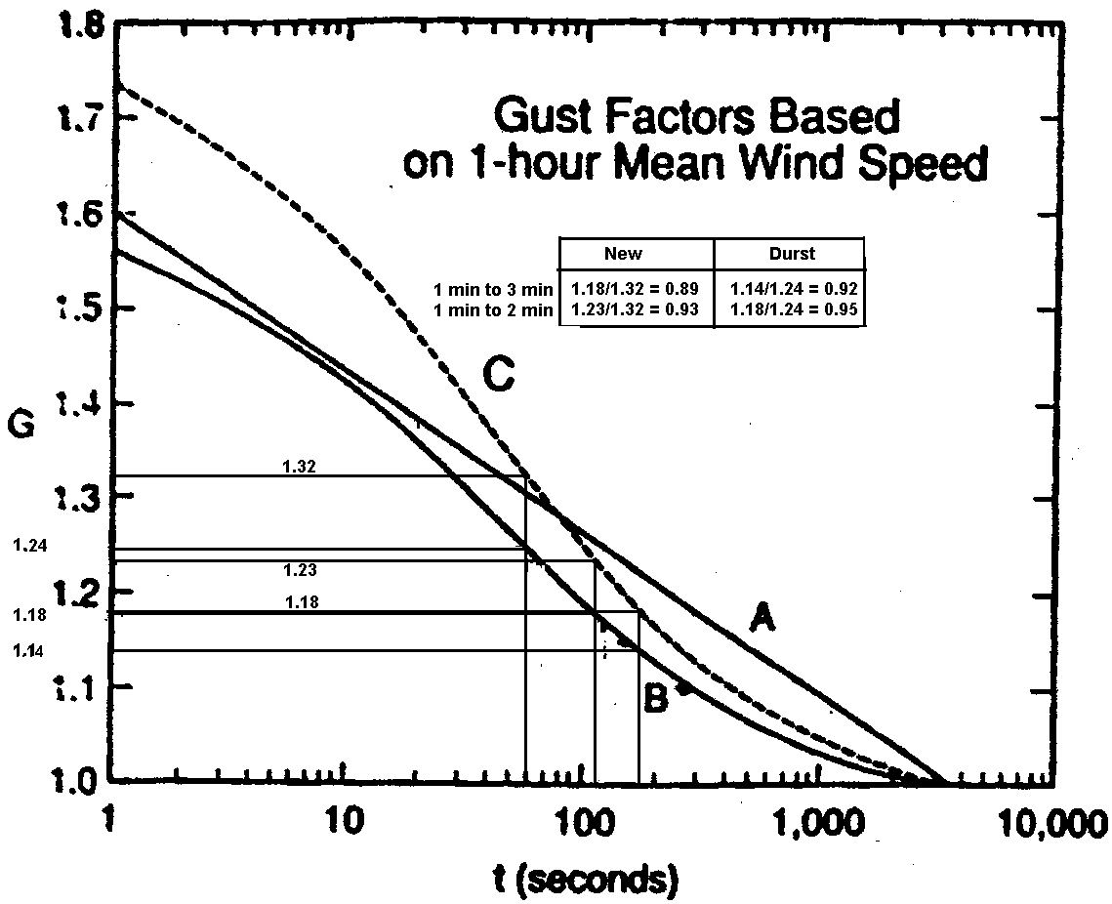
Figure G-1 Gust factors for hurricane wind speed (Curve C) as a function of time (From Gust Factors Applied to Hurricane Winds, Bulletin American Met. Society, Vol. 73, No. 5, May 1992)

The graph above depicts the gust factors as a function of time. Gust factor is given along the Y-axis and the time along the X-axis. A, B, C are the curves depicting various relations for the gust factors that has been reported by different scientist in the past. If we stick to Curve C for example and we want to find the conversion factor to convert one minute average wind speed to a three minute averaged wind speed then the factor can be determined as follows:
C^{f}₁₋₃ = gust factor for 3 minutes average/geust factor for 1 minutes average
= 1.18/1.32 = 0.894
In the Indian project we have applied a correction factor C^{f}₁₋₃ = 0.88 that has been used by IMD. Because this value does not differ much from the value found above and to be consistent with IMD we have applied their factor in WES when the maximum wind speed reported by JTWC (Hawaii) bulletin is used as input data.
Appendix H Selection criteria of input parameter values that are accepted by WES

 | V_{max}  (kts) | Pd | R  35 | B | A | Action
 | X | - | - | - | - | ERROR
 | < 20 |  |  |  |  | No wind/pressure generated
 | ✓ | ✓ | ✓ | ✓ | ✓ | Warn for redundancy, disregard R_35 + Pdrop. Rescale Pdrop
 | ✓ | ✓ | ✓ | ✓ | X | Warn for redundancy, disregard R_35 + Pdrop, calculate A & rescale Pdrop
 | ✓ | ✓ | X | ✓ | ✓ | Warn for redundancy, disregard Pdrop, Rescale Pdrop
 | ✓ | ✓ | X | ✓ | X | Warn for redundancy, disregard Pdrop, calculate A and Rescale Pdrop!
 | ✓ | X | ✓ | ✓ | ✓ | Warn for redundancy, disregard R_35, calculate Pdrop!
 | ✓ | X | ✓ | ✓ | X | Warn for redundancy, disregard R_35, calculate A and Pdrop
 | ✓ | X | X | ✓ | ✓ | Calculate Pdrop
 | ✓ | X | X | ✓ | X | Calculate Pdrop and A
 | ✓ | ✓ | ✓ | X | ✓ | Wrong input ? A given while B = PMDI; set A = PMDI
 | ✓ | ✓ | X | X | ✓ | Wrong input ? A given while B = PMDI; set A = PMDI
 | ✓ | X | ✓ | X | ✓ | Wrong input ? A given while B = PMDI; set A = PMDI
 | ✓ | X | X | X | ✓ | Wrong input ? A given while B = PMDI; set A = PMDI
 | ✓ | ✓ | ✓ | X | X | Warn for redundancy, disregard Pdrop, calculate A+B from R_35 & rescale Pdrop
 | ✓ | ✓ | X | X | X | Calculate B and A from Pdrop
 | ✓ | X | ✓ | X | X | Calculate A, B and Pdrop from R_35
 | ✓ | X | X | X | X | ERROR unable to continue!

 | V_{max}  (kts) | Pd | R  35 | B | A | Action
1 | X | - | - | - | - | ERROR
2 | < 20 |  |  |  |  | No wind/pressure generated
9 | ✓ | X | X | ✓ | ✓ | Calculate Pdrop
10 | ✓ | X | X | ✓ | X | Calculate Pdrop and A
16 | ✓ | ✓ | X | X | X | Calculate B and A from Pdrop
17 | ✓ | X | ✓ | X | X | Calculate A, B and Pdrop from R_35
18 | ✓ | X | X | X | X | ERROR unable to continue!

LEGEND: Input data made redundant; not used

Appendix I Common Errors and Suggested Solutions in WES

- ERROR inconsistent LAT/ LON value
Reason: This lat / lon values correspond to the coordinates of the Lower Left Hand corner (LHC) and upper Right Hand corner (RHC) of the domain specified for the NWP data.
Action: Check these values and input them correctly in the *.lmf file

- ERROR TOP RIGHT LAT/LON must be > LEFT DOWN LAT,LON
Reason: This error occurs if in the lmf file, while writing the latitudes and longitudes of the Ascii file if Northern latitude is less than or equal to Southern latitude OR Longitude of the eastern boundary is less than that of western boundary
Action: Make necessary corrections in the *.lmf file

- ERROR Background wind file type must be either GRIB OR ASCII'
Reason: Both file path and file type should be mentioned in the *.lmf file. If either of them is omitted this error occurs.
Action: In the *.lmf file, Type GRIB or ASCII against file type depending on the format in which the data is received.

- ERROR opening NWP file
Reason: If the track file and the GRIB data are taken from different agencies, use of GRIB data should be restricted to the period of the track prediction.
Action: a) Check whether the GRIB or the ASCII in the *.lmf file are of the same date and time, and are of equal time steps with the *.trk file

- ERROR Cyclone/typhoon parameter file not found
Reason: This error occurs if the path of the track file is not specified / incorrectly specified in *.lmf file.
Action: The correct path should be given.

- ERROR (3*) MAX. radius value must be between 150 & 1500 KM
Reason: Maximum value of the radius of the cyclone is incorrect in the *.lmf file
Action: Check the maximum value of the radius of the cyclone. This should be specified in meters.

- ERROR Sp.web grid dimension must be >0
Reason: This error occurs if the values against the variable “SPIDERS_WEB_DIMENS” in the *.lmf file are less than zero. In that case replace the values with 16. The number 16 refers to the 16 direction of compass in which the grid values are computed and the number 400 refers to the number of values on each radius.
Action: Write appropriate dimensions for the spider-web in the *.lmf file

- ERROR Delft3D grid must = GRD or XYZ
Reason: This error occurs if the entry against the variable “D3D_GRID_FILE_TYPE” is left blank in the *.lmf file.
Action: If the grid is in (m,n) coordinates, type “GRD” or if the grid is in xyz type “XYZ”

- ERROR Delft3D grid file not found
Reason: This error occurs if the path for Delft3D grid is not specified / incorrect in the *.lmf file.
Action: Give correct path.

- ERROR Delft3D grid file is compulsory
Reason: This error occurs if the Delft3D grid is not specified in the *.lmf file.
Action: Specify the Delft 3D grid.

- ERROR Delft3D grid dimension must be >0
Reason: The grid dimensions of the Delft3D grid should be greater than zero
Action: The Delft3D grid dimensions in the *.lmf file should be 260 X 136

- ERROR Delft3D coord. must equal SPHERICAL, CURVI- or RECTILINEAR
Reason: If the Delft3D coord in the *.lmf file is not specified this error occurs
Action: Delft3D grid should be specified as Curvilinear.

- ERROR No Background wind and cyclone data?'
Reason: Do not leave “BACKGROUND_WIND” in *.lmf file blank.
Action: Answer either "YES" or "NO" depending on the availability of the background wind.

- ERROR Cyclone/typhoon parameter file not found
Reason: This error occurs if the correct path for "CYCLONE_PAR._FILE" is not mentioned in the *.lmf file or when the parametric file is missing.
Action: Give the correct path or enter the name of the parameter file in the file path

- ERROR reading predicted track, itime=',itime
Reason: In *.trk file, if there is a blank space between the entries in one line and the subsequent line, this error occurs.
Action: There should not be any cursor space either at the end or in between the file of the data. Delete all cursor spaces where ever they are.

- ERROR - Max. WIND SPEED NOT SPECICIFIED
Reason: The maximum wind speed should not be 1e30 or left blank.
Action: number should be given in the *.trk file under max. wind speed.

- ERROR - INCOMPLETE DATA UNABLE TO CONTINUE
Reason: This error occurs if the data is not complete
Action: Check the availability of all appropriate input data parameters in .trk file and *.lmf file

- ERROR - dimension in grid file mismatch
Reason: This error occurs if the grid dimensions *.lmf file are not appropriate
Action: The grid dimensions in *.lmf file should not differ from 260 X 136

- ERROR - Reading grid in XYZ-file
Reason: This error occurs if the entries in "D3D_GRID_FILE_TYPE" and "D3D_GRID_FILE_NAME" mismatch.
Action: The end entry in grid file name should be same as that of grid file type.

- ERROR specified input file not found
Reason: If the correct path of the existing *.lmf file is not defined while invoking WES program or wrong *.lmf file name is given this error occurs.
Action: Give the correct path and name of the *.lmf file while invoking WES.

- ERROR BACKGR. WIND must = YES or NO
Reason: In the *.lmf file if the background wind is left blank this error occurs
Action: The background wind should be specified either “YES” or “NO”

- ERROR CYCLONE DATA must = YES or NO
Reason: In the *.lmf file if the cyclone data is left blank this error occurs.
Action: The cyclone data should be specified “YES” or “NO”

- ERROR MERGE output MUST equal YES or NO
Reason: In the *.lmf file, depending on the requirement of the derivation of the merged file, give input as “Yes” or “No” against MERGE_WINDS_&_PRES column. It should never be left blank.
Action: The MERGE output should be specified “YES” or “NO”

- ERROR Extended Report option must equal YES or NO
Reason: In the *.lmf file Choose “YES” or “NO” depending on the requirement. It should not be left blank.
Action: The Extended Report option should be specified “YES” or “NO”

- ERROR - Cyclone/typhoon eye OUTSIDE flow grid
Action: The cyclone is outside the study area
Action: Grid must be extended to cover the area

- ERROR reading record ', irec,' of GRIB data
Action: If GRIB data is available, the start date and time for both the GRIB data and *.trk file should be the same.
Action: the duration of the GRIB data is equal or more than that of the track file.

- ERROR decoding record ', irec,' of GRIB data
Reason: The time steps of *.trk file and the GRIB data should be the same. In case the GRIB data is available say 6hr interval and the *.trk file is available at 12 hr’ly intervals, this can still be used by interpolating the track file at 6hr’ly intervals so as to make the time interval same in both the cases .
Action: Make the time steps equal for both the *.trk file and the GRIB

- ERROR - Fatal error reading grid details
Reason: If the grid details are incorrect this error occurs
Action: Give correct grid details in the *.lmf file

- ERROR - Incompatible Delft3D times and cyclone data
Reason: In the *.lmf file, if the simulation period mismatches with the duration of the *.trk file, this error would occur.
Action: Change the simulation period according to the duration of the *.trk file.

- ERROR Unable to create wind file for Delft3D
Reason: To create wind file in the lmf file SVWP should be mentioned
Action: In the *.lmf file write SVWP in the option SVWP OUTPUT TYPE

- ERROR - Fatal error processing GRIB data
Reason: The time steps of the track file and the GRIB file should be same.
Action: See that the time steps of the track file and the GRIB file are of same starting date and time step.

- ERROR - Error in converting LATLON of Cyclone eye to grid coord. Resetting to previous position
Reason: The cyclone is outside the study area
Action: Grid must be extended to cover the area
Appendix J Some additional and specific information for the Indian Project
    - Quality checks of winds
The derived winds from WES can be compared with either those from the Satellites or from the surface winds reported by coastal observatories or the surface winds reported by the telemetry stations along the Coast of Andhra Pradesh. Under this project 5 Met.Stations namely at (1) Pallepalem (Nellore dist), (2) Gollalamoda (Krishna dist), (3) Patavala (E.Godavari dist), (4) Bhimunipatnam (Visakhapatnam dist) and Bhavanapadu (Srikakulam dist) are established. These stations measure pressure, temperature, surface wind direction & speed and the water elevation. These hourly observations are transmitted through an INSAT to earth station located at Hyderabad. This processed data would be sent to the database. These values can be used to monitor the derived direction and speed of winds through WES as a part of quality check. The model derived winds, which are co-located with the telemetry stations can be compared with the observations. This step of comparison if carried out over a period of time, would be helpful in calibrating and updating the model. Similar comparison and analysis can be carried out with the available Satellite derived winds over the ocean.
    - How to obtain the winds?
As stated above, winds derived from Satellite data (QuickScat) can also be used for comparison. Open the site and type the year and Julian day for which the winds are required. Identify the required area whether in descending or ascending phase and click on that area to get the display of winds. Such a comparison is made in the case of Orissa cyclone (26th -30th Oct 1999), Cuddalore Cyclone (27-29 Nov, 2000). The results have been discussed in the report.
    - Procedure to obtain data sets for comparison
- WindPresProfile.f which is a routine in FORTRAN which splits the spiders web file into separate files for each time step and thus can be used for comparing the WES winds with the Scaterometer winds. Given spider-web file as input for a given cyclone situation, this file lists out distance from the centre (m), wind direction, wind speed and pressure drop for all the dates and times of the duration of the cyclone (As per the time steps contained in the track file). Select a particular part of that file for a given date and time for which you wish to make comparison and convert to *.xls file.
- Load quick Scat winds from the site and a printout of the winds around the cyclone for the selected date and time in the step above is taken. Measure the distance between 2 successive latitudinal co-ordinates and find out the distance for 1 cm (at these latitudes, in the Mercater projection the distance between successive latitudes and longitudes is nearly the same and hence the grids are near squares).
For example if the distance between the two successive 5º latitude square is 12 cm, 1 cm represents (5/12)º which is roughly about 46 km i.e., 1 cm on the diagram represents a distance of 46 km.
The winds are available at 1.5 km interval in WES file selected above. i.e., the distance between 2 points is 1.5 km. In order to compare the winds with Quick Scat with 1cm interval in any direction (longitudes separation also will be on the same order is almost a square). The corresponding points in WES have to be chosen at an interval of approximately 31 cells (31 X1.5 = 46 km). Prepare the plot of the diagrams for speed as well as direction in chosen cross section. From the cross-section of Quick Scat winds, pick out the winds at appropriate points and plot points in appropriate diagram. In the similar fashion, the land based wind observations are also compared with the corresponding date and time of the WES winds at the grid points closer to the location of the stations.

However, when running WES for official forecasting purpose (e.g. of storm surge and wind damage) the track prediction from the local meteorological agency should be used to produce results that are consistent with the official track forecast.
Check your Operating System manual of your PC to find out how to create a short cut
The wind is specified in term of its components along the West-East and South - North co-ordinate system. These definitions differ from the nautical convention (used for uniform wind), which is specified relative to true North

