HANDS ON EXERCISES
Santander spit evolution (2DH): The second case we will run is much more complex and is executed on a curvi-linear grid. It concerns the spit “El Puntal” located in the “Bay of Biscay”, which is the entrance to the Port of Santander. The morphological response of the spit during a severe storm is studied. You can work on the following assignments:

- Go to the folder “Examples\Santander” and double click the file “run_model.bat”. The simulation will start (and will run for about 20 minutes). While the model is running continue with the following questions.
- Open params.txt in which you specify model input files and settings. Check the number of grid-points in x-direction (nx) and y-direction (ny). How many directional wave bins are defined and what is their width (thetamin, thetamax, dtheta).
- How many wave conditions do we apply in this simulation? What is the offshore mean wave direction? Does the surge level change in the simulation?
- In this simulation the grid is specified in Delft3D format. Open RGFGRID in the Delft3D menu (Grid → RGFGRID) and use the brief tutorial to read in the grid. Does the grid resolution vary in cross-shore direction? And in longshore direction? What are the minimum dx and dy?
- Inspect the bathymetry with QUICKIN (Grid → Quickin). What is the height of the spit “El Puntal”? Does the spit height vary? What (morphological) storm impact do you expect given the hydrodynamic boundary conditions and the spit’s topography?
- What is the simulation time (hydrodynamic and morphological)?
- Inspect the model results and make an animation of the short wave height and the water levels (For the water levels simulation set the color limits manual between -0.5 and 4.5).
- Look at the mean flow field. Plot the flow field in colored vectors. Where are the flow velocities highest and what is the direction of the flow (cross-shore or longshore)? Is there (also) a longshore current present and what is its intensity?
- Make an animation of cumulative sedimentation/erosion; plot the depth contour lines as a reference. Describe what is happening. (For the cum. sedimentation/erosion set the color limits manual between -3 and 3)
- If you have time left feel free to:
  - Narrow or broaden the imposed spectrum by changing the parameters in ‘jonswap.inp’ (you could i.e set s = 100 and s = 2 respectively). Make animations of the instantaneous short wave height to see what is happening to the size of the wave groups.
  - Change the direction of the storm and associated storm waves.
  - Lower the surge level and look at the difference in morphological response
  - Include a river discharge at the landside boundary.

Long term stationary case with a river discharge: This is a classic case used in De Vriend et al., 1993 where a river enters a straight coast with obliquely incident waves. It explains how to apply the simple and fast stationary wave solver and how to specify a river discharge. You can work on the following assignments

- Go to the folder “Examples\RiverOutflow” and double click the file “run_model.bat”. The simulation will start (and will run about 7 minutes). In the meantime you can work on question 2 to 5.
- You see the number of iterations per grid line. This is an indication of how the model steps forward iteratively, solving the wave energy balance including refraction.
- Inspect the params.txt file. Check the wave conditions. What is the Hm0 wave height?
- Look at how the discharge is specified. What is the total discharge and how does it vary in time?
- The wave dissipation model according to Baldock is used, break=2. Do you know why? (Hint: maybe you can find something about this in the XBeach manual).
- Open Quickplot and select the xboutput.nc file. Plot the wave height. Notice the absence of disturbances at the lateral boundaries, thanks to the use of Neumann boundary conditions.
- See how the current pattern evolves, first to a stationary condition before the morphology update starts (when?) and then as it follows the bed evolution.
- Make a nice 3D animation of the bed level (use continuous shades, then use the button to turn).
- Inspect the cross-shore profile change by selecting N=40 (uncheck All). This can be influenced by the combined wave skewness and asymmetry factor facua or separate factors facAs and facSk.
- Repeat the simulation for another combination of wave conditions and river discharge. Can you explain the resulting evolution?
- If you have time and want to help improve navigation conditions, go to the folder “Examples\RiverOutflowGroyne”.
- Run the model
- Inspect the bathymetry and non-erodible layer file.
Is this structure effective in stabilizing the navigation channel? Do you have a better plan?

TUTORIALS
Quickplot Tutorial

Quickplot can be used to do a first inspection of XBeach output.

- You can start quickplot via the Delft3D menu, (Utilities → Quickplot)
- Click to open a file.
- Choose Files Type ‘NetCDF and GRIB Files’ and open ‘xboutput.nc’. Select ’Hrms wave height based on instantaneous energy’ as the data-field to plot. Select the proper location (M corresponds to cross-shore locations and N to longshore locations) or station you want to investigate and press . If you want to make plots together and compare, you can choose a different colour by , and then click . Use icons to zoom in/out. Drag or click on the toolbar to view different time steps.
- To make animations of multiple variables instantaneously, variables need to be linked in time (space is another option). You can do this by pressing and then select:
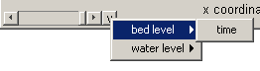
- In the Quickplot figure click to make animations. Select ‘avi’ files in the output window to generate your own avi files.
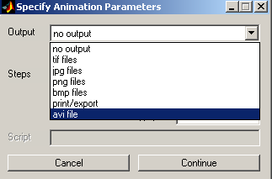

RGFGRID / Quickin Tutorial

Quickin can be used to inspect computational grids or adapt bathymetries.

- Importing a computational grid by selecting ‘File → Import → Grid’
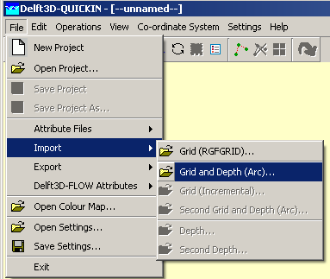

- View the Grid and domain properties by selecting ‘Operations →Actual and Maximum Data Dimensions’.
- Select on the toolbar and press A key on the keyboard, an anchor will appear, which acts as zero-distance point. The grid size can be measured in that way. The distance (in meter) is displayed in the status bar at the right of the co-ordinate.
- To edit model bathymetry select 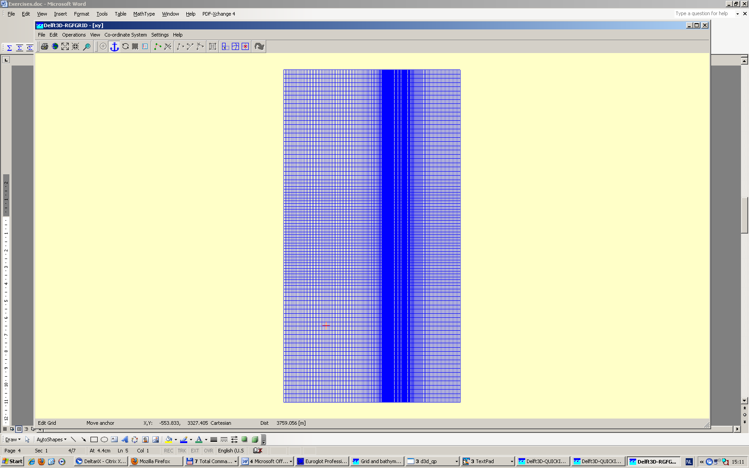 and draw a polygon. You close the polygon by clicking right mouse button. Next you can edit bathymetry in the polygon created. To do so i.e select ‘Operations → Delete → Depth’, this will delete all depth within the Polygon. Next you can select ‘Operations → Combine Depth and Uniform Value → Fill Missing Depth With Uniform Value. The new bathymetry can be exported to a new bathymetry file via ‘File → Export → Depth’.

