GETTING STARTED
The course materials contain the XBeach executable, model examples and some Deltares software (RGFGRID, Quickin and Quickplot) that will help us to analyze and modify model (results).

HANDS ON EXERCISES
Dune erosion at Delfland, Netherlands (1D): The first case we will run is a relative simple 1D case. It concerns a profile along the Dutch coast and hydraulic boundary conditions are based on the 1953 storm surge that caused substantial flooding in the Netherlands. You can work on the following assignments:

- Go to the folder “Examples\DelflandStorm” and double click the file “run_model.bat”. The simulation will start. The model will run for a few minutes, but in the meantime you can already work on question 2 to 5.
- Open params.txt in which you specify model input files and settings. Check the number of grid-points in x-direction (nx) and y-direction (ny). Check the filenames in which you specify the wave conditions (bcfile) and the storm surge level (zs0file).
- Do wave conditions change during the simulation? What is/are the wave height(s) and wave period(s) applied in the simulation?
- Does the surge height change during the simulation? What is the maximum surge height in the simulation (surge height is defined w.r.t. MSL)?
- What is the simulation time (tstop)? Do we apply a morphological acceleration factor (morfac)? What variables are stored as output and with what time interval? How much hydrodynamic time is simulated?
- Probably the simulation has finished. When you start the model, it generates a file named XBlog.txt. Open this file and check what is stored in the file. What was the total simulation time?
- To check out the simulation results we make use of the Quickplot tool (A brief tutorial is attached to this document). You can start Quickplot via the Delft3D environment we installed (Start → Programs → Deltares → Delft3D → Delft3D). In the Delft 3D menu choose Utilities → Quickplot. Choose Files of type “NetCDF files and GRIB files” and open “xboutput.nc” in the simulation folder.
- Use the Quickplot tutorial and try to make an animation in which you plot short wave height, water level (including long wave variations) and bed level as function of time.
- Plot the offshore waterlevel as function of time. Also open the file “tide.tek” (Tekal data files format), which contains the imposed surge level. Did the model correctly simulate the imposed surge level?
- Copy all model files to a new folder named “superfast”,. Edit params.txt and set ny=0 (instead of ny=2), and run the model. How does the simulation time compare to the original simulation?
- Compare simulation results for the “superfast” and “default” simulation. Are these the same? What option will you use in the future?

Nourishment scenarios near Kijkduin, Holland (1D): This case concerns the exploration of a nourishment strategy near Kijkduin along the Holland coast in the Netherlands. At this location a mega nourishment of 21 Mm3 named the Sand Engine was constructed. In this case we will explore to what extent nourishments can reduce the (dune and beach) erosion during a storm event. You can work on the following assignments:

- Go to the folder “Examples\Nourishment case” and double click the file “runall.bat”. This batch file will run three simulations sequentially in which the profile configuration varies and corresponds with the undisturbed profile (folder reference), a shoreface nourishment (folder shoreface) and a beach nourishment (folder beach) respectively. Each model will run for a few minutes. While running you can already answer question 2 to 6.
- For the reference case open the file params.txt in which you specify model input files and settings. Check the number of grid-points in x-direction (nx) and y-direction (ny). How many directional wave bins are defined and what is their width (thetamin, thetamax, dtheta).
- Do wave conditions change during the simulation? What is/are the wave height(s) and wave period(s) applied in the simulation? What is the offshore mean wave direction?
- Does the surge height change during the simulation? What is the maximum surge height in the simulation (surge height is defined w.r.t. MSL)?
- What is the simulation time (tstop)? Do we apply a morphological acceleration factor (morfac)? What variables are stored as output and with what time interval? How much hydrodynamic time is simulated?
- Probably the simulation has finished. When you start the model, it generates a file named XBlog.txt. Open this file and check what is stored in the file. What was the total calculation duration of the simulation?
- Inspect the initial bathymetries of each simulation with QUICKPLOT (Utilities → Quickplot). Choose Files of type “NetCDF files and GRIB files” and open “xboutput.nc” in the simulation folder).
  - At what cross-shore position the shoreface nourishment and beach nourishment were placed?
  - What Is the (average) thickness of the nourishments?
  - Is the volume of the nourishments comparable?
  - Plot the reference profile with markers; does the grid resolution vary in cross-shore direction?
- Use the Quickplot tutorial and try to make an animation in which you plot short wave height, water level (including long wave variations) and bed level as function of time.
- Plot the offshore water level as function of time. Also open the file “tide.tek” (Tekal data files format), which contains the imposed surge level. Did the model correctly simulate the imposed surge level?
- Inspect the final bathymetries of each simulation.
  - What is the dune face retreat in the three simulations you have carried out?
  - Where does the eroded sediment form the dunes deposit?
  - What nourishment type is most effective in reducing the impact of a storm?
  - Do you have an explanation for this?
- In the folder “banquette” you find a final simulation in which a special beach nourishment type is evaluated named a banquette. This beach nourishment has a highly elevated flat area that connects to the dune foot on which beach restaurants can be build.
  - Run the model and compare in Quickplot the banquette design with the beach nourishment design we have evaluated before. Do you expect more or less erosion?
  - Check your hypothesis by comparing the final profile of the banquette simulation to the other simulations.
  - What would be your approach to further reduce beach and dune erosion?

Overwash at Santa Rosa Island , USA (2DH): This case concerns overwash at Santa Rosa island in the Gulf of Mexico during hurricane Ivan in 2004. You can work on the following assignments.

- Open params.txt in which you specify model input files and settings. Check the number of grid-points in x-direction (nx) and y-direction (ny). How many directional wave bins are defined and what is their width (thetamin, thetamax, dtheta).
- In this simulation the grid is specified in Delft3D format. Open Quickin in the Delft 3D menu (Grid → Quickin) and use the brief tutorial to read in the grid and bathymetry. Does the grid resolution vary in cross-shore direction? And in longshore direction? What are the minimum dx and dy? Why can the grid be coarse offshore?
- How many wave conditions do we apply in this simulation? What is the offshore mean wave direction? Does the surge level change in the simulation?
- What is the simulation time (hydrodynamic and morphological)?
- Inspect the model results and make an animation of the short wave height and the water levels (For the water levels simulation set the color limits manual between -0.5 and 3.5).
- Make an animation of cumulative sedimentation/erosion. Describe what is happening. (For the cum. sedimentation/erosion set the color limits manual between -3 and 3)
- Look at the mean flow field. Plot the flow field in colored vectors. Where are the flow velocities highest and what is the direction of the flow (cross-shore or longshore)? Is there (also) a longshore current present and what is its intensity?
- If you have time left feel free to:
  - Narrow or broaden the imposed spectrum by changing the parameter s in ‘jonswap.inp’ (you could i.e set s = 100 and s = 2 respectively). Make animations of the instantaneous short wave height to see what is happening to the size of the wave groups.
  - Design a nourishment in Quickin (see tutorial for a bit of help) to reduce the impact of the storm on Santa Rosa Island. Change the depfile in params.txt to make a simulation with the updated bathymetry.

Yanchep perched beach and natural breakwater (2DH): This case is an example of a beach 60km north of Perth most commonly known as Yanchep lagoon. Many beaches in WA like Yanchep are fronted by shallow reef and here we are investigating the effects of the reef on the morphodynamics. You can work on the following assignments:

- Go to the folder “Examples\YanchepBeach” and double click the file “run_model.bat”. The simulation will start (and will run about 15 minutes).
- Meanwhile, inspect the bathymetry file and the structure file (using Quickin). What is the depth in the lagoon? Is the reef enclosing the lagoon below or above the model initial water level? What is the wave height at the boundary condition?
- Make an animation of the water level, RMS wave height and velocity. What happens in the lagoon?
- Make an animation of cumulative sedimentation/erosion. What happens in the lagoon?
- How is the lagoon affected by the mean water level? Increase or decrease the mean water level condition, run the model again (maybe for a shorter time by reducing tstop). How are circulation and sediment transport affected?
- What would happen if the lagoon was open at the southern end? Open the structure file with Quickin tool and modify it to allow the southern end of the lagoon to be eroded. Modify the param.txt file to use this new structure file and run the model. Alternatively, remove the reef from the bathymetry (using Quickin) and rerun the model without the structure file.
- If you still have time;
  - Reefs are very rough what happens in the model when the friction is increased? Reduce values of C and increase value of fw, rerun the model what do you observe?
  - Is wave/current interaction (wci) switched on? Rerun the model with the wave/current switch on/off. Compare the output with model you ran previously. How much effect do you see on the morphology?

TUTORIALS
Quickplot Tutorial

Quickplot can be used to do a first inspection of XBeach output.

- You can start quickplot via the Delft3D menu, (Utilities → Quickplot)
- Click to open a file.
- Choose Files Type ‘NetCDF and GRIB Files’ and open ‘xboutput.nc’. Select ’Hrms wave height based on instantaneous energy’ as the data-field to plot. Select the proper location (M corresponds to cross-shore locations and N to longshore locations) or station you want to investigate and press . If you want to make plots together and compare, you can choose a different colour by , and then click . Use icons to zoom in/out. Drag or click on the toolbar to view different time steps.
- To make animations of multiple variables instantaneously, variables need to be linked in time (space is another option). You can do this by pressing and then select:
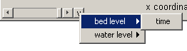
- In the Quickplot figure click to make animations. Select ‘avi’ files in the output window to generate your own avi files.
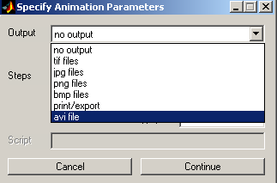

RGFGRID / Quickin Tutorial

Quickin can be used to inspect computational grids or adapt bathymetries.

- Importing a computational grid by selecting ‘File → Import → Grid’
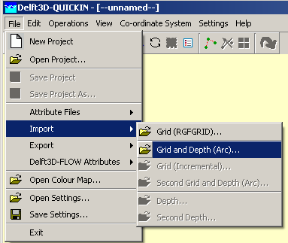

- View the Grid and domain properties by selecting ‘Operations →Actual and Maximum Data Dimensions’.
- Select on the toolbar and press A key on the keyboard, an anchor will appear, which acts as zero-distance point. The grid size can be measured in that way. The distance (in meter) is displayed in the status bar at the right of the co-ordinate.
- To edit model bathymetry select 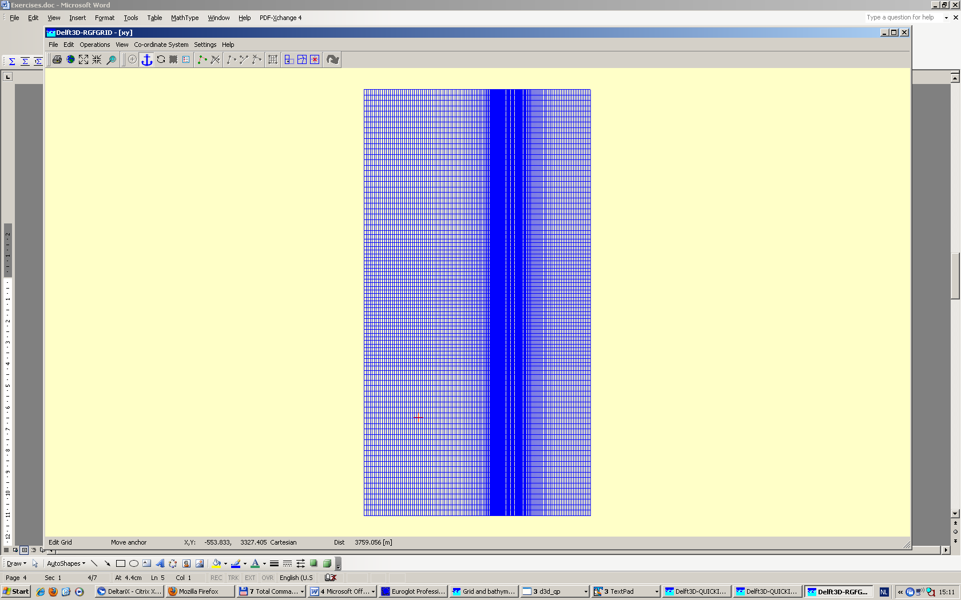 and draw a polygon. You close the polygon by clicking right mouse button. Next you can edit bathymetry in the polygon created. To do so i.e select ‘Operations → Delete → Depth’, this will delete all depth within the Polygon. Next you can select ‘Operations → Combine Depth and Uniform Value → Fill Missing Depth With Uniform Value. The new bathymetry can be exported to a new bathymetry file via ‘File → Export → Depth’.

