## Introduction

The Tropical Cyclone Wind Statistical Estimation Tool (TCWiSE) tool is a Matlab-based tool to determine reliable estimates of extreme tropical cyclone (TC) wind speeds in a probabilistic approach using synthetic TC tracks, which results in more reliable results than a deterministic approach considering only historical tracks. The tool uses the method of Empirical Track Modelling (ETM) to generate the synthetic cyclone tracks from their genesis to termination points with 3-hourly intervals. The coordinates of the cyclone eye, the heading and forward speed are the variables used to determine the cyclone track, and the maximum sustained wind speed is used to determine the intensity of the event. Changes in these variables are sampled each time step from probability distributions constructed at each cell of a spatial grid defined around the oceanic basin where the tool is applied. This results in a set of synthetic TCs with at each time step the heading, forward speed and maximum sustained wind speed. When a TC is over land, the maximum sustained wind speed decreases exponentially based on Kaplan & DeMaria (1995).

## Background

To determine the wind speed at an exact location, the spatial wind field around the eye is computed by applying Holland’s parametric wind field model (Holland et al., 2010), see the folder ‘*00_literature*’. TCWiSE uses the wind pressure relationships from Holland (2008). Wind radii are dependent on the relationships of Nederhoff et al. (2019), which are needed to generate improved (accurate) parametric wind fields for all ocean basins. TC asymmetry is computed based on Schwerdt (1979) and with assuming a constant inflow angle of 22 degrees (Zhang & Uhlhorn, 2012). It is possible to apply a factor on the frequency and intensity due to climate change. For example, Knutson et al., (2015) provides an overview of the expected changes of TCs in the future climate based on RCP 4.5 for late twenty-first century.

In the TC generation part of TCWiSE, wind speeds are in knots (kt) and 1-minute averaged. However, the created spiderwebs are in meter per second (m/s) and 10-minute averaged in order to be consistent with wind drag formulations. A conversion of 0.514 for knots to m/s is used and a conversion of 0.93 to go from 1-minute to 10-minute averaged winds (Harper et al., 2010).

The initial tool is created by Maarten van Ormondt, further developed by Jasper Hoek (Hoek, 2017) and cleaned up and documented by Tim Leijnse and Kees Nederhoff including a journal publication (Nederhoff et al. 2020).

## How to use TCWiSE for your case study?

TCWiSE runs within the Matlab script called ‘*apply_TCWiSE.m’*. Before you can use it for your case study, you will have to do the following steps:

1. Create a check-out of the OpenEarthTools (OET) on your machine and add this to your path in Matlab (i.e. run *oetsettings.m*). For more information on this step: <https://publicwiki.deltares.nl/display/OET/OpenEarth>
2. Change the settings in ‘*apply_TCWiSE.m’* in folder *‘02_application’* to match your case study
   1. Define path of TCWiSE toolbox in *‘foverall’*
   2. Choose an output location (‘*setting.destout*’)
   3. Change the oceanic basin (e.g. North Indian Ocean; NI) in ‘*Settings – user’*. Other options are: 'NA'=North Atlantic, 'SA'=South Atlantic, 'WP'=Western Pacific, 'EP'=Eastern Pacific, 'SP'=Southern Pacific, 'SI'=South Indian. For more information about the data subsets of IBTrACS see [1].
   4. Choose the source for that oceanic basin (recommended is: Joint Typhoon Warning Center; ‘*usa*’). Not all sources have data for all basins, for an overview see Figure 1 below.
   5. Determine the number of years you would like to compute synthetic tracks for (e.g. 1000 years)
   6. Provide an area of interest for a region to generate spiderweb files for (generally smaller than the entire basin) in *’Settings - user: area of interest’.* The synthetic tracks themselves are always created for the entire selected basin.
   7. For future conditions it is possible to change settings in ‘*Settings - user: Climate change effects*’ being the frequency of TCs (i.e. how often TCs get generated) and there change in intensity (i.e. increase of wind speed). Knutson et al. (2015) gives an overview per ocean basin what these values are in Table 3. However, there are also other sources for this kind of information. Leaving values at 1 means simulating for the current climate.
   8. Change additional parameters if needed in ‘*Settings – advanced’* (explanation provided in i). It is advised for the first time to run TCWiSE using the default settings as provided
   9. Names of created output files are given in ‘*5. Output file names*’
   10. And run the script!

NB: depending on the basin and area of interest size and the number of years to compute synthetic tracks for, the script takes a few hours to several days to run to completion! Be aware of this when you start to run it. The creation of spiderweb files in *‘cyclonestats_write_WES_input.m’* can take considerable time, unselect this line to prevent this step.

1. The output of TCWiSE consists of generated historical and synthetic tracks in a mat-file (*‘cyclone_files.observed’* and *‘cyclone_files.simulated’*) as well as historic spiderweb files (*cyclone.spw*) based on the historic tracks from the used source in *‘\spw_observed\’*, and simulated spiderweb files for the chosen number of years in *‘\spw_simulated\’* (there can be multiple tracks per year). Additionally, some simple figures are produced as a starting point for further post-processing for your case study.

In case of problems or questions, don’t hesitate to contact Tim Leijnse or Kees Nederhoff.

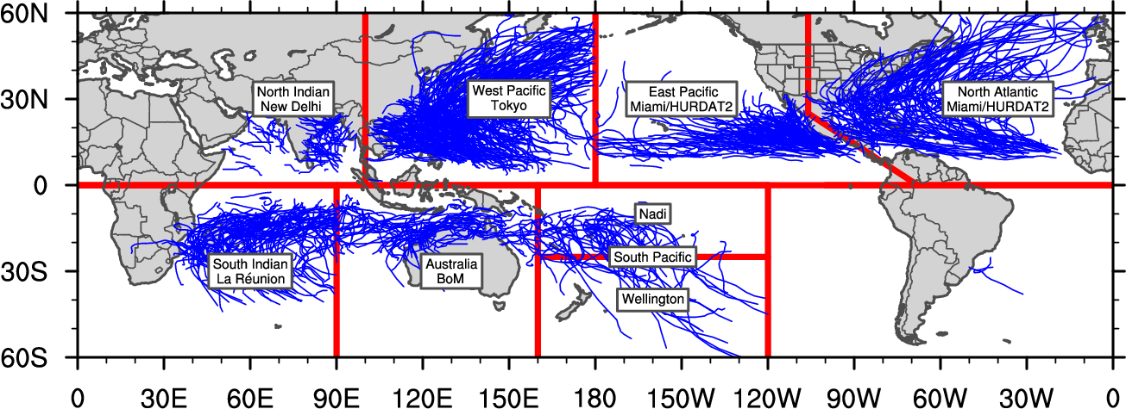

Figure 1 Overview of wmo regions with corresponding data sources, note that these do not fully overlap with available basins as defined by IBTrACS.

## References

Holland, G. J. (2008). A Revised Hurricane Pressure – Wind Model. Monthly Wearther Review, (2), 3432–3445. http://doi.org/10.1175/2008MWR2395.1

Schwerdt, R. W., Ho, F. ., & Watkins, R. R. (1979). Meteorological criteria for standard project hurricane and probable maximum hurricane windfields, gulf and east coasts of the United States NOAA Technical Report NWS 23, (September).

Holland, G. J., Belanger, J. ., & Fritz, A. (2010). A Revised Model for Radial Profiles of Hurricane Winds. American Meteorological Society, 4393–4401. http://doi.org/10.1175/2010MWR3317.1

Kaplan, J., & DeMaria, M. (1995). A simple empirical model for predicting cyclone wind decay after landfall_cyclone_inland wind decay_1995_JAM_Kaplan_inland-wind.pdf. Journal of Applied Meteorology. Retrieved from http://rammb.cira.colostate.edu/research/tropical_cyclones/ships/docs/1995_JAM_Kaplan_inland-wind.pdf

Harper, B. A., Kepert, J. D., & Ginger, J. D. (2010). Guidelines for converting between various wind averaging periods in tropical cyclone conditions. World Meteorological Organization, (October). Retrieved from https://www.wmo.int/pages/prog/www/tcp/documents/WMO_TD_1555_en.pdf

Knutson, T. R., Sirutis, J. J., Zhao, M., Tuleya, R. E., Bender, M., Vecchi, G. A., … Chavas, D. (2015). Global projections of intense tropical cyclone activity for the late twenty-first century from dynamical downscaling of CMIP5/RCP4.5 scenarios. Journal of Climate, 28(18), 7203–7224. http://doi.org/10.1175/JCLI-D-15-0129.1

Nederhoff, C. M., van Ormondt, M., Giardino, A., & Vatvani, D. (2019). Estimates of tropical cyclone size parameters based on best track data. Natural Hazards and Earth System Sciences (NHESS).

Nederhoff, K., Hoek, J., Leijnse, T., van Ormondt, M., Caires, S., and Giardino, A.: Simulating Synthetic Tropical Cyclone Tracks for Statistically Reliable Wind and Pressure Estimations, Nat. Hazards Earth Syst. Sci. Discuss. [preprint], https://doi.org/10.5194/nhess-2020-250, in review, 2020.

Zhang, J. A., & Uhlhorn, E. W. (2012). Hurricane Sea Surface Inflow Angle and an Observation-Based Parametric Model. Monthly Weather Review, 140(11), 3587–3605. http://doi.org/10.1175/mwr-d-11-00339.1

Hoek, J. (2017). Tropical Cyclone Wind Statistical Estimation In Regions with Rare Tropical Cyclone Occurrence.

1. https://www.ncdc.noaa.gov/ibtracs/pdf/IBTrACS_version4_Technical_Details.pdf