Updated wave current interaction modeling
The interaction of waves and currents has been reformulated to obtain a more robust description during the extreme conditions that are encountered during severe storm conditions. Starting with the wave action balance given by:

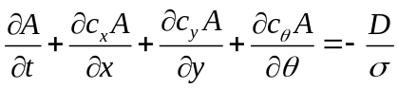

with the wave action:

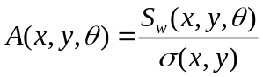

where 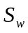 represents the wave energy in each directional bin and the intrinsic wave frequency. The wave action propagation speeds in x- and y-direction are given by:

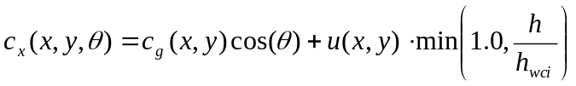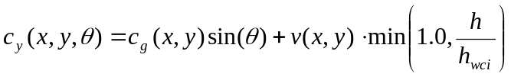
where represents the angle of incidence with respect to the x-axis and h represents the minimum depth at which wave current interaction is still fully accounted for. For smaller depths a linear decay is used. Effectively this means that close to the water line wave current interaction is reduced. The propagation speed in -space is obtained from:

taking into account bottom refraction (first term on the RHS) and current refraction (last two terms on the RHS). The wave number k is obtained from the eikonal equations (e.g. Dingemans, 1993):

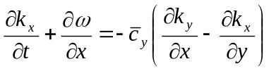

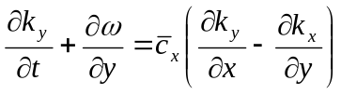

where the subscripts refer to the direction of the wave vector components and represents the absolute radial frequency. The RHS of the eikonal equations ensures the irrotationality of wave number vector field (pers. Comm. RJ Labeur, Delft University of Technology). The wave number is the obtained from:

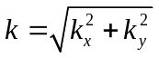

The absolute radial frequency is given by:

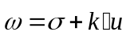

and the intrinsic frequency is obtained from the linear dispersion relation:

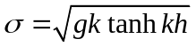

The group velocity is obtained from linear wave theory:

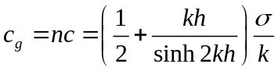

This concludes the advection of wave action.

To test the wave current interaction a numerical rip-current experiment is performed. The root mean square incident wave height at the offshore boundary is 1 m, with a mean wave period of 5 s, normally incident on the rip-channelled beach. The rip-channel configuration is similar to the rip-channels found in Monterey Bay (Reniers et al., 2007). The case without wave current interaction shows a strong rip current exiting the rip channel. This rip current is highly unstable due to its strong velocity shear (Yu and Slinn, 2003, Haller and Dalrymple, 2001 ) resulting in local vortices that are transported offshore by the rip current flow. Including wave current interaction limits the offshore extend of the rip current considerably (compare panels in Figure below). The rip current flow is still unstable but the instabilities now occur within the surfzone resulting in a strong eddy circulation. It must be noted that the turbulent eddy viscosity has been ignored in the present computations. Inclusion of the turbulent eddy viscosity again stabilizes the flow further. An increased wave height is observed within the rip-channel at locations of opposing currents, consistent with results of Yu and Slinn [2003] and Reniers et al. [2007].

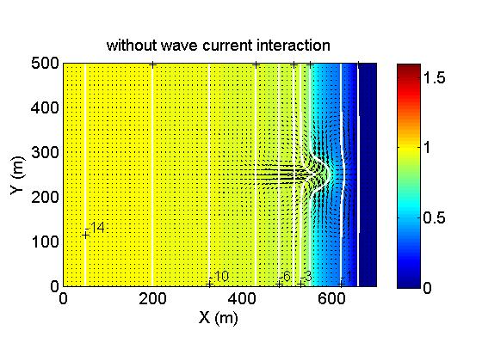
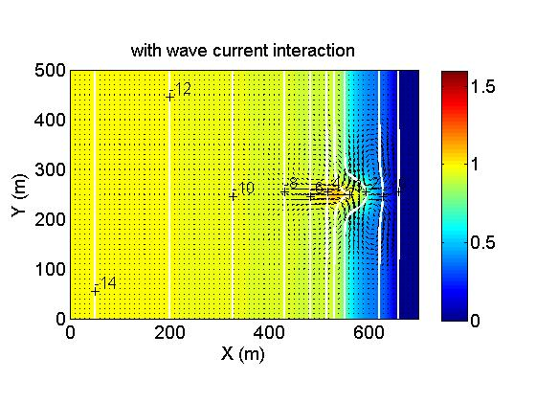
Figure Upper panel: Snapshot of the root mean square wave height (indicated by the colour bar in m) and corresponding velocity field (arrows indicate direction and magnitude) without wave current interaction. Lower panel: Similar but with wave current interaction.

References

Haller, M.C., and D.A. Dalrymple: Rip current instabilities, J. Fluid Mech., 433, 161-192, 2001.

Reniers A. J. H. M., J. H. MacMahan, E. B. Thornton and T. P Stanton, Modeling of very low frequency motions during RIPEX, J. Geophys. Res., 112, C07013, doi:10.1029/2005JC003122, 2007.

Yu, J. and D.N. Slinn: Effects of wave-current interaction on rip currents, J. Geophys. Res., 108, 3088, doi:10.1029/2001JC001105, 2003

