XBeach Model Description and Manual
Z4175
Report

Unesco-IHE Institute for Water Education, Deltares and Delft University of Technology
November 2009

XBeach Model Description and Manual
Dano Roelvink (P.I.), Ad Reniers, Ap van Dongeren, Jaap van Thiel de Vries, Jamie Lescinski, Robert McCall
Report
November 200
Unesco-IHE Institute for Water Education, Deltares and Delft University of Technology
wlL5 wlSummary

Contents
wlL2 wlL1 wlL3 wlL4
1 Introduction 1–1
1.1 Motivation 1–1
1.2 Objective 1–2
1.3 Context 1–2
1.4 Model approach 1–2
1.5 Outline of the report 1–4
2 Descripton of program structure 2–1
2.1 Single domain setup 2–1
2.2 Implementation of parallel computing using MPI 2–2
3 Model formulations 3–1
3.1 Coordinate system 3–1
3.2 Grid Setup 3–2
3.3 Wave action equation solver 3–3
3.4 Roller energy equation solver 3–5
3.5 Shallow water equations solver 3–7
3.5.1 Depth-averaged equations 3–7
3.5.2 Quasi-3D equations 3–8
3.6 Sediment transport 3–9
3.7 Bottom updating 3–11
3.8 Multiple sediment fractions 3–12
3.9 Groundwater flow 3–12
3.9.1 Physical and numerical principles 3–12
3.9.2 Determining groundwater head 3–12
3.9.3 Momentum balance 3–12
3.9.4 Determining vertical flow 3–12
3.9.5 Mass balance 3–12
3.10 Boundary conditions 3–12
3.10.1 Offshore flow boundary conditions 3–12
3.10.2 Bay-side flow boundary condition 3–12
3.10.3 Lateral flow boundary conditions 3–12
3.10.4 Offshore wave boundary conditions 3–12
3.10.5 Groundwater boundary conditions 3–12
4 Compiling the model 4–12
5 Running the model 5–12
5.1 Input file structure 5–12
5.2 Specifying grid and depth 5–12
5.3 Wave input 5–12
5.3.1 Action balance 5–12
5.3.2 Wave dissipation model 5–12
5.3.3 Roller model 5–12
5.4 Flow input 5–12
5.5 Wave boundary conditions 5–12
5.5.1 User input 5–12
5.5.2 Use of JONSWAP spectrum 5–12
5.5.3 Use of SWAN spectrum 5–12
5.5.4 Use of formatted variance density spectrum 5–12
5.5.5 Reusing existing boundary condition files 5–12
5.5.6 Use of time-varying spectra 5–12
5.5.7 Examples 5–12
5.5.8 Explanation of spectral input/output 5–12
5.6 Flow boundary conditions 5–12
5.7 Time-varying tide/surge 5–12
5.8 Wind 5–12
5.9 Limiters 5–12
5.10 Groundwater 5–12
5.11 Hydrodynamic simulation 5–12
5.12 Sediment transport 5–12
5.13 Morphological updating 5–12
5.14 Selecting output data types 5–12
5.14.1 Regular spatial output 5–12
5.14.2 Time-averaged spatial output 5–12
5.14.3 Point output 5–12
5.14.4 Default values 5–12
5.15 Choosing output times 5–12
5.15.1 Output at fixed intervals 5–12
5.15.2 Output times defined by external file 5–12
5.15.3 Combinations of fixed interval and external files 5–12
5.15.4 Default values 5–12
5.16 Example 5–12
5.17 Reading output files in Matlab 5–12
5.18 Variable keywords 5–12
6 Distribution and maintenance 6–12
7 Tutorial 7–12
7.1 Profile mode 7–12
7.1.1 Creating grid and depth information 7–12
8 References 8–12
Appendices
A Description of gen.ezs file (instat+2,3) A–12
B Blank params.txt B–12

wlListTabs wlListFigs wlListPhotos wlListSymb

Abstract

XBeach is a numerical model of nearshore processes intended as a tool to assess the natural coastal response during time-varying storm and hurricane conditions, including dune erosion, overwash and breaching.

The model consists of formulations for short wave envelope propagation, nonstationary shallow water equations, sediment transport and bed update. Innovations include a newly-developed time-dependent wave action balance solver, which solves the wave refraction and allows variation of wave action in x, y, time and over the directional space, and can be used to simulate the propagation and dissipation of wave groups. An added advantage to this set-up, compared to the existing surfbeat (infragravity wave) model, is that a separate wave model is not needed to predict the mean wave direction, and it allows different wave groups to travel in different directions. Full wave-current interaction in the short wave propagation is included. Roelvink (1993) wave dissipation model is implemented for use in the nonstationary wave energy balance (in other words, when the wave energy varies on the wave group timescale).

The Generalised Lagrangean Mean (GLM) approach was implemented to represent the depth-averaged undertow and its effect on bed shear stresses and sediment transport, cf. Reniers et al. (2004).

Soulsby – Van Rijn transport formulations have been included, which solves the 2DH advection-diffusion equation and produces total transport vectors, which can be used to update the bathymetry. The pickup function follows Reniers et al (2004) was implemented. An avalanching routine was implemented with separate criteria for critical slope at wet or dry points providing a smooth and robust solution for slumping of sand during dune erosion.

Since length scales are short in terms of wave lengths and supercritical flow frequently occurs, the numerical implementation is mainly first order upwind, which in combination with a staggered grid makes the model robust. The momentum-conserving form of Stelling and Duinmeijer (2004) is applied which improves long-wave runup and backwash on the beach. The model scheme utilizes explicit schemes with an automatic time step based on Courant criterion, with output at fixed or user defined time intervals, which keeps the code simple and makes coupling and parallellization easier, while increasing stability.

The model has been validated with a series of analytical, laboratory and field test cases. The model performs well in different situations including dune erosion, overwash and breaching and these cases are all modelled using a standard set of parameter settings.

Introduction

Motivation
The devastating effects of hurricanes on low-lying sandy coasts, especially during the 2004 and 2005 seasons have pointed at an urgent need to be able to assess the vulnerability of coastal areas and (re-)design coastal protection for future events, but also to evaluate the performance of existing coastal protection projects compared to ‘do-nothing’ scenarios. In view of this the Morphos-3D project was initiated by USACE-ERDC, bringing together models, modelers and data on hurricane winds, storm surges, wave generation and nearshore processes. Concurrently, the Dutch Dune Safety Assessment required that advanced models be developed which can be used to assess the protection provided by dunes against flooding of the hinterland for situations where empirical model assumptions do not hold anymore. In the Netherlands, most of the central Holland Coast is protected by dunes. For these reasons an open-source program, XBeach for eXtreme Beach behavior, has been developed to model the nearshore response to hurricane impacts and storms.

Existing tools to assess dune erosion under extreme storm conditions assume alongshore uniform conditions and have been applied successfully along relatively undisturbed coasts (Vellinga, 1986, Steetzel, 1993, Nishi and Kraus, 1996, Larson et al., 2004), but are inadequate to assess the more complex situation where the coast has significant alongshore variability. This variability may result from anthropogenic causes, such as the presence of artificial inlets, sea walls, and revetments, but also from natural causes, such as the variation in dune height along the coast or the presence of rip-channels and shoals on the shoreface (Thornton et al., 2007). A particularly complex situation is found when barrier islands protect storm impact on the main land coast. In that case the elevation, width and length of the barrier island, as well as the hydrodynamic conditions (surge level) of the back bay should be taken into account to assess the coastal response. Therefore, the assessment of storm impact in these more complex situations requires a two-dimensional process-based prediction tool, which contains the essential physics of dune erosion and overwash, avalanching, swash motions, infragravity waves and wave groups.

With regard to dune erosion, the development of a scarp and episodic slumping after undercutting is a dominant process (van Gent et al., 2008). This supplies sand to the swash and surf zone that is transported seaward by the backwash motion and by the undertow; without it the upper beach scours down and the dune erosion process slows down considerably. One-dimensional (cross-shore) models such as DUROSTA (Steetzel, 1993) focus on the underwater offshore transport and obtain the supply of sand by extrapolating these transports to the dry dune. Overton and Fisher (1988), Nishi and Kraus (1996) focus on the supply of sand by the dune based on the concept of wave impact. Both approaches rely on heuristic estimates of the runup and are well suited for 1D application but difficult to apply in a horizontally 2D setting. Hence, a more comprehensive modeling of the swash motions is called for.

Swash motions are up to a large degree a result from wave group forcing of infragravity waves (Tucker, 1954). Depending on the beach configuration and directional properties of the incident wave spectrum both leaky and trapped infragravity waves contribute to the swash spectrum (Huntley et al., 1981). Raubenheimer and Guza (1996) show that incident band swash is saturated, infragravity swash is not, therefore infragravity swash is dominant in storm conditions. Models range from empirical formulations (e.g. Stockdon et al, 2006) through analytical approaches (Schaeffer, 1994, Erikson et al, 2005) to numerical models in 1D (e.g. List, 1992, Roelvink, 1993b) and 2DH (e.g. van Dongeren et al, 2003, Reniers et al, 2004a, 2006). 2DH wave group resolving models are well capable of describing low-frequency motions. However, for such a model to be applied for swash, a robust drying/flooding formulation is required.

Objective

The main objective of the XBeach model is to provide a robust and flexible environment in which to test morphological modeling concepts for the case of dune erosion, overwashing and breaching. The top priority is to provide numerical stability and robustness, while still providing accurate results in a reasonable computational time.

Context

The XBeach model can be used as stand-alone model for small-scale (project-scale) coastal applications, but will also be used within larger (shelf sea) systems, where it will be driven by boundary conditions provided by the wind, wave and surge models and its main output to be transferred back will be the time-varying bathymetry and possibly discharges over breached barrier island sections.

Model approach
Our aim is to model processes in different regimes as described by Sallenger (2000). He defines an Impact Level to denote different regimes of impact on barrier islands by hurricanes, which are the 1) swash regime, 2) collision regime, 3) overwash regime and 4) inundation regime. The approach we follow to model the processes in these regimes is described below:

To resolve the swash dynamics the model employs a novel 2DH description of the wave groups and accompanying infragravity waves over an arbitrary bathymetry (thus including bound, free and refractively trapped infragravity waves). The wave group forcing is derived from the time-varying wave action balance e.g. Phillips (1977) with a dissipation model for use in combination with wave groups (Roelvink, 1993a). A roller model (Svendsen, 1984, Nairn et al., 1990, Stive and de Vriend, 1994) is used to represent momentum stored in surface rollers which leads to a shoreward shift in wave forcing.

The wave-group forcing drives infragravity motions and both longshore and cross-shore currents. Wave-current interaction within the wave boundary layer results in an increased wave-averaged bed shear stress acting on the infragravity waves and currents (e.g. Soulsby et al., 1993 and references therein). To account for the randomness of the incident waves the description by Feddersen et al. (2000) is applied which showed good skill for longshore current predictions using a constant drag coefficient (Ruessink et al., 2001).

During the swash and collision regime the mass flux carried by the waves and rollers returns offshore as return flow or rip-current. These offshore directed flows keep the erosion process going by removing sand from the slumping dune face. Various models have been proposed for the vertical profile of these currents (see Reniers et al. (2004b) for a review). However, the vertical variation is not very strong during extreme conditions and has been neglected for the moment.

Surf and swash zone sediment transport processes are very complex, with sediment stirring by a combination of short-wave and long-wave orbital motion, currents and breaker-induced turbulence. However, intra-wave sediment transports due to wave asymmetry and wave skewness are expected to be relatively minor compared to long-wave and mean current contributions (van Thiel de Vries et al., 2008). This allows for a relatively simple and transparent formulation according to Soulsby – Van Rijn (Soulsby, 1997) in a short-wave averaged but wave-group resolving model of surf zone processes. This formulation has been applied successfully in describing the generation of rip channels (Damgaard et al., 2002 Reniers et al., 2004a) and barrier breaching (Roelvink et al., 2003).

In the collision regime, the transport of sediment from the dry dune face to the wet swash, i.e. slumping or avalanching, is modeled with an avalanching model accounting for the fact that saturated sand moves more easily than dry sand, by introducing both a critical wet slope and dry slope. As a result slumping is predominantly triggered by a combination of infragravity swash run-up on the previously dry dune face and the (smaller) critical wet-slope.

During the overwash regime the flow is dominated by low-frequency motions on the time-scale of wave groups, carrying water over the dunes. This onshore flux of water is an important landward transport process where dune sand is being deposited on the island and within the shallow inshore bay as overwash fans (e.g. Leatherman, 1977, Wang and Horwitz, 2007). To account for this landward transport some heuristic approaches exist in 1D, e.g. in the SBeach overwash module (Larson et al, 2004) which cannot be readily applied in 2D. Here, the overwash morphodynamics are taken into account with the wave-group forcing of low frequency motions in combination with a robust momumtum-conserving drying/flooding formulation (Stelling and Duinmeijer, 2003) and concurrent sediment transport and bed-elevation changes.

Breaching of barrier islands occurs during the inundation regime, where a new channel is formed cutting through the island. Visser (1998) presents a semi-empirical approach for breach evolution based on a schematic uniform cross-section. Here a generic description is used where the evolution of the channel is calculated from the sediment transports induced by the dynamic channel flow in combination with avalanche-triggered bank erosion.

To this end, the code has the following functionalities:
- Depth-averaged shallow water equations including time-varying wave forcing terms; combination of sub- and supercritical flows;
- Time-varying wave action balance including refraction, shoaling, current refraction and wave breaking;
- Roller model, including breaker delay
- Wave amplitude effects on wave celerity;
- Depth-averaged advection-diffusion equation to solve suspended transport;
- Bed updating algorithm including possibility of avalanching;
- Numerical scheme in line with Stelling and Duinmeijer method, to improve long-wave runup and backwash on the beach. The momentum-conserving form is applied, while retaining the simple first-order approach. The resulting scheme has been tested against the well-known Carrier and Greenspan test.
- Generalised Lagrangean Mean (GLM) approach to represent the depth-averaged undertow and its effect on bed shear stresses and sediment transport, cf. Reniers et al. (2004)
- Roelvink (1993) wave dissipation model for use in the nonstationary wave energy balance (in other words, when the wave energy varies on the wave group timescale)
- Soulsby – Van Rijn transport formulations, cf Reniers et al (2004).
- Multiple sediment fractions and bed layer bookkeeping.
- Automatic time step based on Courant criterion, with output at fixed or user-defined time intervals.
- Avalanching mechanism, with separate criteria for critical slope at wet or dry points.
- Quasi 3D formulation
- Hard structures
- Wave-current interaction
- Ground water flow
- Non-hydrostatic formulation
- MPI (Message Passing Interface) implementation with automatic domain decomposition for parallel (multi-processor) computing

Outline of the report
In the following report we will detail the model development, activities and results. Chapter 2 provides a description of the XBeach structure, as well as an overview of siginificant attributes of the program. Chapter 3 contains an overview of all formulations used and their numerical schematization. Chapter 4 provides instructions on how to run the model, with a detailed input description. Chapter 5 offers a small discussion of how it is intended to distribute and maintain XBeach.

Descripton of program structure

Single domain setup
The program XBeach consists of a main Fortran 90 program, xbeach.f90, and a number of subroutines that operate on two derived types (structures):
- par – this contains general input parameters
- s - this contains all the arrays for a given computational domain

For a single-domain run, one structure s is passed between flow, wave, sediment and bed update solvers, which extract the arrays they need from the structure elements to local variables, do their thing and pass the results back to the relevant structure elements. This makes the overall program clear, prevents long parameter lists and makes it easy to add input variables or arrays where needed. The various subroutines and their purposes are outlined in Table 2.1.

Table 2.1. Overview of Fortran 90 subroutine calls by xbeach.f90
Function call | Purpose
wave_input(par) | Creates elements of structure par containing wave input parameters
flow_input(par) | Adds elements of structure par containing flow input parameters
sed_input(par) | Adds elements of structure par containing sediment input parameters
grid_bathy(s) | Creates grid and bathymetry and stores them in structure s
distribute_par(par) | MPI
space_alloc_scalars(sglobal)
grid_bathy(s,par)
xmpi_determine_processor_grid(s%nx | s%ny)
readtide(s,par) | Read tide levels
readwind (s, par) | Read wind field
init_output | Read output requests and initialize output files
wave_init (s,par) | Initialises arrays (elements of s) for wave computations
flow_init (s,par) | Initialises arrays (elements of s) for flow computations
gwinit(s,par) | Initialises arrays (elements of s) for groundwater module
sed_init (s,par) | Initialises arrays (elements of s) for sediment computations
init_output(sglobal,slocal,par,it)
call readkey
Start time loop
timestep (s,par,it) | Calculate automatic timestep
wave_bc (s,par) | Wave boundary conditions update, each timestep
gwbc(s,par) | Groundwater boundary conditions update, each timestep
flow_bc (s,par) | Flow boundary conditions update, each timestep
wave_timestep(s,par) | Carries out one wave timestep, OR
wave_stationary(s,par) | Carries out stationary wave computation
gwflow(par,s) | carries out flow timestep of groundwater flow
flow_timestep (s,par) | Carries out one flow timestep
drifter (s,par)
transus(s,par) | Carries out one suspended plus bedload transport timestep
bed_update(s,par) | Carries out one bed level update timestep
var_output(it,s,par) | Performs output
End time loop

Implementation of parallel computing using MPI

To be done.

Model formulations
The model solves coupled 2D horizontal equations for wave propagation, flow, sediment transport and bottom changes, for varying (spectral) wave and flow boundary conditions. Because the model takes into account the variation in wave height in time (long known to surfers) it resolves the long wave motions created by this variation. This so-called ‘surf beat’ is responsible for most of the swash waves that actually hit the dune front or overtop it. With this innovation the XBeach model is better able to model the development of the dune erosion profile, to predict when a dune or barrier island will start overwashing and breaching and to model the developments throughout these phases.

Coordinate system
XBeach uses a coordinate system where the computational x-axis is always oriented towards the coast, approximately perpendicular to the coastline, and the y-axis is alongshore, see Figure 3.1 . This coordinate system is defined relative to world coordinates (x_{w},y_{w}) through the origin (x_{ori},y_{ori}) and the orientation alfa, defined counter-clockwise w.r.t. the x_{w}-axis (East). The grid size in x- and y-direction may be variable but the grid must be rectilinear.

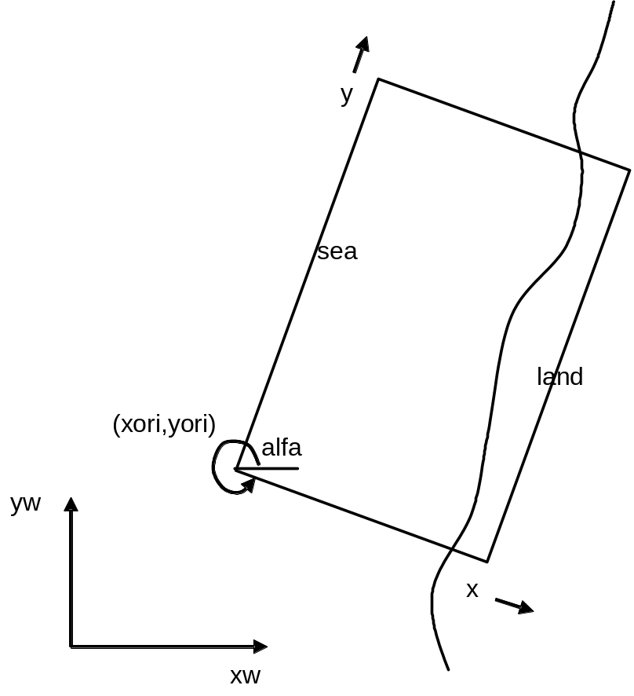
Figure 3.1 Coordinate system

Grid Setup
The grid applied is a staggered grid, where the bed levels, water levels, water depths and concentrations are defined in cell centers, and velocities and sediment transports are defined in u- and v-points, viz. at the cell interfaces. In the wave energy balance, the energy, roller energy and radiation stress are defined at the cell centers, whereas the radiation stress gradients are defined at u- and v-points, see Figure 3.2.

Velocities at the u- and v-points are denoted by uu and vv respectively; velocities u and v at the cell centers are obtained by interpolation and are for output purpose only. The water level, zs, and the bed level, zb, are both defined positive upward. uv and vu are the u-velocity at the v-grid point and the v-velocity at the u-grid point respectively. These are obtained by interpolation of the values of the velocities at the four surrounding grid points.

The model solves coupled 2D horizontal equations for wave propagation, flow, sediment transport and bottom changes, for varying (spectral) wave and flow boundary conditions. Because the model takes into account the variation in wave height in time (long known to surfers) it resolves the long wave motions created by this variation. This so-called ‘surf beat’ is responsible for most of the swash waves that actually hit the dune front or overtop it. With this innovation the XBeach model is better able to model the development of the dune erosion profile, to predict when a dune or barrier island will start overwashing and breaching and to model the developments throughout these phases.
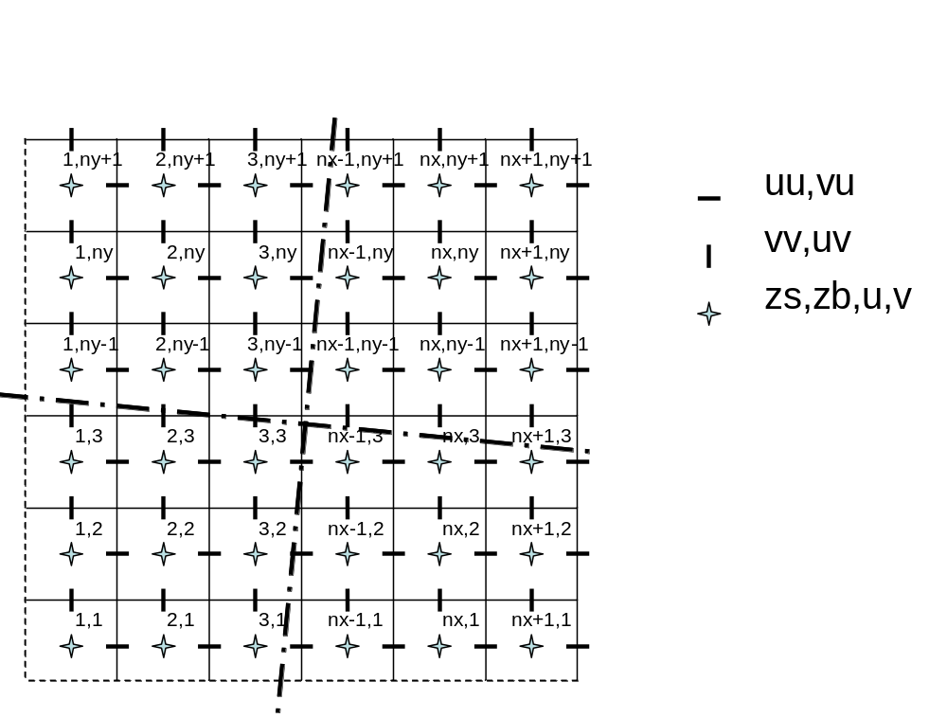
Figure 3.2 Staggered grid

Wave action equation solver
The wave forcing in the shallow water momentum equation is obtained from a time dependent version of the wave action balance equation. Similar to Delft University’s (stationary) HISWA model (Holthuijsen et al., 1989), the directional distribution of the action density is taken into account whereas the frequency spectrum is represented by a frequency, best represented by the spectral parameter f_{m,-1,0}.. The wave action balance is then given by:

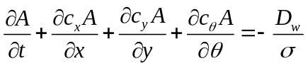

with the wave action:

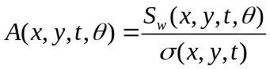

where represents the angle of incidence with respect to the x-axis, 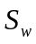 represents the wave energy density in each directional bin and the intrinsic wave frequency. The wave action propagation speeds in x- and y-direction are given by:

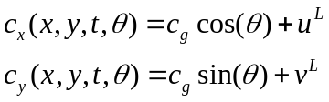

With u^{L} and v^{L} the cross-shore and alongshore depth-averaged Lagrangian velocities respectively (defined below), and the group velocity c_{g} obtained from linear theory. The propagation speed in -space is obtained from:

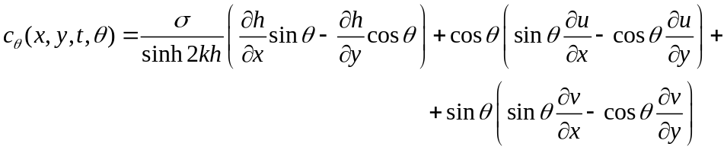

taking into account bottom refraction (first term on the RHS) and current refraction (last two terms on the RHS) and h is the total water depth. The wave number k is obtained from the eikonal equations:

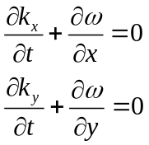

where the subscripts refer to the direction of the wave vector components and represents the absolute radial frequency. The wave number is then obtained from:

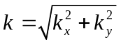

The absolute radial frequency is given by:

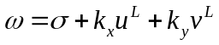
and the intrinsic frequency is obtained from the linear dispersion relation.

The total wave energy dissipation, i.e. directionally integrated, due to wave breaking is modelled according to Roelvink (1993a);

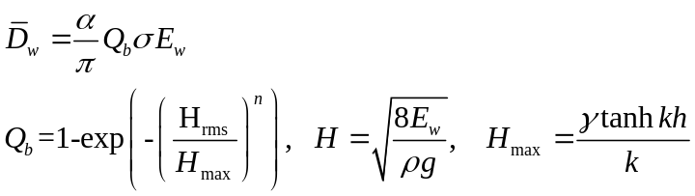

with 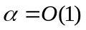, ρ the water density, γ the breaker index (a free parameter) and the total wave energy is given by:

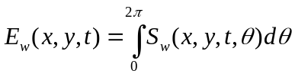.
In the stationary case, we apply Baldock et al. (1998) which states
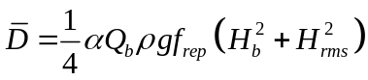

With and 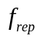representing a representative intrinsic frequency. The fraction of breaking waves is given by:
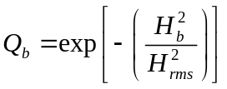

Where the breaking wave height is:

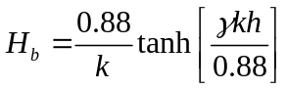

Andis a calibration parameter.

In either instationary or stationary case the total wave dissipation, 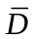, is distributed proportionally over the wave directions:

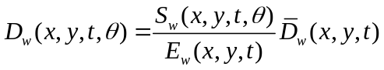
This closes the set of equations for the wave action balance. Given the spatial distribution of the wave action and therefore wave energy the radiation stresses can be evaluated (using linear wave theory):

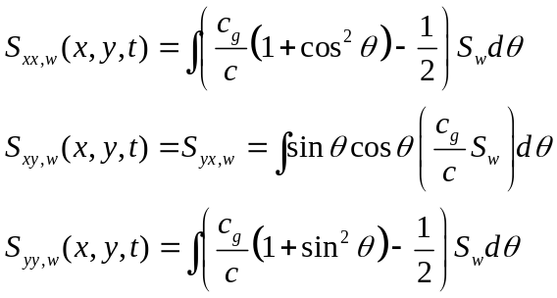

Instationary vs. stationary wave solver
For situations where infragravity motions play an important role the wave and roller equations must be solved in instationary, wave-group resolving mode (instat=1, by default). For some applications which do not focus on swash motions and where surfbeats are small, we have implemented an option (instat=0) to solve the stationary problem directly using a forward marching technique, where the equations are solved grid row by grid row in an iterative fashion. The wave module is then called every wavint seconds rather than each time step, which often means a large reduction in computation time.

Roller energy equation solver
The roller energy balance is coupled to the wave action/energy balance where dissipation of wave energy serves as a source term for the roller energy balance. Similar to the wave action the directional distribution of the roller energy is taken into account whereas the frequency spectrum is represented by a single mean frequency. The roller energy balance is then given by:

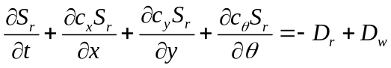

with the roller energy in each directional bin represented by 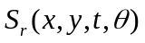.The roller energy propagation speeds in x- and y-direction are given by:

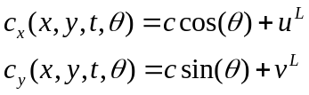
where represents the angle of incidence with respect to the x-axis.
The propagation speed in -space is identical to the expression used for the wave energy density propagation, (eq. ), thus assuming that waves and rollers propagate in the same direction. The phase velocity is obtained from linear wave theory:

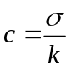

The total roller energy dissipation is given by (Reniers et al., 2004a):

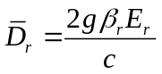

which combines concepts by Deigaard (1993) and Svendsen (1984)

Next the total roller dissipation,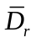, is distributed proportionally over the wave directions:

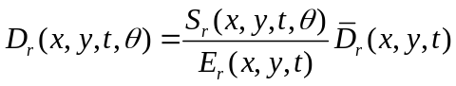

This closes the set of equations for the roller energy balance.

The roller contribution to radiation stress is given by:

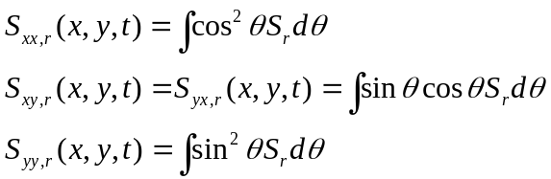

These roller radiation stress contributions are added to the wave-induced radiation stresses (eq. ) to calculate the wave forcing utilizing the radiation stress tensor:

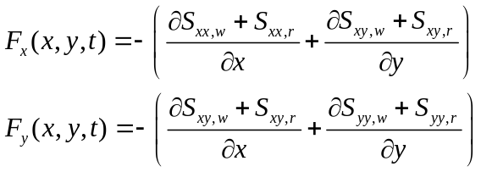

Shallow water equations solver

Depth-averaged equations
For the low-frequency and mean flows we use the shallow water equations. To account for the wave induced mass-flux and the subsequent (return) flow these are cast into a depth-averaged Generalized Lagrangian Mean (GLM) formulation (Andrews and McIntyre, 1978, Walstra et al, 2000). In such a framework, the momentum and continuity equations are formulated in terms of the Lagrangian velocity, u^{L}, which is defined as the distance a water particle travels in one wave period, divided by that period. This velocity is related to the Eulerian velocity (the short-wave-averaged velocity observed at a fixed point) by:

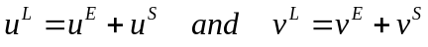

Here u^{S} , v^{S} represents the Stokes drift in x- and y-direction respectively (Phillips, 1977):

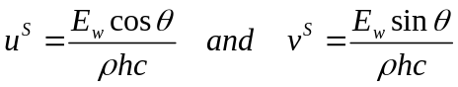

where the wave-group varying short wave energy and direction are obtained from the wave-action balance (eq.). The resulting GLM-momentum equations are given by:

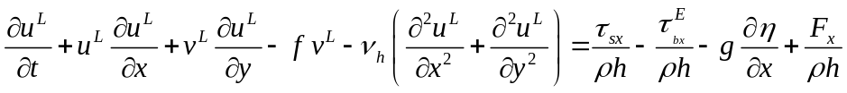
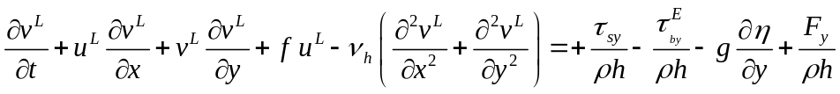
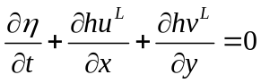
Here 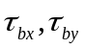 are the bed shear stresses, is the water level, 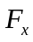,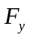 are the wave-induced stresses, 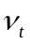is the horizontal viscosity and f is the Coriolis coefficient. The bottom shear stress terms are calculated with the Eulerian velocities as experienced by the bed:

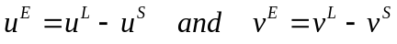

and not with the GLM velocities. Also, the boundary condition for the flow computations are expressed in functions of (u^{L} , v^{L} ) and not (u^{E}, v^{E}).

Quasi-3D equations

x

Sediment transport

Advection-diffusion scheme
The sediment transport is modeled with a depth-averaged advection diffusion equation [Galappatti and Vreugdenhil, 1985]:

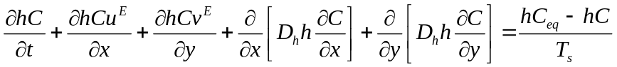

where C represents the depth-averaged sediment concentration which varies on the wave-group time scale, and D_{h} is the sediment diffusion coefficient. The entrainment of the sediment is represented by an adaptation time T_{s}, given by a simple approximation based on the local water depth, h, and sediment fall velocity w_{s}:
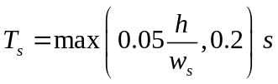
where a small value of T_{s} corresponds to nearly instantaneous sediment response. The entrainment or deposition of sediment is determined by the mismatch between the actual sediment concentration, C, and the equilibrium concentration, C_{eq}, thus representing the source term in the sediment transport equation.

The bed-updating is discussed next. Based on the gradients in the sediment transport the bed level changes according to:
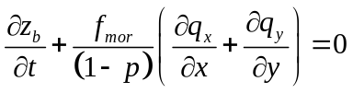

where p is the porosity, 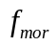 is a morphological acceleration factor of O(1-10) (e.g. Reniers et al., 2004a) and q_{x} and q_{y} represent the sediment transport rates in x- and y-direction respectively, given by:
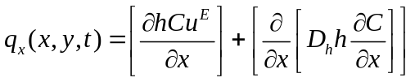
and
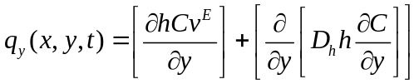

To account for bed-slope effects on sediment transport a bed-slope correction factor f_{slope} is introduced.

Transport formulations
The equilibrium sediment concentration can be calculated with various sediment transport formulae. At the moment the sediment transport formulation of Soulsby-van Rijn (Soulsby, 1997) has been implemented. The C_{eq} is then given by:

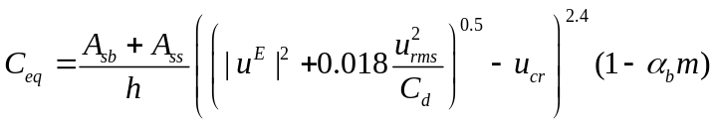

where sediment is stirred by the Eulerian mean and infragravity velocity in combination with the near bed short wave orbital velocity, u_{rms}, obtained from the wave-group varying wave energy using linear wave theory as
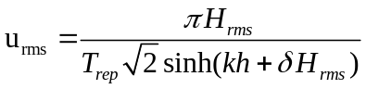

The combined mean/infragravity and orbital velocity have to exceed a threshold value, u_{cr}, before sediment is set in motion. The drag coefficient, C_{d}, is due to flow velocity only (ignoring short wave effects). To account for bed-slope effects on the equilibrium sediment concentration a bed-slope correction factor is introduced, where the bed-slope is denoted by m and 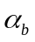 represents a calibration factor. The bed load coefficients A_{sb} and the suspended load coefficient A_{ss} are functions of the sediment grain size, relative density of the sediment and the local water depth (see Soulsby (1997) for details). Note that the transport model does not contain transport contributions related to wave skewness.

The Soulsby-Van Rijn formulation is not strictly valid for sheet flow conditions. If applied in high velocity situations, the formulation as used in XBeach leads to unrealistically high sediment transport rates. In order to compensate this, steady flow velocities used to mobilize sediment are limited by an upper-bound Shields parameter for the start of sheet flow (θ_{sf} = 0.8 – 1.0):

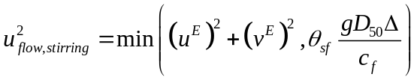

This approach assumes that in sheet flow conditions higher velocities lead to higher sediment transport rates, but not to higher equilibrium sediment concentrations, which is not necessarily correct. However, the assumption does cause sediment discharge under sheet flow conditions to become a linear function of flow discharge, which is in line with Kobayashi et al. (1996).

Bottom updating

Avalanching
To account for the slumping of sandy material during storm-induced dune erosion avalanching is introduced to update the bed-evolution. Avalanching is introduced when a user-defined critical bed-slope (keywords: wetslp and dryslp) is exceeded:

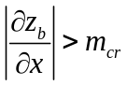

Where the estimated bed slope is given by:

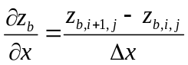

The bed-change within one time step is then given by:

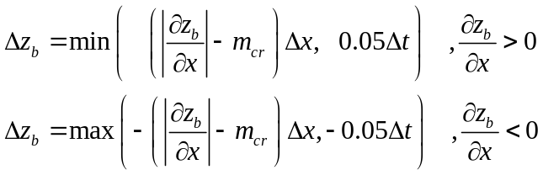

Where a threshold of 0.05 m/s has been introduced to prevent the generation of large shockwaves. The corresponding bed update is given by:

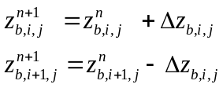

To account for continuity, e.g. when sand is deposited within the wet part of the domain, the water level is also updated:
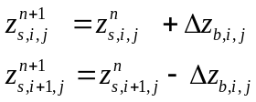

Similar expressions are used for the subsequent avalanching in the y-direction. Here we consider that inundated areas are much more prone to slumping and therefore we apply separate critical slopes for dry and wet points; default values are 1 and 0.3, respectively. The former value is consistent with the equilibrium profile according to Vellinga (1986); it is higher than the angle of natural repose and must be seen as an average slope observed after dune erosion, where some stretches may exhibit vertical slopes and other, drier parts may have slumped further. The underwater critical slope is much lower, and our estimate is based on the maximum underwater slopes we have observed in experiments, e.g. the Zwin test (see below) and tests carried out at Oregon State University with initially rather steep profiles.

When the critical slope between two adjacent grid cells is exceeded, sediment is exchanged between these cells to the amount needed to bring the slope back to the critical slope. This exchange rate is limited by a user-specified maximum avalanching transport rate, which for sandy environments is usually set so high as to have no influence on the outcome, while ensuring numerical stability.

In our model simulations, the avalanching mechanism is typically triggered when a high infragravity wave reaches the dune front and partly inundates it. The critical underwater slope is suddenly exceeded and the two grid cells at the dune foot are adjusted during the first timestep when this happens. In subsequent timesteps a chain reaction may take place both in points landward, where now the critical dry slope may be exceeded because of the lowering of the last wet point, and in points seaward, where now the critical wet slope may be exceeded. As a result, sediment is brought from the dry dune into the wet profile, where it is transported further seaward by undertow and infragravity backwash. An essential difference with similar procedures in other dune erosion models is the fact that avalanching is only applied between adjacent grid cells, rather than extrapolating profile behaviour well beyond the wet domain. This is made possible by explicitly resolving the long-wave swash motions. Another big advantage with respect to existing procedures is that the simple avalanching algorithm is readily applied in two dimensions.

Multiple sediment fractions

To model the overwash deposits at barrier islands during extreme conditions XBEACH has been extended with a multiple sediment class formulation. This allows for the tracking of sediment but also for assigning different sediment characteristics such as grain size diameter, fall velocity, mobility, etc. For each sediment class, i, the equilibrium sediment concentration,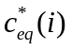, is calculated according to the Soulsby-van Rijn formulation, see equation (3.70).

The actual concentration then depends on the mismatch with the equilibrium concentration in combination with the available fraction at that location. It is assumed that a top-layer of 10 cm depth is readily available for sediment pick-up. So based on the fractions of the various sediment classes present in the top-layer the equilibrium concentration per sediment class can be expressed as:

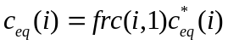

Where the index 1 refers to the top layer and frc the fraction of a specific sediment class. Next the advection-diffusion equation (see eq. ) is solved independently for the different sediment classes leading to class dependent sediment transport rates, 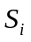 , from which the bottom changes per sediment class, 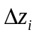 , can be derived:

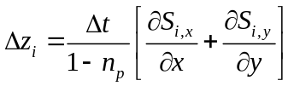

Changes in fractional composition of the sediment classes in the top-layer due to sediment deposition are then calculated by:

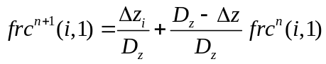
Given dz <= Dz, else:
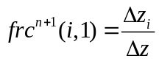

And similarly for erosion:

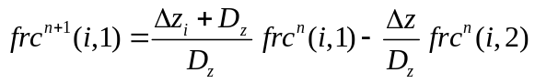
Where the number 2 refers to the layer immediately below the top layer. D_{z} is the constant layer thickness of 10 cm and 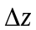 is the total change in bed elevation (all classes combined and positive upward) at time step n+1 where n represent the time index. Next the underlying layers are updated according to:

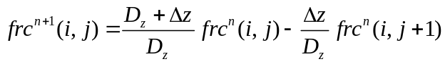
For erosion and:

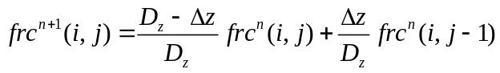

During sedimentation where the subscript j refers to the individual layers. In case of erosion, sediment is thus moving from the bottom layers towards the top layer and vice versa.

Proof of concept
To test the implementation of the sediment class formulation a comparison is made with observations of pre-and post hurricane Ivan cross-barrier island profiles (see Figure 1) at Beasly Park, Florida, USA (Wang and Horwitz, 2007).

The hurricane Ivan impact is simulated with a constant surge level of 1.8 m present for 10 hours at which time the offshore incident significant wave height is kept at 10 m with a mean wave period of 12 s. The sediment class distribution used in the calculations discriminates between sand located within the frontal dune (class 1) and sand located on and behind the barrier island (class 2) (see upper panel in Figure 3.3). The sand on the barrier island is mostly vegetated which mitigates the erosion. Hence this sand has been given a mobility restriction that makes it more difficult to pick-up by means of a reduction factor of 0.25 on the equilibrium concentration. Grain sizes for both sand composites are the same with a D₅₀ of 0.0035 m and a D₉₀ of 0.005 mm. The initial sediment class distribution is presented in the top panel of Figure 1, where an intensity of 1 corresponds to sediment class one only and -1 to the presence of sediment class 2 only.

The bed-elevation and sediment class distribution after 10 hours are shown in the lower panel of Figure 3.3. The calculated bed-level is similar to the observations although differences are apparent. These differences can be related to the fact that the hurricane impact is simply modeled (i.e. constant conditions) and the fact that the post-survey was performed approximately 10 months after the hurricane had past. Still the overall evolution is consistent with the observations. The calculated changes in the sediment classes are also consistent with the observations of Wang and Horwitz (2007) based on a number of cores showing that the intersection of the new washover with the pre-hurricane sediment occurs approximately at the original bed level.

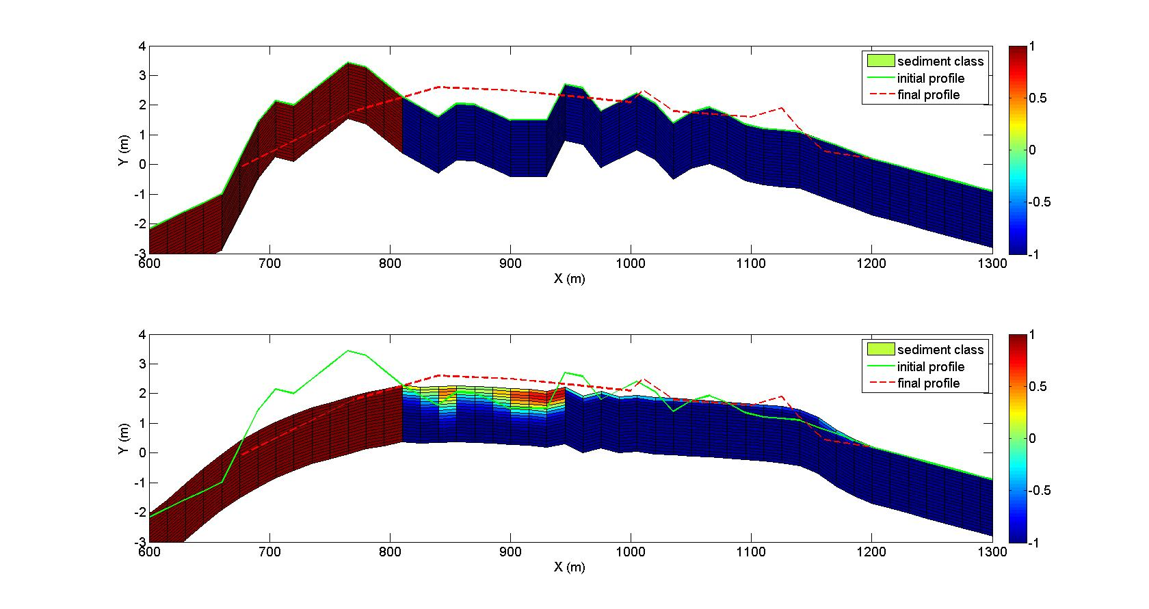

Figure 3.3 Top panel: Initial pre-hurricane bed elevation (green line) and sediment class distribution. A value of 1 corresponds to 100% of sediment class 1, a value of 0 to 50% of class 1 and 50 % of class 2, and a value of -1 corresponds to 100 % of sediment class two. Post-hurricane bed elevation (dashed red line) given as a reference. Bottom panel: Calculated bed-evolution (corresponding to the position of the top layer) and corresponding sediment class distribution showing the thickness of the wash-over layer located behind the initial dune. Pre- (green line) and post-hurricane (red dashed line) bed elevation given as a reference.

Groundwater flow

Physical and numerical principles
The groundwater module in XBeach utilizes the principle of Darcy flow and is therefore limited to laminar flow conditions. In situations in which the groundwater flow may become turbulent, the full momentum equations (e.g. van Gent, 1995) should be applied. The module includes a vertical interaction flow between the surface water and groundwater. This flow is assumed to be a magnitude smaller than horizontal flow and is not incorporated in the momentum balance.

Determining groundwater head
The driving force behind groundwater flow according to Darcy is the groundwater head gradient. In the XBeach module, the groundwater head 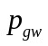 has the unit [m]. Where there is no surface water, the groundwater head is equal to the groundwater surface level 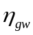:

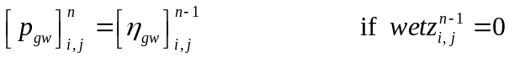

Where there is surface water and the groundwater surface level is just below the surface of the bed 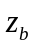, the groundwater head is affected by the surface water head 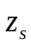. If the groundwater surface level is equal to the bed level, the groundwater head is equal to the surface water head. If the groundwater surface level is more than 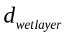 below the surface of the bed, the groundwater head is unaffected by the surface water head and is equal to the groundwater surface level. At intermediate depths a linear interpolation takes place, using the relative groundwater level 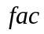:

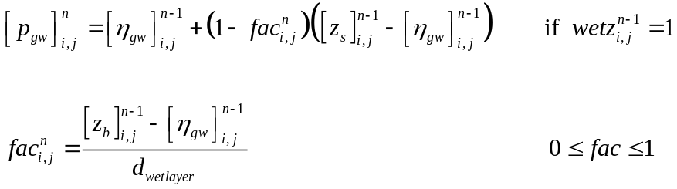

Momentum balance
Darcy flow is described by the following relationship between the groundwater head gradient, the permeability , and the horizontal velocity:

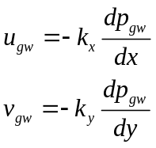

In the module, the head gradient is found numerically using:

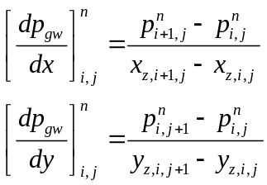

And horizontal flow is calculated by:

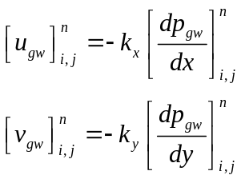

Determining vertical flow
In order to simulate the interaction between the surface water and groundwater, a vertical flow between the surface water layer and groundwater layer () is introduced. This flow has the unit [ms⁻¹] and is defined positive from surface water to ground water and is given in terms of surface water for the continuity equation (i.e. 100% porosity).

Exfiltration
Exfiltration, or flow from the groundwater layer to the surface water layer, takes place if the groundwater surface level exceeds the bed level. The volume of groundwater (including porosity 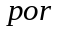) exceeding the bed level is joins the surface water within the same numerical time step. The vertical velocity can therefore be calculated by:

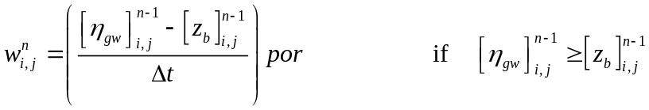

Vertical infiltration model
Surface water running up and down a dry slope will infiltrate into the ground. In order to model this fully, a 3D model must be used. In the XBeach groundwater module, the option is made to model infiltration using a quasi-3D model.
In areas where there is surface water and the groundwater level is not greater than the bed level, infiltration can take place. To a certain degree of truth, infiltration can be calculated using Darcy flow:

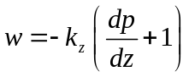

In an area that is covered by surface water, the head on the top of the bed can be said to be equal to the surface water head. In the absence of groundwater at the bed level, the head under the bed level is zero. As the distance between the top and bottom of the bed level is zero, the head gradient is infinite. The resulting vertical velocity becomes infinite and the method becomes numerically unstable. In order to circumvent this problem the vertical infiltration is divided into an instantaneous, but finite reaction in the upper ground layer and Darcy flow across a non-zero depth. The proportion of the instantaneous part to the Darcy flow part is governed by the relative groundwater level , as in section 3.9.2. The instantaneous part is handled in the same way as exfiltration. The head gradient for the Darcy flow is found by assuming the head at the bottom of the infiltration layer is zero, and the head on the top of the infiltration layer is equal to the height of water standing on the bed (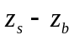).

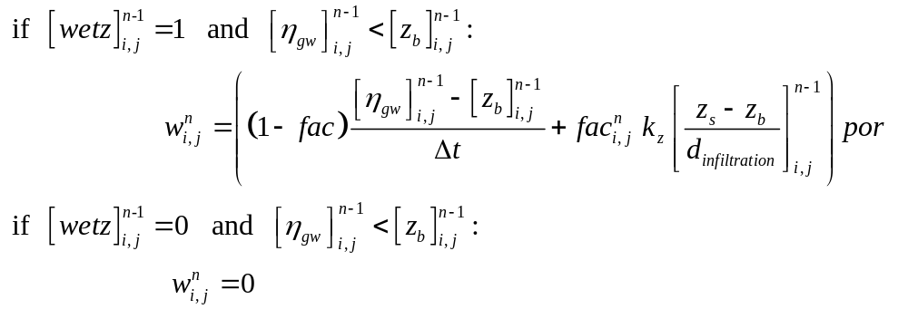

The infiltration velocity is limited by the amount of surface water available in the cell:

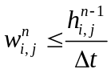

The thickness of the infiltration layer (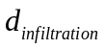) is increased at the end of every time step by the infiltrating water. The infiltration speed in the next time step will therefore be less than that in the current time step. Infiltrating water is assumed to immediately become part of the groundwater for the purpose of groundwater level and groundwater head calculations. This approach is therefore not fully 3D and only uses a quasi-3D approximation to limit the infiltration speed.

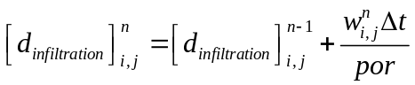

For numerical stability, the infiltration layer thickness is restricted to a minimum of one third of , corresponding with the centroid of the instantaneous infiltration part. The maximum thickness of the infiltration layer is equal to the depth of the groundwater level below the bed level. Once an area has no surface water, the thickness of the infiltration layer is reset to the minimum value, representing the fact that the infiltrated water has sunk out of the way of subsequent infiltrations.

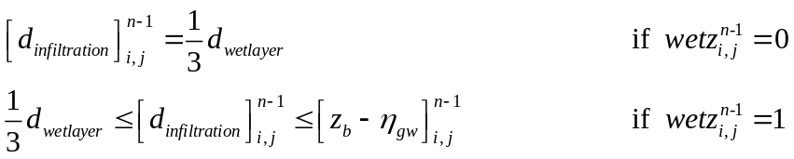

Mass balance
The continuity equation for the groundwater system can be written as:

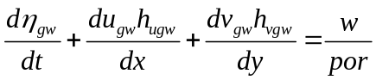

The effective depths through which horizontal ground water flow takes place (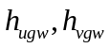), are found by taking the mean difference between the groundwater level and bed of the aquifer (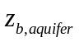) in the two surrounding -points:

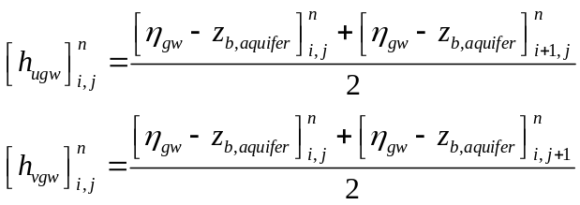

This method is faster, but less momentum conservative than the method used in the surface water flow routine. Since large gradients in the groundwater level are not expected, the scheme is assumed sufficient.
Groundwater flux is limited in cells that are empty of groundwater. For such cells, groundwater may enter the cell, but no groundwater may leave until the amount of groundwater exceeds a minimum value (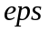).

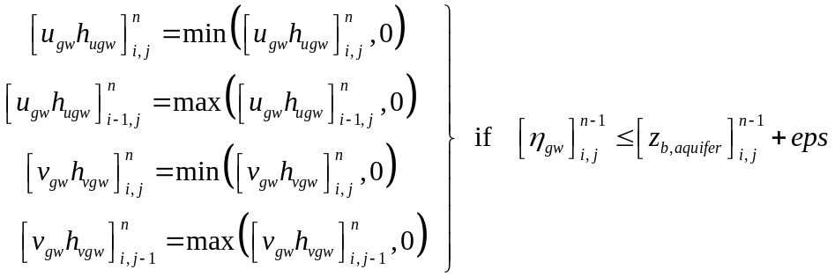

The continuity equation for the groundwater level is solved by the following:

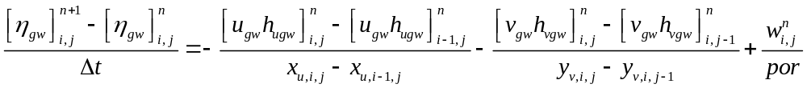

To account for infiltrating and exfiltrating groundwater, an additional term is added to the continuity equation of the surface water, but none to the momentum balance, see also eq. :

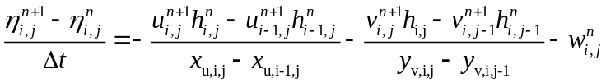

Boundary conditions

Offshore flow boundary conditions
The offshore boundary is an artificial boundary which has no physical meaning. On the offshore boundary wave and flow conditions are imposed. In the domain waves and currents will be generated which need to pass through the offshore boundary to the deep sea with minimal reflection. One way to do this is to impose a weakly reflective-type boundary condition.

In XBeach, there are two options with regard to the offshore absorbing-generating boundary condition. With the parameter setting “front = 0” a simple one-dimensional radiating boundary condition is activitated. It reads

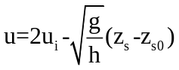

Where u_{i} is the incoming particle velocity and z_{s} is the surface elevation of the incoming bound long wave, and z_{s0} is the mean water level (averaged over many wave groups). This boundary condition assumes all incoming and outgoing waves propagate normal to the boundary. It is therefore only useful for 1D (flume like) simulations.

With option “front = 1” (default value) the formulation by Van Dongeren and Svendsen (1997) is activated which in turn is based on Verboom et al. (1981) and is based on the Method of Characteristics. This boundary condition allows for obliquely-incident and reflected waves, and is therefore suited for 1D and 2D computations.

The boundary conditions satisfy the following two necessary conditions:
- the region outside the computation domain can influence the motion within the domain only through the incident (long) waves and through the currents along the boundaries; and
- the (long) waves propagating out of the computational domain must be allowed to freely propagate through the open-ocean offshore boundary with minimal reflection.

By placing the open boundaries carefully, one can achieve weak local forcing near these boundaries. In practice this means that the offshore boundary is placed in sufficiently deep water, i.e. outside the shoaling zone. Then the dominant terms in the continuity and momentum equations near these boundaries are the nonlinear shallow water equation.s

For the general case of an arbitrary angle υ between the boundary at a point and the coordinate axes, one can follow the work of Abbott (1979) and Verboom et al. (1981) to derive the governing equations, which are valid for an arbitrary angle υ between the coordinate axes and the model boundary (Figure 3.4a).

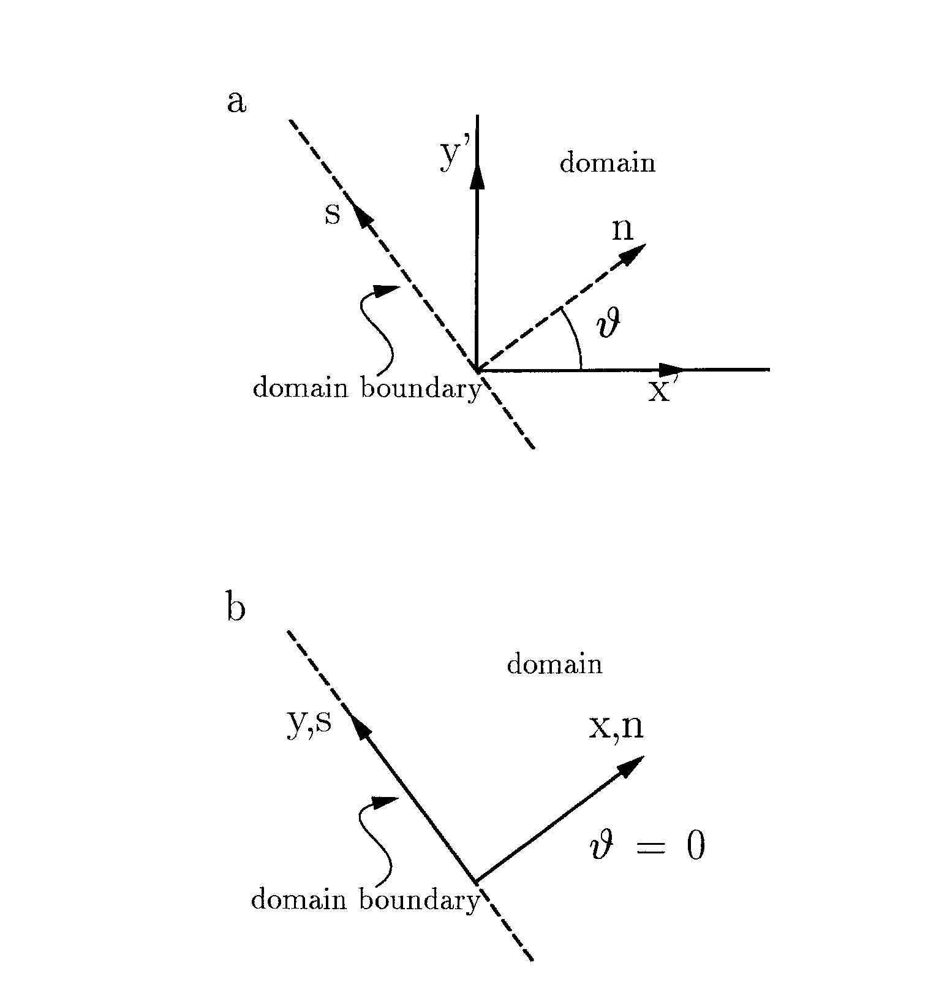
Figure 3.4 Coordinate system (a) for arbitrary angle υ between domain boundary and x-axis; (b) for υ=0

The derivation becomes simplified if the coordinate system is defined in a way the the x-axis is normally inward to the seaward boundary of the rectangular domain, which sets υ=0 (Figure 3.4b). The governing equations derived following Abbott (1979) and Verboom et al. (1981) then simplify to

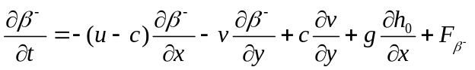
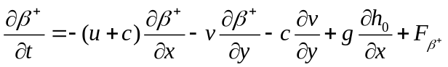
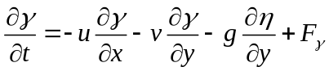

Where, F includes all local forcing and friction terms for the motion, c is the wave celerity, and h₀ is the still water depth. The Riemann variable β⁻ is defined as

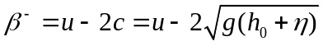
Here ū is the depth-averaged velocity. The Riemann variable β+ is similarly defined as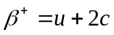. The γ-equation is the y-momentum equation, which has the Riemann variable

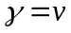
The definition sketch in Figure 3.5 shows that β- propagates in the negative x-direction, β+ propogates in the positive x-direction, and γ in the y-direction. The forcing terms, F, in equations - originate from the right-hand side of the nonlinear shallow water equations, which imply that β- , β+, and γ are variables rather than constants.

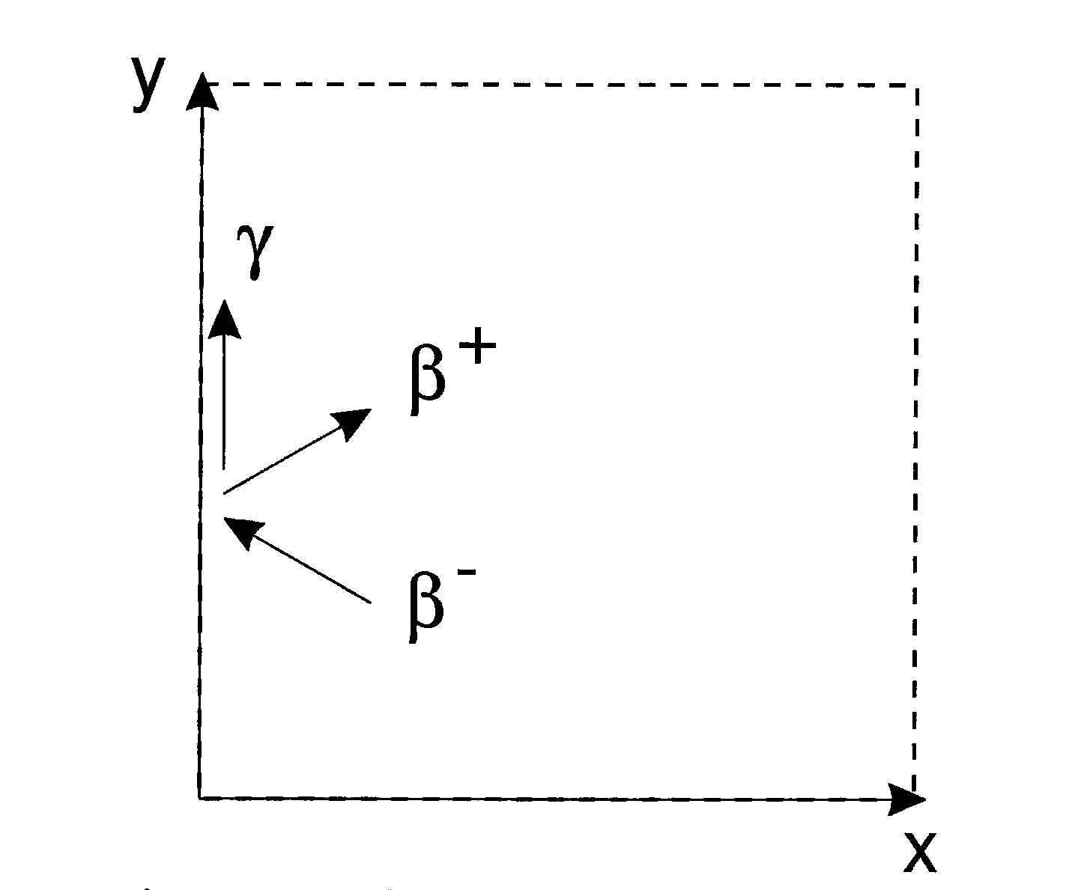
Figure 3.5 Definition sketch of the characteristics.

The offshore boundary conditions uses the outgoing β- variant which contains information about the waves leaving the domain and the γ variant which propagates along the boundary. The latter is extra information which we will use to estimate the direction of the outgoing wave which is the innovation in Van Dongeren and Svendsen (1997).

The procedure is as follows: during the computation, at time step n, we know the values of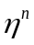 and the total velocities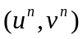 at all points in the domain. The incoming wave is specified along the open boundaries through the x and y components of the particle velocities of the incident wave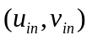. The numerical integration of nonlinear shallow water equations will provide the values of the total , u, and v for the interior points in the domain at time step n+1, and then the equivalent total (incoming plus outgoing) values need to be determined along the boundaries at n+1. In other words, given the incoming wave, the outgoing wave needs to be determined.

In XBeach the lowest-order derived equations are implemented for the weakly reflective boundary conditions, with x=0 at the boundary. The outgoing wave angle (θ_{r}) and velocity in the x-direction (u_{r}) are solved iteratively. For specifics on this derivation we refer to Van Dongeren and Svendsen (1997), the shorter outline is given below

The β- is updated along the boundary only through which discretized in XBeach (similarly as the x-momentum equation) reads
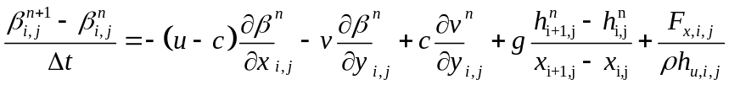

And is thus known at the time level n+1. We can then solve for the outgoing velocity u_{r} by expanding the Riemann variant to lowest order as

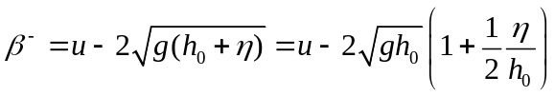
We further have the identities
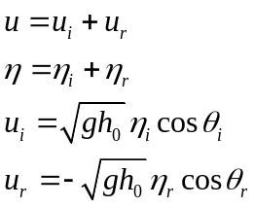
where the last two identities assume a wave propagating in shallow water with constant form where θ_{i} and θ_{r} are the angles of the incoming (known) wave and the outgoing (yet unknown) wave, relative to the x=0 boundary. Inserting these identities into and re-arranging gives
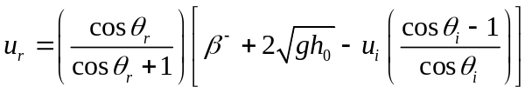
All the terms on the right hand side are known except for θr which can be solved from the γ = v variant as
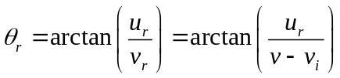
Eqs. and are then solved iteratively to yield both u_{r} and θ_{r}. The final boundary condition is then the total velocity u u = u_{i} + u_{r} at the boundary at the time level n+1.

Bay-side flow boundary condition
In many cases, the onshore boundary will be a land boundary. In some case the “onshore” will be a bay behind a barrier island. In that case it is possible to specify a number of boundary conditions

- 1D absorbing boundary condition

This boundary condition type is activated using “back = 0’ and is analoguous to without the possibility of specifying an incoming particle velocity.

- wall

This boundary condition type is activated using “back =1” and is a simple no flux boundary
condition

- 2D absorbing boundary condition (default)

This boundary condition type is activated using “back = 2” and is analoguous to the
absorbing-generating boundary condition by Van Dongeren and Svendsen (1997), but without the incoming particle velocities (so 2D absorbing only).

Lateral flow boundary conditions

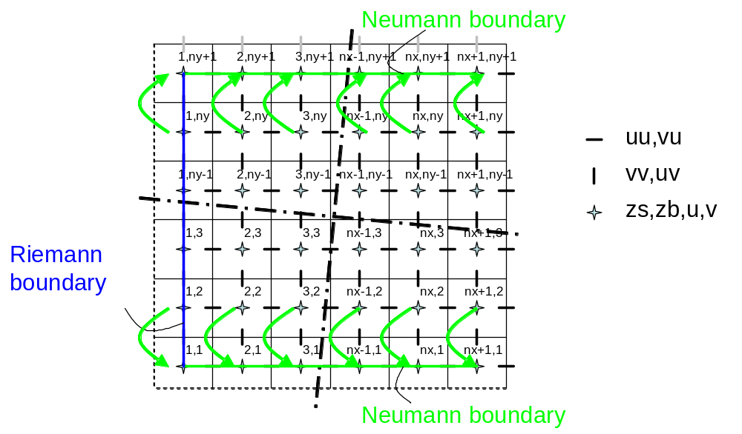
Figure 3.6 Stencil for Neumann-type boundary conditions.

For the lateral boundaries so-called Neumann boundaries can be used (“left = 0” and/or “right = 0”), where the longshore water level gradient is prescribed. The alongshore gradient is prescribed by the difference in specified water levels at the offshore corner points, divided by the alongshore length of the domain.

This type of Neumann boundary condition has been shown to work quite well with (quasi-) stationary situations, where the coast can be assumed to be uniform alongshore outside the model domain. So far we have found that also in case of obliquely incident wave groups this kind of boundary conditions appears to give reasonable results, though rigorous testing still has to be done. The implementation consists of copying water levels from row 2 to row 1 and from row ny to row ny+1, and doing the same for the cross-shore (along-boundary) velocities. The alongshore velocities can now be computed from row 1 through row ny; no additional boundary conditions are required for the alongshore velocity.

Simple no-flux boundary conditions (walls) can be set using “left = 1” and/or “right = 1”. Wall boundary conditions are more effective than Neumann boundary conditions in 1D models.

Offshore wave boundary conditions
At present, a number of wave boundary conditions can be specified at the offshore boundary. These are numbered “instat=0” through “instat=7”.

• Stationary wave boundary conditions (instat = 0).

In this case a uniform, constant wave energy distribution is set, based on given values of H_{rms}, T_{m01}, direction and power of directional distribution function.
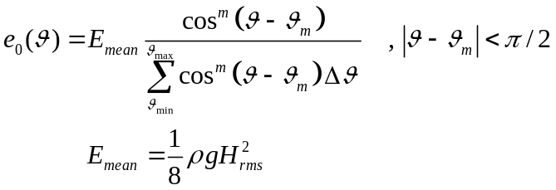

• Wave energy varying periodically in time (instat = 1):

In this case regular wave groups (i.e. bichromatic waves) are specified.
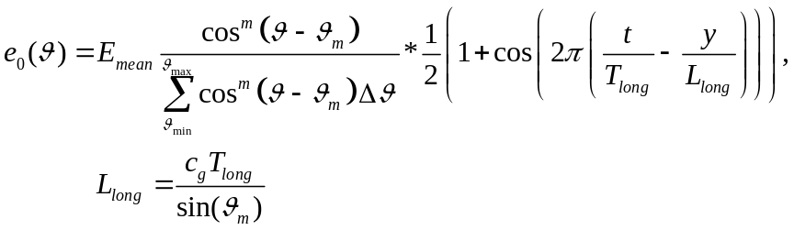

• First-order longcrested, irregular wave groups (instat = 2)

In this case E is read in as a function of time; the timeseries is shifted along the y-axis to account for the oblique incidence.
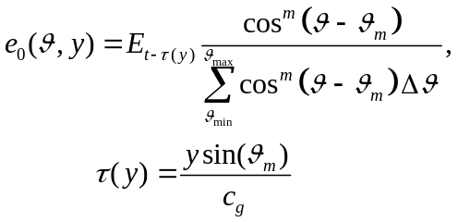

This time series needs to be made by a separate routine (not part of XBeach). An example of the required input format is given in the Appendix B

• Second-order longcrested, irregular wave groups (instat = 3)

In this case a bound wave is added to the wave groups using Longuet-Higgins and Stewart’s (1964) theory. The format is prescribed in Appendix B

• Standard JONSWAP spectrum, based on user-input spectrum coefficients (instat = 4)

With this option alongshore varying timeseries of the wave energy E and bound long wave z_{s} are generated on the basis of a specified analytical 2D Jonswap-type spectrum. With this option realistic second-order bound, directionally-spread seas can be created.

The spectrum is determined by the peak period, wave height, spectral peakedness, mean angle and directional spreading (see section 5.5 for details on the input values). The routine follows the procedure as outlined by Van Dongeren et al. (2003), see next paragraph.

• Unmodified SWAN 2D spectrum output file (instat = 5)

This option uses a SWAN 2D output file (sp2 file) in unmodified form. The procedure to calculate the boundary conditions is analoguous to the instat=4 option.

• Formatted variance-density spectrum file (instat = 6)

This option uses a formatted variance-density spectrum file, which needs to adhere to certain criteria (see section 5.5). On the basis of this formatted spectrum, boundary conditions are calculated using the procedure as outlined under instat = 4.

• Reuse boundary condition files from an earlier XBeach simulation (instat = 7)

If the user does not wish to recalculate spectrum-based boundary condition files or specifically wants to reuse the spectrum-based boundary condition files of another XBeach simulation, it is possible to do so. In this case the user should select ‘instat = 7’ in params.txt. No further wave boundary condition data need be given in params.txt. Obviously, the calculation grid should remain the same between runs, as the angles and number of grid points are embedded in the boundary condition files. In order to use instat 7, the user should copy ebcflist.bcf and qbcflist.bcf to the current directory. Additionally, the user should also copy all files listed in ebcflist.bcf and qbcflist.bcf. Generally, these files have E_ and q_ prefixes.

With instat=4, 5 and 6 time-varying (on the scale of wave groups) boundary conditions are computed on the basis of stationary input spectra. It is also possible to use a sequence of varying spectra to compute boundary conditions which not only vary on the time scale of the wave groups but also have a variation on the longer timescale. The procedure is similar to the one described above, only the implementation is through the specification of a list of spectrum files, see section5.5.

Procedure for converting spectra to wave energy and bound long wave boundary conditions
The spectrum is determined by the peak period, wave height, spectral peakedness, mean angle and directional spreading (see section 5.5 for details on the input values). The routine follows the procedure as outlined by Van Dongeren et al. (2003).

In order to create a time series of wave energy along the offshore boundary, the input spectrum is assumed to be composed of K single summation wave components [Miles and Funke, 1989; in van Dongeren et al., 2003] in the range around the spectral peak where the energy density is greater than a certain fraction of the peak energy density (proscribed by the keyword “sprdthr”). Each wave component has a specific frequency, phase, amplitude and direction. Summed together the wave components create a time series of the sea surface at the offshore boundary:

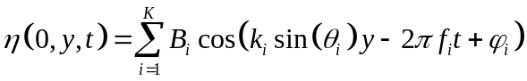
where B_{i} represents the amplitude of each wave component.

In order to determine the specific properties of the wave components, the frequencies of all K components are distributed uniformly in the range around the spectral peak. This choice leads to a frequency resolution which is dependent on K. Each wave component is given a wave phase using the random phase model. The direction of each wave component is determined randomly using the Cumulative Distribution Function of the wave direction of the input spectrum, see Figure 3.7. At this stage the directional CDF is based on integration across all frequencies. In the case of strong frequency-directional correlation, it may be advisable to use frequency dependent CDFs instead.

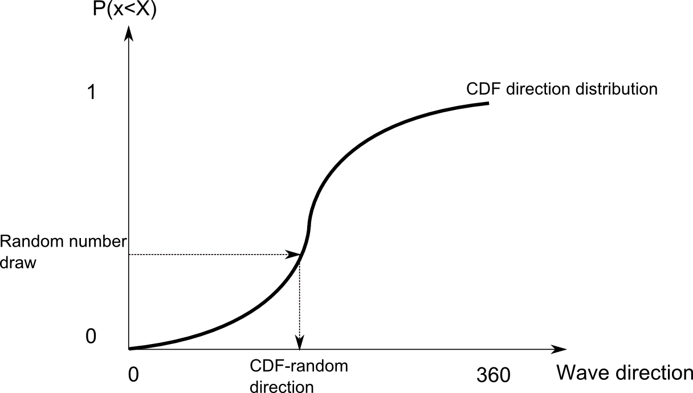
Figure 3.7 Random wave angles are chosen using a random number generator and the cumulative distribution function of the directional spreading of the input spectrum

Once the frequency and direction of each wave component has been selected, the amplitude Bi can be calculated by two dimensional interpolations across the 2D-input wave variance spectrum. A linear correction is made to the amplitudes of the wave components to ensure the integrated wave variance of the K components is the same as that of the input spectrum. The wave number k_{i} is determined using the dispersion relation, given the mean still water depth at the offshore boundary.

Equation can now be used to generate a time series of the sea surface elevation at the offshore boundary. The envelope of the sea surface time series can be calculated using a Hilbert transform, the amplitude of which being a measure for the wave energy:

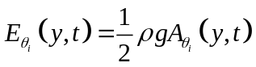

The particle velocity due to bound infragravity waves at the offshore boundary is calculated according to the expressions developed by Herbers et al. [1994]. It is stated that bound infragravity waves are generated by the interaction of two wave components with different frequencies. The frequency of the bound infragravity wave is given as:

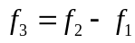

In the equation above, the subscripts on the right hand side refer to the indices of interacting short wave pairs. In order to ensure positive interaction frequencies, indices should be ordered according to increasing frequency of the short wave components. It should be noted that two interacting wave components contribute to only one infragravity wave frequency. However, one infragravity wave frequency may be forced by many different wave component interactions.

Similarly, other properties of the bound infragravity wave can be deduced from the associated properties of the short wave components. The bound wave number, wave group velocity and wave phase are given as:

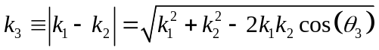
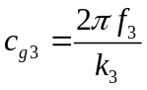
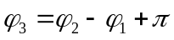

Note that equation is based on the assumption that the short wave groups and bound long waves are in equilibrium, and therefore are 180° out of phase. The angle of the bound long wave can be found using the following relation:

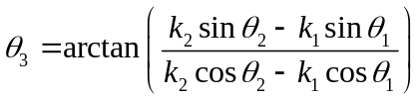
The energy related to a bound infragravity wave with a specific frequency is given as [van Dongeren et al., 2003]:

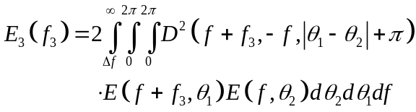
Where in equation the first term behind the triple integral is the interaction coefficient as defined by Herbers et al.[1994]. This interaction coefficient is determined through a perturbation expansion of the Bernouilli equation, details are in original publication. In the wave boundary condition module a modification of the interaction coefficient is implemented to convert the output to surface level elevation instead of bed level pressure:

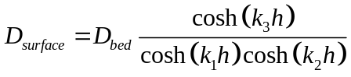
The amplitude of each bound wave can be found from the bound wave energy [van Dongeren et al., 2003]:

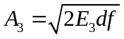
Where df refers to the frequency resolution of the short waves, i.e. the frequency step used to generate all K frequency components around the peak of the short wave spectrum.

A time series for the cross shore water flux across the offshore boundary is generated by means of an Inverse Fourier Transform:

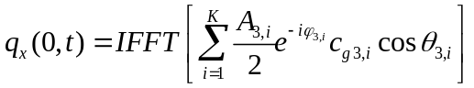
This cross-shore flux is phase-shifted along the offshore boundary as:
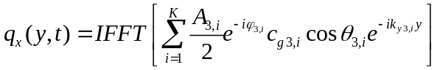

The cross-shore flux and the wave energy are specified along the boundary.

3.9.5 Lateral wave boundary conditions

For the lateral boundary conditions we make the following reasonable assumptions for the incoming wave energy:

- In the stationary case, we assume that the alongshore gradient of the wave energy is zero; this means we copy the value of one row inside the domain to the boundary, for the directional bins where the direction is into the model domain;
- In the instationary case, we assume that the gradient along the crest of the wave group is zero. The direction of the crest is derived from the local mean wave direction and the values at the boundary are determined by interpolation between the two points on the row inside around a virtual point taken along the crest direction; in the figure, for example, the value at point (3,1) is interpolated from points (2,2) and (3,2).

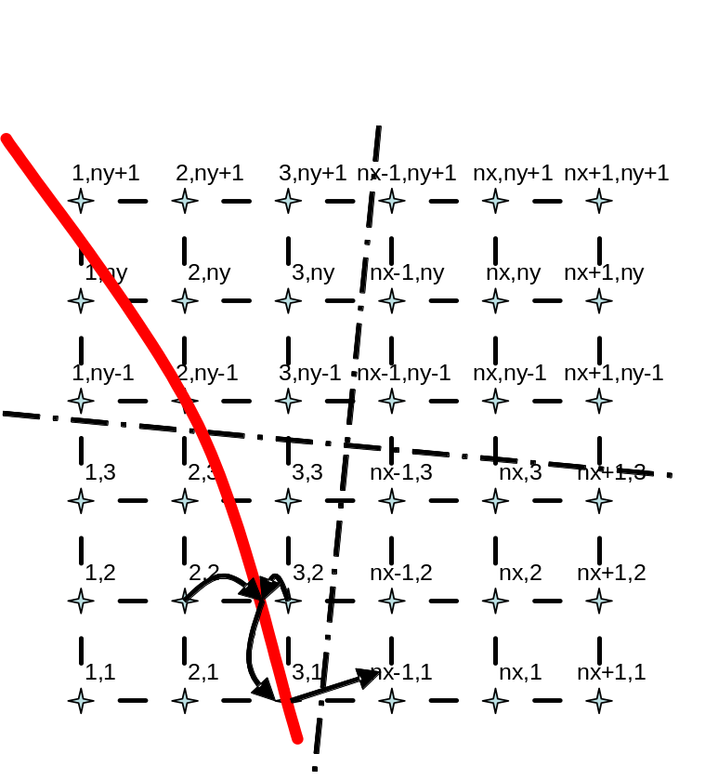
Figure 3.8 Example of interpolation at the lateral boundary.

Groundwater boundary conditions

Vertical boundary conditions
The groundwater level is bounded by the bottom of the aquifer. In the central domain the groundwater level is adjusted naturally by infiltration and exfiltration. The groundwater level has no bounding maximum in the vertical, except on the offshore, bay side and lateral boundaries. Here the groundwater level is bounded vertically by the bed level on the boundaries:

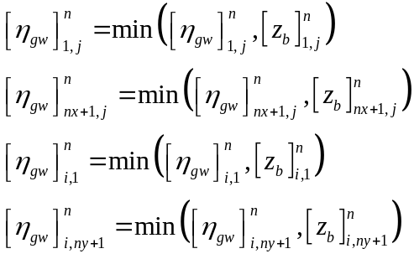

The bed of the aquifer is set equal to or less than the regular bed level:

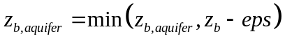

Offshore boundary condition
At the offshore boundary, the groundwater head is set equal to the offshore surface water head:

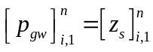

Bay side boundary condition
For cases in which a bay side water level is given explicitly with a tidal level record (tideloc = 4, tideloc = 2 and paulrevere = 0), the groundwater head on the bay side boundary is set equal to the bay side surface water head:

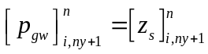

In all other cases, the bay side groundwater head is kept at the initial value:

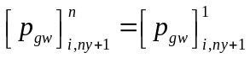

Lateral boundary conditions
Neumann boundary conditions are applied to the groundwater head on the lateral boundaries:

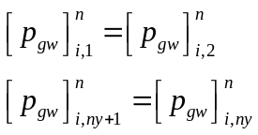

Initial conditions
The bed of the aquifer and the initial groundwater head must be specified, see section 5.10 for a description. The initial groundwater level is calculated from the initial groundwater head.

Compiling the model

The source code has been extensively tested in a version compiled under Compaq Visual Fortran version 6.6. We expect it to compile with only minor problems under other compilers and/or under Linux, since only standard Fortran 90/95 is used. Once an executable has been created, it will be called xbeach.exe.

Running the model

Input file structure
On execution the xbeach.exe executable will open the file params;txt in the current directory and interpret the keyword=value combinations in it. The keywords refer to parameter values or filenames and can be listed in any order. Lines not containing an ‘=’ sign are ignored and may be used for comments.

The ‘params.txt’ file contains grid and bathymetry info, wave input, flow input and morphological input. The tables below contain a description of the keywords, the default values and recommended minimum and maximum values.

params.txt
depth file
(optional) x- and y-grid files
(optional) water level time series
(optional) incident wave energy and long wave time series
(optional) spectral input (time series)

Specifying grid and depth
keyword | description | default value | minimum value | maximum value | unit | remarks
nx | number of grid points in x | 50 | 2 | 10000 | -
ny | number of grid points in y | 2 | 2 | 10000 | -
dx | grid size in x | 0 | -1e9 | 1e9 | m
dy | grid size in y | 0 | -1e9 | 1e9 | m
xori | x - origin in world coordinates | 0 | -1e9 | 1e9 | m
yori | y – origin in world coordinates | 0 | -1e9 | 1e9 | m
alfa | angle of grid | 0 | -360 | 360 | deg
posdwn | depth defined positive down | 1 | -1 | 1 |  | 1 = positive down  -1 = positive up
vardx | option of variable grid size | 0 | 0 | 1 | - | 1 = varying grid size  0 = non-varying grid size
depfile | bathymetry file |  |  |  |  | no values; specify name
xfile | variable gridsize file x |  |  |  |  | no values; specify name;only with vardx=1
yfile | variable gridsize file y |  |  |  |  | no values; specify name only with vardx=1

The depfile keyword contains the reference to a bathymetry file, which should contain, for each of ny+1 rows, nx+1 depth values, which may be defined positive downward or upward, depending on a keyword posdwn that may be 1 (depth positive downward) or -1 (positive upward).

If a non-equidistant grid is chosen, the keyword vardx=1 should be selected and an xfile and yfile have to be specified.

Wave input

Action balance
For simple simulations with stationary waves or regular wave groups the wave parameters Hrms, Trep and dir0 can be entered directly in the params.txt file; for more advanced options see section 5.5. The directional grid for short waves and rollers can either be specified as Cartesian (angle w.r.t. the computational x-axis) or as nautical directions (direction waves come from in deg. N, so from W is 270 deg. N); this depends on thetanaut (1 means nautical, default Cartesian is 0) .
With the switch wci one can turn off or on the wave-current interaction, viz. the feedback of currents on the wave propagation, see section 3.3.

keyword | description | default value | minimum value | maximum value | unit | remarks
dir0 | mean wave direction (Nautical convention) | 270 | 180 | 360 | deg | instat=0-3 only
Hrms | rms wave height | 1 | 0 | 10 | m | instat=0,1 only
wavint | interval between stationary wave module calls | 1 | 1 | 3600 | s | instat = 0 only
m | power in cos^m directional distribution | 10 | 2 | 128 | - | instat=0-3 only
Tm01 | spectral period | 10 | 1 | 20 | s | instat=0-3 only
Trep | alternative keyword for representative period | 10 | 1 | 20 | s | overrules value for Tm01
Tlong | long wave / wave group period | 80 | 20 | 300 | s | instat = 1 only
thetamin | lower directional limit | -80 | -180 | 180 | deg | angle w.r.t computational x-axis
thetamax | upper directional limit | 80 | -180 | 180 | deg | angle w.r.t computational x-axis
dtheta | directional resolution | 10 | 0.1 | 20 | deg
thetanaut | option to enter thetamin thetamax in nautical convention | 0 | 0 | 1 | -
taper | time to spin up wave boundary conditions | 100 | 0 | 1000 | s | not for stationary waves
nspr | set directional spreading long waves | 0 | 0 | 1 | - | 1 = bin all incoming long wave directions (instat 4+) in the centres of the short wave directional grid cells
wci | wave current interaction option | 0 | 0 | 1 | - | instat = 0 only
scheme | Switch numerical schemes for wave action balance | 1 | 1 | 2 | - | 1 = Upwind  2 = Lax Wendroff

Wave dissipation model
For instationary model runs, use the Roelvink (1993) model with either break=1or break=3. Note that the standard value gamma=0.55 and n=10 was calibrated for option break=1. for break=3 the wave dissipation is proportional to H³/h instead of H²; this affects the calibration.

For stationary runs the Baldock et al, 1998 model will be suitable.
keyword | description | default value | minimum value | maximum value | unit | remarks
break | option breaker model | 3 | 1 | 3 | - | 1=roelvink,  2 = baldock,  3 = roelvink adapted
gamma | breaker parameter in Baldock or Roelvink formulation | 0.6 | 0.4 | 0.9 | -
alpha | wave dissipation coefficient | 1 | 0.5 | 2 | -
n | power in roelvink dissipation model | 5 | 5 | 20 | -

Roller model
Using the roller model will give a shoreward shift in wave-induced setup, return flow and longshore current. This shift becomes greater for lower beta values.

keyword | description | default value | minimum value | maximum value | unit | remarks
roller | option roller model | 1 | 0 | 1 | - | keyword not implemented yet. Roller model is turned on by default
beta | breaker slope coefficient in roller model | 0.15 | 0.05 | 0.3 | -

Flow input
The bed friction is influenced by the dimensionless friction coefficient cf or the dimensional C value. These values are uniform and stationary.

The horizontal viscosity is first composed by adding an overall background viscosity nuh and a viscosity depending on the roller dissipation, tuned by nuhfac. In the alongshore direction the viscosity may be multiplied by a factor nuhv to account for additional advective mixing.
keyword | description | default value | minimum value | maximum value | unit | remarks
cf | friction coefficient | 0.003 | 0 | 0.1 | -
C | Chezy coefficient | sqrt(g/cf) | 20 | 100 | m1/2/s | alternative for cf, overrules cf if set
nuh | horizontal background viscosity | 0.5 | 0 | 1 | m2/s
nuhfac | viscosity coefficient for roller induced turbulent horizontal viscosity | 0 | 0 | 1 | -
nuhv | additional shear dispersion factor | 1 | 1 | 20 | - | svendsen and putrevu (1994)
lat | latitude | 0 | 0 | 90 | deg N
wearth | angular velocity of earth | 1/24 | 0 | 1 | 1/hour

Wave boundary conditions

User input
The user input options include instat = 0,1,2,3,4, 5, 6 or 7 in params.txt. The meaning of each is summarised below:
- Instat 0: Stationary wave conditions specified by Hrms, Trep, dir0
- Instat 1: Regular bichromatic wave groups specified by Hrms, Trep, dir0, Tlong
- Instat 2: Read in unidirectional time series of wave energy from file bc\gen.ezs, direction given by dir0
- Instat 3: Reads in unidirectional time series of wave energy and incident long wave from file bc\gen.ezs, direction given by dir0
- Instat 4: Standard JONSWAP spectrum, based on user-input spectrum coefficients
- Instat 5: Unmodified SWAN 2D spectrum output file
- Instat 6: Formatted variance-density spectrum file
- Instat 7: Reuse boundary condition files from an earlier XBeach simulation

The new module in XBeach converts the input spectral data into boundary condition time series that can be read by the main XBeach program. Boundary condition time series that are created from input spectral data are non-stationary. Due to the randomness used to generate the time series, see Theory, no two time series generated from the same input data will be identical. They will however share the same statistical properties. The user can avoid random variations between simulations by reusing the boundary condition time series of an earlier XBeach simulation.

The user has the option to carry out the simulation using one wave spectrum during the entire simulation period. In this case the spectral properties of the generated waves will be constant in time. Alternatively, the user may choose to vary the spectral properties of the boundary conditions in time. In this case the spectral properties of the generated waves depend on a time series of input spectral data.

The steps that should be taken for an XBeach simulation using the new wave boundary conditions are explained in the following sections. The reader is advised to consult Figure 5.9 to determine which sections are relevant to the simulation.

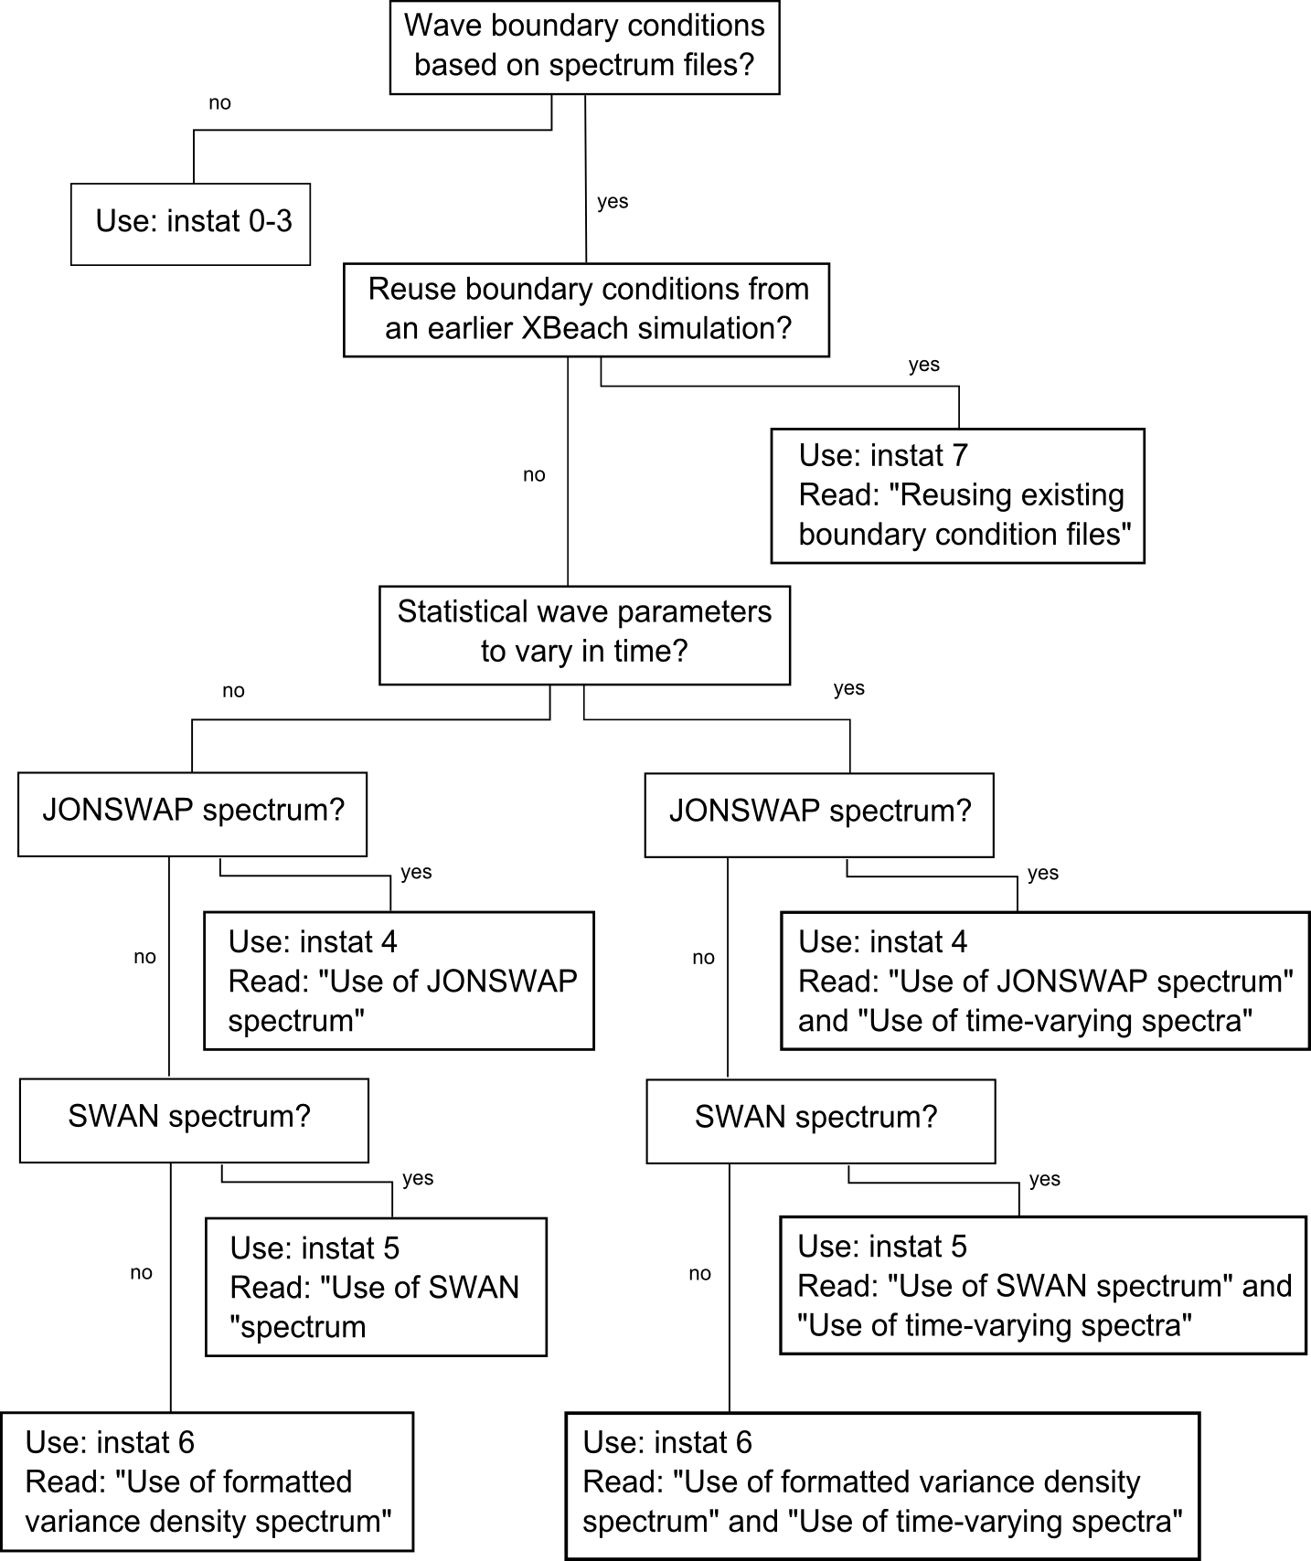

Figure 5.9 Reading guide

Use of JONSWAP spectrum
The new XBeach module allows the user to provide JONSWAP parameters from which XBeach computes a spectrum. To make use of this option, the user must specify ‘instat = 4’ in params.txt. XBeach will then attempt to read JONSWAP parameters from a separate file specified by ‘bcfile =’ in params.txt. The user must also state in params.txt the required record length for the boundary condition file and the boundary condition file time step (keywords ‘rt = ‘ and ‘dtbc = ‘ respectively). If the record length (rt) is less than the total simulation time, XBeach will reuse the boundary condition file until the simulation is completed. The boundary condition file time step should be small enough to accurately represent the bound long wave, but need not be as small as the time step used in XBeach, see Explanation of input/output.

The contents of the file specified by ‘bcfile =’ in params.txt is a list of keyword = value combinations which determine the JONSWAP spectrum. These keywords are:

Keyword | Type | Description | Default | Minimum | Maximum
‘Hm0 = ’ | real | H_{m0} of the wave spectrum, significant wave height [m] | 0.0 | 0.0 | 5.0
‘fp = ’ | real | Peak frequency of the wave spectrum [s⁻¹] | 0.08 | 0.0625 | 0.4
‘gammajsp = ’ | real | Peak enhancement factor in the JONSWAP expression [-] | 3.3 | 1.0 | 5.0
‘s = ’ | real | Directional spreading coefficient, cosine law [-] | 10. | 1.0 | 1000.
‘mainang = ’ | real | Main wave angle (in nautical terms) [°] | 270. | 180. | 360.
‘fnyq = ’ | real | Highest frequency used to create JONSWAP spectrum [s⁻¹] | 0.3 | 0.2 | 1.0
‘dfj = ’ | real | Step size frequency used to create JONSWAP spectrum [s⁻¹] | fnyq/200 | fnyq/1000 | fnyq/20

All variables are optional. If no value is given, the default value is used. It is advised not to specify dfj and allow XBeach to calculate the default value.

A typical input file contains the following:

Hm0 = 0.8
fp = 0.125
mainang = 285.
gammajsp = 3.3
s = 10.
fnyq = 0.3

Use of SWAN spectrum
The new XBeach module has been programmed to read standard SWAN 2D variance density or energy density output files (.sp2 files), as specified in the SWAN v40.51 manual.
To make use of this option, the user must specify ‘instat = 5’ in params.txt. XBeach will then attempt to read the SWAN output spectrum from a separate file specified by ‘bcfile =’ in params.txt. The user must also state in params.txt the required record length for the boundary condition file and the boundary condition file time step (keywords ‘rt = ‘ and ‘dtbc = ‘ respectively). If the record length (rt) is less than the total simulation time, XBeach will reuse the boundary condition file until the simulation is completed. The boundary condition file time step should be small enough to accurately represent the bound long wave, but need not be as small as the time step used in XBeach, see Explanation of input/output.

XBeach assumes the output of the SWAN file is in nautical terms. If the file is in Cartesian angles, the user must specify the angle in degrees to rotate the x-axis in SWAN to the x-axis in XBeach (in Cartesian terms). This value is specified in params.txt after the keyword ‘dthetaS_XB =’.

An example of a SWAN 2D output file is given below:
SWAN 1 Swan standard spectral file, version
$ Data produced by SWAN version 40.51
$ Project:'projname' ; run number:'runnum'
LOCATIONS locations in x-y-space
1 number of locations
22222.22 0.00
RFREQ relative frequencies in Hz
23 number of frequencies
0.0545
0.0622
0.0710
0.0810
0.0924
0.1055
0.1204
0.1375
0.1569
0.1791
0.2045
0.2334
0.2664
0.3040
0.3470
0.3961
0.4522
0.5161
0.5891
0.6724
0.7675
0.8761
1.0000
CDIR spectral Cartesian directions in degr
12 number of directions
30.0000
60.0000
90.0000
120.0000
150.0000
180.0000
210.0000
240.0000
270.0000
300.0000
330.0000
360.0000
QUANT
1 number of quantities in table
VaDens variance densities in m2/Hz/degr
m2/Hz/degr unit
-0.9900E+02 exception value
FACTOR
0.675611E-06
51 242 574 956 1288 1482 1481 1286 957 579 244 51
129 610 1443 2402 3238 3725 3724 3234 2406 1454 613 128
273 1287 3054 5084 6846 7872 7869 6837 5091 3076 1295 271
665 3152 7463 12402 16712 19229 19221 16690 12419 7518 3172 662
1302 6159 14608 24275 32688 37618 37603 32644 24309 14716 6198 1296
2328 10989 26020 43341 58358 67109 67080 58281 43401 26213 11058 2317
3365 15922 37712 62733 84492 97150 97110 84380 62820 37991 16021 3349
3426 16230 38440 63939 86109 99010 98969 85995 64027 38724 16331 3410
2027 9612 22730 37790 50909 58529 58505 50841 37843 22898 9672 2018
672 3178 7538 12535 16892 19440 19432 16870 12552 7594 3198 669
101 479 1135 1890 2542 2924 2923 2539 1892 1144 482 101
2 11 26 43 57 66 66 57 43 26 11 2
0 0 0 0 0 0 0 0 0 0 0 0
0 0 0 0 0 0 0 0 0 0 0 0
0 0 0 0 0 0 0 0 0 0 0 0
0 0 0 0 0 0 0 0 0 0 0 0
0 0 0 0 0 0 0 0 0 0 0 0
0 0 0 0 0 0 0 0 0 0 0 0
0 0 0 0 0 0 0 0 0 0 0 0
0 0 0 0 0 0 0 0 0 0 0 0
0 0 0 0 0 0 0 0 0 0 0 0
0 0 0 0 0 0 0 0 0 0 0 0
0 0 0 0 0 0 0 0 0 0 0 0
0 0 0 0 0 0 0 0 0 0 0 0

Use of formatted variance density spectrum
If the user has 2D spectrum information, but not in SWAN or JONSWAP form, the user can create a formatted spectrum file which can be read by XBeach.

To make use of this option, the user must specify ‘instat = 6’ in params.txt. XBeach will then attempt to read the formatted output spectrum from a separate file specified by ‘bcfile =’ in params.txt. The user must also state in params.txt the required record length for the boundary condition file and the boundary condition file time step (keywords ‘rt = ‘ and ‘dtbc = ‘ respectively). If the record length (rt) is less than the total simulation time, XBeach will reuse the boundary condition file until the simulation is completed. The boundary condition file time step should be small enough to accurately represent the bound long wave, but need not be as small as the time step used in XBeach, see Explanation of input/output.

The contents of the file specified by ‘bcfile =’ in params.txt must follow a specified format. The information should be as follows:
- First line: number of frequencies (integer)
- Second line onwards: column with frequencies in Hz (each on a new line)
- Then: number of angles (integer)
- Then onwards: column with angles in degrees (each on a new line)
- Then per line: row of variance density in each direction, per frequency (i.e. first row corresponds to variance density per direction in the first frequency band, second row of the second frequency band, etc.).

Note that the angles in the input file must be in the calculation coordinate system of XBeach, i.e. 0° is in the direction of the x-axis, 90° is in the direction of the y-axis. Also, the angles must be increasing.

An example of a formatted variance density file is given below:

15
0.0418
0.0477
0.0545
0.0622
0.0710
0.0810
0.0924
0.1055
0.1204
0.1375
0.1569
0.1791
0.2045
0.2334
0.2664
13
-180.0000
-150.0000
-120.0000
-90.0000
-60.0000
-30.0000
0.0000
30.0000
60.0000
90.0000
120.0000
150.0000
180.0000
0 0 0 0 0 0 0 0 0 0 0 0
51 242 574 956 1288 1482 1481 1286 957 579 244 51
129 610 1443 2402 3238 3725 3724 3234 2406 1454 613 128
273 1287 3054 5084 6846 7872 7869 6837 5091 3076 1295 271
665 3152 7463 12402 16712 19229 19221 16690 12419 7518 3172 662
1302 6159 14608 24275 32688 37618 37603 32644 24309 14716 6198 1296
2328 10989 26020 43341 58358 67109 67080 58281 43401 26213 11058 2317
3365 15922 37712 62733 84492 97150 97110 84380 62820 37991 16021 3349
3426 16230 38440 63939 86109 99010 98969 85995 64027 38724 16331 3410
2027 9612 22730 37790 50909 58529 58505 50841 37843 22898 9672 2018
672 3178 7538 12535 16892 19440 19432 16870 12552 7594 3198 669
101 479 1135 1890 2542 2924 2923 2539 1892 1144 482 101
2 11 26 43 57 66 66 57 43 26 11 2
0 0 0 1 1 1 1 1 1 0 0 0
0 0 0 0 0 0 0 0 0 0 0 0
0 0 0 0 0 0 0 0 0 0 0 0

Reusing existing boundary condition files
If the user does not wish to recalculate boundary condition files or specifically wants to reuse the boundary condition files of another XBeach simulation, it is possible to do so. In this case the user should select ‘instat = 7’ in params.txt. No further wave boundary condition data need be given in params.txt. Obviously, the calculation grid should remain the same between runs, as the angles and number of grid points are embedded in the boundary condition files.

In order to use instat 7, the user should copy ebcflist.bcf and qbcflist.bcf to the current directory. Additionally, the user should also copy all files listed in ebcflist.bcf and qbcflist.bcf. Generally, these files have E_ and q_ prefixes.

Use of time-varying spectra
The new XBeach module allows the user to specify time-varying wave spectra on the offshore boundary. This is done by feeding in several input data files such as those used for instat 4, 5 or 6, and specifying the duration for which these spectra should occur.
To make use of this option, the user must specify the instat value (4, 5 or 6) associated with the input data type for the wave boundary conditions. XBeach will then attempt to read a list of input data filenames from a separate file specified by ‘bcfile =’ in params.txt. This keyword is the same keyword as used for non-time-varying spectra. In order for XBeach to differentiate between time-varying and non-time-varying wave spectra, the file must have the following format.

The first word in the file must be the keyword ‘FILELIST’. In the following lines, each line contains the duration of this wave spectrum condition in seconds (similar to ‘rt’ in params.txt), the required time step in this boundary condition file in seconds (similar to ‘dtbf’ in params.txt) and the name of the input data file used to generate these boundary conditions. The duration and boundary condition time step in this file overrules ‘rt’ and ‘dtbf’ in params.txt. XBeach will now not reuse any boundary condition time series, so the user must ensure that the total record length is greater than or equal to the simulation time.

A typical input file contains the following:

FILELIST
1800 0.2 jonswap1.inp
1800 0.2 jonswap1.inp
1350 0.2 jonswap2.inp
1500 0.2 jonswap3.inp
1200 0.2 jonswap2.inp
3600 0.2 jonswap4.inp

Note: It is not possible to use a mix of JONSWAP, SWAN and Variance Density files. It is also not possible to vary dthetaS_XB between files in case of non-nautical SWAN output.

Examples
In order to clarify the instructions given above, a number of examples are given. In the first example, the user wishes to use a constant JONSWAP spectrum. In order to save calculation time and memory use, the user decides to recycle the boundary condition file every 30 minutes. Wave input parameters in the params.txt file are given below:

Boundary condition options
instat = 4

Required for instat 4,5,6
bcfile = jonswap.inp

if file is reused, else this information in file-list:
rt = 1800
dtbc = 0.2

The file jonswap.inp contains information as described in the section “use of one JONSWAP input file”. As the user has only one input file, rt and dtbc must be specified in params.txt.

In the second example the user wishes to use a constant JONSWAP spectrum, but does not want to reuse the same boundary condition file as in the previous example. This can be achieved by using the multiple files option, but only using one JONSWAP data file. For instance in params.txt:

Boundary condition options
instat = 4

Required for instat 4,5,6
bcfile = jonswaplist.txt

And in the file jonswaplist.txt:

FILELIST
1800 0.2 jonswap.inp
1800 0.2 jonswap.inp
1800 0.2 jonswap.inp
1800 0.2 jonswap.inp
1800 0.2 jonswap.inp
1800 0.2 jonswap.inp

Note that in this case if the simulation time is greater than 3 hours (10800 seconds), XBeach will abort due to lack of input data.

In the third example the user wishes to use one SWAN 2D spectrum file. The output of the SWAN model is in nautical degrees, so dthetaS_XB does not need to be specified. Wave input parameters in the params.txt file are given below:

Boundary condition options
instat = 5

Required for instat 4,5,6
bcfile = swan14a.sp2

if file is reused, else this information in file-list:
rt = 3600
dtbc = 0.5

The file swan14a.sp2 contains information as described in the section “use of one SWAN input file”. As the user has only one input file, rt and dtbc must be specified in params.txt. If the simulation time is more than one hour (3600 seconds), the boundary condition file is reused.

In the final example, the user wishes to reuse the exact boundary conditions of the simulation in the previous example. In this case the user copies the files ebcflist.bcf and qbcflist.bcf and E_reuse.bcf and q_reuse.bcf to the current directory (the directory with the XBeach executable). The params.txt would now contain the following options for the wave boundary conditions:

Boundary condition options
instat = 7

Explanation of spectral input/output
At the start of the XBeach simulation, XBeach checks whether non-stationary varying wave boundary conditions are to be used. If this is the case, it next checks whether the wave spectrum of the wave boundary conditions is to change over time, or remain constant. If the wave spectrum is to remain constant, XBeach will only read from one input file to generate wave boundary conditions. If the wave spectrum is to vary in time, XBeach reads from multiple files.

Whether or not the wave spectrum of the boundary conditions changes over time, the XBeach module requires a record length during which the current wave spectral parameters are to apply. For the duration of the record length, boundary conditions are calculated at every boundary condition file time step. These time steps are not required to be the same as the time steps in the XBeach main program; XBeach will interpolate where necessary. The boundary condition time steps should therefore only be small enough to accurately describe the incoming bound long waves. The statistical data for the generation of the wave boundary conditions is read from user-specified files. At this stage the XBeach module can interpret SWAN 2D variance density output files and JONSWAP parameters.

The beginning and end of the boundary condition file is tapered by the XBeach module. This is done to ensure smooth transitions from one boundary condition file to the next.

The combination of a large record length and a small time step lead to large demands on the system memory. If the memory requirement is too large, the user must choose to either enlarge the boundary condition time step, or to reduce the record length. In case of the latter, several boundary condition files can be generated and read sequentially. It is unwise however to reduce the record length too much, as then the transitions between the boundary condition files start to play an important role.

Every time the XBeach wave boundary condition module is run, it outputs data to the local directory. Metadata about the wave boundary conditions are stored in list files: ebcflist.bcf and qbcflist.bcf. The main XBeach program uses the list files to know how and when to read and generate boundary condition files. The actual incoming short-wave energy and long-wave mass flux data is stored in other files. These files have E_ and q_ prefixes. The main XBeach program uses these files for the actual forcing along the offshore edge.
----------------------------------------------------
Grid input

nx = 104
ny = 124
xori = 0.
yori = 0.
alfa = 0.
thetamin = -90.
thetamax = 90.
dtheta = 20
depfile = depth.grd
posdwn = -1
vardx = 1

Required if vardx 1
xfile = x.grd
yfile = y.grd

Required if vardx 0
dx = 1.
dy = 1.

----------------------------------------------------
Numerics input
CFL = 0.2
eps = 0.01

----------------------------------------------------
Time input
tstart = 0
tint = 1.
tstop = 1800
taper = 20

----------------------------------------------------
General constants
rho = 1000
g = 9.81

----------------------------------------------------
Wind boundary conditions
rhoa = 1.25
Cd = 0.002
windv = 0.
windth = 90.

----------------------------------------------------
Water level boundary conditions
tideloc = 1

Required if tideloc > 0
zs0file = zs0input.bcf
tidelen = 2
paulrevere = 1

Required if tideloc 0
zs0 = 4.

----------------------------------------------------
Boundary wave conditions absorbing
front = 1
left = 0
right = 0
back = 0

----------------------------------------------------

Continued on next page …
Boundary wave conditions generating
instat = 4
ARC = 1

Required for instat 0,1,2,3
dir0 = 270.

Required for instat 0,1
Hrms = 0.4
Tm01 = 6.0
m = 200

Required for instat 0
waveint = 1

Required for instat 1
Tlong = 31.2

Required for instat 5 (if SWAN is Cartesian):
Angle in Cartesian degrees to rotate the x-axis in SWAN to the x-axis in XBeach dthetaS_XB = 0.

Required for instat 4,5,6:
Name of boundary condition file
bcfile = jonswap.inp

Required for instat 4,5,6 if spectra are not time-varying:
Record length for the boundary condition file
rt = 1800.
Boundary condition file time step
dtbc = 0.2

----------------------------------------------------
Wave calculation options
break = 1
wci = 0
roller = 1
beta = 0.1
gamma = 0.55
gammax = 5.
alpha = 1.
delta = 0.0
n = 10.
order = 2

--------

Flow boundary conditions
The input parameters below refer to functionality described in section 3.10.1. With these options you can mimic the seaward, lateral and basin boundary conditions at a real stretch of coast or in a flume. Default values give weakly reflective boundary conditions at offshore and basin sides and Neumann boundary conditions at lateral sides. With ARC on or off you can simulate a flume with or without active wave absorption; with order at 1 or 2 you can generate waves without resp. with bound long waves. With the keywords left and right set to 1 you can turn the sides of the flume or basin into walls.

The carspan keyword is useful when you want to specify timeseries of free long waves incident on the sea boundary. In that case use the file bc\gen.ezs, specify the time in the first column, the long wave elevation in the second column and zero wave energy in the third column.

keyword | description | default value | minimum value | maximum value | unit | remarks
front | seaward boundary condition | 1 | 0 | 1 | - | 0 = 1D absorbing,  1 = 2D absorbing
ARC | active reflection compensation at seaward boundary | 1 | 0 | 1 | - | 0 = off, 1 = on
order | order of wave steering at seaward boundary | 2 | 1 | 2 | - | 1 = first order , 2 = second order
back | bayside boundary condition | 2 | 0 | 2 | - | 0 = 1D absorbing, 1 = wall, 2 = 2D absorbing
epsi | weighting factor between steady flow and particle velocity | 0 | 0 | 1 | - | 0=waves, 1=steady flow for seaward and bayward boundaries only
left | left lateral boundary condition | 0 | 0 | 1 | - | 0 = Neumann, 1 = wall
right | right lateral boundary condition | 0 | 0 | 1 | - | 0 = Neumann, 1 = wall
carspan | free long wave input | 0 | 0 | 1 | - | 0 = use cg (default); 1 = use sqrt(gh) in instat = 3 for c&g tests
fcutoff | low freq cutoff frequency for boundary conditions | 0 | 0 | 40 | Hz
sprdthr | threshold above which spec dens are read in | 0.08 | 0 | 1 | -

Time-varying tide/surge

XBeach can take in up to four time-vary tidal signals to be applied to the four boundaries. A time-varying water level signal is read into XBeach by readtide.f90, which is called from XBeach.f90. readtide opens the specified file in par%zs0file, and uses par%tideloc (number of water level signal locations to be read in) and par%tidelen (length of input signals) to format the file reading statements. The par%zs0file must follow the format with the first column being time and each subsequent column containing the water level signals. As a note, the input signal will be interpolated to the local time step of the simulation; therefore the signals only need to be long enough and temporally-fine enough to resolve the water level phenomenon of interest (i.e. tide variations, surge event). The above parameters and file name are specified in params.txt. If par%tideloc is equal to zero, readtide is not utilized and a uniform water level is applied according to par%zs0.

There are now four options for handling the tidal and/or surge contribution to the boundaries:
- Uniform water level
- One time-varying water level signal
- Two time-varying water level signals, which requires point of application indication.
- Four time-varying water level signals

The uniform water level is applied according to par%zs0, as stated above. For par%tideloc equal to 1, one water level signal is read and applied to the offshore boundary and par%zs0 is applied to the land boundary. If par%tideloc is equal to 2, two water level signals are read by readtide. par%paulrevere is utilized to indicate the locations of application for the two signals. For par%paulrevere equal to 0, one tidal record is applied to both sea corners and one tidal record to both land corners, whereas if par%paulrevere is equal to 1, the first tidal record is applied to the (x=1,y=1) sea corner and the second tidal record (third column) to the (x=1,y=N) sea corner. For par%tideloc equal to 4, four tidal records are read. These four time-varying signals need to be in ordered columns going clockwise around the domain, with first column signal being applied to (x=1,y=1). Therefore, the columns must follow the order of: 1. (x=1,y=1), 2. (x=1,y=N), 3. (x=N,y=N), 4. (x=N,y=1).

The input signal(s) is(are) interpolated spatially along the boundaries for par%tideloc is equal to 2 (if par%paulrevere=2, and if par%paulrevere=1 and no land mass blocks the flow between the land and sea boundaries) and higher. The spatial interpolation occurs initially in wave_init, and subsequently at every time step in flow_bc. The input signal(s) is(are) also interpolated to the local time step in flow_bc.

keyword | description | default value | minimum value | maximum value | unit | remarks
zs01 | initial water level | 0 | -5 | 5 | m
tideloc | number of input tidal time series | 0 | 0 | 4 | -
paulrevere | option of sea/sea corner or sea/land corner specification | 0 | 0 | 1 | -
tidelen | length of tidal record | 0 | 0 | 1000000 | - | .

Wind

keyword | description | default value | minimum value | maximum value | unit | remarks
rhoa | air density | 1.25 | 1 | 2 | kg/m3
Cd | wind drag coefficient | 0.002 | 0.0001 | 0.01 | -
windv | wind velocity | 0 | 0 | 200 | m/s
windth | wind direction (nautical convention) | 90 | -180 | 180 | deg | .

The implementation of the wind stress in the momentum balance in XBeach is based upon the work of Ruessink et al. (2001). The wind field is specified by the following parameters in params.txt:
- par%windth, the wind direction (Nautical coordinates)
- par%windv, the wind velocity specified in m/s
- par%rhoa, the air density (default 1.25 kg/m³)
- par%Cd, the air drag coefficient (default 0.002, but should be looked into for simulations with wind velocities exceeding 50 m/s)

The input wind direction is converted to radians and Cartesian coordinates prior to use in the momentum balance. The wind contribution is computed as an additional term in the x and y momentum balances.

Limiters
Especially in very shallow water some processes need to be limited to avoid unrealistic behaviour. The parameters below can be adjusted by the user. Reducing gammax will reduce wave heights in very shallow water, probably 2 is a reasonable value. hmin prevents very strong return flows or high concentrations. eps determines whether points are dry or wet and can be taken quite small. hwci limits the computation of wav-current interaction in very shallow water where the procedure may not converge.

keyword | description | default value | minimum value | maximum value | unit | remarks
gammax | maximum ratio Hrms/hh | 5 | 0.4 | 5 | -
hmin | threshold water depth for concentration and return flow | 0.01 | 0.001 | 1 | m
eps | threshold depth for drying and flooding | 0.1 | 0.001 | 1 | m
umin | threshold velocity upwind scheme | 0.1 | 0.001 | 5 | m/s
Hwci | depth below which wci is not applied | 0.01 | 0.001 | 1 | m

Groundwater
In order to use the groundwater module in XBeach, a number of parameters have been added to params.txt. The keywords, their type, default value and description are given below.

keyword | type | default value | description
qwflow | integer | 0 | Turns the groundwater module on (1) or off (2)
kx | real | 1E-4 | The Darcy permeability coefficient of the aquifer in x-direction [ms⁻¹]
ky | real | kx | The Darcy permeability coefficient of the aquifer in y-direction [ms⁻¹]
kz | real | kx | The Darcy permeability coefficient of the aquifer in z-direction [ms⁻¹]
dwetlayer | real | 0.2d0 | Thickness of the interaction layer [m]
aquiferbot | real | minval(zb)-3.d0 | The bed level of the aquifer is set to the value of aquiferbot across the entire domain [m]
aquiferbotfile | character | - | The initial bed level of the aquifer is read from the file named by the keyword aquiferbotfile. The file has the same dimensions as the bathymetry file. This keyword overrides the aquiferbot keyword
gw0 | real | 0.d0 | The initial groundwater head is set to the value of gw0 across the entire domain [m]
gw0file | character | - | The initial groundwater head is read from the file named by the keyword gw0file. The file has the same dimensions as the bathymetry file. This keyword overrides the gw0 keyword

Example
An example is given in which the groundwater module is used and the vertical permeability coefficient in the vertical is set differently to that in the horizontal. The initial bed level of the aquifer is read from a file and the initial groundwater head is set to a uniform value. Other parameters are kept at their default values.

-----------------------------
Groundwater options

gwflow = 1
kx = 0.00015
kz = 0.0005
aquiferbotfile = zbaquifer.txt
gw0 = 0.5

Hydrodynamic simulation
The hydrodynamic simulation starts at time 0 and starts outputting at time tstart; it stops at tstop. The time intervals are described in detail in section 5.15. The actual time step of the hydrodynamic simulation is determined based on a given maximum Courant number CFL.
In future versions a nonhydrostatic pressure correction term will be implemented in the flow solver, allowing the modelling of individual short waves. This is not available in the present code yet.

keyword | description | default value | minimum value | maximum value | unit | remarks
tstart | start time of simulation | 1 | 0 | 1000000 | s
tint | time interval output global values | 1 | 0.01 | 100000 | s
tintg | time interval output global  values | tint | 0.01 | 100000 |  | supercedes tint if specified
tintm | time interval output mean global values | ting | 0.01 | 100000
tintp | time interval output point values | ting | 0.01 | 100000
tsglobal | file with list of output times for global values |  |  |  |  | no values; specify name
tsmean | file with list of output times for meanglobal values |  |  |  |  | no values; specify name
tspoints | file with list of output times for point values |  |  |  |  | no values; specify name
tstop | stop time simulation | 2000 | 1 | 1000000 | s
CFL | maximum courant number | 0.2 | 0.1 | 0.9 | - | actual CFL number varies during calculation
nonh | nonhydrostatic option | 0 | 0 | 1 | - | not implemented yet

Sediment transport
form | equilibrium sed. conc. formulation | 1 | 1 | 3 | - | 1 = Soulsby van rijn, 2 = Van Rijn 2008 (not tested yet)
dico | diffusion coefficient | 1 | 0 | 10 | m2/s
z0 | zero flow velocity level in Soulsby van Rijn (1997) sed.conc. expression | 0.006 | 0.0001 | 0.05 | m
facsl | bed slope factor | 0 | 0 | 1.6
hswitch | water depth at interface from wetslp to dryslp | 0.1 | 0.01 | 1
rhos | density of sediment | 2650 | 2400 | 2800 | kg/m3
struct | option for hard structures | 0 | 0 | 1 |  | 0 = no revetment, 1 = multiple sediment classes
ngd | number of sediment classes | 1 | 1 | 3 | -
nd | number of sediment class layers | 1 | 1 | 20 | -
dzg | thickness of sediment class layers | 0.1 | 0.01 | 1 | -
D50 | D50 grain diameter first (or only) class of sediment | 0.0002 | 0.00005 | 0.001 | m
D90 | D90 grain diameter first (or only) class of sediment | 0.0003 | 0.00005 | 0.001 | m
D502 | D50 grain diameter second class of sediment | 0 | 0 | 0.001 | m
D902 | D90 grain diameter second class of sediment | 0 | 0 | 0.001 | m
D503 | D50 grain diameter third class of sediment | 0 | 0 | 0.001 | m
D903 | D90 grain diameter third class of sediment | 0 | 0 | 0.001 | m
sedcal1 | calibration factor for sediment class 1 | 1 | 0 | 10
sedcal2 | calibration factor for sediment class 2 | 1 | 0 | 10
sedcal3 | calibration factor for sediment class 3 | 1 | 0 | 10
tsfac | max value for fall velocity | 0.1 | 0.01 | 1 | [-]
thetanum | option to switch between central and upwind scheme | 1 | 0.5 | 1 | [-]
smax | max shields value for overwash | -1 | 0 | 3 | [-]

Morphological updating
morfac | morphological factor | 0 | 0 | 1000 | -
morstart | start time of morphological updates | 120 | 0 | 10000 | s
por | porosity | 0.4 | 0.3 | 0.5 | -
wetslp | critical avalanching slope under water | 0.3 | 0.1 | 1 | -
dryslp | critical avalanching slope above water | 1 | 0.1 | 2 | -
hswitch | water depth at interface from wetslp to dryslp | 0.1 | 0.01 | 1

Selecting output data types
XBeach v12 allows the user to choose between three types of output data: regular spatial output, time-averaged spatial output and point output. Of these three types, only the regular spatial output existed in previous versions of XBeach.

Regular spatial output
Regular spatial output describes the instantaneous state of variables across the entire model domain at various points in time. In previous versions of XBeach, the program automatically generated regular spatial output of 20 variables. In the current version of XBeach, the user may determine how many and which variables are output.

To make use of this option the user must specify the number of output variables required using the ‘nglobalvar=’ keyword in params.txt. The value of nglobalvar is always integer. This line is immediately followed by the keywords of the required variables, one per line. Refer to the Variable keywords section for a list of keywords. An example of the declaration of regular spatial output is given below.

-----------------------------
Output options

nglobalvar = 5
H
zb
zs
u
v
Example of the declaration of regular spatial output variables

Output files generated using this option are given the name keyword.dat, for example zs.dat. The only exception is that files containing information about the wave height of the short waves are called hrms.dat instead of H.dat to maintain backward compatibility.

Time-averaged spatial output
This output describes the time-averaged state of variables across the entire model domain at various points in time. The period used to average the variables is selected by the user and is described in the section Choosing output times. The user may determine how many and which variables are output. To make use of this option the user must specify the number of output variables required using the ‘nmeanvar=’ keyword in params.txt. The value of nmeanvar is always integer. This line is immediately followed by the keywords of the required variables, one on each subsequent line. Refer to the Variable keywords section for a list of keywords. This statement block may be made before or after the regular spatial output block. An example of the declaration of time-averaged spatial output is given below.

-----------------------------
Output options

nmeanvar = 2
u
v

Example of the declaration of time-averaged spatial output variables

Output files generated using this option are given the name keyword_mean.dat, for example zs_mean.dat.

Point output
Point output allows the user to select one or more locations for which a time series of data is provided. This output type is divided into two classes: fixed point output and runup gauge output.

Fixed point output
This output describes a time-series of a number of variables at one point in the model domain. To make use of this option, the user must specify the number of output locations using the ‘npoints=’ keyword in params.txt. The value of npoints is always integer. This statement is always immediately followed by one line per output location describing the location coordinates, the number of output variables required at that location and the output variable keywords. The location coordinates are given separately as x-coordinate and y-coordinate, in world coordinates. XBeach will link the output location to the nearest computational point. The number of required variables is integer. Variables are stated using their respective variable keywords, see the Variable keywords section. Each keyword, including the last keyword, must be followed by a number symbol (#).This statement block may be made before or after any other output option block.

An example is given below in which two output locations are defined. The first point is located on the offshore boundary (x-coordinate = 0.0) and somewhere in the middle of the model domain in y-direction (y-coordinate = 800.0). This location has two output variables, u and v. The second point is located on the lateral boundary (y-coordinate = 1600.0) and somewhere in the middle of the domain in x-direction (x-coordinate = 2000.0). This location has four output variables, H, zs, zb and D.

-----------------------------
Output options

npoints = 2
0. 800. 2 u#v#
2000. 1600. 4 H#zs#zb#D#

Runup gauge output
This output describes a time-series of a number of variables at the waterline. In this case XBeach scans in a x-directional transect defined by the user to find the last wet point before shore (defined as the first dry point in a transect). Output information is recorded for this point. This is particularly useful to keep track of runup levels in cross shore transects.

The definition of runup gauges is similar to the definition of fixed point output. To specify runup gauges, the user should specify the number of runup gauges using the ’nrugauge=’ keyword in params.txt. The value of nrugauge is always integer. This statement is always immediately followed by one line per output location describing the location coordinates, the number of output variables required at that location and the output variable keywords. The location coordinates are given separately as x-coordinate and y-coordinate, in world coordinates. XBeach will link the output location to the nearest computational grid row.. The number of required variables is integer. Variables are stated using their respective variable keywords, see the Variable keywords section. Each keyword, including the last keyword, must be followed by a number symbol (#).This statement block may be made before or after any other output option block.

Point output file structure
All data corresponding to point locations will be stored in files called pointxxx.dat in the case of fixed point data and rugauxxx.dat in the case of runup gauge data. In the filenames xxx represents a number between 001 and 999, corresponding to the order in which the points are declared in params.txt. The data files contain one row per output time step. The first position on each row is the time at which the output is given. The subsequent positions in the row are the values of the variables at the given point at that given moment. The order of the variables is the same as the order in which they are defined for that point in params.txt.

Default values
If no output information is given with respect to the numbers and types of output, XBeach assumes the user requires only the original 20 regular spatial output types. The default number of time-averaged output variables and point output locations is zero.

Choosing output times
The user may determine the output times for regular spatial output variables, time averaged spatial variables and point location variables individually. Runup gauge output and fixed point output are given at the same points in time. For all three types of output the user may choose to either state a fixed interval time at which output is given, or supply an additional file containing times at which output should be given.

Output at fixed intervals
In this case the user should define a point in time (in seconds) after the start of the simulation at which the first output is generated. The user can do this by using the ‘tstart=’ keyword in params.txt. All output that is being generated at fixed intervals uses tstart as their base. The interval for regular global output is given by the ‘tintg=’ keyword in params.txt. The keywords for the interval of time-averaged global output and point output are ‘tintm=’ and ‘tintp=’ respectively. Note that tintg, tintm and tintp supersede the older tint parameter. An example of the definition of fixed intervals is given below.

-----------------------------
Output options

tstart = 100.
tintg = 100.
tintp = 2.
tintm = 3600.

-----------------------------
Example of the declaration of fixed interval output times

In the case of regular global output and point output, the first output is given at tstart. In the case of time-averaged global variables, the first output is given at tstart+tintm. This output represents the average condition over the interval between tstart and tstart+tintm.

Output times defined by external file
The user is given the option to have output at a set of points in time that are not separated by regular intervals. In this case the user must supply an additional file for each output type (regular, time-averaged or point). The user specifies the name of the output time series file for regular spatial output using the ‘tsglobal=’ keyword in params.txt. The keywords for time series files for time-averaged output and point output are ’tsmean=’ and ‘tspoint=’ respectively. All time series files must contain on the first line the number of output times (integer) followed by every output time (in seconds after the start of the simulation) on a new line. An example of the definition of varying output time intervals is given below. An example of the contents of one of the time series definition files is given in the second example below.

-----------------------------
Output options

tsglobal= timeseries1.txt
tspoints = timeseries2.txt
tsmean= timeseries3.txt

Example of the declaration of varying output time intervals

18
0.05
0.15
0.2
0.8
12.0
12.5
19.124
30.
60.
90.
120.
150.
160.
170.
177.
178.
179.
180.
Example of an output time series definition file (in the previous example this could be timeseries1.txt)

In the case of regular global output and point output, the first output is given at the first stated point in time. In the case of time-averaged global variables, the first output is given at the second stated point in time. This output represents the average condition over the interval between first and second stated point in time. Subsequent averaging is made over every interval.

Combinations of fixed interval and external files
The user is allowed to define certain types of output using fixed intervals and others using external files. The use of an external file supersedes the use of fixed intervals. Note that tstart will only apply to output of fixed interval type. An example of mixing fixed and varying output time intervals is given below.

-----------------------------
Output options

tstart = 100.
tintg = 100.
tspoints = timeseries2.txt
tintm = 3600.

-----------------------------
Example of the declaration of fixed and varying output time intervals

Default values
The default value of tintg is one second. If tintp or tintm is not stated, but output is declared (npoints, nrugauge or nmeanvar is stated larger than zero), XBeach assumes the same output interval as tintg. XBeach v12 has been designed to be backward compatible with older versions. Therefore if tint is defined, this replaces the default value of tintg.

Example
The following example shows a partial params.txt file in which all three types of output are specified.
Output options

tstart = 100.
tintg = 60.
tintm = 720.
tspoints = timespoints.txt

nglobalvar = 4
zs
zb
H
ue

nmeanvar = 2
ue
H

npoints = 3
124 12 2 H#zs#
174 12 2 H#zs#
199 12 4 H#zs#ue#ve#

nrugauge = 1
12 3 zs#ue#ve#

Example of a shortened params.txt file with various output options

Reading output files in Matlab
Various functions have been developed to help users read XBeach output in Matlab. The following script can be used to gather information about the XBeach output before reading the output.

function XBdims=getdimensions
% XBdims=getdimensions
%
% Must start in XBeach output directory
% Output structure XBdims
% XBdims.nt = number of regular spatial output timesteps
% XBdims.nx = number of grid cells in x-direcion
% XBdims.ny = number of grid cells in y-direcion
% XBdims.ngd = number of sediment classes
% XBdims.nd = number of sediment class layers
% XBdims.ntp = number of point output timesteps
% XBdims.ntm = number of time-average output timesteps
% XBdims.tsglobal = times at which regular output is given
% XBdims.tspoints = times at which point output is given
% XBdims.tsmean = times at which time-averaged output is given
% XBdims.x = x-coordinates grid
% XBdims.y = y-coordinates grid
%
% Created 19-06-2008 : XBeach-group Delft

fid=fopen('dims.dat','r');
XBdims.nt=fread(fid,[1],'double');
XBdims.nx=fread(fid,[1],'double');
XBdims.ny=fread(fid,[1],'double');
XBdims.ngd=fread(fid,[1],'double');
XBdims.nd=fread(fid,[1],'double');
XBdims.ntp=fread(fid,[1],'double');
XBdims.ntm=fread(fid,[1],'double');
XBdims.tsglobal=fread(fid,[XBdims.nt],'double');
XBdims.tspoints=fread(fid,[XBdims.ntp],'double');
XBdims.tsmean=fread(fid,[XBdims.ntm],'double');
fclose(fid);

fidxy=fopen('xy.dat','r');
XBdims.x=fread(fidxy,[XBdims.nx+1,XBdims.ny+1],'double');
XBdims.y=fread(fidxy,[XBdims.nx+1,XBdims.ny+1],'double');
fclose(fidxy);

Matlab function to extract output metadata

Regular spatial output and time-averaged output can then be read using the following function.

function Vardata=readvar(fname,XBdims)
% Var=readvar(fname,XBdims)
%
% Output Var is [nx+1,ny+1,nt] array, where nt is XBdims.nt or XBdims.ntm
% Input - fname : name of data file to open, e.g. 'zb.dat' or 'u_mean.dat'
% - XBdims: dimension data provided by getdimensions function
%
% Created 19-06-2008 : XBeach-group Delft

if (length(fname)>9 && strcmp(fname(end-8:end), '_mean.dat'))
nt=XBdims.ntm;
else
nt=XBdims.nt;
end
fid=fopen(fname,'r');
Vardata=zeros(XBdims.nx+1,XBdims.ny+1,nt);
for i=1:nt
Vardata(:,:,i)=fread(fid,size(XBdims.x),'double');
end
fclose(fid)

Matlab function to read spatial output variables

To read point data the following function can be used.

function Pointdata=readpoint(fname,XBdims,nvar)
% Pointdata=readpoint(fname,XBdims,nvar)
%
% Output Point is [ntp,nvar+1] array, where ntp is XBdims.ntp
% First column of Pointdata is time
% Second and further columns of Pointdata are values of
% variables
% Input - fname : name of data file to open, e.g. 'point001.dat' or 'rugau001.dat'
% - XBdims: dimension data provided by getdimensions function
% - nvar : number of variables output at this point location
%
% Created 19-06-2008 : XBeach-group Delft

Pointdata=zeros(XBdims.ntp,nvar+1);
fid=fopen(fname,'r');
for i=1:XBdims.ntp
Pointdata(i,:)=fread(fid,nvar+1,'double');
end
fclose(fid);

Matlab function to read point output variables

Variable keywords
The keywords to define which model variables are to be output are givenin the tables below.

Keyword Unit Description
c : [m/s] wave celerity
cg : [m/s] group velocity
D : [W/m²] dissipation
DR : [W/m2] roller energy dissipation
dzav : [m] total bed level change due to avalanching
dzbdt : [m/s] rate of change bed level
E : [Nm/m²] wave energy
Fx : [N/m²] wave force x-direction
Fy : [N/m²] wave force y-direction
H : [m] wave height
hh : [m] water depth
k : [rad/m] wave number
kb : [m²/s²] near bed turbulence intensity due to depth induced breaking
maxzs : [m] maximum elevation in simulation
minzs : [m] minimum elevation in simulation
n : [-] ratio group velocity/wave celerity

R : [Nm/m²] roller energy
sedero : [m] cum. sedimentation/erosion
sigm : [rad/s] mean frequency
Sxx : [N/m] radiation stress
Sxy : [N/m] radiation stress
Syy : [N/m] radiation stress

Keyword Unit Description
--------------------------------------------------------------------------------------

thetamean : [rad] mean wave angle
u : [m/s] (GLM) x-velocity cell centre (for output)
ue : [m/s] Eulerian mean x-velocity cell centre (for output)
uoff : [m/s] offshore directed peak orbital velocity
uon : [m/s] onshore directed peak orbital velocity
urms : [m/s] orbital velocity
usd : [m/s] return flow due to roller after breaker delay
ust : [m/s] Stokes drift
ustr : [m/s] return flow due to roller
uwf : [m/s] x-comp. Stokes drift
v : [m/s] (GLM) y-velocity cell centre (for output)
ve : [m/s] Eulerian mean y-velocity cell centre (for output)
vmag : [m/s] velocity magnitude in cell centre

vwf : [m/s] y-comp. Stokes drift
wetz : [-] mask wet/dry eta-points
zb : [m] bed level
zs : [m] water level
zs0 : [m] water level due to tide alone

Add some kind of output for c, ceq and Su, Sv, summed across all sediment classes?
Add sediment distribution in bed

Distribution and maintenance
XBeach.org
Repos.deltares.nl/xbeach/trunk

Tutorial

Profile mode
For many applications it is useful to start by running in profile mode. This is certainly true for more or less uniform coasts. The way the model operates is that it assumes longshore gradients to be zero. Numerically this is done by copying water levels and wave energy from row 2 to row 1 and from row 2 to row 3; the number of cells in y-direction must be ny=2, which gives 3 grid points in y-direction.

Creating grid and depth information
An easy way to create grid and depth for XBeach given a table of (x,zb) values is by using a Maatlab script like below. The script reads the table from the file profile.dat; based on a given dx (5 m in our case) it creates a computational grid xdata and interpolates the depth data onto the grid as zdata. It then writes the block of grid data form the params.txt file to a file griddata.txt; this info can be cut and pasted into the params.txt file. The depth data is written to the file ‘profile.dep’. It is written three times, once for each grid row.

dx=5;
profname='profile.dat';

xz=load(profname)
xdata=xz(:,1);
zdata=xz(:,2);

xgrid=[xdata(1):dx:xdata(end)];
zgrid=interp1(xdata,zdata,xgrid);

fi=fopen('griddata.txt','wt');
fprintf(fi,'nx = %3i \n',length(xgrid)-1);
fprintf(fi,'ny = %3i \n',2);
fprintf(fi,'dx = %6.1f \n',dx);
fprintf(fi,'dy = %6.1f \n',dx);
fprintf(fi,'xori = %10.2f \n',xdata(1));
fprintf(fi,'yori = %10.2f \n',0);
fprintf(fi,'alfa = %10.2f \n',0);
fprintf(fi,'depfile = profile.dep \n')
fprintf(fi,'posdwn = -1 \n')
fclose(fi);

fi=fopen('profile.dep','wt');
for i=1:3
fprintf(fi,'%7.3f ',zgrid);
fprintf(fi,'\n');
end
fclose(fi);

Next, we cut and paste the contents of griddata.txt into an example params.txt file and start editing the rest of the file.
nx = 200
ny = 2
xori = 0.00
yori = 0.00
alfa = 0.00
depfile = profile.dep
posdwn = -1
vardx = 0
dx = 5.0
dy = 5.0

Note that only lines with an ‘=’ are considered, any other lines are comments. We start by specifying the theta-grid:
thetamin = -90
thetamax = 90
dtheta = 180
thetanaut= 0

This means we have a single directional bin that covers the whole directional spectrum, since in our 1D case we cannot represent longshore variations.

In stationary mode, waves may be obliquely incident and a longshore current will be generated. In instationary mode (with wave energy varying on the wave group scale) the wave direction must be shore-normal.
We specify the duration of the run, the CFL number that is used to determine the automatic timestep, we select the numerical scheme for wave propagation and for morphology updating and set a number of limiters.
----------------------------------------------------
Time input
----------------------------------------------------
tstop = 1800
----------------------------------------------------
Numerics input
----------------------------------------------------
CFL = 0.9
scheme = 1
thetanum = 1
----------------------------------------------------
Limiters
----------------------------------------------------
gammax = 2
hmin = .01
eps = .001
umin = 0.
hwci = 0.1

We continue with the boundary conditions; the seward boundary and landward boundary are 2D Riemann boundaries, the side boundaries Neumann,
----------------------------------------------------
Boundary numerics
----------------------------------------------------
front = 1
back = 2
left = 0
right = 0

We set a simple tidal boundary by specifying tideloc=0 and zs0=0. Note that the rest of the text is ignored as long as no ‘=’ is used.
----------------------------------------------------
Boundary tide options
----------------------------------------------------
tideloc = 0

if tideloc 0
zs0 = 0
else if tideloc >0
zs0file
tidelen
paulrevere

We set a negligible taper time and select instat=4 to specify a parametric Jonswap spectrum. We use the default options for wave generation, with reflection compensation (ARC) and including incident bound waves.(order=2)
----------------------------------------------------
Wave generating boundary options
----------------------------------------------------
taper = 1.e-3
instat = 4
ARC = 1
order = 2

We set some wave calculation and flow calculation options:
----------------------------------------------------
Wave calculation options
----------------------------------------------------
break = 1
gamma = 0.55
n = 10
----------------------------------------------------
Flow calculation options
----------------------------------------------------
cf = 0.003
nuhfac =1

Then some sediment transport parameters:
----------------------------------------------------
Sediment transport calculation options
----------------------------------------------------
form =1
smax =0.8
tsfac =0.1
D50 =.0002
D90 =.0003
rhos =2650
ngd = 1

We specify the morphological parameters as follows:
----------------------------------------------------
Morphological calculation options
----------------------------------------------------
morfac = 10
morstart = 300
por = 0.4
dryslp = 1.0
wetslp = 0.3
hswitch = 0.1

And finally we specify the output requests:
----------------------------------------------------
Output options
----------------------------------------------------
tstart = 0
tintg = 1
tintp = 1
tintm
tsglobal
tspoints
tsmean
nglobalvar
-----------------------------
npoints = 1
150 2 4 H#zs#zb#u#
nrugauge= 1
2 4 H#zs#zb#u#

References
Abbott, M.B., 1979. Computational Hydraulics. Elements of the theory of free surface flow. Pitman Publishing, London, 324 pp.
Arcilla, A.S., Roelvink, J.A., O'Connor, B.A. Reniers, A., and Jimenez. J.A. (1994). The Delta Flume '93 Experiment. Coastal Dynamics '94. Arcilla, Stive and Kraus (eds), ASCE, New York, pp. 488-502.
Carrier, G.F. and H.P. Greenspan (1958). Water waves of finite amplitude on a sloping beach. J. Fluid Mech., Vol. 4, pp. 97-109.
Galapatti, R., 1983. A depth integrated model for suspended transport. Report 83-7, Communications on Hydraulics, Department of Civil Engineering, Delft University of Technology.
Reniers, A.J.H.M., J.A. Roelvink and E.B. Thornton. (2004). Morphodynamic modelling of an embayed beach under wave group forcing. J. of Geophysical Res. , VOL. 109, C01030, doi:10.1029/2002JC001586, 2004
Reniers, A.J.H.M., E.B. Thornton, T. Stanton and J.A. Roelvink. (2004b) Vertical flow structure during Sandy Duck: Observations and Modeling. Coastal Engineering, Volume 51, Issue 3, May 2004, Pages 237-260
Roelvink, J.A. (1993a) Dissipation in random wave groups incident on a beach. Coastal Eng., 19 (1993) pp. 127-150.
Roelvink, J.A. (1993b) Surf beat and its effect on cross-shore profiles. Ph.D. thesis, Delft University of Technology.
Ruessink, B.G., J.R. Miles, F. Feddersen, R.T. Guza and S. Elgar, 2001. Modeling the alongshore current on barred beaches. Journal of Geophysical Research, 106, 22451-22464.
Soulsby, R. (1997). Dynamics of marine sands. Thomas Telford Publications, London, ISBN 0 7277 2584 X.
Stelling GS, Duinmeijer SPA. A staggered conservative scheme for every Froude number in rapidly varied shallow water flows. International Journal for Numerical Methods in Fluids. 2003; 43:1329-1354.
Van Dongeren, A.R. and I.A. Svendsen (1997). An Absorbing-Generating Boundary condition for Shallow Water Models. J. of Waterways, Ports, Coastal and Ocean Engineering, vol. 123, no. 6, pp. 303-313.
Van Dongeren, A.R., A.J.H.M. Reniers, J.A. Battjes and I.A. Svendsen (2003). “Numerical modeling of infragravity wave response during Delilah.” J. Geoph. Res, 108, (C9) , 3288, doi:10.1029/2002JC001332
van Gent, M.R.A., 1995. Wave Interaction with Permeable Coastal Structures, Delft University of Technology, Delft.
Verboom, G.K., G.S. Stelling and M.J. Officier (1981). Boundary conditions for the shallow water equations. In: Abbott, M.B. and J.A. Cung, eds. Engineering Applications of Computational Hydraulics, vol. 1., pp. 230-262.

Description of gen.ezs file (instat+2,3)
This file should be in subdirectory bc and has a fixed name of gen.ezs.
The contents are as follows:
- An arbitrary header line
- Number of time points, number of columns
- Values for time, long wave elevation and wave energy (3 columns)

Example:

BL01
10 3
0 0.10 0
2 0.25 200
4 0.20 300
6 0.15 250

Blank params.txt

----------------------------------------------------
General constants
----------------------------------------------------
rho
g

----------------------------------------------------
Grid input
----------------------------------------------------
nx
ny
xori
yori
alfa
depfile
posdwn
vardx

if vardx 0 (regular sized grid)
dx
dy
else if vardx 1 (varying dx and dy)
xfile
yfile

thetamin
thetamax
dtheta
thetanaut

----------------------------------------------------
Time input
----------------------------------------------------
tstop

----------------------------------------------------
Numerics input
----------------------------------------------------
CFL
scheme
thetanum

----------------------------------------------------
Limiters
----------------------------------------------------
gammax
hmin
eps
umin
hwci

----------------------------------------------------
Boundary numerics
----------------------------------------------------
front
back
left
right

----------------------------------------------------
Advanced wave boundary options
----------------------------------------------------
fcutoff
sprdthr
carspan
nspr
epsi

----------------------------------------------------
Boundary tide options
----------------------------------------------------
tideloc

if tideloc 0
zs0
else if tideloc >0
zs0file
tidelen
paulrevere

----------------------------------------------------
Wave generating boundary options
----------------------------------------------------
taper
instat
ARC
order

if instat 0,1,2
dir0
Hrms
Trep
m

if instat 0
waveint

if instat 1
Tlong

else if instat 4,5,6
bcfile

if instat 4,5,6 and bcfile is a spectrum file (not a list file)
rt
dtbc

if instat 5 and SWAN spectrum output is carthesian
dthetaS_XB

----------------------------------------------------
Wind options
----------------------------------------------------
rhoa
Cd
windv
windth

----------------------------------------------------
Coriolis options
----------------------------------------------------
lat
wearth

----------------------------------------------------
Wave calculation options
----------------------------------------------------
wci
break
roller
beta
gamma
alpha
delta
n

----------------------------------------------------
Flow calculation options
----------------------------------------------------
Choose between C or cf
C
cf

nuh
nuhfac
nuhv

----------------------------------------------------
Sediment transport calculation options
----------------------------------------------------
form

smax
tsfac
dico
z0
facsl
sedcal1
struct

D50
D90
rhos
ngd

if ngd>1
nd
dzg
D502
D902
D503
D903
sedcal2
sedcal3

----------------------------------------------------
Morphological calculation options
----------------------------------------------------
morfac
morstart
por
dryslp
wetslp
hswitch

----------------------------------------------------
Output options
----------------------------------------------------
tstart
tintg
tintp
tintm
tsglobal
tspoints
tsmean

nglobalvar
npoints
nrugauge
nmeanvar
----------------------------------------------------
----------------------------------------------------

Numerical implementation

Wave action equation

We use an up-wind schematisation to solve the wave action balance (keyword “scheme = 1’ and activated by default). The wave action is given at the same points at the water level. The advection of wave action is then discretized as follows:

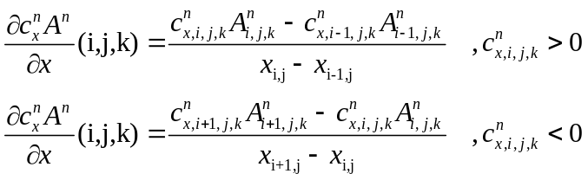
The discretization using a Lax-Wendroff scheme (“scheme = 2”) is:
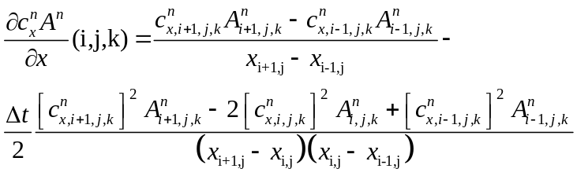
In y-direction, the upwind discretization is

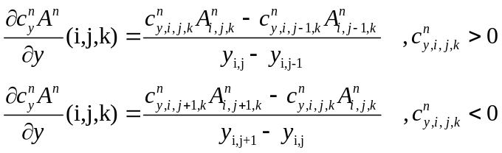
In the Lax-Wendroff discretization:

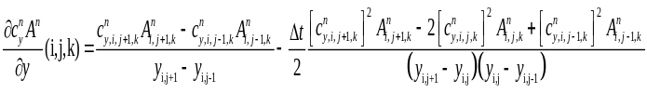

In theta-space an upwind scheme is used only:

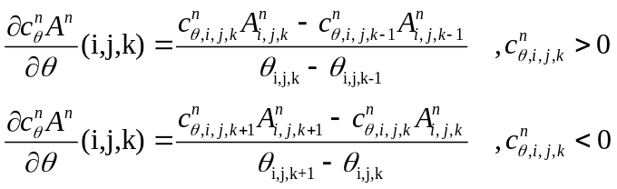

Similar for the wave action balance:

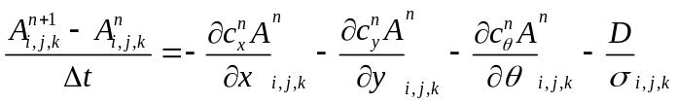

We apply an upwind schematisation, since the horizontal scale of the problem is limited and such a scheme deals with shocks in a natural way.

Shallow water equations

We apply a staggered grid, where bed levels and water levels are defined in the centre of cells, and velocity components at the cell interfaces.

If nx,ny are the number of cells in both directions, the water level points are numbered from 1 to nx+1 and from 1 to ny+1.

The water level gradients are computed at the cell interfaces and are given by:

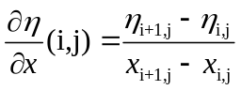
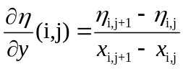
For computing the shear stresses at the cell interfaces we need the velocity magnitudes at these interfaces. These are composed by combining the normal velocity component at the interface and the average of the 4 adjacent tangential components:
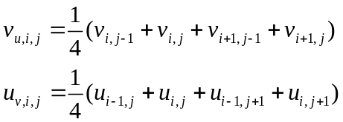
The water depth in each cell is computed as:
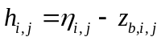

For the depth at cell interfaces, following Stelling and Duinmeijer (2003) we distinguish between the depth used in the continuity equation and that used in the momentum equation.
The depth at the interfaces for the continuity equation is taken as the upwind depth in case the velocity is greater than a minimum velocity, or the maximum water level minus the maximum bed level in case the velocity is less than this minimum velocity:

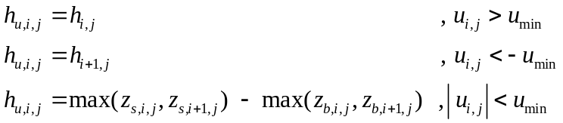

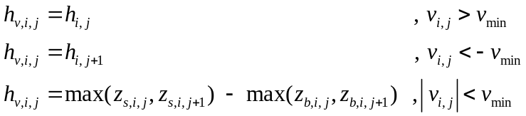

For the depth in the momentum balance we take the average depth between the cell centers:

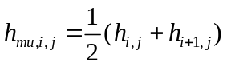
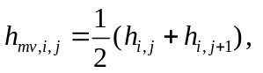

The advection terms in x-direction are approximated as follows:

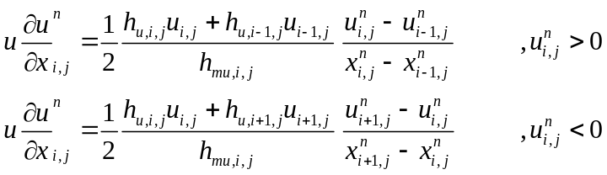

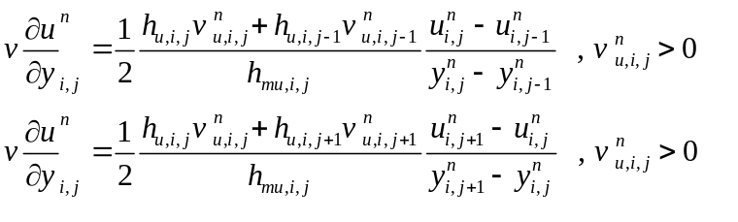
The advection terms in y-direction are approximated as follows:

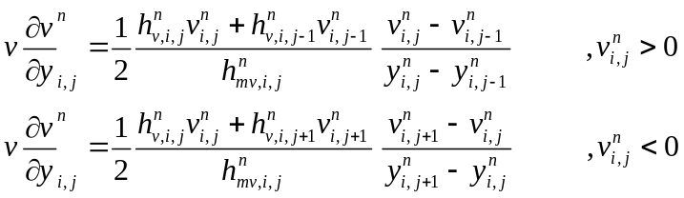

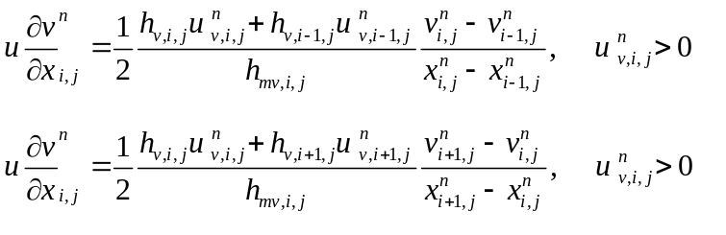

The momentum equation is discretized as follows:

From this, the velocities at the new time step level are computed. The water level is then updated by:
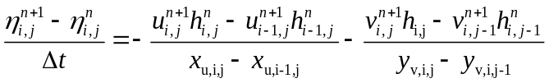
which yields the wave energy at the new time level.

Advection-diffusion equations
The differential equations for the advection diffusion of sediment is solved with finite differences using the first order up-wind scheme discussed earlier with the water depths at the old time level and the corresponding velocities at the new time level. The horizontal x-advection is then given by:

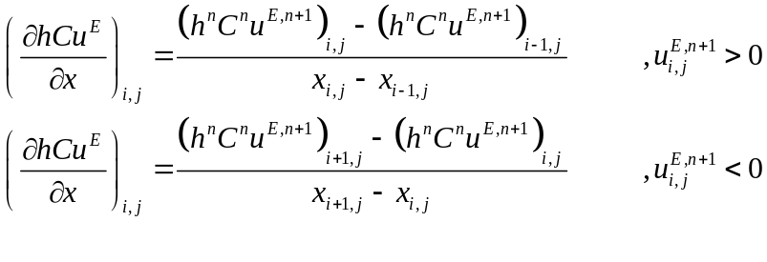
A similar expression for the horizontal advection in the y-direction:

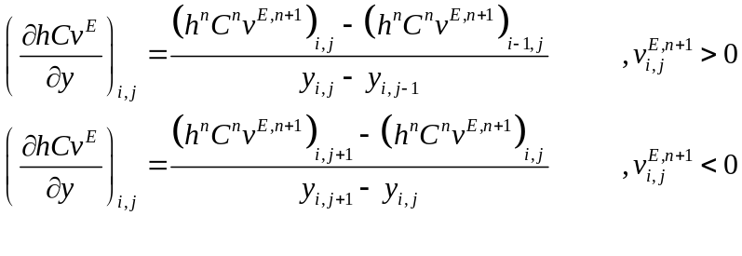
The horizontal diffusion is evaluated at the old time level n and approximated by:

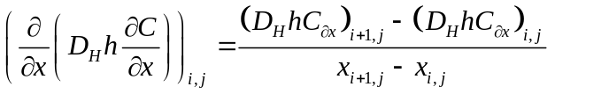

Where the cross-shore gradient in the sediment concentration is given by:

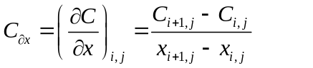

And similarly for the y-direction:

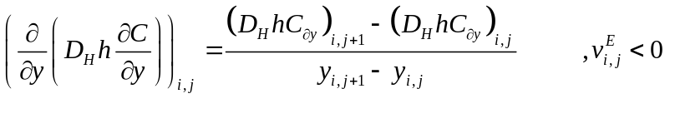
Where the along-shore gradient in the sediment concentration, C_{y} , is given by:

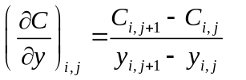

The time up-date of the sediment concentration is then given by:

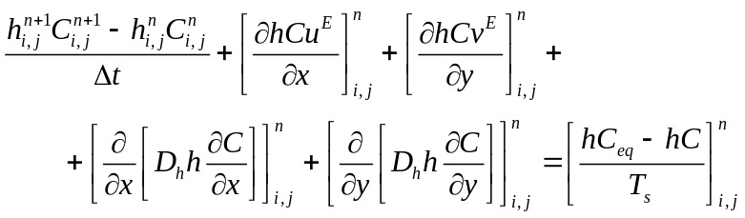

Bed update

The bed-update is then approximated by:

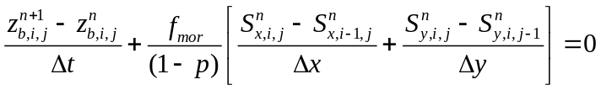
Where f_{mor} represents a morphological factor to speed up the bed evolution (see e.g. Roelvink, 2006).

