Development of a specification for the
Exchange of ECVET data

Abstract
In recent years, numerous ECVET pilot projects were carried out, thus creating a data schema for the description of 'learning outcomes' in vocational training, to make them comparable across Europe. In addition, taxonomies have been described to make these outcomes measurable in so-called EQF levels and thus be able to decide whether a defined minimum qualification is achieved in a vocational training.
Workflows have been partially outlined in pilot projects allowing the formation of stakeholders to jointly and simultaneously create drafts of Learning Outcomes to vote on them later or merge them.
In addition, a number of documents must be jointly prepared and must be available in the respective national language. This includes descriptions of the qualifications, examination regulations, examinations, curricula, certificates, etc.
To facilitate the exchange and the organization of data across Europe, it would be useful to design a technical specification that accurately standardizes these data and document structures but also regulates the management, the versioning (Draft, Final, revisions), the collaboration between actors and the reusability of existing data sets.
In addition, the specification of a meta-data model would be useful to classify Learning Outcomes into groups and thus to facilitate later retrieval and re-use of existing data
A standardization of the data structure would also avoid misunderstandings in the formulation of learning outcomes in relation to the reference system and its indicators.
In addition, a technical specification could serve not only to ensure interoperability between ECVET systems, but also to provide interfaces to other systems that are used in the field of e-learning, such as e-portfolios, LMS or EOR in general.

Objective

Description of a standardized grammar
The term refers to grammar in computer science in about the same, as it is known from one natural language here:
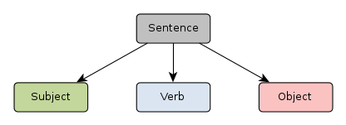

IMPACT-Project developed a specification

A sentence formed from this grammar is correct and understandable for all people who speak the language. The content of this sentence can thus be interpreted by the communication partners in the same way.

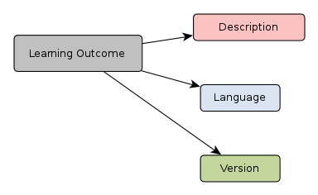

In the same way this principle applies to the electronic exchange of data. Systems that know the underlying grammar can "exchange" data with each other and correctly interpret or process the data.

Classification Systems
Classification systems are data structures allowing the integration of information into context. Such systems are used e.g. in libraries, archives or retail management:
Books → Non-fiction Books → Hobby → Garden → Growing tulips
Clothing → Men's Clothing → Underwear → Socks → Tennis socks
Recreation and sports → Tennis → Clothing → Tennis socks
Books → Non-fiction → Hobby and Sports → Tennis → Clothing → Tennis socks
As shown in the second example the same data can be involved in different contextual relationships and overlapping of paths in different data sets may happen.
From the information technology's point of view, it is important to develop a hierarchical model allowing cross-linking or recognizing of semantic links between individual nodes. Nodes lying deeper in the tree structures may contain properties of parent nodes (so-called inheritance). A tennis sock is a sock, underwear is also clothing.
In the process of describing qualifications in an ECVET conform way a very large number of learning outcomes must be described. This is a time-consuming and therefore costly task.
Many qualifications, however, are based on quite similar or even the same learning outcomes or units of learning outcomes. One of the main objectives of a standardized data model should therefore be the classification of learning outcomes and units of learning outcomes so that these can be easily found after developing and so be used again in other contexts. The standardization should allow to build - especially through the unification of the underlying data model - new qualifications in a modular way using existing learning outcomes or units of them where possible and thus reducing the workload significantly and therefore reducing costs.

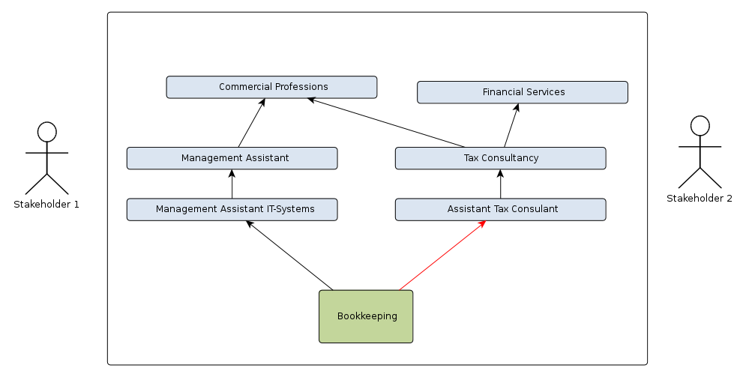
Stakeholder 1 creates an ECVET conform description for the qualification “Management Assistant IT-Systems” containing, among others, a unit of learning outcomes “Bookkeeping”, persisting it in a database.
Stakeholder 2 can access existing (units of) learning outcomes in the database and so might link the unit “Bookkeeping” to the qualification “Assistant Tax Consultant”.
The standardized data models enables the seamless integration of the requested datasets into other already existing datasets.

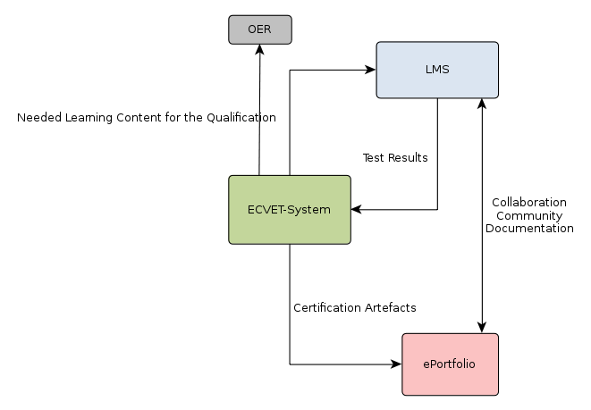
In addition to the data exchange between ECVET Systems it would be interesting to be able to define interfaces to other systems and resources.

Technical Implementation

Interchange format
The data should be exchanged in an XML format. XML is specified by the W3C consortium and is a standard for cross-platform data exchange in the Internet.

Grammar
The grammar should be designed as XSD and DTD. It describes how the XML data must be structured to be processed by the software systems.

Document structure
The document structure should fully represent ECVET:
- on learning outcome level
- on reference system level (EQF)
- a classification system on unit level and on qualification level should be contained
- different languages and revisions should be supported.
- documents and multimedia files (in different languages and versions) should be referenceable.
- It should be possible to integrate further specifications (IMS, Level5, etc.) as references
- It should be possible to reference OER
- Following international standards (ISCO 88, ISO 639 etc.)
- the document structure should follow object-oriented approaches (especially to be able to process the data by object-oriented programming languages)

Usage of experience from e-commerce and e-government
There are specifications successfully in use in the e-commerce sector, which data structures have a strong resemblance to the ECVET data structure (e.g. the BMEcat specification for the exchange of catalogue data being used internationally by now).
So it might be useful for designing an ECVET specification to analyse and reproduce approved protocols from e-commerce (as BMEcat) and e-government (as OSCI), benefiting from long lasting experiences in developing these protocols.

