|  |  |  |
| --- | --- | --- |
| 商品目录 | AC/DC电源连接器 |  |
| 连接器类型 | DC电源插座 |  |
| 安装方式 | 弯插 |  |
| 触点内径 | - |  |
| 触点外径 | - |  |
| 额定电流 | 5A |  |
| 额定电压 | 20V |  |
| 工作温度范围 | -25℃~+70℃ |  |

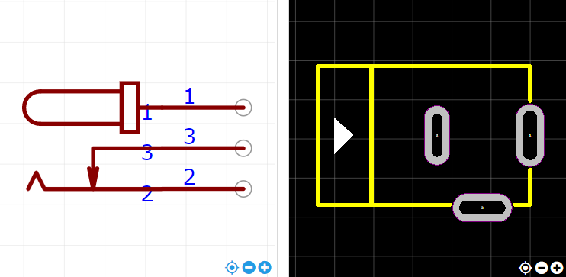

<https://item.szlcsc.com/419795.html>