OpenEMR Users Guide

Based on Version 3.0.1

Table of Contents

- Getting Started pg 3
- Getting to the Login Page pg 3
- Logging In pg 3
- Changing Passwords pg 4
- Main Screen & Navigation pg 5
- Navigation pg 5
  - Traditional pg 5
  - Tree View pg 6
  - Radio Buttons pg 6
- Setting Up Your Clinic pg 8
- Facility Administration pg 8
- User Administration pg 9
- Practice Administration pg 12
- Lists pg 19
- Address Book pg 23
- Adding a New Patient pg 28
- Patient Demographics pg 28
- Patient History pg 34
- Uploading Documents pg 36
- Using the Calendar pg 39
- Setting Up Schedules pg 39
- Making Appointments pg 43
- Appointment Status pg 48
- New Encounters & Coding pg 50
- Opening a New Encounter pg 51
- Encounter Forms pg 55
- Using the Fee Sheet pg 58
- Adding Prescriptions pg 66
- Issues & Immunizations pg 71
- Adding Issues pg 71
- Associating Issues with Encounters pg 77
- Immunizations pg 80
- Patient Notes & Transactions pg 85
- Patient Notes pg 85
- Transactions pg 90
  - Referrals pg 91
  - Basic Transactions pg 95
- Basic Billing pg 97
- Billing Reports pg 99
- Generating Claims pg 101
- Generating HCFA Forms pg 106
- Accounting & Receivables pg 110
- Explanation of Benefits pg 110
- Entering Payments pg 111
- Patient Invoices and Payments pg 113
- Reporting pg 116
- General Reports pg 116
- Billing Reports pg 121
- Patient Reports pg 122

Getting Started

Getting to the Login Page

In your browser's address bar you will need to enter the location of your OpenEMR installation. For most users this address will consist of the name of your server followed by a forward leaning slash, "openemr" and another forward leaning slash. This should look like this:

http://MyServerName/openemr/

Be sure to check with your Administrator, as the location of your OpenEMR installation may be different. As an example the OpenEMR live demo is located at: http://www.oemr.org/demo/openemr/

Once you have entered the correct address, you should be presented with the login screen:

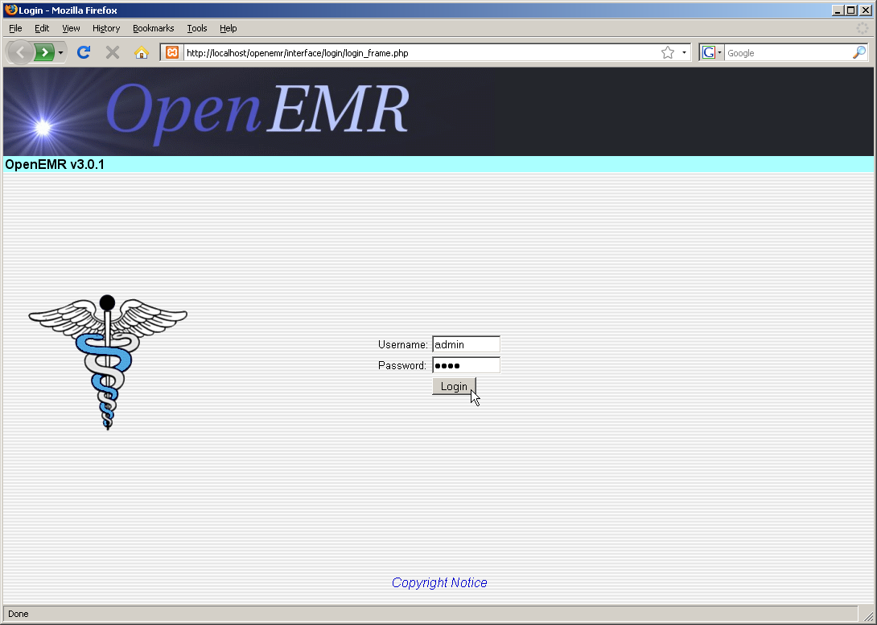

Logging In

The login screen contains two input boxes: Username and Password. The first time you log in to a fresh installation of OpenEMR you will need to log in as "admin" with a password of "pass". Your administrator may provide with a your own username and password. ( Note that the OpenEMR login is case-sensitive.) Once you have entered the correct username and password, simply click the 'Login' button or press 'Enter'.

Changing Passwords

If this is your first time logging in to OpenEMR it is recommended that you change your password to something more secure. To do this select 'Password' from the navigation list on the left.

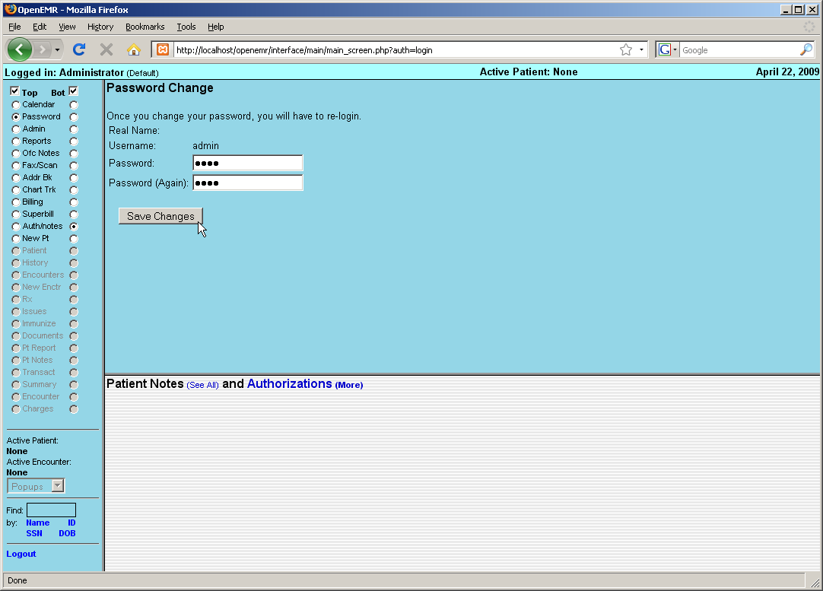

This will bring up the “Password Change” screen. Enter your new password into the two input boxes, make sure you type the same thing into each box. And remember that OpenEMR's username and passwords are case sensitive!

Once you've done this, click the 'Save Changes' button. You will then be required to login again with your new password.

Main Screen & Navigation

A successful login will bring you to the main screen of OpenEMR. The user is presented with two windows, the Calendar, and below that, the Patient Notes & Authorizations page.

Navigation

OpenEMR can be configured with your choice of three navigation schemes. Traditional, Tree View, or Radio Buttons. You can specify which scheme you would like to use by editing the file openemr/interface/globals.php ( Detailed instructions can be found here. )

Traditional

The Traditional navigation scheme uses context-sensitive menus located at the top of the screen, which change depending on what page is being viewed. The patient search function is also located at the top left corner of the screen.

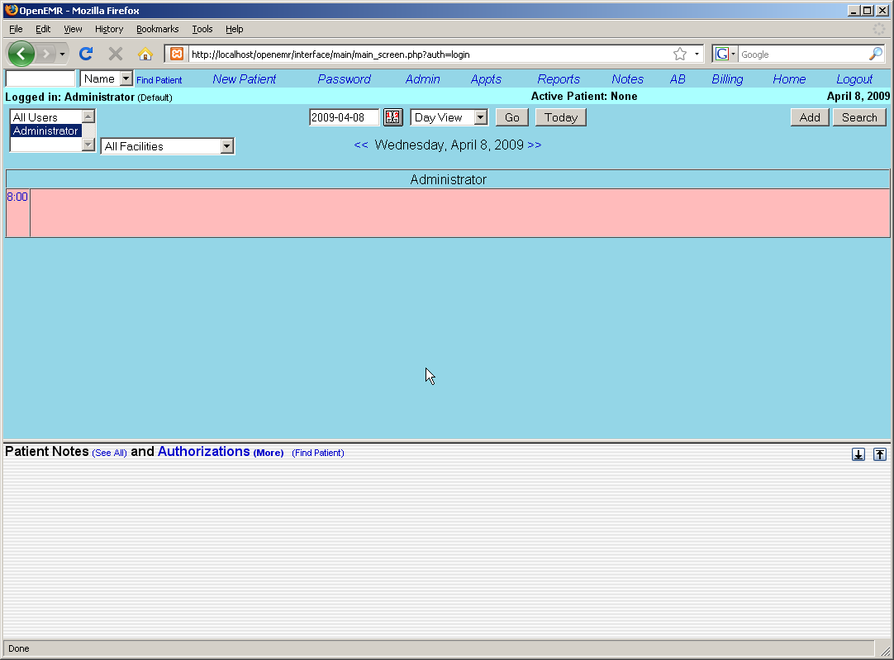

In the Traditional navigation scheme related pages are linked. Pages load simultaneously to facilitate the data entry process.

Tree View

The Tree View navigation scheme presents a hierarchical list of page links on the left side of the screen which can be directed to load in either the top or bottom widow of the main screen.
The patient search function is located below the navigation list on the left hand side of the screen.

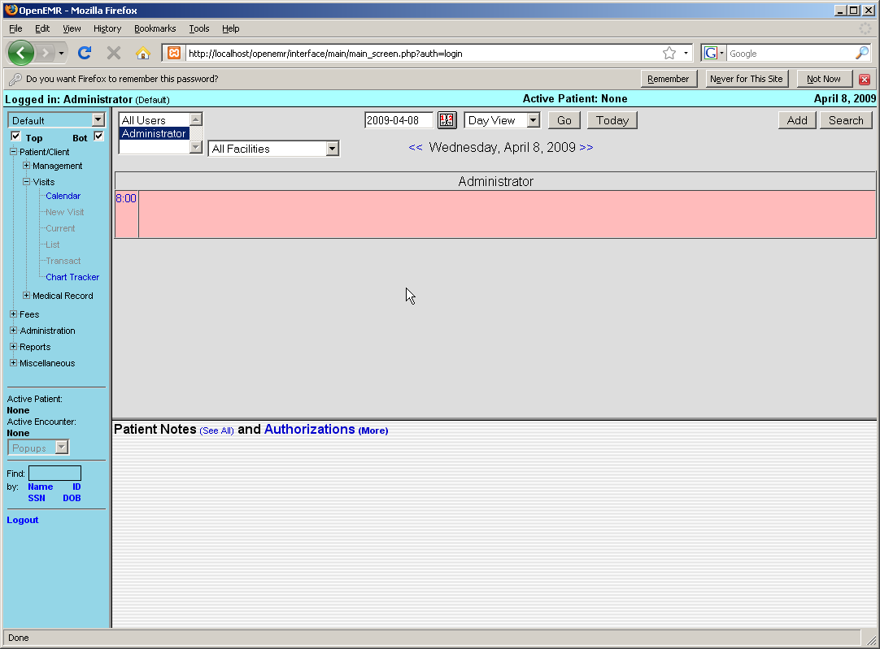

Radio Buttons

The Radio Button scheme is the default navigation scheme for OpenEMR 3.0. It functions similar to the Tree View except that the links are presented as an unordered list, with a series of radio button to the right and left of each item.

Selecting the left radio button will load the desired page in the top window, while selecting the right hand button will load the page in the bottom window. You can also disable the top or bottom window by clicking on the appropriate checkbox at the top of the navigation menu.

For the purposes of this Users Guide, we will assume you are using the default navigation scheme, the Radio Button scheme described above.
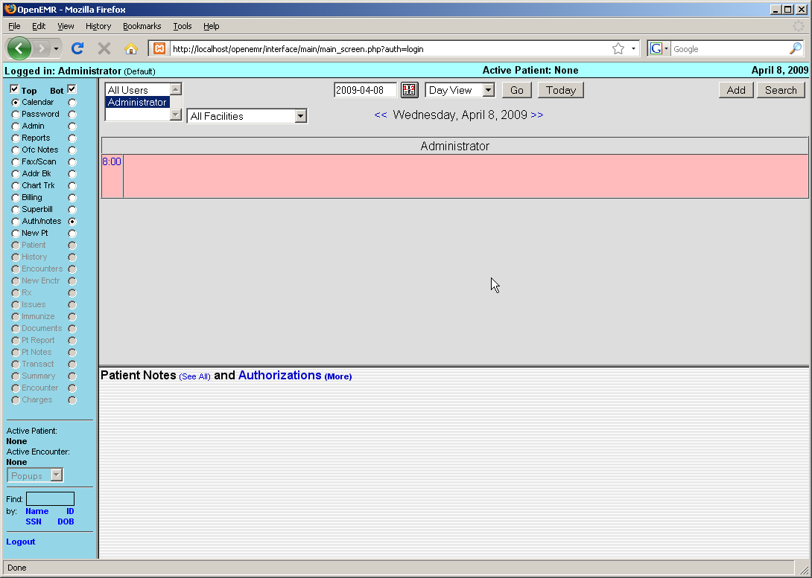

Setting Up Your Clinic

To begin using OpenEMR, navigate to your server's installation directory and log in using your assigned username and password.

A successful login brings you to the appointment calendar. Before you begin scheduling appointments you'll want to configure some basic information for your users. To start setting up your clinic, select 'Admin' from the navigation list on the left of the screen.

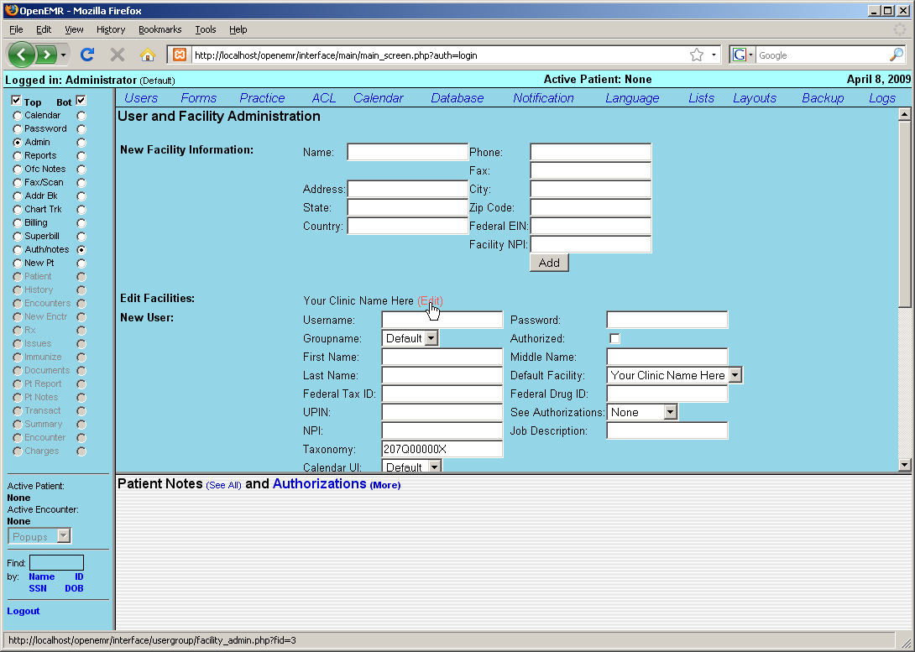

This will bring up the User & Facility Administration page. This is one of several pages within the Administration section of OpenEMR. Administration also includes sections for managing your facility's Forms, Practice information, Calendar categories, Lists, Database administration, and more.

Facility Administration

We'll start by setting up your facility for your users. There is a default clinic already built in. It will need to be updated with the correct information for your clinic. To do this, click 'edit' next to the line labeled “Your Clinic Name Here”

This takes you to the Edit Facility page.

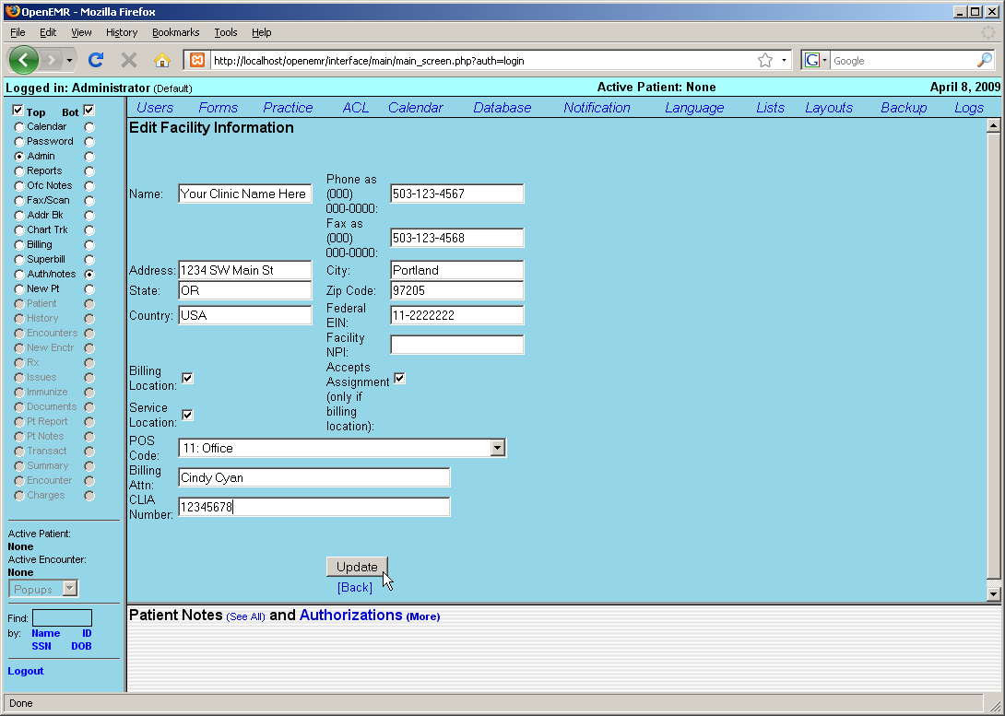

Enter the correct name, address & contact information for your clinic. This information will be used for billing, so make sure to include who to direct billing information to, and enter your facility's NPI and CLIA number. Indicate whether your facility is a billing and/or service location by clicking the checkbox next to the appropriate option. If your clinic is a billing location, you may also want to check the “Accepts Assignment” box.

When you are finished entering your clinic's information click the 'Update' button, then click 'Back' to return to the User & Facility Administration page.

Your clinic may have additional facilities in which care is given, such as a hospital. To add these, enter them into the “New Facility Information” section and click the 'Add' button.

User Administration

The bottom of the User & Facility Admin page contains a list of your clinic's users. If you have not yet added any users, then only "admin" will be shown.

You can add a new user by filling in the form to the right of the "New User" heading and then clicking 'Add.' Or you can modify an existing user by clicking the 'Edit' link next to that user's name.
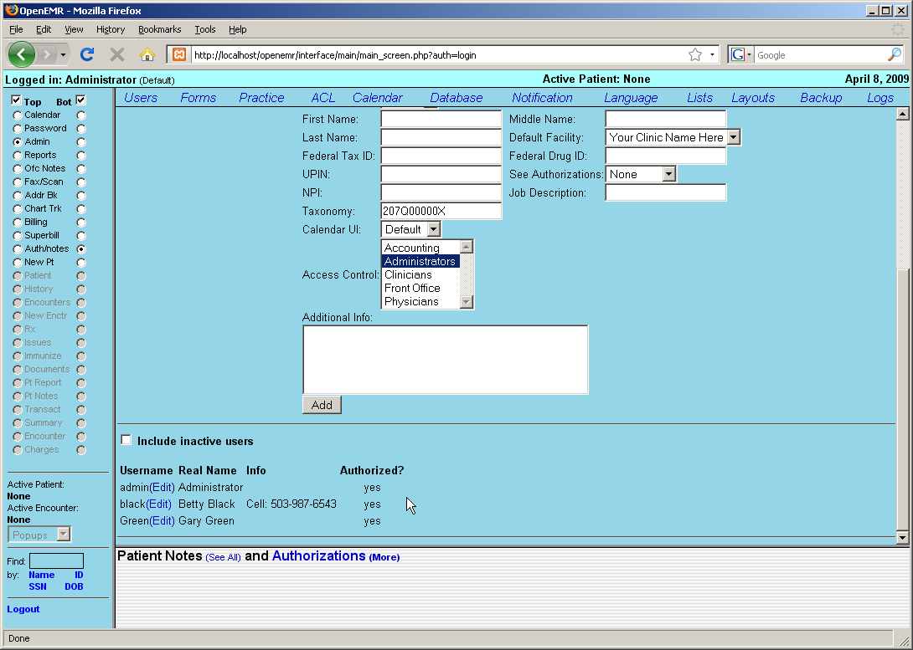

Clicking 'Edit' will bring up the User Administration page. Here you can edit a user's password, facility information and access controls, as well as their authorization status. Authorized users are practitioners, and will appear in the appointment calendar. They can also be associated with encounters for billing purposes, and are able to authorize encounter information entered by non-authorized users so that the encounter will be billable.

Make sure that your practitioners are 'Authorized' by clicking the check box in the User Administration page. Other facility staff do not need to be authorized. Practitioners will also need their UPIN and Federal Tax ID entered for correct billing, as well as their Federal Drug ID for prescription writing.

Once your users' information has been updated successfully click 'Save' and then 'Back' to return to the User & Facility Information page.

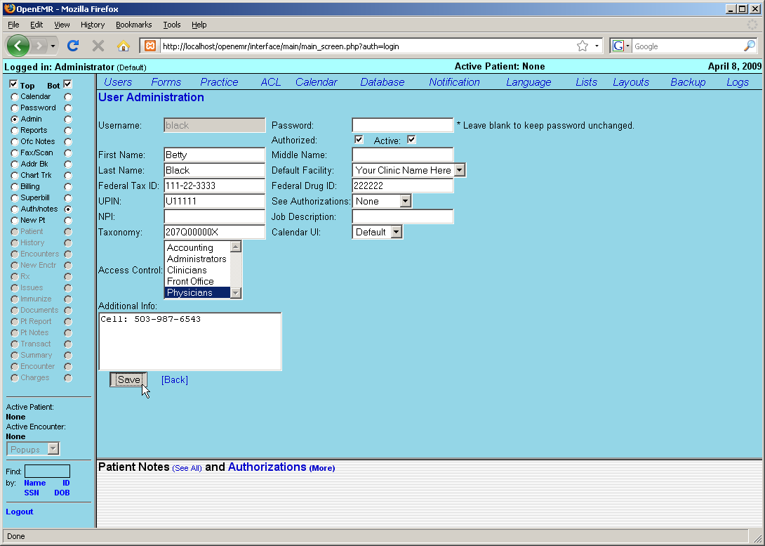

Practice Administration

Next you'll need to enter the relevant practice information for your clinic. This includes pharmacy and insurance company information, as well as the types of documents your clinic accepts.

Clicking the 'Practice' link at the top of the screen will bring you to the Practice Administration page.

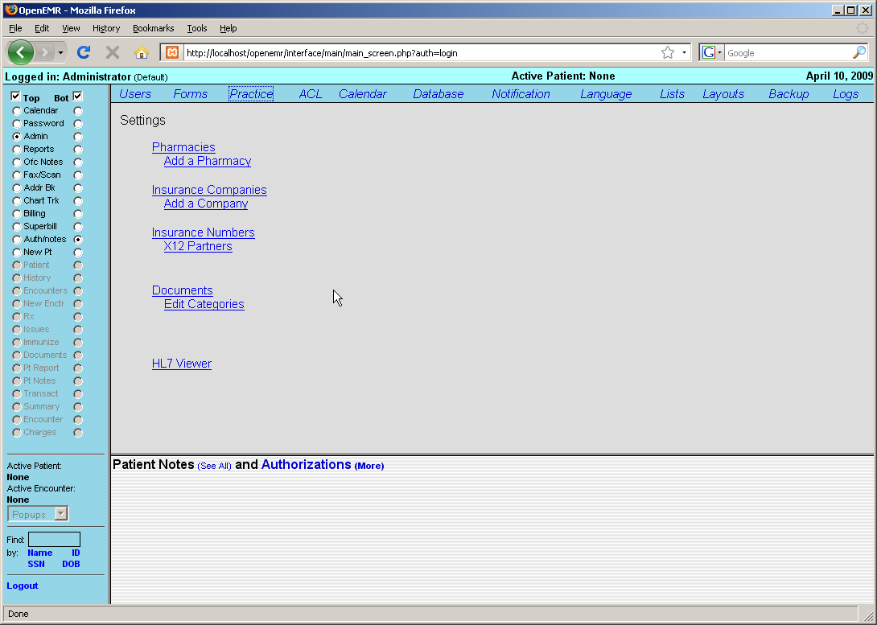

Click 'Add a Pharmacy' to enter the contact information for your clinic's pharmacy. A drop down menu lets you select the preferred method for transferring prescription information. Once you've entered the correct information, click 'Update' to save your new pharmacy.

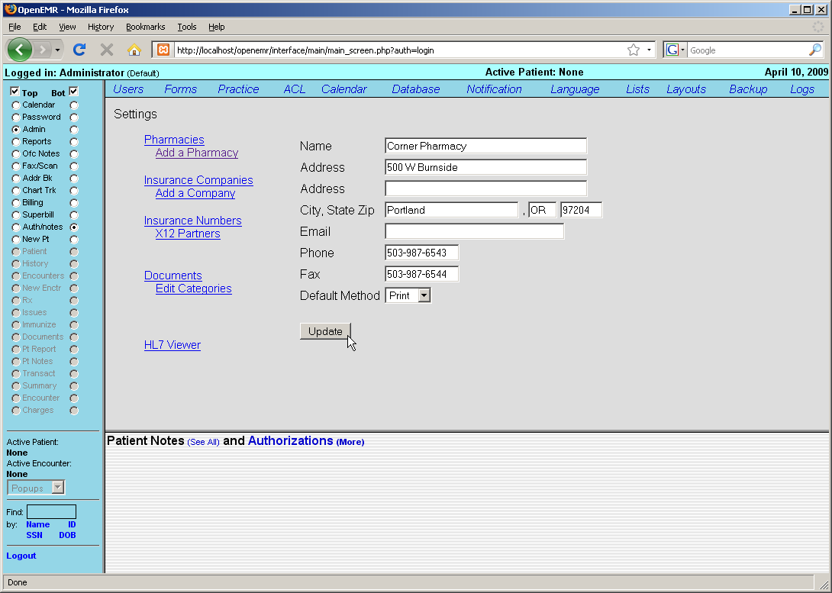

Before setting up any insurance companies, you'll want to enter your X12 Partner information. These are the clearinghouses or large payers to whom you will send electronic billing. Most practices will probably just use a single clearinghouse.

To add one of these clearinghouses, click on 'X12 Partners' and then click 'Add New Partner'.
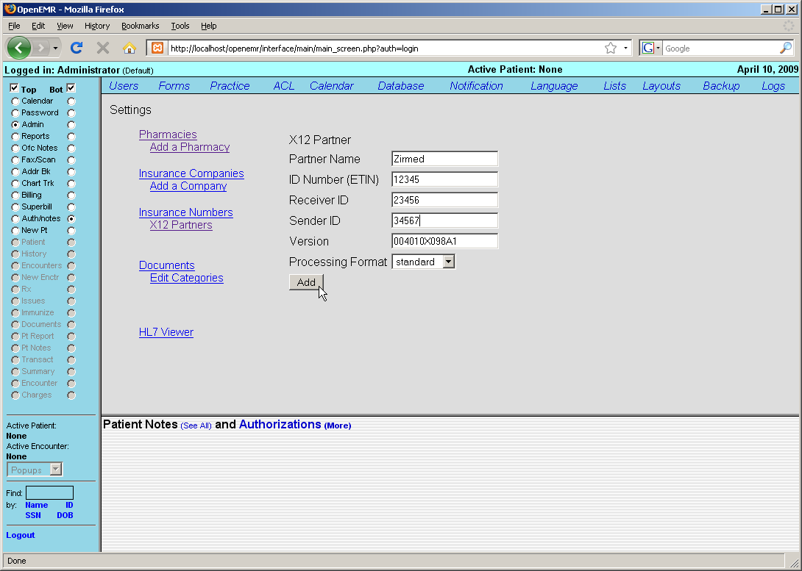

The ID numbers that you enter here will need to be provided to you by the clearinghouse/partner. The Version number refers to the version of the X12 837p protocol specification used and should probably not be changed. Click 'Add' to save the information you've entered.

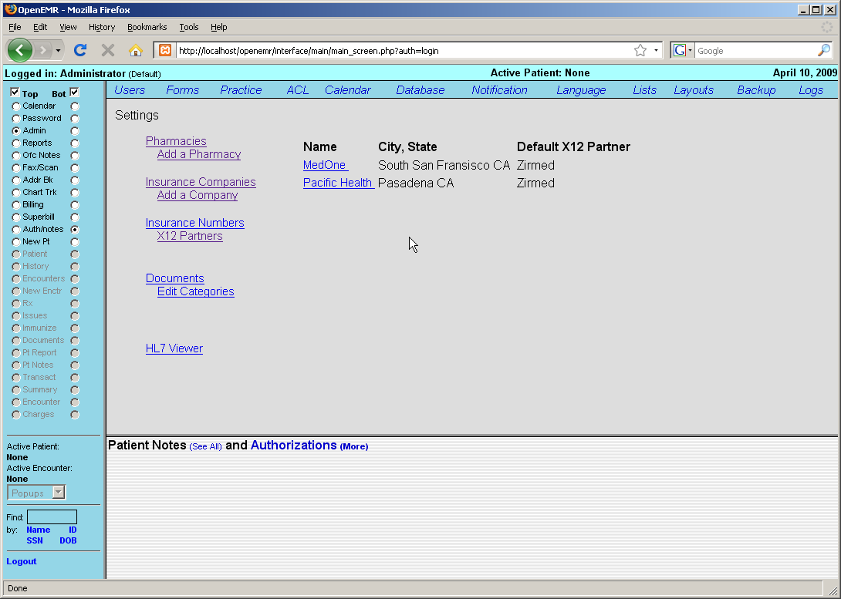

Selecting 'Insurance Companies' from the links to the left of the page brings up a list of Companies that have been added to your clinic. If this is a new installation of OpenEMR, this list will be empty. You can add a new insurance company by clicking 'Add a Company'. Or, you can edit an existing company by clicking on it's name in the list.

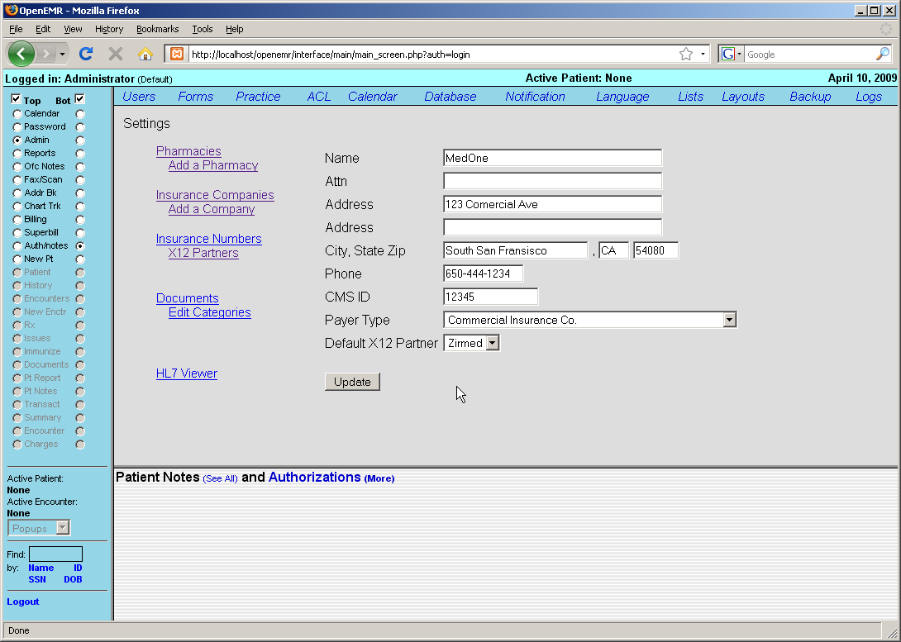

Once you have entered the correct information, click 'Update' to save any changes, or add the new company to the list.

In practice, many insurance companies have multiple insurance plans with a separate billing address for each plan. At this time, you will need to add each plan as a separate insurance company.

Many insurance companies also assign their own doctor-specific ID numbers, and these numbers must appear in your claims. Click on 'Insurance Numbers' to see a list of your clinic's providers and their default ID numbers.
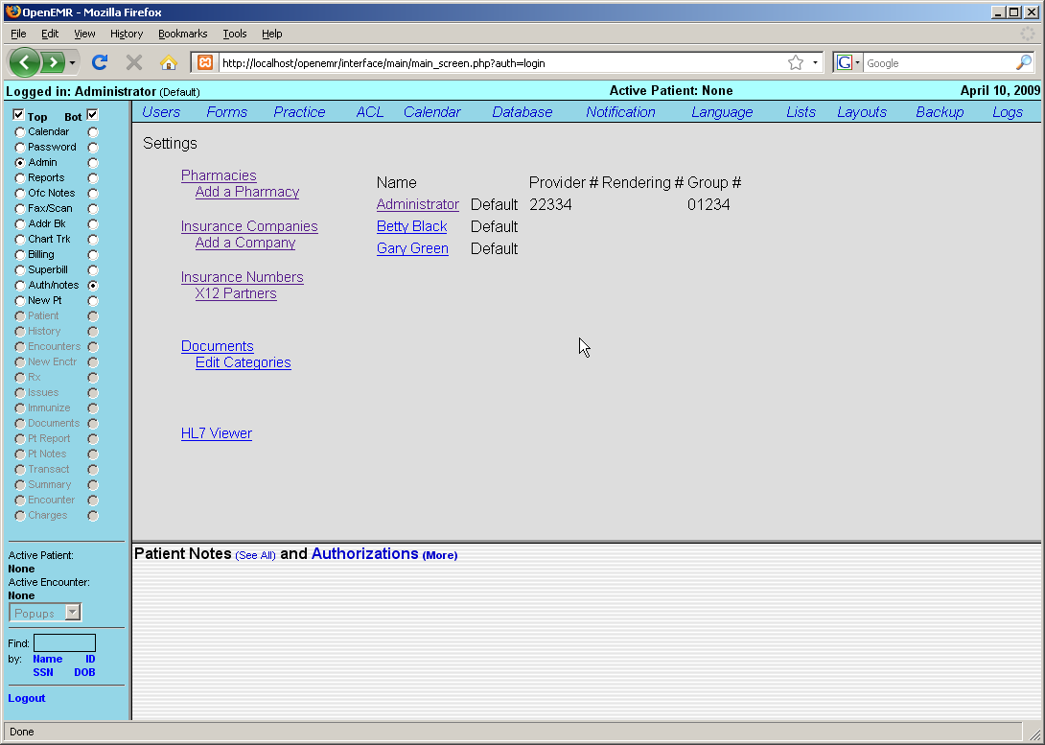

Click on a provider's name to bring up a list of insurance companies and the corresponding ID numbers that have been entered for that provider.

Selecting 'Add New...' presents a form for adding this provider's numbers for another insurance company. Fill in this information and click the 'Add' button to save. You can also edit an existing set of numbers by clicking on the company name in the list.

Note that one of the selections in the drop down list of insurance companies is "Default"; you can use this to fill in default numbers for insurance companies not otherwise entered.

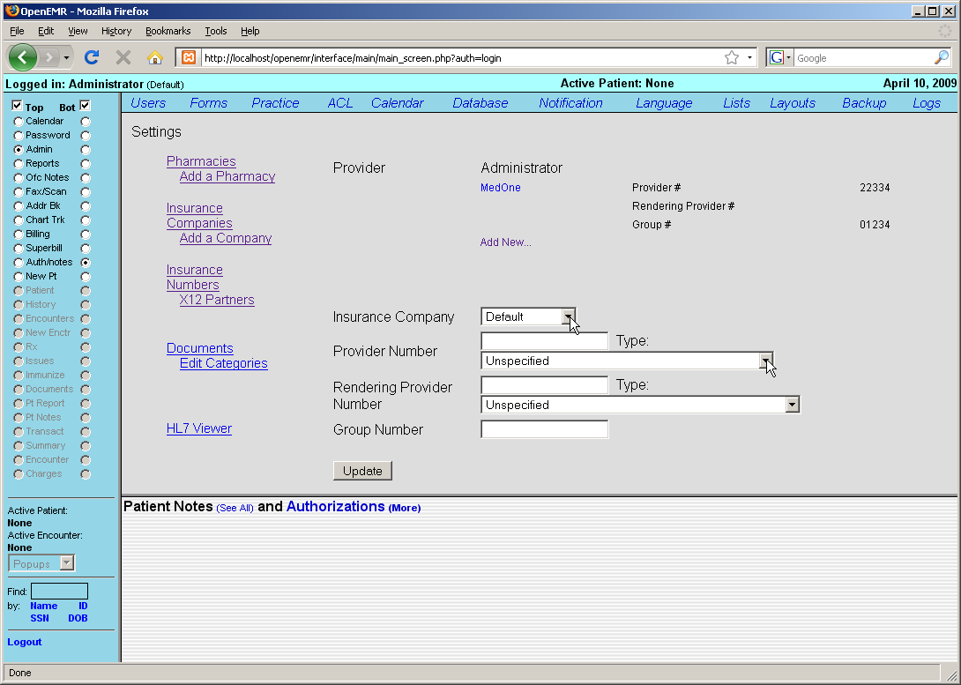

Next click on 'Edit Categories'. This displays a hierarchy of the different types of documents that you can attach to a patient. The default set is shown. To add more categories click on the desired parent name, fill in the name of the new document type, and click 'Add Category'
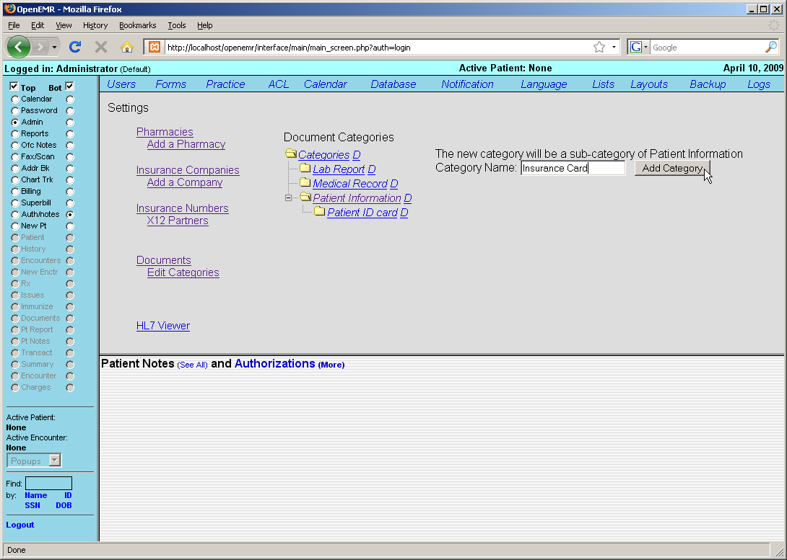

Lists

Select 'Lists' from the menu at the top of the Admin page. This brings you to OpenEMR's List Management system. This is where many of the selection lists within OpenEMR are stored and edited. Before you begin using OpenEMR you will need to populate these lists with data appropriate to your clinic.

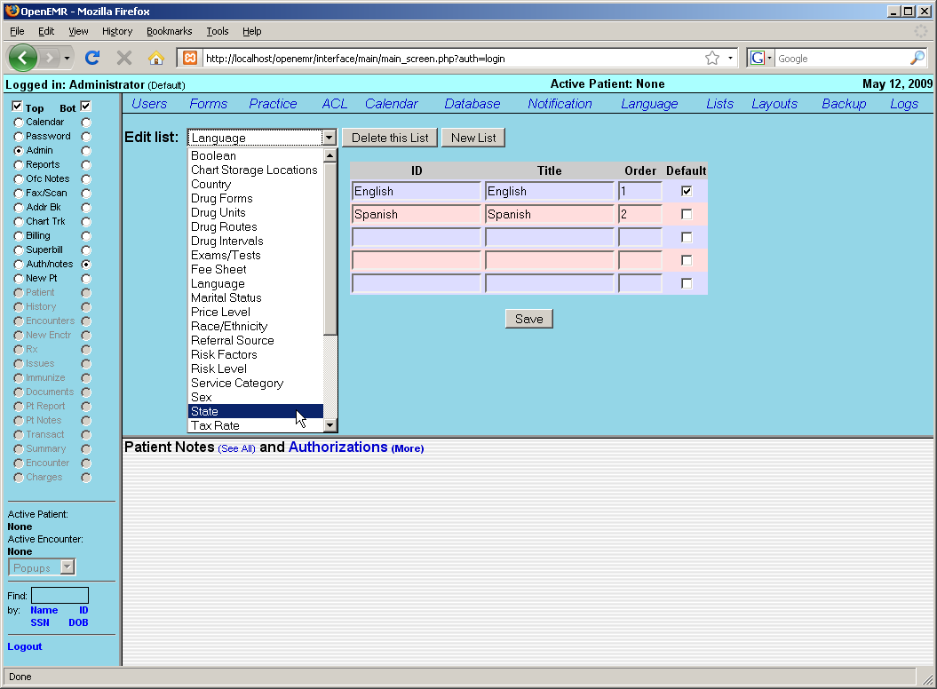

Select 'State' from the drop-down list. OpenEMR comes configured with only one state by default. If your clinic sees patients from only one state you can simply replace the default state by clicking in the 'ID' and 'Title' fields and replacing them with the appropriate information.
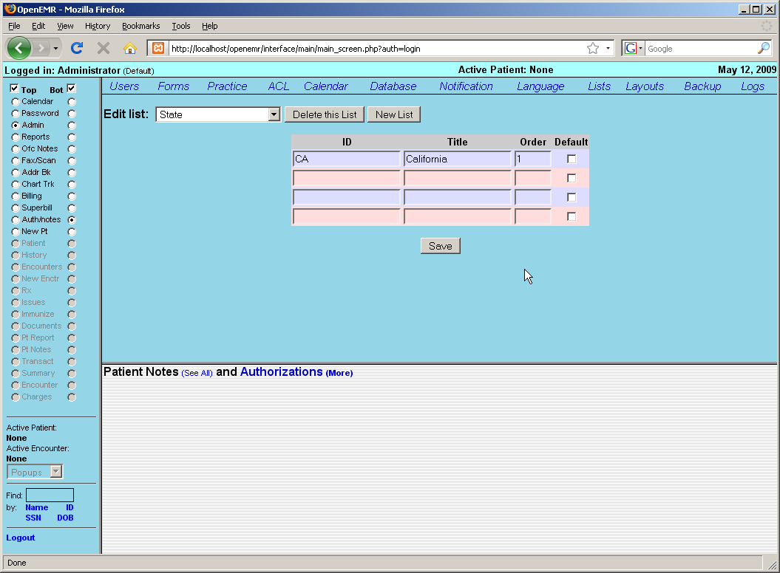

Alternatively, you can add multiple states by filling in the empty fields that are provided for you. You can also specify which state you would like to use as the default by selecting the checkbox next to that state.

When you are finished modifying the list, click 'Save'. This will update the list and generates a new set of empty fields should you need to add additional states to the list.
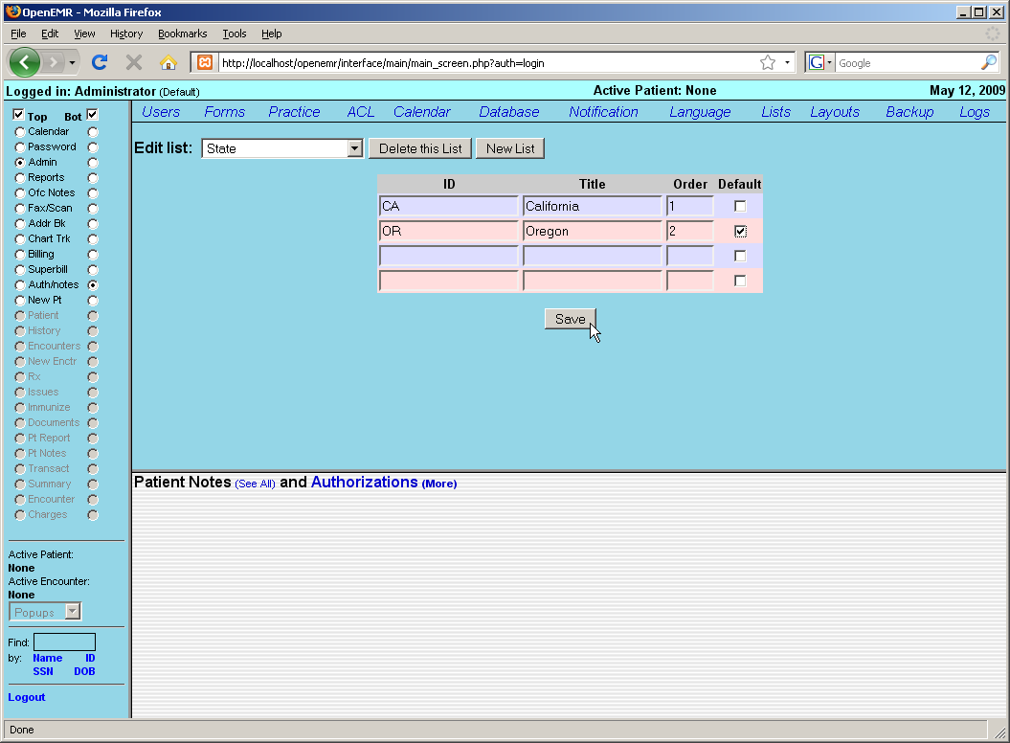

The drop-down contains lists for Race/Ethnicity, common billing codes that appear in the Fee Sheet, Price Levels, common Exams/Tests, etc. All of these lists may be modified in this same manner.

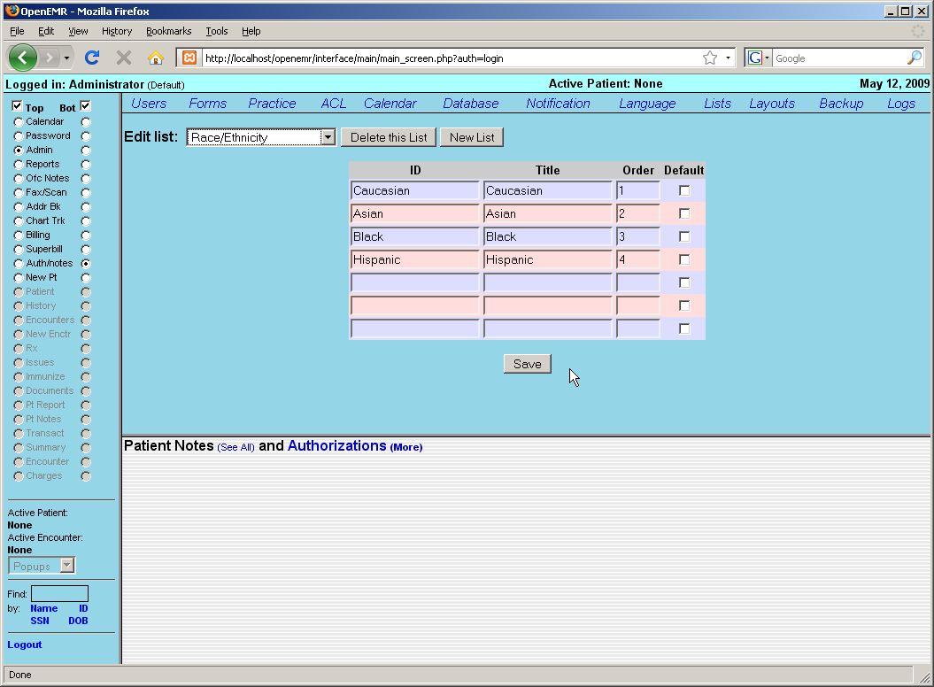

Address Book

OpenEMR also contains a built-in address book for storing useful contact information for your staff as well as other doctors, clinics, etc. that your office may contact on a regular basis.

Select 'Addr Bk' from the navigation menu to bring up your clinic's Address Book.

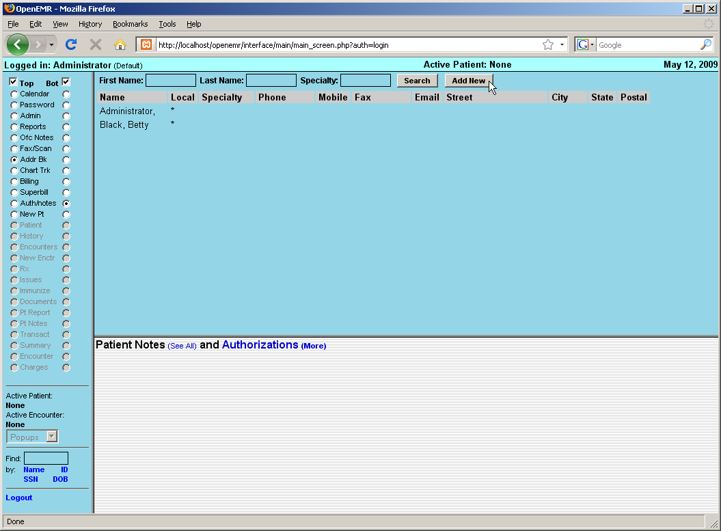

This will present you with a list of all of the contacts currently contained in your Address Book. Click on a person's name to edit their contact information, or click 'Add New' to enter a new contact into your address book.

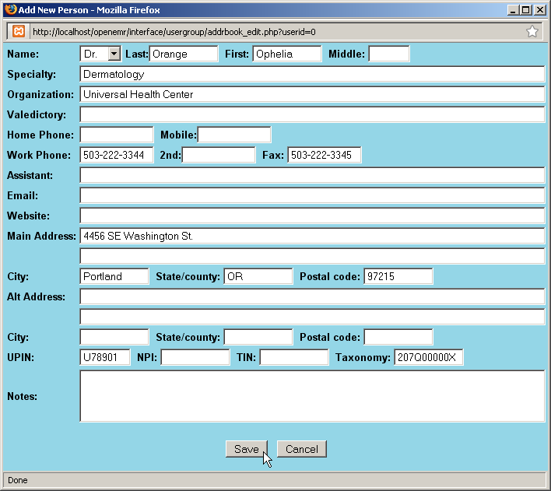

In the 'Add New Person' dialog box, select a title, and enter their name and address. If you are adding a physician to your address book, be sure to include their UPIN and other ID numbers for billing and referrals. Entering a 'Specialty' will allow you to narrow your search parameters when writing letters to a particular physician, etc.

When you are finished entering the new contact information, click 'Save'.
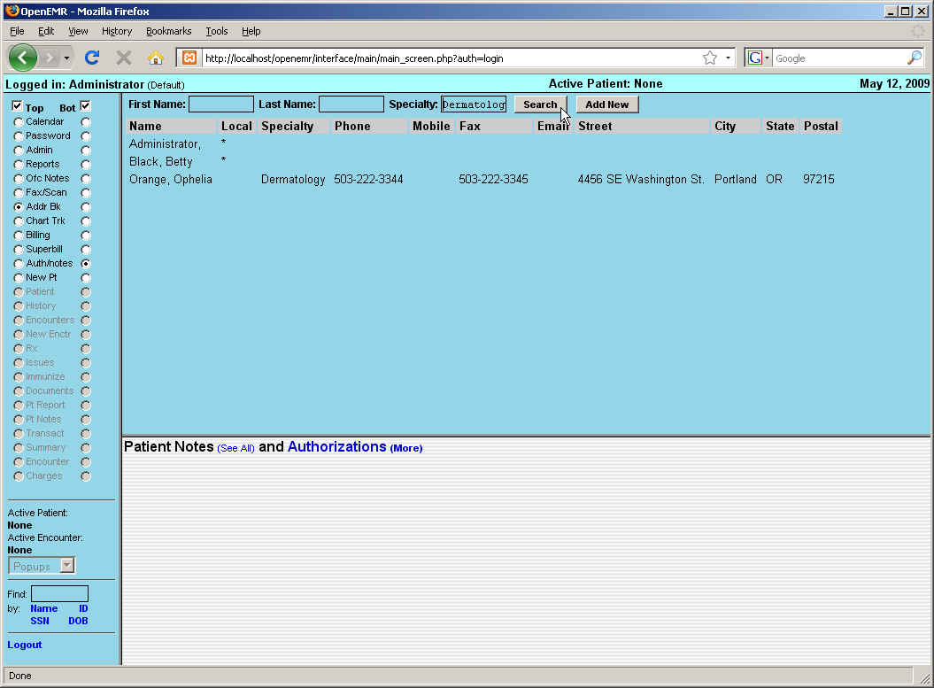

Note that the new contact has been added to the list.

You can search for a particular contact in the address book by enter their name and/or specialty at the top of the page and clicking 'Search'. This brings up a list of any contacts matching your search parameters.
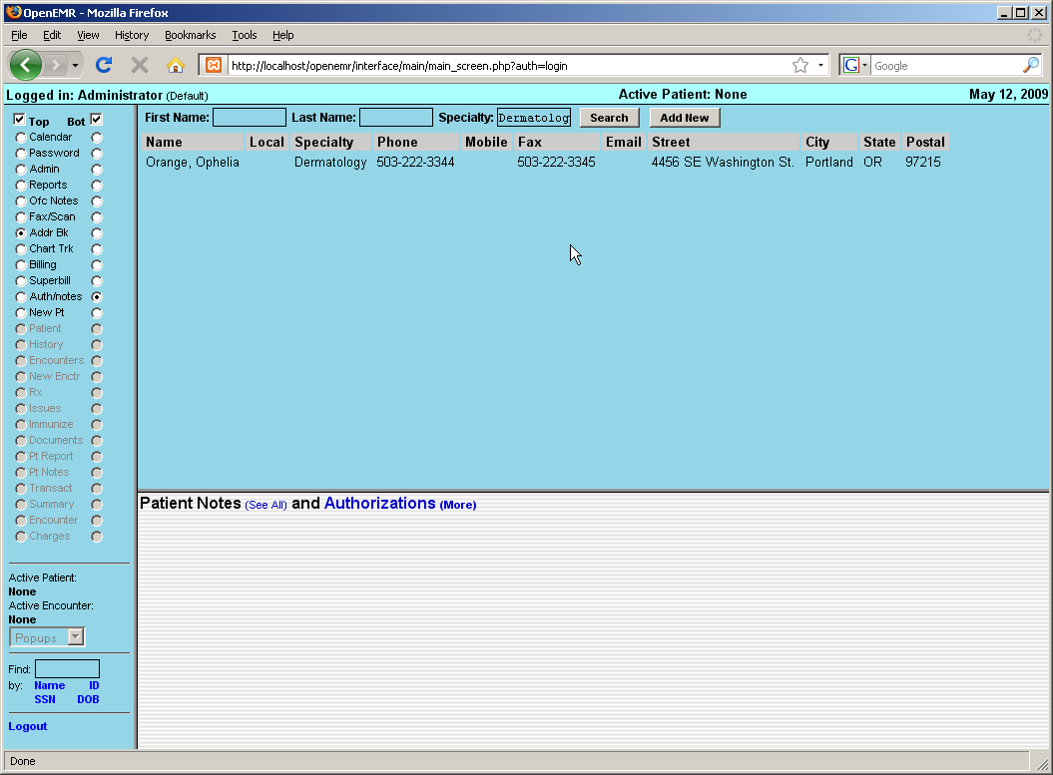
Adding A New Patient

Once you have entered all the necessary clinic information you can begin entering patient data.

Click 'New Pt.' in the navigation menu on the left of the screen to begin entering a new patient into the system.

Patient Demographics

Enter the patient's name & birth date. If you have an existing chart for this patient, you may enter the chart number in here. If you do not enter a number the system will automatically assign one that is equal to its internal patient ID. When you are finished click 'Create'.

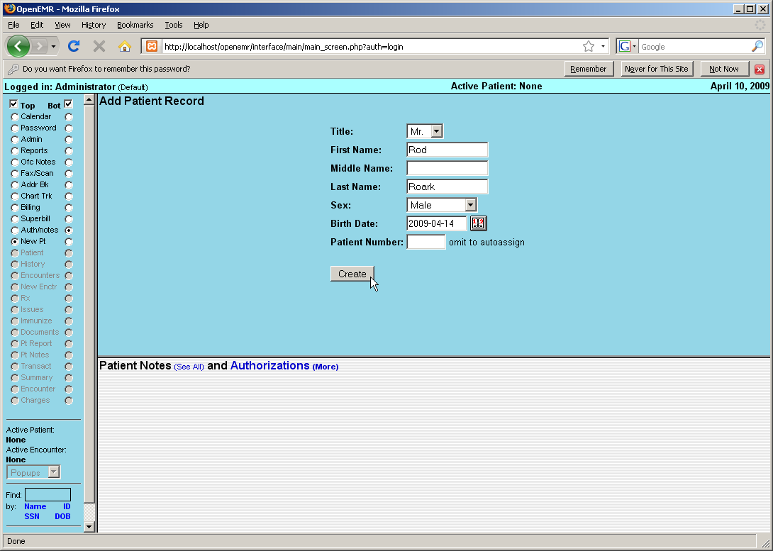

You should now be presented with the patient Demographics page, which contains a summary of the patient's identifying information, including employment, insurance and provider information.

Notice that all of the patient related pages are now accessible via the navigation menu to the left.
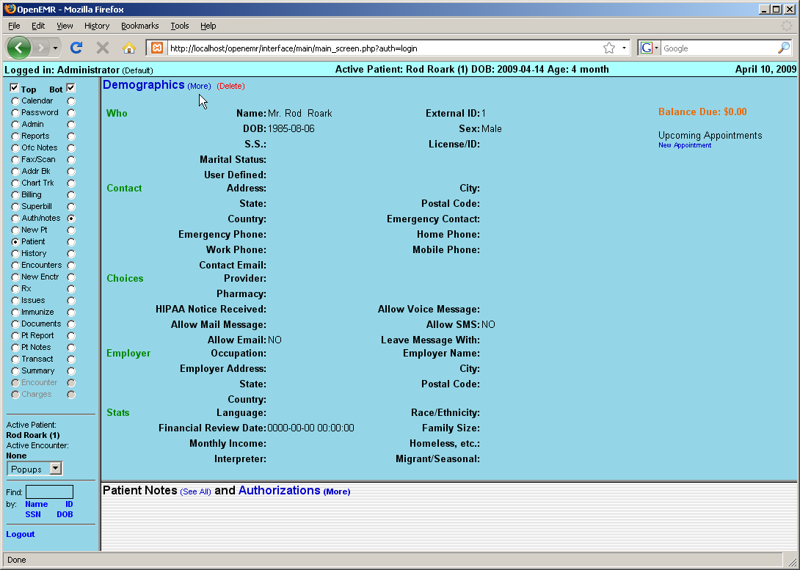

To continue entering patient information click 'Demographics (more)' at the top of the page.

This will bring up a series of expandable sections containing inputs for the various types of patient data. Click the checkbox next to the section or sections you would like to work with. Fill in the desired fields. Note that fields labeled in red are required in order for billing to work properly.

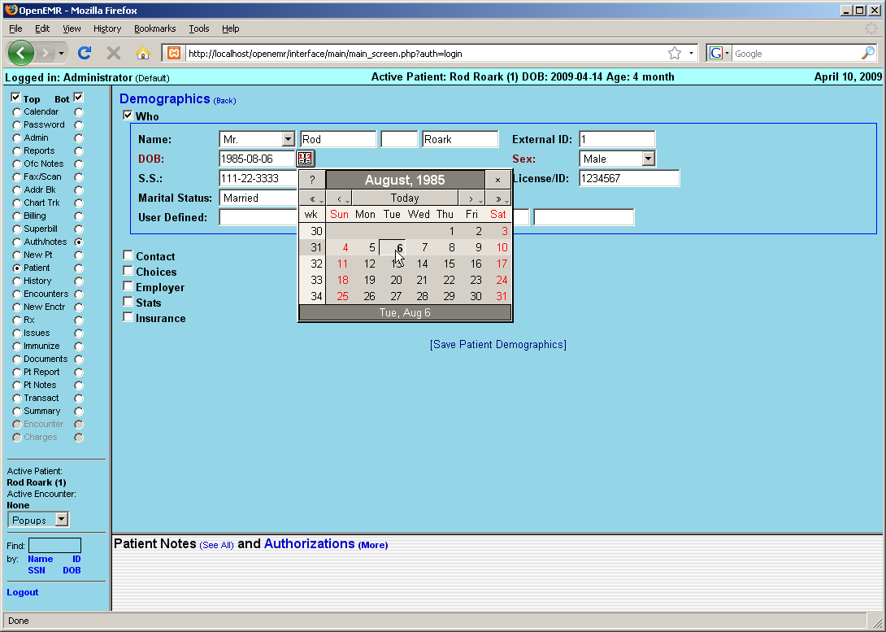

Clicking the calendar button next to the “DOB” field will pop up an easy to use date selection tool found throughout the OpenEMR program. Simply click the arrows to the right or left of “Today” to advance the date forward or back a single month or year, or hold an arrow down to select the month or year manually. Selecting the day of the month will then fill the selected date into it's respective field in the proper format (YYYY-MM-DD)

Continue entering data as necessary.

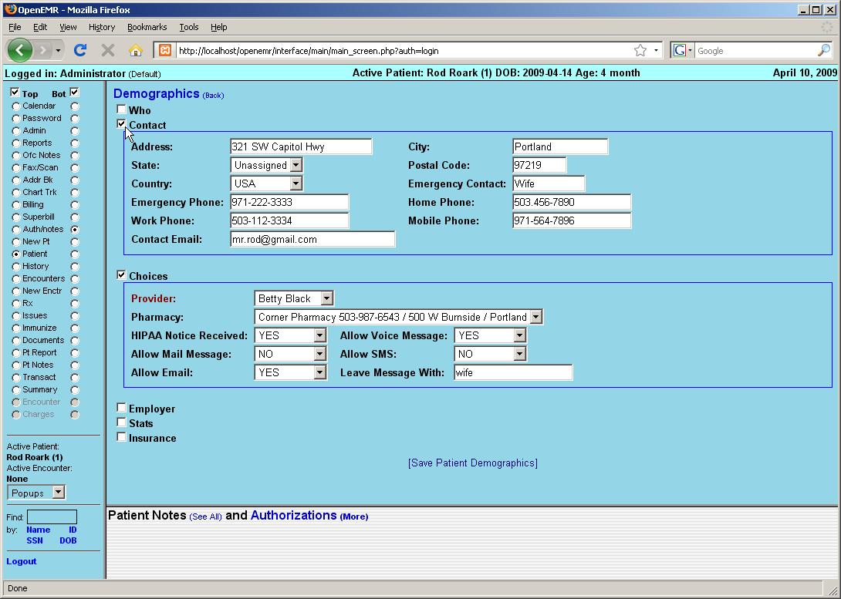

The last section in the Demographics area is the Insurance section.

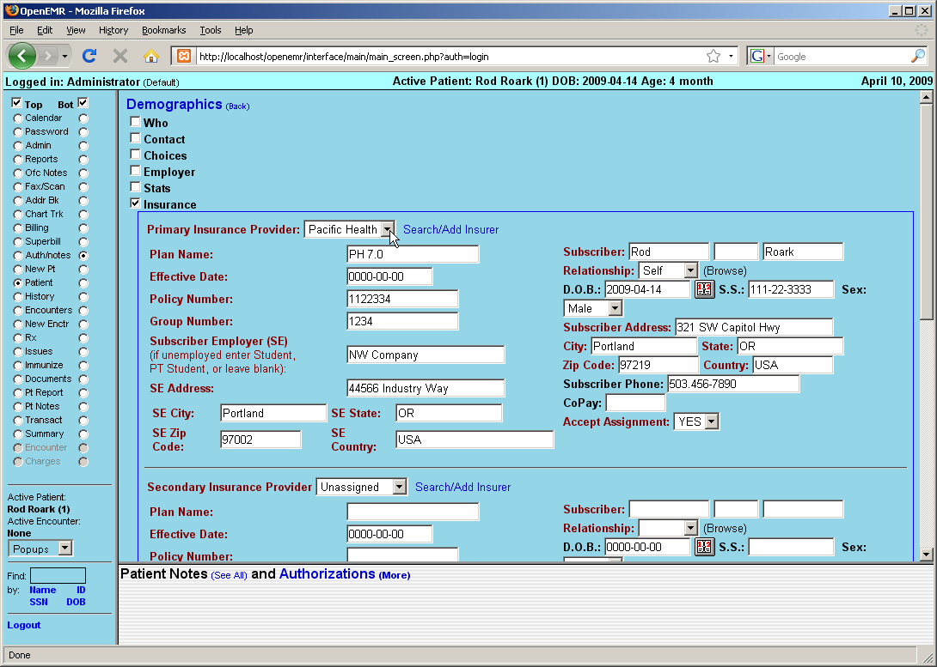

Select the patient's insurance company from the drop-down list, or you can search for it by clicking 'Search/Add Insurer'. Doing so brings up a dialog box containing several fields which are searchable (labeled in green). Entering a partial value into one or more fields and clicking the 'Search' button pops up a second dialog containing a list of all insurance companies matching those parameters.

Selecting the desired name from the list will automatically make it the selection for that patient.
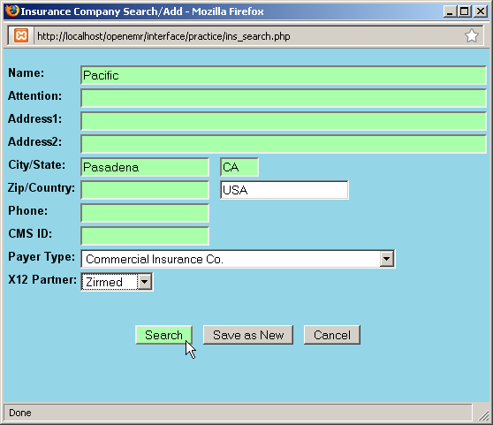
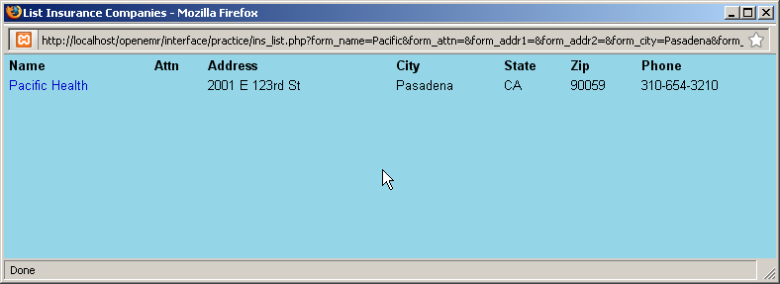

If the desired insurance company is not yet entered, you can also add it here by completing all the fields and clicking 'Save as New'. This also selects the newly added insurance company for this patient.

If the patient is the also the insured party, then selecting “self” from the drop-down list will automatically populate the “subscriber” section with the relevant data for you.

When you are finished, click 'Save Patient Demographics' at the bottom of the page to save and return to the Demographics summary. You can see that all of the new patient data is now visible on the summary page.
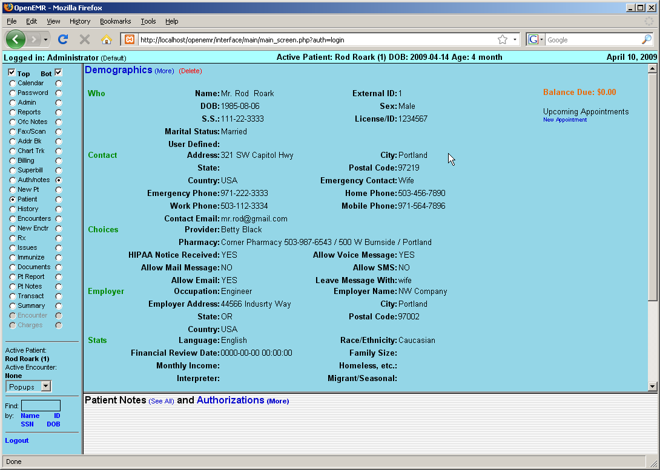

Patient History

Next select 'History' from the navigation menu on the left side of the screen. This brings up a summary page containing information about the patient's medical history.

Clicking on 'Patient History / Lifestyle (more)' will bring up a data entry page with expanding sections, similar to that of the Demographics page.

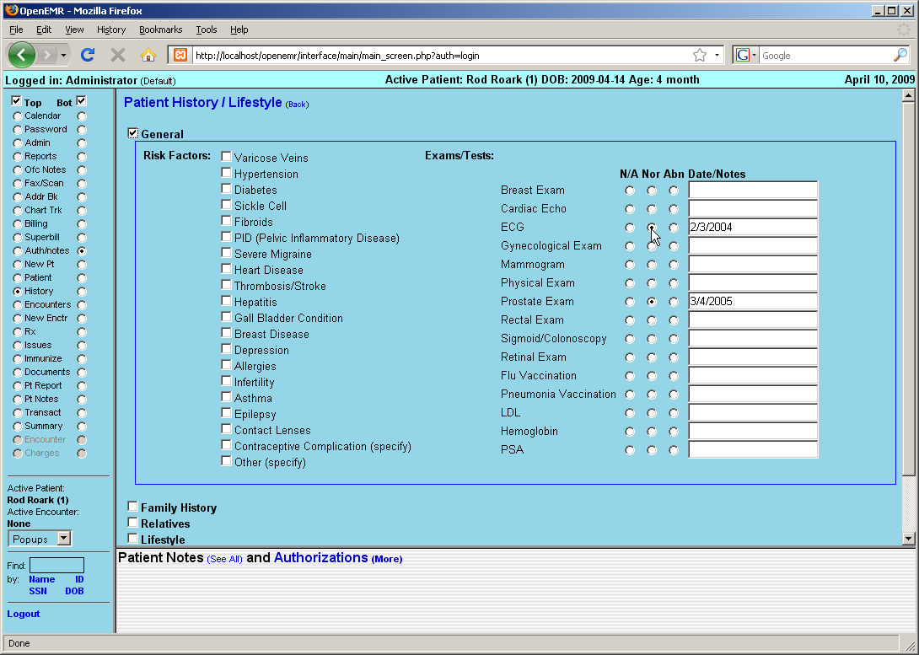
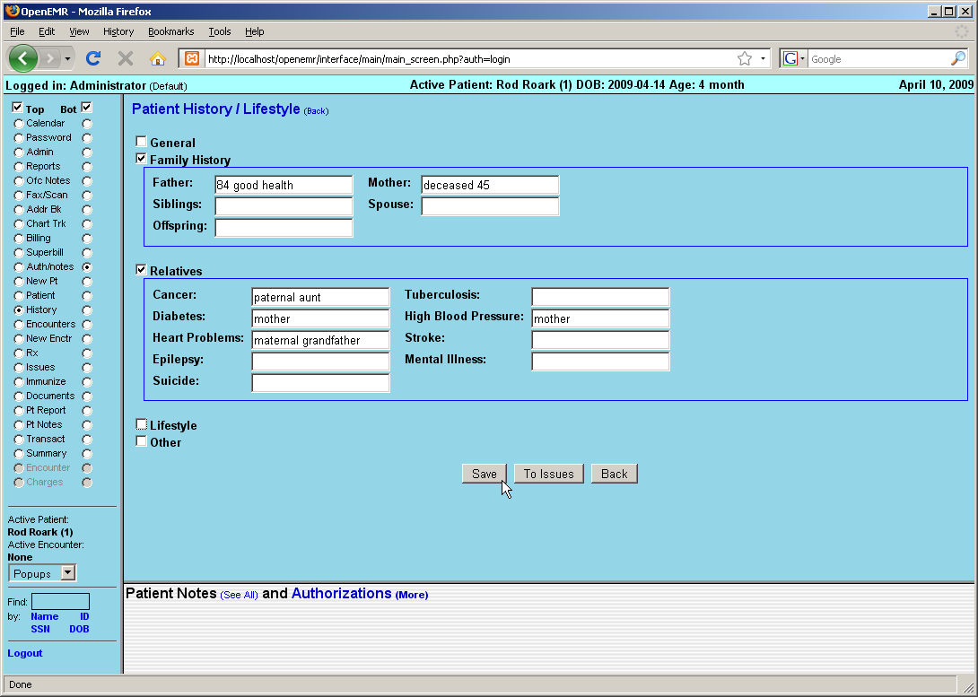

Access the desired sections by clicking on the appropriate check box, and enter in the patient's data as necessary, then click 'Save'.

Uploading Documents

Select 'Documents' from the navigation menu on the left. Here you may upload files that you have scanned and/or saved, such as a patient's ID or insurance card.

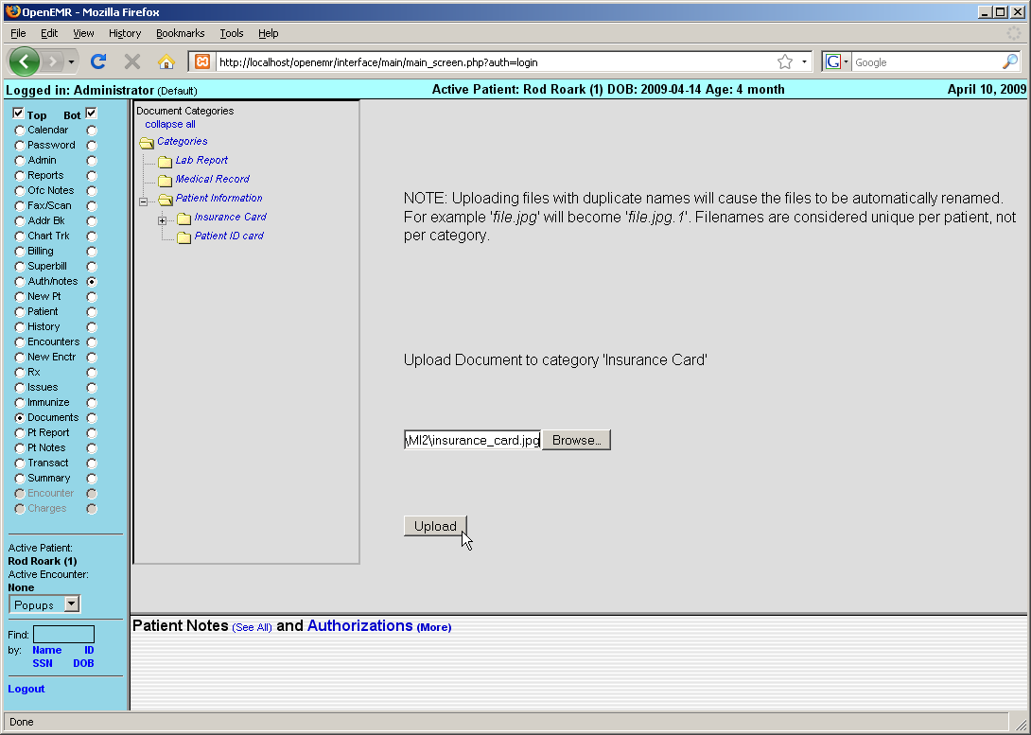

First, click the appropriate Document Category for the file you wish to upload, then click 'Browse'. This will present you with the standard dialog for locating the file on your computer. Once the desired file has been selected, click 'Upload' to save the file in OpenEMR.
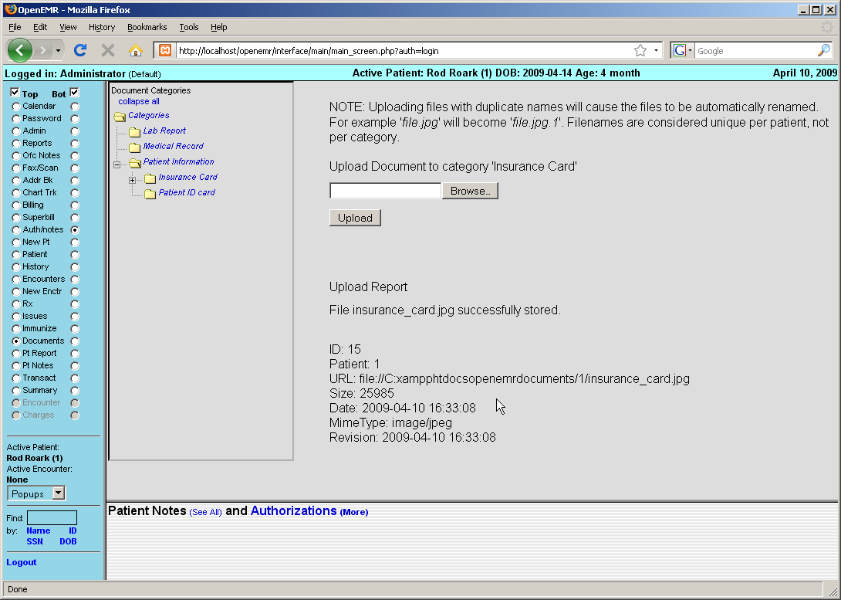

Once the file is uploaded, you will be presented with a report, confirming the file has been uploaded successfully. To see the new file, click on the arrow next to the appropriate document category which displays a list of all the files in that category. Click on the name of the new file to view it.
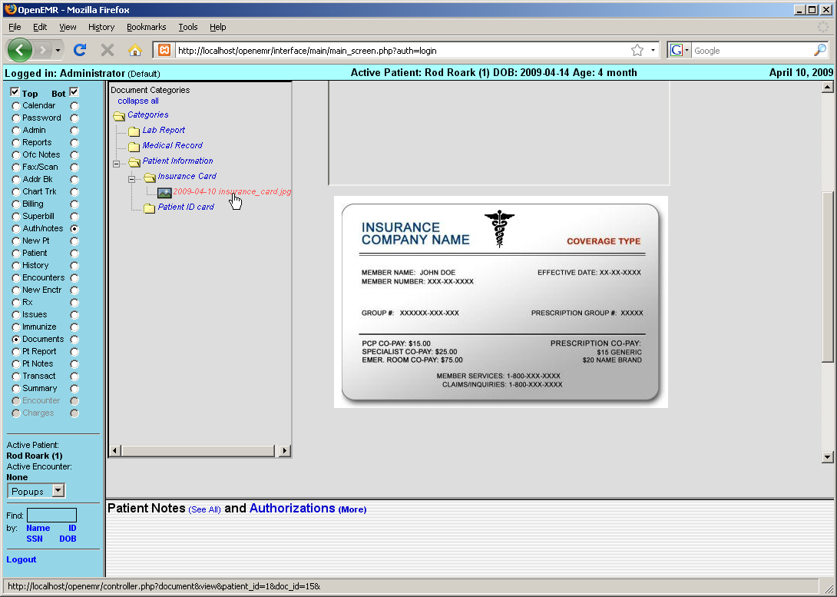
Using The Calendar

In this section we'll discuss setting up a doctor's schedule in the calendar and adding patient appointments.

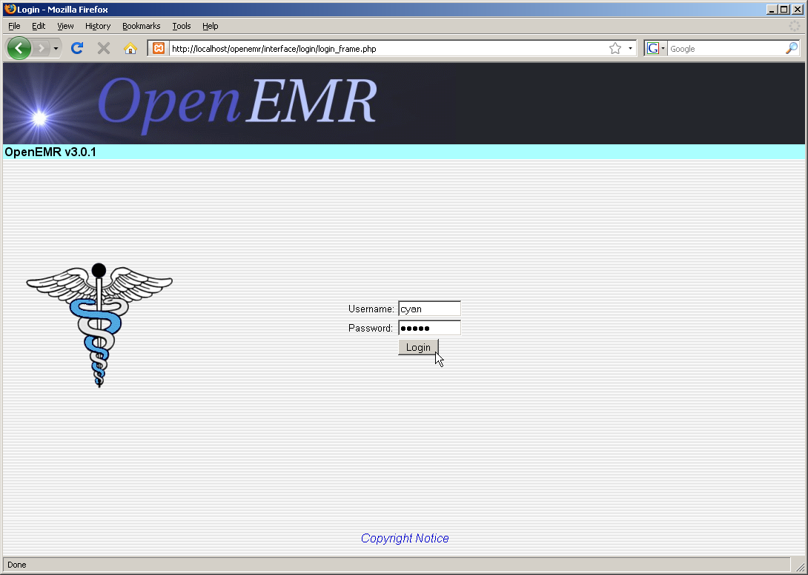

Setting Up Schedules

Login to OpenEMR using your assigned username and password.

For users who are not practitioners, such as someone who works at the front desk, the Calendar will show the schedules of all the practitioners at the clinic by default. When you first start using OpenEMR you will need to set up schedules for all of your practitioners.

To do this, click on “8:00” under the Name of the doctor who's schedule you wish to set up.
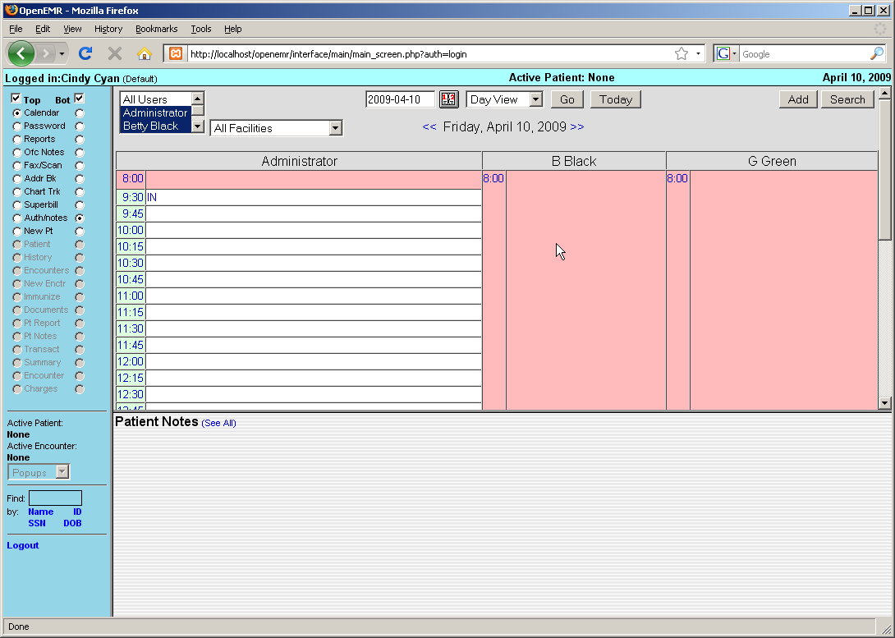

This will present you with the 'Add New Event' dialog box.

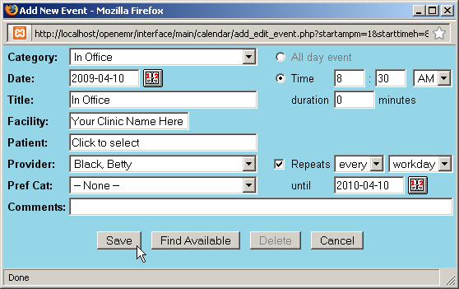

The clinic and provider name should be automatically filled in for you. Set the time at which the doctor arrives by filling in the appropriate time on the right, and choosing “In Office” from the 'Category' drop-down list.

You can also choose to make this a repeating event, which allows you to only have to set up an event once for a given period of time. Do this by selecting the 'Repeats' checkbox, and setting the appropriate frequency & duration.

When you are finished click 'Save' to update the calendar. Now you will see a list of available time slots for that doctor's schedule. Scroll down and click on the time that doctor is scheduled to leave the office for the day.

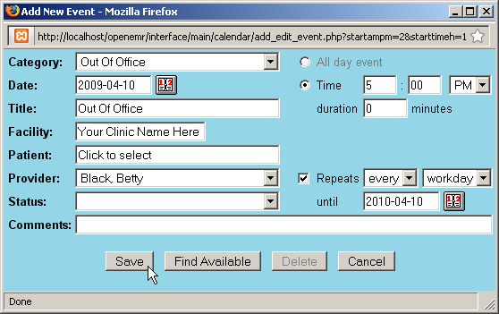

Now the time is automatically selected, as well as the provider and facility information. The same process is used to create a repeating “Out Of Office” event.

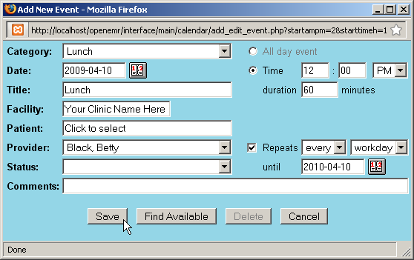

You can also add a lunch break in your practitioners' schedules. This is done the same way, with the exception of the duration, which in this case is non-zero.
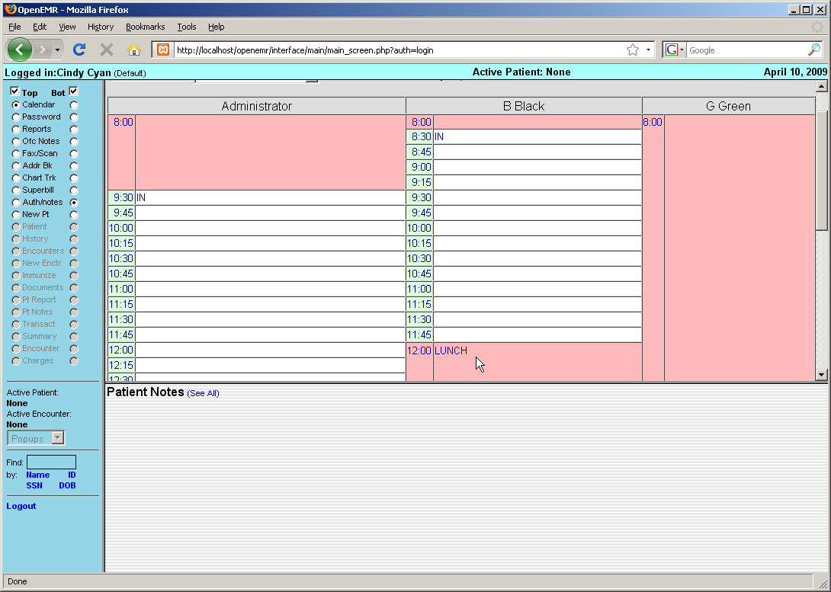

Now you can see your practitioner's full schedule laid out on the Calendar page. Continue setting up the Calendar in this fashion until all your practitioners' schedules have been entered.
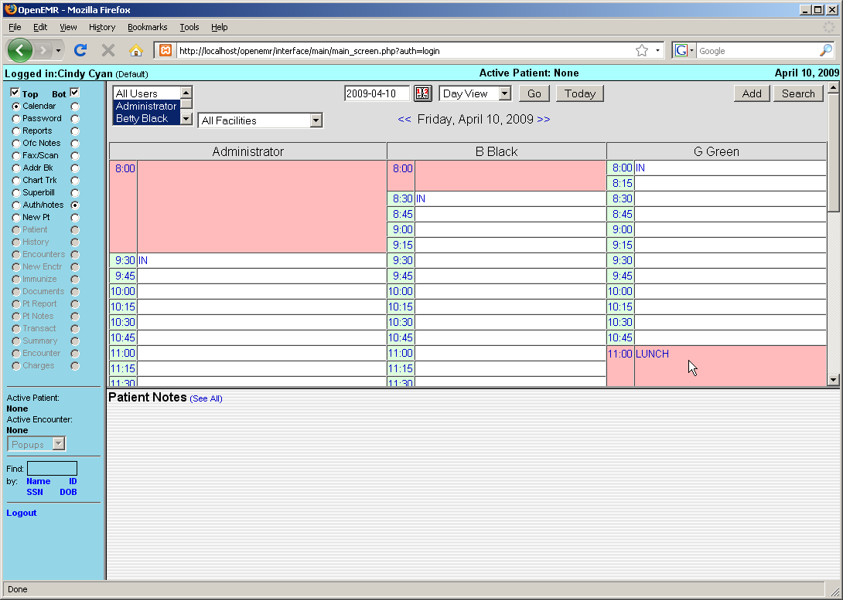

Making Appointments

Now that the clinic and all it's practitioners are set up, you can begin scheduling appointments for your patients.

To locate a patient in the system, enter all or part of their name into the search field in the bottom left corner of the screen (below the navigation list) and click 'Name'. This will bring up a list of all the patients in your system matching that name. If you need to narrow the list, you can enter a longer search term, such as their full name (Eg. “rourk, rod”).

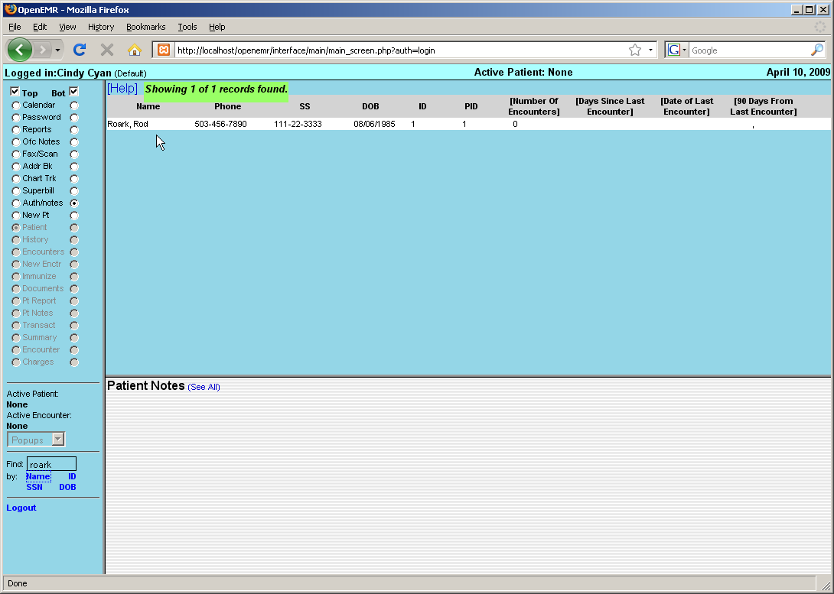

Click on the desired name to bring up the Demographics summary for that patient. If you have the patient on the phone, now would be a good time to confirm that their contact and insurance information is up to date. If the patient is not already in the system, you can select 'New Pt.' from the menu to begin entering their information.
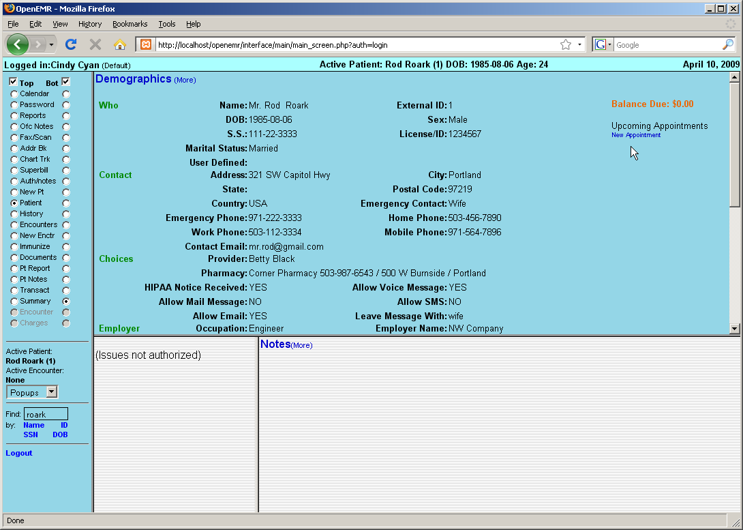

The right-hand side of the Demographics summary shows a list of all current and future appointments for that patient. Click 'New Appointment' to schedule an office visit.

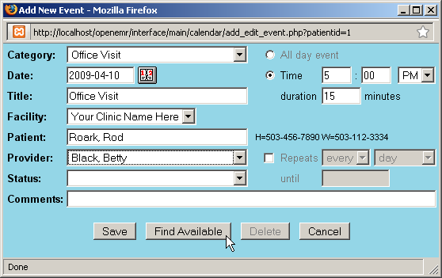

This will present you with the same 'Add New Event' dialog used earlier. This time select “Office Visit” as the Category. If a primary provider has been entered for that patient, they will be selected automatically.

Click 'Find Available' to see a list of appointment times available for that provider for the next 7 days. You can change the start date or the number of days shown and click 'Search' to display a new list using those parameters.

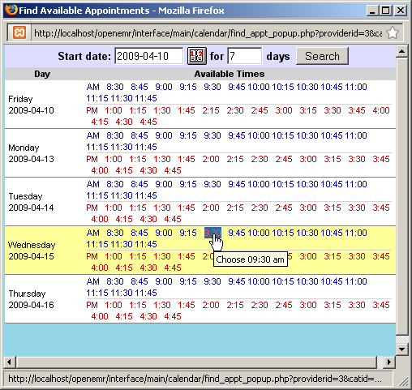

Once a date and time have been agreed upon, selecting that time from the list will close the window, and the selected time will appear in the 'Add Event' dialog.
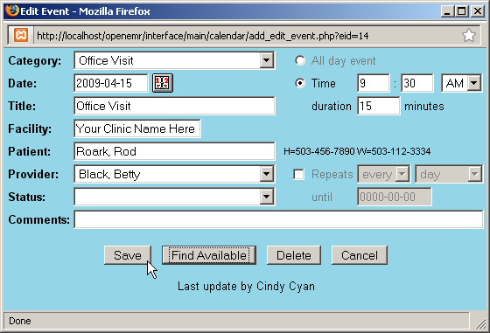

Make sure to enter the correct duration for the appointment and click 'Save'.

Return to the calendar using the navigation menu on the left. Advancing to the appropriate date, using the arrows to the right of the current date ('>>'), shows the new appointment listed in the provider's schedule. Mousing over the appointment displays a toot-tip with information about that patient, such as date of birth.
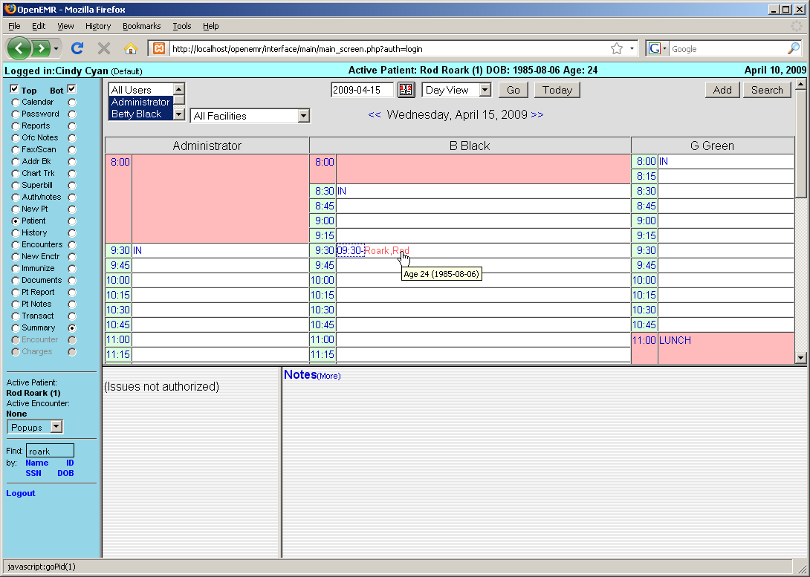

Appointment Status

OpenEMR's calendar system includes a status indicator, allowing doctors and staff to see at a glance what is going on with all appointments and the corresponding encounters for the day.

To change the status of a given appointment, click on the time portion of the appointment line (to the immediate left of the patient's name). This brings up the 'Edit Event' window. Choose the correct appointment status from the drop-down list. Notice each status has a unique symbol associated with it.

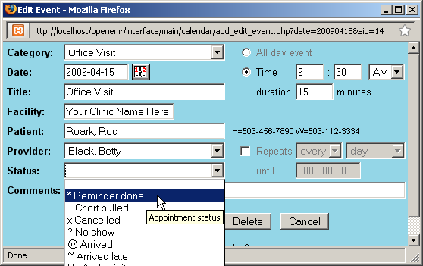

You can also type a note into the 'Comments' line if more information is needed. Click 'Save' to update the status of the appointment.

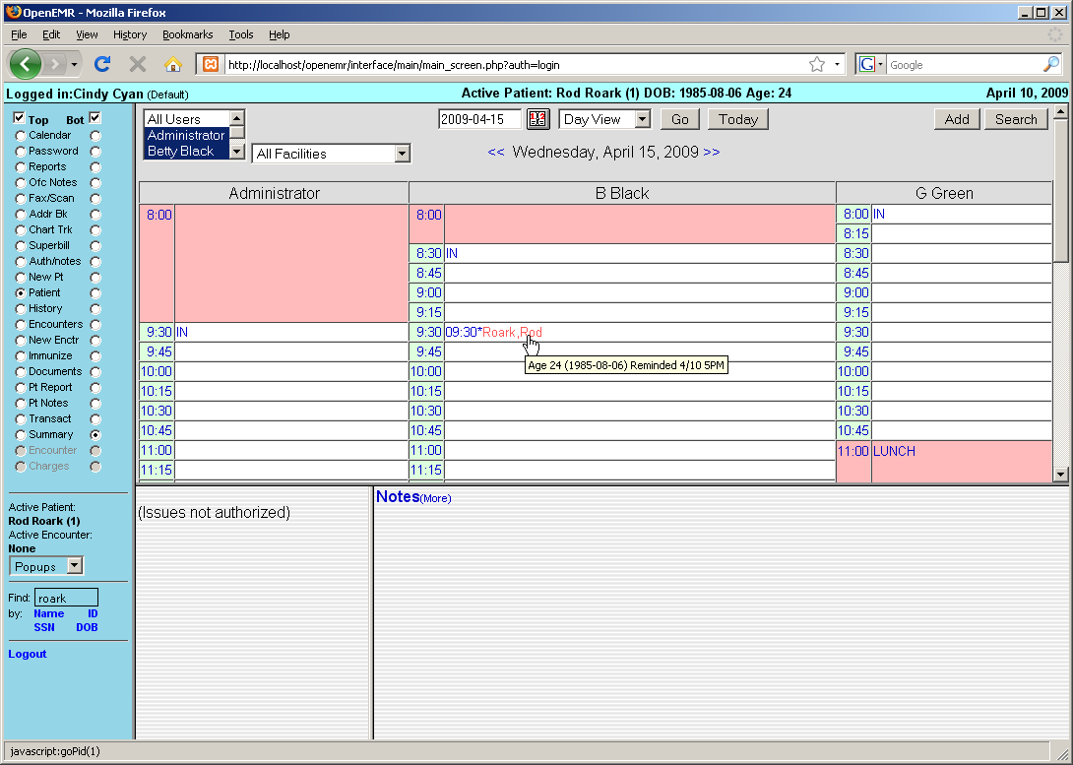

Mousing over the appointment in the calendar now shows the note that was added to it, and the symbol next to the appointment time has changed to indicate it's new status.
Encounters & Coding

Patient encounters are handled primarily by a clinics providers.

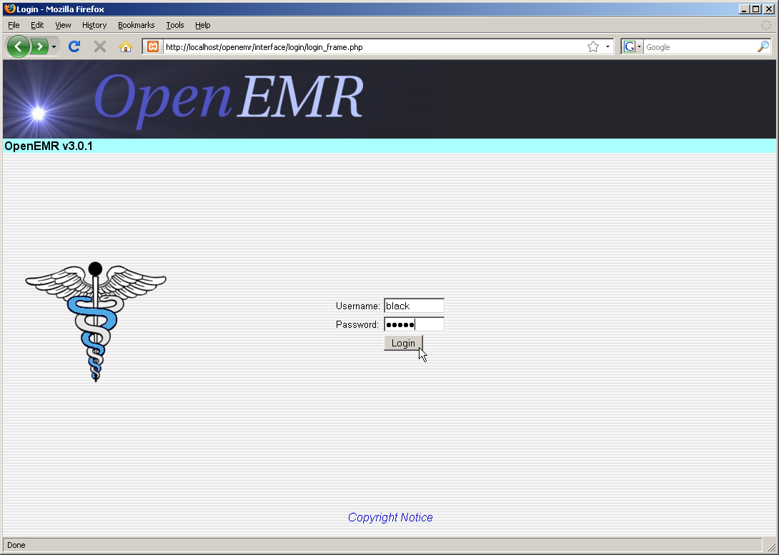

Logging in as a provider presents you with the Calendar page showing only that provider's schedule by default. To view another provider's schedule, select the desired user from the list at the top left of the page and click 'Go'.

The bottom window also shows any notes left for that provider about their patients.

The Calendar shows the appointments scheduled for that day. Providers can see the status of any given appointment, indicated by the symbol show between the appointment time and the patient's name. The “@” symbol, for example, indicates that the patient has arrived at the clinic and is ready to begin their appointment.

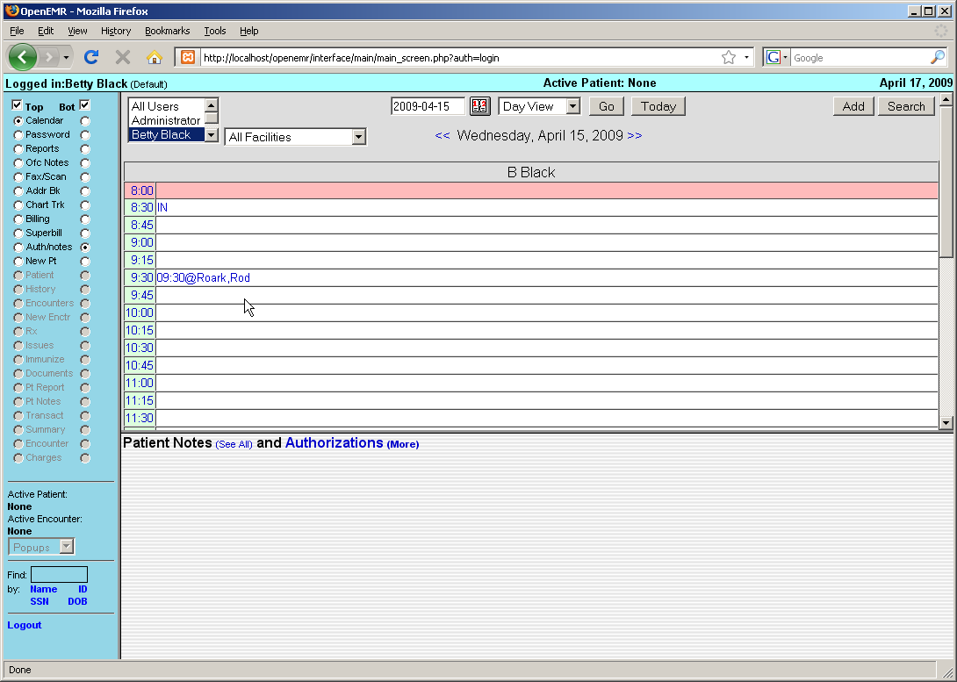

Opening a New Encounter

To begin the encounter, click on the patients name in the Appointment Calendar. This brings you to the patient's Demographics page, as well as the Patient Summary page which list any notes specific to that patient, and any medical issues, medications, etc. for that patient.

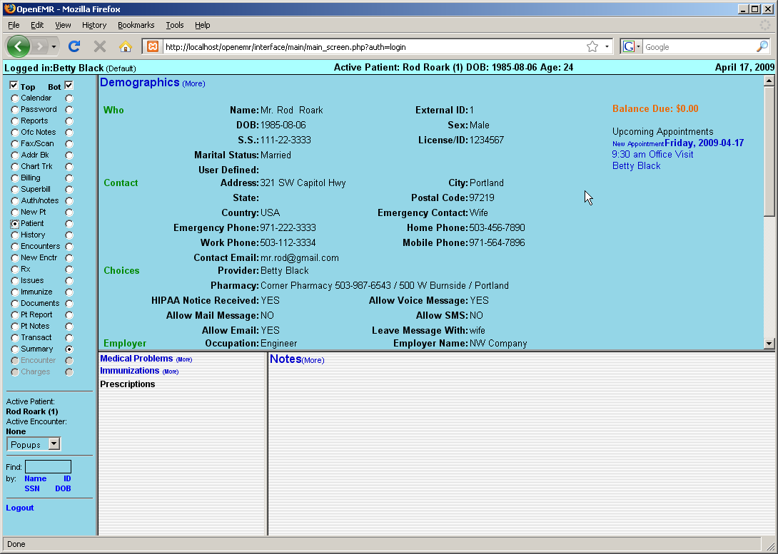

Select 'History' from navigation menu to view a summary of the patients Medical History and Lifestyle information. Click 'Patient History / Lifestyle (more)' to enter any information that may be incomplete.
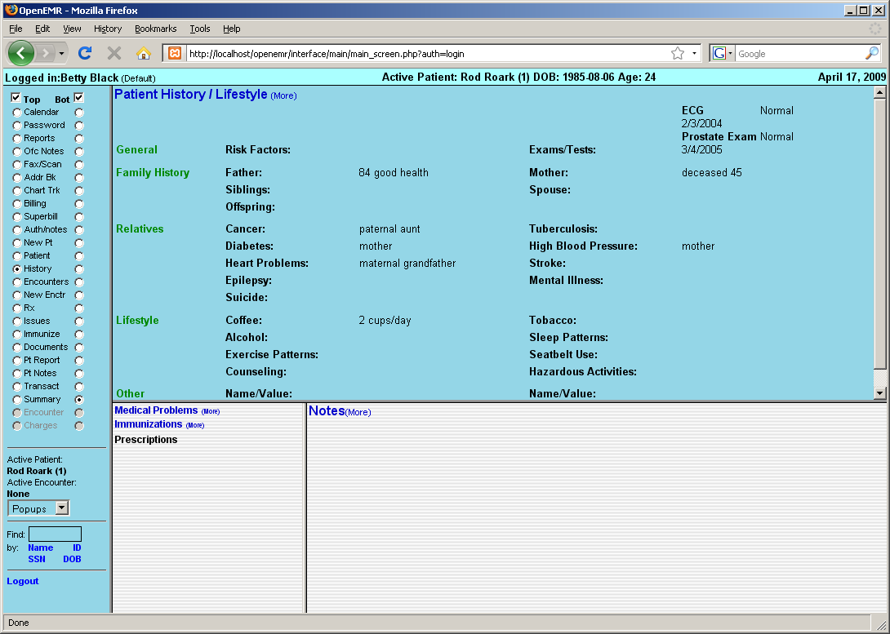

When you're done, select 'Encounters' from the navigation menu on the left. This displays a list of all encounters that have been entered for this patient. For new patients, there may be no encounters listed.

By default, OpenEMR is set to generate an empty Encounter when a patient's status has been set to “Arrived (@)”. To open this encounter and begin entering data, click on the new entry in the Encounters list, then click on 'Patient Encounter' next to the provider's name.

If your clinic's version of OpenEMR is configured differently, you can begin a New Encounter manually by selecting 'New Enctr' from the navigation list on the left.

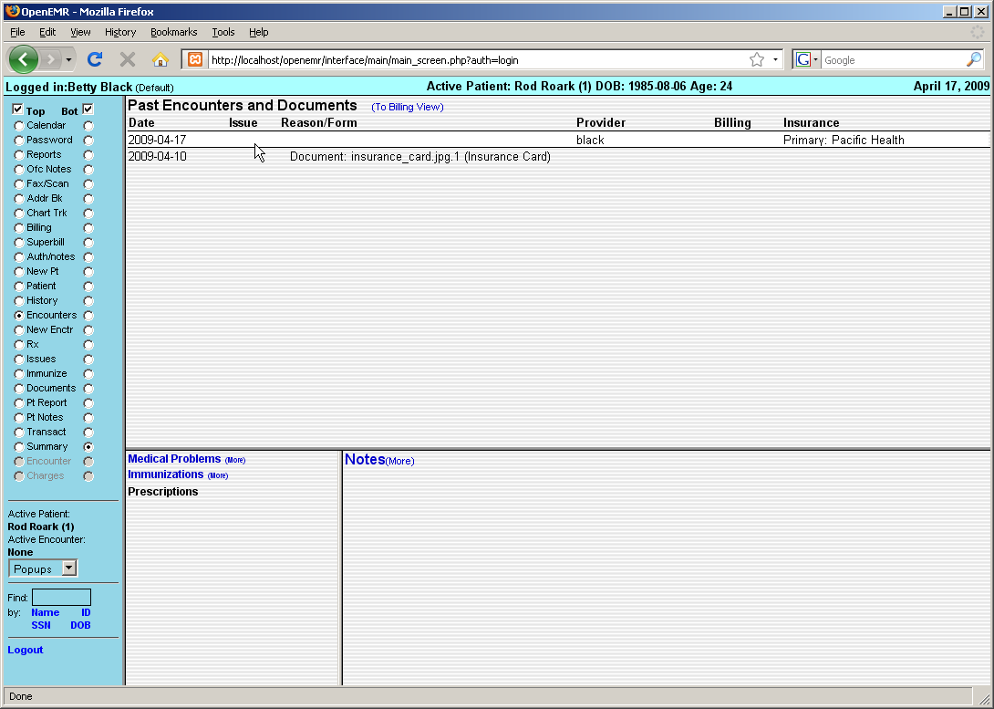

Both methods will bring you to the New Encounter Form.

Here you can enter a brief description of the encounter and the date of service. Encounters for new patients will not have any Issues or Diagnoses associated with them at this time, so click 'Save' to continue with the encounter.

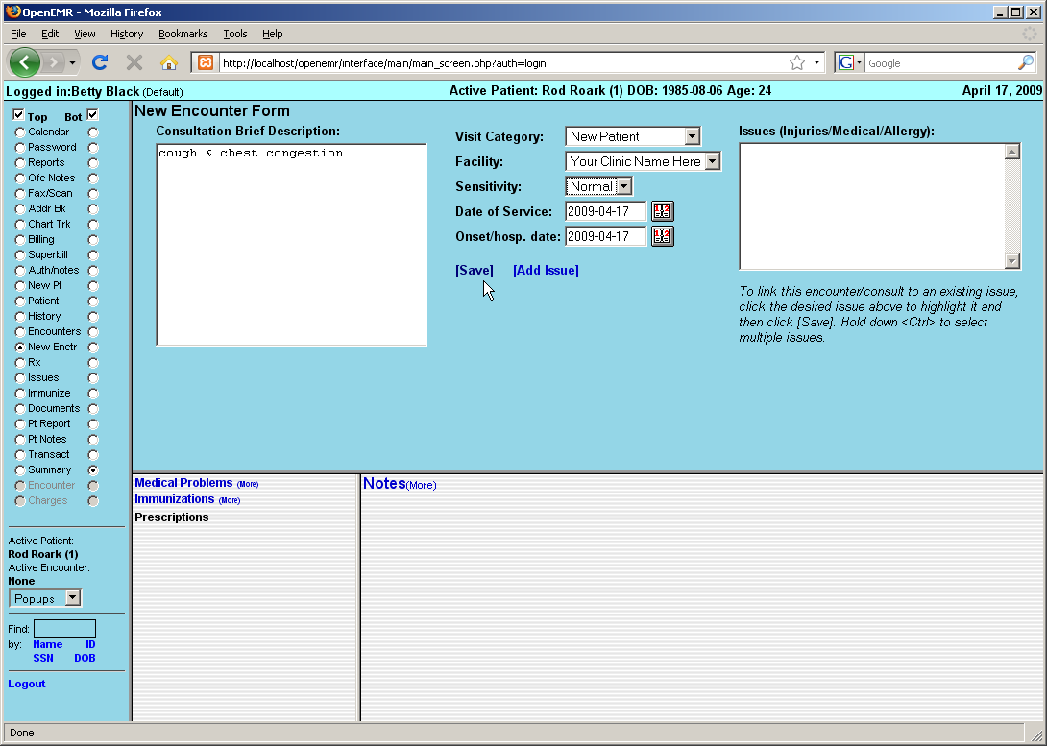

Encounter Forms

This will bring you back to the summary page for This Encounter. Displayed is a list of all the forms associated with this encounter. You may click on the name of any of these forms to edit its contents.

To the right is a drop-down list of forms that can be added to the encounter. OpenEMR comes configured with several common encounter forms by default, but your clinic may have their own customized encounter forms as well.

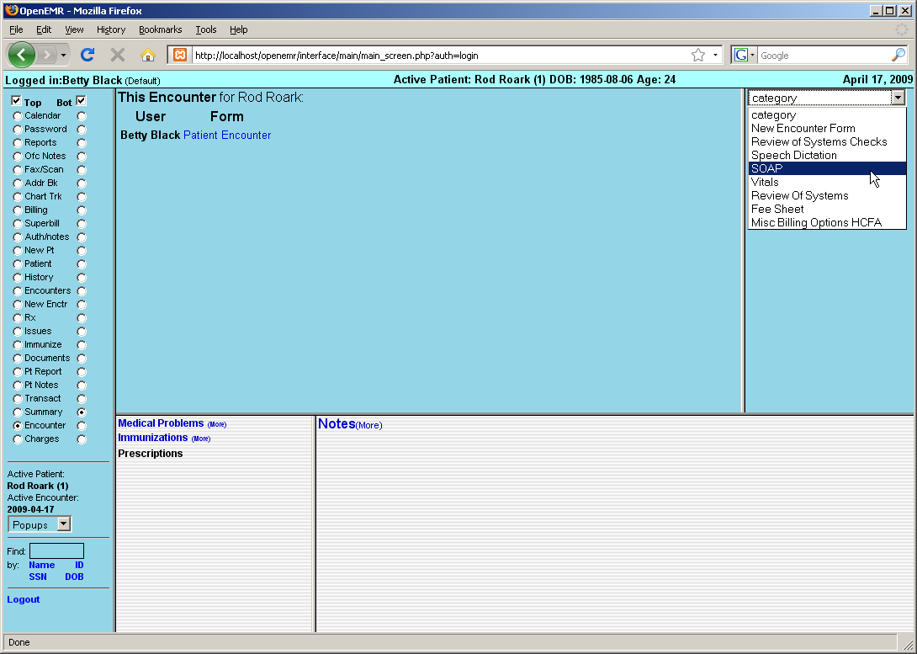

Select 'SOAP' from the drop-down list to add it to the encounter.

The SOAP form will contain a subjective & objective record of the patient’s vital information, as well as any notes on the assessment of the patient's health and suggested treatment plans.
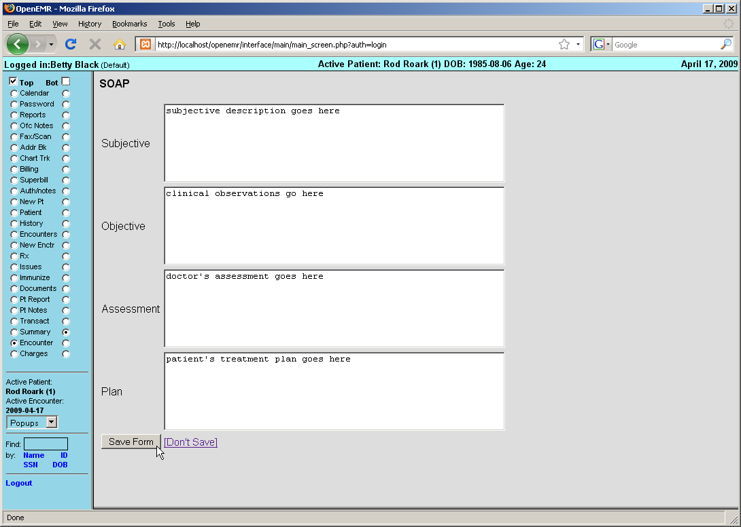

Enter the appropriate information and click 'Save Form' to return to the Encounter summary page.

You'll see that the SOAP form has been added to the list of forms for this encounter. Also shown is a summary of its contents.
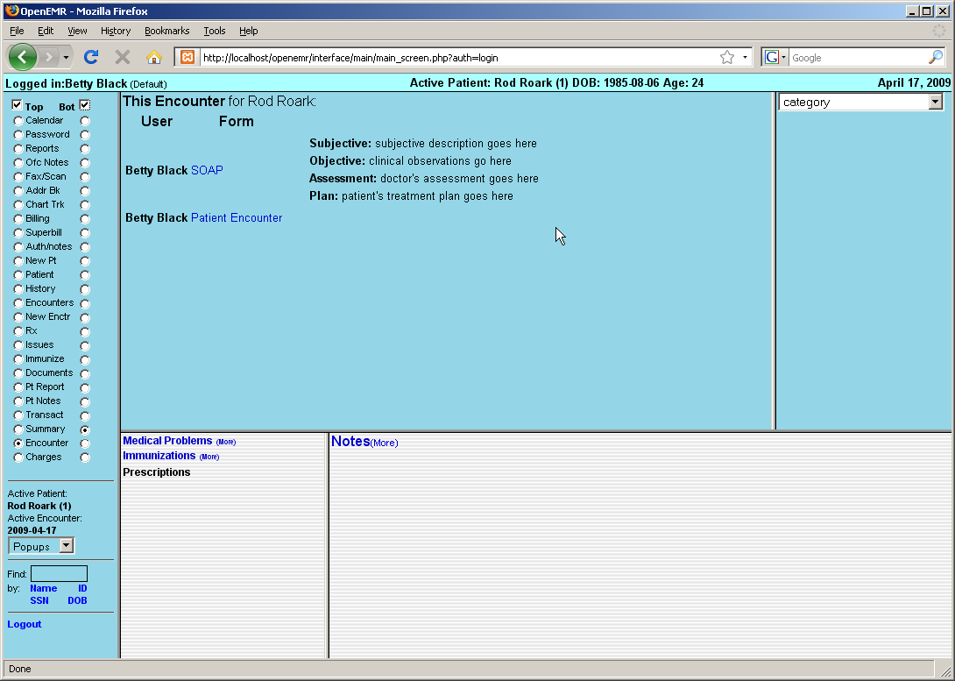

Using the Fee Sheet

Next select the 'Fee Sheet' from the drop-down list. The Fee Sheet is different from most other forms in that it enters and modifies billing information that is stored elsewhere in the system; it is not really an encounter form, and when used it will not appear in the encounter's list of forms.

You can select 'Charges' from the navigation menu on the left to see where information from the Fee Sheet will be displayed.
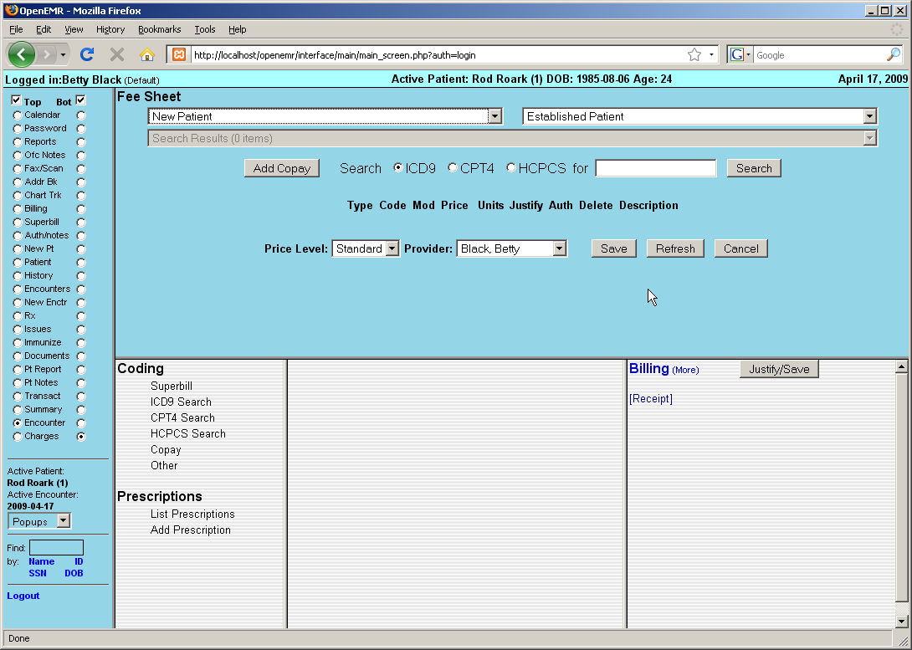

The Fee Sheet includes several drop-down lists of the most commonly used billing codes. It can and should be customized so that it's most suitably adapted to your practice;

Included is a search feature, where you can search for and select from the thousands of billing codes in the database. And below that is a list of all the billing codes, along with their charges and other related information, that have been selected for this encounter.

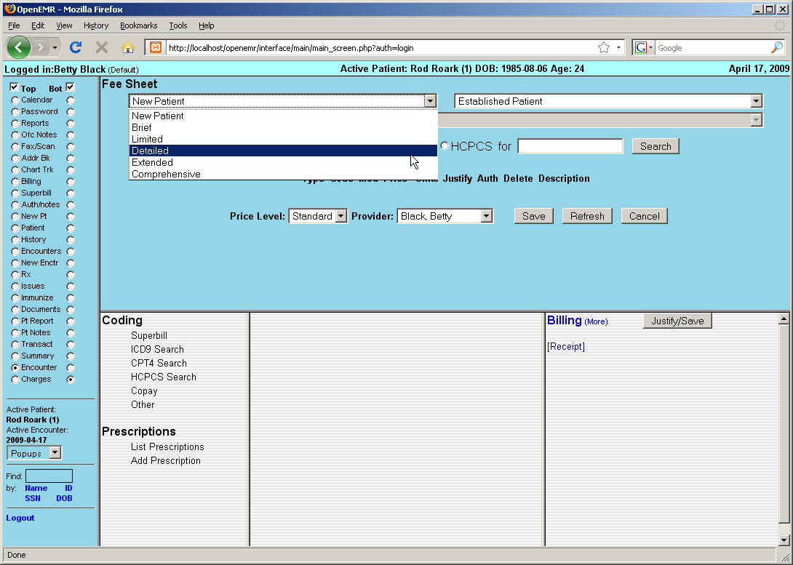

For example, select 'Detailed' from the “New Patient” drop-down list. The associated CPT code now appears on the list.

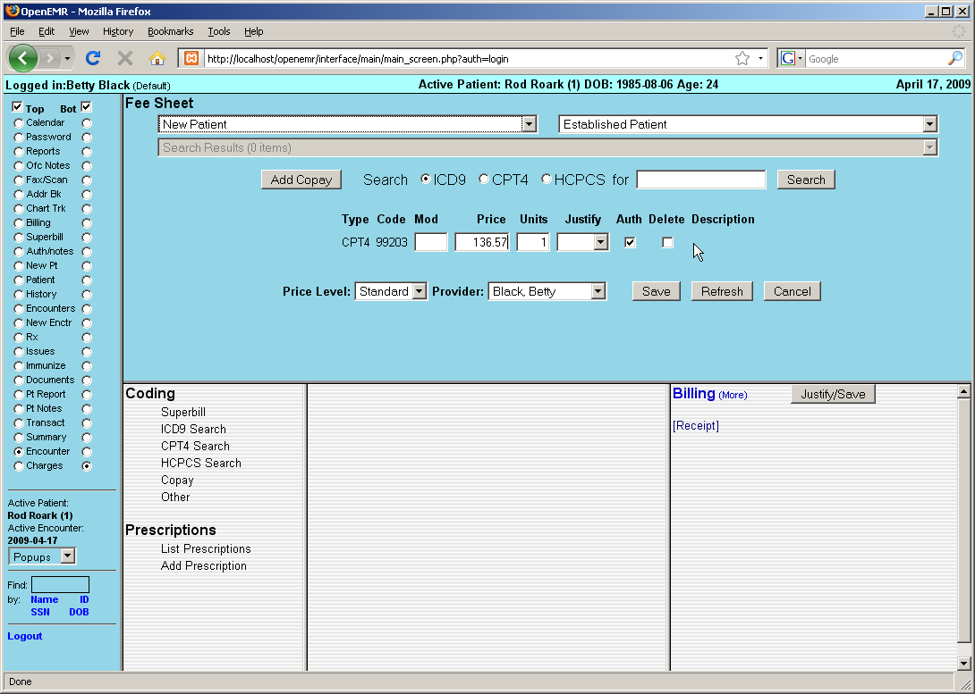

Look for an appropriate billing code by entering a search term in the box to the left of the 'Search' button. Make sure the correct code type is selected and click 'Search'.

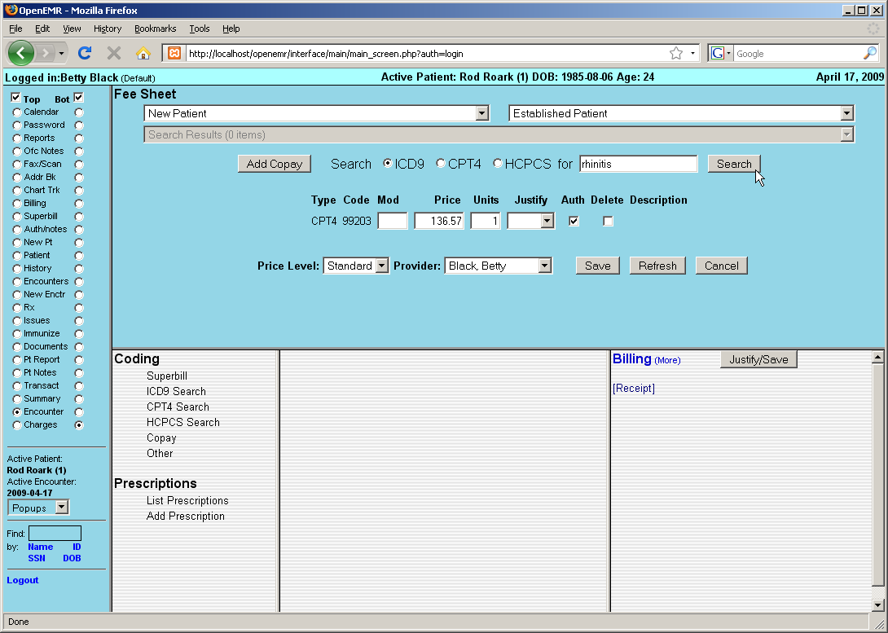

A drop-down list will then be populated with any billing codes that match your search parameters. Selecting the desired code from the list will add it to the list of codes for this encounter.
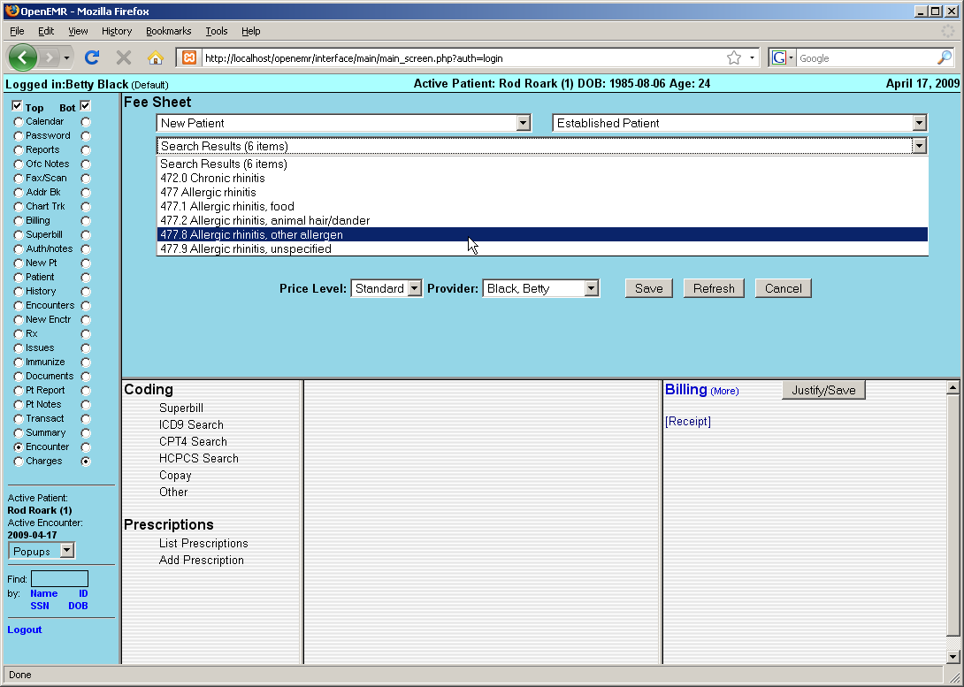

The Fee Sheet also allows you to justify the selected codes for billing purposes. Justification is the association of ICD9 codes with procedure codes. Insurance companies require this for billing, in order to "justify" paying for procedures.

To do this, click the drop-down menu under 'Justify' for the desired CPT code. Select the appropriate ICD9 code from the list and click 'Save'.
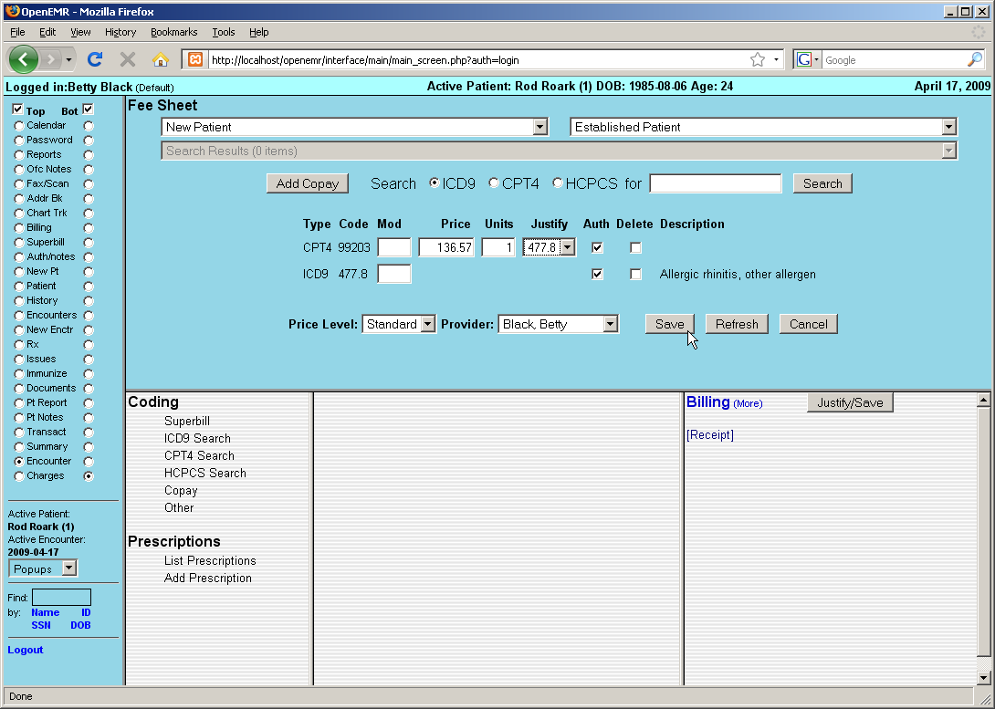

To see the Feet Sheet has been associated with this encounter, click 'Encounters' in the navigation menu to go to the list of encounters for this patient. You can see that the CPT & ICD9 codes are listed next to the new encounter, as well as the SOAP form that was added earlier.
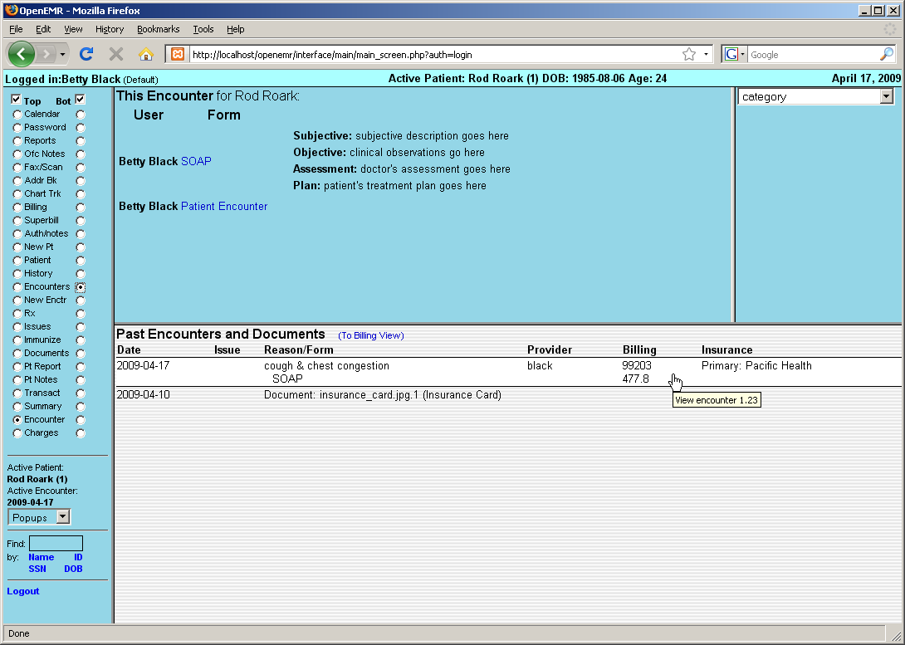

Return to the Charges page to see a more detailed view of billing codes for this encounter. If you did not justify these codes in the previous step, you can do so now by selecting the checkboxes next to the codes you wish to associate and click 'Justify/Save'. This will also refresh the display in the Billing window.
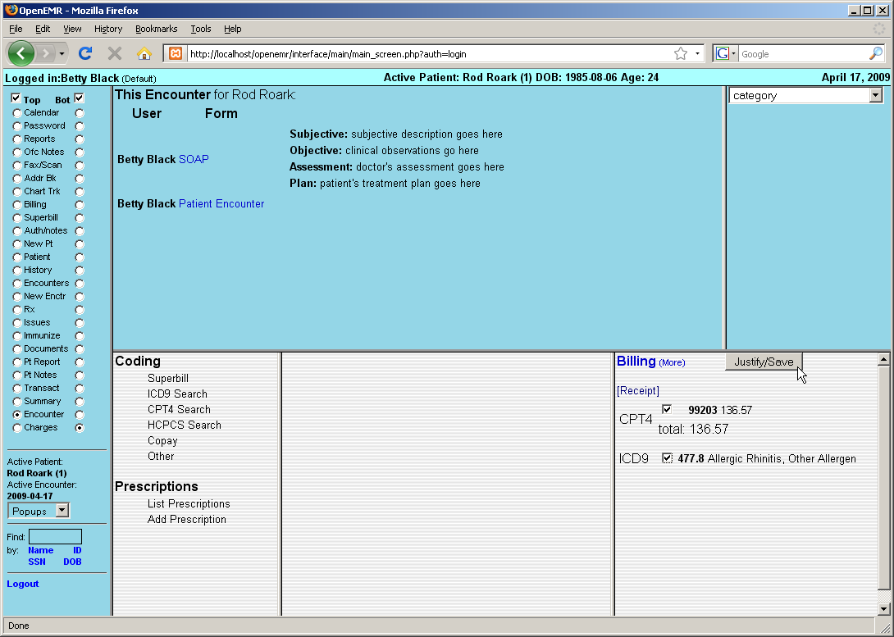

You can see that the ICD9 code has now been associated with the appropriate CPT procedure, as indicated by the code in parentheses to the right.

Adding Prescriptions

To prescribe medication for this patient, click 'Add Prescription' on the left of the Charges page.
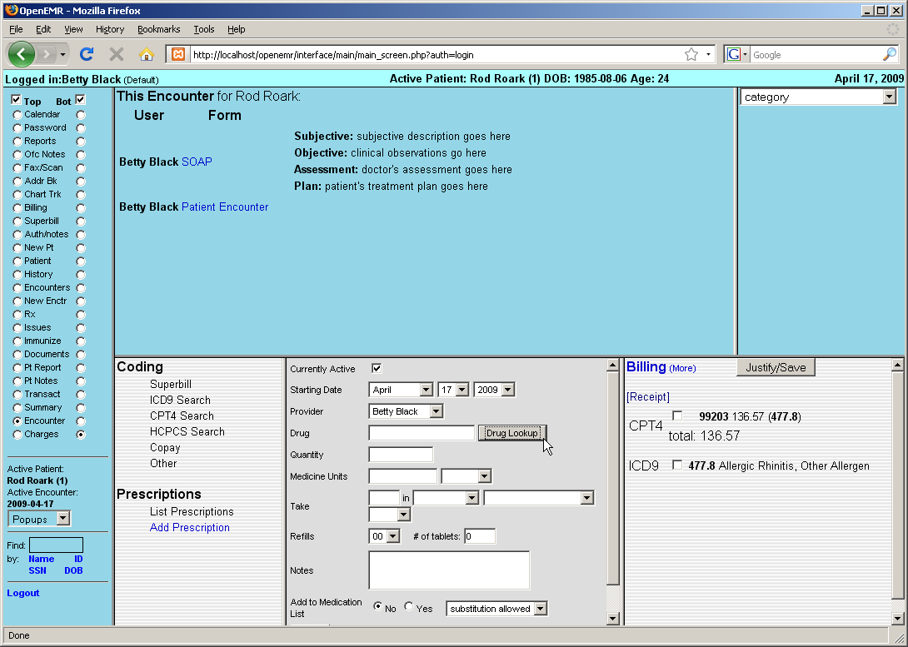

This presents you with a form for entering prescription data, including dosage, refills, and whether or not generic over-the-counter substitutions are allowed for this patient.

The Prescription form includes a search function for looking up a particular type of medication. To use this function click 'Drug Lookup'. A box will pop up into which a search term may be entered.

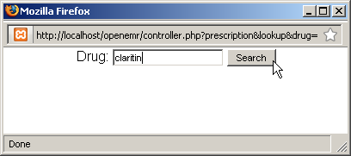

Clicking 'Search' displays a drop-down list of possible medications generated by connecting to the web site www.rxlist.com.
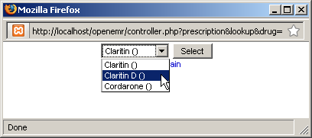

Select the desired medication to return to the Prescription form. The selected medication has now been filled in for you. Also, clicking 'Yes' next to “Add to Medication List” will allow the prescription to be included in the Issues list as a Medication.

Enter the correct data to complete the form and click 'Save'.

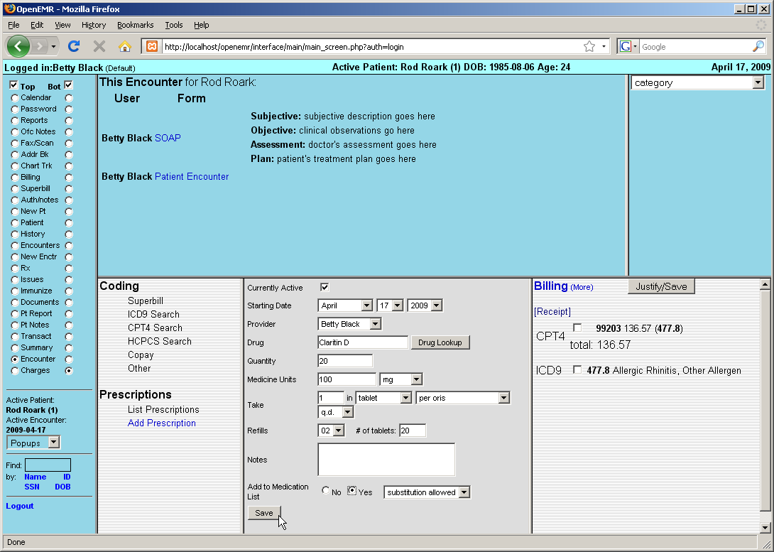

You are then presented with a form for generating a PDF of the prescription information. It may be printed or sent by email or fax. "Auto Send" will use whichever default method was selected when you set up the pharmacy.
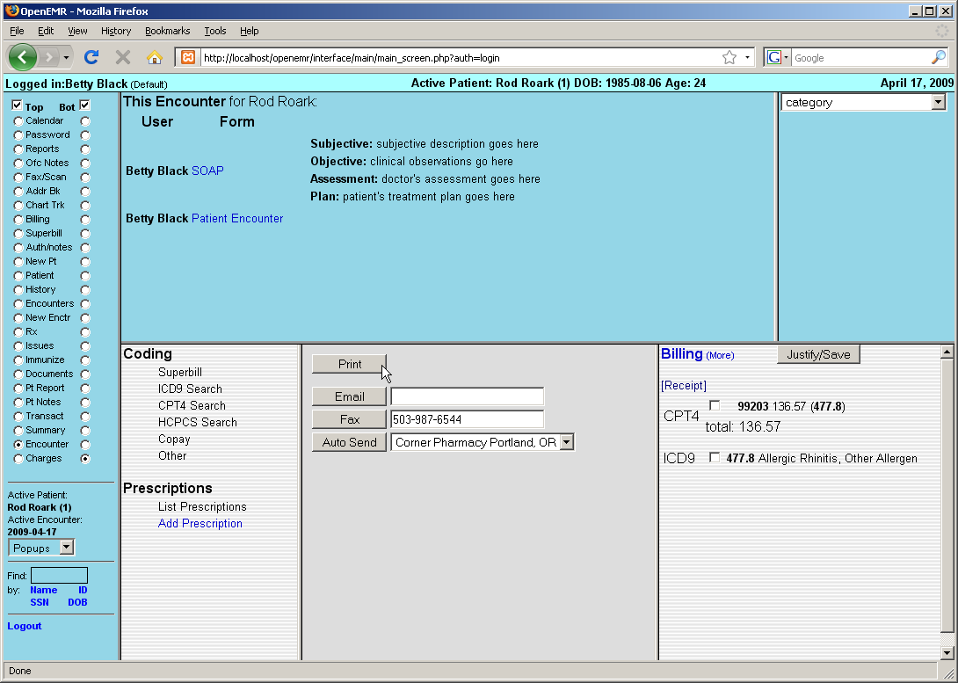

Clicking 'Print' will generates the following PDF document to be saved or printed as necessary. The default template for this form may also be customized to your clinic's own specifications.
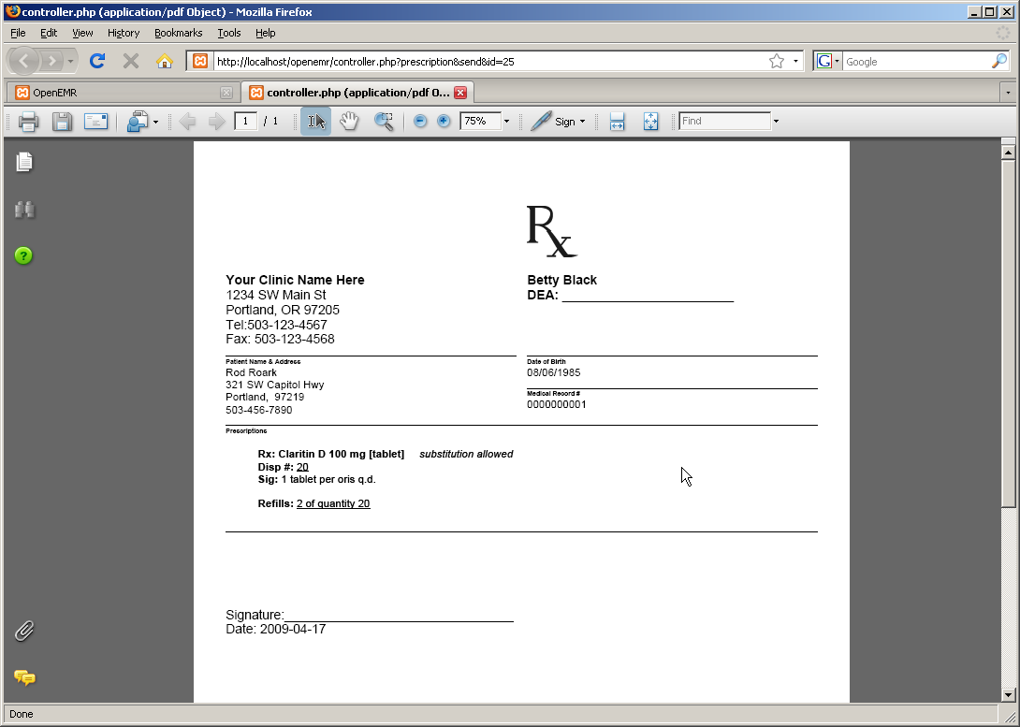

Issues & Immunizations

Adding Issues

An "issue" is a medical problem, allergy, medication, surgery or dental issue. These issues are related in that they can all be associated with multiple encounters.

This is especially useful with medical problems, where the user may want to quickly determine which encounters treated a particular problem, or which problems were treated by a particular encounter.

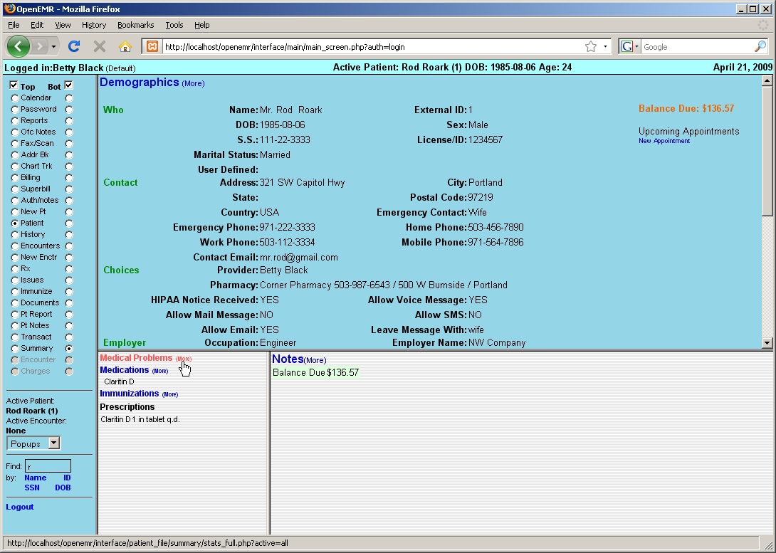

From the patient's Summary page, click 'Medical Problems (more)', or select 'Issues' from the navigation menu on the left to display the Issues list.

You can now see the prescription added earlier has been included in the Issues list as a Medication. Click 'Add Issue' to add a new medical issue you want to kept track of for this patient.
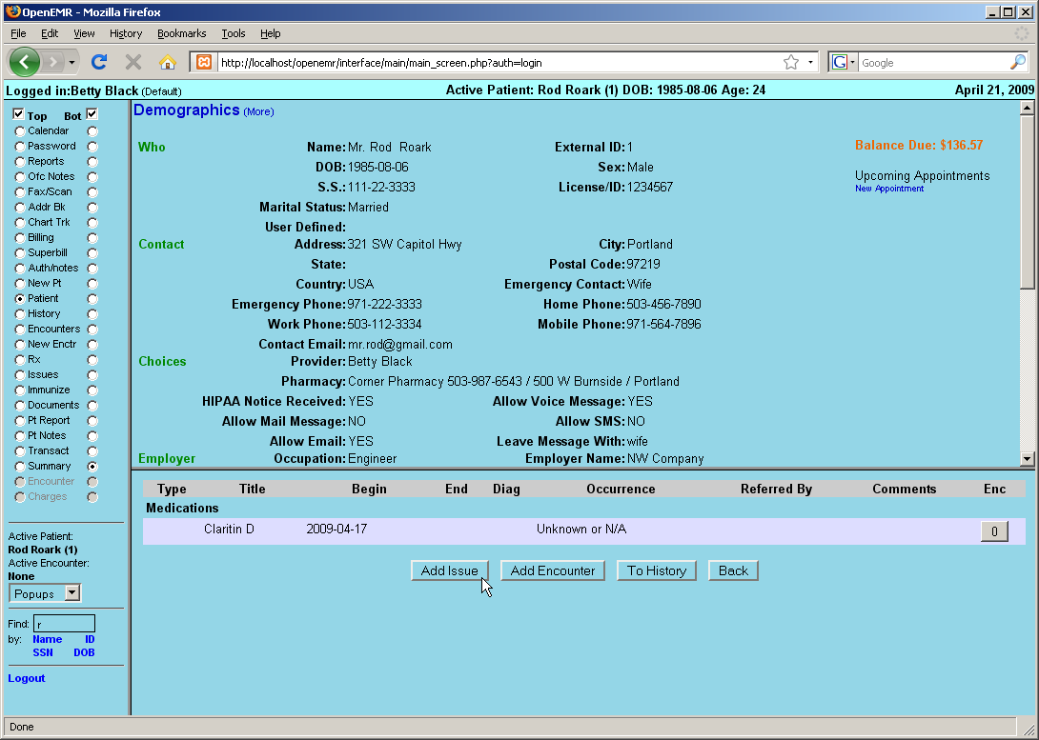

This pops up the 'Add Issue' dialog box.

The default issue type is set to 'Problem'. For each issue type there is a list of commonly selected titles which are customizable for your clinic's specific needs. If the desired title is not included, it can be typed into the text box below the list.

Enter the appropriate beginning and end dates, and select the 'Occurrence' from the drop-down list provided.
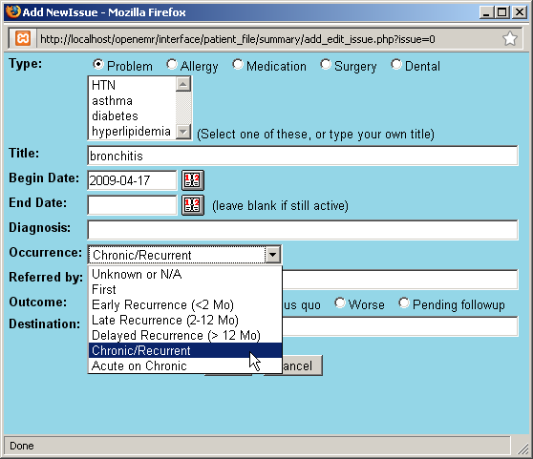

Clicking in the 'Diagnosis' field will present a search dialog for locating the correct ICD9 code for this issue. Enter the appropriate search term and click 'Search' to bring up a list of possible ICD9 codes. Selecting the desired code will close the search window and enter the selected code in the text field.
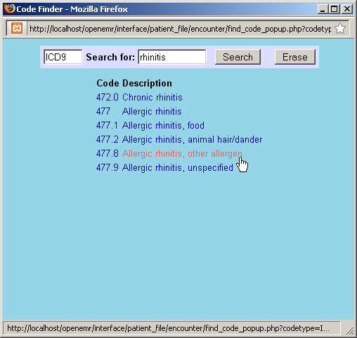

Complete the remainder of the form as necessary and click 'Save'.
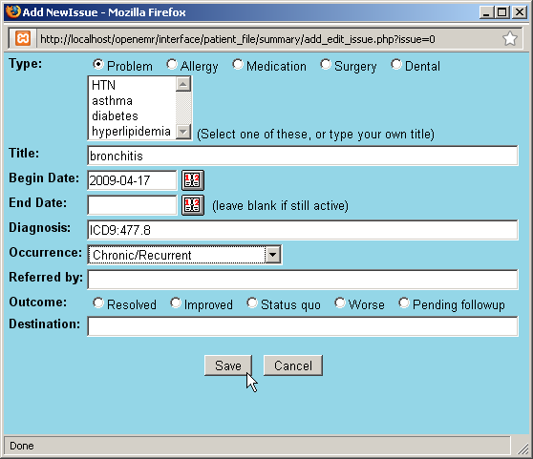

Additional issues are entered in the same manner; clicking 'Add Issue' and selecting the appropriate type, such as 'Allergy'. Notice that the 'Add New Issue' dialog also uses the OpenEMR date selection tool described earlier.
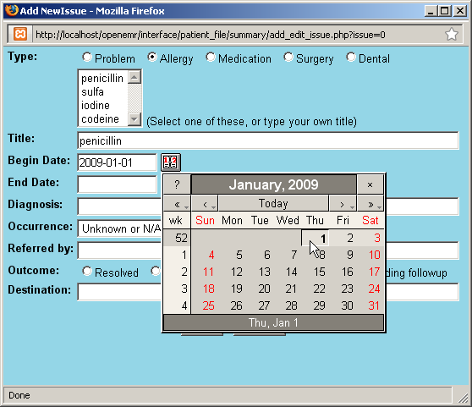

Once the new issues have been added successfully you should see an updated list of all the issues that have been entered for this patient. You may click on an issue in the list at any time to edit it.

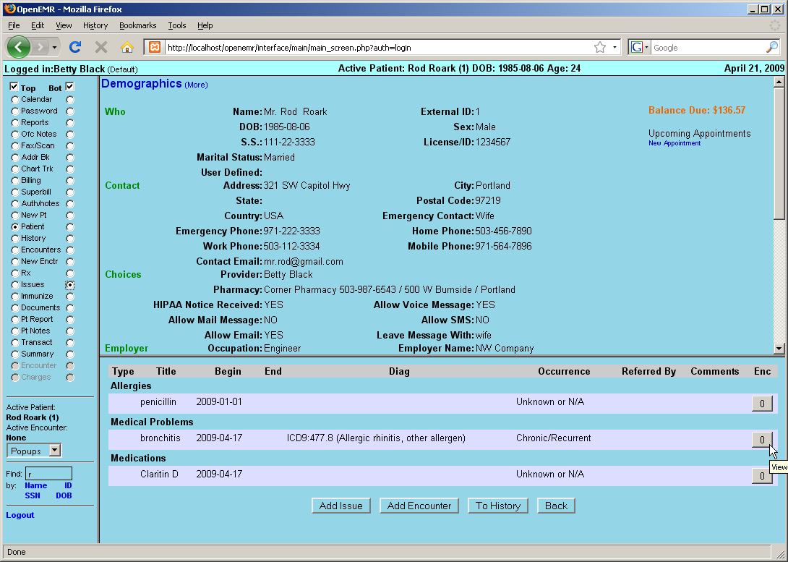

Associating Issues with Encounters

The far right column in the Issues list represents the number of encounters associated with a given issue. Click on the '0' next to a newly added issue to bring up the 'Issues & Encounters' dialog.

This dialog contains a list of all the issues and encounters associated with this patient. It is used to set (and view) the relationships between issues and encounters. Note that the issue that was just clicked on has been highlighted.
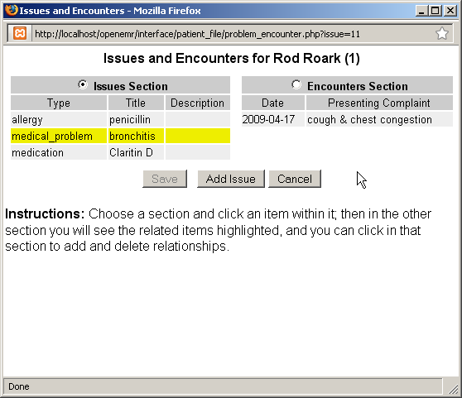

Select the appropriate encounter from the list on the right to highlight it. Clicking 'Save' now links the selected issue to the selected encounter.
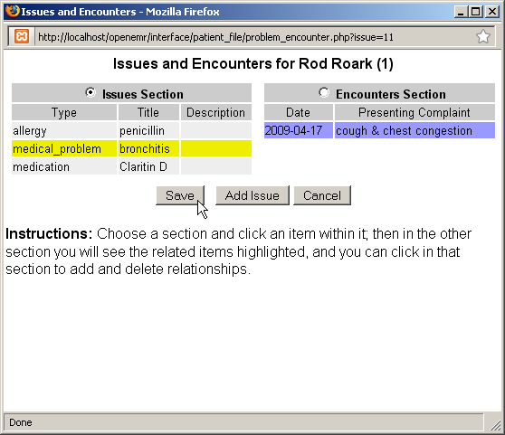

Continue associating issues with encounters as necessary. Refreshing the Issues list shows the current information for all issues.
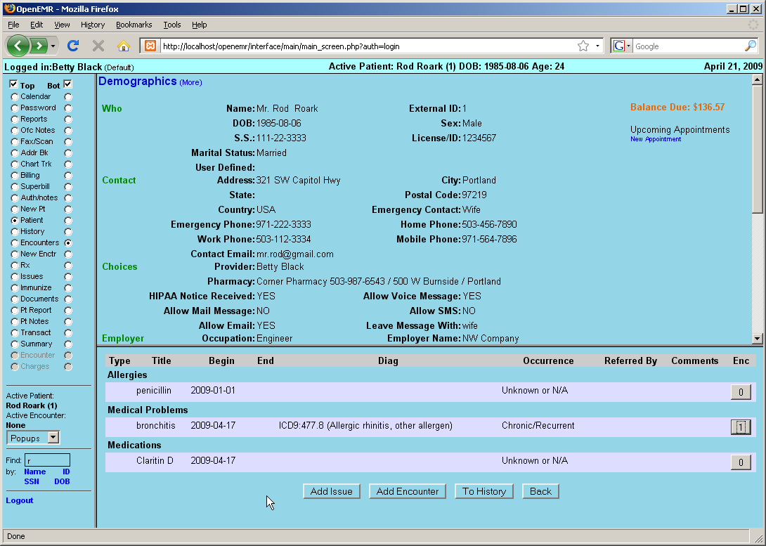

Immunizations

Click 'Summary' on the left to return to the Patient Summary page. Now click 'Immunizations (more)' to add an immunization for this patient.
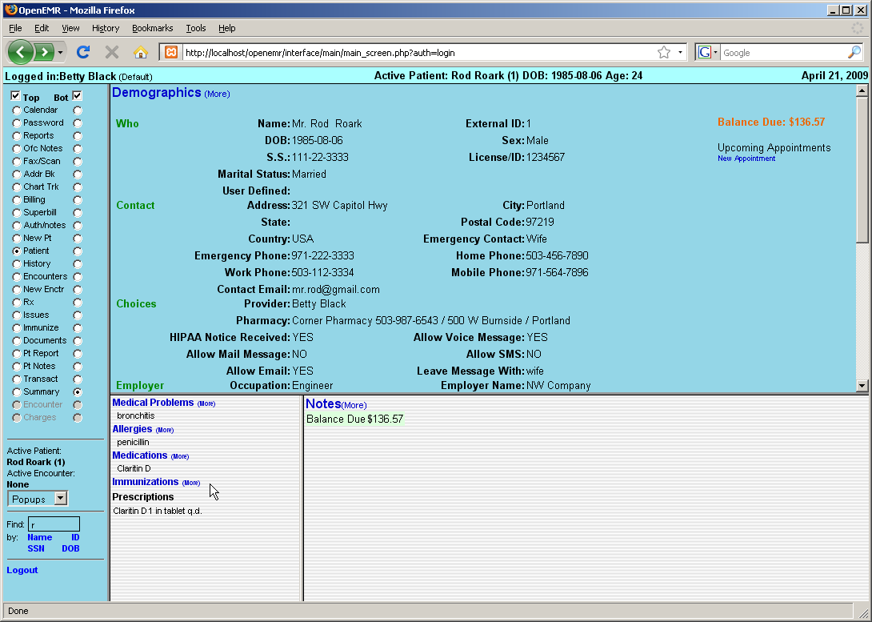

This page contains a form for entering information on the any immunizations the patient has received.

Select the type of immunization from the drop-down list provided, and enter any data you may have, including the date of the shot, and the name of the provider who administered it.
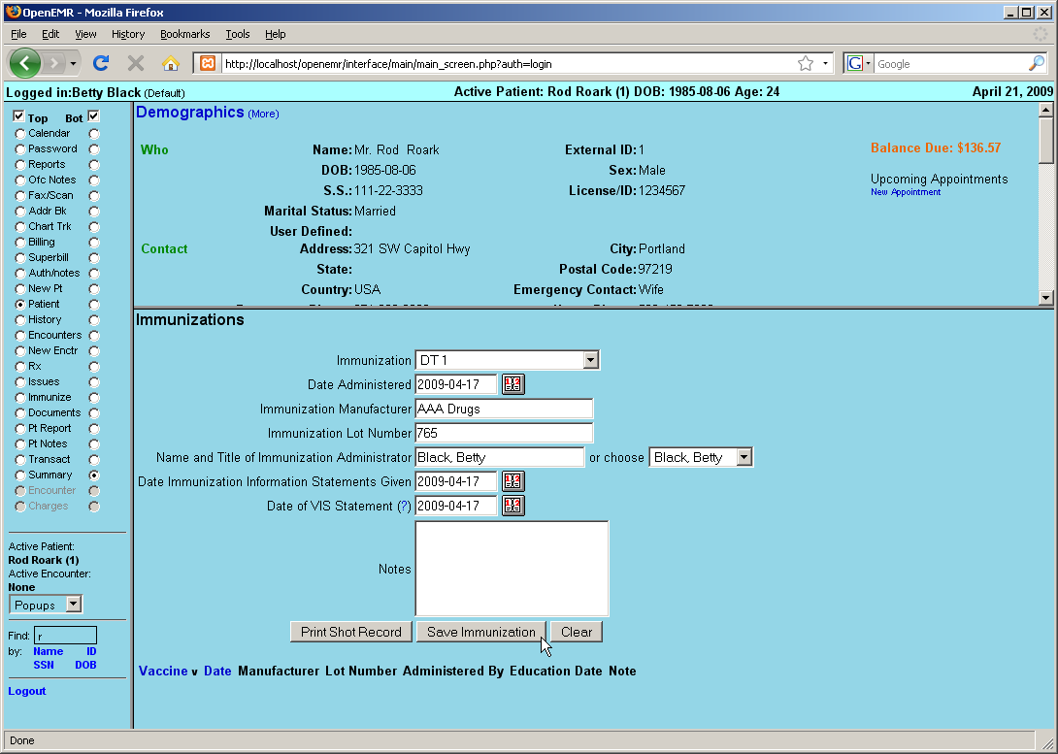

Click 'Save Immunization'. The newly added immunization now appears in the list at the bottom of the screen.
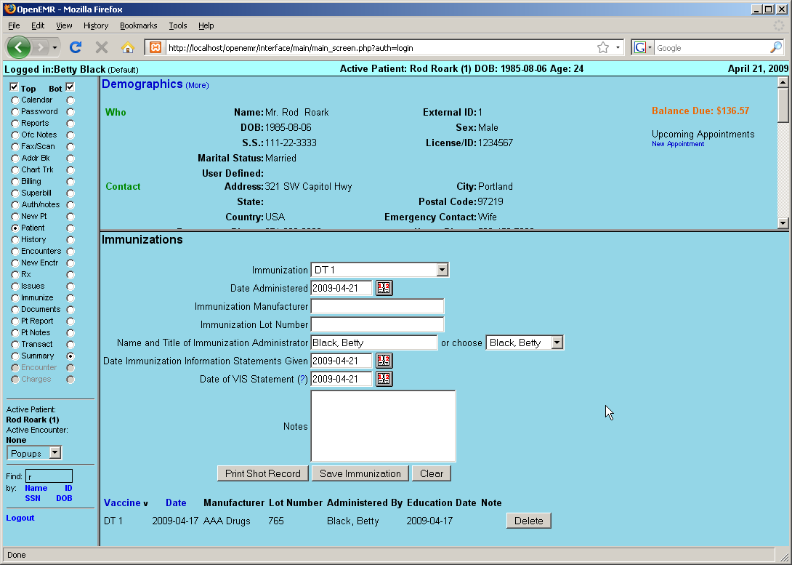

Return to the Summary page via the navigation menu on the left. Notice that the lower left portion of the patient summary now shows a brief list of all active issues, immunizations and prescriptions.
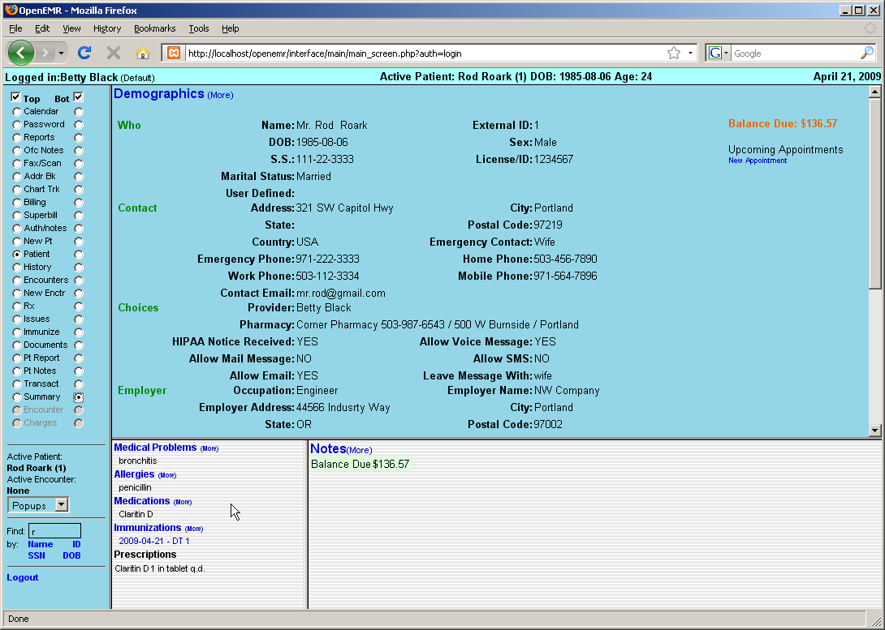
Patient Notes & Transactions

Patient notes store patient information that is unrelated to the patient's medical condition. Such information may include outstanding balances, changing insurance information or patient requests for actions by the clinic.

Transactions are somewhat similar, but record events that have already occurred. These may be referrals, requests from either the patient or the doctor, or legal transactions.

Patient Notes

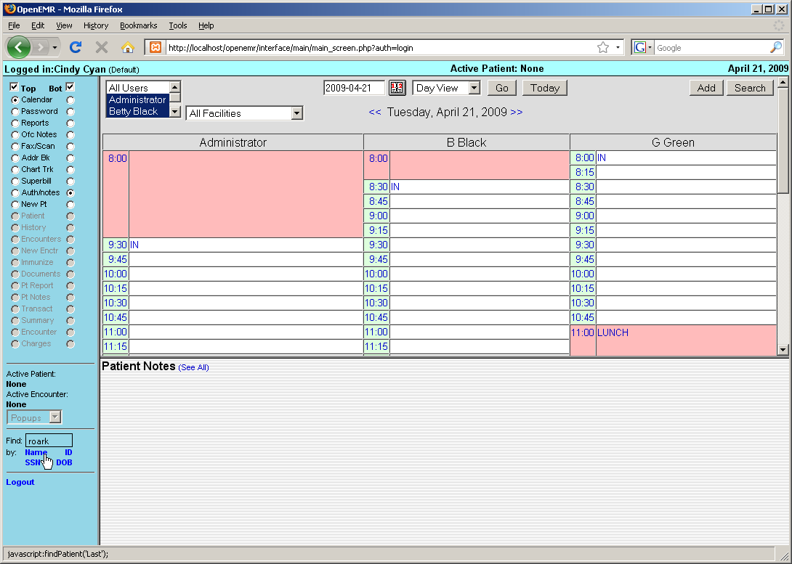

To begin, log in to OpenEMR, and use the search function in the lower left-hand corner to locate the patient for which you would like to add a note.

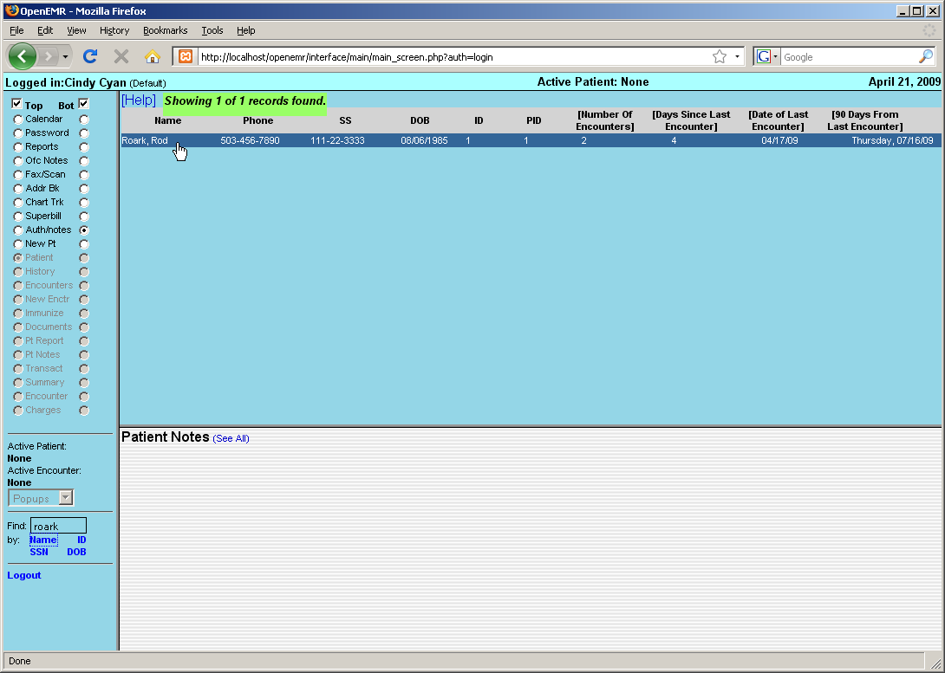

Click on the desired patient to bring up the 'Summary' page.
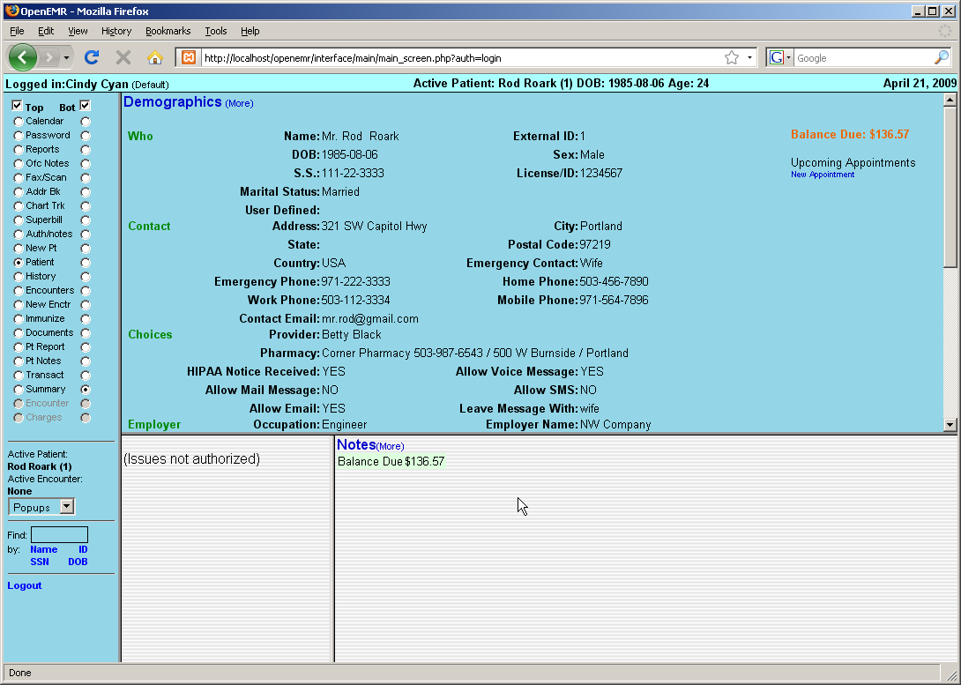

If the user is not Authorized they will be unable to see the patient's medical details such as issues, immunizations and prescriptions.

Click 'Notes (more)' to add a note for this patient.
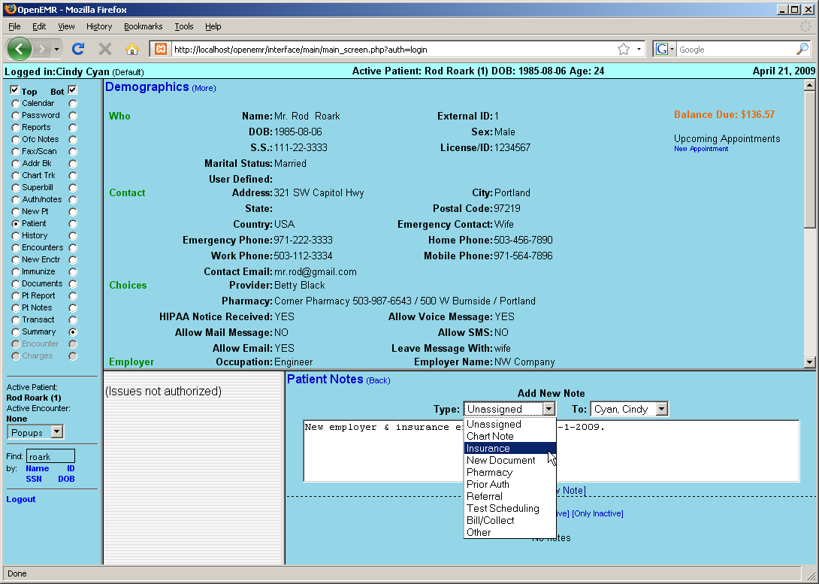

The 'Patient Notes' page will present you with a text box for entering the note, as well as drop-down lists for selecting the type of note, and the person to whom the note is addressed.

Type your note in the text box and click 'Add New Note'.
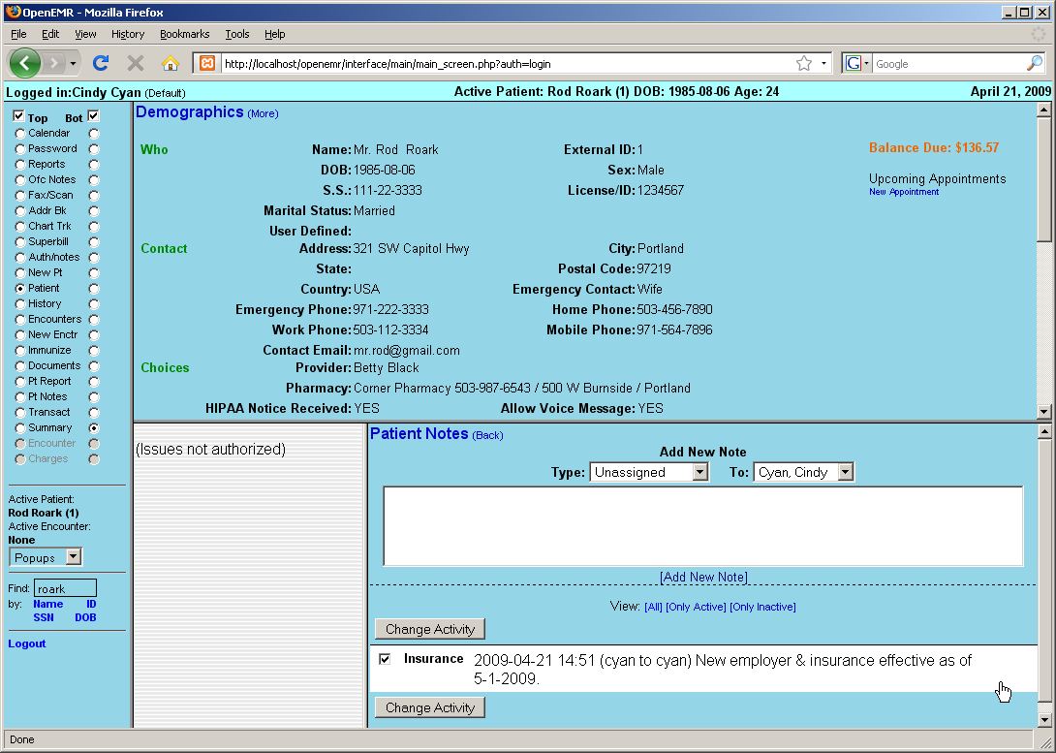

The new note now appears in the list of notes on the same screen. The checkbox is used to control whether the note is "active". Above are options to view only the active or inactive notes.

Click 'Patient Notes (back)' to return to the patient summary.
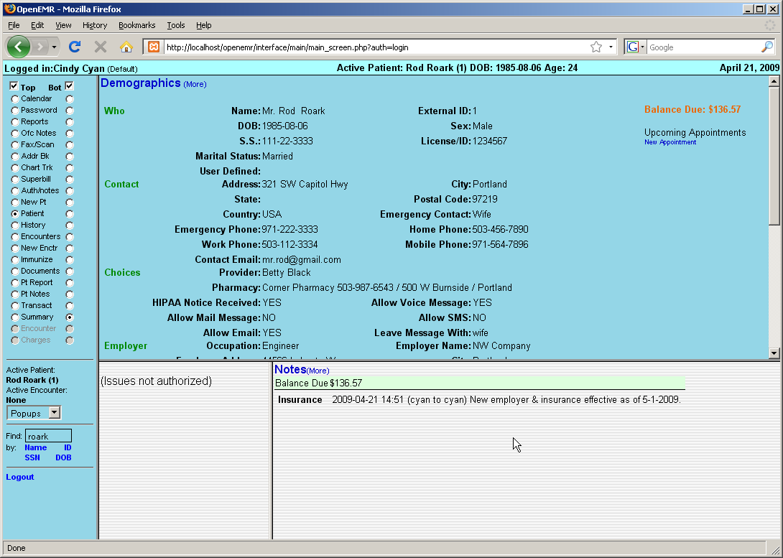

The new note is now listed on the Summary page.

Transactions

Click 'Transact' in the navigation menu to go to the Transactions page.

The Transactions page contains two basic form types. A simple form for internal transactions such as patient requests or billing transactions, and a Referral form.

Referrals

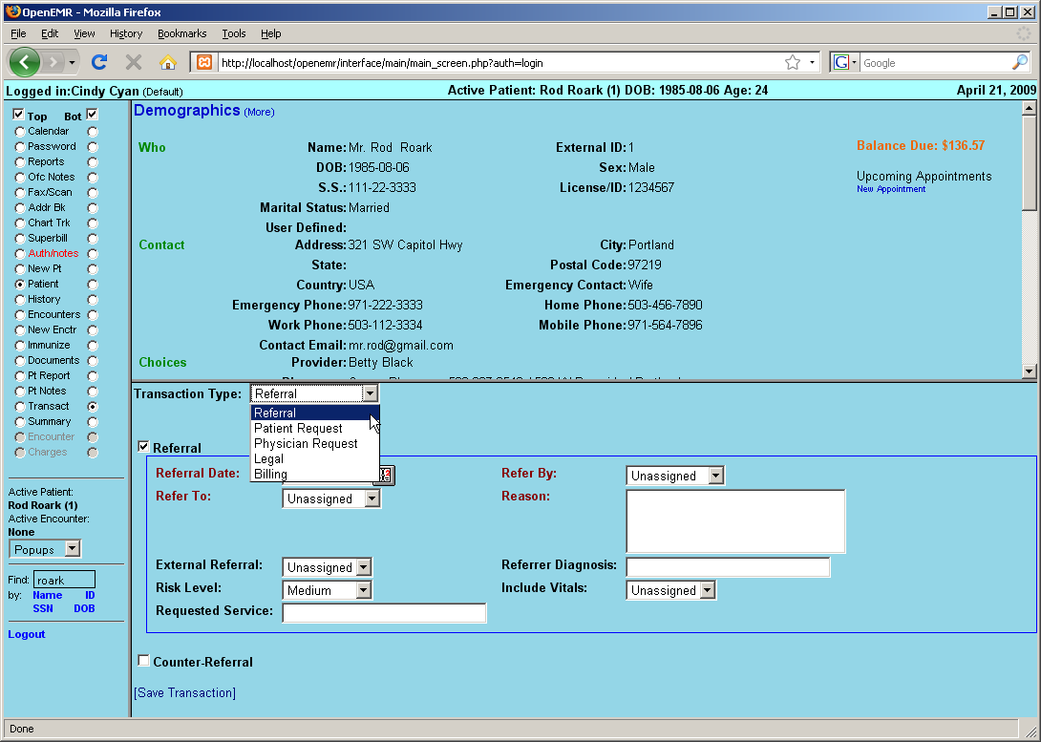

Select 'Referral' from the drop-down list to begin a new Referral transaction.

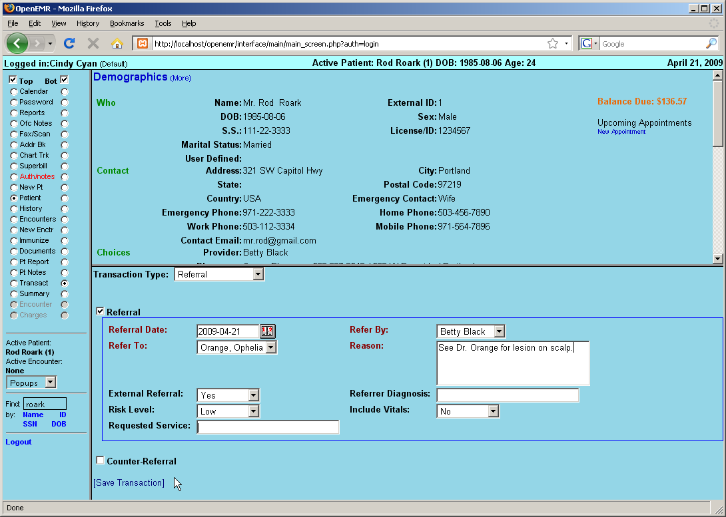

Another drop-down contains a list of physicians and clinics from the Address Book to which you can refer your patient. Select the referring physician, risk level, etc., and enter a reason for the referral.

Click 'Save Transaction'.
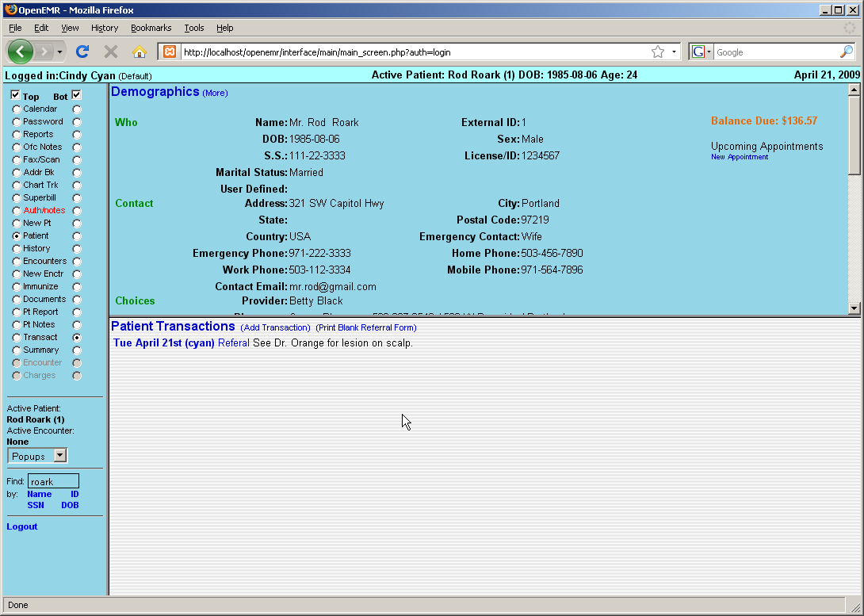

The referral is now in the Patient Transactions list.

Click 'Referral' next to the transaction to generate a printable version of the Referral form.
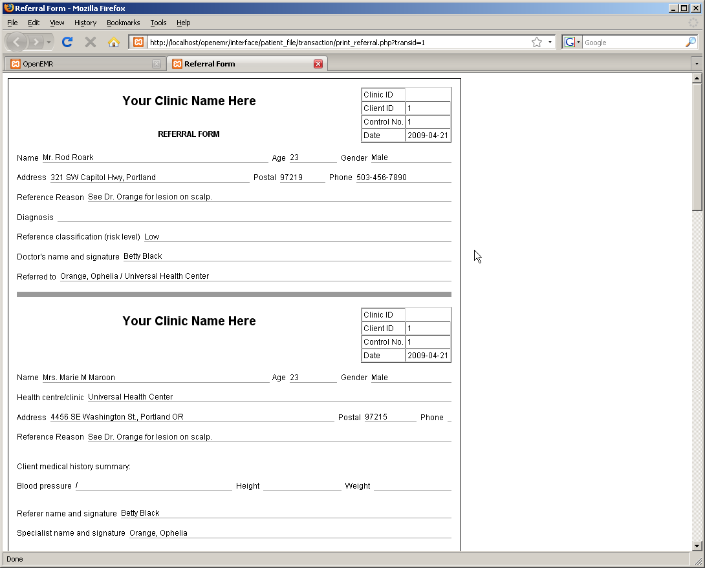

Depending on your system's configuration, you may be asked to save the file, or it may be printed automatically.

When you are finished return to the Transaction list and click 'Add Transaction'.

Basic Transactions

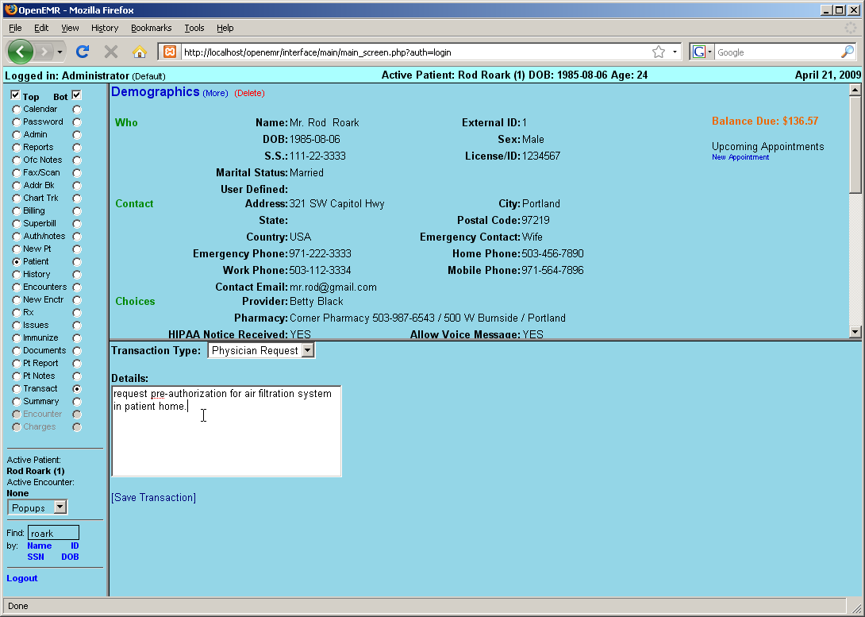

Other transaction types use the simple transaction form. Select the desired type from the list and enter the transaction details in the text box provided. Click 'Save Transaction' when finished.
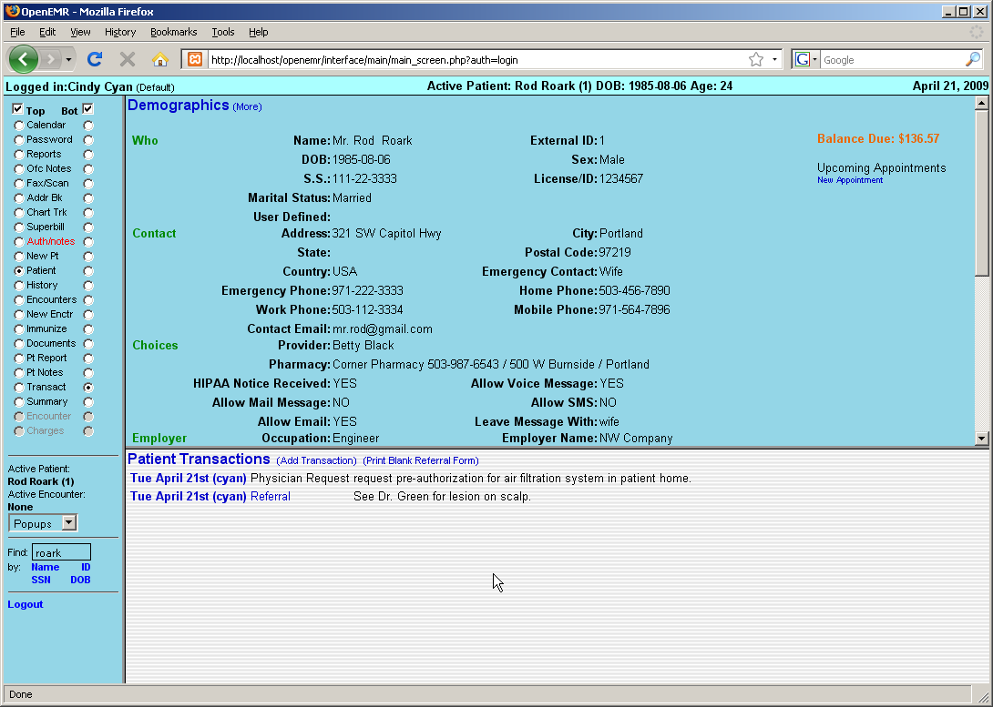

The new transaction has now been added to the list along with the referral. Click on the date of a transaction to edit its contents.
Basic Billing

Only the Administrator, authorized users, and those with Access Control designated as 'Accounting' in their user profile can access OpenEMR's Billing system.

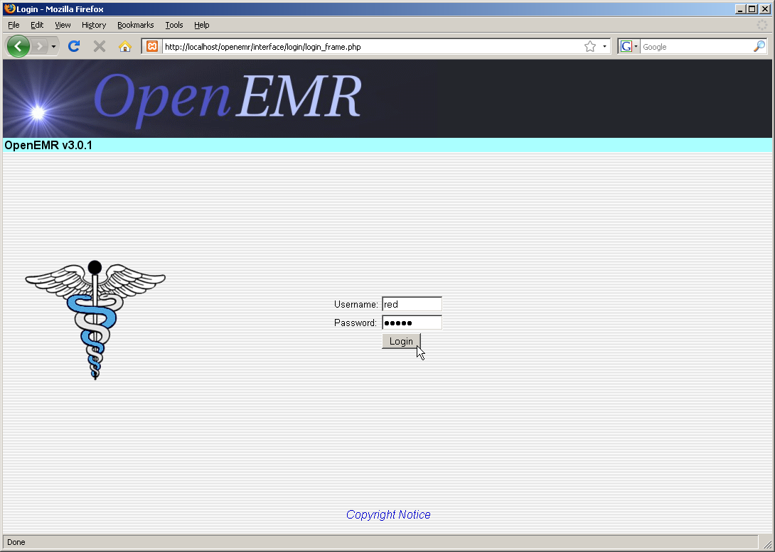

To begin, log in with your designated username and password.
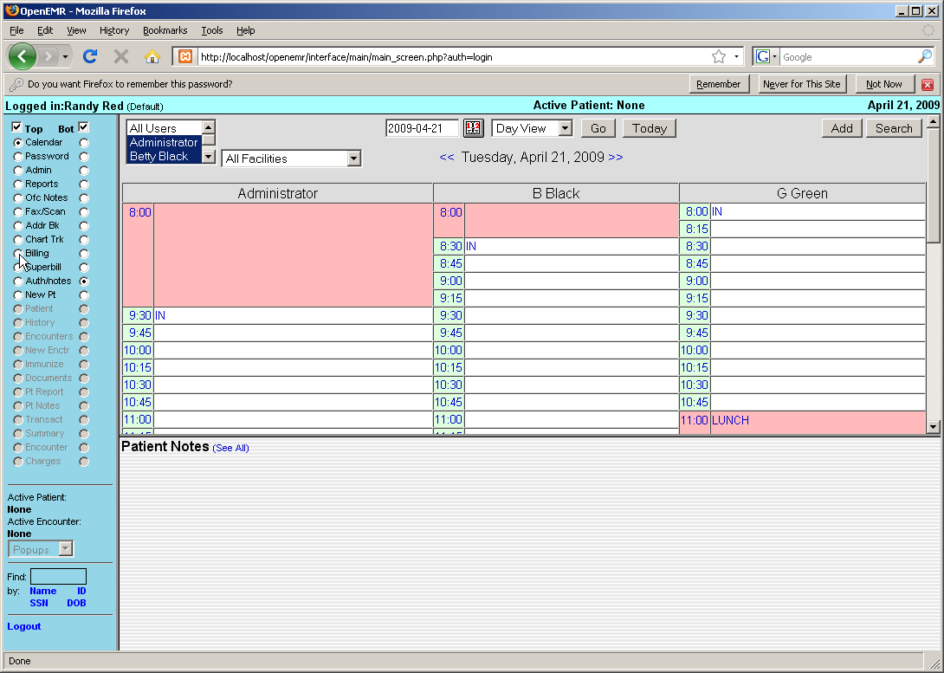

Select 'Billing' from the navigation menu on the left. This brings you to the main Billing screen. This will present you with options to generate a variety of printable and electronic claims and reports.

Billing Reports

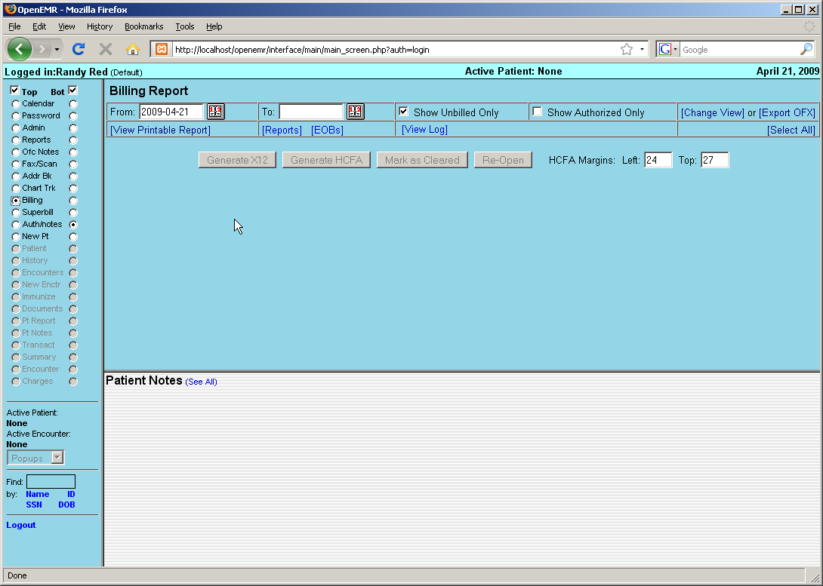

The Billing Report page will automatically display any billable encounters that were generated today. To view billables from a different time period enter the 'From' and 'To' dates using the date selection tool, and click 'Change View' in the top right corner of the screen.

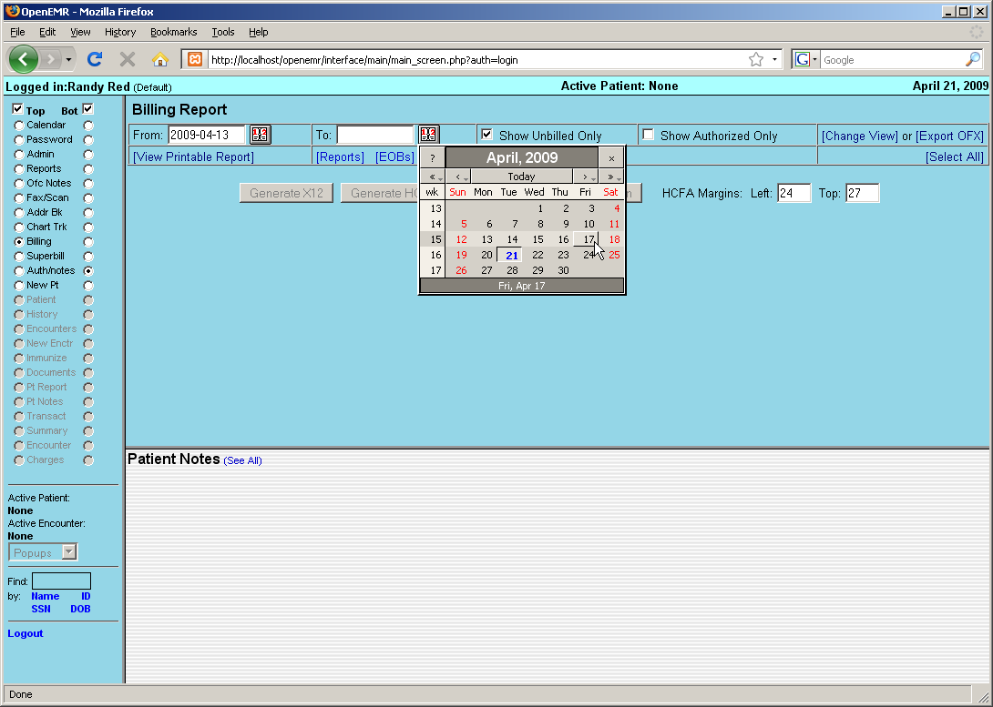

The list should now display all billables from the selected date range.
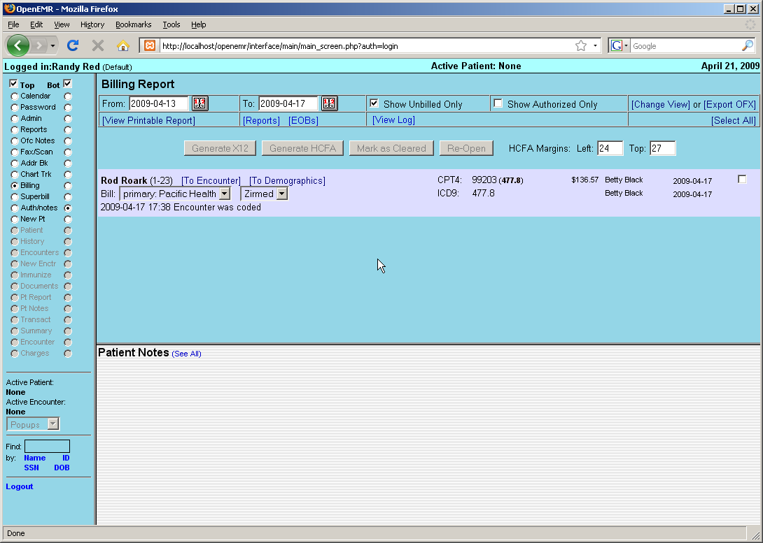

Generating Claims

Clicking the checkbox to the right of the desired encounter will enable a set of buttons for generating claims. Your system should be configured with the appropriate set of forms for the insurance companies and clearinghouses used by your clinic.

Click 'Generate X12' to create a claim file that is suitable for sending to the clearinghouse.
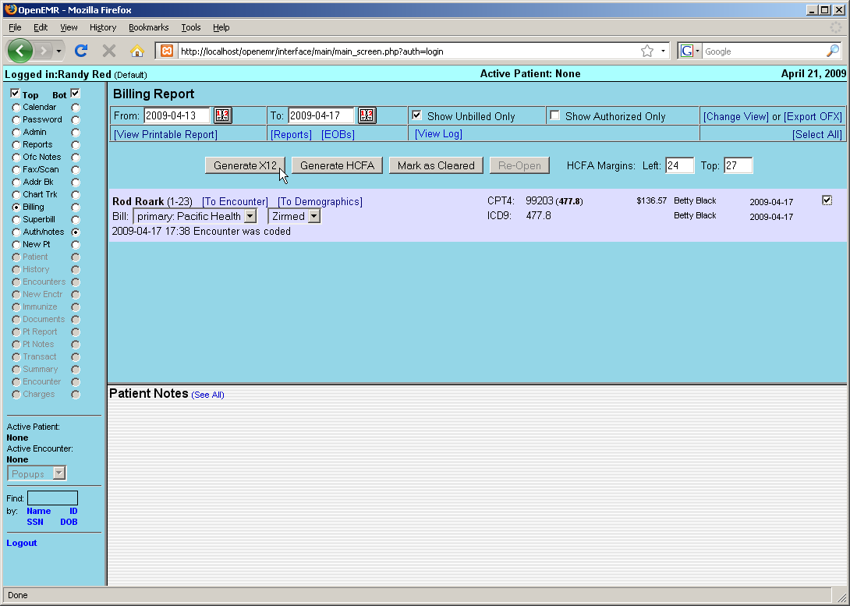

OpenEMR will present you with a confirmation popup, reminding you to check the log file after you have finished generating your claims.

Click 'OK' to proceed.

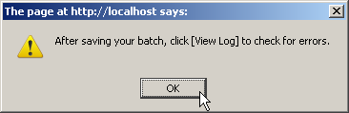

The standard Save File dialog should appear, allowing you to save the generated batch file to your computer.
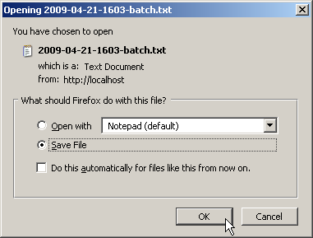

Once the file has been saved, click 'View Log' to check whether the claims were generated successfully.

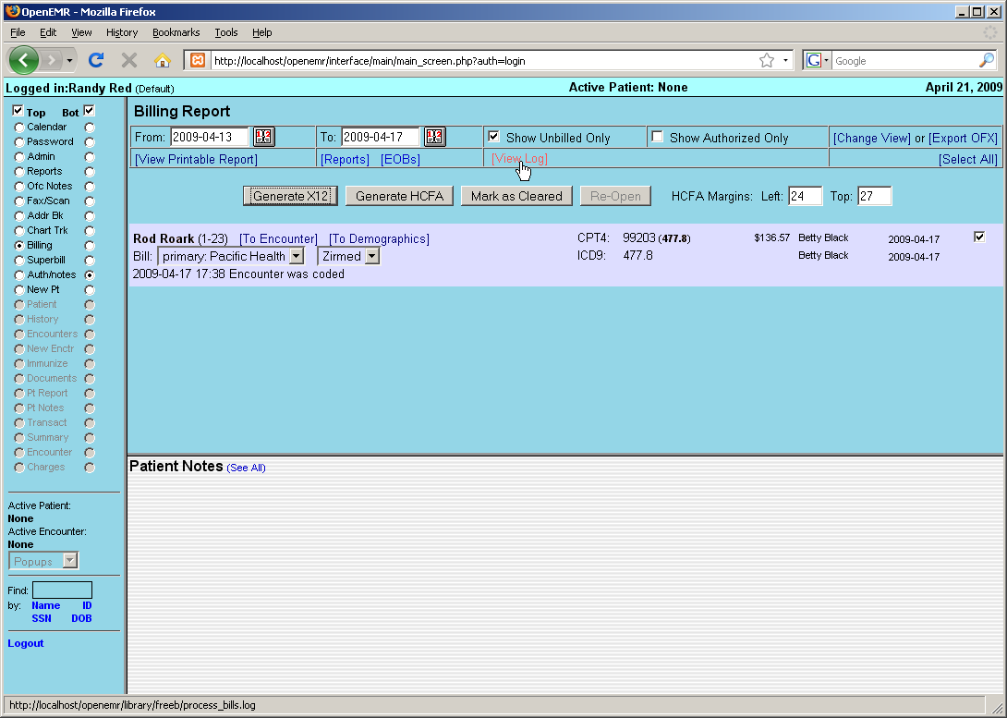

If there were any errors in the claim generation process, they will be displayed here. Otherwise you will see a note indicating that the file was generated successfully.
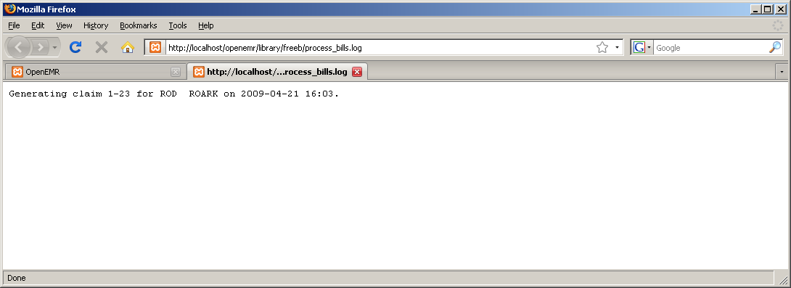

The downloaded claim file should contain the necessary encounter information, formatted for billing. This is what will be sent to the clearinghouse, by whatever method has been specified.

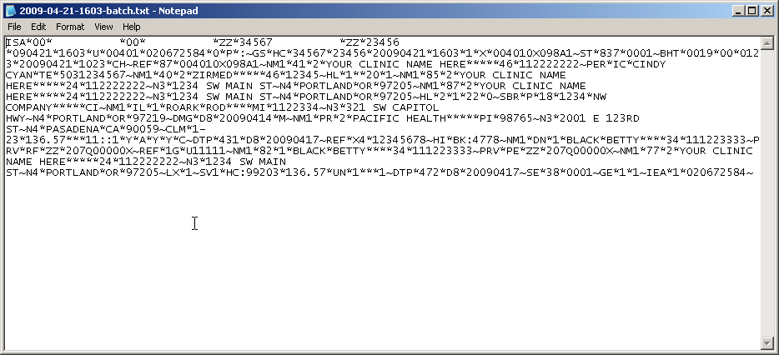

Uncheck 'Show Unbilled Only' and click 'Change View' to refresh the billing list and see the updated status of the encounter.

Click 'Mark as Cleared' to indicate that billing has been completed for this encounter.
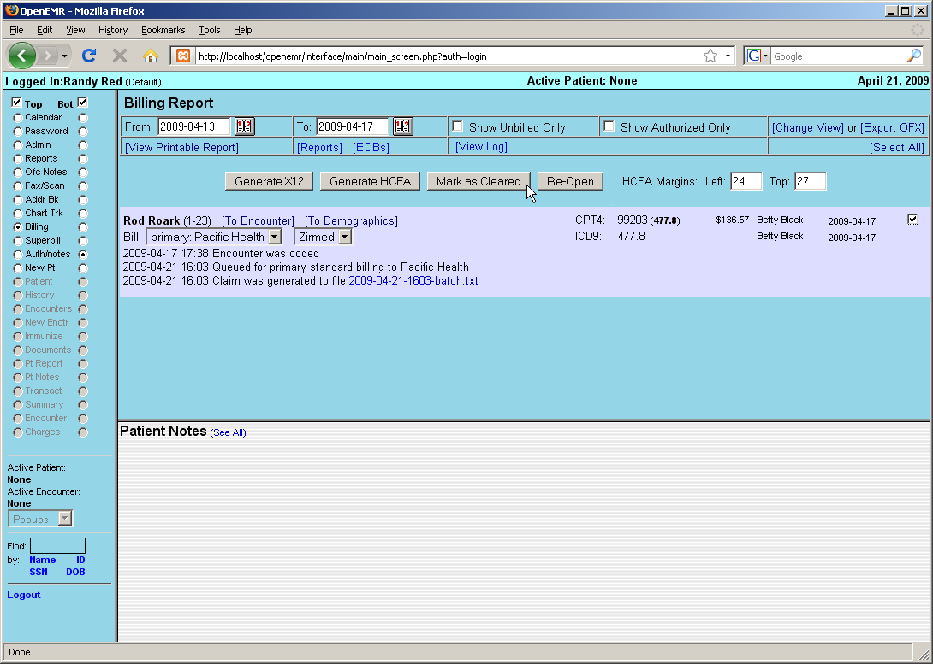

You will then be presented with a screen indicating that the claim has been “marked as billed only.”

Click 'Back' to return to the Billing Report page.
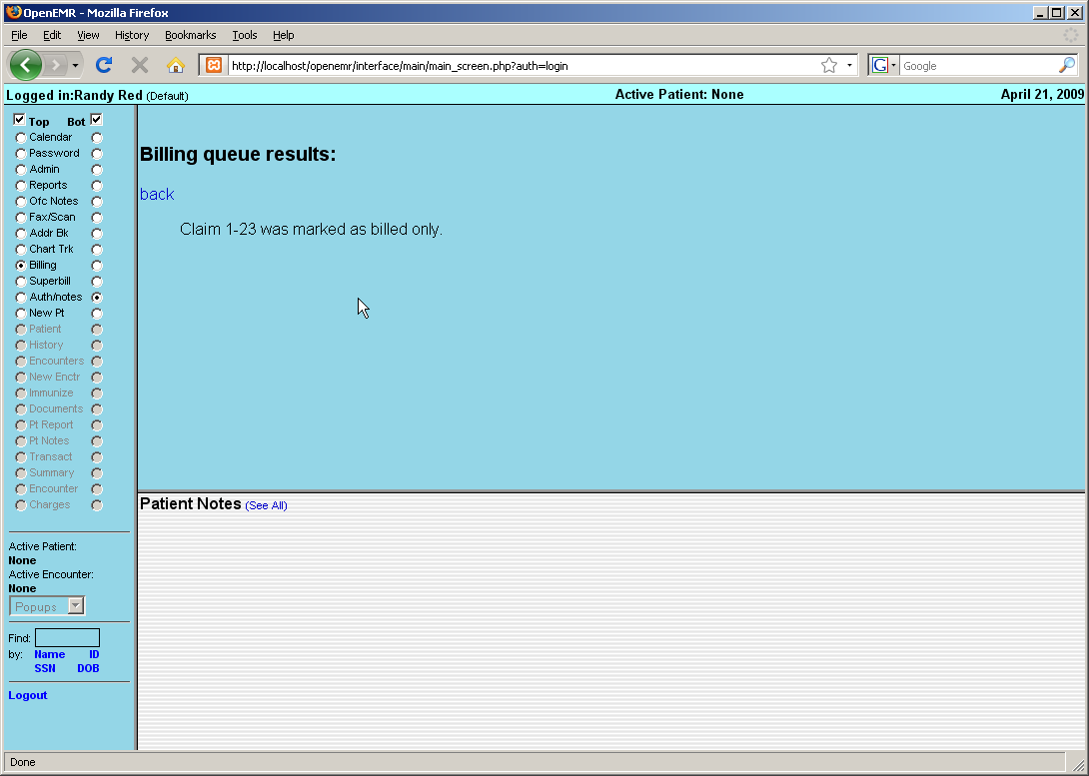

Generating HCFA Forms

In OpenEMR multiple forms may be generated for each claim.

For example, re-enter the desired date range, uncheck 'Show Unbilled Only' and click 'Change View' again to show the current status of the claim. You can see that the claim has been “Marked as cleared.”

Check the box to the right of the encounter and click 'Generate HCFA'.
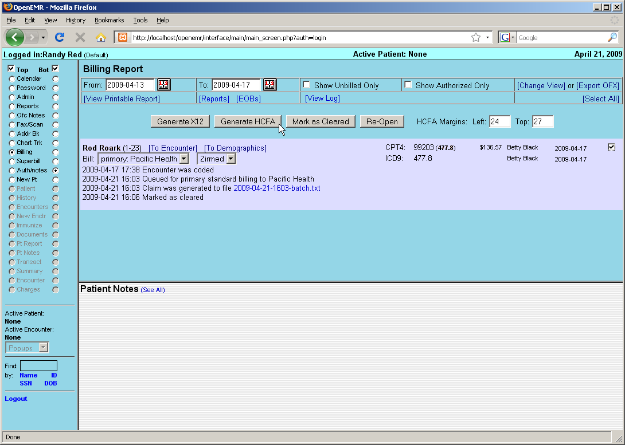

OpenEMR will now generate a PDF of the HCFA claim, based on the standard HCFA form template. The new form can be viewed using a built-in PDF viewer, or printed automatically on a pre-printed HCFA 1500 form, depending on your system's configuration.
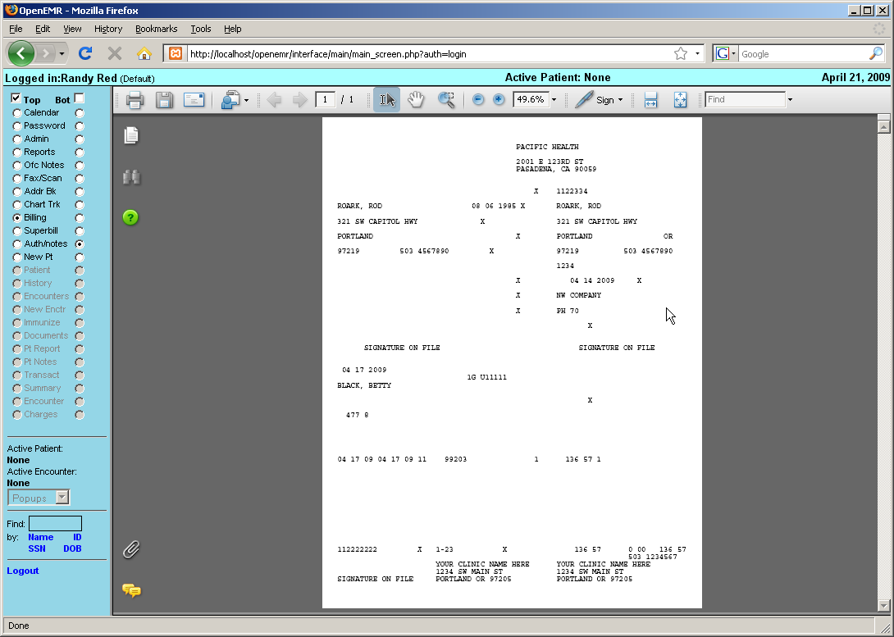

Returning to the Billing Report, you can see that the status of the billable encounter has been updated.
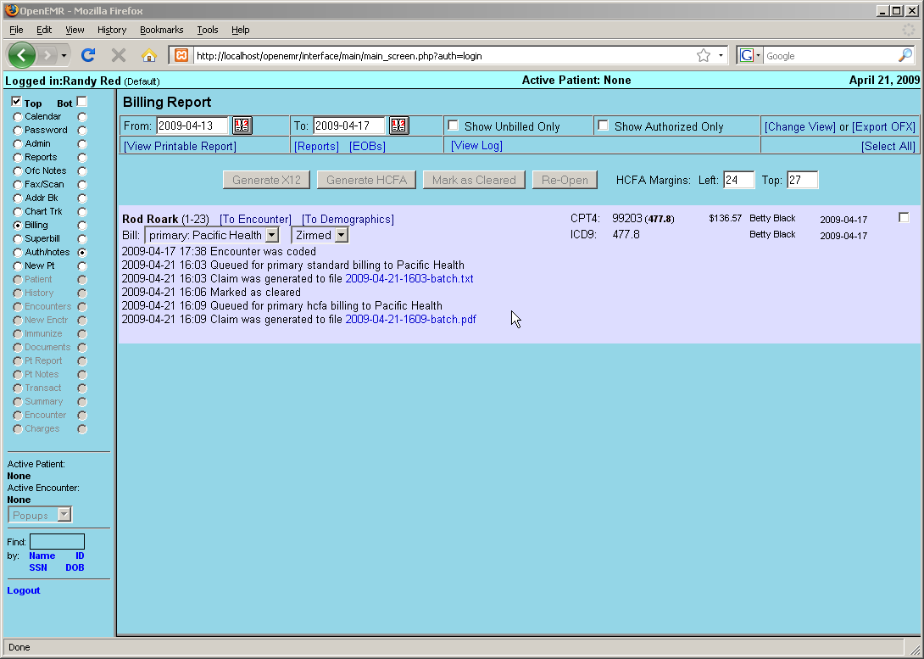
Accounting & Receivables

Users classified as Accounting or Administrator are also authorized to enter receivables for the clinic. Checks received from insurance companies can be entered here and distributed to cover the appropriate encounters. Patients can also be billed, and their payments recorded.

Explanation of Benefits

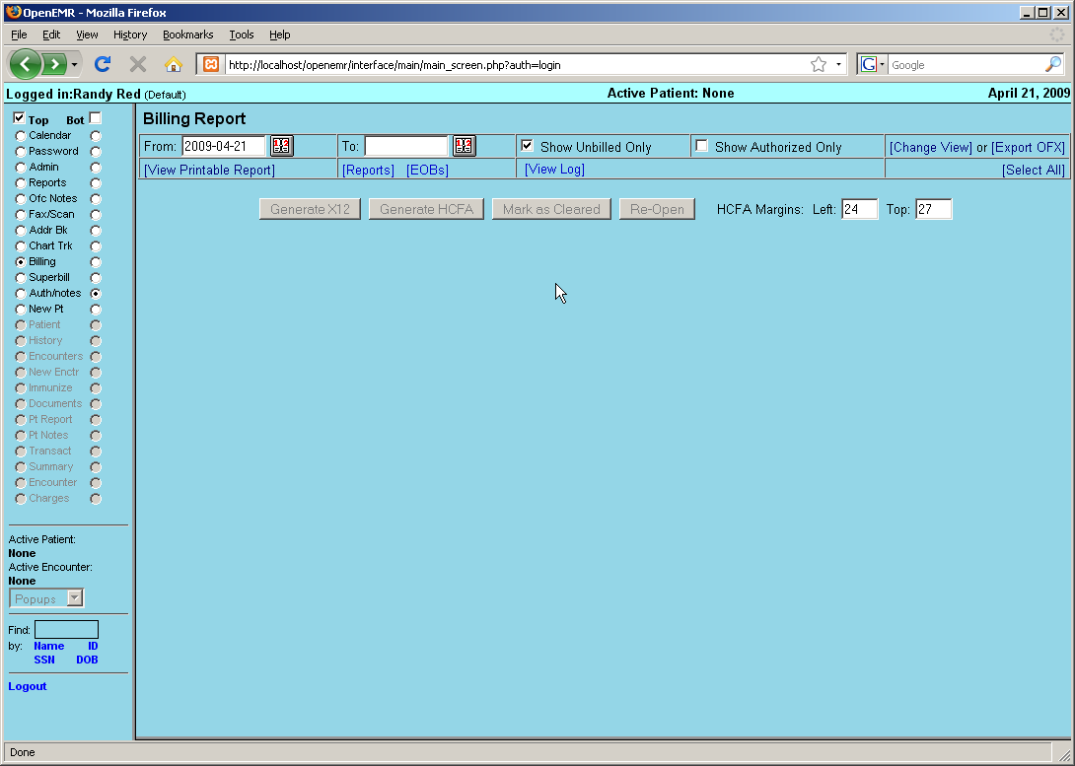

To begin, select 'Billing' from the navigation menu and click 'EOBs' to bring up the Explanation of Benefits Search window. This is where you can upload an ERA file (click 'Help' in the upper right-hand corner for more information) or begin inputting payments manually.

At the top you may enter a source (Eg. check number), pay date and check amount. The amount field will be automatically decremented as payments are entered into the associated invoices. When all invoices have been completed this value should be zero.
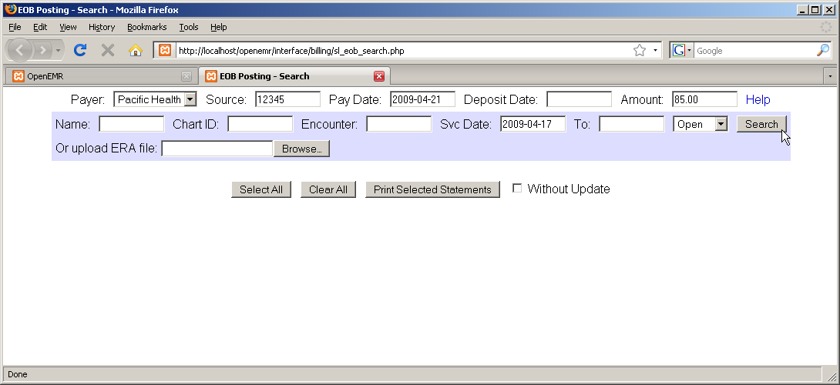

The search fields, with the blue background, are for locating a specific invoice (or invoices). Enter the appropriate parameters, such as the date of service, and click 'Search' to bring up a list of all invoices (claims) matching the requested parameters.

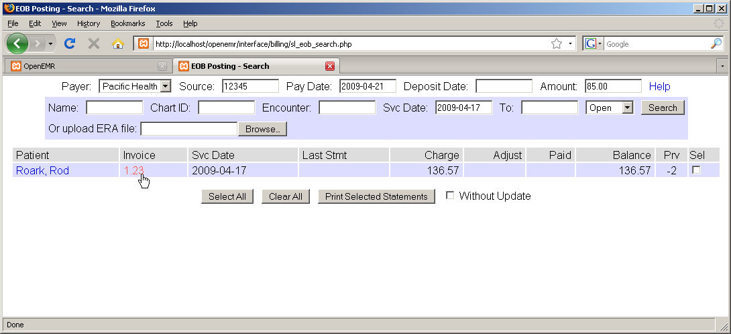

The list shows the patient and invoice number, as well as the current balance to be paid. The number with a '-' in the 'Prv' column indicates the number of insurance companies for which this invoice is awaiting payment.

Entering Payments

Clicking the invoice number you wish to work with opens the EOB Invoice window. Notice that the source and pay date from the previous window have been copied over; this saves time in the common case where a single check from the insurance company pays for multiple claims.
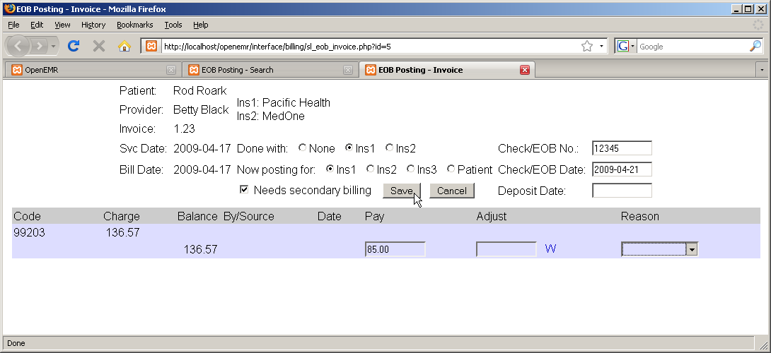

The EOB Invoice page contains a detailed list of payments made on this invoice so far. Enter the payment amount next to the remaining balance, and check 'Needs secondary billing'. This will allow the claim to be re-billed to the secondary insurance. Select 'Done with Ins1' above to indicate that the primary insurance EOB has been posted. When you are finished, click 'Save'.

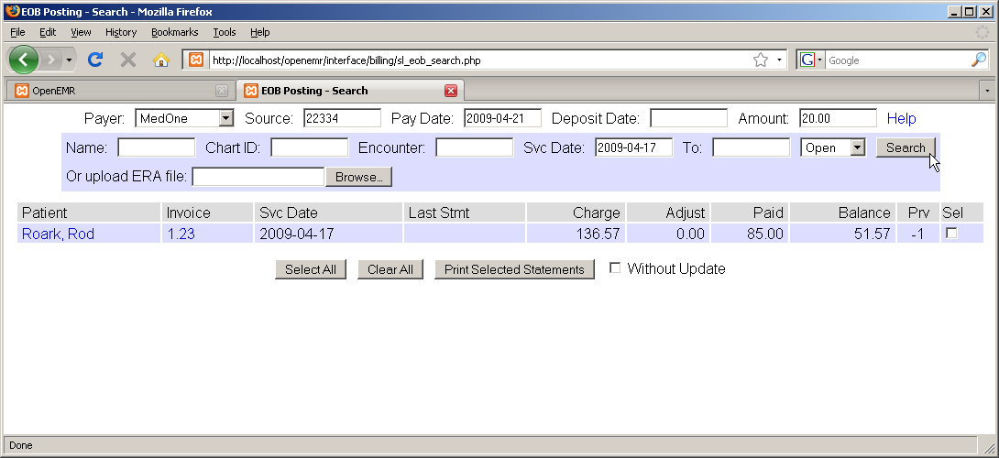

Once payment has been billed and received from secondary insurance, it can be entered in the same way. Enter the source and pay date, etc. and locate the appropriate invoice(s) using the search function.

Payment amounts are now shown along with the remaining balance. The number in the 'Prv' column has also decreased. Select the invoice number to bring up the EOB Invoice window again.

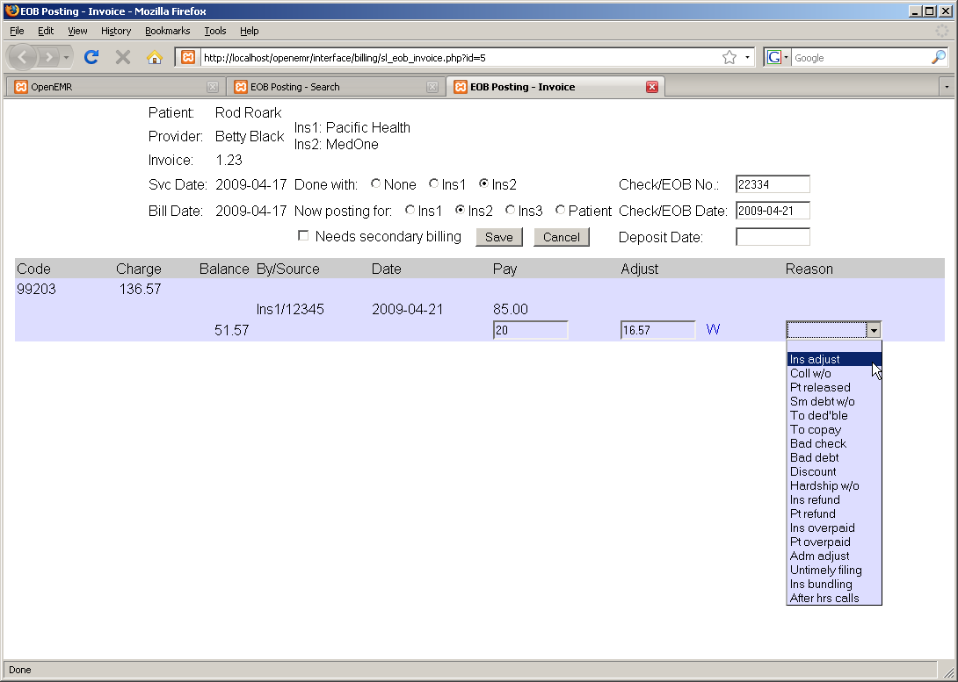

Enter the payment amount and select 'Ins2' to indicate that the secondary insurance EOB has been posted.

Invoice adjustments may also be made here. Enter the adjustment amount (or click 'W' to waive the entire remaining balance), and select a reason for the adjustment from the drop-down list provided. Click 'Save' when finished.

Patient Invoices and Payments

Once payments from the insurance companies have been received and entered, you can use OpenEMR's EOB page to generate invoices for billing patients the remaining amounts.

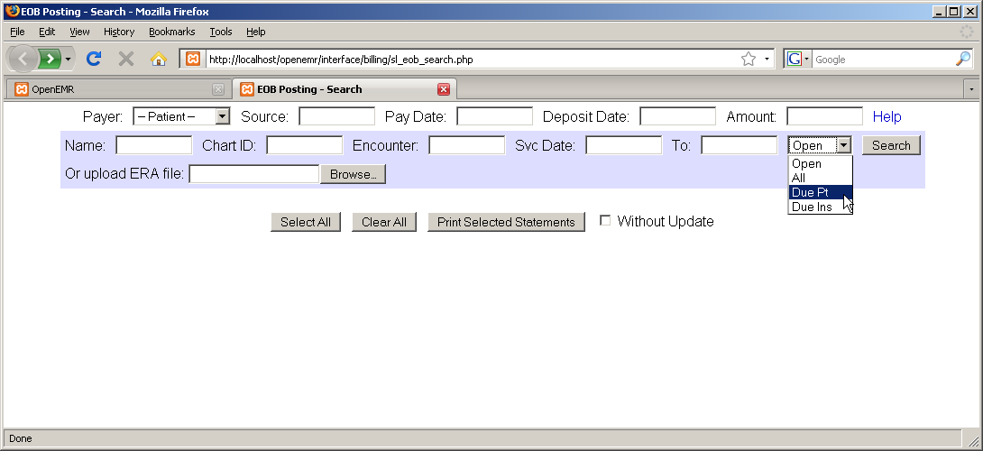

Select 'Due Pt' from the drop-down list and click 'Search' to display a list of all invoices that are awaiting payment from patients. Invoices still awaiting payments from insurance companies will not be shown.

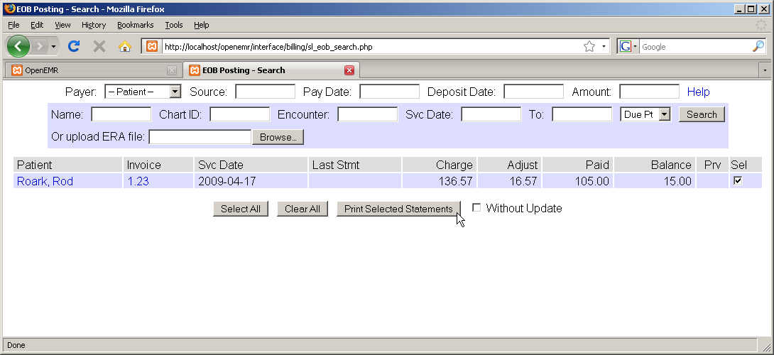

Check the box next to the desired invoice and click 'Print Selected Statements' to generate an invoice for that patient using a customizable template. Depending on your clinic's OpenEMR configuration, the invoice may be printed automatically.

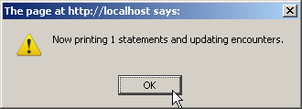

A '1' in the 'Prv' column now indicates that the patient has been billed once for this claim. This number will increment every time a new invoice is printed for this encounter. This is useful when printing so that second and later notices may be worded differently from the initial statement.

You can also click on the patient's name in the invoice list to create a billing note for that patient. Enter your note into the text field and click 'Save'.

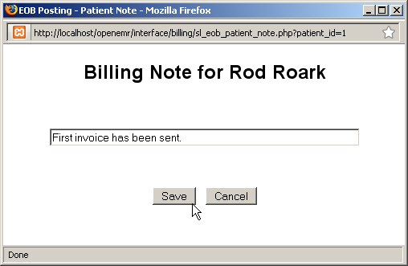

Once payment has been received, it can be entered into the invoice in the same manner as the insurance payments. In the 'Now posting for' list be sure to select 'Patient'. Enter the payment amount as before and click 'Save'.

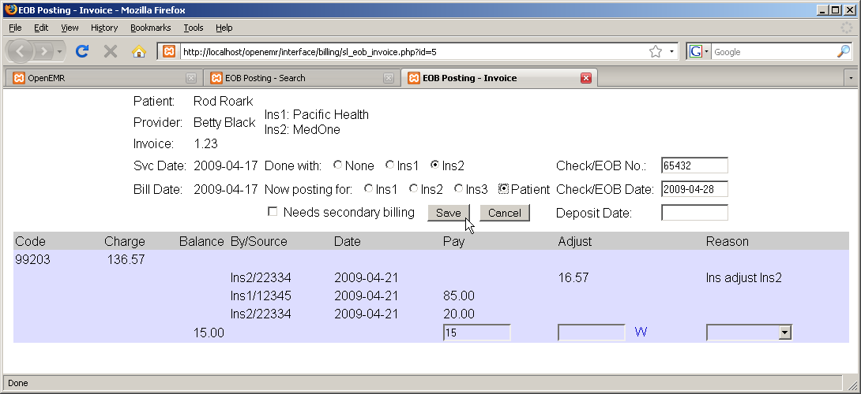
Reporting

Within OpenEMR there are a wide array of reports you can generate which may be useful for your practice. These include general reports such as appointment and encounter reports, billing reports, and patient specific reporting.

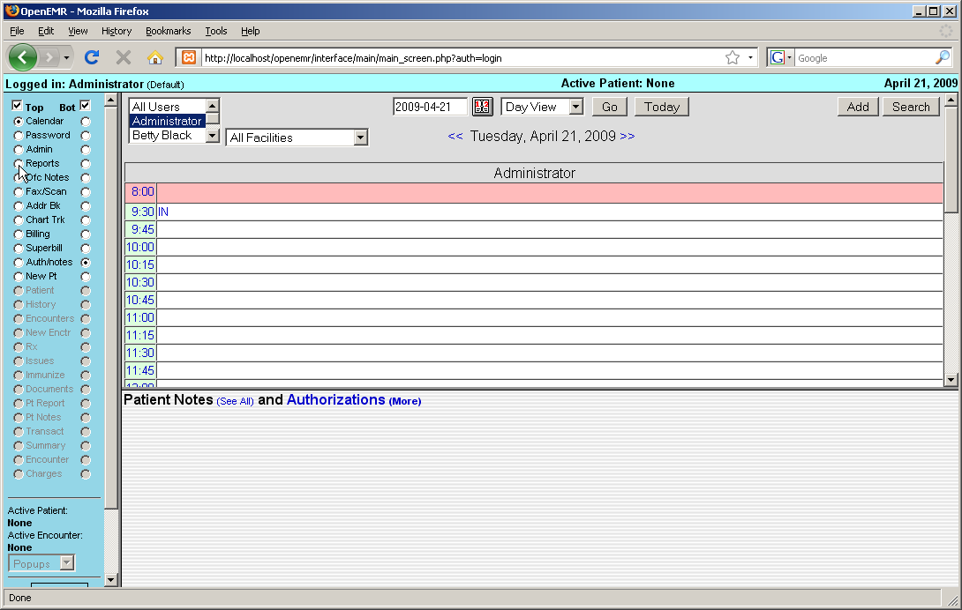

General Reports

Most general reporting tools can be found by selecting 'Reports' from the navigation menu at left.
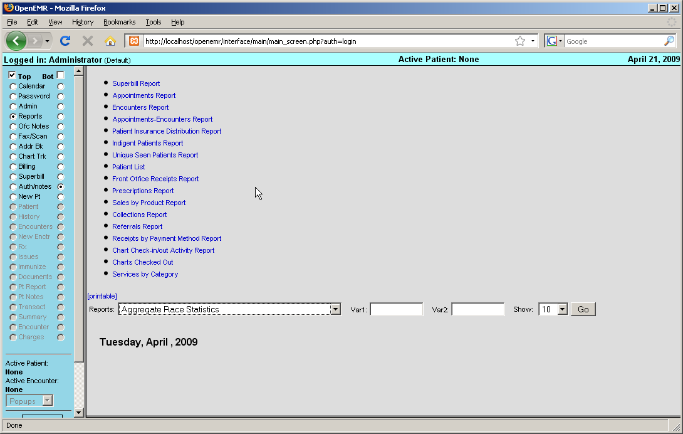

Examples of some commonly used reports:

The Superbill Report presents you with a dialog for selecting a date range.

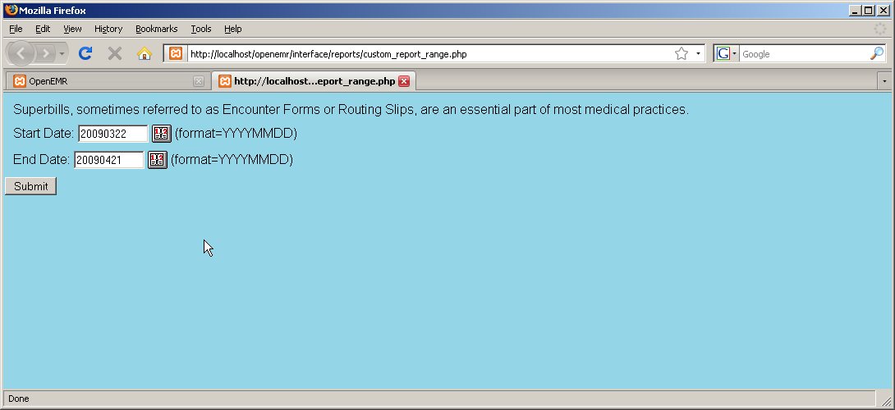

Clicking 'Submit' produces a report for each encounter in the date range, and shows patient demographics and insurance information

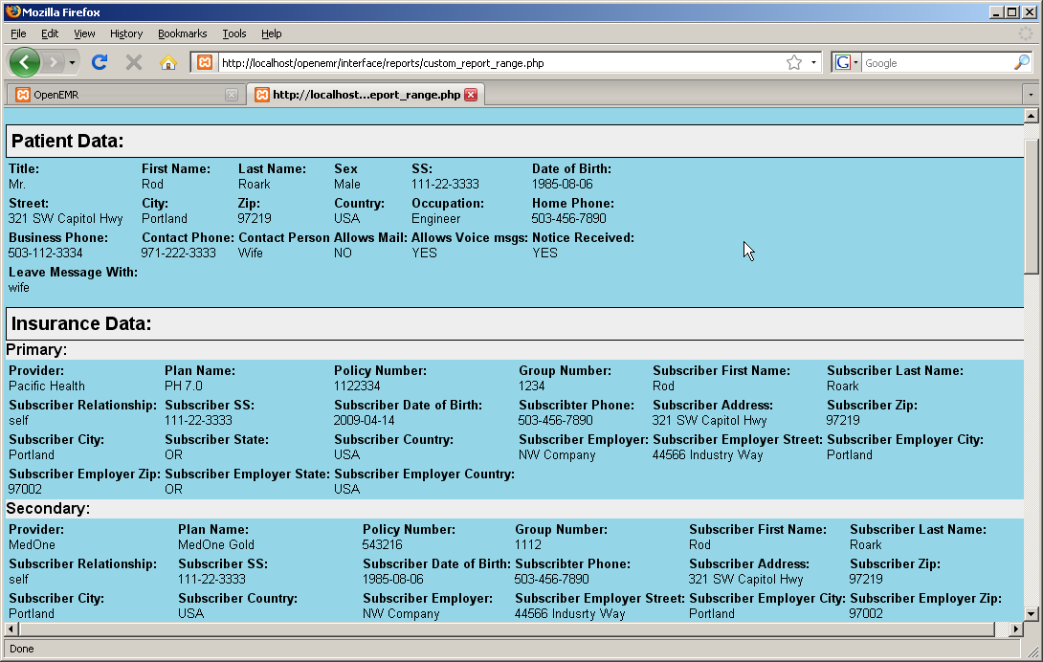

As well as the billing codes and amounts.

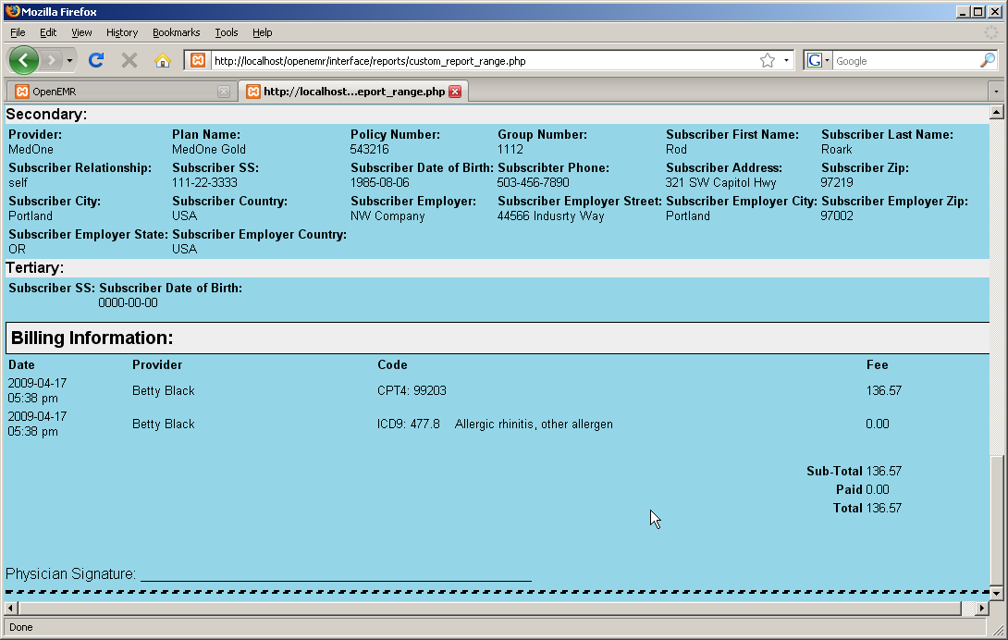

The Appointments Report gives you a list of appointments for a given provider, or for all providers, in a specified date range. It can be sorted by clicking on any of the four column headings.
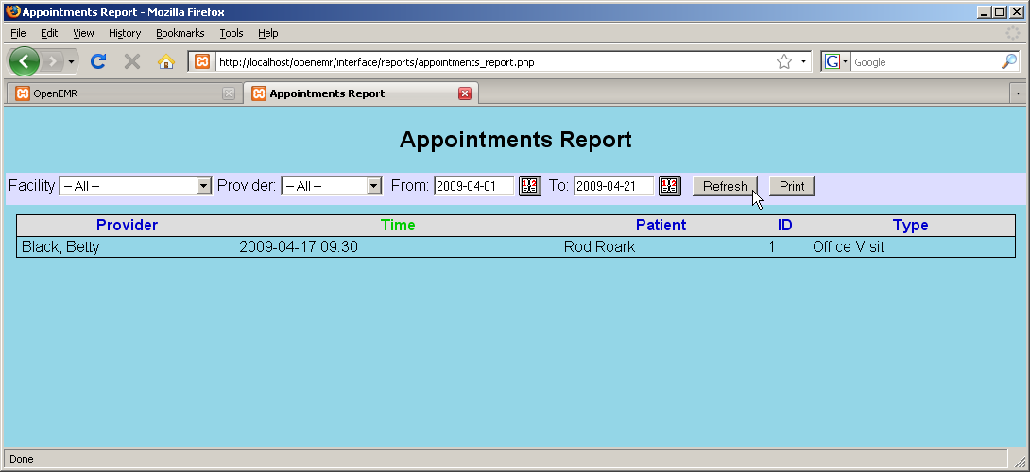

The Appointments and Encounters Report gives you a useful cross-reference of appointments with their corresponding encounters. This allows you to easily spot many types of errors, such as appointments with missing encounters, encounters with missing appointments, missing charges, and authorizations or justifications that are required but not done.

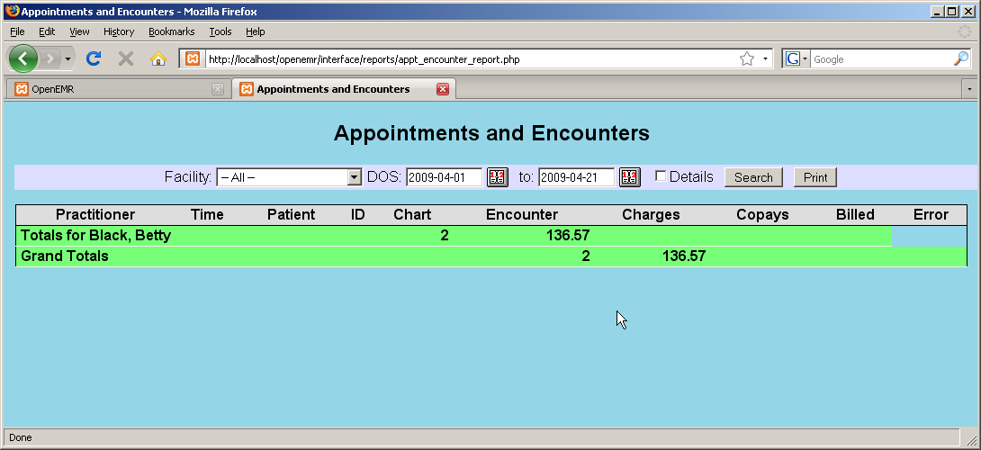

The Insurance Distribution report shows you how many patients seen over a given time period use each kind of insurance.
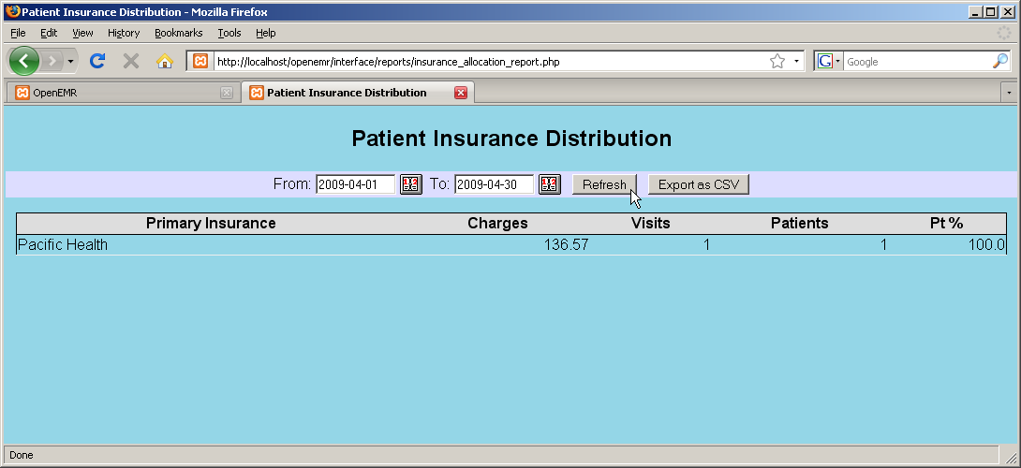

The Indigent Patients report lists all encounters for patients that were seen without insurance. (None shown here.)

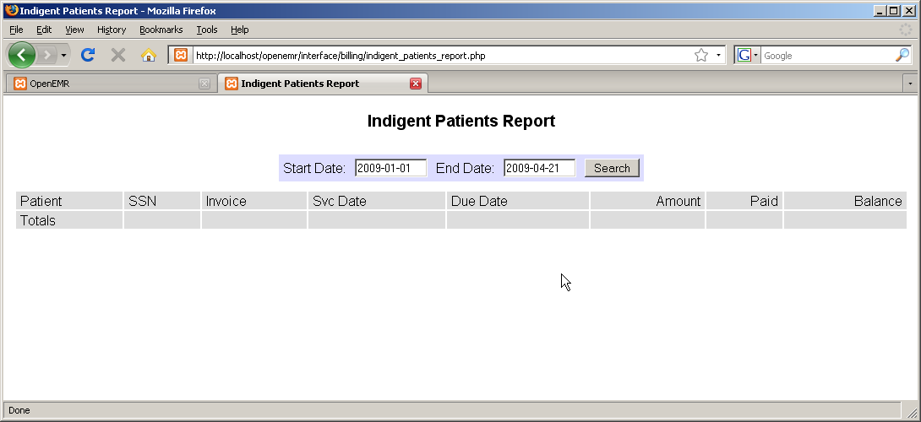

OpenEMR also allows you to create custom reports using the Database Reporting section of Administration. Some examples have been included by default.
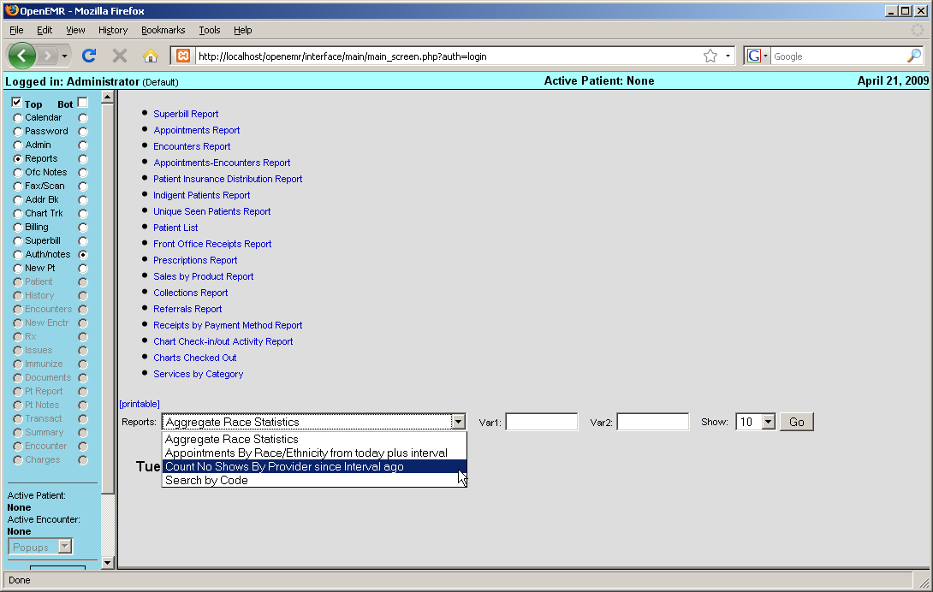

Billing Reports

From the main Billing page select 'Reports'.

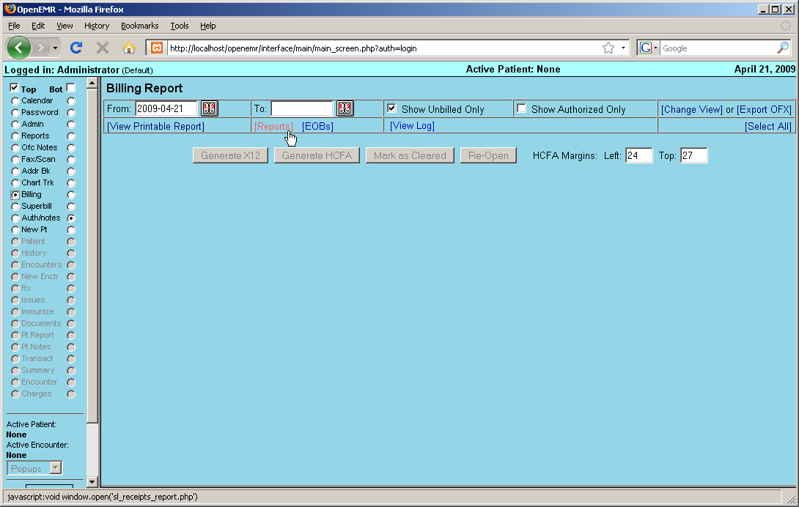

This is the Cash Receipts report. It breaks down gross income by provider for a given time period.

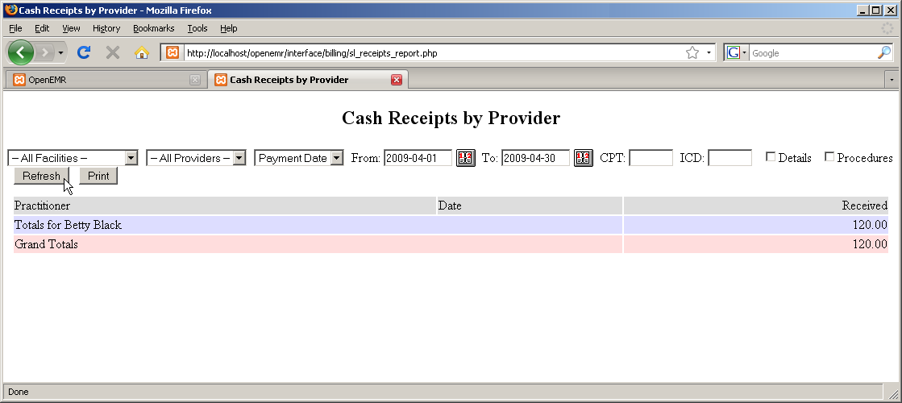

The user can also elect to see a detailed breakdown of cash receipts, itemizing each procedure for which a charge was made.

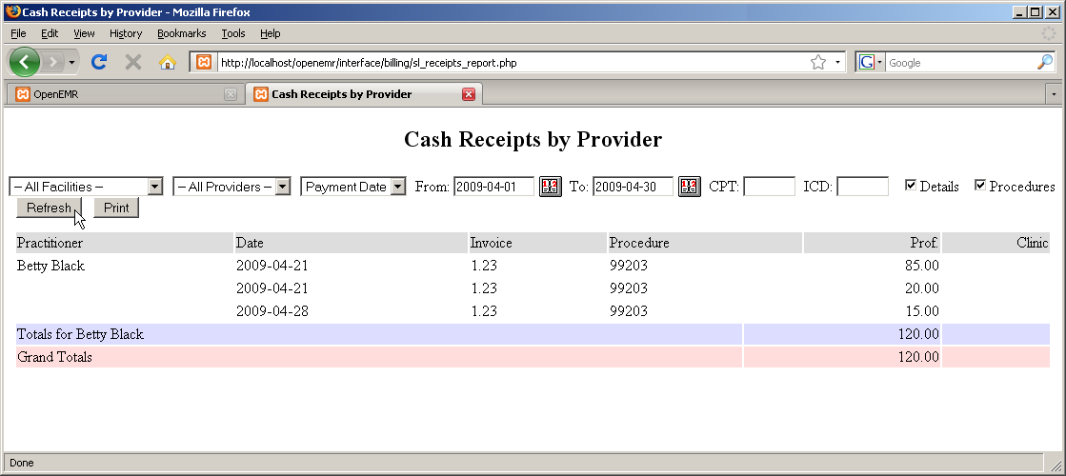

Patient Reports

When a patient is active within the system, the user has the option of generating a report for that specific patient. To do so, click on 'Pt Report' which is now visible in the navigation menu.
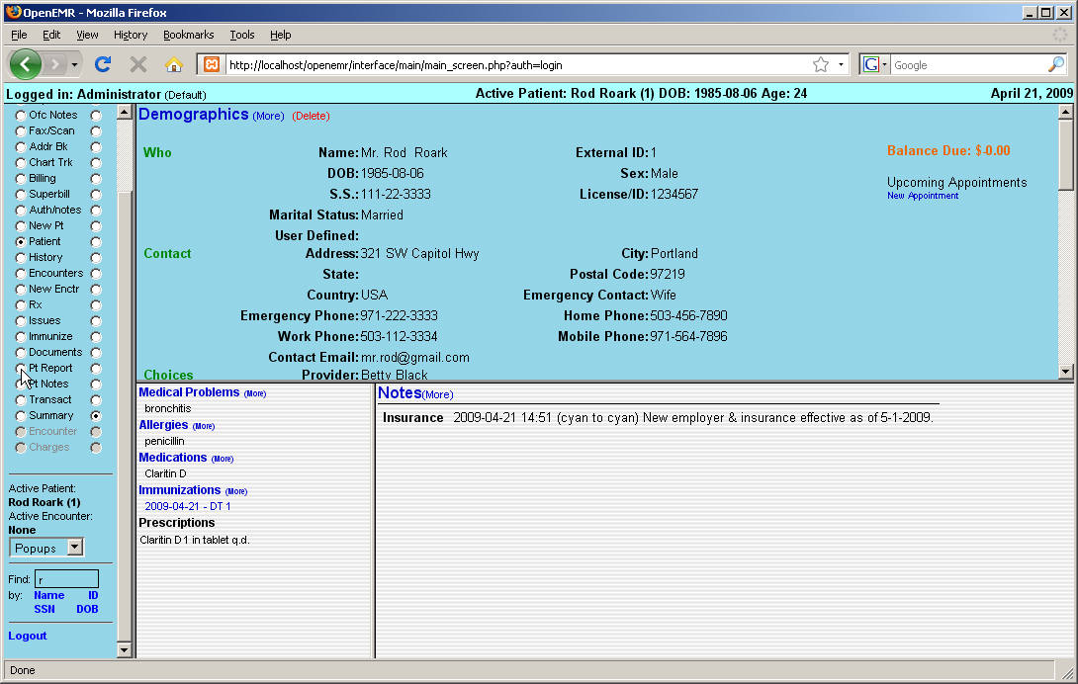

The user can choose to include or omit a wide variety of patient information. When satisfied with your selections, click 'Generate Report'.

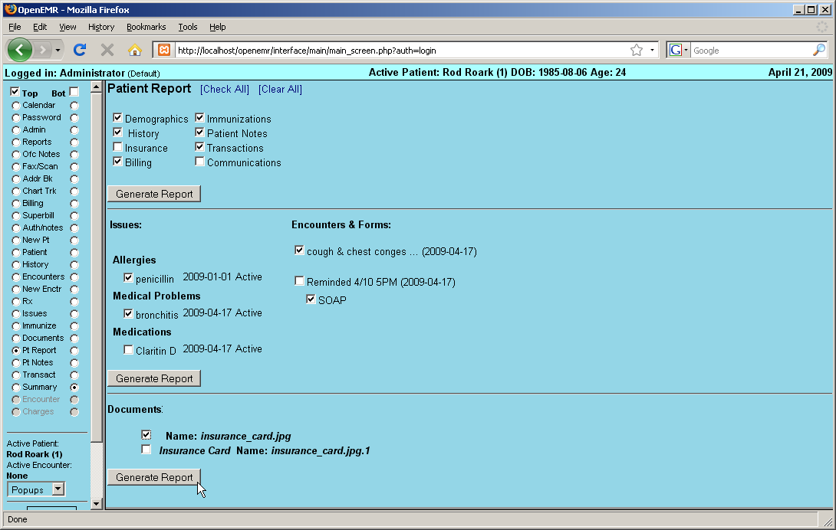

This produces a report including all the specified patient information.


