

Put your own pictures and Images here and delete the OpenEMR samples.
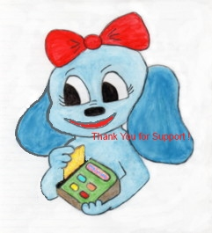

Declaration of SUPPORT for OpenEMR.

Today, {DOS} I want to DONATE!

{City}, {State}

This Practice and my official health care provider {ReferringDOC}, uses OpenEMR. This is a GNU licensed freeware supported Software Development program.

To continue Development of OpenEMR there are certain parts that are in need of financial support to continue compliance with Official State of {State} Requirements.

Users in the United States have reaped the bounty of the EHR Bonuses. Probably will do so again in the next Stages for certification. The majority of users, outside of the United States, have benefited from this Software product as well. Also through enhancements as Electronic Prescribing, Clinical Reminders and Secure Messaging. The experience of our colleagues abroad will continue to improve with further Certification.

See more at: Donation options for OpenEMR Support

I acknowledge receipt of this notice, and my understanding and my agreement to its terms, and are informed that my Financial Support can be tax deductible under the State of {State} laws, but I am aware this tax deduction can not be guaranteed by my health care provider.

Patient Name: {PatientName}; ({PatientSex})
{PatientID}; Born: {PatientDOB}
Home Address: {Address}
{City}; {State}; {Zip}
Home Phone: {PatientPhone}

{PatientName}
Patient Signature:

_________________________ , {City}, {DOS}

