OpenEnergyMonitor Factory Test

For emonPi2
1. Plug in the touch screen unit and allow it to boot-up:
2. Connect the following to the emonPi2 under test:
- USB-C connector
- RJ45 connector (ensure voltage sample power supply is connected to mains)
- RF antenna
- Hold probe onto middle UDPI pad (see Fig2)
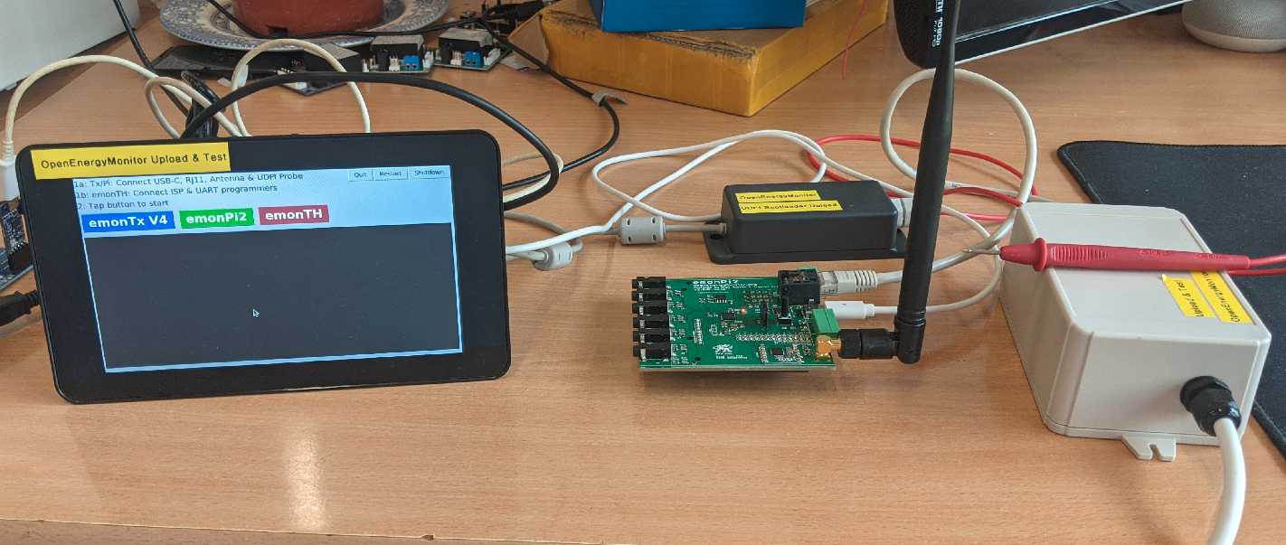Figure 1

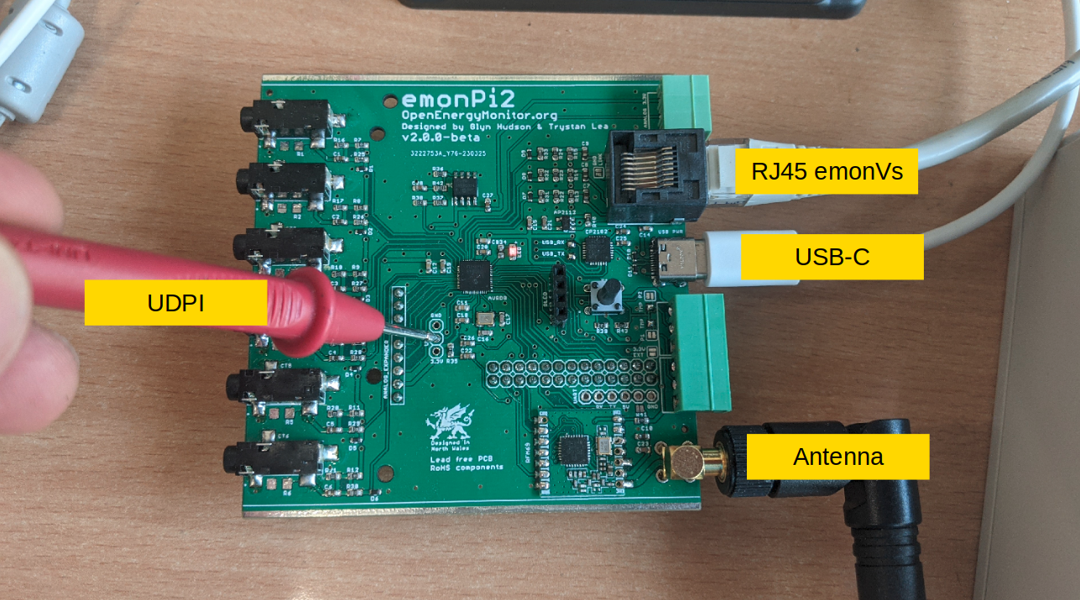Figure 2
3. Tap emonPi2 button on touch screen to start factory upload & test.
Monitor display output for results of test. Successful test should show multiple PASS and zero FAIL. If any FAIL’s are present the test should be repeated, if unit fails multiple times it should be treated as a failure.
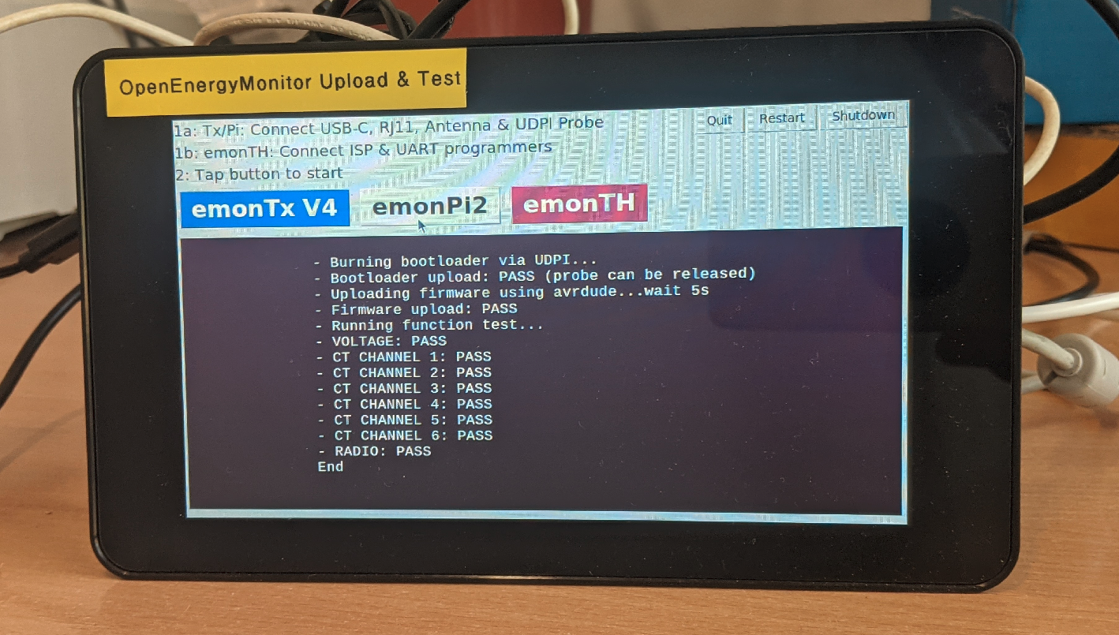

For emonTH
1. Plug in the touch screen unit and allow it to boot-up:
2. Connect the following to the emonTH under test:
- AVR ISP MK2 ISP Programmer
- LC231X UART Programmer
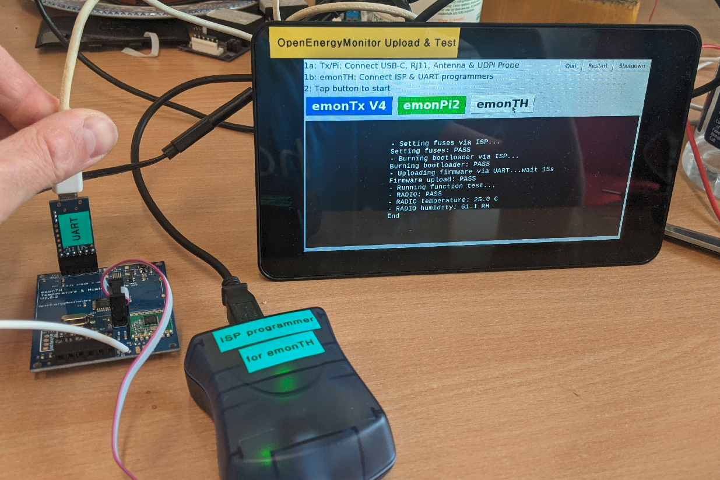Figure 3

3. Tap emonTH button on touch screen to start factory upload & test.
Monitor display output for results of test. Successful test should show multiple PASS and zero FAIL. If any FAIL’s are present the test should be repeated, if unit fails multiple times it should be treated as a failure.


