**OpenEXP: An open-source platform for crowdsourcing behavioral and EEG experiments**

Laboratory-based research studies have uncovered a wealth of knowledge about the nature of the human psyche, as well as the relationship between cognition and the brain. One of the most practical -- as well as fruitful -- methodologies in this domain is electroencephalography (EEG), a method that directly records electrical activity from electrodes placed on the scalp. Until relatively recently, EEG equipment has been confined to laboratory study due to its meticulous preparation, as well as its hefty price tag. However, recent advances in EEG collection devices as well as dry electrode technology have allowed for the collection of high-quality EEG data outside of the laboratory setting and at a fraction of the price. With these critical advancements, it is now possible to run EEG experiments at a much larger scale and with more ecological validity than was ever possible before.

To harness the true potential of this new technology, we are developing an open-source scientific platform designed to facilitate the large-scale collection of high-quality EEG and behavioral data. Our platform will be of high enough caliber to conduct publication-grade experiments, but will also be very intuitive and user-friendly such that anyone interested in the brain can use it. The software will be designed to:

1. connect to EEG hardware

2. provide real-time visualization of EEG data for monitoring and debugging

3. provide a simple graphical interface for the design and execution of psychology/neuroscience experiments

4. provide state-of-the-art scientific analytic capabilities

5. provide an online repository of open-source experiments and EEG data.

While this is undoubtedly an ambitious project, a large majority of the application’s functionality will be distilled from other open-source software/hardware projects, which we will unpack in the pages below. We believe that this software will be extremely valuable to the research community (as well as the general public) because it provides an open-source tool for running large-scale, ecologically-valid and easily reproducible behavioral and EEG experiments. Because experiments and data in our proposed software are designed to be easily shared, this platform promotes ‘open science’ and fosters collaboration and sharing of data and resources among research groups. Furthermore, this project is unique in that to our knowledge, it is the first effort to ‘crowd-source’ EEG experiments. We feel that this has great implications for research, as well as for education. Researchers will be able to collaborate on large-scale and high-quality EEG studies, and educators and students will be able to utilize the technology to teach and learn about the human brain. We are working together with an expert team composed of scientists, engineers, designers and web application developers to create a collaborative open-science platform for brain research. In the pages below, we describe the scope of the app in detail.

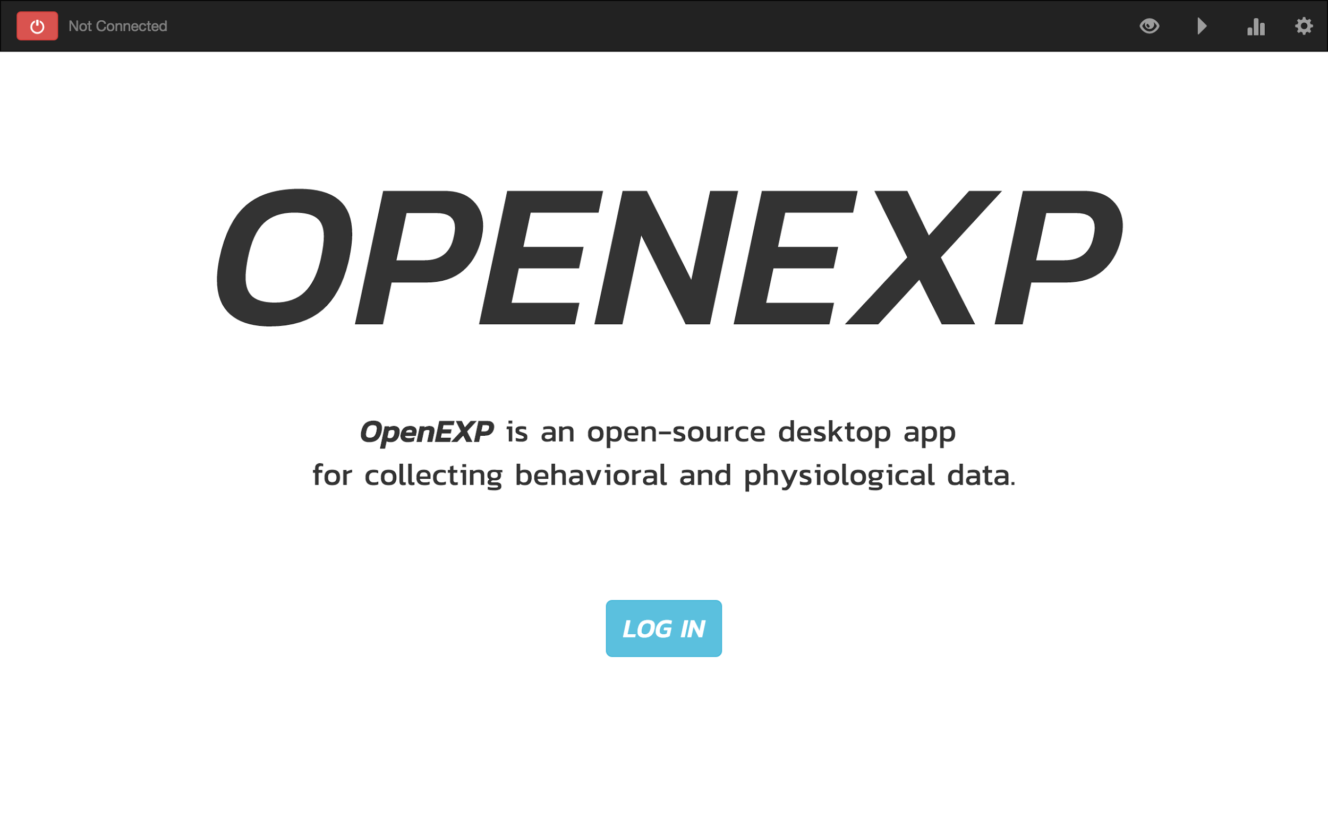

**Figure 1.** Prototype of OpenEXP application home page.

**Connecting to Hardware**

In support of EEG data gathering, we’ve started with OpenBCI, a fully open-source, wireless Arduino-based microcontroller for measuring small electrical bio-potentials. This will provide support for a maximally accessible tool that anyone can use to conduct research. We’ve designed the hardware driver to be a self-contained JavaScript package, [openbci-sdk](https://www.npmjs.com/package/openbci-sdk) (written by [AJ Keller](http://www.pushtheworldllc.com/)), which is completely open-source and integrates seamlessly with OpenEXP and is designed to be extremely portable (i.e. easy to build into other software). Using our driver, we can interact with the EEG device, connect to the application and wirelessly stream data into it.

We vow to hold true to this open-source and modular model as we expand our hardware support. The added benefit of maintaining this modularity in hardware support is that we will be bolstered by our open-source community of developers to build these drivers, while we continue to develop the infrastructure of OpenEXP in parallel.

**Real-time visualization dashboard**

In order to properly run an EEG experiment, it is necessary to have some feedback about the characteristics of the signal being collected. Thus, we propose to build a simple analytics dashboard using the open-source visualization library, [D3.js](https://d3js.org/). The dashboard will display a real-time plot for each EEG electrode, a topographic plot to visualize the spatial distribution of activity, and a Fourier spectral plot to visualize the frequency composition of the EEG signal. There will be a plugin option for easy addition of custom graphics. Furthermore, we will provide a limited set of filtering and scaling options. Below, is a prototype of the visualization concept:

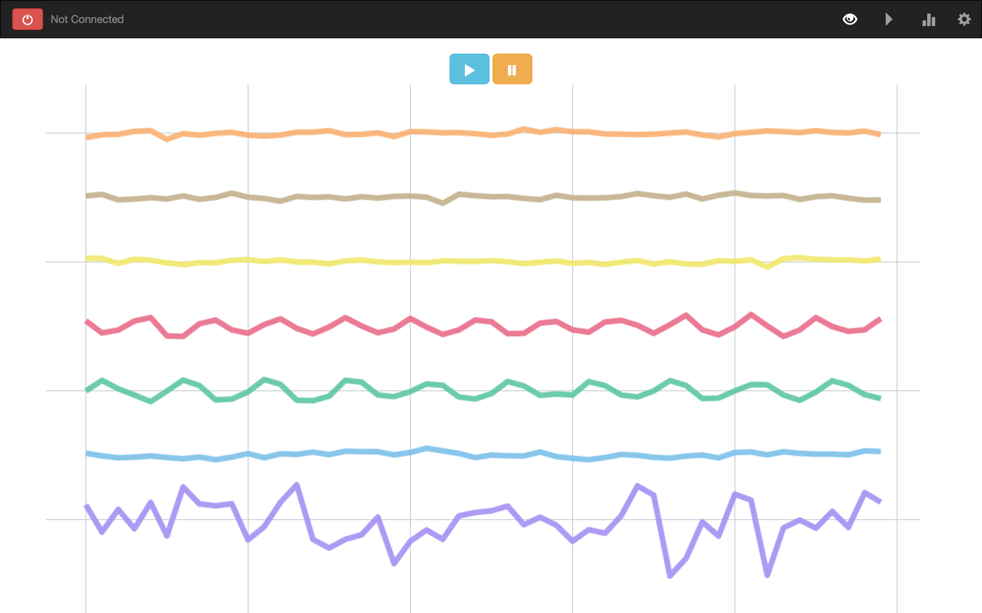

**Figure 2.** Prototype of the visualization component of the application. Each colored line represents a time series for a distinct EEG electrode. In addition to a line plot, a topographical plot and Fourier plot will be built and added.

To allow the real time plots and analysis results to be easily sharable, we will embed each OpenEXP visualization in the open-source visualization framework, [Lightning.js](http://lightning-viz.org/). Within Lightning, both real-time and static plots can be seamlessly shared to a public server, so that they can be accessed by anyone with the web link. Furthermore, lightning visualizations can be published to node package manager (npm), the largest repository of open-source software ever [created](https://www.npmjs.com/npm/open-source). The advantage of this is that anyone can use, contribute to or modify the visualizations for their own use, and the visualizations are version-controlled, allowing for the tracking of the development of software in a standardized and transparent way.

**Experimental design and execution**

Rather than starting from scratch, we will build upon other open-source packages for the majority of our application. To design and execute experiments in the application, we will utilize an open-source JavaScript library called [jsPsych](http://www.jspsych.org/) (built by [Josh DeLeeuw](http://pages.iu.edu/~jodeleeu/) and a collaborator on this project) for creating and running behavioral experiments using modern web technologies. jsPsych provides a flexible framework for constructing a wide range of laboratory-like experiments. To adapt jsPsych for our application, there are a number of ways that we plan to extend the software.

We propose to design a graphical user interface (GUI) for building experiments, so that users without JavaScript programming experience can easily create their own experiments. In this way, users could focus on designing high-quality experiments instead of getting bogged down by coding intricate experiments. This GUI would be designed such that users could create their experiments using ‘drag-and-drop’ components paired with the ability to include custom stimuli (such as pictures, words, sounds, etc). It is important to note that this would not limit more advanced users from writing their experiments in JavaScript directly. It would merely provide the option for those with less programming experience to build high-quality experiments. The development of this experiment builder software is in very early stages, but can see seen and downloaded [here](https://github.com/jodeleeuw/jsPsych-GUI).

A second important extension that we’d like to make is to incorporate EEG event tags into the jsPsych software. In EEG research (and most other neuroimaging research), accurately tagging *when* a computer stimulus event occurred relative to *when* a neural EEG event occurred is critical to subsequent analysis of the brain data. To do this, we’ve already implemented one approach, which timestamps the EEG data when jsPsych presents a stimulus to the screen. A summary of this work can be seen [here](http://openbci.com/community/tagging-stimulus-events-using-openbci-part-1-2/).

**Open-source repository of experiments**

In a typical research lab in a psychology/neuroscience department, a number of experiments are being run simultaneously. With each new experiment, graduate students and research assistants alike will spend an enormous amount of time designing, counterbalancing their stimuli, programming, and debugging their experimental code. When the experiment is completed, the code used to run the experiment is typically stored on a local computer or local server, never to be used again. We feel that this common scenario stifles scientific progress. If experiments could be easily shared and distributed in a standardized way, other research labs executing similar designs could use others’ code to run new experiments, similar experiments, or simply replicate the results of an experiment in a new population of subjects. We envision this as an open-source ‘marketplace’ for high-quality behavioral and EEG experiments. We propose to build an open-source repository of experiments written in jsPsych that can be retrieved via a RESTful API. The ‘experiment’ server would allow users to search and access any available experiment in the database, as well as upload their own custom experiments to share with others. This service would be accessible in the app, but also be accessible outside of the context of the application, so that experiments could be performed directly in a web browser if the experimenter prefers.

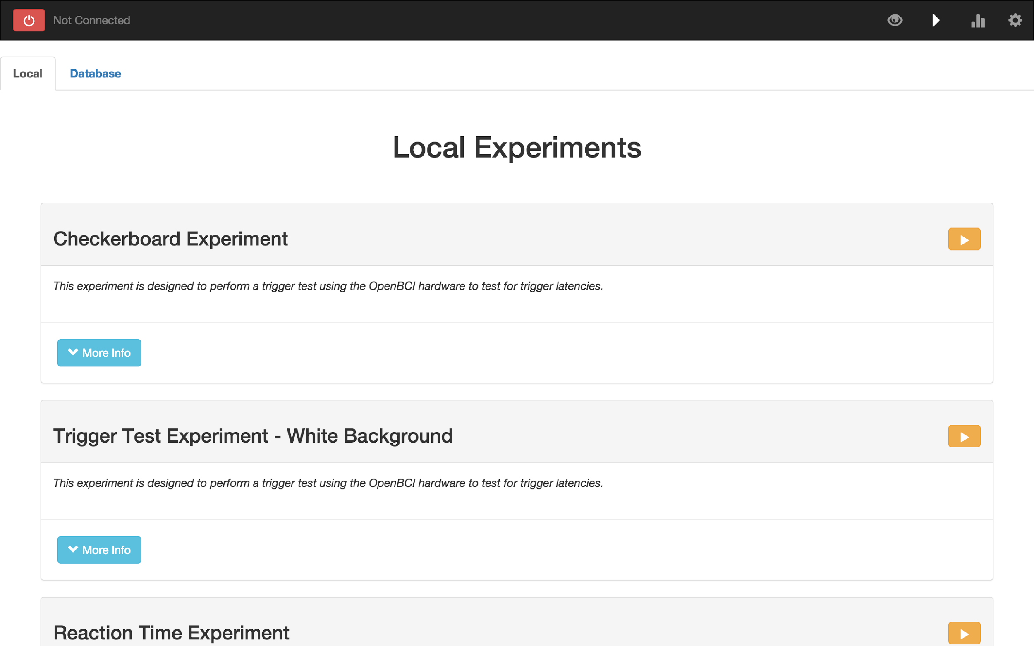

Figure 3. Prototype of the ‘experiments’ state of the application. Users will be able to access experiments that are stored locally, as well as experiments stored on a remote server accessible to anyone.

We have already made some progress on this front. We have started building the front-end infrastructure to provide users details of and access to the experiments. It is designed such that users can access local experiments (i.e. experiments built and stored on the user’s local computer) in one section of the application. In a separate tab in the “experiments” section of the application, users will be able to search through an open-source repository of experiments to access experiments designed by other researchers. As research scientists, an open-source repository of experiments would not only be extremely useful, but also a major advancement toward an open approach to science.

**Data Analysis**

For the analysis state of the application, we will embed a [Binder](http://mybinder.org/) notebook inside of our application. Binder is an open-source project which builds upon the [Jupyter](http://jupyter.org/) framework to construct a self-contained virtual environment with all of the necessary packages a researcher will need to conduct data analyses and create data visualizations.

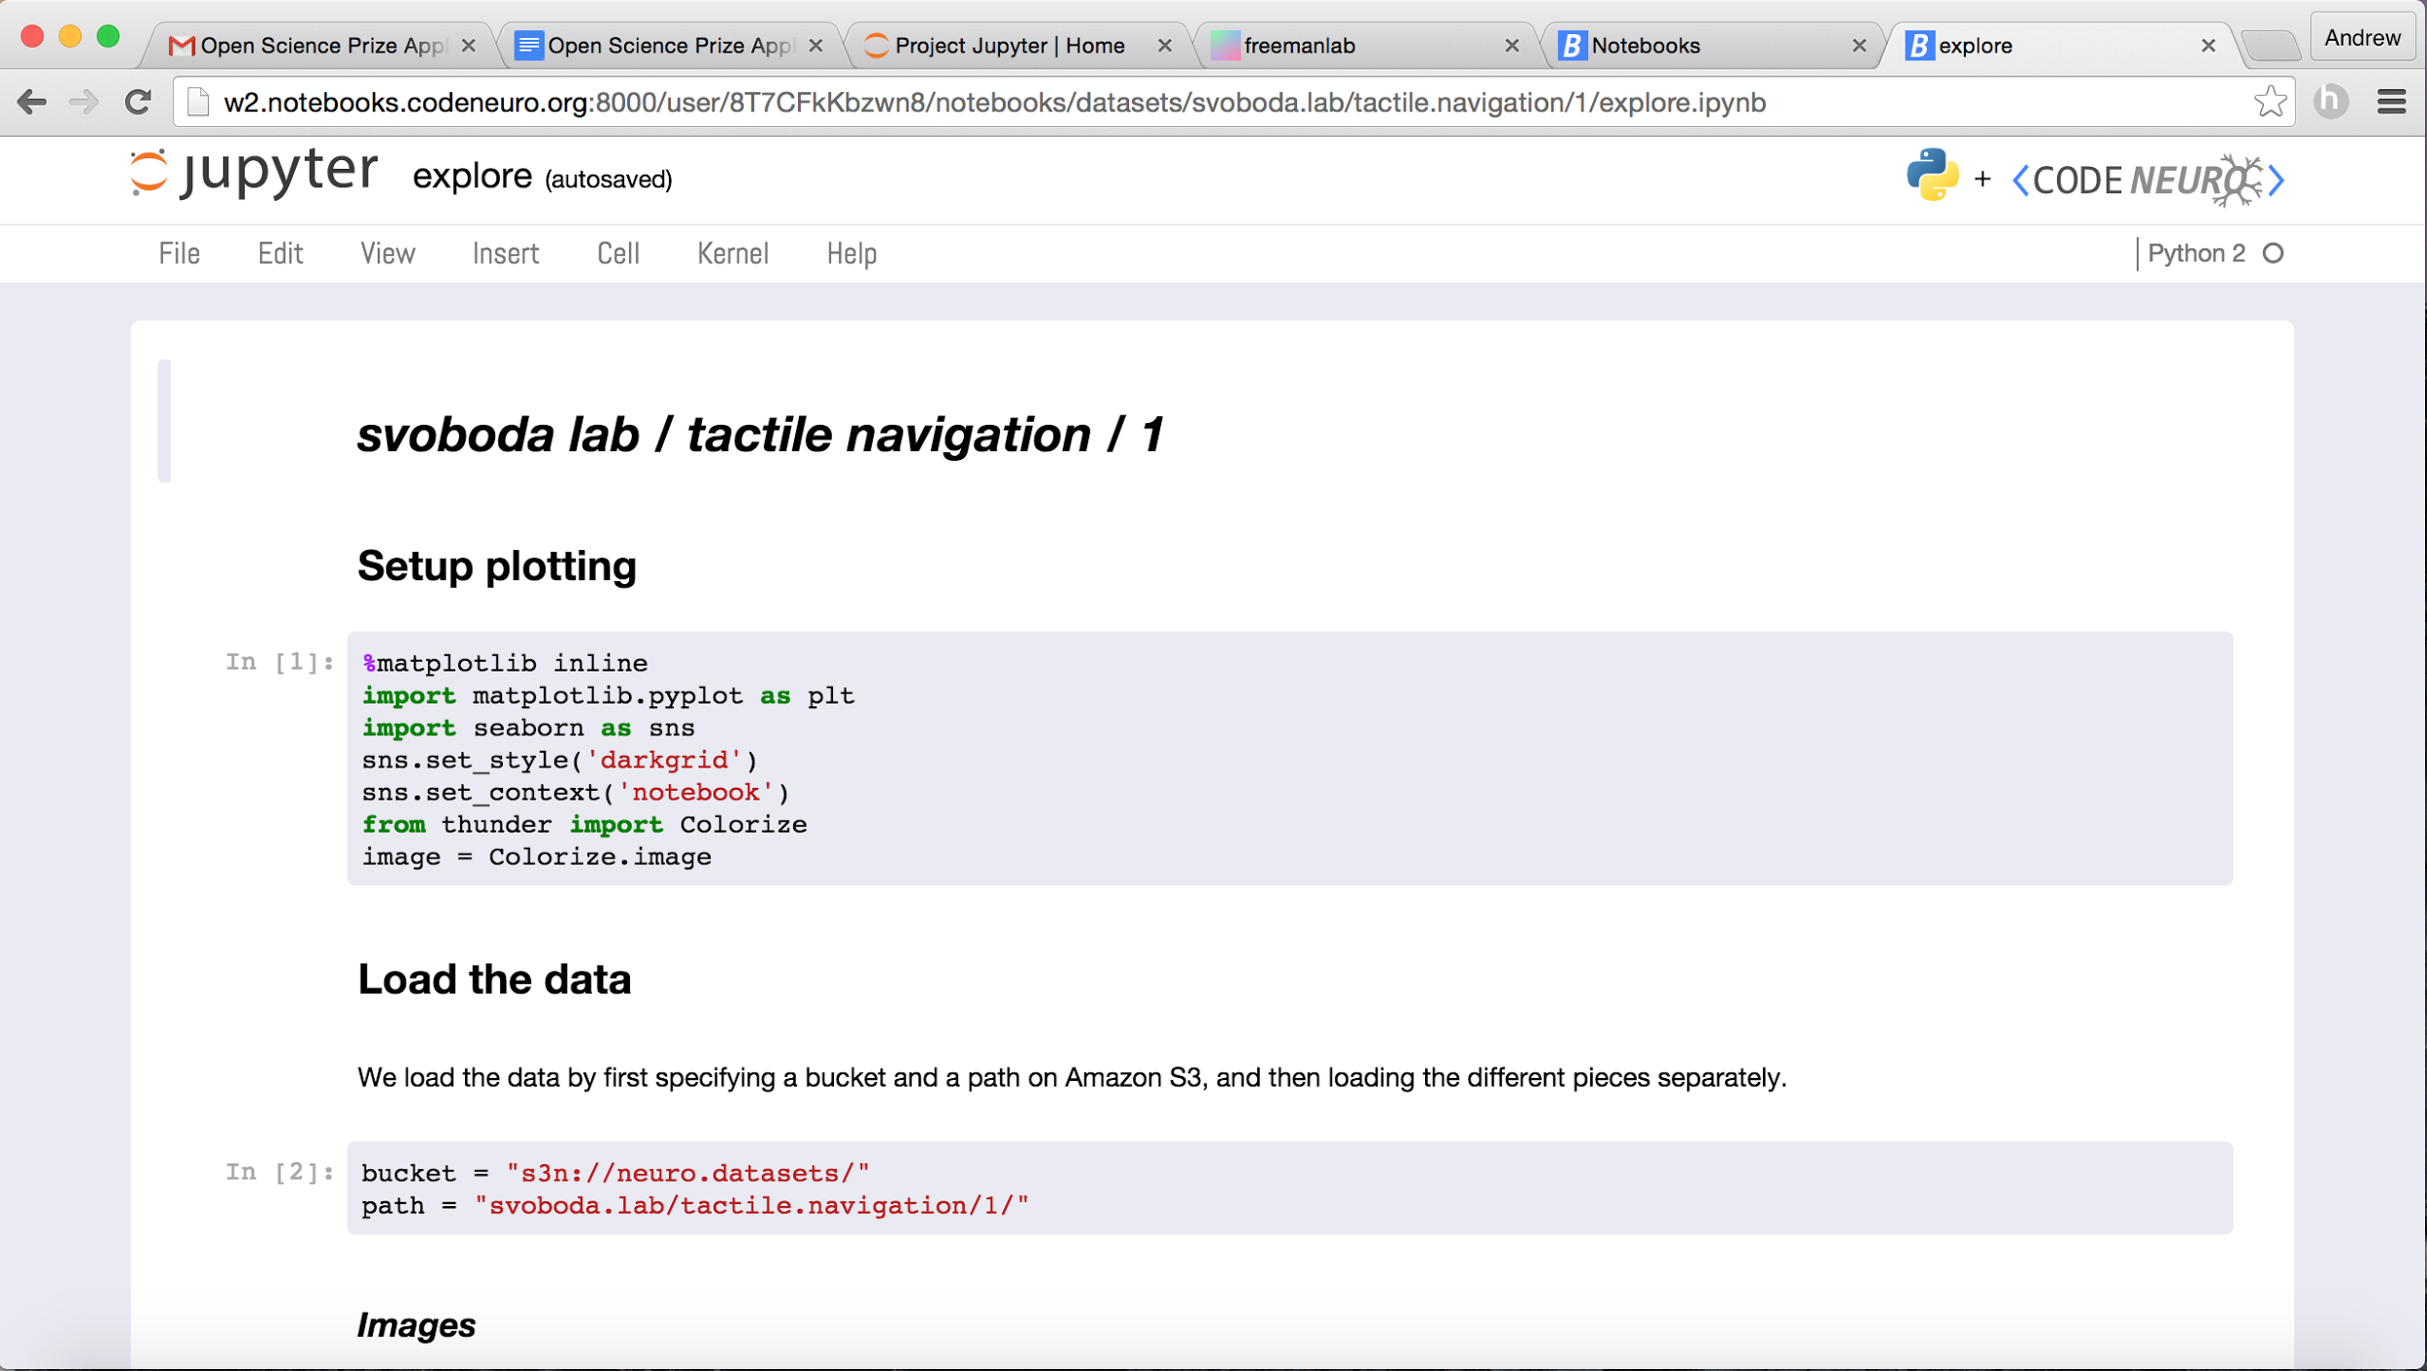

Figure 4. Example of a Binder notebook.

We are partnering with [MNE](http://www.martinos.org/mne/) to provide data analytic tools and recommended best practices for data processing and analysis. MNE is a community-driven open-source software package designed for processing magnetoencephalography (MEG) and electroencephalography (EEG) data. Its developer base consists of neuroscientists and engineers from all across the world who remotely collaborate via GitHub. We are working directly with several MNE developers to integrate these data analysis tools into OpenEXP. In addition to traditional analytics, MNE offers new and powerful machine learning tools with seamless extensions to [scikit-learn](http://scikit-learn.org/), bringing new data science tools to psychological sciences.

Users will be able to create their own data analysis binders within the OpenEXP framework. These binders can be version-controlled and commented, becoming virtual lab notebooks for researchers. This allows the user to go back to previous committed saves and track progress through their analysis pipeline. This binder interface will be beneficial to users because they will create a fully autonomous environment to execute data analysis scripts that can be shared along with published research, which will provide transparent, interactive, and falsifiable results.

Additionally, we plan to create a number of analysis tutorials using the Binder technology. These tutorials will serve as templates for researchers to design their own custom analysis pipelines. Furthermore, and perhaps more importantly, these tutorials could be used to teach students and the community about scientific analysis and about the relationship between the brain and behavior.

**Architecture of the Application**

The proposed open-source software will be built by a team of cognitive neuroscientists, engineers and computer scientists and will be hosted publicly on GitHub. Our software is currently licensed under the MIT License. A prototype of OpenEXP can be viewed and cloned [here](https://github.com/openexp/OpenEXP). We have also attached a runnable prototype of the application, as well as a video overview to the application. The software will be written entirely in modern web technologies (HTML, CSS, Javascript), and will be distributed in [Electron](http://electron.atom.io/) so that the software can be easily downloaded as a desktop application running natively on any platform (windows, mac, linux). To organize the front-end of the application, we will use [Angular.js](https://angularjs.org/). For server-side functionality, we will use a combination of [Node.js](https://nodejs.org/en/) and Electron. For database services, we will use [MongoDB](https://www.mongodb.org/). With our team of experienced scientists, engineers (hardware and software), and web developers, we are very confident that we have the technical means to build this software.

**Summary and Future Plans**

OpenEXP aims to provide an open-source, unified environment for creating, executing and analyzing EEG and behavioral experiments. Using a wide variety of open-source software (such as d3.js, Lightning.js, jsPsych, MNE, Jupyter, Binder and more), our hope is to create an extensive open-science ecosystem, allowing users of the app to learn about the brain, collaborate with others and share what they’ve learned. We are absolutely dedicated to the open-science mission, and feel that the proposed software truly has the potential change the face as cognitive research as we know it. By allowing researchers and community members to collaborate on difficult problems related to the brain, we will learn exponentially more than if we perform our research in isolation.

One of our longer-term goals for the project is to support many different open-source hardware interfaces. We have already been in contact with [Pupil-Labs](https://pupil-labs.com), who created an open-source eyetracker, which would extend our hardware coverage to the vast majority of psychological paradigms. In addition to supporting open-source hardware, we aim to support a large array of EEG hardware, both commercial and research-grade, which will help researchers transition to open-source tools. Ultimately, we aim to support all types of peripheral devices (e.g. galvanic skin response boxes, button boxes, etc.) to allow researchers to use our software for a wide range of experimental setups.

We also see this app having great applicability beyond its research use. Another longer term goal of ours is to use this app to redesign the curriculum of cognitive science. Using the OpenEXP framework, we would like to build an interactive course map (cf. [Fundamentals of Neuroscience](https://www.mcb80x.org/)) that emphasizes different subdomains (perception, learning, memory, attention, language) and is centered around interactive learning by experimentation. Students will have the opportunity to participate in classic psychology experiments curated through our marketplace (e.g. The Stroop Task, The Word Superiority Effect) and gain deeper insights to the way experiments are done. They will also have the opportunity to design their own experiment to get a sense of how research is conducted. A course curriculum would be designed with this active learning approach to encourage students to engage with the subject matter, learn basic programming skills using web-based technology, and spark the interests of young, aspiring scientists. Instructors would be able to aggregate classroom level data, demonstrate the power of reproducible science, and engage with students with this integrative approach.

**Targets for the OpenEXP project:**

Connecting to Hardware -

-Complete software development kit for OpenBCI hardware (Phase I)

-Add support for additional EEG and other biosensing devices (Phase II)

Visualization -

-Build dashboard for real-time EEG visualization (Phase I)

-Add debugging/calibration support to dashboard (Phase I)

-Connect visualizations to Lightning server for remote streaming (Phase I)

-Build dashboard templates for additional hardware (Phase II)

Experimental design and experiment builder -

-Turn jsPsych into an npm module (Phase I)

-Extend jsPsych to include event tagging (Phase I)

-Build initial designs for experiment builder GUI (Phase I)

-Finish experiment builder GUI (Phase II)

Open-source repository of experiments -

-Set up infrastructure for repository of experiments (Phase I)

-Set up remote database to house experiments (Phase I)

-Build RESTful API for communication with database (Phase II)

Data Analysis -

-Embed Binder notebook into application (Phase I)

-Create examples and tutorials of data analyses (Phase II)