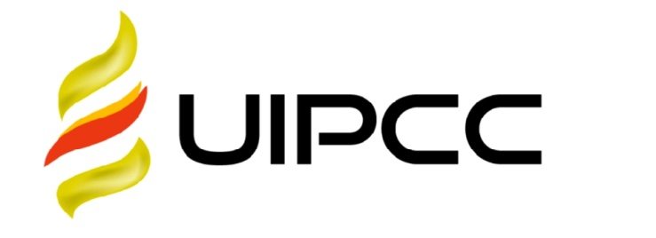

**UNIKEN INTERNATIONAL CO., LTD**



TO : ${airline_name}

${airline_address}

.

DATE :${week}, ${date}

To whom it may concern,

_________

To the AviationFue1 Supply Contract Agreement No. : ${agreement_no}

Payment for uplifts at ${airport_code}

Issuing date: ${issuing_date}

Date of supply: ${supply_start_date} – ${supply_end_date}

CLIENT NAME: ${airline_name}

|  |  |  |  |  |  |  |
| --- | --- | --- | --- | --- | --- | --- |
| **${title}** | | | | | | |
| DATE 日期 | **Airport机场** | **加油量（USG）** | **Price单价（USD/USG）** | **Sum总金额（美元）** | **Tax** | **Incl.Tax USD** |
| ${supply_start_date} – ${supply_end_date} | ${airport_code} | ${usg} | ${price} | ${total} | ${tax} | ${incl_tax} |
| **TOTAL：${usd_total}** | | | | | | |

Please pay this invoice in US Do11ars obligatory mentioning our complete invoice number:

MULTI-CURRENCY SAVINGS ACCOUNT  
Beneficiary Name : UNIKEN INTERNATIONAL CO.,LIMITED

BeneficiaryBank : BANK OF CHINA (HONG KONG) LIMITED  
Bank Address : Shop 608, Level 6 Phase One, New Town Plaza, Sha Tin, New Territories, Hongkong  
Bank Account : 01269592122051

SWIFT : BKCHHKHH

In your banking documents when you pay for fue1 to do the mark- the number of contract between our companies and the number of invoice. The Buyer should to pay any banking services caused to yours.