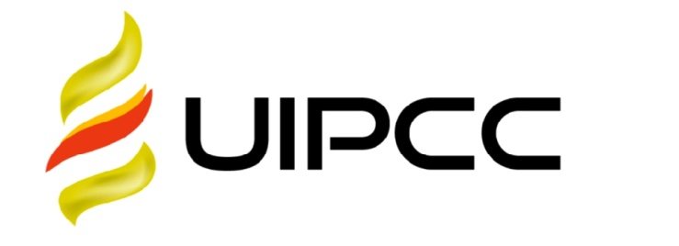

**UNIKEN INTERNATIONAL CO., LTD**



TO : 东航2

test

.

DATE :Tuesday, 13.10.2020

To whom it may concern,

_________

To the AviationFue1 Supply Contract Agreement No. : 123123

Payment for uplifts at FRU

Issuing date: 13.10.2020

Date of supply: 27.03.2020 – 30.04.2020

CLIENT NAME: 东航2

|  |  |  |  |  |  |  |
| --- | --- | --- | --- | --- | --- | --- |
| **2020年3月下半月 FRU 机场加油汇总表** | | | | | | |
| DATE 日期 | **Airport机场** | **加油量（USG）** | **Price单价（USD/USG）** | **Sum总金额（美元）** | **Tax** | **Incl.Tax USD** |
| 27.03.2020 – 30.04.2020 | FRU | 36526.1810 | 2.2738 | 83053.4730 | 0.0000 | 83053.4730 |
| **TOTAL：{$usd_total}** | | | | | | |

Please pay this invoice in US Do11ars obligatory mentioning our complete invoice number:

MULTI-CURRENCY SAVINGS ACCOUNT  
Beneficiary Name : UNIKEN INTERNATIONAL CO.,LIMITED

BeneficiaryBank : BANK OF CHINA (HONG KONG) LIMITED  
Bank Address : Shop 608, Level 6 Phase One, New Town Plaza, Sha Tin, New Territories, Hongkong  
Bank Account : 01269592122051

SWIFT : BKCHHKHH

In your banking documents when you pay for fue1 to do the mark- the number of contract between our companies and the number of invoice. The Buyer should to pay any banking services caused to yours.