(HELP90)

(Double-click anywhere on text to close)

Having selected a site-boat combination it is now possible to add new data or modify previously entered information.

The following data are displayed on the right part of the screen:

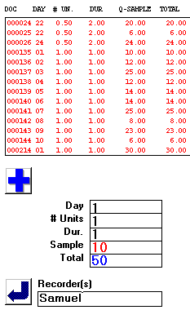

Each red line represents a summary of earlier landing documents identified by a unique identification number of six digits.

ADDING NEW DATA
================
To add a new landings form the user must first enter summary information consisting of:

1. Day of the survey (1,5,13, etc.).
2. Number of fishing units that have landed the catch (in most cases it is 1).
3. Duration of fishing operations in days. Duration can be any integral number or fraction of days, such as 1,2,3, 0.5, etc.

A fraction (such as 0.5) indicates that the catch should be raised to an entire day. This occurs when the recorder sampled catch of one out of two fishing operations that took place on the same day using the same gear.

4. Sample catch used for species composition.
5. Total catch in case only part of the landings was used for species composition/
6. Name of the recorder.

After all these data have been entered the large plus (+) sign must be pressed. In this manner the landing form has been assigned a new document number for reference purposes and the newly entered summary will appear as the last line of the summary list.

Clicking on this new line will allow a species composition table to appear on the left part of the screen.

MODIFICATION OF DATA
=====================
This is done by clicking on a red line containing summary information for a specific document. In this manner users can change summary data or the species composition information that will appear on the left part of the screen.

NOTE: Zero catches must also be entered using a small quantity of say 0.001 kg. Preferably and for precision purposes this negligible catch ought to be entered under the species called OTHER, if such as species exists, else any other species (targeted by this gear) can serve this purpose.

