(HELP21)

(Double-click anywhere on text to close)

The program communicates that:

1. The workstation is ADMINISTRATOR and thus it has access to all tables.

2. There are no tables for the selected period.

3. There are two options:

OPTION 1
========
Create completely new tables using the TABLES button:



OPTION 2
========
Copy tables from any earlier period. These tables are given in a list like this:

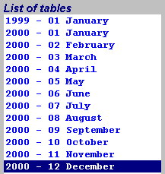

By selecting a set of tables and clicking the duplication button:



all tables will be copied for the new period.

