(HELP30)

(Double-click anywhere on text to close)

From this screen the following tables can be set-up and/or edited:

(1) Major strata:



(2) Minor strata:

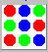

(3) Associating (2) to (1)

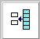

(4) Sites



(5) Associating (4) to (2)

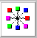

(6) Boat-gear types

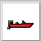

(7) Frame survey

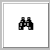

(8) Species

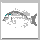

(9) System units

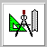

====================================
Use of buttons within tables:

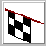 Save table and return

 Print table

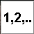Renumber codes (only if no catch/effort
data have been entered)

 Add blank lines for new entries

 Return without saving the table

