(HELP60)

(Double-click anywhere on text to close)

It is mandatory to enter the recorder’s name at the appropriate box shown at the bottom of the screen.

Boat activities are entered into rows of three columns each, representing days of the month.

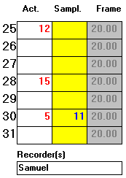

In this example:

FRAME=No. of boats in frame survey. This number cannot be changed here.

SAMPL=If omitted then all 20 boats were examined for being active on days 25,28.

On day 30 the recorder examined only 11 boats, of which 5 were found to be active.

=======================================
After finishing data entry the user may choose:

 Save data and continue

 Print data

 Save data and stay

 Delete all data and re-start

 Return without saving

NOTE: Zero activities must be entered as 0.001.

