(HELP21w)

(Double-click anywhere on text to close)

The program communicates that:

1. This is a WORKSTATION and thus it has no access to the system tables.

2. There are no tables for the selected period.

3. There are two options:

OPTION 1
========
Copy tables from any earlier period. These tables are given in a list like this:

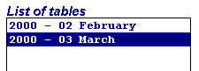

By selecting a set of tables and clicking the duplication button:



all tables will be copied for the new period.

OPTION 2
========
Use the Data Services button:



and on the displayed options list indicate IMPORT TABLES in order to bring in tables that have been set-up by the ADMINISTRATOR.

These tables must reside in C:\ARTBASIC_TABLES.

