(HELPa0)

(Double-click anywhere on text to close)

Having clicked on a document summary will make available a species composition table on the left part of the screen.

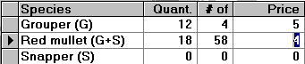

Users may enter:

1. Quantities (integral figures or fractions)
2. Number of fish (optional)
3. Prices (integral or fractions)

NOTE: The sum of entered quantities must tally the specified sample catch of the summary line, else an error message will appear.

After finishing the species composition users must press the OK button in order to continue:



To cancel a doument and remove it from the file of landings the DELETE button must be pressed:



