(HELP10)

(Double-click anywhere on text to close)

The current procedure computes catch/effort estimates using data from sample-based surveys. A second module will later be used for integrated reports, graphics and statistical analyses.

Before accessing the system primary functions, the user has the option to select a language by clicking on one of:



It is then essential to specify the YEAR and MONTH of the survey period.

To select a year the following box is used:

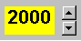

Months are specified by clicking on one of:

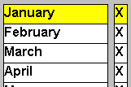

The X sign indicates that there exist data for the selected period.

Selection of YEAR and MONTH will activate the:



button. When pressed the user will access the primary functions.

To exit this program the following button is used:



