Artbasic case study

Part 3: Implementation of Artbasic for system tables

1. Starting Artbasic

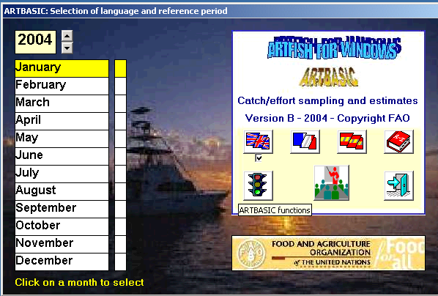

Artbasic is the Artfish module used for table set-up, inputting of sample data and performing estimation procedures. Before these functions become available, Artbasic requires that a time context (or reference period) be specified. This is achieved by first setting-up the year and then clicking on the desired month. The “green light” for Artbasic functions will be turned on and the Artbasic main functions enabled. These will be relating exclusively to the period selected. When in doubt as to what to do next, users may consult the tutorial functions appearing to the right of the green light.

2. Artbasic main functions
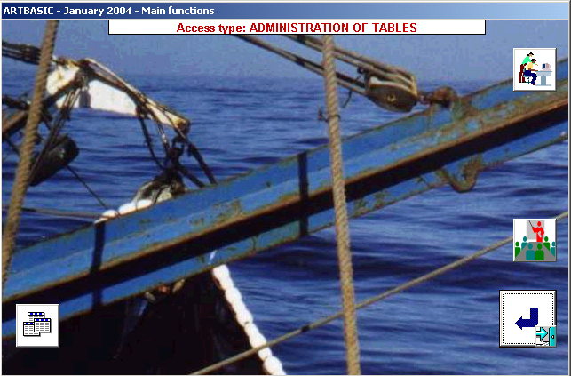

The screen appears after the green light on the start screen was clicked on. At this point there is only one main function available, that for setting-up tables. The corresponding button is found on the leftmost part of the bottom of the screen. By clicking on this function users will be presented with the screen for setting-up the nine Artbasic tables.

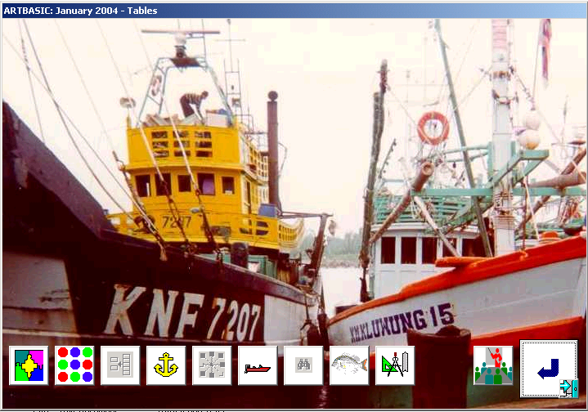

The nine system tables may be worked out in the following sequence:

- Major strata.
- Minor strata.
- Associating minor strata to major strata.
- Sites (landing places and/or homeports).
- Associating sites to minor strata.
- Boat/gear types.
- Species.
- Frame survey data.
- Units used in the system (e.g. kg for weight, US$ for values)

3. General structure of Artbasic tables

Most of the Artbasic tables are constructed in an identical manner, using a common format. Such is the case for major and minor strata, sites, boat/gear types and fish species. For instance, the table illustrated below refers to sites but its functions are applicable to all five tables.

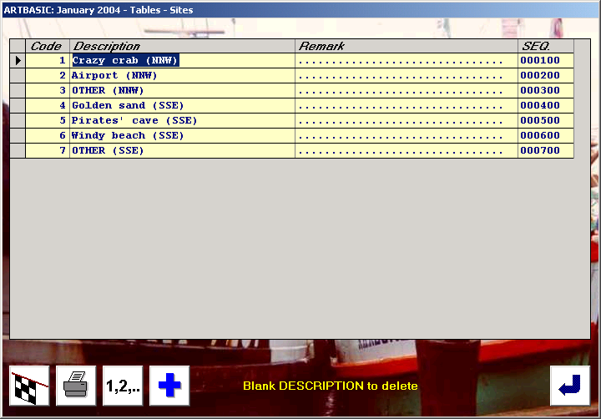

The four buttons at the bottom have the following meaning:

- Blank lines are added by clicking on the icon with the blue cross. Each click adds a block of ten lines. Blank lines are automatically erased when the data are saved.
- Clicking on the rally flag will save the data and return to the table menu.
- The 1,2,... button is used to re-number the table entries. It becomes inactive once sample data have been inputted.
- The printer icon is used to produce a hardcopy of the table.

Each table entry consists of the following elements:

- An internal numerical code attributed automatically. Users cannot change this code except in cases of automatic re-numbering. The latter is only optional and does not affect further processing.
- A description of the table entry (maximum 30 chrs.).
- An optional remark (maximum 30 chrs.), further defining the table entry.
- A sequence code controlled by the user. It can be alphabetic, numeric, and also contain special characters. It determines the sequence in which Artfish standards will appear in reports and input sessions.

Note: A record is deleted by blanking out the description field.

4. Geographical stratification

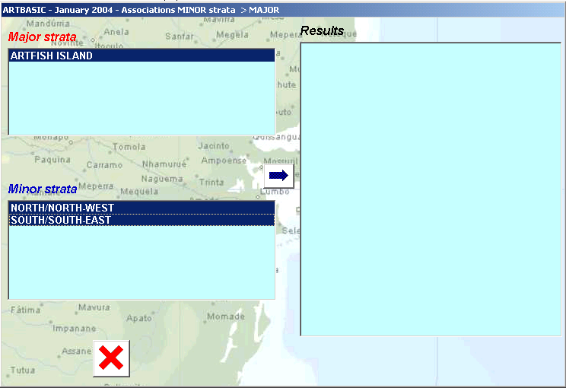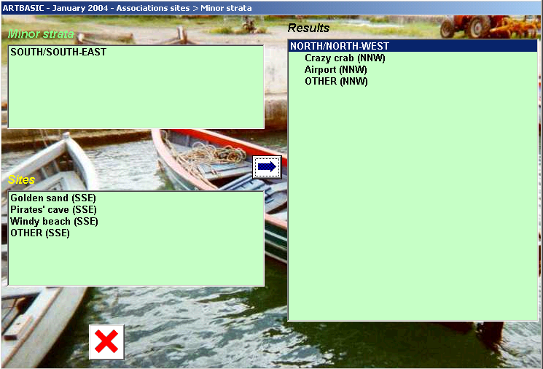

After the tables of major and minor strata have been set-up, Artbasic will associate them using the third table function. This is illustrated by the first screen above. The upper box contains major strata, while the lower contains minor strata. Association works as follows:

- Click and select a major stratum on the upper box
- Click and select all associated minor strata of the lower box
- Click on the blue arrow to confirm operation
- Continue until all major and minor strata have been linked
- Save and return

The second picture illustrates the same approach used for associating sites to minor strata, thus completing the geographical stratification of the Artfish set-up.

Note: Associations are cancelled and the work must resume in case the tables for strata and sites are accessed for modification. For this reason, users that simply want to view/print the tables are advised to use the REPORT function on the right hand side of the screen of the main functions. This function becomes automatically available as soon as tables have started to be built.

5. Case study tables

At this stage users are advised to work in the following order:

- Setting-up major strata
- Setting-up minor strata
- Linking major to minor strata
- Setting-up the sites
- Linking minor strata to sites
- Setting-up boat/gear types
- Setting-up fish species

The following lists may assist in this exercise:

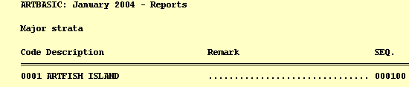

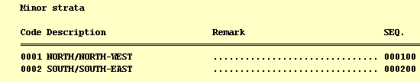

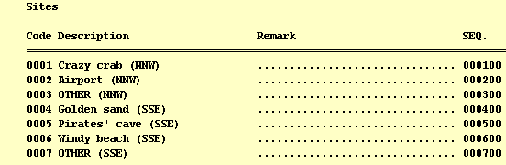

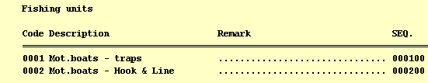

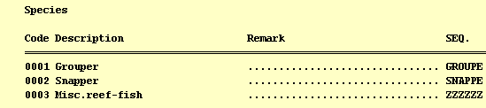

6. Entering frame survey data

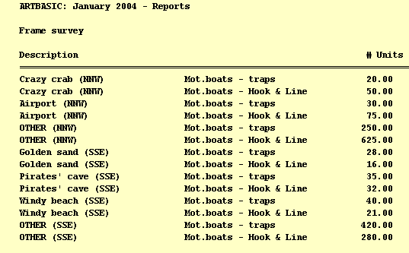

By clicking on the binoculars icon users will be able to enter data to be used as spatial extrapolation factors for estimating fishing effort. The system automatically creates records representing all combinations of sites and boat/gear types. When a boat/gear is not applicable the corresponding entry will show a zero. In all other cases the numbers of units of a specific boat/gear type operating at a site must be inputted.

In this particular exercise users may make use of the above table which contains the data given in Table 1 of Part 2.

8. System units

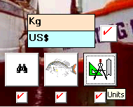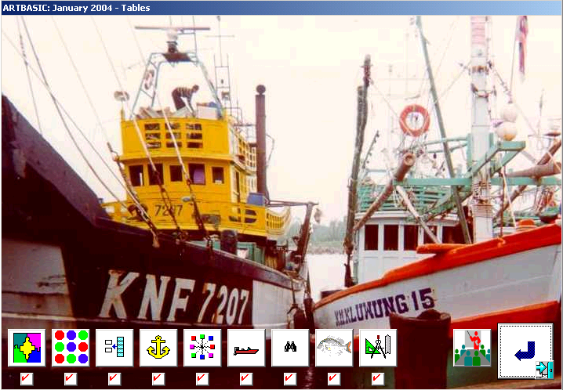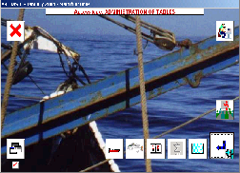

Last action concerns the definition of weight and value units. This is achieved by clicking on the Units button, setting-up codes for the units and then clicking on the OK button.

All nine tables are now marked as completed (second picture) and in the screen of Artbasic main functions (third picture), three new functions are activated. These refer to sample effort, sample catch and active days respectively, and will be the subject of the fourth part of the case study.

