Artbasic case study

Part 4: Sample data on fishing effort

1. The Artbasic screen of main functions

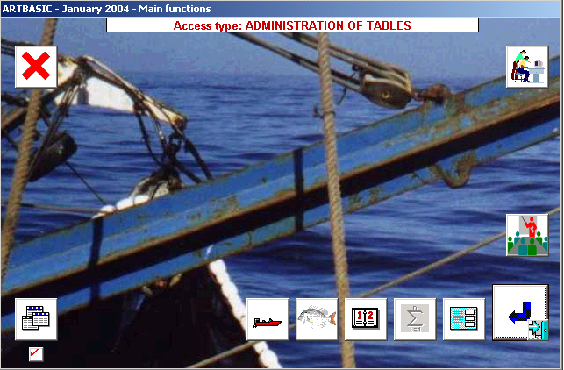

The Artbasic screen of main functions indicates that all tables have been completed. These tables can be viewed and/or printed using the REPORT button. This is always preferable to accessing the tables for updating when there is no such need.

Three new buttons have appeared. The first (with the icon of a boat) is used for entering sample data on boat activities. The second (illustrating a fish) is used for inputting samples of landings. The third (with the calendar) is used for setting-up time extrapolation factors or active days.

2. Active days

Next figure illustrates a completed table of active days.

This table is first set-up automatically by combining minor strata with boat/gear types, the reason being that events of reduced or no activity may affect certain areas or gears but not others.

It is recalled that boats operating fishing traps do not work on Sundays, whereas for those operating hook & line Sundays are normal working days. Since non-active days are determined in a uniform manner (for individual activity level another survey is used), the result here is that traps operate for a maximum of 27 days, computed by subtracting 4 Sundays from the 31 days of January. For hook & line this maximum is set to 31.

The process is ended by clicking on the rally flag, so that the table is saved and control is returned to the main functions screen. The table of active days (see figure below), is now marked as completed.

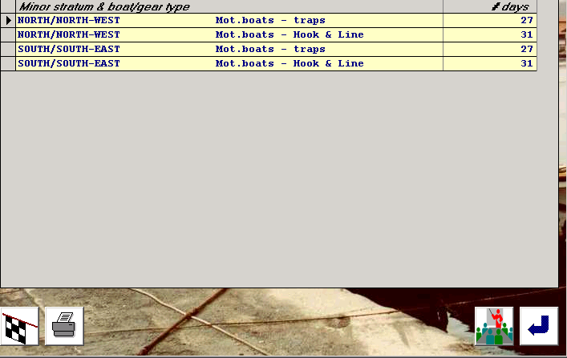

3. Sample data on boat activities

Clicking on the button with the boat icon will activate the following screen:

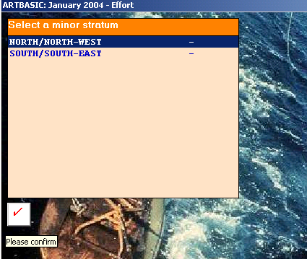

Here the user will select the minor stratum, for instance NNW, and then click on the confirm key. This operation will activate another screen containing sites and boat/gear types for which sample activity data may have been collected.

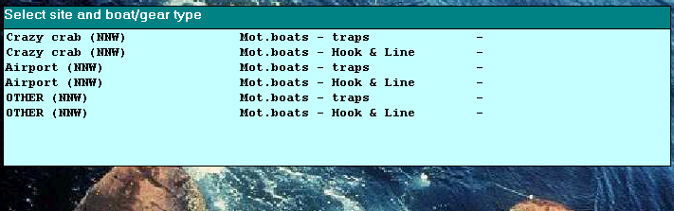

The table above is created automatically by combining only those sites in the selected minor stratum for which non-zero boat/gears have been specified in the frame survey. A minus sign means that no data have been inputted for a given combination, whereas a plus sign means that some or all samples on boat activities already exist.

By clicking on a combination: Sampling site + boat/gear, the following screen will appear:

4. The boat activity screen

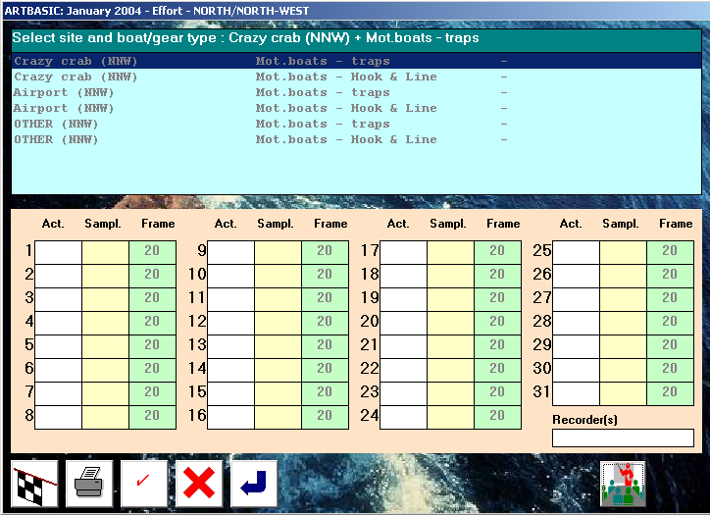

Function keys

- The rally flag is used for saving the data and returning
- The printer icon is used for obtaining a hardcopy after OK was clicked
- The OK sign saves the data and remains on the present screen
- The red X is used for resetting the screen
- The RETURN key quits without saving the data

Table structure and format

The first element to be entered is the recorder’s name using a maximum of 15 characters.

Activity data are entered on the calendar chart. The third column indicates the number of units expected to be potentially operational at the selected homeport on any day, and is obtained from the frame survey. This figure is read-only and cannot be altered at this stage.

The first column is used for indicating the number of boats that were found active during the sampling day. If no figure is entered on the second column, this means that all boats at the site have been examined.

If a figure appears on the second column, this means that only part of the boats were examined. For instance, in the current case study the data recorder will examine at each site a pre-selected sub-set of ten boats of a specific boat/gear, since he will not have the time to examine all boats at the site. An example of this technique is given below:

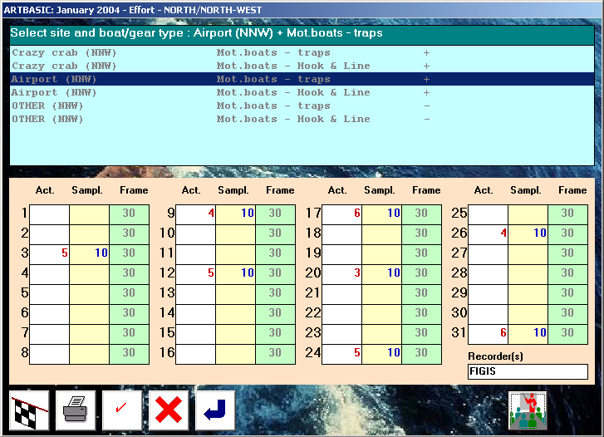
5. Inputting of boat activities for the case study

Following is a chart of boat activity data that have been used by the present case study. It is recalled that for the NNW minor stratum sampling days are the:

3, 9, 12, 17, 20, 24, 26, 31

whereas for minor stratum SSE the days are:

2, 7, 10, 16, 19, 23, 27, 30.

Here active and examined boats are separated by “/”, for instance 6/10 means 6 boats active out of 10 examined. In Artbasic format this will require 6 to be entered in the first column and 10 in the second.

Chart of boat activities to be used in Artbasic

Sampling days → | 3 | 9 | 12 | 17 | 20 | 24 | 26 | 31
Crazy crab - traps | 6/10 | 5/10 | 4/10 | 7/10 | 5/10 | 8/10 | 4/10 | 7/10
Crazy crab – H&L | 4/10 | 2/10 | 6/10 | 5/10 | 1/10 | 3/10 | 4/10 | 2/10
Airport – traps | 5/10 | 4/10 | 5/10 | 6/10 | 3/10 | 5/10 | 4/10 | 6/10
Airport – H&L | 1/10 | 3/10 | 4/10 | 2/10 | 6/10 | 5/10 | 4/10 | 3/10
Sampling days → | 2 | 7 | 10 | 16 | 19 | 23 | 27 | 30
Golden sand - traps | 6/10 | 4/10 | 7/10 | 7/10 | 6/10 | 5/10 | 8/10 | 7/10
Golden sand – H&L | 5/10 | 4/10 | 6/10 | 4/10 | 8/10 | 3/10 | 5/10 | 7/10
Pirates’ cave – traps | 10/10 | 9/10 | 7/10 | 7/10 | 5/10 | 6/10 | 8/10 | 6/10
Pirates’ cave – H&L | 3/10 | 4/10 | 5/10 | 5/10 | 6/10 | 6/10 | 7/10 | 4/10
Windy beach – traps | 5/10 | 5/10 | 7/10 | 8/10 | 5/10 | 7/10 | 4/10 | 6/10
Windy beach – H&L | 1/10 | 3/10 | 4/10 | 1/10 | 4/10 | 3/10 | 4/10 | 6/10

