Artbasic case study

Part 5: Sample data on landings

1. Selecting a minor stratum

Clicking on the button with the fish icon for entering landings, will activate the following screen:

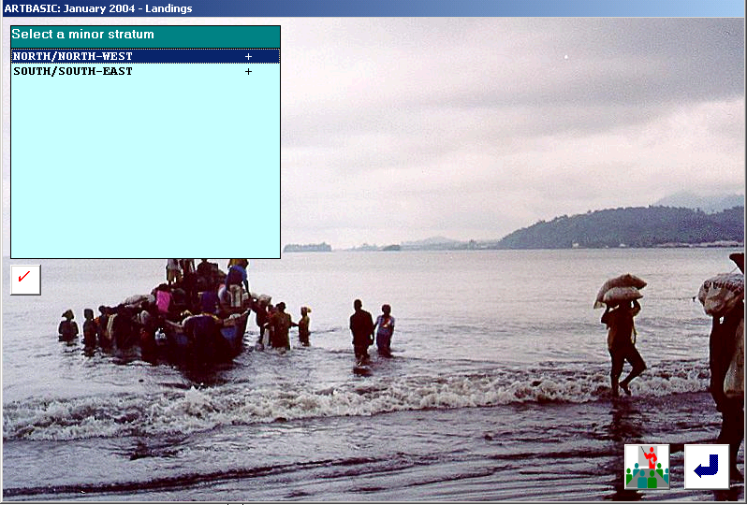

Here the user will select a minor stratum, for instance NNW, and then click on the confirm key. This operation will activate another screen containing sites and boat/gear types for which sample landings may have been collected.

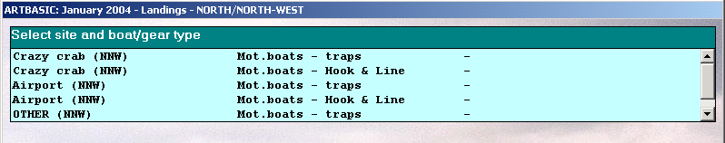

The table above is created automatically by combining only those sites in the selected minor stratum for which non-zero boat/gears have been specified in the frame survey. A minus sign means that no data have been inputted for a given combination, whereas a plus sign means that some or all sample landings have already been recorded.

By clicking on a combination: Sampling site + boat/gear, the following screen will appear:

2. The screen of fishing operations

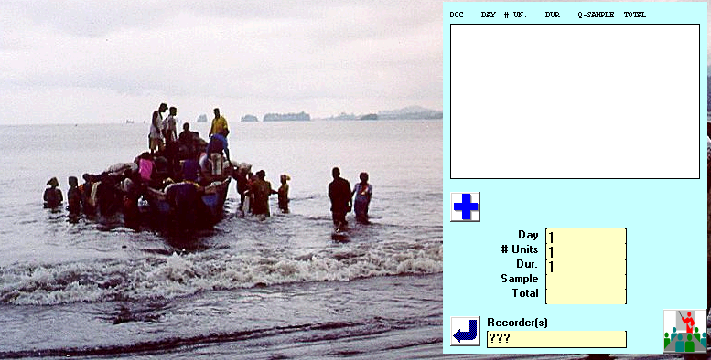

Before entering species composition data, users have to:

- Specify the recorder’s name (to the right of the RETURN key)
- Indicate the sampling day of the month i.e. 3, 7, etc.
- Specify the duration of trip in days.
- Specify the total landings sampled. This must equal the total by species. It is used for control purposes.
- Click on the blue cross to enable the screen for catch by species, numbers of fish in the sample and price.

Note: The “# of Units” and “Total” fields will not be used in this case study. The first is in fact rather rarely required, when more than one fishing units operate and land together. The “Total” field is used when the landings are large and only part is used for species composition.

Clicking on the blue cross will cause the following actions:

- A line summarizing the fishing operation (in red) will be added to the white box.
- A document number will be generated automatically and displayed in red. It is advisable to write this number on the hardcopy form, for cross-reference purposes.
- An inputting chart for species composition will appear.
- For each species the quantity, the number of fish and the price are recorded in separate columns. The last two fields are optional.
- Number of fish and prices may also be used on a sub-sampling basis, that is they need not be always present.
- At the end of the operation the OK button must be used.
- The sum of species must tally the figure specified as “Sample”, else an error message is displayed and the current sample is not accepted.

Following is an example of a completed landings screen.

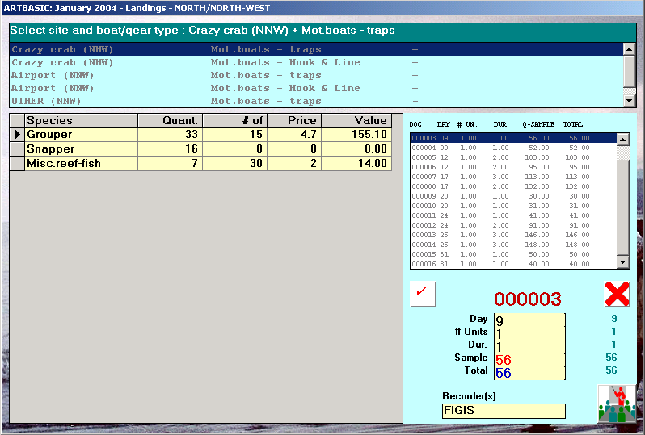

3. Inputting sample landings for the case study

Following is a series of tables containing test data for landings. Although users are not obliged to input the entire dataset, they are advised however to cover as many sites and as many boat/gear types as possible, so as for the results to be reasonably comparable to those produced by the case study.

The tables refer to the following 4 estimation contexts:

- January 2004, minor stratum NNW, boats with traps

  - Site Crazy crab: 16 samples
  - Site Airport: 16 samples

- January 2004, minor stratum SSE, boats with traps

  - Site Golden sand: 16 samples
  - Site Pirates’ cave: 16 samples
  - Site Windy beach: 16 samples

- January 2004, minor stratum NNW, boats with H & L

  - Site Crazy crab: 16 samples
  - Site Airport: 16 samples

- January 2004, minor stratum SSE, boats with H & L

  - Site Golden sand: 16 samples
  - Site Pirates’ cave: 16 samples
  - Site Windy beach: 16 samples
Table 1. Input data (16 samples) for site “Crazy crab” and for boats operating traps.

Crazy crab  Boats with traps | Quant. | # of fish | Price | Day  Duration  Sample total
Grouper | 32 | 20 | 5 | 3
Snapper | 4 | 10 | 5 | 1
Misc. reef-fish | 7 | 20 | 1.5 | 43
Grouper | 117 | 50 | 5.2 | 3
Snapper | 54 |  |  | 3
Misc. reef-fish | 8 |  |  | 179
Grouper | 33 | 15 | 4.7 | 9
Snapper | 16 |  |  | 1
Misc. reef-fish | 7 | 30 | 2 | 56
Grouper | 37 | 0 | 4.2 | 9
Snapper | 8 | 20 | 5.1 | 1
Misc. reef-fish | 7 | 10 |  | 52
Grouper | 69 |  |  | 12
Snapper | 26 |  |  | 2
Misc. reef-fish | 8 | 12 | 2 | 103
Grouper | 65 |  |  | 12
Snapper | 20 |  | 5.2 | 2
Misc. reef-fish | 10 |  |  | 95
Grouper | 62 | 25 | 4 | 17
Snapper | 30 |  |  | 3
Misc. reef-fish | 21 |  |  | 113
Grouper | 78 | 30 | 5.6 | 17
Snapper | 38 |  | 6 | 2
Misc. reef-fish | 16 |  | 2 | 132
Grouper | 20 | 8 | 4.2 | 20
Snapper | 6 | 10 |  | 1
Misc. reef-fish | 4 |  |  | 30
Grouper | 21 | 11 |  | 20
Snapper | 9 | 14 | 6.1 | 1
Misc. reef-fish | 1 | 5 | 1.2 | 31
Grouper | 23 | 12 |  | 24
Snapper | 12 | 10 |  | 1
Misc. reef-fish | 6 |  |  | 41
Grouper | 51 |  |  | 24
Snapper | 22 |  | 5.8 | 2
Misc. reef-fish | 18 |  | 1.5 | 91
Grouper | 107 |  | 4.7 | 26
Snapper | 36 |  |  | 3
Misc. reef-fish | 3 | 10 |  | 146
Grouper | 70 |  | 3.8 | 26
Snapper | 51 |  |  | 3
Misc. reef-fish | 27 |  |  | 148
Grouper | 32 |  | 4 | 31
Snapper | 13 |  |  | 1
Misc. reef-fish | 5 |  |  | 50
Grouper | 25 |  | 4 | 31
Snapper | 6 | 15 |  | 1
Misc. reef-fish | 9 |  |  | 40

Table 2. Input data (16 samples) for site “Airport” and for boats operating traps.

Airport  Boats with traps | Quant. | # of fish | Price | Day  Duration  Sample total
Grouper | 49 | 25 | 4 | 3
Snapper | 19 | 40 | 6 | 2
Misc. reef-fish | 6 | 15 | 1 | 74
Grouper | 58 | 30 | 4 | 3
Snapper | 36 |  |  | 2
Misc. reef-fish | 14 |  |  | 108
Grouper | 59 | 22 |  | 9
Snapper | 6 | 10 |  | 2
Misc. reef-fish | 18 | 40 | 1.2 | 83
Grouper | 30 | 11 |  | 9
Snapper | 11 | 20 | 6 | 1
Misc. reef-fish | 7 |  |  | 48
Grouper | 24 | 7 | 3.8 | 12
Snapper | 16 |  |  | 1
Misc. reef-fish | 8 | 23 |  | 48
Grouper | 21 | 10 | 4.2 | 12
Snapper | 12 | 20 |  | 1
Misc. reef-fish | 2 |  | 0.8 | 35
Grouper | 28 | 12 |  | 17
Snapper | 51 |  | 6 | 1
Misc. reef-fish | 9 |  |  | 88
Grouper | 35 |  |  | 17
Snapper | 10 | 20 |  | 1
Misc. reef-fish | 8 |  |  | 53
Grouper | 107 |  | 5.1 | 20
Snapper | 9 | 12 | 6.1 | 3
Misc. reef-fish | 4 |  |  | 120
Grouper | 78 | 30 |  | 20
Snapper | 16 |  |  | 3
Misc. reef-fish | 27 |  |  | 121
Grouper | 43 | 0 | 5.2 | 24
Snapper | 9 | 15 |  | 2
Misc. reef-fish | 14 |  | 1.5 | 66
Grouper | 51 | 26 |  | 24
Snapper | 26 |  |  | 2
Misc. reef-fish | 16 |  |  | 93
Grouper | 33 |  |  | 26
Snapper | 24 |  | 5.8 | 1
Misc. reef-fish | 3 | 12 |  | 60
Grouper | 76 |  | 4 | 26
Snapper | 42 |  |  | 2
Misc. reef-fish | 12 |  |  | 130
Grouper | 67 |  |  | 31
Snapper | 15 | 30 | 5.5 | 3
Misc. reef-fish | 3 |  |  | 85
Grouper | 36 |  | 5 | 31
Snapper | 12 |  |  | 1
Misc. reef-fish | 1 |  |  | 49

Table 3. Input data (16 samples) for site “Golden sand” and for boats operating traps.

Golden sand  Boats with traps | Quant. | # of fish | Price | Day  Duration  Sample total
Grouper | 13 | 2 | 4.5 | 3
Snapper | 5 | 4 | 6.5 | 1
Misc. reef-fish | 23 |  | 1.2 | 41
Grouper | 33 | 8 |  | 3
Snapper | 12 |  |  | 1
Misc. reef-fish | 28 |  |  | 73
Grouper | 27 | 7 | 5.5 | 9
Snapper | 18 |  | 6 | 1
Misc. reef-fish | 24 |  | 0.5 | 69
Grouper | 32 | 10 |  | 9
Snapper | 8 | 6 |  | 1
Misc. reef-fish | 15 | 56 |  | 55
Grouper | 65 | 20 | 6 | 12
Snapper | 57 |  | 6 | 3
Misc. reef-fish | 10 |  |  | 132
Grouper | 44 | 10 |  | 12
Snapper | 14 |  |  | 2
Misc. reef-fish | 58 |  |  | 116
Grouper | 40 | 8 |  | 17
Snapper | 28 |  |  | 2
Misc. reef-fish | 34 |  | 1 | 102
Grouper | 22 | 5 | 5.5 | 17
Snapper | 15 |  | 5.9 | 1
Misc. reef-fish | 28 |  |  | 65
Grouper | 29 | 8 |  | 20
Snapper | 14 | 17 |  | 1
Misc. reef-fish | 18 | 100 | 1.1 | 61
Grouper | 41 |  |  | 20
Snapper | 24 |  | 6.5 | 2
Misc. reef-fish | 38 |  |  | 103
Grouper | 86 |  | 6 | 24
Snapper | 24 |  | 6.2 | 3
Misc. reef-fish | 54 | 120 | 0.9 | 164
Grouper | 77 | 14 |  | 24
Snapper | 34 |  |  | 2
Misc. reef-fish | 52 |  |  | 163
Grouper | 71 |  | 5.1 | 26
Snapper | 24 |  | 6.1 | 2
Misc. reef-fish | 22 |  | 1 | 117
Grouper | 31 | 5 |  | 26
Snapper | 7 | 6 |  | 1
Misc. reef-fish | 22 |  |  | 60
Grouper | 32 |  | 6 | 31
Snapper | 10 | 10 |  | 1
Misc. reef-fish | 26 |  | 1 | 68
Grouper | 39 |  |  | 31
Snapper | 8 | 12 |  | 1
Misc. reef-fish | 23 | 75 |  | 70

Table 4. Input data (16 samples) for site “Pirates’ cave” and for boats operating traps.

Pirates’ cave  Boats with traps | Quant. | # of fish | Price | Day  Duration  Sample total
Grouper | 27 |  | 4.5 | 3
Snapper | 4 | 6 |  | 2
Misc. reef-fish | 28 |  |  | 59
Grouper | 25 | 6 |  | 3
Snapper | 5 | 5 |  | 1
Misc. reef-fish | 11 | 55 |  | 41
Grouper | 48 |  |  | 9
Snapper | 15 | 10 | 5.8 | 2
Misc. reef-fish | 38 |  | 1 | 101
Grouper | 108 | 27 |  | 9
Snapper | 5 | 8 |  | 3
Misc. reef-fish | 39 |  |  | 152
Grouper | 54 |  | 5.1 | 12
Snapper | 39 |  | 6.1 | 2
Misc. reef-fish | 28 |  | 1 | 121
Grouper | 35 | 9 |  | 12
Snapper | 26 |  |  | 1
Misc. reef-fish | 4 | 22 |  | 65
Grouper | 26 | 5 |  | 17
Snapper | 16 |  | 6.2 | 1
Misc. reef-fish | 9 | 16 | 1 | 51
Grouper | 27 |  | 5.1 | 17
Snapper | 6 | 10 |  | 1
Misc. reef-fish | 6 | 18 |  | 39
Grouper | 42 | 14 |  | 20
Snapper | 8 | 10 | 6.4 | 2
Misc. reef-fish | 2 | 15 | 1.1 | 52
Grouper | 26 |  | 6 | 20
Snapper | 14 |  |  | 1
Misc. reef-fish | 26 |  |  | 66
Grouper | 32 | 10 |  | 24
Snapper | 21 |  | 6.5 | 1
Misc. reef-fish | 1 | 5 | 0.8 | 54
Grouper | 20 |  | 6 | 24
Snapper | 20 |  |  | 1
Misc. reef-fish | 24 |  |  | 64
Grouper | 74 | 25 |  | 26
Snapper | 32 |  | 6 | 2
Misc. reef-fish | 32 |  | 0.9 | 138
Grouper | 55 |  | 5.8 | 26
Snapper | 11 | 15 |  | 2
Misc. reef-fish | 54 |  |  | 120
Grouper | 58 |  |  | 31
Snapper | 14 |  | 5.8 | 2
Misc. reef-fish | 28 |  |  | 100
Grouper | 104 |  |  | 31
Snapper | 14 |  |  | 3
Misc. reef-fish | 84 |  |  | 202

Table 5. Input data (16 samples) for site “Windy beach” and for boats operating traps.

Windy beach  Boats with traps | Quant. | # of fish | Price | Day  Duration  Sample total
Grouper | 14 | 4 | 5 | 3
Snapper | 5 |  |  | 1
Misc. reef-fish | 5 | 15 | 1 | 24
Grouper | 28 |  |  | 3
Snapper | 10 | 12 | 5.9 | 1
Misc. reef-fish | 3 | 20 |  | 41
Grouper | 41 | 10 | 0 | 9
Snapper | 12 | 15 | 0 | 2
Misc. reef-fish | 58 | 0 | 0 | 111
Grouper | 64 |  | 6 | 9
Snapper | 28 |  |  | 2
Misc. reef-fish | 2 | 13 | 1 | 94
Grouper | 61 | 17 |  | 12
Snapper | 10 | 12 | 5.8 | 2
Misc. reef-fish | 20 |  |  | 91
Grouper | 61 |  |  | 12
Snapper | 21 |  |  | 3
Misc. reef-fish | 51 |  |  | 133
Grouper | 37 | 9 | 6 | 17
Snapper | 5 | 6 | 6 | 1
Misc. reef-fish | 13 |  |  | 55
Grouper | 33 | 9 |  | 17
Snapper | 8 | 12 |  | 1
Misc. reef-fish | 14 |  | 0.8 | 55
Grouper | 39 | 12 |  | 20
Snapper | 11 |  |  | 1
Misc. reef-fish | 7 | 25 |  | 57
Grouper | 32 |  |  | 20
Snapper | 15 |  | 6 | 1
Misc. reef-fish | 9 | 28 | 1.5 | 56
Grouper | 119 |  |  | 24
Snapper | 30 |  |  | 3
Misc. reef-fish | 30 |  |  | 179
Grouper | 82 | 20 |  | 24
Snapper | 33 |  |  | 3
Misc. reef-fish | 60 |  | 1.2 | 175
Grouper | 68 |  | 5.4 | 26
Snapper | 34 |  |  | 2
Misc. reef-fish | 50 |  |  | 152
Grouper | 22 |  |  | 26
Snapper | 17 |  | 6.6 | 1
Misc. reef-fish | 20 |  | 1.1 | 59
Grouper | 53 |  | 5.8 | 31
Snapper | 30 |  |  | 2
Misc. reef-fish | 12 | 56 |  | 95
Grouper | 38 |  |  | 31
Snapper | 12 | 15 |  | 1
Misc. reef-fish | 14 |  | 1 | 64

Table 6. Input data (16 samples) for site “Crazy crab” and hook & line.

Crazy crab  Hook & Line  Duration = 1 | Quant. | # of fish | Price | Day  Sample total
Grouper | 25 | 20 | 5.7 | 2
Snapper | 3 | 8 | 5.2 | 28
Grouper | 31 | 50 | 5.7 | 2
Snapper | 14 |  |  | 45
Grouper | 26 | 15 | 5.2 | 7
Snapper | 12 |  |  | 38
Grouper | 29 |  | 4.6 | 7
Snapper | 6 | 12 | 5.4 | 35
Grouper | 27 |  |  | 10
Snapper | 10 |  |  | 37
Grouper | 26 |  |  | 10
Snapper | 8 |  | 5.5 | 34
Grouper | 16 | 25 | 4.4 | 16
Snapper | 8 |  |  | 24
Grouper | 31 | 30 | 6.2 | 16
Snapper | 15 |  | 6.3 | 46
Grouper | 16 | 8 | 4.6 | 19
Snapper | 4 | 10 | 4 | 20
Grouper | 16 | 11 |  | 19
Snapper | 7 | 14 | 6.4 | 23
Grouper | 18 | 12 |  | 23
Snapper | 9 | 10 |  | 27
Grouper | 20 |  |  | 23
Snapper | 8 |  | 5 | 28
Grouper | 28 |  | 5.2 | 27
Snapper | 9 |  |  | 37
Grouper | 18 |  | 4.2 | 27
Snapper | 13 |  |  | 31
Grouper | 25 |  | 4.4 | 30
Snapper | 10 |  |  | 35
Grouper | 20 |  | 4.4 | 30
Snapper | 4 | 9 | 5 | 24

Table 7. Input data (16 samples) for site “Airport” and hook & line.

Airport  Hook & Line  Duration = 1 | Quant. | # of fish | Price | Day  Sample total
Grouper | 11 | 25 | 4 | 2
Snapper | 4 | 10 | 5.2 | 15
Grouper | 14 | 30 | 4 | 2
Snapper | 9 |  |  | 23
Grouper | 14 | 22 |  | 7
Snapper | 1 | 10 |  | 15
Grouper | 15 | 11 |  | 7
Snapper | 5 | 10 | 5.3 | 20
Grouper | 12 | 7 | 3.8 | 10
Snapper | 8 |  |  | 20
Grouper | 10 | 10 | 4.2 | 10
Snapper | 6 | 10 |  | 16
Grouper | 14 | 12 |  | 16
Snapper | 25 |  | 5.4 | 39
Grouper | 17 |  |  | 16
Snapper | 5 | 9 |  | 22
Grouper | 17 |  | 5.1 | 19
Snapper | 1 | 3 | 5.5 | 18
Grouper | 13 | 30 |  | 19
Snapper | 2 |  |  | 15
Grouper | 10 |  | 5.2 | 23
Snapper | 2 | 5 |  | 12
Grouper | 12 | 26 |  | 23
Snapper | 6 |  |  | 18
Grouper | 16 |  |  | 27
Snapper | 12 |  | 4.9 | 28
Grouper | 19 |  | 4 | 27
Snapper | 10 |  |  | 29
Grouper | 11 |  |  | 30
Snapper | 2 | 3 | 5.9 | 13
Grouper | 18 |  | 5 | 30
Snapper | 6 |  |  | 24

Table 8. Input data (16 samples) for site “Golden sand” and hook & line.

Golden sand  Hook & Line  Duration = 1 | Quant. | # of fish | Price | Day  Sample total
Grouper | 17 |  | 4 | 2
Snapper | 5 | 12 | 4.8 | 22
Grouper | 10 | 8 | 4.9 | 2
Snapper | 2 | 5 | 5 | 12
Grouper | 7 | 6 | 4.8 | 7
Snapper | 3 | 4 | 5 | 10
Grouper | 9 | 7 | 4.5 | 7
Snapper | 5 | 8 | 5 | 14
Grouper | 10 |  | 4.6 | 10
Snapper | 7 |  | 5.1 | 17
Grouper | 18 | 12 | 5.2 | 10
Snapper | 10 | 20 | 5.5 | 28
Grouper | 10 | 10 | 5 | 16
Snapper | 5 | 10 | 5.2 | 15
Grouper | 30 | 20 | 5 | 16
Snapper | 4 | 6 | 5.2 | 34
Grouper | 10 |  |  | 19
Snapper | 8 |  |  | 18
Grouper | 13 |  |  | 19
Snapper | 9 |  |  | 22
Grouper | 6 | 7 | 5 | 23
Snapper | 2 | 3 | 5.3 | 8
Grouper | 11 |  |  | 23
Snapper | 5 |  |  | 16
Grouper | 15 |  |  | 27
Snapper | 8 |  |  | 23
Grouper | 21 |  |  | 27
Snapper | 7 |  |  | 28
Grouper | 30 | 20 | 5.2 | 30
Snapper | 11 | 15 | 5.4 | 41
Grouper | 21 | 15 | 4.8 | 30
Snapper | 4 | 4 | 6 | 25

Table 9. Input data (16 samples) for site “Pirates’ cave” and hook & line.

Pirates’ cave  Hook & Line  Duration = 1 | Quant. | # of fish | Price | Day  Sample total
Grouper | 15 | 12 | 5 | 2
Snapper | 13 | 18 | 5.1 | 28
Grouper | 10 | 6 | 5 | 2
Snapper | 5 | 8 | 5.1 | 15
Grouper | 11 |  |  | 7
Snapper | 7 |  |  | 18
Grouper | 10 |  |  | 7
Snapper | 12 |  |  | 22
Grouper | 25 | 30 | 4.5 | 10
Snapper | 13 | 15 | 5.8 | 38
Grouper | 11 |  |  | 10
Snapper | 6 |  |  | 17
Grouper | 20 |  |  | 16
Snapper | 14 |  |  | 34
Grouper | 19 |  |  | 16
Snapper | 9 |  |  | 28
Grouper | 11 | 6 | 5.5 | 19
Snapper | 6 | 8 | 5.6 | 17
Grouper | 19 | 8 | 5.2 | 19
Snapper | 3 | 4 | 5.5 | 22
Grouper | 9 |  |  | 23
Snapper | 5 |  |  | 14
Grouper | 20 |  |  | 23
Snapper | 3 |  |  | 23
Grouper | 11 | 10 | 5 | 27
Snapper | 8 | 12 | 5.8 | 19
Grouper | 20 |  |  | 27
Snapper | 5 |  |  | 25
Grouper | 28 |  |  | 30
Snapper | 9 |  |  | 37
Grouper | 15 | 6 | 5.5 | 30
Snapper | 6 | 6 | 6 | 21
Table 10. Input data (16 samples) for site “Windy beach” and hook & line.

Windy beach  Hook & Line  Duration = 1 | Quant. | # of fish | Price | Day  Sample total
Grouper | 20 | 20 | 5 | 2
Snapper | 10 | 10 | 6 | 30
Grouper | 12 |  |  | 2
Snapper | 10 |  |  | 22
Grouper | 10 |  |  | 7
Snapper | 6 |  |  | 16
Grouper | 19 |  |  | 7
Snapper |  |  |  | 19
Grouper | 20 | 15 | 5 | 10
Snapper | 15 | 18 | 5.2 | 35
Grouper | 20 |  |  | 10
Snapper | 9 |  |  | 29
Grouper | 12 |  |  | 16
Snapper | 3 |  |  | 15
Grouper | 20 | 12 | 5.2 | 16
Snapper | 2 | 3 | 6 | 22
Grouper | 22 | 15 | 5 | 19
Snapper | 8 | 12 | 5.2 | 30
Grouper | 12 |  |  | 19
Snapper | 5 |  |  | 17
Grouper | 12 |  |  | 23
Snapper |  |  |  | 12
Grouper | 20 |  |  | 23
Snapper | 5 |  |  | 25
Grouper | 12 | 5 | 5.5 | 27
Snapper | 4 | 10 | 4.8 | 16
Grouper | 15 |  |  | 27
Snapper | 14 |  |  | 29
Grouper | 30 |  |  | 30
Snapper | 15 |  |  | 45
Grouper | 11 | 5 | 5.3 | 30
Snapper | 2 | 2 | 6 | 13

