Artbasic case study

Part 6: Estimation and reporting

1. Ready to estimate

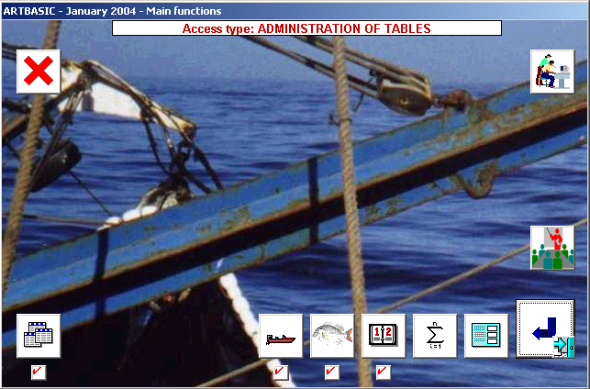

In the Artbasic screen of main functions the four buttons for tables, landings, boat activities and active days have been marked as completed.

The system has also activated the estimation function (represented by the summation symbol), that was not enabled before.

Clicking on this function will bring in the following screen:

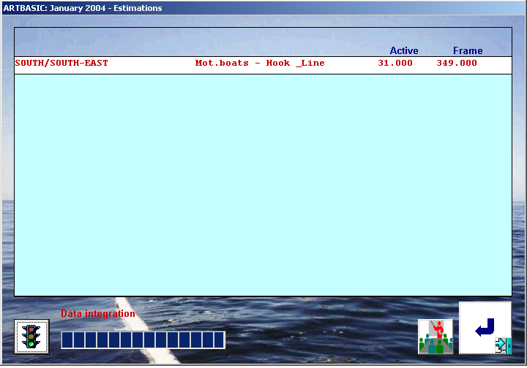
Clicking on the button with the green traffic light will trigger the automatic computation of estimates for all estimation contexts, that is for all combinations of minor strata and boat/gear types for the month of January 2004.

At the end of the process a computations log containing messages and diagnostics will be displayed.

2. Reporting of results

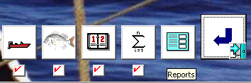

All Artbasic data (including tables, inputted samples and results), are included in the REPORTS function. Clicking on it will activate the following screen:

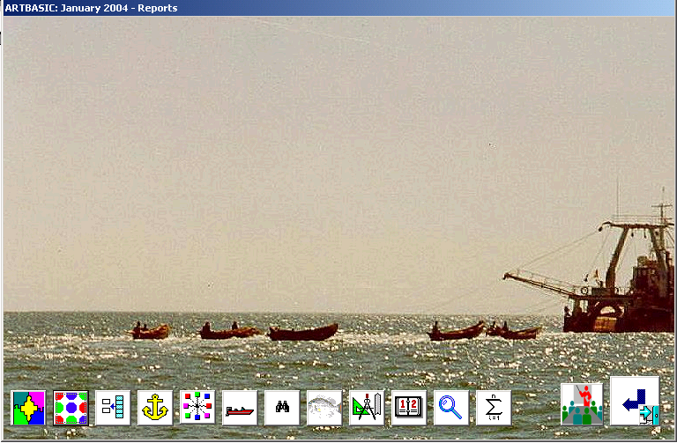

- The first 10 buttons are used for displaying/printing the nine system tables and the table of active days.
- The function with the magnifying glass is used for obtaining an insight into the inputted sample landings.
- The function with the summation symbol will take to the reporting procedures of estimates (see figure below).

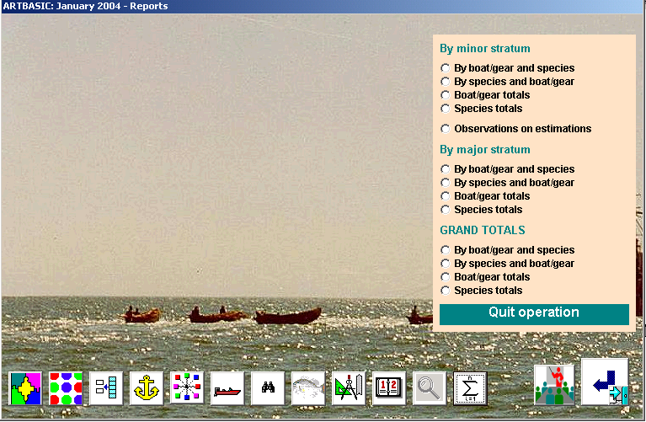

Reporting of estimates can be done in three geographical levels represented by three distinct blocks of reporting procedures:

- At minor stratum
- At major stratum
- Grand total

Within each block there are four identical data grouping functions:

- Statistics for each boat/gear type and then for all species caught by the gear
- Statistics for each species and then for all boat/gears that have targeted the same species
- Grouped estimates for boat/gears (all species together)
- Grouped estimates for species (irrespective of boat/gear)

The very first report is by minor stratum and then by each boat/gear type and then for all species caught by the gear. It is the most detailed of all reports and contains all statistical messages and diagnostics required for evaluating the reliability of the resulting estimates.

Notes:

- Clicking on the yellow part of the screen will return to the reports menu
- All different reports produced in a single session are accumulated into an Execl worksheet (see last section)

Some examples of reports are given below:

Example 1: Details by boat/gear and species, and at minor stratum level

ARTBASIC: January 2004 - Reports ( Estimation )

Minor stratum : NORTH/NORTH-WEST
Order : By boat/gear and species
===========================================================================================
UNITS IN USE

Catch in: Kg
Effort in: Fishing days
CPUE in: Kg/Fishing days
Prices in: US$/Kg
Values in: US$
Average weight of fish in: Kg/fish

NORTH/NORTH-WEST : Mot.boats - traps
===========================================================================================
Estimation of effort

BAC - Boat Activity Coefficient......... 52.500 %
Accuracy level.......................... 92.329 %
Units sampled........................... 160
Active.................................. 84

# sites................................. 2
# days.................................. 8
BAC variability......................... 6.325 %
BAC var component (space)............... 1.568 %
BAC var component (time)................ 4.758 %
BAC lower limit at 95%.................. 45.991 %
BAC upper limit at 95%.................. 59.009 %

Units in frame survey................... 300
Active days............................. 27.000
Estimated effort (days)................. 4 253
Effort lower limit at 95%............... 3 725
Effort upper limit at 95%............... 4 780

Estimation of catch

CPUE.................................... 46.625
Accuracy level.......................... 90.033 %
Landings sampled........................ 32
Sample catch............................ 2 611
Sample effort........................... 56.000

# sites................................. 2
# days.................................. 8
CPUE variability........................ 4.614 %
CPUE var component (space).............. 0.565 %
CPUE var component (time)............... 4.049 %
CPUE lower limit at 95%................. 42.408
CPUE upper limit at 95%................. 50.842

Estimated catch (Kg) ................... 198 273
Catch variability....................... 7.829 %
Catch lower limit at 95% (Kg) .......... 167 847
Catch upper limit at 95% (Kg) .......... 228 699

Total value (US$) ...................... 899 787
Average price (US$/Kg) ................. 4.538

<
Catch by species Quant. CPUE Value
Effort Aver.W Price

Grouper 124 310 ( 62.7%) 29.232 569 537 ( 63.3%)
4 253 2.279 4.582

Snapper 50 498 ( 25.5%) 11.875 293 747 ( 32.6%)
4 253 0.553 5.817

Misc.reef-fish 23 465 ( 11.8%) 5.518 36 503 ( 4.1%)
4 253 0.384 1.556

<
NORTH/NORTH-WEST : Mot.boats - Hook & Line
===========================================================================================
Estimation of effort

BAC - Boat Activity Coefficient......... 34.375 %
Accuracy level.......................... 92.279 %
Units sampled........................... 160
Active.................................. 55

# sites................................. 2
# days.................................. 8
BAC variability......................... 11.526 %
BAC var component (space)............... 0.563 %
BAC var component (time)................ 10.963 %
BAC lower limit at 95%.................. 26.609 %
BAC upper limit at 95%.................. 42.141 %

Units in frame survey................... 750
Active days............................. 31.000
Estimated effort (days)................. 7 992
Effort lower limit at 95%............... 6 187
Effort upper limit at 95%............... 9 798

Estimation of catch

CPUE.................................... 26.219
Accuracy level.......................... 90.017 %
Landings sampled........................ 32
Sample catch............................ 839
Sample effort........................... 32.000

# sites................................. 2
# days.................................. 8
CPUE variability........................ 6.289 %
CPUE var component (space).............. 2.650 %
CPUE var component (time)............... 3.640 %
CPUE lower limit at 95%................. 22.987
CPUE upper limit at 95%................. 29.451

Estimated catch (Kg) ................... 209 545
Catch variability....................... 13.131 %
Catch lower limit at 95% (Kg) .......... 155 617
Catch upper limit at 95% (Kg) .......... 263 473

Total value (US$) ...................... 1 056 917
Average price (US$/Kg) ................. 5.044

<
Catch by species Quant. CPUE Value
Effort Aver.W Price

Grouper 148 605 ( 70.9%) 18.594 725 436 ( 68.6%)
7 992 0.855 4.882

Snapper 60 940 ( 29.1%) 7.625 331 481 ( 31.4%)
7 992 0.480 5.439

Example 2: Summary by boat/gear type and at major stratum level

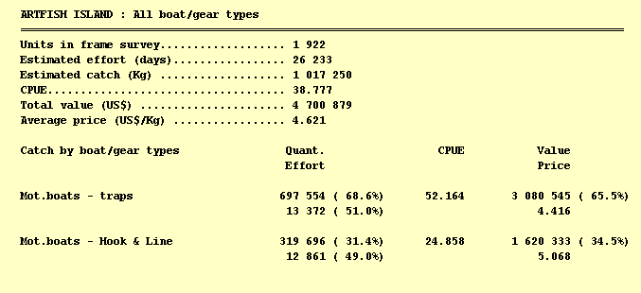

Example 3: Summary by species and at major stratum level

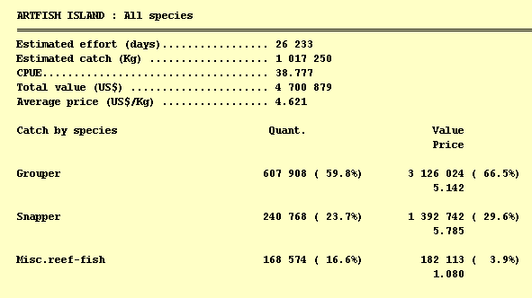

3. Exporting of results

During an Artbasic reporting session all different reports that have been produced by the same run are accumulated automatically into the Excel worksheet ARTBASIC.XLS which is in:
C:\ARTBAS\EXPORTS

Calling it up must be followed by the following two actions:

- Enabling the worksheet macros
- Pressing CTL+a

The worksheet will have the following format:

