(HELP40)

(Double-click on text to terminate)

The following diagram illustrates the five types of reporting functions.

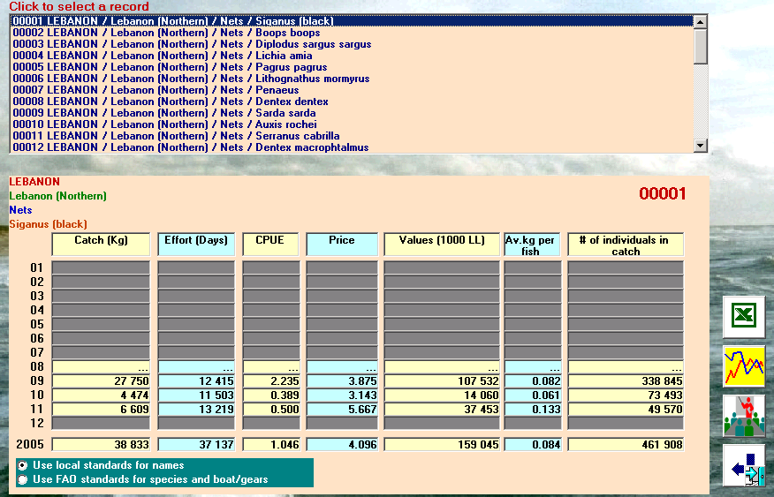
1
2
3
4
5

1. SELECTING A RECORD FROM THE CREATED DATABASE

The program displays for selection all records of the newly created database. Depending on the type of selection and/or computations, this database can be as detailed as resulting from the estimates or in summary form by grouping and ranking.

In its most detailed form it displays monthly estimates and yearly totals organized by major stratum, minor stratum, boat/gear type and species.

2. DISPLAY OF A SINGLE RECORD

By clicking on a record its contents will be displayed in seven columns including: Catch, effort CPUE, price, value, average fish size in kg, and number of individuals in the catch.

In case data are incomplete a red label will flash the event and users may consult an error list displaying all records with missing data.

3. FAO STANDARDS

The reporting program provides the option to work with FAO standards for species, boat/gear codes and areas. However, such information must exist in the secondary tables of the catch/effort estimation system.

4. EXCEL reports

By clicking on the EXCEL button all records will appear in EXCEL format. Users are informed that:

- Only one EXCEL report can be produced at a time, else an error message is displayed.
- Prior to using the EXCEL facility users are asked to check the GENERAL.BAT procedure in the EXCEL_REPORTS sub-folder. In there the command invoking EXCEL must be pointing to the correct Microsoft Office/OfficeXX sub-folder.

5. PLOTTING OF A RECORD

A simple graphics function will be made available by means of which users can plot up to five variables, i.e. catch, effort, CPUE, price and average fish size in kg.

