(HELP10)

(Double-click on text to terminate)

--- ABOUT THIS PROGRAM ---

This is the data integration and reporting program by means of which monthly estimates are grouped together on a yearly basis. The following diagram illustrates the five basic functions that are made available when the program is launched.

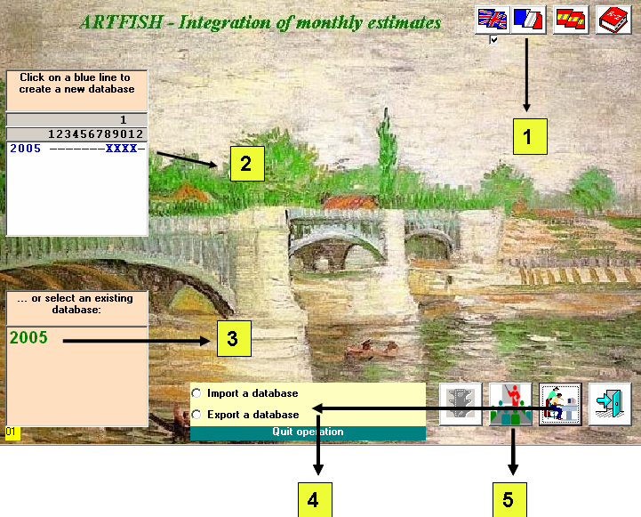

1. WORKING LANGUAGE

Selection of one of three standard languages (English, French, Spanish), or of a local language. If a local language is required then users must translate the system messages included in the Excel document ARTSMSG.XLS in the MESSAGES sub-folder.

2. CREATE A DATABASE FROM MONTHLY ESTIMATES

If the user’s PC is also used for the monthly production of catch/effort estimates, the program detects all periods (years and months) for which monthly estimates have been produced.

Clicking on a blue line that corresponds to a year will automatically create a database for this specific year. The presence of monthly estimates is marked with an “X”, their absence with a “-“.

It is recommended that this function is used at all times, even if an existing database will be replaced by the same results, so as to ensure that the integrated data are up-to-date.

3. USE AN EXISTING DATABASE

Once a database has been created it is catalogued and appears in a separate box. Clicking on a year (equivalent to a database for this year), will activate the green traffic light which will take the user to the second screen.

4. DATA SERVICES (importing/exporting databases)

The user who is responsible for generating databases can export them for use by other users by clicking the EXPORT ALL DATABASES option. In this case all data and tables will be recorded under the folder:

C:\ARTSER_DATA_AND_TABLES

which can then be passed on or sent to other users.

Alternatively, users who do not have monthly estimates on their PCs can always use the integrated databases by first making them appear under:

C:\ARTSER_DATA_AND_TABLES

and then clicking on the IMPORT DATABASES option.

5. BUILT-IN TUTORIAL

All five screens of this program contain built-in tutorial to assist users during the initial phase of implementation. To close a tutorial screen users simply double-click anywhere on the text.

