Karl Winner

Sr. Systems Engineer

Advanced Navigation and

Positioning Corporation

Hood River OR USA

e-mail: kwinner@anpc.com

**Application of the Transponder Landing System**

**To Achieve Airport Accessibility**

# Abstract

The Transponder Landing System (TLS) is a precision approach landing system designed for use at airports where rough terrain or real estate constraints make Instrument Landing System (ILS) installation cost-prohibitive. All aircraft that are equipped to fly an ILS and are equipped with a transponder can also use TLS. TLS determines the aircraft’s position in space from signals emitted by the aircraft’s transponder, using time and angle measurements at ground-based sensors. ILS-like localizer and glide slope corrections are computed to guide the aircraft to the desired course. The pilot can fly a precision approach to Category I minimum decision heights, just like flying an ILS. TLS is inherently easier to site than ILS and therefore can be less costly to install and to successfully flight inspect. TLS can provide Category I signals-in-space without extensive ground conditioning.

# Background

ILS glide slope equipment can be challenging to site at airports that are located near rough terrain. Lateral ground plane requirements are sometimes costly to satisfy where antenna tower offset criteria are applied to comply with Obstacle Free Zone surfaces. At some airports, upslope of terrain below the proposed approach path precludes the use of ILS glide slope equipment without extensive earth removal to reduce multipath.

ILS localizer performance can be diminished by multipath from large buildings located on the airport property itself. Restrictions to aircraft and vehicular movement can cause significantly reduced airport throughput when critical area protective measures are in effect.

What is needed is a new precision landing system that can measure the aircraft location and compensate for the effects of ground-based multipath. Critical areas associated with ground sensors and transmitters should be designed to have minimal operational impact.

# Introduction

From a pilot’s perspective, a TLS approach is similar to an ILS approach, except that transponder operation with an IFR transponder code is required. The aircraft must be equipped with an ILS localizer and glide slope receiver, a localizer and glide slope Horizontal Situation Indicator (HSI) or Course Deviation Indicator (CDI), and a Mode 3/A compatible transponder. The ground-based TLS determines the location of the aircraft by interrogating the aircraft transponder and then measuring the transponder Time-Of-Arrival (TOA), azimuth angle and elevation angle with two Angle-of-Arrival (AOA) sensors. Once the location of the aircraft is determined, the amount of localizer or glide slope correction is determined to guide the aircraft back to the desired course. This guidance information is transmitted throughout the TLS service volume to the tracked aircraft using the VHF localizer and UHF glide slope signals modulated with 90 and 150 Hz tones. The pilot can fly a TLS precision approach to Category I minimum decision heights, as supported by TERPS and approach lighting.

All TLS glide slope and localizer signal parameters comply with ICAO Annex 10[1] standards for Category I ILS, including service volume, displacement sensitivity, clearance, alignment, modulation, frequency and crossing height.

ILS frequency engineering principles also apply to TLS.

Flight inspection of TLS is very similar to flight inspection of ILS with some differences described in *FAA Order 8200.40 Flight Inspection of the Transponder Landing System*.

# TLS components & subsystems

## Interrogator Antenna

TLS mode 3/A interrogation coverage has been designed to trigger transponder replies within the standard service volume. Side Lobe Suppression (SLS) is transmitted to suppress transponder replies outside the coverage volume. TLS interrogator emissions exhibit low pulse repetition frequency and low transmit amplitude to yield virtually no impact on the operation of nearby Secondary Surveillance Radars (SSR) or Aircraft Collision Avoidance Systems (ACAS)2. The interrogator antennas are shown in Figure 1.

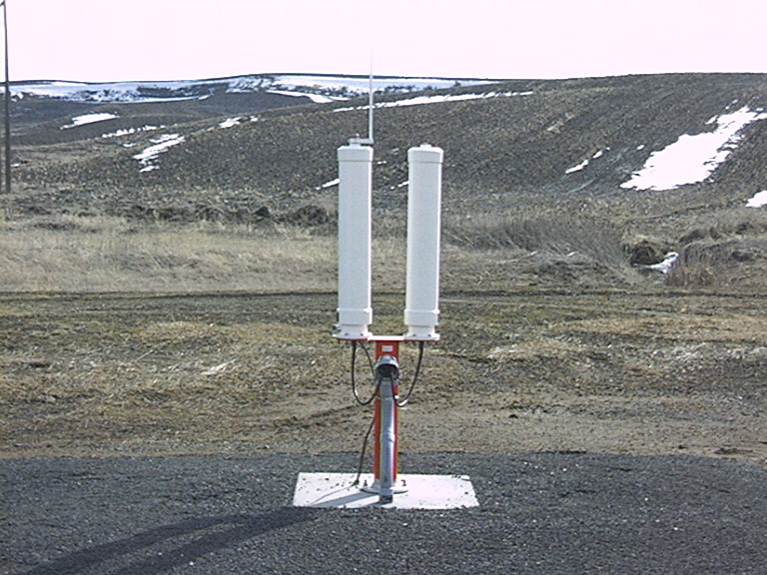

Figure 1: Interrogation and SLS antennas are shown; each antenna is vertically polarized with 6 driven, radiating elements. Main lobe peak is +3 degrees above the horizon. The assembly is 2 m tall.

## Elevation Measurement Subsystem

The transponder reply time-of-arrival (TOA) and elevation angle-of-arrival (AOA) is measured using an interferometer array of four receiving antenna. By designating the lowest antenna as a Reference signal and applying differential carrier phase measurement techniques to the received signal at each of the other three antennas (each differenced with the reference signal), three measurements of the angle of arrival can be computed.

Two or more transponder signal wavefronts arriving at an antenna will sum vectorially based on their phase and amplitude with a resultant phase  as shown in equation 1.

 eq. 1

where:

, are the amplitude and phase of the direct path signal.

, are the amplitude and phase respectively of the multipath signal.

The most straightforward method to achieve an accurate measurement of quantity is to reduce the amplitude  of the multipath signal. To reduce the amplitude of the ground-based multipath signal, the antennas used for the TLS elevation array have been selected to have a steep gain from –3 degrees to +4 degrees about the horizon, as shown in Figure 3. The steep slope significantly reduces the amplitude of reflections below the horizon relative to those above the horizon. Aircraft on final approach will generally be around 3° above the horizon and the most significant multipath returns from an ideal (flat) ground plane surface will have a reflection angle of approximately -3°. Referring to Figure 2, this 6° separation centered about the horizon provides about 12.5 dB suppression of the multipath from the direct path signal.



Figure 2: Elevation antenna vertical pattern. Each antenna element is a vertical array of 6 wavelengths in height to reduce the amplitude of ground-based multipath.

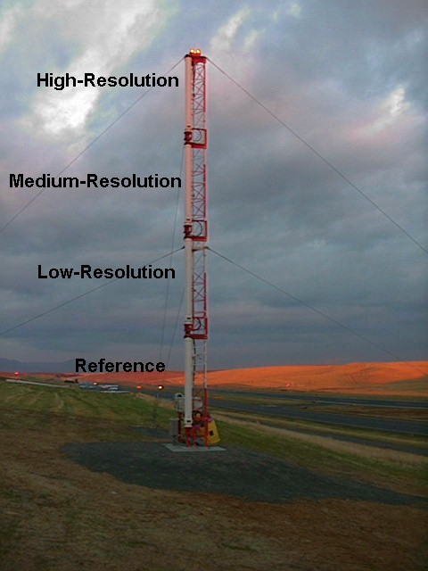

Figure 3: The elevation measurement assembly is shown with 4 antennas, each one vertically polarized with 10 receive elements. Main lobe peak is 7 degrees above the horizon. The assembly is 9 m tall.

The elevation AOA subsystem installed at Pullman, Washington USA is shown in Figure 3. This view is from the front of the array with the runway to the right side of the Picture. Since each of the three measurement antennas is spaced progressively further from the Reference antenna, associated measurement data becomes increasingly more accurate (better in resolution) and has diminished cycle size. As a result of the inherent resolution associated with each phase center aperture, the antennas have been designated Low, Medium and High, in reference to the resolution of the AOA measurement associated with each antenna.

Figure 4 illustrates a possible ground profile from which the following reflection producing surfaces can be identified:

* A flat ground plane extending out from the array. A common variation of this profile includes a lateral tilt immediately in front of the AOA array.
* A valley and hill, significant enough in size that there is a large surface area inclined toward and visible to the top antenna.

Referring to Figure 4 and the two types of surface profiles indicated, Pullman Washington airport has lateral slope directly in front of the elevation measurement antenna with hills rising to 1.6 degrees under the approach path. Data collected at Pullman is shown in Figure 5 for the High-resolution AOA measurement (blue – with 2 cycle wraps) and a single TOA (black – steadily decreasing from 8.7nm to 2.6nm). This data is compiled from a single level approach with the aircraft on course centerline at constant altitude (ILS-2 profile). The AOA measurement has low and high frequency components.



Figure 4: Multiple ground planes with respect to the elevation measurement antenna.

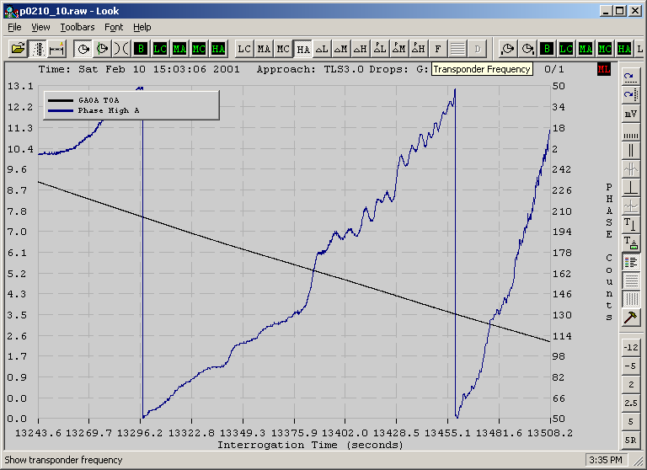

Figure 5: TOA and AOA data from the elevation measurement sensor at Pullman ,WA USA. A high frequency ripple is present on the AOA measurement (blue). AOA measurement cycle wrap occurs near interrogation time 13455.

The frequency of the error is a direct consequence of the antenna geometry and in particular the height of the antennas above the reflection point. Slowly varying error can be easily accounted for with a simple multipath compensation data file and algorithm. A description of this processing method is discussed.

**Multipath Compensation Data File.** The antennas cannot completely eliminate all multipath signals so there will be a remaining low frequency phase error at each antenna characterized by reflections from ground surfaces. Since the AOA Sensor measures the differential phase between the two antennas, the resulting error in the measurements is the differential phase error between the two antennas. Any errors common to both antennas will be canceled due to the difference measurement process.

Multipath Compensation processing of the AOA measurements further reduces the effects of multipath to provide a smooth glide slope signal. After the system is installed, a Multipath Compensation data file is generated by gathering AOA data correlated to theodolite data. A theodolite is placed near the runway such that the theodolite eyepiece coincides with the geometric glide path. Data is gathered from the theodolite with the system operating and tracking an aircraft. The aircraft conducts several level crossings established near the approach course centerline and at the outer marker intercept altitude, typically near 1600 feet above ground for a 3.0 degree glide path. The level crossing provides data as shown in Figure 5, and the comparison with the theodolite reference is displayed in Figure 6. The TLS Multipath Compensation process provides a site-specific look-up table containing corrections to apply to the AOA measurements. During system operation, the measurement processing algorithms apply the look-up table to the AOA measurements to ensure that the actual Path Angle (PA) and Threshold Crossing Height (TCH) correspond to the desired PA and TCH.

Additional theodolite data collection with an aircraft established near the glide path can be used to establish multipath dependencies in range and azimuth. A data file can then be generated that contains compensation data as a function of range and azimuth in addition to elevation.

The TLS multipath compensation processing directly results in symmetrical glide slope displacement sensitivity (50%+/-2% at all sites) and reduced glide slope structure.

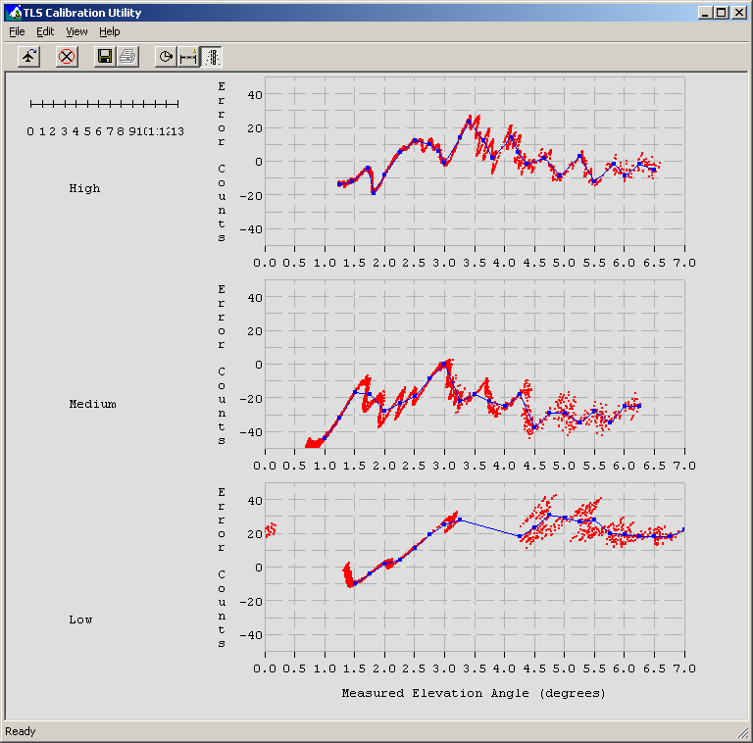

Figure 6 : Measured elevation in degrees (abscissa) vs error in counts (ordinate). Divide counts by 100 to get degrees (approximately). Error established by computing difference between theodolite estimate of aircraft elevation and High-resolution measurement. The least squares best fit (blue line) through data represents the compensation data file.

**Multipath Compensation by Antenna Placement.** At sites where up-sloping terrain exists under the approach path, there will be a small angular separation between the direct transponder reply and multipath. At The Dalles, WA USA, the angular separation is small enough that high frequency differential phase error will be superimposed on the low frequency error as shown in Figure 7. The low frequency error can be modeled and compensated by a simple data file and algorithm, however it is not practical to do so with the high frequency error.



Figure 7: Differential Phase Error for High Resolution measurement; TLS facility at The Dalles, WA USA.

An effective mitigation for the high frequency error is to add a second antenna; picking a location such that its phase error will be opposite in sign and similar in magnitude to the error of the High-resolution measurement. An antenna has been added to the TLS for this purpose. Because it is mounted below the High-resolution antenna, resulting in less angle-of-arrival resolution, it is referred to as the Medium-resolution antenna. Figure 8 is a plot of the Medium-resolution measurement differential phase error at The Dalles, WA USA.



Figure 8: Differential Phase Error for Medium Resolution measurement; TLS facility at The Dalles, WA USA.

When compared to the High-resolution phase error in Figure 7, The Medium measurement is seen to be significantly out of phase and therefore largely able to cancel these errors. The combined signal is shown in Figure 9where it is apparent that much of the high frequency error has been removed from the two signals. The remaining high frequency error is time varying due to its dependence on the aircraft position and it is treated essentially as noise in the TLS Kalman filter algorithm.



Figure 9: Combined Differential Error for High and Medium Resolution measurements at The Dalles, WA USA. The high frequency differential error present in both the individual measurements has been eliminated in the combined data.

**Aircraft Elevation Track Estimate.** The initial elevation estimate is computed from the Low resolution AOA measurement. This elevation estimate will be enhanced by the greater accuracy of the other two measurements from the Medium and High-resolution antennas. Again referring to Figure 3, a typical installation is shown which also includes a Medium resolution antenna just below the uppermost High-resolution antenna. The cycle ambiguity of the Medium and High-resolution measurements must be resolved.

The algorithm that resolves the cycle ambiguity is based on finding the minimum residual (minimum difference) between the Low-resolution angle-of-arrival estimate and the Medium-resolution estimate, factoring in the integer cycle k. There are multiple potential elevation solutions for the Medium-resolution measurement but the minimum residual between the Low and any Medium resolution aoa estimate within ½ of a Medium-resolution cycle will result in the correct cycle for the Medium resolution. The actual implementation of this algorithm works in the space as defined by equation 2.

eq. (2)

where:  is one Medium-resolution cycle size in meters.

In order to filter noise and provide a robust glide slope estimate, the Low-resolution and Medium-resolution systems are independently tracked using a linear kalman filter with the state defined as  whereis defined in equation 2. Once the Medium cycle is initialized, the same cycle ambiguity resolution is applied to select a High-resolution measurement. By using linear processing of the measurement tracks, there is significantly more stable track behavior.

## Azimuth Measurement Subsystem

The transponder reply time-of-arrival (TOA) and azimuth angle-of-arrival (AOA) is measured using an interferometer array of three receiving antenna. Using the same AOA measurement techniques described above for the elevation subsystem, an azimuth angle-of arrival is measured by the subsystem shown in Figure 10. The right most pictured antenna as designated the Reference, the middle antenna designated the Low, and the remaining antenna designated the High. The AOA sensor is visible behind and between the Low and High antennas.

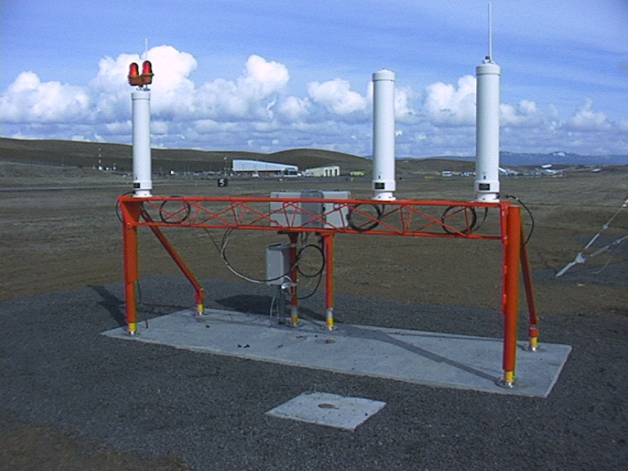

Figure 10: The azimuth measurement assembly is shown with three antennas. Each antenna is vertically polarized with 6 receive elements. Main lobe peak is +3 degrees above the horizon. The assembly is 2 m tall, 105 Kgs (230 lbs) and mounted on frangible couplings.

Ground-based multipath has little effect on the azimuth tracking accuracy because the antenna phase centers are all the same height above the reflection plane. Although reflections from vertical surfaces of buildings are attenuated by the 3dB beam width of 30 degrees, the primary mitigation of this source of multipath is provided by siting this antenna array near the GPI such that vertical reflection sources are kept at the horizontal edge of the antenna pattern.

**Aircraft Azimuth Track Estimate.** The azimuth position of the aircraft is first established using Differential Time Of Arrival (DTOA) to determine the aircraft position on a hyperbolic arc. This position can then be used to resolve the cycle ambiguity on the Low-resolution AOA measurement and establish a Kalman filter estimate (track) of aircraft azimuth. The Low-resolution track is then used to resolve the High-resolution measurement cycle ambiguity and establish a Kalman filter track based on the High-resolution measurement.

## Aircraft Guidance Uplink

After computing an estimate of the aircraft position in azimuth, elevation and range, RF guidance is generated to guide the aircraft to the desired approach. A three-dimensional track defined as , where x and y are developed from the TOA measurement and azimuth AOA, and altitude z is developed from the elevation AOA measurement. Given this altitude, the three-dimensional track is updated with a kalman filter resulting in an accurate estimate of the total track state. Using the method of computing a three-dimensional track state, the array can be placed at various locations with respect to the aircraft touchdown point.

A composite field pattern that is amplitude modulated by a 90 Hz and a 150 Hz tone is generated that emulates ILS guidance at the tracked aircraft position. This composite modulation signal is input to the localizer and glide slope RF transmitters where it is used to modulate the carrier at the appropriate frequency. Since both the VHF and UHF guidance are composite signals, the Difference Depth Modulation (DDM) is immune to the degrading effects of multipath, although signal fade can occur in response to site-specific terrain masking. The uplink antenna locations are shown in Figure 11. The base station shelter, also shown within Figure 11, contains the interrogation transmitter, guidance transmitter and CPU’s.

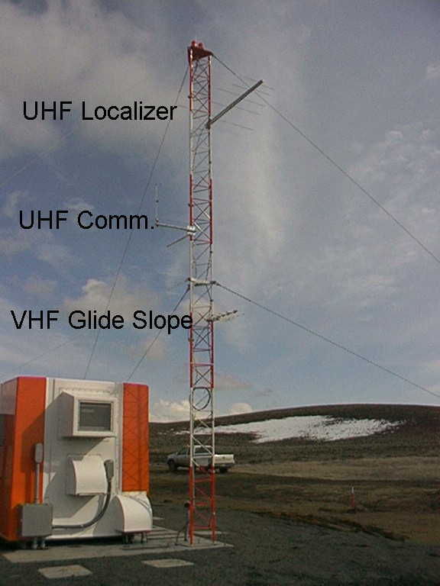

Figure 11: Uplink antenna tower with VHF localizer and UHF glide slope antennas. The tower is 9 m tall. Climate controlled base station shelter houses transmitters and CPU’s.

## Monitoring Critical Parameters

The Integrity Monitoring (IM) has been designed in accordance with system safety principles and airworthiness requirements within SAE ARP 47543,4 that are also applied to airborne navigation systems. Potential hazards resulting from Hardware/Software or System failure modes have been eliminated or mitigated by implementing self-test and redundant systems. The TLS software has achieved Level B design assurance in accordance with RTCA DO-178B5.

The integrity level for TLS has been established as meeting or exceeding the level 2 integrity value specified in table C-2 of ICAO Annex 10. The IM examines variations in the ground equipment that could adversely affect the accuracy and availability of guidance to a landing aircraft. The IM has been designed such that guidance to the aircraft will cease in the event of degradation to the ground equipment or if the monitor itself should fail. The Cal/BIT (Calibration / Built In Test) component of the IM is shown in Figure 12. This assembly is installed in front of the azimuth and elevation measurement antenna arrays and transmits a test signal that can be used to evaluate the accuracy of the TOA and AOA subsystems.

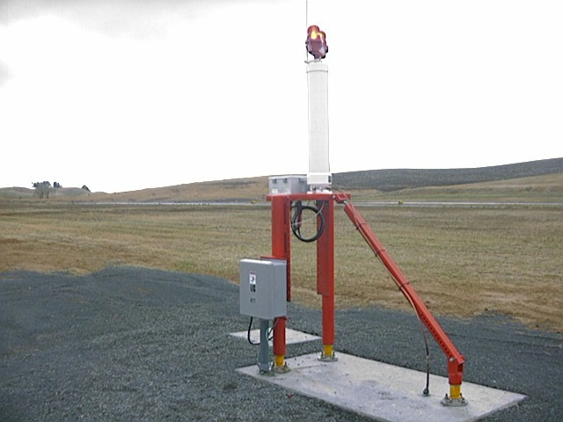

Figure 12: The Calibration / Built In Test transmitter assembly is shown. It provides a 1090 MHz signal used to monitor the accuracy of the measurement subsystems. The assembly is 2 m tall, 40 Kgs (90 lbs) and mounted on frangible couplings.

## Error Budget and Siting Criteria

A basic advantage of a ground-based measuring system is that there is a much greater freedom associated with equipment siting as compared to present day ILS (notwithstanding the possible emergence of frangible ILS glide slope equipment). Computations can easily correct for the AOA elevation equipment offset from the GPI. TLS equipment siting is derived by the application of an error budget to all sources of error that contribute to measurement degradation. Both range and angle errors must be accounted for as the final localizer and glide slope guidance is derived from both range and angle measurements. The primary range error is caused by the transponder encoding delay and is accounted for in the Error Budget and Geometric Dilution of Precision (GDOP) modeling. Frangible, lightweight and low profile equipment design allows safe placement within obstacle clear areas adjacent to runways and taxiways. This siting flexibility also helps position critical areas to minimize their impact on airport operations.

Table 1: Primary Glide Slope Alignment Error Sources

|  |  |
| --- | --- |
| alignment error source | 2σ error (deg) |
| aoa sensor | 0.12 |
| critical area multipath | 0.08 |
| siting, snow, standing water | 0.08 |
| rss error (incl gdop) | 0.19 |
| uplink transmitter | 0.03 |
| total | 7.5% Path angle |

The TLS TOA measurement accuracy is 10ns (2σ). After accounting for critical area considerations and service volume requirements for off-bore site performance, the elevation and azimuth sensors must be installed at least 100 meters apart. Standardization of a service volume width substantially smaller than the +/-35 degrees recommended by Annex 10 would allow the sensor spacing to be much closer.

# System Validation

## Flight Inspection Results

During Flight Inspection, the ground technician can set TLS signal-in-space parameters using a software tool. The ground technician can easily adjust course width, path width, glide path angle and localizer alignment.

Path angle alignment measured during the course of 3 months at Madras OR is reported in Figure 13. The Figure shows a mean path angle of 3.03° with weekly results staying within +/- 0.04 degrees of the mean.

Figure 13: Glide slope angle measured twice per week during 3 months at Madras OR.

A TLS Localizer type Directional Aid (LDA) approach with glide slope has been commissioned at Subic Bay, Philippines. The Subic Bay LDA has an offset of 8.87 degrees.

Results from US FAA Flight Inspections are shown in Table 2.

Glide slope flight check using a ground-based theodolite are shown in Figure 14.

Table 2: TLS flight inspection results at six TLS facilities.

|  |  |  |  |
| --- | --- | --- | --- |
| **Site** | Site Characteristics | **Glide slope / structure as % of tolerance** | **Localizer structure % of tolerance** |
| Madras, OR USA | Ideal / flat | 3.0° / 30% | 8% |
| The Dalles, WA USA | Hill elevation 2.8° @ 3 nm from threshold directly under approach | 4.0° / 50% | 15% |
| Subic Bay, Philippines | Terrain rising under approach such that 3.1° glide path offset 8.9 degrees is required. Airport security fence near azimuth sensor causes multipath. | 3.1° / 66% | 40% |
| Watertown, WI USA | 3% Upslope in front of elevation sensor with hill rising to 1.8° directly under the approach. No property to install ILS localizer. | 3.6° / 50% | 15% |
| FAA Tech Center, NJ USA | Gully with 6% grade between equipment and runway; elevation sensor is 600 feet from runway. | 3.0° / 30% | 8% |
| Pullman, WA USA | 10% lateral grade in front of elevation sensor, hills under the approach rising to 1.6° | 3.0° / 56%  80% near Pt C; FAA result was 38 uamps near Pt C and will recheck | 15% |

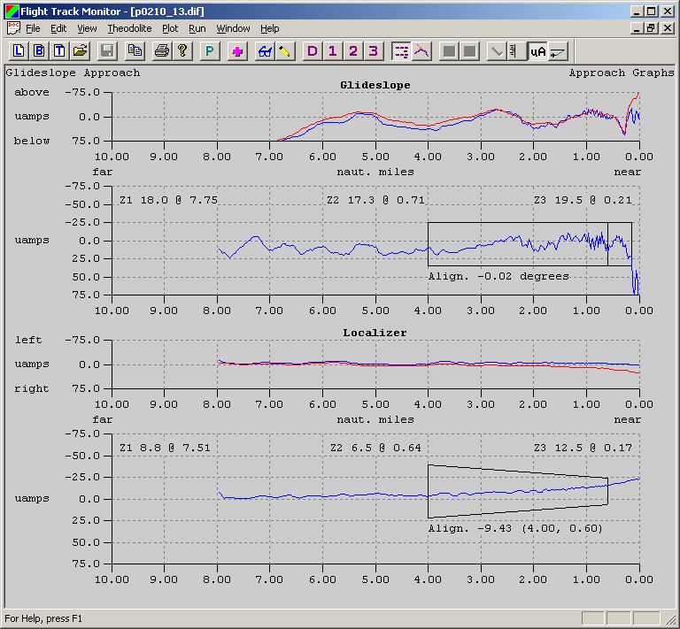

Figure 14: Glide Slope structure and alignment at Pullman WA. Upper plot shows the theodolite plotted in red with the TLS elevation AOA track in blue. Lower plot shows the difference and the ICAO tolerance (box). Glide path angle 3.02 degrees with 17 and 20 microamps recorded in zone 2 and zone 3 respectively.

# Conclusion

TLS provides accurate glide slope signals over terrain that can be cost prohibitive to ILS installation. Multipath mitigation is accomplished using directional antennas. The effects of multipath are further reduced though a process of calibration that yields a database of angle-of-arrival offsets used during system operation to correct ground-based multipath induced error.

Standardization of an azimuth volume substantially smaller than the 35 degrees recommended by annex 10 would further increase TLS siting flexibility.

The operational impact of critical areas associated with the TLS azimuth and elevation sensors can be minimized when designing the placement of TLS equipment near a runway and taxiway.

Computation of the uplink guidance can easily incorporate a correction for the TLS equipment offset from the glide path intercept point. The path angle and TCH are determined by a site-specific database. The apparent emanation point for the localizer can also be projected a great distance from the TLS azimuth AOA equipment. The TLS localizer’s proportional guidance volume width is independent of runway length, and can be nominally set to 6 degrees at all airports where TLS is installed.

# 

# 

# 

# 

# 

# 

# 

# 

# 

# 

# REFERENCES

1. International Standards and Recommended Practices and Procedures for Air Navigation Services: Aeronautical Telecommunications, Annex 10 to the Convention on International Civil Aviation; Fifth Edition, Volume I, Part I -- Equipment and Systems; International Civil Aviation Organization; 1996.
2. The Effect Of Transponder Landing System Emissions On ATC Performance, DOD Joint Spectrum Center, November 1997.
3. Certification Considerations for Highly Integrated or Complex Aircraft Systems, ARP 4754, Systems Integration Requirements Task Group, Society of Automotive Engineers 1996.
4. Guidelines and Methods for Conducting the Safety Assessment Process on Civil Airborne Systems and Equipment, ARP 4761, S-18 Committee, Society of Automotive Engineers, 1996.
5. Software Considerations in Airborne Systems and Equipment Certification, Document No. RTCA/DO-178B – December 1, 1992.