Document with some images

## My first image

This is my first image

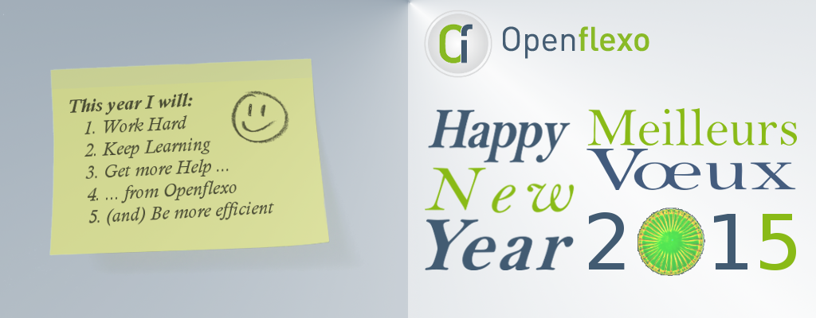

This is another image:  with some text before and after.

## Some other images:

Image 1: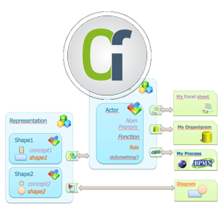

Image 2: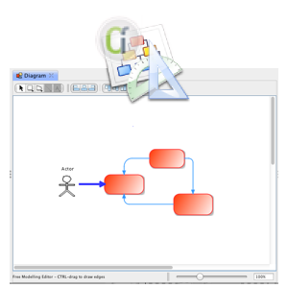

Image 3: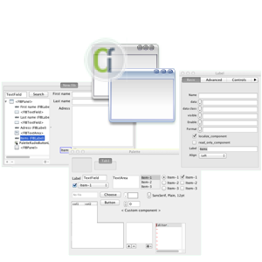

Many images on same run:  

Hope this works !