This document uses a basic set of Word features; you can look at the WordML to see how those features are stored.

This is an unstyled paragraph.

# This is style Heading 1

Left indent

Centre

Align Right

Justified text

Indented

First line indent, Left indent, Hanging indent aaa bbb aaa bbb aaa bbb aaa bbb aaa bbb aaa bbb aaa bbb aaa bbb aaa bbb aaa bbb aaa bbb aaa bbb aaa bbb aaa bbb

Tabbed

Normal

A parapgraph with 10 points spacing before, 20 points after.

Normal

Font styles Aerial Black

Font styles 18 point

Font styles **bold**

Font styles *italic*

Font styles underline

Font styles ~~strikeout~~

Font styles colour

Font styles example

Bullets

* Level 1
  + Level 2

Numbering

1. Level 1
   1. Level 2
      1. Level 3

Here is some change tracking. An insertion Followed by.

This line contains a soft return  
and here it continues…

A cross reference: 1)

Jpeg:

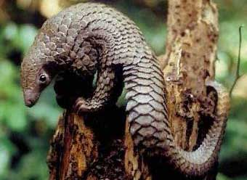

Gif (scaled):

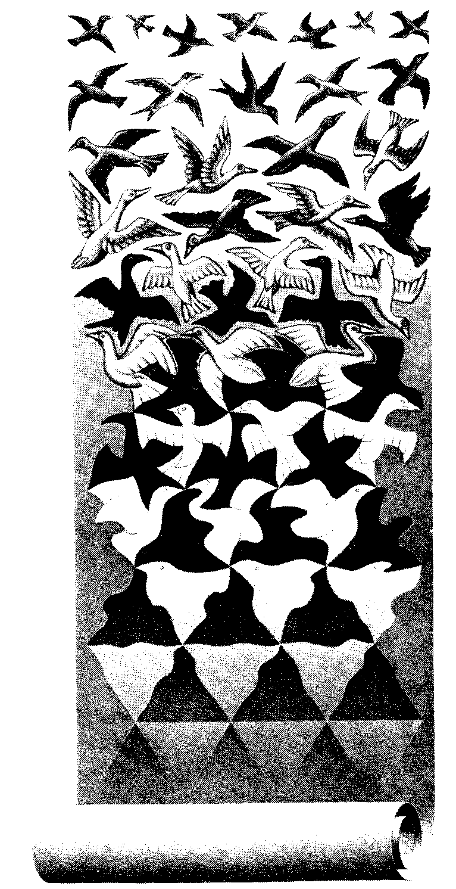

Png (from <http://davidpritchard.org/images/pacsoc-s1b.png> )

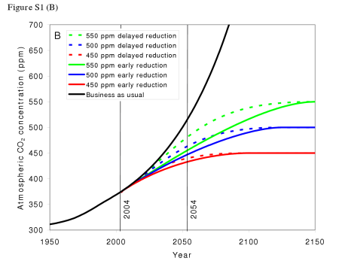

That was a page break

Finally, a table:

|  |  |  |
| --- | --- | --- |
| Cell text |  | Shaded grey |
| Vertical merge |  | Shaded grey |
|  |  |
|  | Horizontal merge | |

We should also have a content control in here (sdt):

This is a rich text content control.