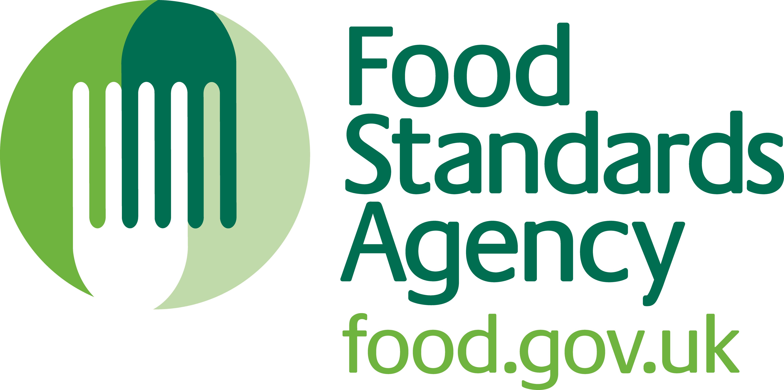
Application for Approval of an Establishment Subject to Approval under Regulation (EC) No. 853/2004

PROTECT COMMERCIAL WHEN COMPLETED

Please complete this form with a black pen in BLOCK CAPITALS. If completed on screen, please print off a copy, sign, date and either post or submit a scanned copy by email to:

Contact Name: FSA in NI
Address: 10A-C Clarendon Road
Belfast
BT1 3BG

Telephone: 028 9041 7700
Fax: 028 9041 7726
E-mail: niapprovals@foodstandards.gsi.gov.uk

The DARD officer responsible for assessing the application will make an appointment in due course to inspect the establishment. This will be followed by an inspection by FSA in order to assess whether it may be granted approval.

If you need any help of advice about how to complete this form or about the products to which the Regulations relate, or the circumstances in which approval under the Regulations is required, please contact FSA in NI.

PART 1 – Establishment for which approval is sought

Trading name
(if applicable)

(Trading name is the name under which someone carries on business other than their own i.e. the approval name)
Full establishment address  (inc. Postcode) |  |  |  |  | Telephone  number
 |  |  |  |  | Fax number
Email

Please select one of the following three options:
1. New approval |  |  |  | 2. Additional Activities Approval no: UK/ /EC UK/ /EC
3. Change to Business Ownership Date of change: Approval no: UK/ /EC UK/ /EC

PART 2 – Food Business Operator (FBO) details and Business structure

Please indicate the type of business; Incorporation now complete 2a
(Please place a cross in only one box) Partnership now complete 2b
Sole trader now complete 2b
Other business provide details on a separate sheet &
attach*
(* - Other business types will be treated on a case by case basis to identify the natural person or legal person required to be compliant with food law within the food business under their control)
2a – Incorporation details (as registered with Companies House or equivalent)
Full company name

Registered office address
(inc. Postcode)
Company registration number

Company Director/s
Title (Mr, Mrs, Ms, Miss, Dr) |  |  |  |  | Forename(s) |  |  |  |  |  |  |  |  |  |  |  |  |  |  | Surname
Title (Mr, Mrs, Ms, Miss, Dr) |  |  |  |  | Forename(s) |  |  |  |  |  |  |  |  |  |  |  |  |  |  | Surname
Title (Mr, Mrs, Ms, Miss, Dr) |  |  |  |  | Forename(s) |  |  |  |  |  |  |  |  |  |  |  |  |  |  | Surname
(Provide full details for all Company Directors - If required continue on separate sheet and attach)
2b – Food Business Operator(s) (FBO) (complete only if Partnership / Sole trader)
Title (Mr, Mrs,  Ms, Miss, Dr) |  |  |  |  |  | Forename(s) |  |  |  |  |  |  |  |  |  |  |  |  |  | Surname
Telephone  number |  |  |  |  |  |  |  |  |  | Fax  number |  |  |  |  |  |  |  |  |  |  |  | Mobile  number
Home address
(inc. Postcode)
Email

Title (Mr, Mrs, MS, Miss, Dr) |  |  |  |  | Forename(s) |  |  |  |  |  |  |  |  |  |  |  |  |  |  | Surname
Telephone  number |  |  |  |  |  |  |  |  |  | Fax  number |  |  |  |  |  |  |  |  |  |  |  | Mobile  number
Home address
(inc. Postcode)
Email

Title (Mr, Mrs, MS, Miss, Dr) |  |  |  |  | Forename(s) |  |  |  |  |  |  |  |  |  |  |  |  |  |  | Surname
Telephone  number |  |  |  |  |  |  |  |  |  | Fax  number |  |  |  |  |  |  |  |  |  |  |  | Mobile  number
Home address
(inc. Postcode)
Email

(Provide full details for all Partners - If required continue on separate sheet and attach)

PART 3 – Establishment managers and contacts

Duly authorised representative of the Food Business Operator (FBO)
Title (Mr, Mrs, Ms, Miss, Dr) |  |  |  |  | Forename(s) |  |  |  |  |  |  |  |  |  | Surname
Telephone  number |  |  |  |  |  |  |  |  |  |  | Fax  number |  |  |  |  |  |  | Mobile  number
Email

Finance / Invoicing Contact
Approved meat establishments are subject to veterinary supervision by the FSA for which charges apply. Please give details of the contact person, address and email address the FSA should use for sending financial information including invoices and statements.
Title (Mr, Mrs, Ms, Miss, Dr) |  |  |  |  | Forename(s) |  |  |  |  |  |  |  |  |  | Surname
Invoicing address
(inc. Postcode)
Telephone  number |  |  |  |  |  |  |  |  |  |  | Fax  number |  |  |  |  |  |  | Mobile  number
Email

Preferred method of communication: Post… Fax… Email… (Please place a cross in only one box)
Throughput queries contact (if different from above)
Title (Mr, Mrs, Ms, Miss, Dr) |  |  |  |  | Forename(s) |  |  |  |  |  |  |  |  |  | Surname
Telephone  number |  |  |  |  |  |  |  |  |  |  | Fax  number |  |  |  |  |  |  | Mobile  number
Email

Preferred method of communication: Post… Fax… Email… (Please place a cross in only one box)
Out of Hours Emergency Contact information (Optional)
The FSA may require to contact the FBO should there be an emergency and for contingency planning purposes (e.g. foot & mouth outbreak). This information is voluntary and is not specifically collected as part of legislation. The FBO, at any time, can request the FSA remove these details or requests any data to be amended to reflect changes in their contact details. The information will be treated as confidential and only limited members of the organisation will have access.
Contact Name
Telephone number  (Out of hours) |  |  |  |  |  |  |  |  |  |  |  |  |  | Mobile number
Email

PART 4 – Seasonal pattern
Do you intend to operate a pattern of seasonal slaughtering / processing? ................................ YES NO
If YES, please place a cross in the box beside the expected month(s) of operation
 | January |  |  |  |  |  |  |  | April |  |  |  | July |  |  |  | October
 | February |  |  |  |  |  |  |  | May |  |  |  | August |  |  |  | November
 | March |  |  |  |  |  |  |  | June |  |  |  | September |  |  |  | December

PART 5 – Establishment for which approval is sought

(Please tick all that apply)

Establishment | Activities for which approval is sought (Please place a cross in the boxes for all that apply) |  |  | Estimated average weekly throughput
Slaughterhouse  (NB: a slaughterhouse may be approved without slaughter facilities if its activities are limited to the dressing of carcases of farmed or large wild game.) | Slaughter of domestic ungulates:
 | Cattle (including Bubalus and Bison species)
 | Pigs
 | Sheep & Goats
 | Domestic solipeds (horses)
 | Slaughter of:
 | Farmed game mammals (deer, wild boar)
 | - Ratites
 | Dressing of:
 | - Farmed deer, wild boar, bison and ratites slaughtered at the place of production
 | - Large wild game (if also approved as Game Handling Establishment).
 | Slaughter of:
 | - Poultry
 | - Lagomorphs (rabbits, hares and rodents)
 | - Farmed game birds (including ratites)
 | Dressing of:
 | - Delayed eviscerated poultry
 | - Geese and ducks reared for foie gras
 | - Ratites (ostriches) slaughtered at the place of production
 | - Wild game birds and lagomorphs (if also approved as a Game Handling Establishment)
Game Handling Establishment | Dressing of:
Game Handling Establishment | - Wild game (large: deer) (small: game birds, lagomorphs)
Game Handling Establishment | Cutting of:
Game Handling Establishment | - Wild game
Approved Farm Slaughter Facilities | Slaughter at the place of origin of:
Approved Farm Slaughter Facilities | - Poultry
Approved Farm Slaughter Facilities | - Farmed deer and wild boar
Approved Farm Slaughter Facilities | - Bison (when necessary)
Approved Farm Slaughter Facilities | - Farmed ratites
Red meat cutting plant | Cutting of:
Red meat cutting plant | - Meat from domestic ungulates for supply as cut meat (may be approved for cutting of different animal species- please specify if required).
Poultry cutting plant | Cutting of :
Poultry cutting plant | - Meat from poultry and lagomorphs for supply as cut meat (may be approved for cutting of different animal species- please specify if required).
Where co-located or integrated with a slaughterhouse, cutting plant or Game Handling establishment (otherwise approved by the District Council):
Minced Meat/ Meat Preparation /Mechanically Separated Meat establishment | Please specify species  Production of: below
 | - Minced meat,
 | - Meat Preparations
 | - Mechanically Separated Meat
Processing Plant | - Meat Products (approved in accordance with Annex III, Section
Processing Plant | - Rendered animal fats and greaves
Processing Plant | - Treated stomachs bladders and intestines
Intermediate Storage Plant | - Intermediate storage of rendered animal fats and greaves
Collection Centre / Tannery | - Gelatine
Collection Centre / Tannery | - Collagen
Cold Store  (Does not refer to cold storage of product manufactured at the establishment – only product which is brought into the establishment for  distribution) | - Storage of meat (fresh or processed)
Re-wrapping establishment | - Re-wrapping of meat (fresh or processed)
RAW MILK AND DAIRY Please specify species
below
Standalone liquid milk Processing Establishment | - Pasteurisation of liquid milk (i.e. processing of raw milk to which no ingredients have been added e.g. cream, buttermilk,)
Collection Centre | - Collection & temporary storage of raw liquid milk
Coldstore  (Does not refer to cold storage of product manufactured at the establishment – only liquid milk products which are brought into the establishment for  distribution) | - Storage of liquid milk products
Where co-located or integrated with a liquid milk processing establishment (otherwise approved by the District Council):
Processing Plant | - Dairy products
EGGS AND EGG PRODUCTS
Egg Packing centre | - Packing and grading of eggs by quality and weight
Where co-located or integrated with a egg packing centre (otherwise approved by the District Council):
Processing plant | - Egg products
 | - Production of liquid egg
If your establishment also handles or intends to handle products of animal origin requiring approval under Regulation (EC) No 853/2004 (other than identified above) state those operations below:

PART 6 – Information and documentation
A site and building plan MUST accompany this application form.

The following information is required in order to process your application and should be made available at the establishment to the officer carrying out the assessment visit. The officer will contact you if he/she requires any further information to be sent to him/her in advance of the visit.
- A site plan and a buildings plan
- A description of the proposed method of operation
- A description of the proposed equipment maintenance arrangements
- A description of the proposed equipment and transport cleaning arrangements
- A description of the proposed arrangements for the acceptance of raw materials including live animals if appropriate
- A description of the proposed waste collection and disposal arrangements
- A description of the proposed water supply
- A description of the proposed water quality testing arrangements
- A description of the proposed arrangements for product testing
- A description of the proposed pest control arrangements
- A description of the proposed monitoring arrangements for staff health
- A description of the proposed staff hygiene training arrangements
- A description of the proposed arrangements for record keeping
- A description of the proposed arrangements for applying the identification mark to product packaging or wrapping

PART 7 – Application

Name of applicant
Position in business
Name of contact
Position in business
Tel (incl. Dialling code)
Fax (incl. Dialling code)
E-mail

N.B. If you fail to complete all parts of this form your application for approval will not be processed. Please note that the granting of FSA approval under the hygiene legislation in no way removes any obligation you may have; to apply for planning permission / building control for any building works you undertake or the change of use of any building, within the approved establishment. Please contact your District Council for relevant advice.

I hereby apply, on behalf of the business described in Part 1, for approval to use premises at the address specified in Part 2 for the purpose of handling products to which both Regulation (EC) No 852/2004 and Regulation (EC) No 853/2004 apply, to be approved under Regulation (EC) No 853/2004

Name in BLOCK LETTERS |  | Date

Signature

IMPORTANT
Activities that require approval must not be undertaken until the appropriate approval is granted. Once approved Article 6(2) of Regulation (EC) No 852/2004 states the FBO is to “ensure that the competent authority always has up-to-date information on establishments, including by notifying, any significant change in activities and any closure of an existing establishment”. Not complying with this requirement is an offence under the Food Hygiene Regulations (Northern Ireland) 2006.

not currently applicable for approved dairy and egg establishments

