
Open Foris Arena
ver. {{version}}
https://www.openforis-arena.org/

Handbook
{{releaseDate}}


Forestry Division, FAO


Content
1. Introduction 8
2. Typical working process 9
3. Access to Open Foris Arena 9
3.1. Obtaining access to Arena 9
3.2. Log in to Arena Mobile using QR code 13
3.3. User profile 13
3.4. Two-factor authentication (2FA) 15
4. Main user interface 18
5. Selecting and creating a survey 20
6. Dashboard 25
6.1. Edit info 27
6.1.1. Survey basic info 27
6.1.2. Branding 29
6.1.3. Document layout 32
6.1.4. User extra properties 33
6.1.5. Security 33
6.1.6. Map 34
6.2. Publish a survey 36
6.3. Export survey and data backup 38
6.4. Unpublish or delete a survey 38
6.5. Collect Import report 39
6.6. Working with cycles 42
6.7. Compare a survey with another survey 42
7. Survey 45
7.1. Terminology 45
7.2. Form Designer 46
7.2.1. About the Form Designer user-interface 46
7.2.2. Attribute data types 48
7.2.3. Description of properties 49
7.2.4. Attributes or entities advanced actions 55
7.2.4.1. Attribute or entity move 57
7.2.4.2. Attribute clone 57
7.2.4.3. Attribute data type conversion 57
7.2.4.4. Clone an attribute or entity from another survey 58
7.2.4.5. Convert a published integer attribute to decimal 58
7.2.5. Units of attributes 59
7.2.6. Enumerated entity 59
7.2.6.1. Automatically generating rows from category items 59
7.2.6.2. Dynamic enumerated entity 59
7.2.7. Summary on survey schema 62
7.2.8. Form language 64
7.2.9. Form preview (desktop and Arena Mobile) 65
7.2.10. Multiple entities: automatic rows, summary and tables 66
7.2.11. Other attribute properties and layout elements 67
7.3. Expressions and expression editor 68
7.3.1. More expression functions 74
7.3.2. Generate and explain expressions with AI 75
7.4. Hierarchy 77
7.5. Categories 80
7.5.1. Working with categories 80
7.5.2. Extra properties 85
7.5.3. Sampling Point Data 86
7.5.4. Clone a category from another survey 88
7.5.5. Export all category tables 88
7.5.6. Categories with geo capabilities and GeoPackage export 89
7.5.7. Whisp analysis of sampling point data 89
7.6. Taxonomies 90
7.6.1. Working with taxonomies 90
7.6.2. Clone a taxonomy from another survey 93
7.6.3. Updating a taxonomy 93
8. Templates 94
8.1. Using a template 94
8.2. Getting a new template into Arena 96
8.3. Creating and managing templates 97
9. Data 97
9.1. What are the data entry stages? 97
9.2. Adding, editing and viewing records 100
9.3. Deleting a record 105
9.4. Deleting a row in a table 105
9.5. Cloning data 106
9.6. Data Explorer and aggregating data 107
9.6.1. Filtering records and searching attributes 113
9.6.2. Totals and percentages 114
9.6.3. Exporting data as a table or as a data matrix 115
9.6.4. Charts 116
9.6.5. Creating queries with AI 116
9.7. Map 118
9.7.1. Viewing map data 118
9.7.2. Sample-based image interpretation 122
9.7.3. Google Earth Engine queries via Earth Map 125
9.7.4. Polygon data on the map view 129
9.7.5. WMS / WMTS services and XYZ tiles 130
9.7.6. Measuring distances and areas 131
9.7.7. Map screenshots 132
9.7.8. Areas of interest on the map 133
9.8. Data export 135
9.9. Data import 136
9.9.1. Importing data from CSV or Excel file 137
9.9.2. Import data from Collect/Collect Mobile file 143
9.9.3. Import data from Arena/Arena Mobile file 144
9.10. Validation report 146
9.11. Merging data 148
9.12. Creating printable record documents 151
9.12.1. Exporting a printable document 151
9.12.2. QR code 153
10. Analysis 154
10.1. Creating a processing chain 154
10.2. RStudio in programming and data processing 160
10.3. About computing area-based variables 168
10.4. Sampling design and statistical analytics 171
10.4.1. Sampling strategy 171
10.4.2. Settings for sampling design 172
10.4.3. Statistical analysis 176
10.4.4. Area for statistical analysis 176
10.4.5. Non-response bias corrections 177
10.5. Arenalytics - R package for statistical analysis and reporting 179
10.6. Duplicate or clone a chain from another survey 182
10.6.1. Overview 182
10.6.2. Prerequisites 182
10.6.3. Step-by-step: cloning a chain 182
10.6.4. What happens after cloning 183
10.6.5. Notes and limitations 183
10.7. Deleting a chain 184
11. User roles and invitation to access a survey 185
11.1. User roles 185
11.2. Invitation to survey 190
11.3. User Grouping 192
11.3.1. Overview 192
11.3.2. Accessing User Groups 192
11.3.3. Creating and Editing a User Group 192
11.3.4. Qualifiers: Linking a Group to Survey Data 193
11.3.4.1. Marking an attribute as a Qualifier 193
11.3.4.2. Adding qualifier values to a group 194
11.3.4.3. Effect on data entry and data access 194
11.3.5. Managing Group Members 194
11.3.5.1. Method 1. From the group’s edit page 194
11.3.5.2. Method 2. From the Group Assignments board (drag and drop) 195
11.3.6. Members Report 195
11.3.7. Frequently Asked Questions 195
11.3.8. Read-only access to the records of other groups 195
12. Examples of expressions 197
13. Changing or resetting password 199
14. System administration 202
14.1. Backup and restore users 202
14.2. Messages 203
14.3. System Logs 203
Acknowledgements 205
Annex 1. System architecture 205
Annex 2. Abbreviations and acronyms 207
Annex 3. RStudio Server: writing and downloading files created during run-time 208
Annex 4. Templates for Arena 211
Annex 5. JSON file in data processing 220
Annex 6. Plot Grid Generator in making spatial Sampling Point Data 221
Annex 7. Installing Open Foris Arena on a Custom Server 223
Annex 8. Privacy Policy 227

1. Introduction
Arena is an Open Foris (OF) cloud platform for forest inventory data collection, management, analysis, dissemination, and reporting. It combines two current tools, namely OF Collect and OF Calc, into a seamless application. Open Foris Arena is the main entry point for data collected in field-based inventories. It provides a fast, easy, flexible way to set up a survey with a user-friendly interface. Arena manages multiple data types and complex validation rules, all in a multi-language environment.
Open Foris Arena provides an online solution for field data management, allowing full customization of inventory structure, variables and data checks. Arena promotes data quality through an integrated data entry and data cleansing workflow. Arena contains a formal description (i.e., metadata) of the types of variables, classifications and coding schemes used by the inventory. Older OF Collect surveys and data can also be imported into Arena.
What are the main advantages of Arena over the older Open Foris tools?
- No need for user installations;
- All data stored in a secure server in the cloud (hosted by Amazon Web Services, AWS);
- Data sharing and collaboration possible in a working group;
- Easier to maintain: all updates available at the same time for all users;
- No need for trained personnel to maintain the hardware and database management system.
What does OF Arena offer?
- Dynamic form designer;
- Multilingual data entry forms;
- Editor for entering complex validation rules;
- Categories and taxonomies management;
- Multiple surveys management;
- Survey templates management;
- Multi-cycle survey management;
- Map with access to satellite data;
- Map queries using the power of Google Earth Engine via Earth Map;
- Sample-based image interpretation;
- Import for OF Collect survey and data;
- Possibility to use multiple species lists; a species list can contain extra properties;
- Concurrent data entry with workflow and real time updates;
- User management with personal access rights;
- Survey backup (export, import), and cloning;
- Dashboard with activity logs;
- Light and dark theme, and user interface in several languages;
- Two-factor authentication (2FA) for system administrators;
- Data query, cleansing, export;
- Local off-line installation and usage via docker;
- Data analysis with local RStudio or RStudio Server.

The user support is available via Open Foris Support Forum at https://www.openforis.support/
Tag your question as follows:

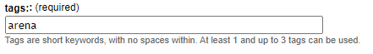

2. Typical working process
OF Arena can host any type of inventory or questionnaire data. A typical process when working with Arena will be as follows:
- Log in to the platform;
- Select a survey;
- Depending on the user role: view, input, validate, edit, or export data;
- Data analysis with the help of R scripts [roles: Survey Administrator, Data Analyst],
- View and export the results and reports;
- Log out from the platform.

3. Access to Open Foris Arena

3.1. Obtaining access to Arena
Arena platform is available at https://www.openforis-arena.org
Every user in the Arena platform has a specific role. These roles are described in detail in this chapter.
The platform limitations are as follows:
- The service is free and the maximum size of survey data is 10 GB.
- Only the Survey Administrator can view the survey data size.
- The maximum upload size of any file is limited to 1 GB.
In general, it is better to avoid uploading very-high resolution images into Arena, and to plan the amount of incoming data.
There are two methods to get access to Arena:
Method 1. Become a Survey Manager.
A Survey Manager can create a new survey and tailor it to meet your needs.
You can also use ready-made templates to tailor your survey.
To become a Survey Manager, go to https://www.openforis-arena.org/
and request access to the Arena platform.
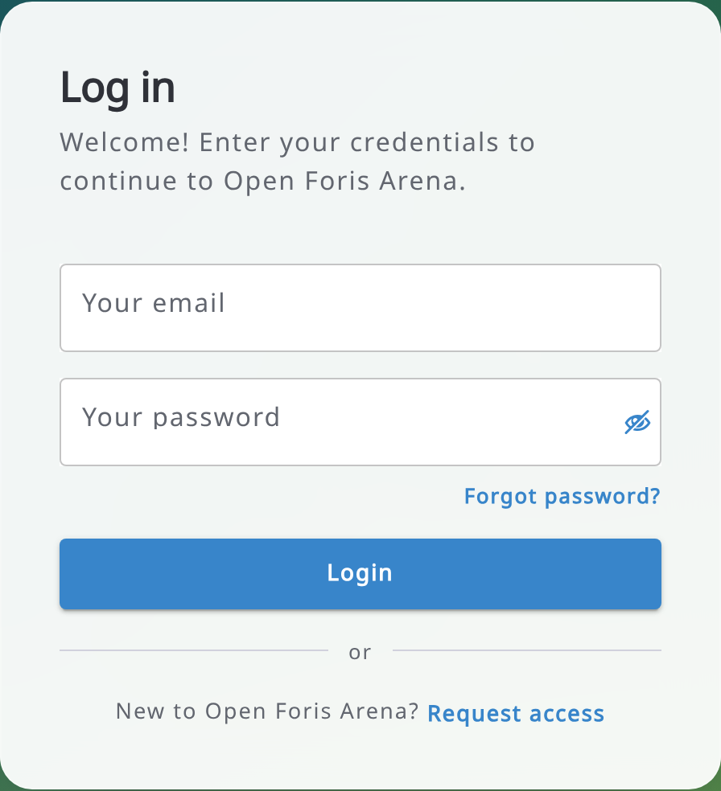
You will next see the following page:
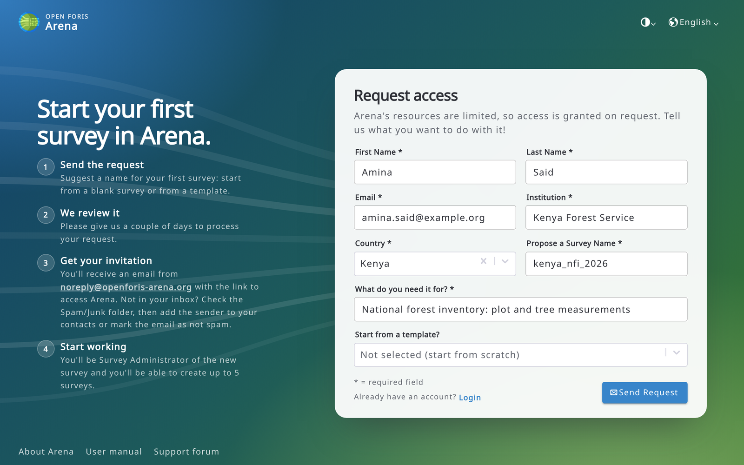
Fill in all information. If you are dealing with forest resource data or are a first-time user with no experience with Open Foris Collect, it is recommended to start using a template: read more about them in this Annex. Then send the request and wait for approval. It takes typically 1-3 working days until you get an invitation to access the Arena platform. When you have the access rights to Arena, your role will be a Survey Administrator for your first survey. If you do not find the emails from Arena in your inbox, check the Spam/Junk folder, then add the sender (shown in the request access page) to your contacts or mark the email as not spam, so that the next emails reach your inbox.
Method 2. To get access to an existing survey, ask for an invitation from the Survey Administrator. This person can send you an invitation to new users by email. The Survey Administrator will specify your role in the survey.
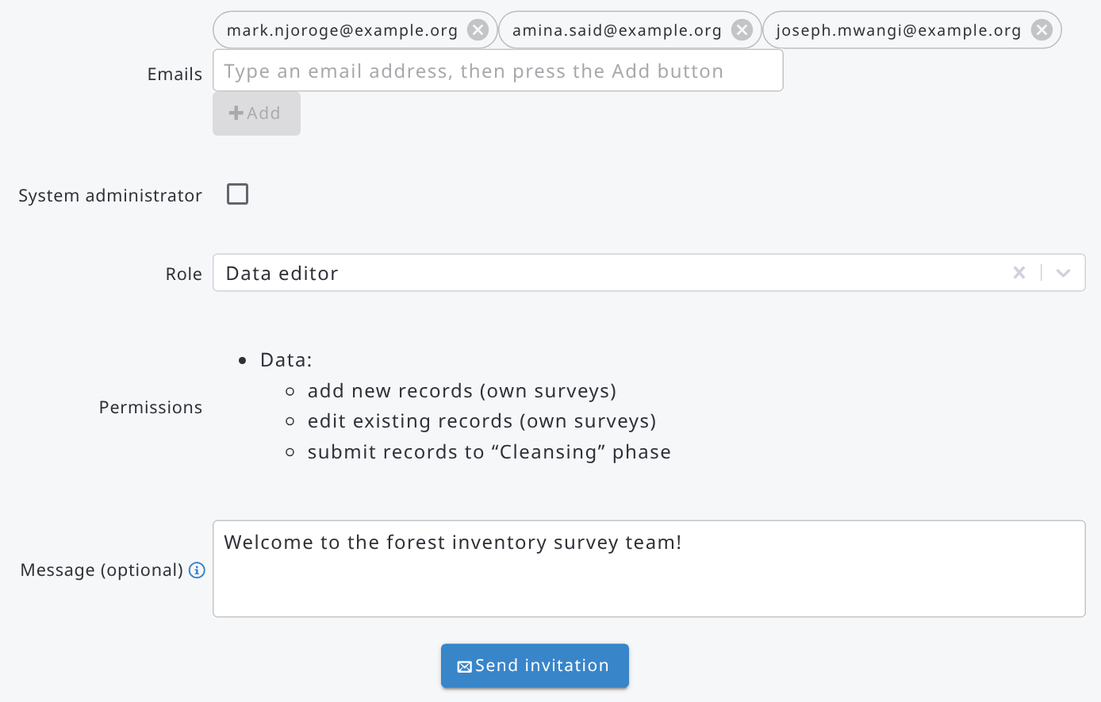

____________________________________________________
When you have access to Arena, type in your email and password. In case you have forgotten your password, click Forgot password? to receive a password reset link by email (see Chapter 13). In the top-right corner of the login page you can also choose the theme (Light, Dark or System default) and the language of the user interface. At the bottom of the page there are links to the Arena website, to this user manual and to the support forum.
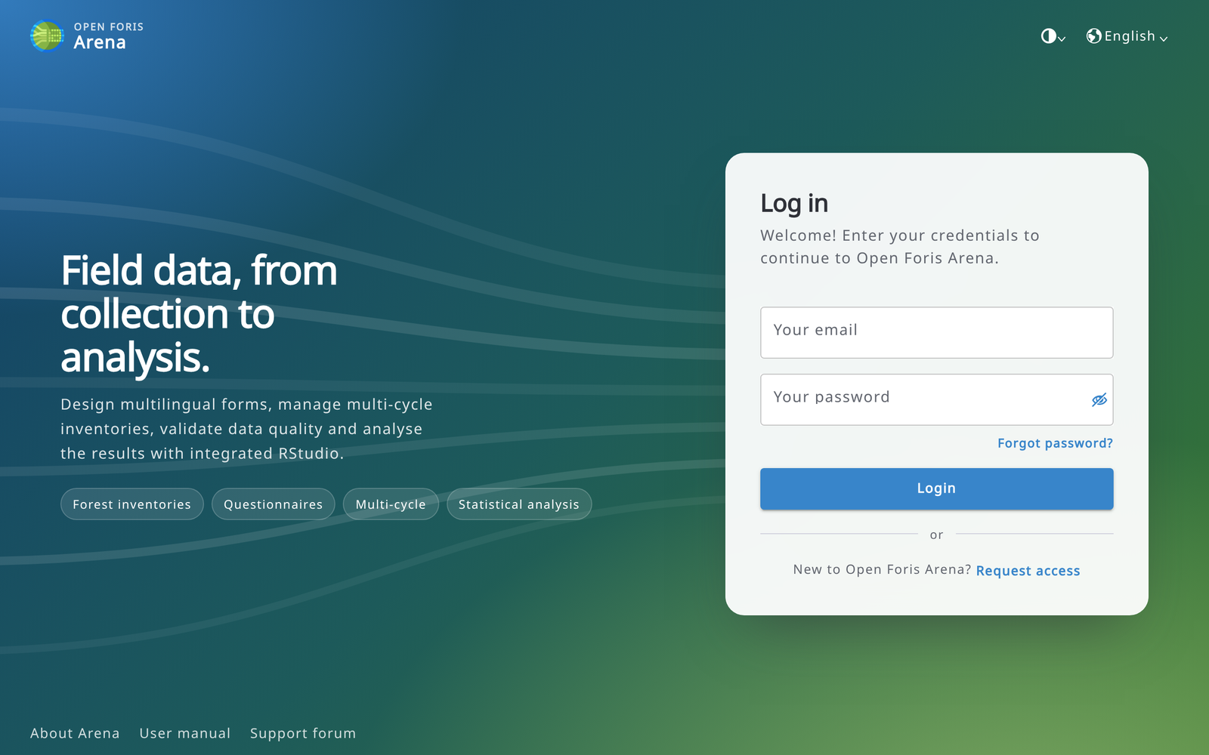
If you are a new user, set first your user profile: click on your profile picture in the upper-right corner of the screen and select My profile.
Here you can set up your title, name and profile picture. Read more about the user profile in section 3.3.

3.2. Log in to Arena Mobile using QR code
Once you have logged in to Arena, you can easily log in to Arena Mobile by scanning a QR code generated by Arena.
To access this feature, you must click on your profile icon in the top right corner and in the menu that opens select “Login to Arena Mobile using QR code”:
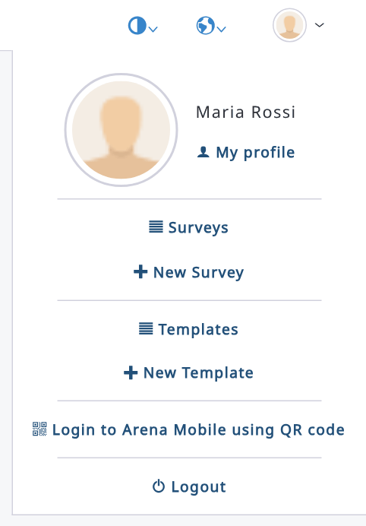
A dialog like this will appear:
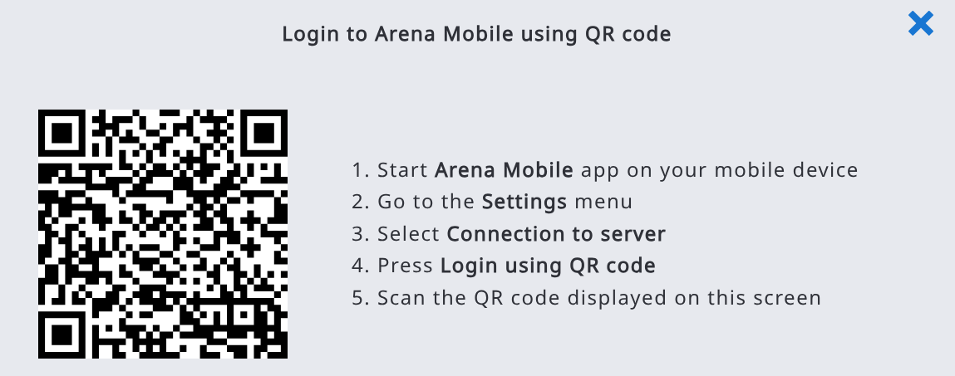
Open Arena Mobile and follow the instructions in the dialog; you will be easily logged into Arena, and you will be able to download your surveys and submit data to the server.

3.3. User profile
To open your user profile, click on your profile picture in the top-right corner and select My profile.
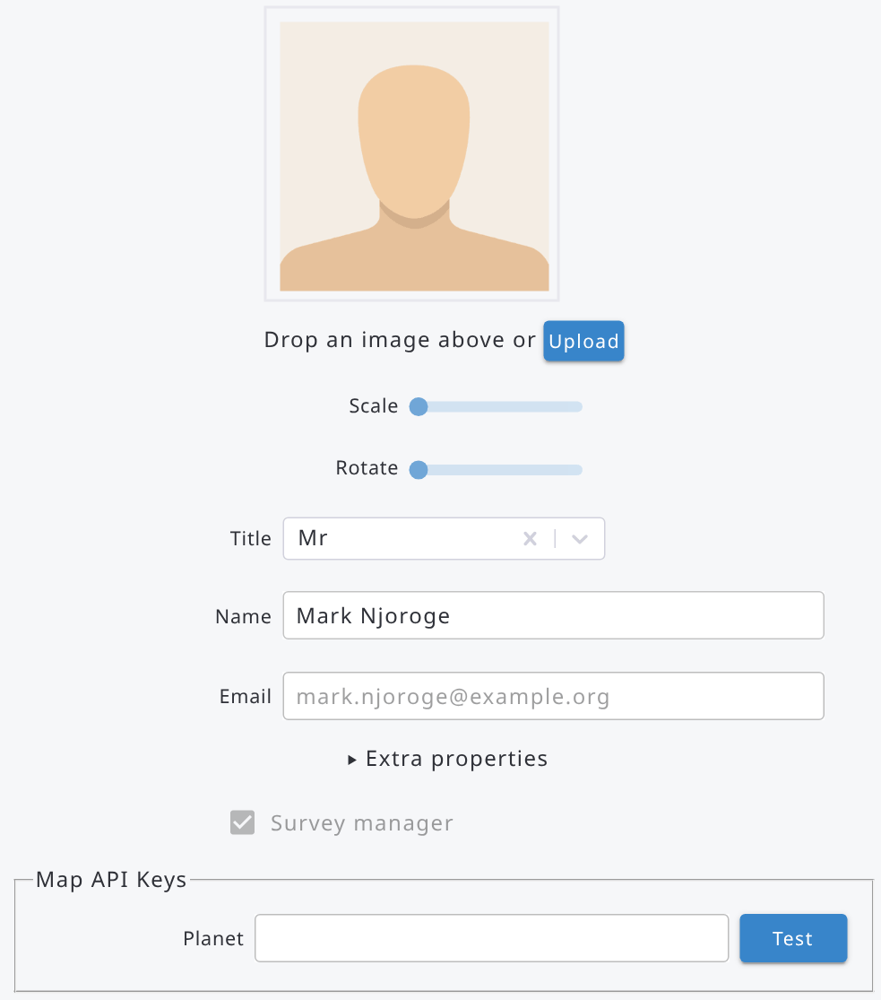
In your user profile you can:
- add a profile picture: drop an image or click Upload, then adjust it with Scale and Rotate;
- set your Title and Name (your email address is your login and cannot be changed here);
- view the Extra properties assigned to you (see 6.1.4);
- type your own API key for Planet basemaps in Map API Keys (click Test to check it);
- enable the AI features and choose which of them to use, if AI features are configured on the server;
- change your password with Change password (see Chapter 13).
Click Save to save your changes.
If the server administrator has configured the AI features, in the AI features panel you can select Enable AI features, choose the AI integration levels you want to use (documentation chatbot, expression generation and validation, label translation, data dictionary, user activity summaries and data queries) and the AI provider. Leave Default to use the AI provider configured by your Arena administrator, or select another provider and type your own API key. With Google Vertex AI (Gemini), paste a service account JSON key (with the Vertex AI User role) or a Vertex AI API key and, optionally, type the Google Cloud region in Location (leave it blank to use the global endpoint). The Documentation chatbot answers your questions based on the English version of this manual, in the language of the user interface.
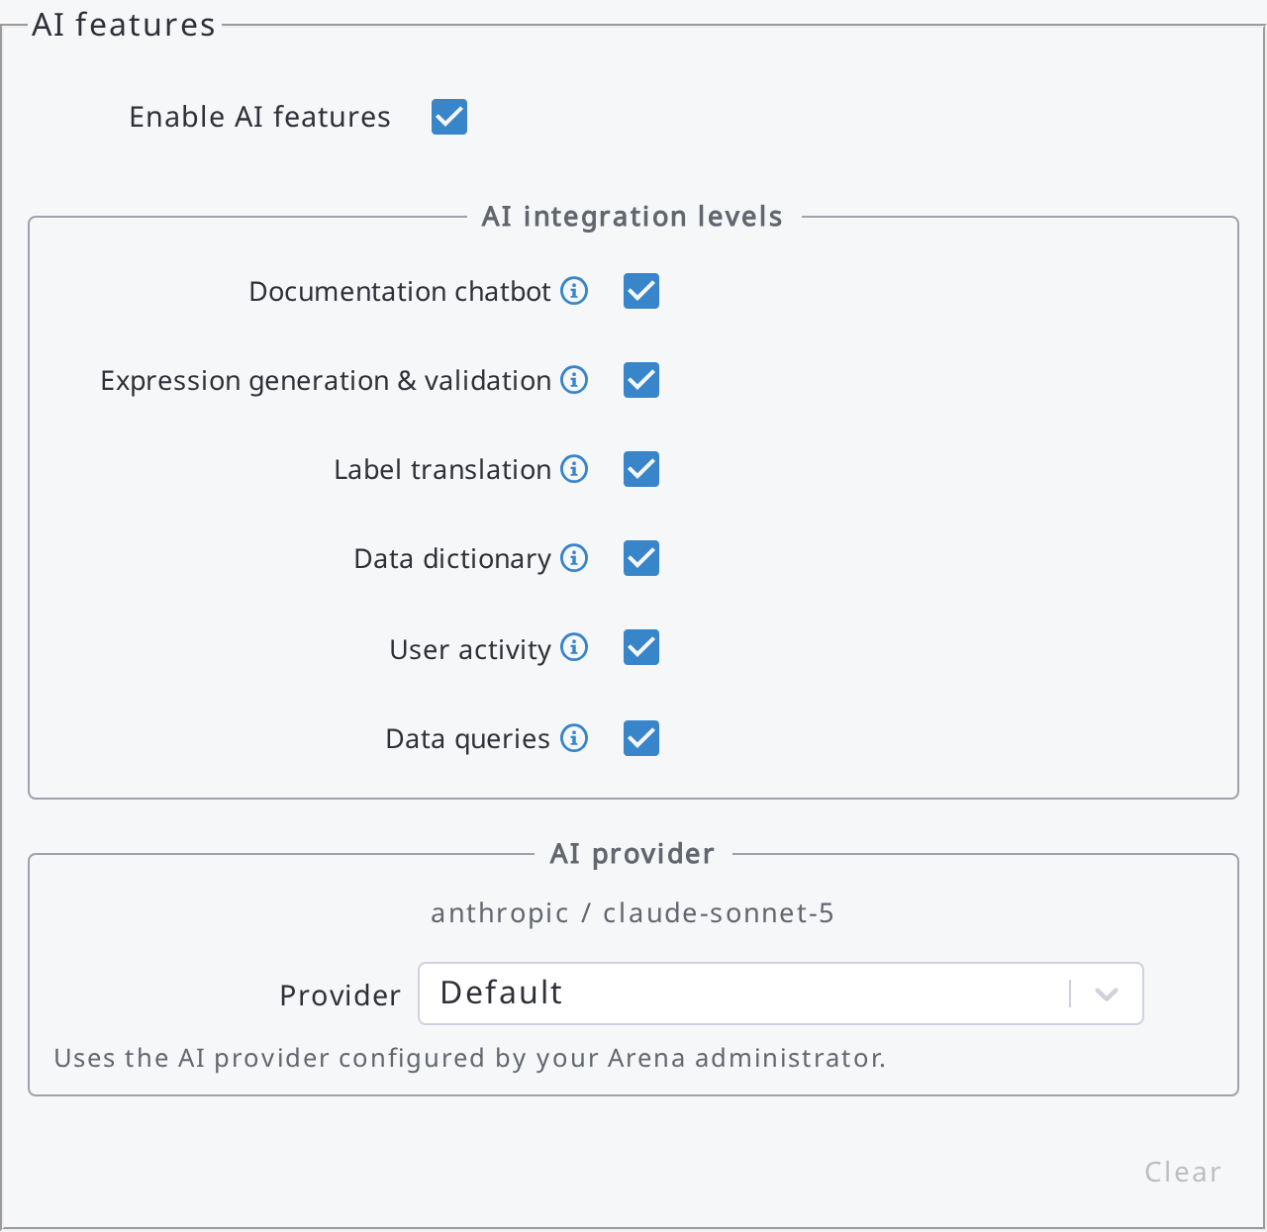
System administrators also find here the Notification preferences (e.g. receive an email for New user access requests) and the Manage 2FA button (see 3.4).

3.4. Two-factor authentication (2FA)
System administrators can protect their account with two-factor authentication: after typing the password, Arena asks for a verification code generated by an authenticator app on a mobile device.
To add a 2FA device:
- Open My profile and click Manage 2FA. The list of your 2FA devices opens.
- Click New, type a Device name (e.g. My phone) and click Create.
- Install an authenticator app on your mobile device (e.g. Google Authenticator or Authy).
- Scan the QR code with the authenticator app (or click Show secret key and type the key in the app).
- Type (or paste) two consecutive codes generated by the app in Authenticator code 1 and Authenticator code 2 (wait 30 seconds before the second code) and click Validate.
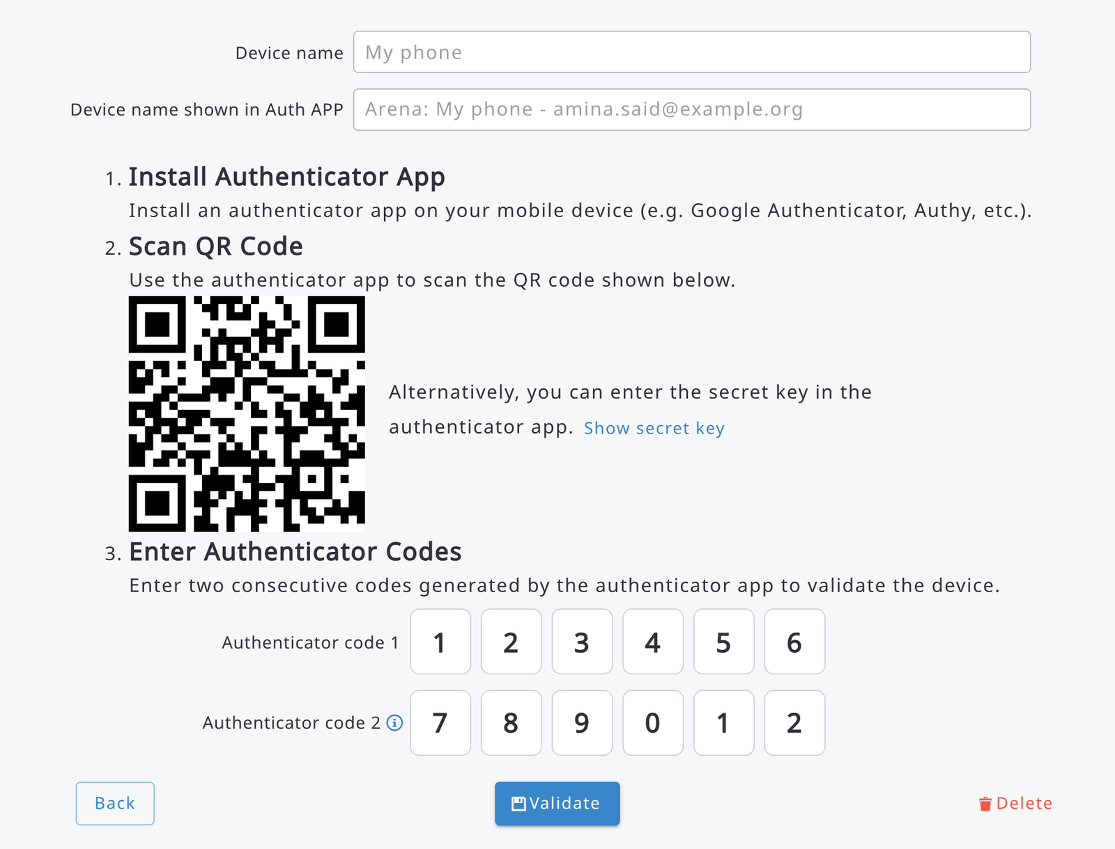
After the validation, Arena shows 8 backup codes. Save them in a safe place: they are shown only once, and each of them can be used only once to log in if you lose access to your authenticator device. Type copied and confirm to close the dialog.
When 2FA is active, after typing your email and password in the login page, type (or paste) the 6-digit Verification code shown by the authenticator app and click Verify. If you do not have your device with you, click Use a backup code and type one of your backup codes.
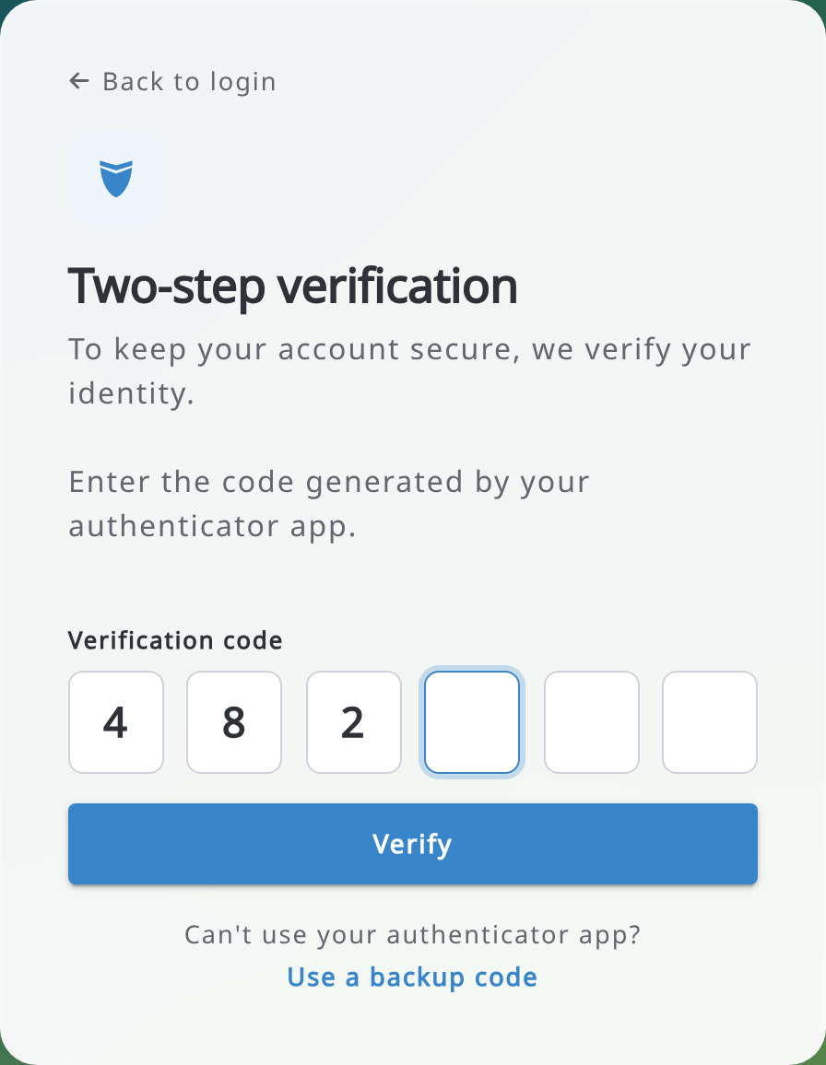
From the details page of a device you can also Regenerate backup codes (the previous ones stop working) or Delete the device.

4. Main user interface
The view in the Arena main window depends on your user role (see Chapter 11). With the full Survey Administrator’s access rights, the left side panel contains the following tools.
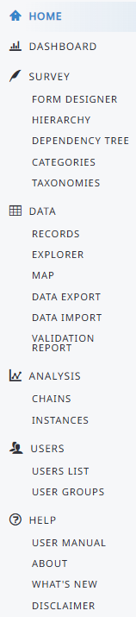
- Survey landing page
- Management of survey properties; delete a survey;
backup, export a survey; settings for map and security
- Design or edit data entry forms
- Visual view on survey hierarchy
- Visual dependency tree
- Management of categories (i.e., code lists)
- Management of taxonomic tables (i.e., species lists)
- Add, view, edit, clone, delete data
- Data queries, and access to data cleansing
- Map view & data editing; access to Earth Map and Whisp
- Export data into Comma Separated (CSV) or Excel files
- Import CSV/Excel/Collect/Collect Mobile/Arena backup data
- Data validation report, and access to data cleansing
- Create, edit, delete data processing chains,
run RStudio
- Show/stop RStudio Server (online process)
- User management, invitation of new users
- User grouping management
-Link to this manual
- Links to support materials and Arena repositories
- List of latest changes in Arena
- Legal Disclaimer
- System Administration menus, shown only to system administrators at the bottom of the sidebar (see chapter 14)

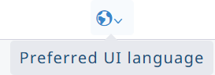 | Preferred user interface language in Arena: Automatically detected (from your browser settings), English, Spanish, French, Japanese, Mongolian, Portuguese, Russian or Serbian (Latin). The same menu is available on the login page.
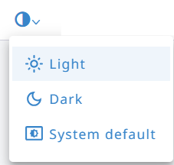 | Switch between the Light and Dark theme, or follow your System default. The same menu is available on the login page.

Lists work the same way in every page (surveys, records, categories, users...): click a row to open its item, to view or edit it. In the records list, where the rows can be selected, a click selects the row and a double click opens the record. With the keyboard, move to a row with Tab and press Enter to open it (Space selects it in the records list). In each row, the view/edit button (pencil, or eye when the item can only be viewed) and the delete button (trash) are the last buttons.

5. Selecting and creating a survey
In the upper right corner, there is access to the following functions:

Surveys page shows a table with all the surveys you can access. Select Only own surveys to show only the surveys you own, or type in the filter box to search surveys by name, label or owner. The list contains the following details.
Header | Explanation
NAME | Name of the survey. It must be at least 6 letters long.
LABEL | Label for the survey
OWNER | Name of survey administrator (owner)
DATE CREATED | Date when the survey was created
DATE LAST MODIFIED | Date when the survey was edited last time
DATE PUBLISHED | Date when the survey was published
STATUS | Draft: The survey is at the editing stage. It contains no data.  Published: The survey is ready to store data. It can contain input data.  Published-Draft: The survey is ‘published’, but there are unpublished changes  in its structure (i.e., changes in attribute properties, new  calculation scripts or setting).
NODES | Number of nodes. This indicates the size of the survey.
CYCLES | Number of cycles in the survey.
LANGUAGES | Languages in the survey (ISO 639 language codes)
RECORDS | Number of records in the survey (across all cycles)
FILES | Number of uploaded files (e.g. photos)
CHAINS | Number of processing chains in the survey
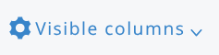 Click Visible columns to show or hide columns. Click Export to Excel to download the list of surveys.
New Survey allows a Survey Manager to create a survey in three ways:
1) Create a new survey from scratch, 2) Clone an existing survey or 3) Import a survey (Arena or Collect).
About naming of a survey:
- The name should only contain lower case letters, underscores,
- No space,
- No special characters (#%&"?).
The entry box will automatically ignore the wrong letters.
Next, some more information on how to create a new survey.
Method 1: Create a new survey from scratch.
Fill in Name, Label, and choose the default language.
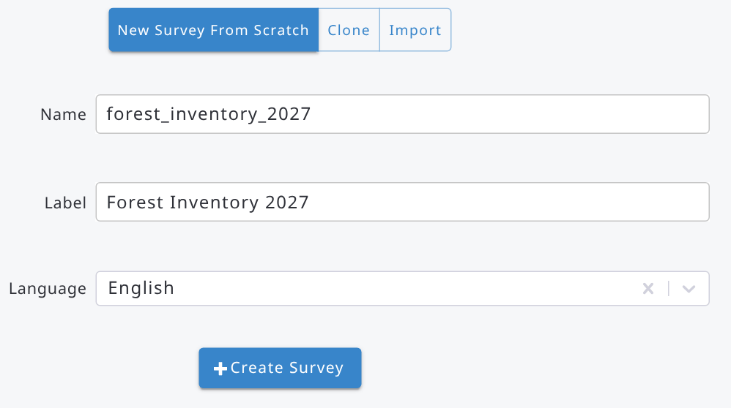
Next steps after creating a new survey:
* Go into Dashboard - Edit Info and set in Description, needed Spatial Reference System(s) (SRS) and survey languages.
* Create the survey structure using the Survey Designer, test your survey and then finally Publish it.

Method 2: Clone an existing survey.
Fill in a new survey Name and select a survey to be cloned. Cloning will only copy the survey structure, not the data. A cloned survey will always be in the ‘draft’ mode.

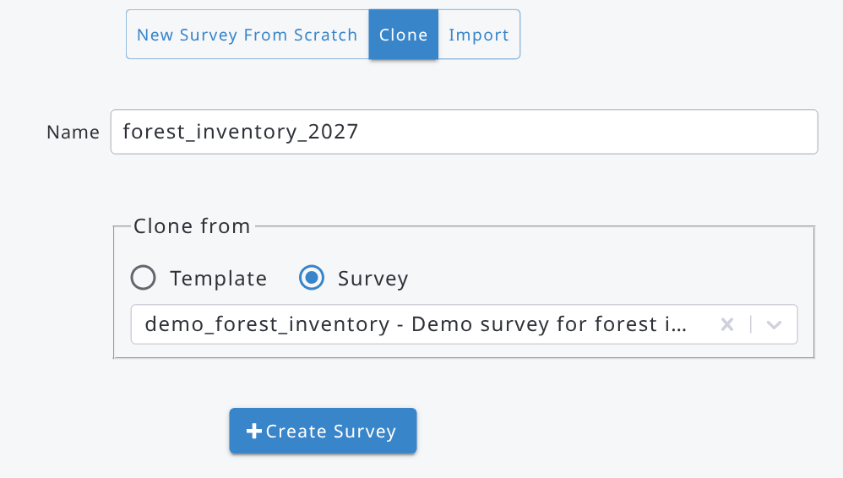

Next steps after cloning the survey:
* Go into Dashboard - Edit Info and edit survey properties as needed.
* If the survey structure needs changes, use the Survey Designer, test your survey and then Publish it.

Method 3: Import a survey.
Import offers two options:
a) Import an Arena survey (.zip). An existing Arena survey, such as an Arena backup, can be imported back into Arena (with a new name).
b) Import an Open Foris Collect survey.
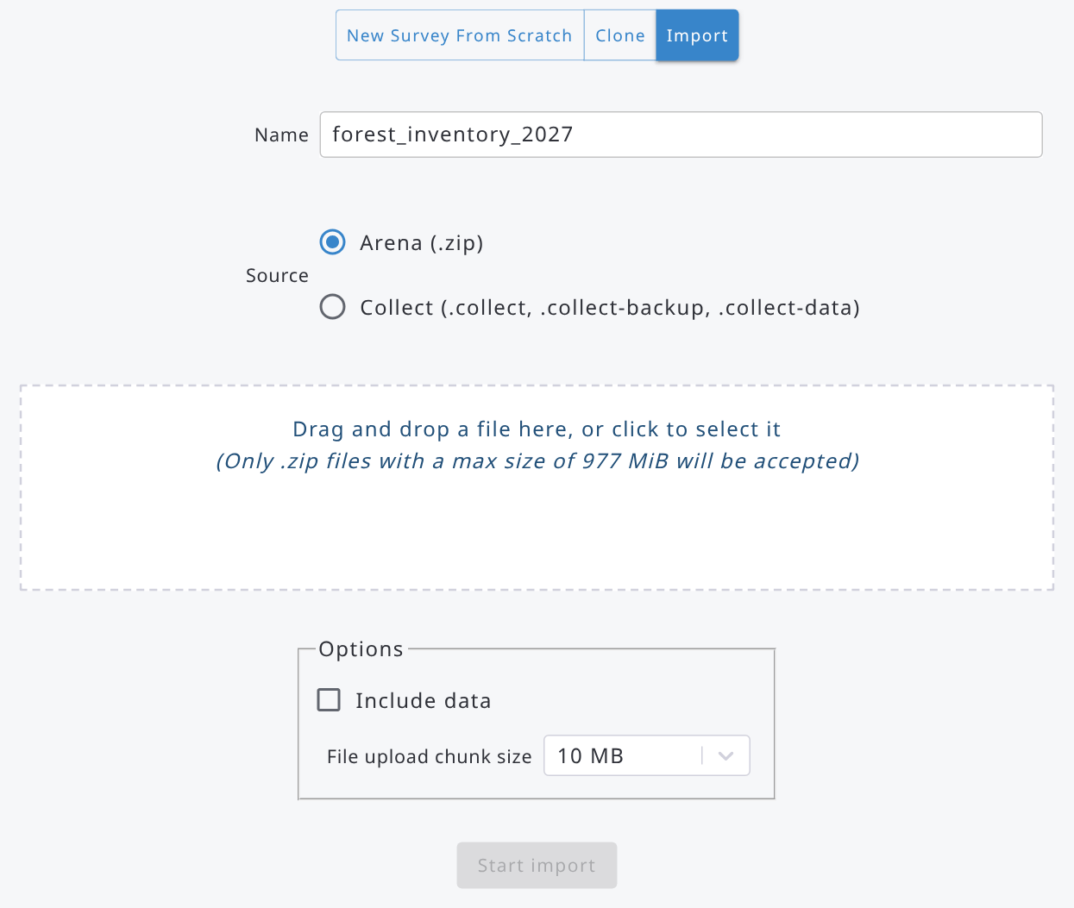

Give first the name of the new survey in Arena. Check the Include Data box if the survey file contains data and needs to be imported, otherwise leave it unchecked. The file is uploaded in parts: if your internet connection is slow or unstable, select a smaller File upload chunk size.

Important: Do not use Export + Import (schema or backup) for cloning a survey! The reason is that a published and exported survey will stay published when imported back into Arena. This means that only a few changes are possible. Instead, if you clone a survey, the new survey will be in the draft mode, and you can, for example, change/edit a taxonomic list.

Next steps after importing the survey:
* Go into Dashboard - Edit Info and edit survey properties if needed.
* If the survey structure needs changes, use the Survey Designer, test your survey and then Publish it.

An Open Foris Collect survey can be imported from a .collect, .collect-backup or .collect-data file. Note that after importing you should view the Collect Import Report at the Dashboard section. In addition, check out that all forms, tables, attributes and their properties are imported correctly.
Follow these steps after importing a Collect survey:
* Go into Dashboard - Edit Info and edit survey properties as needed.
* Use the Survey Designer to modify the user-interface (as location and size of text boxes etc.).
* Go into Dashboard - Collect Import Report, and fix the remaining (unresolved) issues.
* Test your survey in Arena and then finally Publish it.
Note: after an update of Arena, the surveys may be upgraded in the background. If you open a survey while it is being upgraded, Arena shows the message “This survey is being upgraded, please retry shortly.”: wait a few moments and open the survey again.

6. Dashboard
The Dashboard section contains the following functions.
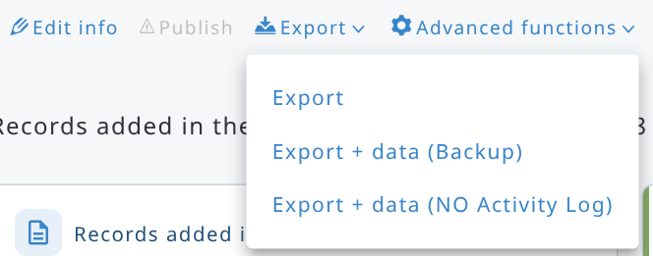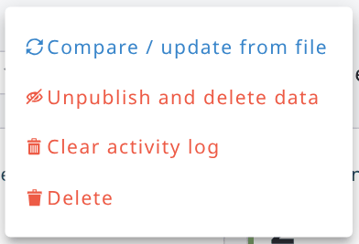
"Edit info" can also be accessed by clicking the survey name.
The Dashboard is a module of its own in the sidebar: open it from the sidebar or with Open dashboard on the survey landing page. It is available to the users who can at least cleanse records (it is not available to Data Editors).
Below the functions, the Dashboard shows a summary of the survey data. Select the period in Records added in the last: (e.g. 1 Year); the cards and the chart refer to the selected period:
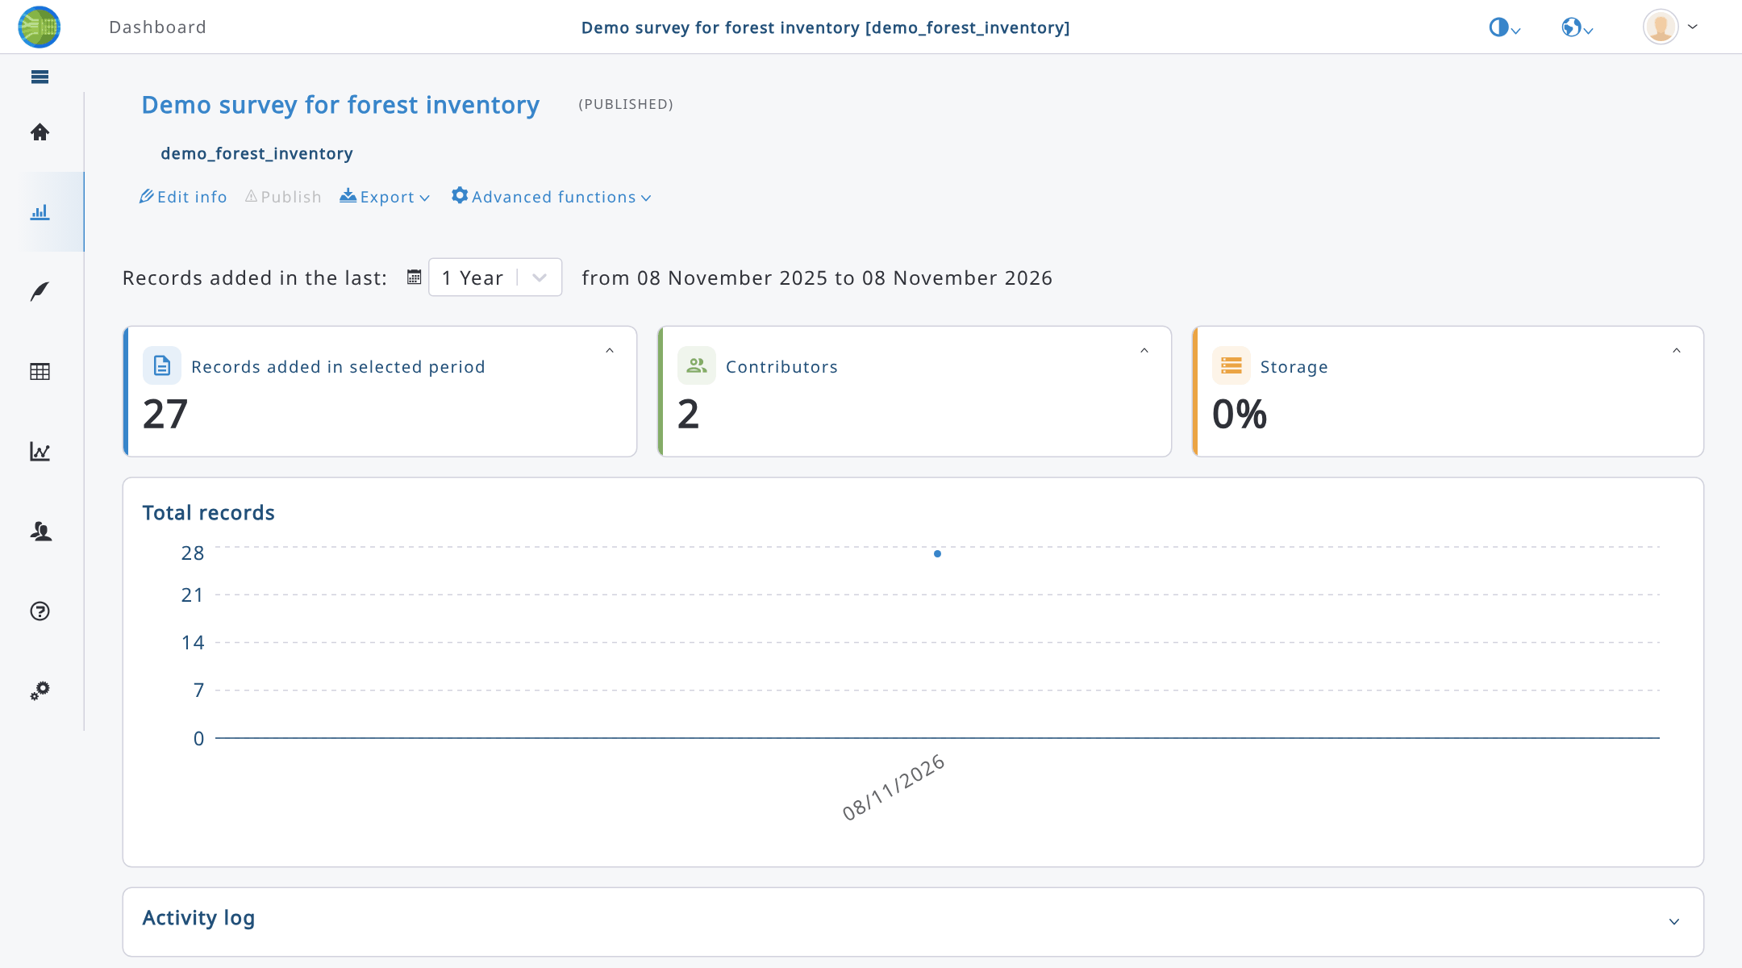
- Records added in selected period: number of records added in the period; expand the card to see the number of records by workflow step (Data Entry, Data Cleansing, Data Analysis, all time).
- Contributors: number of users who added records in the period; expand the card to see the records added by each user.
- Storage: space used by the survey (shown only to users who can edit the survey); expand the card to see the space used by the files and in the database, out of the available space.
- Total records: trend of the number of records in the selected period.
- Map: shown when the survey has geo (polygon) attributes; it shows the polygons of the records, which can be filtered by owner.
- Sampling Point Data Completion: shown to users who can edit the survey, when the records are identified by sampling point data; it shows how many sampling points have been visited.
- Activity log: recent activity on the survey (e.g. records created or updated); shown only when the activity log is enabled on the server, to users who can edit the survey.
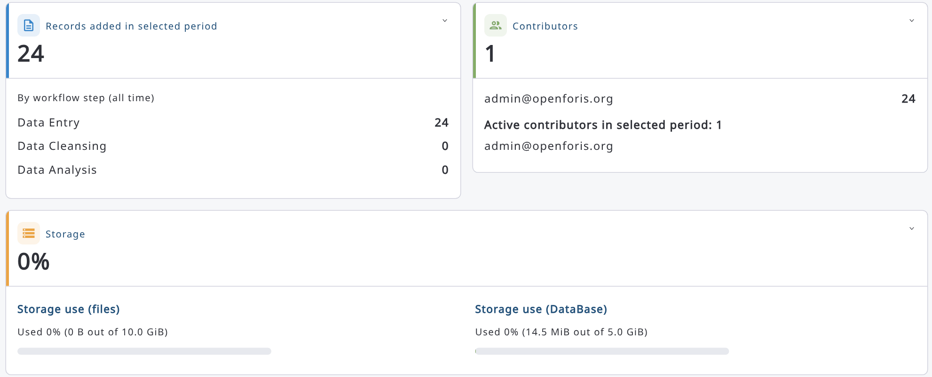
At the top of the Dashboard, the survey label is shown with its status (Draft, Published or Published/Draft) and the survey name:
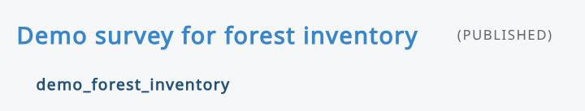

6.1. Edit info
This section allows users to edit the metadata of the survey. The selections are divided into the following pages: Basic info, Branding, Map, Document Layout, User extra properties and Security. System administrators also see the Configuration tab, where they can set the total space available for the files of the survey (Files total space (GB)).
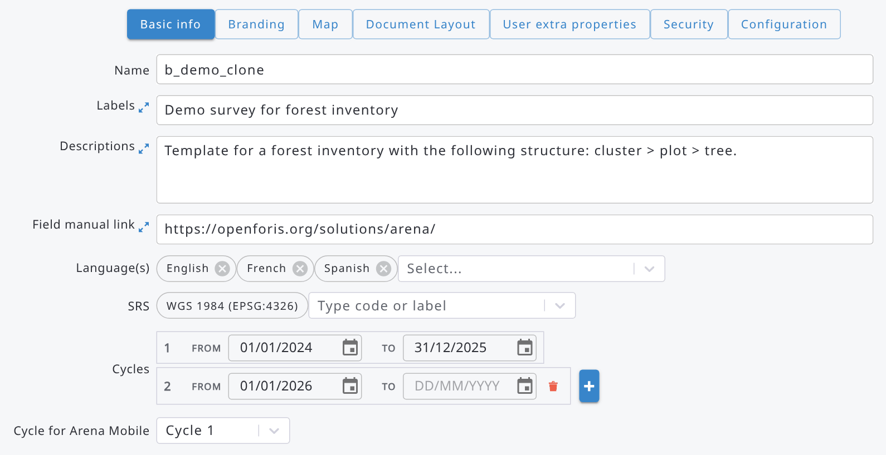

6.1.1. Survey basic info
Basic info contains information about the following survey properties:
Name: Name of the survey in the database.
A Survey Administrator can rename the survey.
Label: Label for a survey, a clear name for the survey.
View/Edit labels with other (selected) languages.
Description: Additional information about the survey (optional).
Field Manual Link: Full URL to the field manual of the survey (text) (optional). The URL must be publicly accessible.
Language(s): Survey language(s). If more than one language is added, then labels need to be given by all selected languages.
SRS: Spatial Reference Systems applied in the survey. Add here all SRSs which will be needed in the data collection.
Hint: to add a new SRS, click the cursor into the input box and to see the options, type in some letters of the EPSG code.
Cycles: Inventory cycle(s) and timing(s). Note: survey times cannot overlap, so for example this data is accepted:
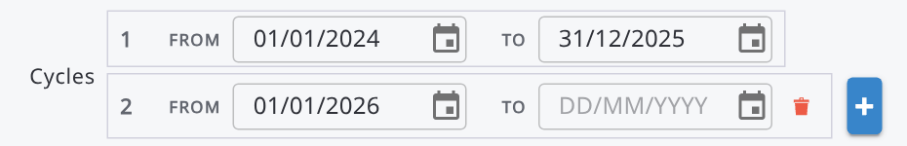
Cycle for Arena Mobile: The cycle for uploading a survey into Arena Mobile in a multicycle survey case.
The Map tab contains the areas of interest (see 6.1.6) and the sample-based image interpretation settings of the Map section, read more about it in this chapter.

6.1.2. Branding
The ‘Branding’ tab lets survey designers customize the visual identity of a survey: its primary color, up to three logos, a background image for the survey landing page, and typography presets for the landing page title and description. Branding settings are saved with the survey and are published together with the rest of the survey definition, so data collectors and reviewers see the same branding once the survey is published.
Branding is entirely optional. A survey with no branding configured still displays a functional, unbranded landing page.
The Branding tab is organized as a form on the top and a live preview of the survey landing page on the bottom, so changes to colors, logos, background, and typography can be checked before saving.
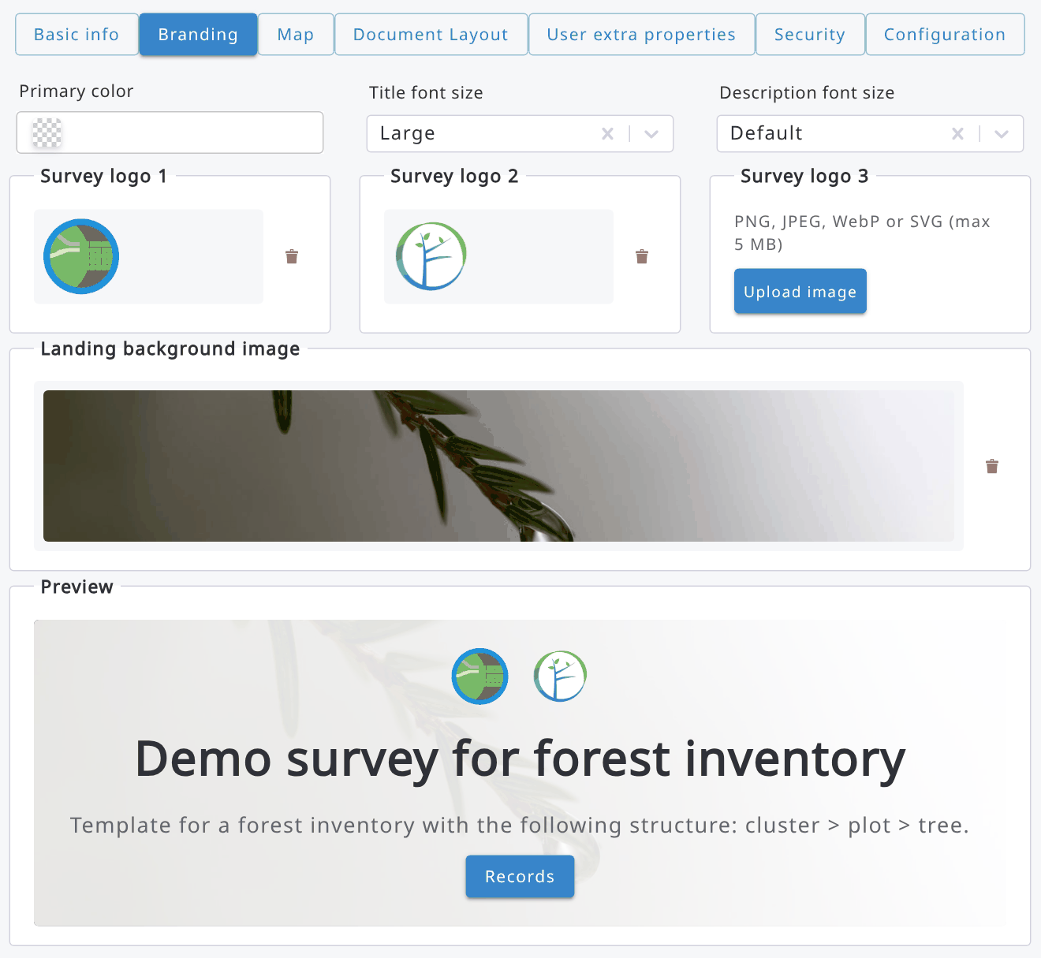

Survey landing page
Branding is applied on the survey landing page, which is the default view when opening a survey from Home. The landing page shows the survey title and description (from the survey labels), a button to go to Records, and, when configured, the survey's branding: primary color, logos, background image, and typography presets. A separate button opens the Dashboard, which has moved to its own top-level module in the sidebar.
Primary color
The primary color is the main accent color for the survey. It is applied to key interface elements such as primary buttons and sidebar highlights, both on the survey landing page and while collecting data, so the tool matches the branding of the project or organization running the survey.
Set the primary color using the color picker or by entering a hex value directly (for example, #2E7D32). If an invalid color value is entered, the field shows a validation error and the branding form cannot be saved until it is corrected.
Typography presets
Typography presets control the text size of the survey title and description as they appear on the landing page. Choose the preset that best fits the length of the survey title and description and the overall look of the branding.
Logos
Up to three logos can be uploaded (Logo 1, Logo 2, and Logo 3). All three are optional and independent of each other.
Logo slot | Typical use | Displayed on
Logo 1 | Main survey / project logo | Survey landing page and header
Logo 2 | Partner or implementing organization logo | Survey landing page
Logo 3 | Additional partner, donor, or country logo | Survey landing page
To upload a logo, select Upload image for the relevant logo slot and choose an image file. Once a logo has been uploaded, the upload button for that slot is replaced by a preview of the image and a delete action; an existing logo must be deleted before a new one can be uploaded in its place. Logos that have been uploaded are shown, in order, on the survey landing page. Click an uploaded image to download it.
Landing page background image
A background image can be uploaded for the survey landing page. Background images are raster images (for example, JPG or PNG) and are limited to 5 MB. Use Upload image to add a background image and the trash icon to remove it; as with logos, an existing background image must be removed before a new one can be uploaded.

6.1.3. Document layout
The Document Layout tab is available in Dashboard → Edit info to users who can edit the survey. It contains two groups of settings.
1) Document images
Images can be added to be shown in the header or footer of every printed document. Examples are an organization logo, a project banner, or a footer with contact details.
To add an image, click the + button. In the dialog that opens, set the following fields:
Field | Explanation
Label | Label of the image (required, in at least one survey language).
Place | Header or Footer (required).
Apply if condition | Optional expression. It is evaluated against the root entity of the record being printed. The image is used only if the condition is met.
File | PNG, JPG or SVG image, max. 5 MB. File names must be unique.
The document contains at most one header image and one footer image. For each place, Arena uses the first image in the list whose "Apply if" condition is met, or which has no condition. This lets you define alternative images for different cases. For example, you could use a different partner logo depending on the region of the record:
- Image 1: Header, Apply if: region == "north"
- Image 2: Header, Apply if: region == "south"
- Image 3: Header, no condition (used when neither of the above applies)
Click a row (or its edit icon) to edit an image. Images can be downloaded with the download icon and removed with the trash icon.
2) Layout options
Option | Default | Explanation
Header on first page only | Enabled | If enabled, the header image is printed only on the first page. If disabled, it is repeated on every page.
Page numbering | Enabled | If enabled, page numbers are printed on each page.
Note: as with other survey settings, publish the survey to make changes available to all users.

6.1.4. User extra properties
User extra properties section allows users to define properties that can be associated with the users working with the survey. These properties can be numeric or text values.
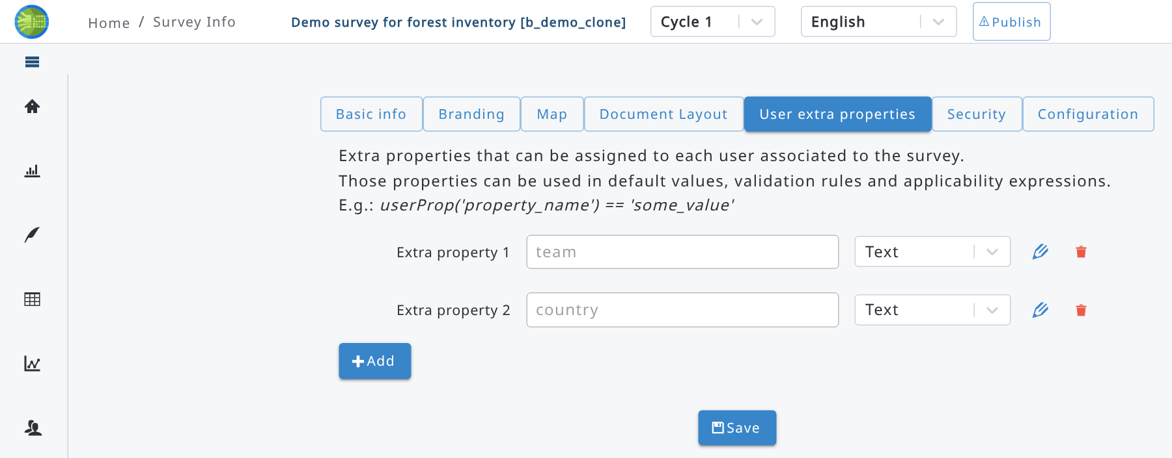
Values can be assigned to the users in the Users list, pressing the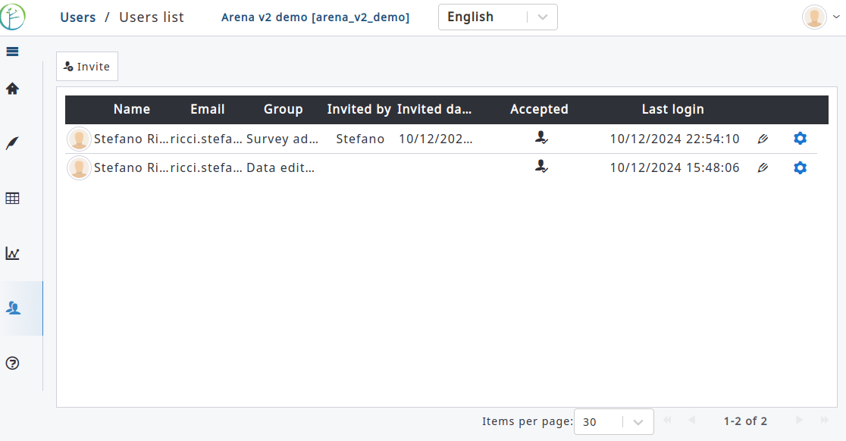icon in each row; in the dialog that opens, values can be specified for each user extra property:
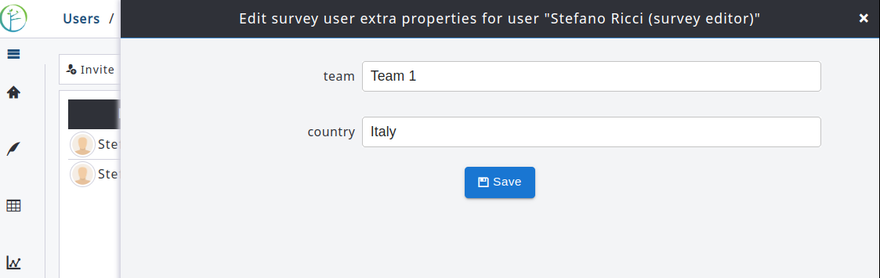
User extra properties can be used in expressions like default values, validation rules etc., or to filter category items or taxa in the taxon attribute search. The function used to retrieve a user extra property is userProp and it can be used in default values, validation rules, items filter expressions etc.
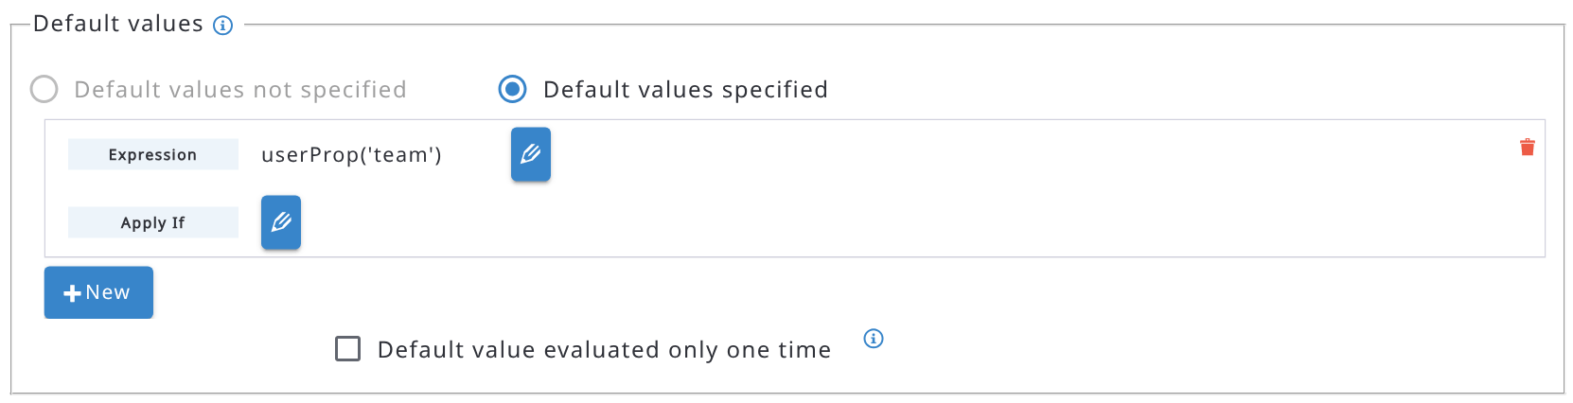

6.1.5. Security
Users who can edit the survey (Survey Administrators and Survey Editors) can view and edit the survey’s Security settings, as follows:
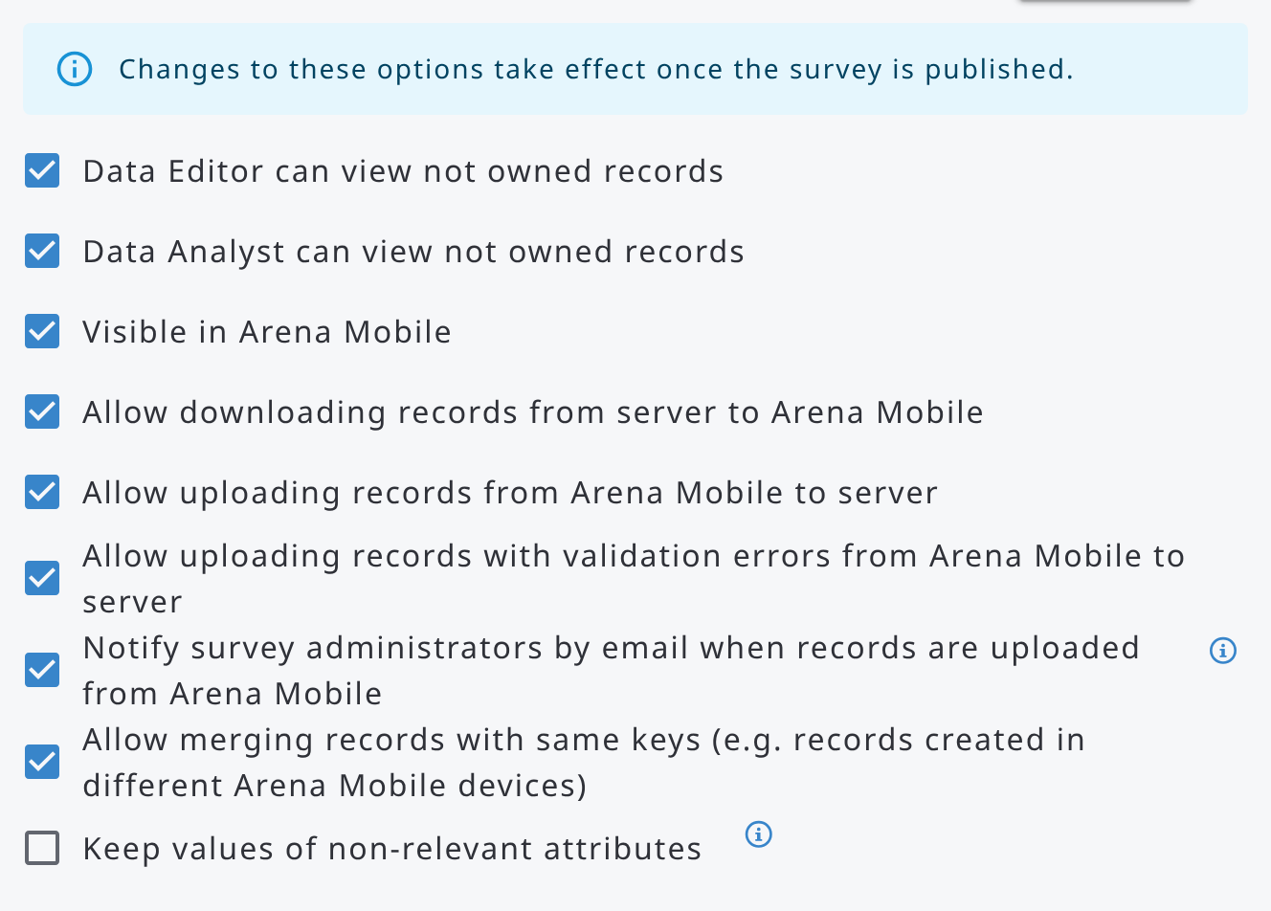
Meaning of “can view not owned records”: If enabled, then a Data Editor/Analyst can view all other users’ records in the survey (on the list of records). If disabled, a Data Editor/Analyst cannot view other users’ records in the survey.
Changes to the Security options take effect once the survey is published, as reminded by the message at the top of the tab.
The other options are the following:
- Visible in Arena Mobile, Allow downloading records from server to Arena Mobile, Allow uploading records from Arena Mobile to server and Allow uploading records with validation errors from Arena Mobile to server define if the survey can be used in Arena Mobile and how records can be exchanged between Arena Mobile and the server.
- Allow merging records with same keys (e.g. records created in different Arena Mobile devices): enabled by default. A record uploaded from Arena Mobile or imported with the same key values as an existing record is merged into it. If disabled, such a record is not imported and an error is reported.
- Notify survey administrators by email when records are uploaded from Arena Mobile: shown when records upload from Arena Mobile is allowed, disabled by default. If enabled, every Survey Administrator receives an email (in English) every time records are uploaded from Arena Mobile, listing for each record the key values, whether it is new or updated, the user who created it, the creation and last modification dates, the number of validation errors and warnings and its internal identifier (UUID), together with the user who uploaded the records and the date of the upload.
- Keep values of non-relevant attributes: when unchecked (default), during data entry the values of attributes that are no longer relevant are cleared, after the user confirms it. When checked, those values are kept in the record, even if the attributes are not relevant anymore.

6.1.6. Map
The Map tab contains the sample-based image interpretation settings (read more in 9.7.2) and the areas of interest of the survey.
Areas of interest
Areas of interest are polygons, for example the boundary of a forest reserve, of a stratum or of an administrative unit. They are used in expressions to check if a location is inside an area, or to find the area containing it. The expressions work also offline in Arena Mobile.
To add an area of interest, click Add. In the dialog that opens, enter the Name (used in the expressions) and optionally the Labels, then select a GeoJSON file (.geojson or .json, max 10 MiB) with one or more polygons in WGS84 coordinates. The polygons are shown on a map in the same dialog, so you can check them before clicking Ok.
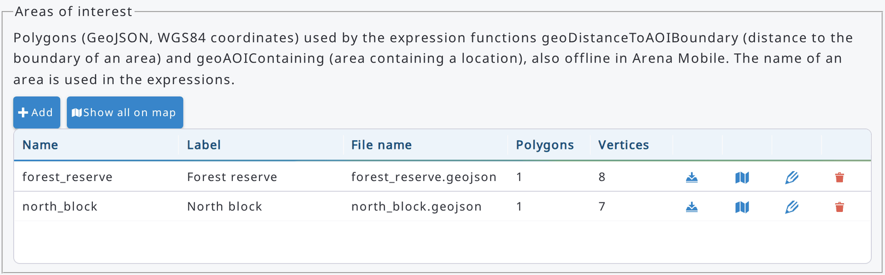
For each area, the list shows the name, label, file name and number of polygons and vertices. Click a row (or its edit icon) to edit the area; use the other icons in each row to download its file, show it on the map or delete it. Show all on map shows all the areas together:
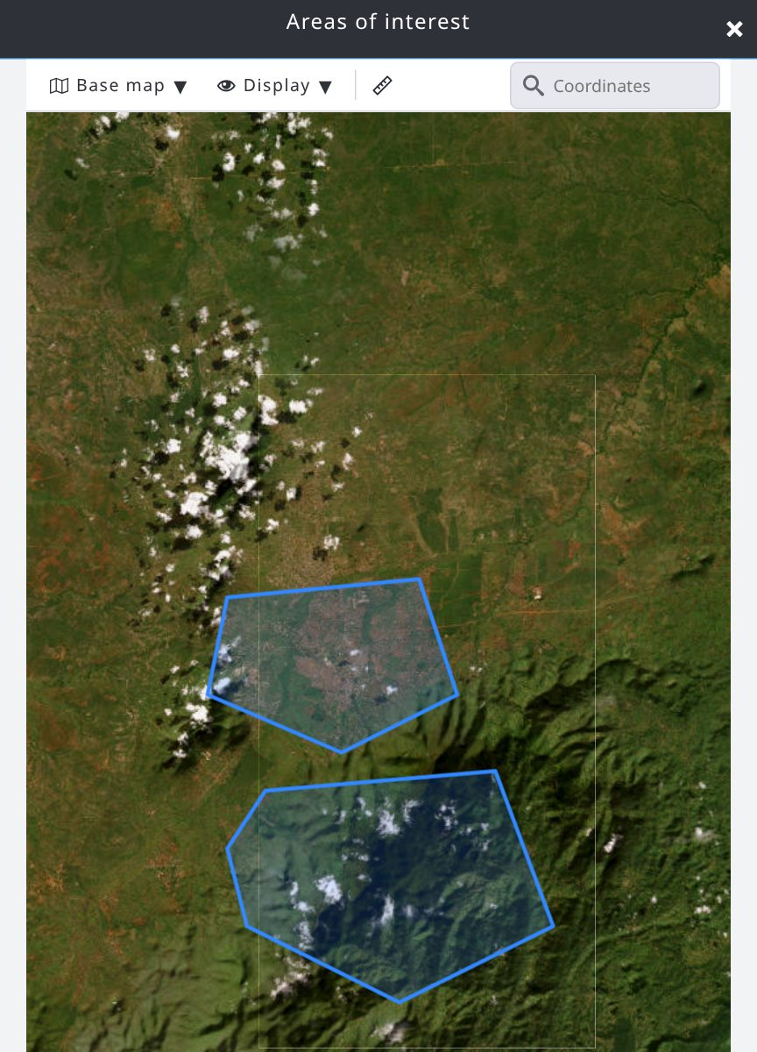
Click Save to store the changes. As with other survey settings, publish the survey to make them available to all users. The areas of interest can also be shown as layers in Data > Map.
The areas of interest are used with these expression functions:
- geoDistanceToAOIBoundary(coordinate, 'area_name'): distance (in meters) between a coordinate and the boundary of the area: negative inside the area, positive outside. For example, the validation rule geoDistanceToAOIBoundary(plot_location, 'forest_reserve') <= 0 checks that the plot is inside the forest reserve. Comparing the distance with the GPS accuracy, you can tell if a location is surely inside, surely outside or too close to the boundary to be sure.
- geoAOIContaining(coordinate): name of the first area of interest (in the order of the list) containing the coordinate, or nothing if no area contains it. For example, use it in the default value of a text attribute to fill in automatically the area where the plot is located.
Map layers shared with all the users of the survey (uploaded files or map services) are added in Data > Map, with the Add data menu.

6.2. Publish a survey
A draft survey needs to be published to make all recent changes available for the users. These changes can be, for example, changes in attributes’ properties (as new validation rules), changes in form layout, new read-only attributes or new calculation scripts.
Publishing a survey will make the following changes to the survey:
- it will be available for data entry in the Data > Records section;
- changes applied to the survey will be visible even in data entry;
- deleted node definitions (e.g. attributes) will be permanently deleted from the records;
- modified validation rules will be evaluated again and records re-validated (only for changed/edited records);
- for surveys imported from Collect: record editing will be available.
When publishing a survey, there is the following warning at the screen.
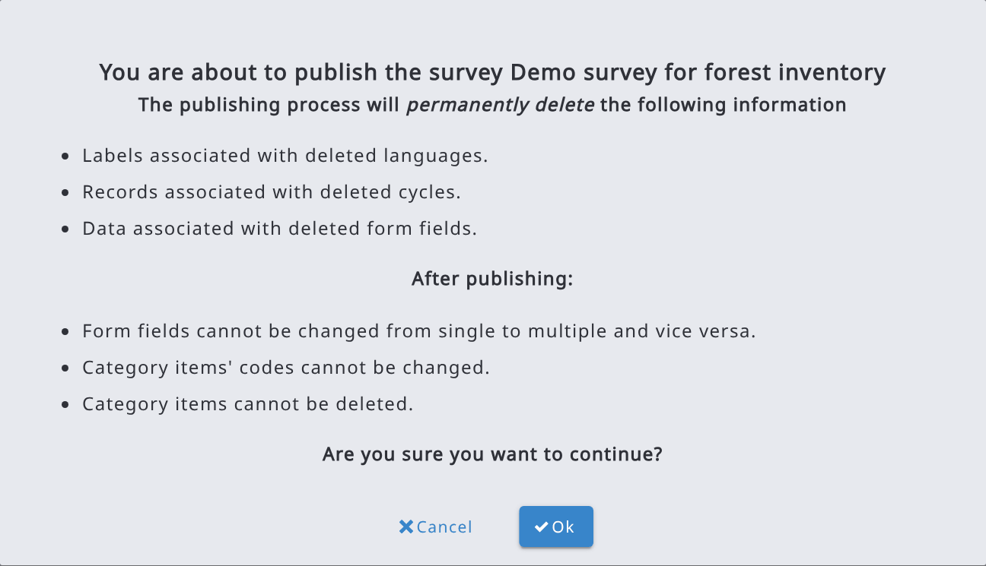
If Publishing a survey fails, you do as follows:
- Open the Details section.
- Scroll into the end of the error list.
- Click on Export and you will get the error list into a CSV file (arena_NodeDefsValidationJob_errors.csv).
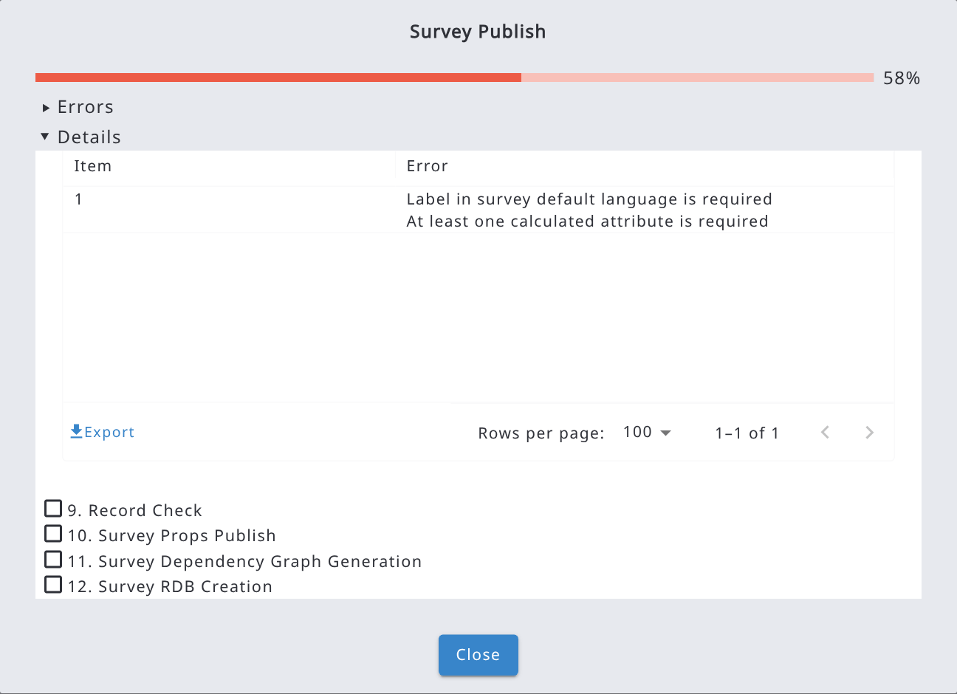
- Fix all issues in your survey and try to publish your survey again.
Changes affecting existing data
If the survey is already published and you changed something that recalculates values already entered in the records (for example the default value or the relevance condition of a published attribute, or an extra property of a category or taxonomy used in expressions), Arena shows a further warning, Existing record data will be updated, listing the affected attributes.
- Click Publish and update data to publish the survey and recalculate the affected values in the existing records. Values can be changed or cleared.
- Check Skip data update (not recommended) to publish without updating the existing data: the affected values are not recalculated until they are entered again, and the records may no longer match the survey definition. In this case, type the survey name to confirm and click Skip data update and publish.

6.3. Export survey and data backup
The survey can be exported into a zip file with or without the data. In this way the user can create and download a backup file. The zip file contains the following content depending on the selected option:
Export Export + data (NO Activity Log) Export + data (Backup)
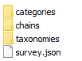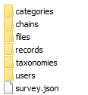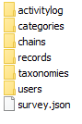
Activity log contains the history of a survey. For example, it can contain data about who and when a certain record attribute was updated with a new value, or who and when a record was upgraded from Cleansing level to Analysis.
It is typically faster to export a survey without the activity log.
The Export + data (NO Activity Log) option is shown only when the activity log is enabled on the server.
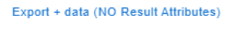
A survey containing a calculation chain and result attributes can be exported also without the result attributes (Export + data (NO Result Attributes), shown only if the survey contains processing chains). In this case, the exported file contains the survey structure and the input data.
The options with data are available only to Survey administrators; Data analysts and Survey editors can use only Export (survey without data), while the other roles cannot export the survey.

6.4. Unpublish or delete a survey
In "Advanced functions", there are methods to unpublish a survey or delete it. Only users who can edit the survey (Survey Administrators and Survey Editors) can unpublish or delete it. Unpublishing removes all data from the survey but keeps its structure; to confirm it, you need to type in the survey name.
Deleting removes both data and the survey structure from the database. To delete a survey, you need to confirm the deletion by typing in the survey name.
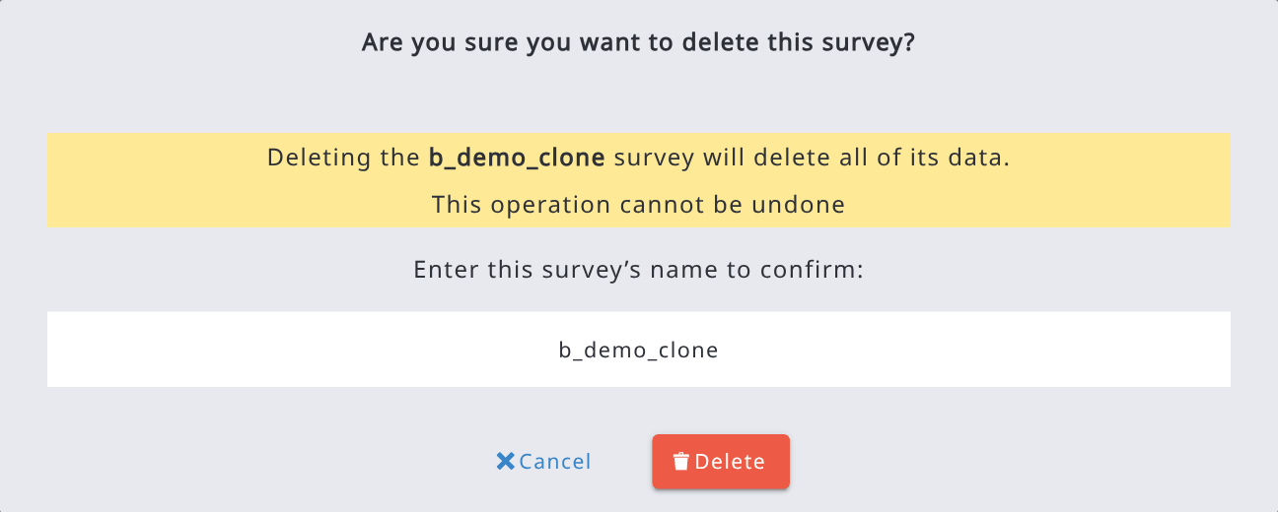
After deleting a survey, you have no active survey selected. This means that most commands will be inactivated. If you go to the Home or Dashboard section, you will see the next text on the screen.
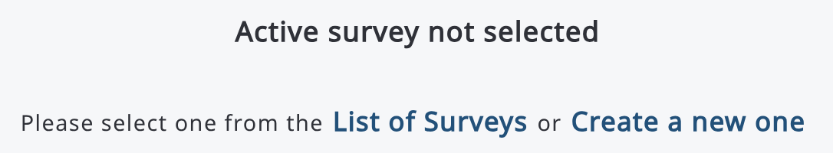
In order to continue working with Arena, you either need to select a survey or start creating a new one.
Clear activity log (shown only when the activity log is enabled on the server) deletes all the activity log data of the survey, reducing the space it occupies in the database. The input data of the survey are not affected. Also this operation must be confirmed by typing in the survey name.

6.5. Collect Import report
If a survey was imported from an Open Foris Collect file, it gets a Collect Import Report. Otherwise, this option is not visible for a survey. The Collect Import Report button is shown in the Dashboard, after Advanced functions, to the users who can edit the survey.
The main difference between Arena and Collect is that Arena uses JavaScript (JS) language in expressions, but OF Collect uses XPath language (for example within Required and Validation rules). So, when a Collect survey is imported, all expressions need to be converted from XPath into JS, either programmatically or by typing them in manually.
After importing a Collect survey into Arena, the Collect Import Report table shows all expressions which need special attention, such as possible modifications. The import process can convert the most typical XPath expressions into JS, but not complex expressions. Therefore, it is essential to fix all remaining issues before trying to publish an imported survey.
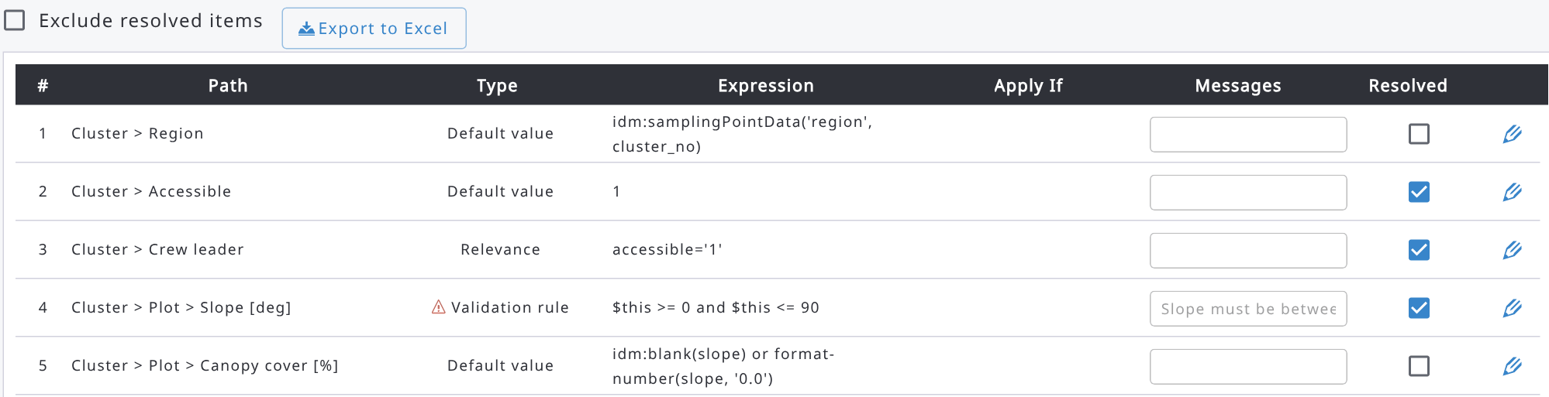

The report table contains the following fields:
PATH: path of entity/attribute in the survey structure.
TYPE: expression type (Default value, Validation rule, Relevance, Required if, Parent code).
EXPRESSION: expression in Collect (Xpath).
APPLY IF: XPath APPLY IF expression in OF Collect.
MESSAGES: Validation rule’s user-tailored message in OF Collect.
View/Edit messages with other (selected) languages.
RESOLVED: If blank, the import process did not do the conversion. Check all unsolved issues before publishing your survey! Mark the issue "solved" (manually) after doing the correction.
Tick shows that the issue is solved.
 Edit the table, form or attribute properties.

The report table can be exported into an Excel file by clicking the Export to Excel button. This is probably the best way to examine what needs to be fixed in the survey. In this table, the value ‘1’ in the column ‘Resolved’ indicates resolved cases, and those with blanks are not converted in the importing process.
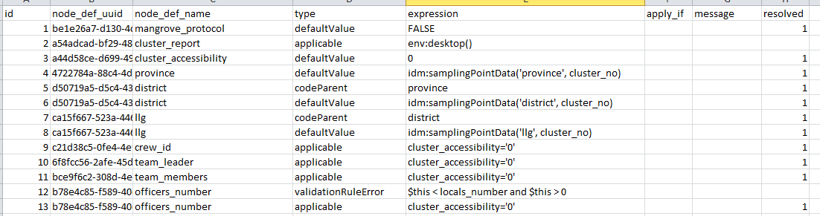
Important:
A Collect survey can contain a validation rule which is logically incorrect but still working (!): a value is checked against an attribute that is given later on the form/table. An example: in Collect, the XPath validation expression is given for "Mechantable" (height) as follows:
In this case, the Collect Import Report shows this as an unresolved issue. The reason is that in this survey "tree_height (Height [m])" is after "Mechantable", as seen below in the table. Arena cannot manage a validation expression with an attribute being second in the hierarchy.

The second typical issue with a Collect survey is that Collect may not require setting in the key fields for multiple-entry entities. In Arena, all multiple-entry entities must have a key (or keys).

6.6. Working with cycles
Arena can host multi-cycle data. By default, all new surveys contain ‘Cycle 1’. Users who can edit the survey can add, edit or delete cycles in Dashboard > Edit info (Basic info tab). Every survey needs to have at least one cycle.
After adding, editing, or deleting a cycle, the survey should be published to make the changes effective. Deleting a cycle will permanently remove all the records of the cycle!
When a new cycle is added, it inherits the survey structure (i.e. schema) from the previous cycle. However, data structure between the cycles can contain differences, so each cycle can have individual properties such as different attributes, form layout, etc.
If the survey contains more than one cycle, an attribute (with a specific name) can belong to one specific cycle, or to preset cycle(s). Attribute’s properties (e.g., name, label, validation rules) are the same across cycles, but an attribute’s position on the forms may vary.

More about cycles:
- Each cycle contains its own records. A record cannot be common across cycles.
- Settings for the Arena Map are common across cycles.
- Categories and taxonomies are common across cycles.
- Chains are common across cycles.
- The Validation Report is executed only for the selected cycle data.
- "Export + data (Backup)" will export data from all cycles.
- "Data Export" into CSV/Excel files will export data from the selected cycle. In every table, the first column indicates the cycle number.
- "Data Import" will import data only into the selected cycle.
- Within a published survey, records can be cloned from a cycle to a newer cycle (read more in Cloning data).
- Data processing with Studio can retrieve data from the Arena server only from the selected cycle, not all data across cycles.

6.7. Compare a survey with another survey
With Advanced functions > Compare / update from file you can compare the current survey with another version of it and apply the selected differences. For example, you can design and test changes on a test server and then bring them to the survey on the production server, without exporting and importing the whole survey. The function is available to the users who can edit the survey.
To compare and update a survey:
- Export the survey without data (Export > Export) from the other Arena server.
- In the survey to update, select Advanced functions > Compare / update from file and drop the exported .zip file in the box (max 20 MB). Instead of a file, you can also select another survey of this server in Or compare with another survey on this server.
- Review the differences and select the changes to apply.
- Click Apply selected changes and confirm.
- The changes are saved as draft: test the form and publish the survey to make them effective.
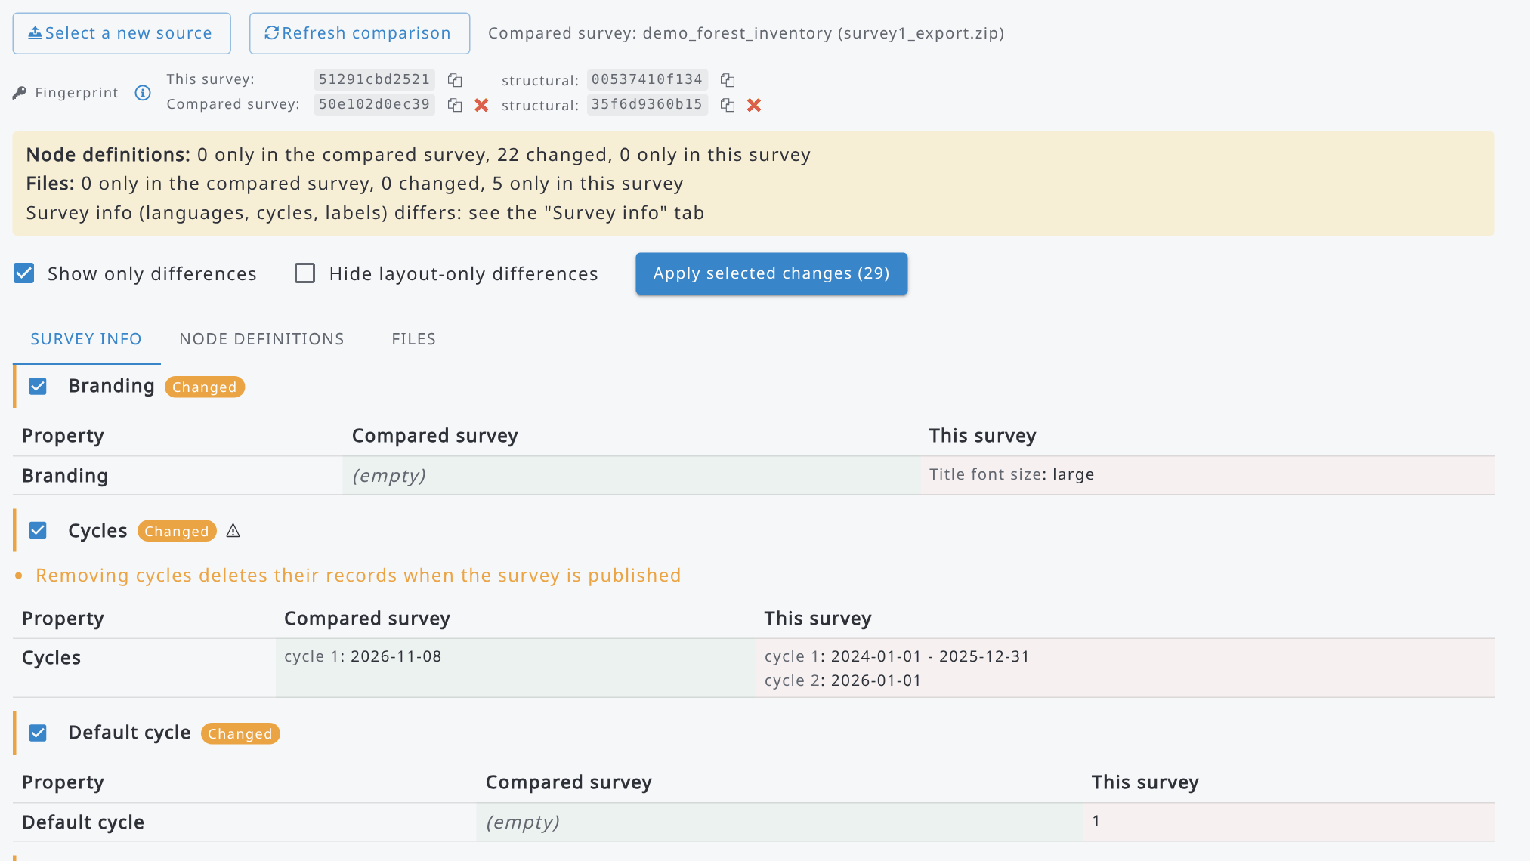
At the top of the page you find:
- Select a new source, to discard the comparison and select another file or survey, and Refresh comparison, to compare the same file again with the current version of this survey (e.g. after editing it).
- Fingerprint: codes of the survey definition (draft) of this survey and of the compared survey. Equal fingerprints mean equal definitions. The first one includes the internal ids, so it is equal only for copies of the same survey; the structural one uses names and codes, so it is equal also for surveys with the same structure created separately.
- A summary of the differences: elements only in the compared survey, changed and only in this survey.
- Show only differences and Hide layout-only differences, to filter the lists.
The differences are grouped in tabs (Survey info, Node definitions, Categories, Taxonomies, Files); only the tabs with differences are shown. Select an element in the list to see, for each property, its value in the compared survey and in this survey. A label shows the status of each element (Only in compared survey, Changed, Only in this survey), and a warning icon marks changes that need attention, for example removing cycles from a published node definition, which deletes its data in those cycles.
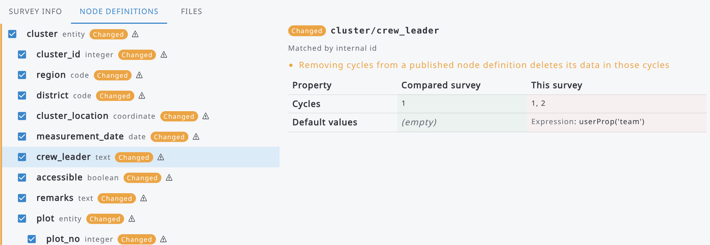
Each element has a checkbox to include it in the changes to apply. Note that:
- Elements only in this survey are deleted if you apply their change, so they are never selected by default. If you select deletions, you have to confirm them by typing the survey name.
- Node definitions are matched by internal id or, when the ids are different, by name. When a node definition could have been renamed, use Match as renamed to apply the change as a rename.
- Some changes cannot be applied to a published survey, for example changing the type, the key or the multiple property of a published node definition: they are skipped and the reason is shown. Changes that depend on each other are applied together.
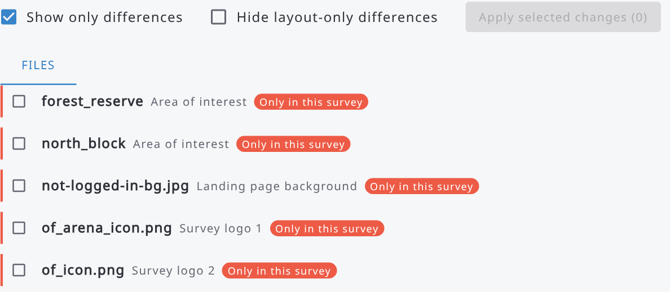
After applying the changes, a message reports how many changes were applied and how many were skipped. Publish the survey to make them effective.

7. Survey
The Survey section contains the following tools:
- Form Designer ^{*)}: tools for creating new data entry forms, creating and editing the tables/forms and attributes and all their properties, and to design the visual outlook of the forms.
- Hierarchy: Show the survey hierarchy, entities, and attributes.
- Dependency tree: Graphical tool that shows how attributes, calculations, validations, and expressions depend on each other within a survey schema.
- Categories ^{**)}: Management of categorical data (i.e. code lists).
- Taxonomies ^{**)}: Management of taxonomic data (i.e. species lists).
^{*)} This is available for a Survey Administrator.
^{**)} Survey Administrator can add, edit and delete lists, other users can only view them.

7.1. Terminology
Entity: Data entities are the objects of the data model such as ‘plot’ or ‘tree’. These are shown in Arena as forms or tables. Entities are containers for attributes and relationships between objects.
Attribute: A data attribute is a unit of information inside a data entity, i.e. it is a single-value descriptor for a data object. These are like properties of data entities: for example, an entity ‘tree’ can contain the following attributes: species, diameter, and age.
Node (object): A node is a basic unit of a data structure, and in Arena the data structure has the shape of a tree. A node object is represented by a single node in a tree, and it can be an element node, attribute node, text node, or any "node type".
A visual presentation of a survey is shown in the following figure.
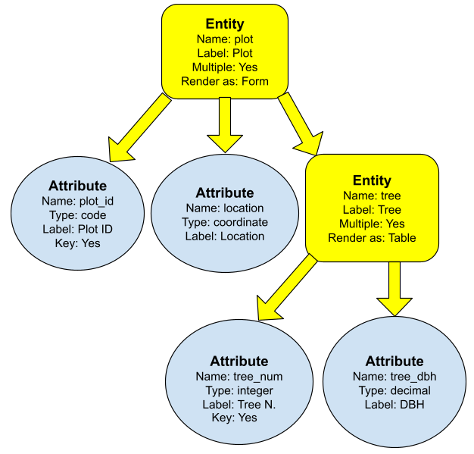

7.2. Form Designer

7.2.1. About the Form Designer user-interface
The Form Designer is a tool for designing the content and outlook of a survey. The Form Designer is a handy tool to create a user-friendly interface for data management. On the left, the page tree shows the pages of the survey (Only pages) or all its entities and attributes (All nodes); click an item to open it. The bar above the form shows the path of the current page; the copy button next to it copies the path (e.g. Cluster -> Plot) to the clipboard. Show names switches between labels and names of the nodes.
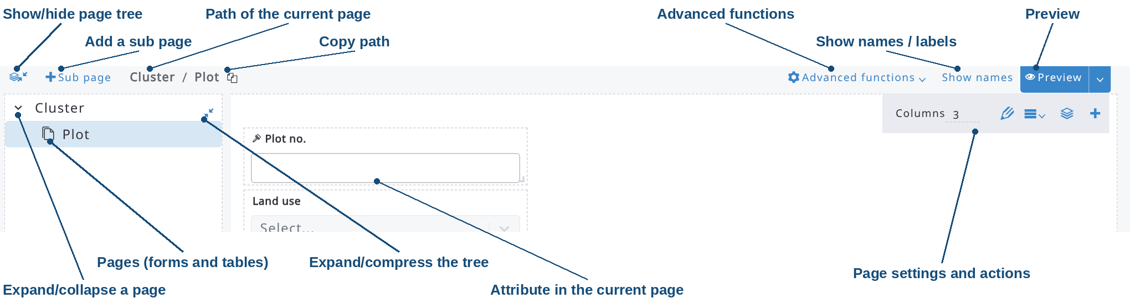
With the help of the Form Designer, you can do the following tasks with the forms:
Method | Icon | Explanation
Add a new subpage | 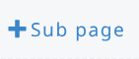 | add a new entity (table/form)
Define the number of columns | 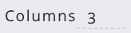 | The default number of columns is 3, this can be changed [1 - 9]
Add a new object | 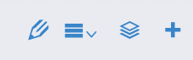 | add a new entity or attribute (+ button in the page toolbar)
Delete an object | 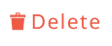 | delete an entity or attribute: Delete in the menu button of the object (☰), or Delete in its edit form
Rename an object |  | change the name of an entity or attribute in its edit form (pencil button)
Add/Edit objects’ properties |  | add/change all properties, such as label, default value(s), validation rules (pencil button)
Resize an object | 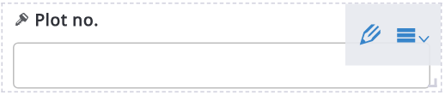 | Move the cursor to the lower right corner of the object, and then drag to resize
Change the order of attributes |  | Drag to an object and drop it to a new place on the forms
Preview of the survey (desktop or Arena Mobile, see 7.2.9) | 
Move up/down | 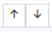 | Move the selected page up or down among its sibling pages (page tree, Only pages view)

7.2.2. Attribute data types
The properties of an entity (table/form) or an attribute describe the characteristics and behavior of data added to that object. The data type is the most important property because it determines what kind of data the field can store. Arena supports the most common data types applied in database management systems, and two composite data types: coordinates and taxonomic data. The data attribute types are presented in the following table.
Data type | Icon | Notes
Boolean |  | true / false  yes / no
Code |  | refers to categorical variables (i.e., code lists).  Read more at Categories  Note: Arena creates two fields into the database:  attributename and attributename_label
Coordinate |  | allows users to enter geographical coordinates  Optional properties: accuracy, altitude, altitude accuracy
Date |  | entered in dd/mm/yyyy format
Geospatial |  | Allows users to enter geospatial data like polygons. It supports only GeoJSON format.
Time |  | entered in hh:mm format, or hh:mm:ss if Include seconds is enabled in the attribute properties
File |  | Allows users to upload a file (e.g. image, audio file, video, document, etc.). Optional property (image): show/hide geotag information
Integer  Decimal |  | An integer is a whole number that can be positive, negative, or zero.  Numbers with decimal digits.  Default number of decimal digits: 6
Taxon |  | Read more at Taxonomies
Text |  | Allows users to add free text

Attribute data type conversion is possible. For example, you can change an attribute from Integer to Decimal. In general, conversion is possible only if the survey has not been published after creating the attribute; the only exception is the conversion of a published Integer attribute into Decimal (see 7.2.4.5). If the survey has been published, and it contains no data (=records), it can be unpublished and a data type can be converted then.
Note 1: When naming attributes, do not use the suffix "_label"! If for example you have a coded attribute cluster_district in the survey, there will (automatically) also be a field cluster_district_label in the database. If there is this type of conflict, this will be shown only when trying to publish the survey.
Note 2: Arena does not contain a data type "range" as applied in OF Collect. When a survey is imported from OF Collect, "range" type attributes are converted into two integer attributes: attributename_from and attributename_to.

7.2.3. Description of properties
The object's data type determines which properties you can set. Each data type can contain several properties which are expressed as parameters. Some properties are common for all data types, while others are unique to a specific type. Below is a list of properties with explanations.
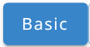
 | This section is used to give the basic properties for forms, tables and attributes
Name | Entity (table/form) or attribute name in lowercase letters. Functions within the survey and variables in R processing use this name.  For naming of entities and attributes in a survey for forest inventory, read more about "Naming of entities, attributes and variables" at openforis.org/materials  The list of reserved words are as follows:  asc, category, date_created, date_modified, desc, exp_factor_, file, id, length, node_def_uuid, owner_uuid, parent_id, parent_uuid, props_advanced, props_draft, props, record, record_cycle, record_step, record_uuid, step, taxonomy, unique, uuid, value, weight  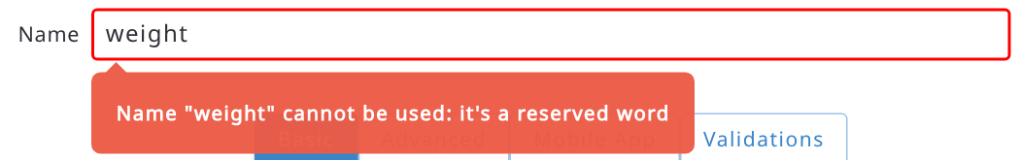
Type | Data type (selected while creating an attribute; it can be converted into another type if the attribute has not been published yet; a published Integer attribute can be converted to Decimal)
Label | Label text
Description | Free text description (optional). There will be an info icon next to the label which will show the text put in description, as follows:  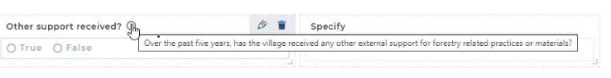
Label value
[Boolean]
Allow only device coordinate  [coordinate] | This applies only to Arena Mobile: if enabled, the user will not be able to modify the X/Y values, but he/she can only record the coordinate using the device GPS
Accuracy, Altitude, Altitude accuracy  [coordinate] | This data can be read from Arena Mobile.
Max number of decimal digits [numeric] | Number of decimal digits
Category  [categorical data] | Category table (i.e. code list) name.  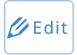 This allows users to edit a selected category table.  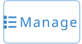 This allows users to select or change the category table.
Parent Code  [categorical] | Parent category (attribute) name for a hierarchical categorical data attribute
Display As
[categorical]
Show code  [categorical] | Show/Hide code
Text transform
[text]
Text input type
[text]
Include in records list | Show the attribute value in the list of Records
Taxonomy  [taxonomic] | Species list name
Visible fields  [taxonomic] | 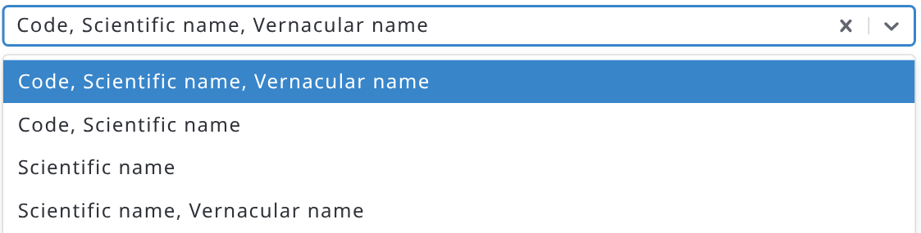
Vernacular name label  [taxonomic] | Vernacular name in user-interface
Key | If enabled, this attribute serves as a unique identifier
Auto incremental | If an attribute is Integer and a key, it can be set increasing automatically by 1
Multiple | Allow multiple entries for this attribute.  Note: These are difficult to use in data analysis, consider using multi-entry forms.
Max. file size (Mb)  [file] | Maximum size of file to be uploaded. On Arena Mobile, if the file type is “image”, when an uploaded picture exceeds the specified maximum size, it will be resized to fit that value.
File name expression [file] | Expression is used to generate the name of the file when it is downloaded or exported as CSV/Excel data. E.g.: suppose that you have some attributes called “region”, “province” and “cluster_id”, the generated file name could be a combination of these 3: region + “_” + province + “_” + cluster_id  The extension will be the same as in the original uploaded file.
File type  [file] | 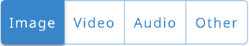
Show geotag information (image file) | Geotagged photos are images that have geographical location data (latitude and longitude) embedded within their metadata. This allows users to see the coordinates and where a photo was taken on a map.
Cycles | 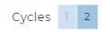If the survey contains more than one cycle, an attribute can belong to one cycle, or to preset cycles. Attribute’s properties (e.g. name, label) are the same across cycles, but the position on the forms may vary.
Included in cloned data | true/false. In a multicycle survey case, when a cycle’s data will be cloned to upper cycle, this setting defines whether this attribute data will be copied or not.
Vernacular name selection kept  [taxonomic] | - Enabled: when a taxon is selected using a vernacular (common) name, the specific vernacular name used for the search will also be stored in the data.  - Disabled: only the taxon code and scientific name will be stored, regardless of which vernacular name was used during the search.  In Arena Mobile:  - Enabled: each vernacular name appears as a separate item in the search results list.  - Disabled: all vernacular names for a taxon are grouped together and displayed alongside the taxon (combined in a single entry). As a result, the autocomplete list contains fewer items.
Vernacular name always included if only one | - Enabled: If this option is enabled and a taxon has only one vernacular name defined, that vernacular name will automatically be stored with the data when the taxon is selected.  - Disabled: only the taxon code and scientific name will be stored, even if the taxon has a single vernacular name.
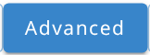
 | This section is used to add default entry values, and conditions when a form table or attribute is applicable
Editability:
- Always editable | This is the default option; the attribute will always be editable.
- Editable if condition is met | If selected, the attribute will be editable only if the specified conditions (expressions) are met.
- Read Only | If enabled, the entry can only get the default value (as from an expression)
Default values:
- Default values not specified | Default values will not be applied.
- Default values specified | Attribute value will be created using one or more expressions.  Every default value expression is made by an “Expression” and an “Apply if” condition. See more about expressions in Chapter Expressions and expression editor and Examples of expressions.  The first expression for which the “Apply if” condition is met will be applied.  If there are multiple expressions, only the last one can have an empty “Apply if” condition; it will be applied if none of the previous ones are met.
Default value evaluated only one time | Disabled: the default value is re-evaluated when the source attributes change.  This selection can cause problems, such as slowness with Arena Mobile.  For example: if false, the autoincrement default value for tree_id will be recalculated repeatedly for every tree (in a table) when you add a new entry or delete a data row.  Enabled: the default value is calculated only once.
Hide in entry form | If an attribute contains a default value or expression, then this attribute can be hidden in the entry form. A ‘hidden’ attribute value will be shown in the Data Explorer and included in the Data Export.
Relevance
- Always relevant | By default, every attribute or entity is always relevant and applicable.
- Relevant if condition is met | Function that determines under what conditions the field is applicable.  When an attribute is read-only and is not relevant, it will not be calculated according to the default value expressions defined.
Visibility
- Always visible | By default, every attribute or entity is always visible.
- Visible if condition is met | Function that determines under what conditions the field is visible.  A field could be relevant but not visible for some conditions, for example it could be hidden to some group of users.  When an attribute is read-only but not visible, it will be calculated still.
- Hidden when not relevant | If a relevant condition is specified and the condition is not met, the field is hidden on the form or table, otherwise it will be shown in light grey. If the field still holds a value (e.g. entered before the condition changed), it is shown in light grey also when this option is set, so that the value can be checked or deleted; Arena Mobile hides it anyway.
- Always hidden | (available only for read-only attributes) the attribute will always be hidden from the users.
Items filter  [categorical data]  [taxonomic] | A JavaScript expression to filter the items from the category table. Read more in Examples of expressions.
Hidden in Analytical Dashboard | The attribute is shown/hidden as a Dimension on Arena Statistical Reporter app
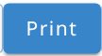
Page orientation | - Default (document): the entity uses the orientation chosen when the document is exported.  - Portrait or Landscape: the entity always uses this orientation, regardless of the choice made at export.
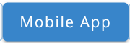
Hidden in Arena Mobile | If enabled, the entry (entity or attribute) cannot be seen on Arena Mobile.  (Key and Required attributes cannot be hidden)
Include in multiple entity summary | Now in the Basic tab. If marked, the attribute value is shown in the entity selector (in Arena) and in the entity summary view (in Arena Mobile)  (for a File attribute this cannot be set)
Include in previous cycle link | If marked, the value from the previous cycle will be shown on the data entry form (when the link to the previous cycle is active on the mobile app)
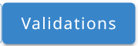
 | This section is used to automatically flag wrong entries during data entry. Using checks greatly minimizes data entry mistakes and facilitates data cleansing.
Min count  -Multiple-entry attribute | Minimum number of entries allowed. Blank (default) = 0
Max count  -Multiple-entry attribute | Maximum number of entries allowed. Blank (default) = no limit
Required
- Not required | (default)
- Always required | Arena displays as an error if the field is left blank
- Required when condition is met | Arena displays an error when the condition is met and the field is left blank.  If the condition is not met, no error is displayed.
Unique | Checks that the entered values are unique (not repeated) within a specified group of values.  When an attribute is marked as Unique, its value must be unique inside the closest multiple entity (an error will be shown otherwise).  E.g. in a structure like cluster -> plot -> tree, if you have an attribute tree_species marked as Unique, you can have only one tree per species inside the same plot.
Expression | Expression that defines the logic of the check. Read more here.
Apply if | Allows users to specify when the check is applicable (see an example below)
Severity | Error - blocks the data entry user from submitting the record to data cleansing  Warning - assigns a warning flag to the record but does not prevent submission to data cleansing
Error message | Message to be displayed to flag error/warning, it should be robust and easy to understand (see an example in this Chapter)

7.2.4. Attributes or entities advanced actions
Move the cursor upon the entity or attribute you want to edit, and an action button with the shape of an “hamburger” will appear; pressing that button will open a menu with advanced functions as follows:
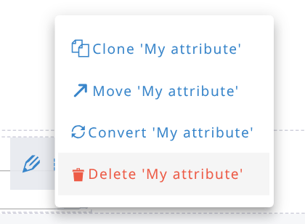
Note: node move or convert is allowed only if the survey has not been published yet, or if the node is new and the changes have not been published yet. Exceptions: a published Integer attribute can be converted to Decimal (see 7.2.4.5), and attributes can always be cloned.

7.2.4.1. Attribute or entity move
An attribute or an entity can be moved into another entity.
By clicking on the item “Move [attribute name]” in the advanced actions menu will open a dialog where the new “parent” entity for the selected node can be selected:
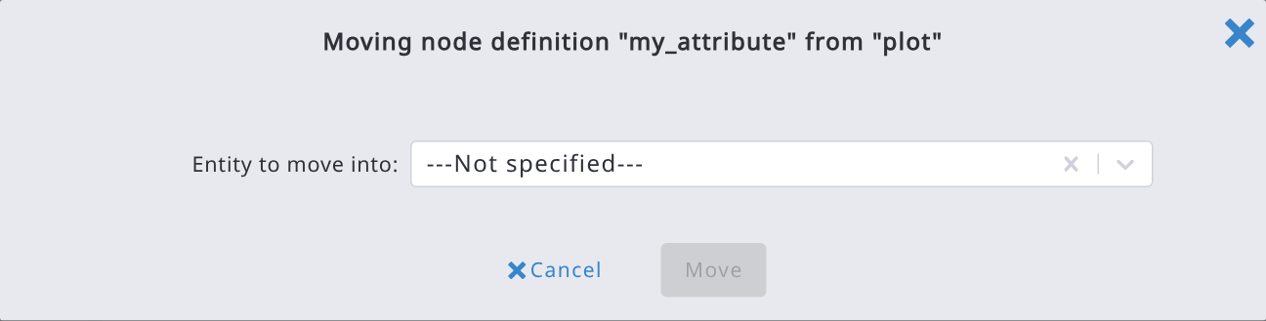
Select the entity where the node should be moved and confirm the selection by pressing the button “Move”.
Note: when moving an entity, only entities not descendants of the current one can be selected.

7.2.4.2. Attribute clone
An attribute can be cloned into another entity. All its properties will be copied, including all the expressions defined for Default value, Relevant if or Validations.
The operation is similar to moving a node; by clicking on the item “Clone [attribute name]” in the advanced menu, a dialog to select the target parent entity will open; select it and confirm the target entity.
Note: since the cloning will copy the expressions defined in the source attribute, it may happen that some of these expressions will be invalid in the new cloned attribute; in that case, after the cloning, the attribute edit form will appear, thus allowing a fix of these errors.
Cloning is available to all survey designers, also for attributes that have already been published. Entities cannot be cloned with this function; to copy an entity from another survey, use Clone Node From Another Survey (see 7.2.4.4).

7.2.4.3. Attribute data type conversion
An attribute can be converted from one data type to another. All properties that are compatible with the new type will be preserved, including expressions defined in Default values, Relevant if, Validations etc.
By clicking on the item “Convert [attribute name]” in the advanced menu, a dialog will appear, allowing the selection of the new data type as follows:
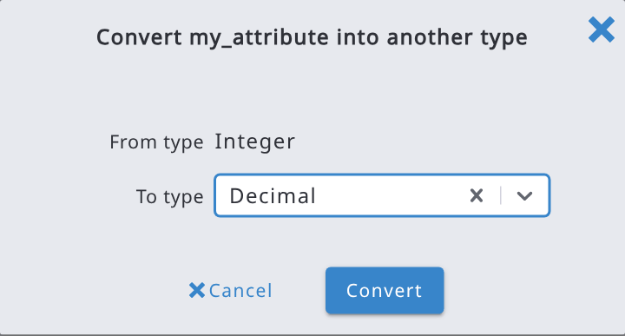
Select the new data type and confirm it by pressing the “Convert” button.

7.2.4.4. Clone an attribute or entity from another survey
In the Form Designer, open the Advanced functions menu (top of the form) and choose Clone Node From Another Survey. In the dialog, expand the source survey's form tree to locate and select the entity or attribute to copy (either one can be picked, not entities only), then choose the Target entity in the current survey under which it should be inserted, and confirm.
If the cloned node (or any of its descendants, when cloning an entity) is a code or taxon attribute, Arena resolves its category or taxonomy automatically, without a separate step:
- If a category/taxonomy with the same internal ID or name already exists in the current survey, the cloned attribute is linked to that existing one instead of creating a duplicate.
- Otherwise, the category/taxonomy is cloned from the source survey automatically, and a notification lists what was cloned along with the node definition.
Note: the dialog lists the other surveys you can access and shows their published version.

7.2.4.5. Convert a published integer attribute to decimal
Once an attribute has been published, its data type cannot be changed, with one exception: an Integer attribute can be converted to Decimal, for example when the field teams need to enter decimal values that were not foreseen.
Open the menu button (☰) of the published integer attribute: the menu contains Convert (besides Clone and Delete; Move is not available for published nodes).
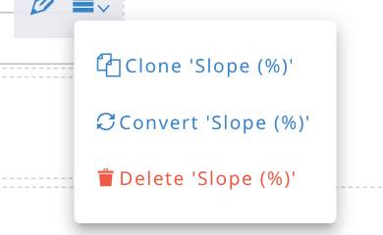
In the conversion dialog, Decimal is the only target type available. Select it and press Convert, then publish the survey.
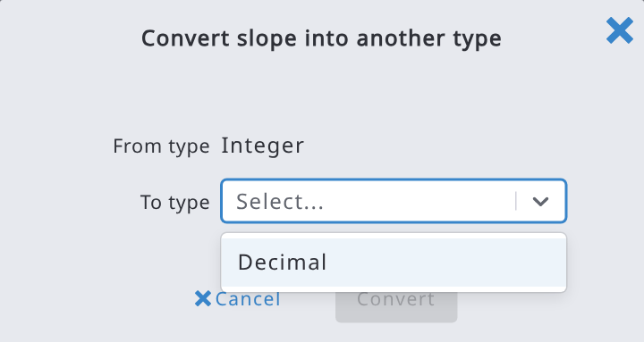
The values already collected are kept, including decimal values already entered (for example in Arena Mobile).

7.2.5. Units of attributes
Arena does not contain a property to set units for numerical attributes, nor automatic conversion between the units. It is therefore recommended to add information about the unit into the attribute’s label, such as "Diameter [cm]", "Area [ha]", etc.

7.2.6. Enumerated entity

7.2.6.1. Automatically generating rows from category items
The rows can be automatically generated in a table, where the key attribute is categorical (code). The “Enumerate” can be set to the entity (i.e., to the table):
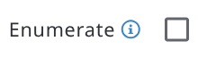
The rows will be generated using the items defined in the category of the key attribute inside the entity one row for each item). In the enumerated table or form, new rows or forms cannot be added or deleted, and the key code attribute will not be editable. In addition, the key attribute should not have an “Items filter” expression (because the items cannot be changed dynamically).
Note: a code attribute marked as “key” should be defined inside the entity, otherwise marking it with “Enumerate” will not make any effect.

7.2.6.2. Dynamic enumerated entity
Enumerate auto-generates one table row per item in the key attribute's category and disables manual add/delete options. Until now that category always had to be used in full. Dynamic Enumerate adds an optional Enumerating items expression to the entity: when set, only the category items whose code is returned by the expression get a row; the rest are skipped. Leave it empty and Enumerate behaves exactly as before.
The expression is typically built around the unique() function, which returns the distinct values found in a multiple attribute or entity. This lets a table auto-generate one summary row per distinct value already present elsewhere in the record, instead of one row per category item regardless of whether it's used.
Example: a table_source table where the field team logs individual measurements, each tagged with a source_type code and a value:
- table_sum is set to Enumerate, linked to a category “types” (items A, B, C), with Enumerating items expression set to unique(table_source.source_type).
- As the user enters table_source rows, table_sum automatically gains one row for each distinct source_type actually used (not all of A, B, C, only the ones present).
- Each table_sum row can carry its own computed attribute, e.g. value_sum with default value sum(table_source[$context.sum_type == source_type].value), to total the matching entries.

Prerequisites
- The entity already meets the standard Enumerate requirements: multiple-entry table, Enumerate checked, with a categorical (code) key attribute linked to a category.
- The category linked to the key attribute must already contain an item for every code the expression can produce; enumeratingItemsExpression only selects among existing items, it does not create new ones. Values with no matching item are silently skipped.
- Like other node-def expressions, anything the expression references must be reachable from the entity's parent context, and the entity cannot reference itself (self-reference is rejected by validation).
Step-by-step
- In the Form Designer, select the multiple-entry table and check Enumerate.
- A new Enumerating items expression field appears directly beneath the Enumerate checkbox.
- Enter the expression, typically unique(<path to a multiple attribute>) - e.g. unique(table_source.source_type). Leave it empty to keep enumerating every category item, as before.
- Save the entity. While the expression field holds a value, the Enumerate checkbox is locked on; clear the expression first if you need to switch Enumerate off again.
- Test in Preview or a draft record: add/remove values in the source attribute the expression reads from, and confirm rows in the enumerated table appear and disappear accordingly.
- Publish the survey.
Behavior and limitations
- Sync is incremental, by design: adding a new distinct value creates one new row; removing the last row with a given value deletes only that row; rows for values that are still present are left completely untouched, including any data already entered in them. Editing an unrelated attribute does not touch the enumerated rows at all.
- Rows still can't be added or deleted manually, only the generated set changes, and only in response to the expression's source data.
- If the entity itself becomes inapplicable (e.g. via relevant when expression), all its enumerated rows are deleted, same as the existing Enumerate behavior.
- Unchecking Multiple, or clearing Enumerate, also clears the enumerating items expression.
- Same authoring and performance guidance as other Arena expressions applies: keep the expression simple, since it's re-evaluated whenever its source data changes.

7.2.7. Summary on survey schema
The Schema Summary is an exported CSV or Excel file showing a summary about the schema. It contains the list with all entities and attributes, data types, labels, and selected properties (see the table below). The required column contains true, false or conditional; for attributes required only when a condition is met, the condition is in the requiredIf column. The hiddenInAnalyticalDashboard column tells if the attribute is hidden in the Analytical Dashboard.
A summary report can be exported from the Advanced functions menu at the top of the Form Designer, choosing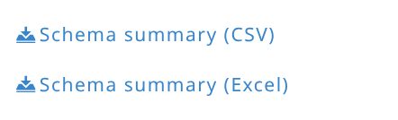. An example of a schema summary report is presented below.
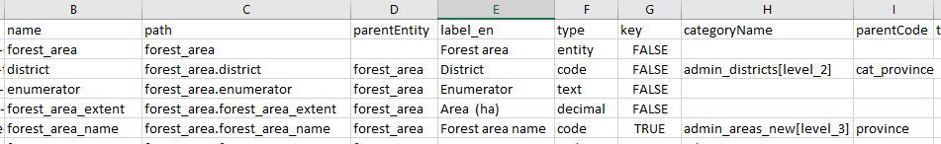
Column | Explanation
uuid | (internal) universally unique identifier
name | name of entity / attribute
path | path in hierarchy
parentEntity | parent entity name
label_en | label text (English)
description_en | description text (English)
type | data type
key | key field?
categoryName | category table name (of code attribute)
parentCode | parent code (of hierarchical code attribute)
categoryLevel | category level number
enumerator | enumerator
taxonomyName | taxonomy table name
multiple | multiple entry?
readOnly | read-only?
fileType | file type
maxFileSize | max. file size
hiddenInForm | hidden in form?
hiddenInMobile | hidden in the Mobile app?
includedInMultipleEntitySummary | included in a multiple entity summary?
allowOnlyDeviceCoordinate | allow only to record coordinates of the device?
relevantIf | 'relevant if' rules
hiddenWhenNotRelevant | hidden when not relevant?
itemsFilter | items filter text
defaultValue | default value
defaultValueApplyIf | default value apply if (rule)
defaultValueEvaluateOnce | default value is evaluated just once?
required | is this required? (true, false or conditional)
unique | is this unique?
minCount | min. count (of multiple entities or attributes)
maxCount | max. count (of multiple entities or attributes)
validations | validations rules
validation_message_en | validation messages (English)
cycle | cycle number

7.2.8. Form language
Every survey can be defined in multiple languages. Languages can be defined in the Survey Info section (Language(s) field).
The users (using the web version or the mobile version of Arena) will see the data entry form in the language of their browser or their device.
When multiple languages are defined, a language selector dropdown will appear in the top bar:
By selecting a language, all the “labels” fields will be shown in the selected language.
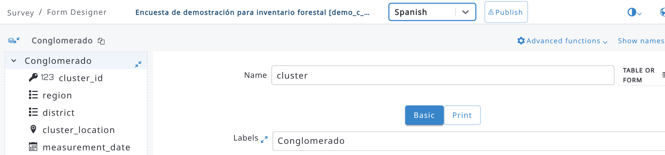
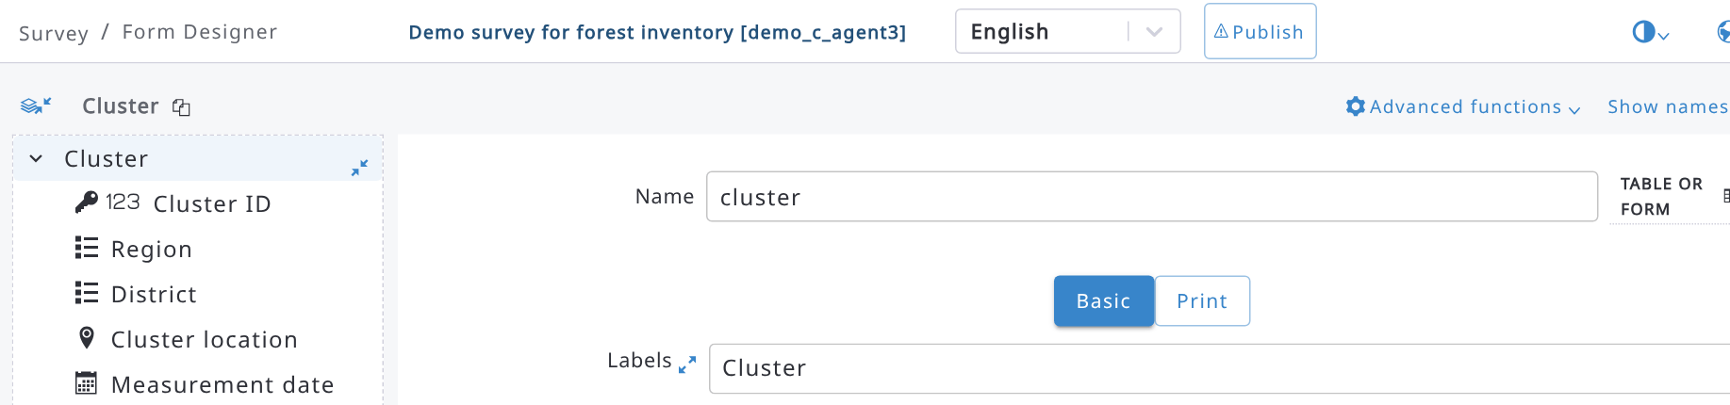
When multiple languages are specified, every label field will have a small icon close to it: Pressing this icon will show all the labels in the languages specified for the survey and it will make easier their translation:
It’s always possible to add new languages and to remove existing ones, even when a survey is published and data has been collected already; this type of change will not affect or break the collected data.
To translate the labels outside Arena, use the items Export labels (CSV) or Export labels (Excel) of the Advanced functions menu: you get a file with one column per language. Fill in the missing translations and load the file back with Import labels from Excel or CSV.
If the AI features are enabled on the server and in your AI settings, a globe button appears next to a multilingual label field when some languages are still empty: press it to fill in the missing translations automatically. The Advanced functions menu also contains AI: Translate labels, which translates the labels of all the nodes of the survey in one go. Always review the suggested translations.
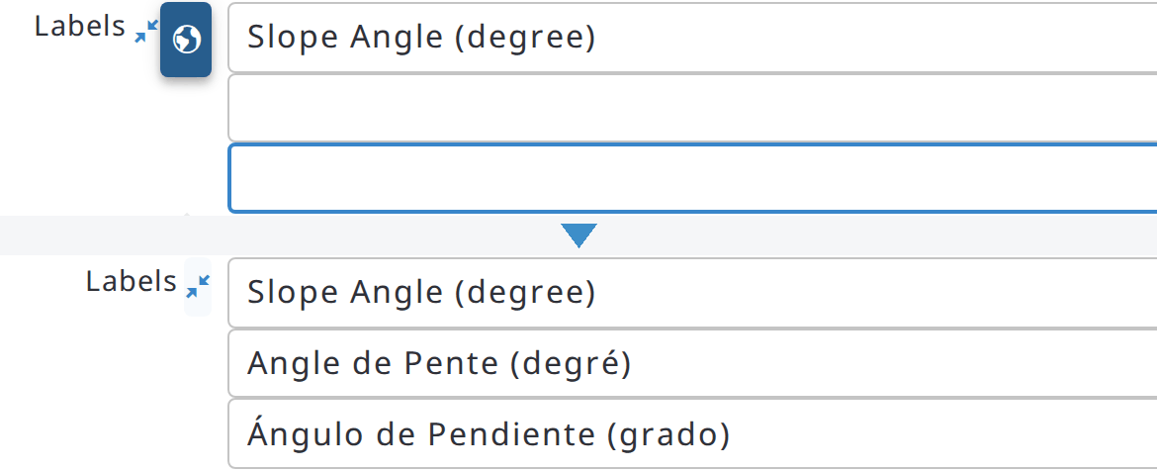

7.2.9. Form preview (desktop and Arena Mobile)
The Preview button at the top right of the Form Designer lets you test the forms while you design them, without creating real records. The main part of the button opens the desktop preview; the arrow next to it opens a menu with the preview options:
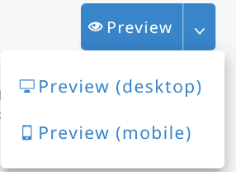
- Preview (desktop): opens a test record in the data entry form of Arena. The data entered in the preview is not saved among the survey records.
- Preview (mobile): opens the Mobile preview panel on the right side of the page, with an approximation of Arena Mobile running in the browser with the draft survey. It is available to all survey designers, when the server provides the Arena Mobile preview.
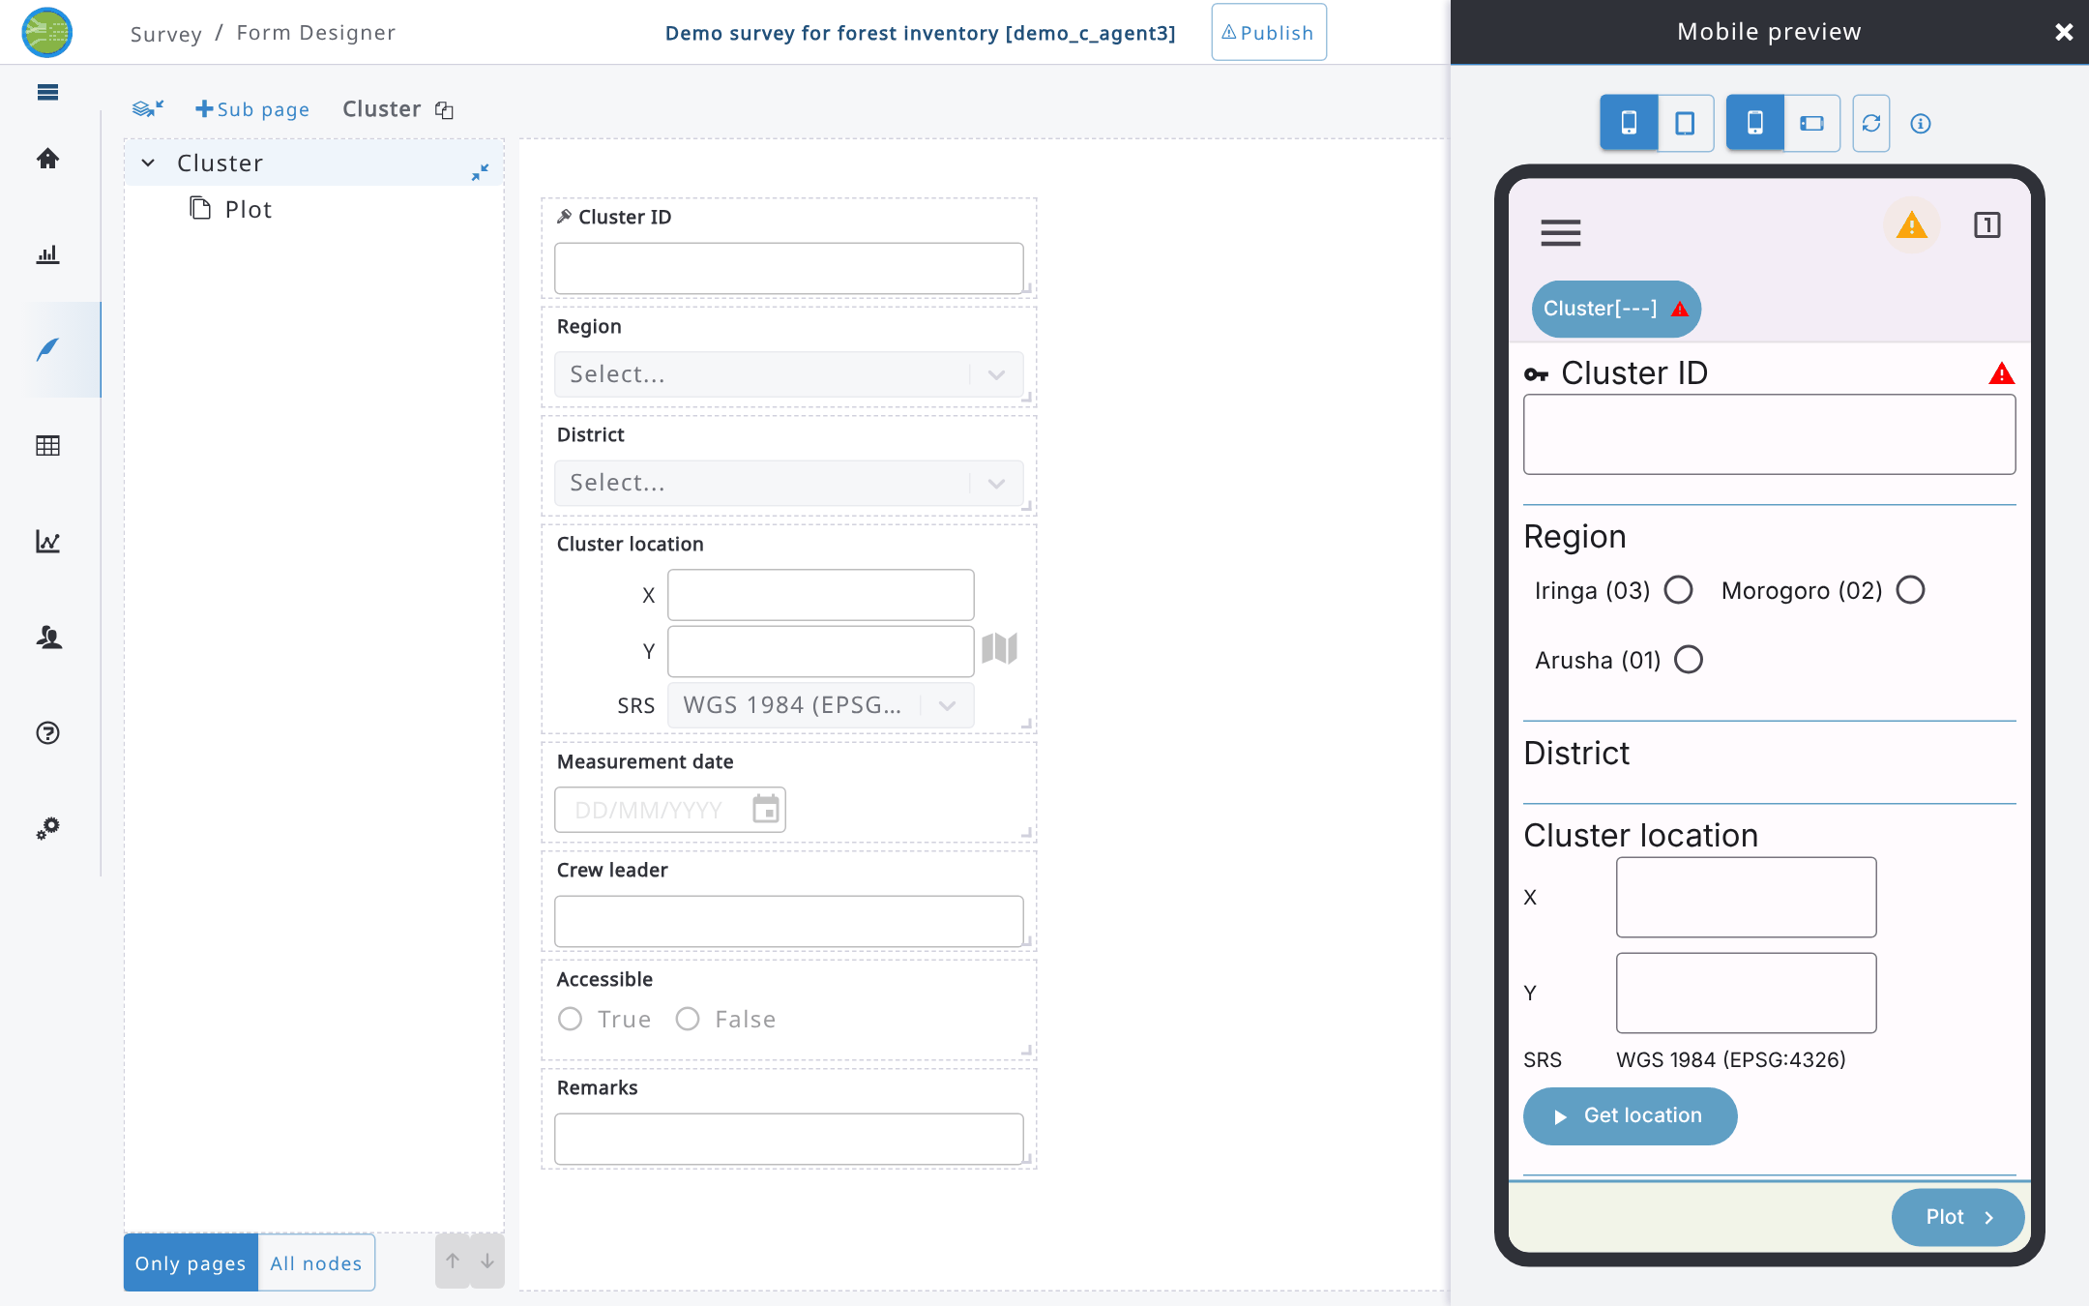
In the toolbar of the mobile preview you can choose Phone or Tablet, Portrait or Landscape orientation, Reload the preview after changing the survey, and open the info button that lists the differences from Arena Mobile on a real device:
- dates and times are typed in a text field instead of the device date/time pickers;
- maps are not available;
- the location is taken from the browser (usually less precise than the device GPS);
- photos and files are selected from the computer (no camera capture and no photo location);
- the data is kept in memory only and lost when reloading; there is no records list, sync or export.

7.2.10. Multiple entities: automatic rows, summary and tables
Auto-create minimum items: for a multiple entity, this option (next to Multiple in the Basic tab) creates automatically, when the entity becomes relevant or its parent entity is created, a number of entities equal to the Min count set in the Validations tab.
Include in multiple entity summary (Basic tab of an attribute inside a multiple entity): the attribute value is shown in the entity selector of Arena (the dropdown used to choose, for example, a plot) and in the entity summary view of Arena Mobile. For attributes of the root entity the same option is called Include in records list and adds the attribute to the list of records.
In data entry, the rows of a table (multiple entity displayed as a table) can be sorted by clicking a column header: one click sorts ascending, the second descending, the third removes the sorting. Sorting by more columns is possible. The sorting only changes the display, not the data.
Read-only values in tables are shown as text (labels), not as input fields; long values are cut with an ellipsis.

7.2.11. Other attribute properties and layout elements
- Include seconds [time]: the time is entered as hh:mm:ss instead of hh:mm.
- Display as [read-only text]: Text, Hyperlink (the value is shown as a link that can be opened) or Markdown (the value is formatted).
- Map marker color [coordinate]: color of the points of this attribute on the map.
- Form Header: besides entities and attributes, the + button of a page lets you add a Form Header, a title that divides the form in sections; choose its Header color (blue, green, orange, red, yellow) in its properties.

7.3. Expressions and expression editor
Expressions are used to determine value. The resulting value is usually one of various primitive types, such as numerical, string (text), Boolean, or complex data type.
Expressions can be defined using the “basic” expression editor and an “advanced” editor; the basic editor is easier to use and allows to define most of the expressions you will need in Arena. The generated expression will be a JavaScript expression.
The basic expression editor lets users define binary expressions, such as variable == some_value. For each operand, users can specify whether it is a constant value, a survey attribute, or a function.
When Variable is selected, the user can select the variable/attribute from a dropdown list; when constant is defined, depending on the attribute where the expression is defined, the value can be inserted in a text field or selected using a dropdown list (e.g. if the attribute is a code attribute, the constant value can be selected among the possible values in the related category).
When a Function is selected, the user can select one of the custom functions defined in Arena and specify the parameters to pass to the selected function using a builder that depends on the selected function. The possible functions are listed in the following table.
Function name | Description
categoryItemProp | Returns the value of the specified Extra Property of a category item having the specified code
count | Returns the number of rows that matches a specified criterion
dateTimeDiff | Returns the difference (in minutes) from two date-time couples
first | Returns the first value or node of the specified multiple attribute or entity
geoCoordinateAtDistance | Returns the coordinate at a specified distance and bearing from the specified coordinates
geoDistance  Note: this replaced function “distance” in Arena 2.3 | Returns the distance (in meters) between the specified coordinates. The parameters can be constant values in the format SRID=srs_code;POINT(x y) (e.g. SRID=EPSG:4326;POINT(12.89463 42.00048) ) or variables referencing coordinate attributes, or also a call to categoryItemProp function to extract the location from a category (e.g. sampling point data category)
geoPolygon | Returns a polygon in GEOJson format. It takes a list of coordinate values as parameters (they can be constant values or coordinate attributes). E.g. geoPolygon(table.location) where “table” is the name of a multiple entity and “location” is the name of a coordinate attribute.
includes | Returns true if the specified multiple attribute includes the specified value
index | Returns the index (starting from 0) of the specified node among its siblings, e.g., returns the current table row (or form) index number
isEmpty | Returns true if the argument has no value specified  Example-  Slop percentage%  Expression: 0  Apply If: isEmpty(plot_slope)
isNotEmpty | Returns true if the argument has some value specified.  Example-  Slop percentage%  Expression: Math.tan( plot_slope * Math.PI / 180) * 100  Apply If: !isEmpty(plot_slope)
last | Returns the last value or node of the specified multiple attribute or entity
ln | Returns the natural logarithm of X
log10 | Returns the base 10 logarithm of X
max | Returns the maximum of the arguments
min | Returns the minimum of the arguments
now | Returns the current date or time
parent | Returns the parent entity of the specified node
pow | Returns the value of a base raised to a power
recordCycle | Returns the cycle of the current record, as a number
recordDateCreated | Returns the creation date and time of the current record as a datetime value. It can be used in a text, date, or time attribute
recordDateLastModified | Returns the last modified date and time of the current record as a datetime value. It can be used in a text, date, or time attribute
recordOwnerEmail | Returns the email of the user owning the record
recordOwnerName | Returns the name of the user owning the record
recordOwnerRole | Returns the role (in the current survey) of the user owning the record
“Row index” | In the Expression editor, this is a shortcut for "index($context)". Returns the current table row (or form) index.
taxonProp | Returns the value of the specified Extra Property of a taxon having the specified code
taxonVernacularName | Returns the vernacular name (by set language code) of a taxon having the specified code
userEmail | Returns the email of the logged-in user
userIsRecordOwner | Returns a Boolean value “true” if the user editing the record is also its owner, “false” otherwise
userName | Returns the name of the logged-in user
userProp | Returns the value of the specified Extra Property of the logged-in user
uuid | Generates a UUID (universally unique identifier) that can be used as an identifier (e.g., as a key attribute of an entity)

Depending on the selected Function, a function builder may appear, letting you select the parameters quickly (in the next image, the builder of the geoDistanceToAOIBoundary function, opened with the edit button next to the function name):
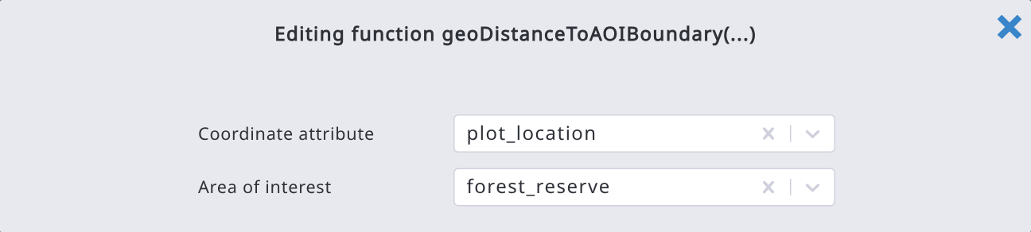
Arena uses the JavaScript Math object that allows users to perform mathematical tasks on numbers. Math is a built-in object that has properties and methods for mathematical constants and functions. See the full list of Math methods here.
For example, constants:
Math.PI = approximately 3.14159
Math.E = approximately 2.718
and static methods:
Math.pow(x, y) Returns base x to the exponent power y
Math.pow(2,3) = 8
Math.round(x) Returns the value of the number x rounded to the nearest integer
Math.round(9.345) = 9

Strings are useful for holding data that can be represented in text form (see link to the String object). In JavaScript, a string is a sequence of characters enclosed in single or double quotes, and single or double quotes are the same thing. Some of the most-used operations on strings are to check their length, to build and concatenate them using the + and += string operators, checking for the existence or location of substrings with the indexOf() method, or extracting substrings with the substring() method.
For example:
"Sri" + " " + "Lanka" = "Sri Lanka"
aString= "Vienna";
aString.substr(0, 4) = "Vien"
aString.length = 6
aString.indexOf("nna") = 3, aString.indexOf("TX") = -1 (not found)
Similarly, Javascript objects Number, Boolean, Date, and Array can be used in the expressions.
Read more about expressions in Chapter "Examples of Expressions".

Examples of the expression editor
Default value: Constant (value)
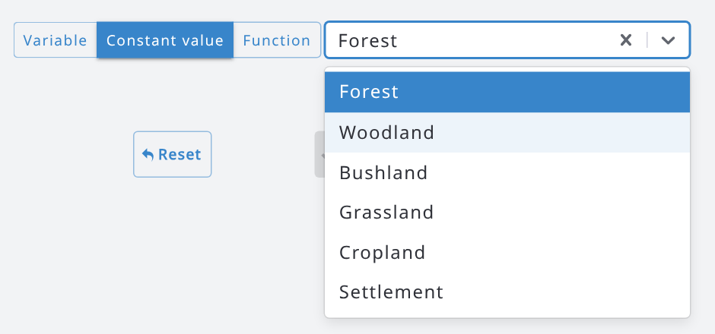 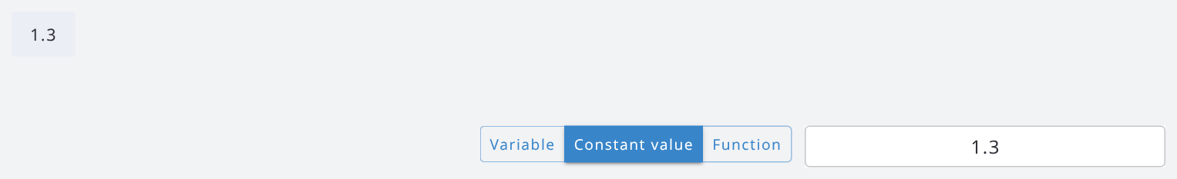
Default land use is Forest (code "1") DBH measurement height (dbh_height = 1.3)

Apply if; Relevant if: the plot is relevant only if the cluster is accessible (accessible == true).
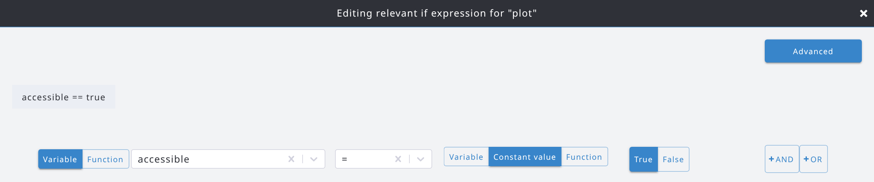

Validations: The current attribute can be replaced with "this". With the date type of data, there will be an option to use a calendar by clicking on the date field.
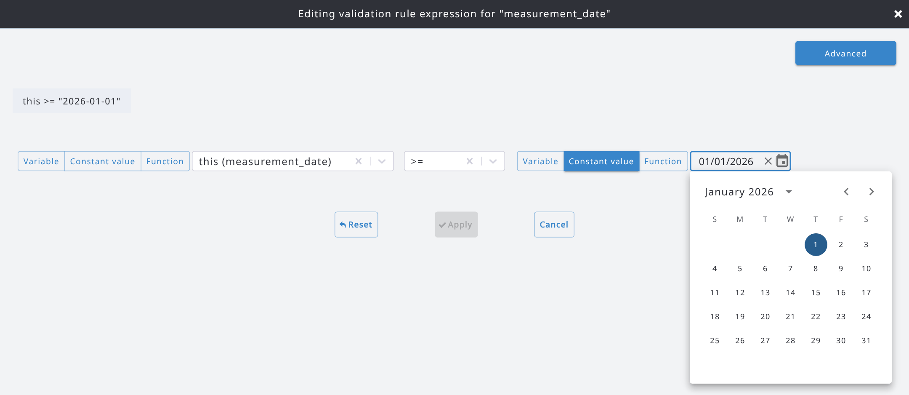
And the validation rule will be written as follows: 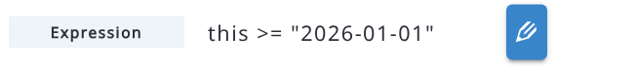
When comparing two attributes in a rule, the validation can be set only to the second attribute! For example, if you want to set a rule that starting date (Start Date) is less or equal to ending data (End Date), the rule can only be set to the End Date attribute.

Advanced editor 
Advanced expression editor allows users to write Javascript clauses. Below is an expression to compute the tree basal area (in m²) from the DBH (in cm). Expressions that the basic editor cannot show (like this one) are opened directly in the advanced editor; in the advanced editor the button is called Basic, and switching back to the basic editor clears an expression that it cannot show.
Pressing Ctrl+Space keys allows users to browse through the list of attributes and add them into the expression.
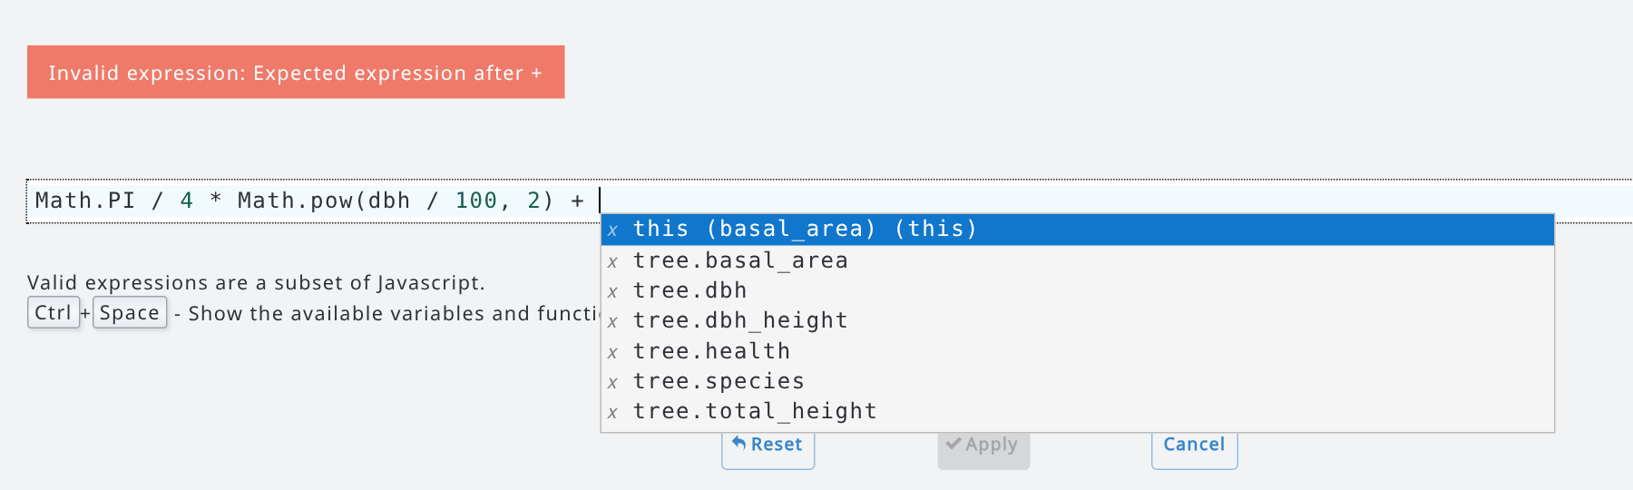
First pressing Ctrl+Space keys into a blank input box and then typing a few letters (of the function), shows also the documentation (see the next image).
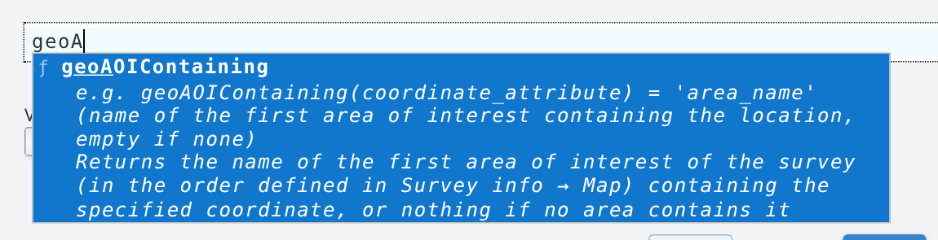

Next here is an example with two default values, each one applied only when its Apply If condition is met: the basal area is computed from the DBH for trees with a DBH of at least 5 cm, otherwise it is set to 0.
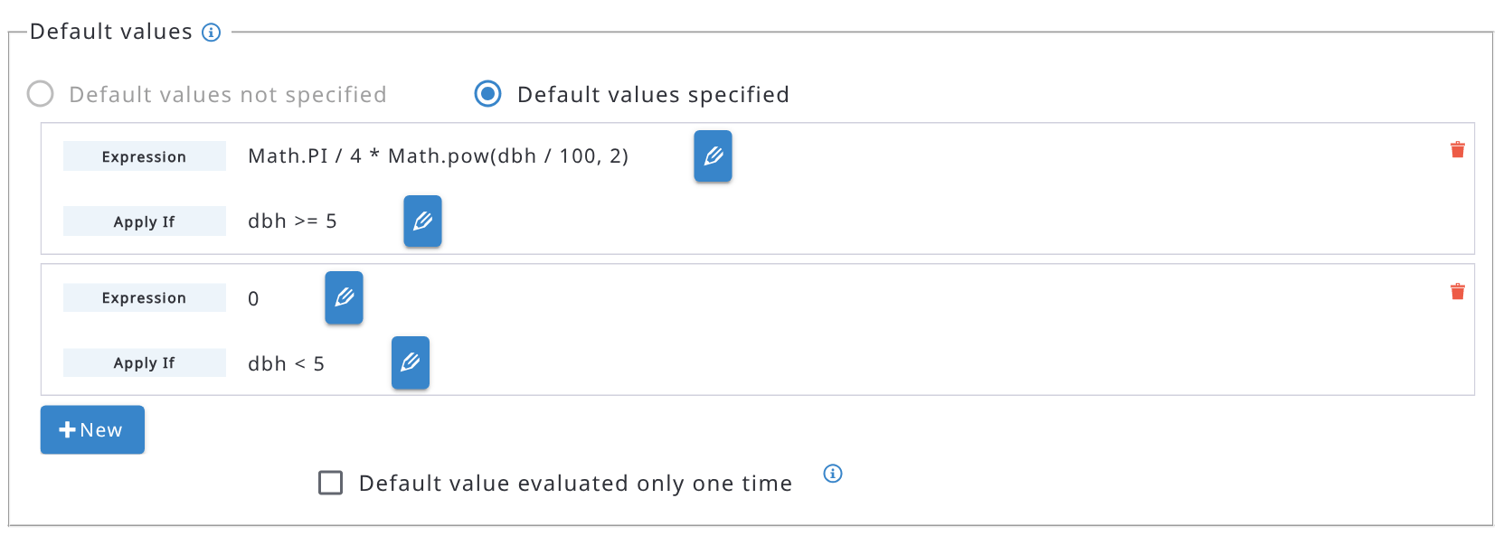
Arena supports regular expressions. If you are new with this concept, you may google "regular expression" for more information. You can build and test regular expressions e.g. at https://regex101.com/
The command buttons function as follows:
 Close the expression editor without applying the changes (same as Cancel).
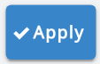 Apply the expression (i.e., save it)
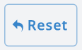 Clear the expression (i.e., delete it)
Cancel: close the expression editor without applying the changes.

Error and Warning messages
By default, Arena and Arena Mobile show error messages as they are written in JavaScript. This is not always convenient, because users may have difficulties understanding these texts. Therefore, in case of any complex expression, write a tailored message into to line "Error message", similarly as follows (or as a real text):
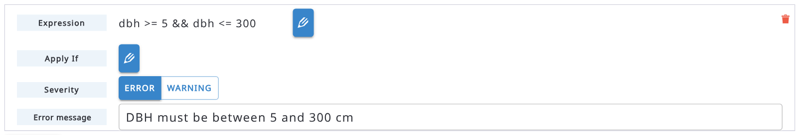
Try to keep the messages short but informative!

7.3.1. More expression functions
Besides the functions listed in the table above, the following functions are available. In the basic editor, the list of functions shows a short description of each function.
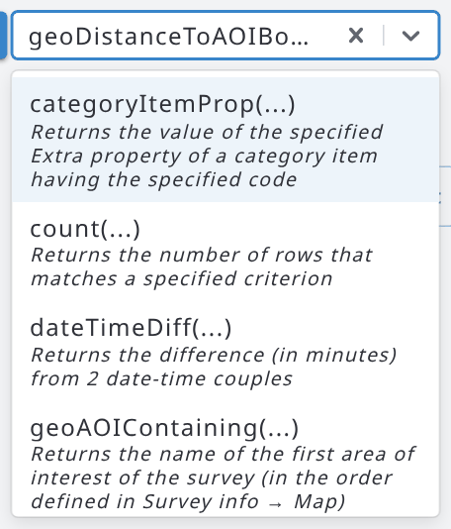
- geoDistanceToAOIBoundary(location, 'area_name'): returns the distance (in meters) between a coordinate and the boundary of the specified area of interest: negative inside the area, positive outside.
- geoAOIContaining(location): returns the name of the first area of interest (in the order defined in Survey info > Map) that contains the coordinate, or nothing if no area contains it.
- numberToWords(number): returns the number written in words, e.g. numberToWords(tree_no) returns 'one hundred twenty-three' for 123. The words are in the language of the survey form (English, French, Japanese, Portuguese, Russian or Spanish; English for the other languages).
- unique(multiple_attribute): returns the distinct values of a multiple attribute or of an attribute of a multiple entity, e.g. unique(tree.species).
- prevCycleValue(attribute) and prevCycleValues(multiple_attribute): return the value (or values) of the same attribute in the record of the previous cycle. They work only in Arena Mobile, when the survey has more cycles and the link to the previous cycle is enabled.
Areas of interest. The areas of interest are polygons (GeoJSON format, WGS84 coordinates) that you add in Survey info > Map, each one with a name: use this name in the expressions. Both functions also work offline in Arena Mobile. Compare the distance with the GPS accuracy of the location (location.accuracy) to classify a location as inside, outside or uncertain. For example, the following validation rule of the plot location, with severity Warning, warns the field team when the plot may be outside the forest reserve:
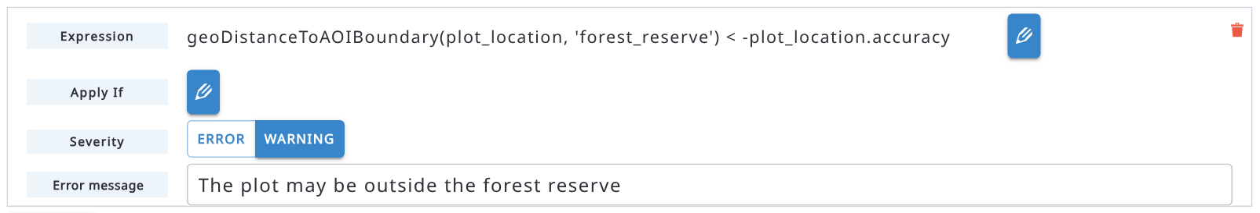
In the same way, a read-only attribute can store the distance with the default value geoDistanceToAOIBoundary(plot_location, 'forest_reserve'), or the name of the area containing the plot with geoAOIContaining(plot_location).

7.3.2. Generate and explain expressions with AI
If the AI features are enabled by the administrator of the Arena server and Expression generation & validation is enabled in your AI Settings, two buttons appear next to the edit button of an expression:
- the magic wand button (Generate expression from description) opens a window where you describe in plain language what the expression should do; press Ctrl+Enter (or Generate) to get the expression in Arena syntax, with a short explanation. Click Use this expression to apply it, or Try a different description. The same button is also available in the toolbar of the expression editor.
- the question mark button (Explain this expression) shows an explanation of the current expression in plain language.
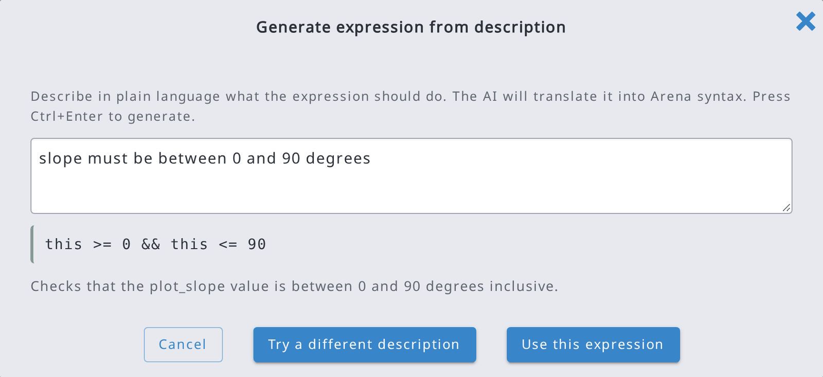
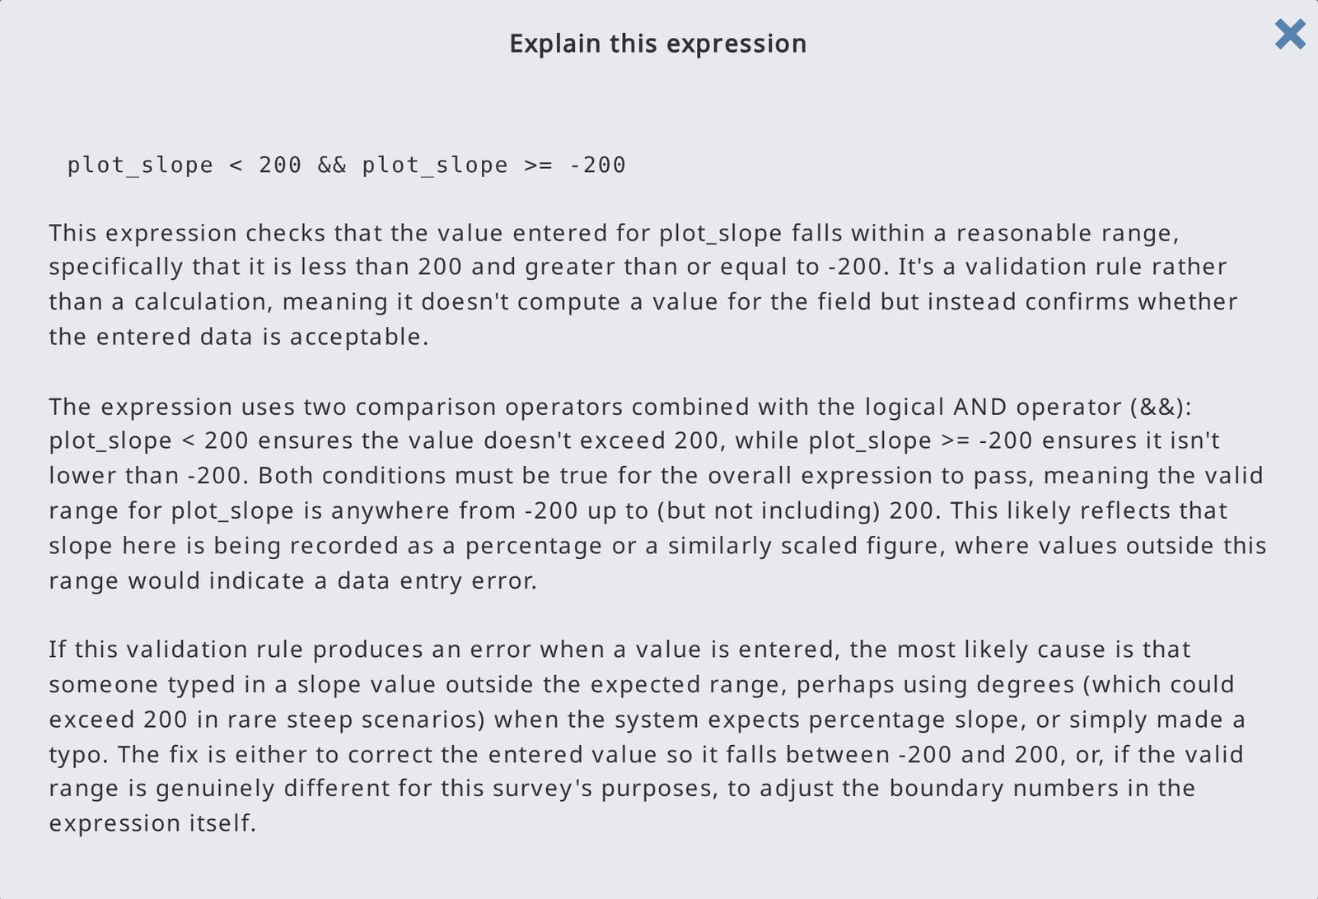
Always check the generated expressions before applying them.

7.4. Hierarchy
In the Hierarchy section you can view a tree diagram that displays the hierarchical structure of your data. The survey can contain multiple hierarchies, which are also each presented as one or more levels in the diagram. The diagram can also be expanded and collapsed with the 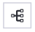 button.
In our example, in the next chart we have a survey for a forest inventory case and the nodes from all three top levels are now displayed by labels.
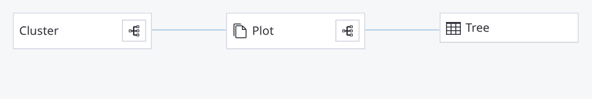
When a node is selected, the application shows a list of all attributes and child entities of the selected node.
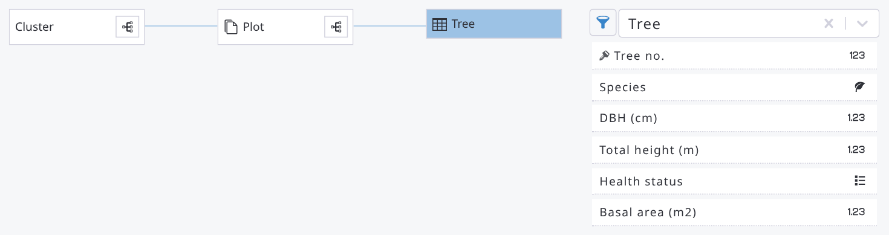
On the Hierarchy page, there is a button to switch the view between labels and names.
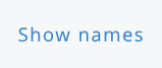 Show the diagram with names.
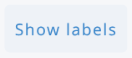 Show the diagram with labels.
There is also a button to export the schema summary.
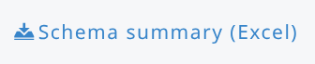
The list of the attributes of the tree entity, shown with names, looks as follows. The filter button next to the entity name lets you show only the attributes of the selected data types (see the second image).
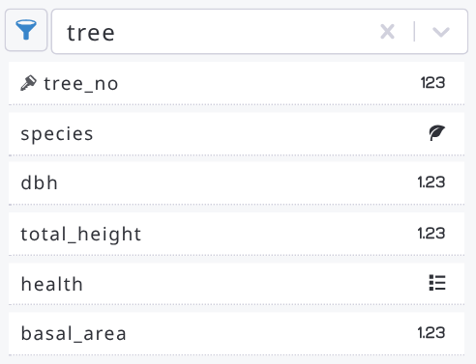
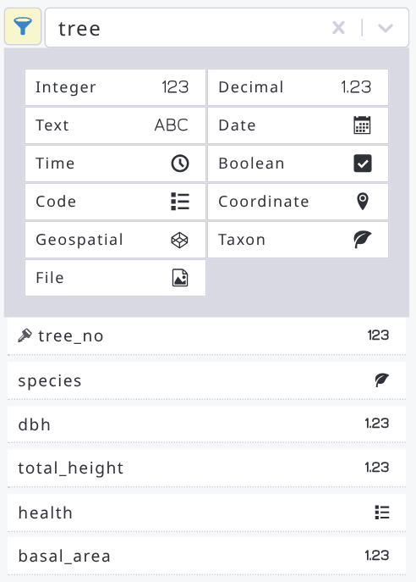
If the survey contains an analysis chain, in the Hierarchy section a Survey Analyst or a person with a higher access role can also see the result variables.
Dependency tree
In Survey > Dependency tree you can see which attributes and entities depend on others through their expressions. Select one or more Dependency types (Applicability, Default value, Editable, Visible, Validations, Min count, Max count, Parent code, Items filter, File name): the tree of the survey shows an arrow, with the color of the dependency type, from each node to the nodes whose expressions use it. In the next example, the plot entity is relevant depending on the Accessible attribute, the basal area default value depends on the DBH, and some attributes have validation rules that use their own value. Use Show names to see the names instead of the labels; the Schema summary (Excel) button is available here too.
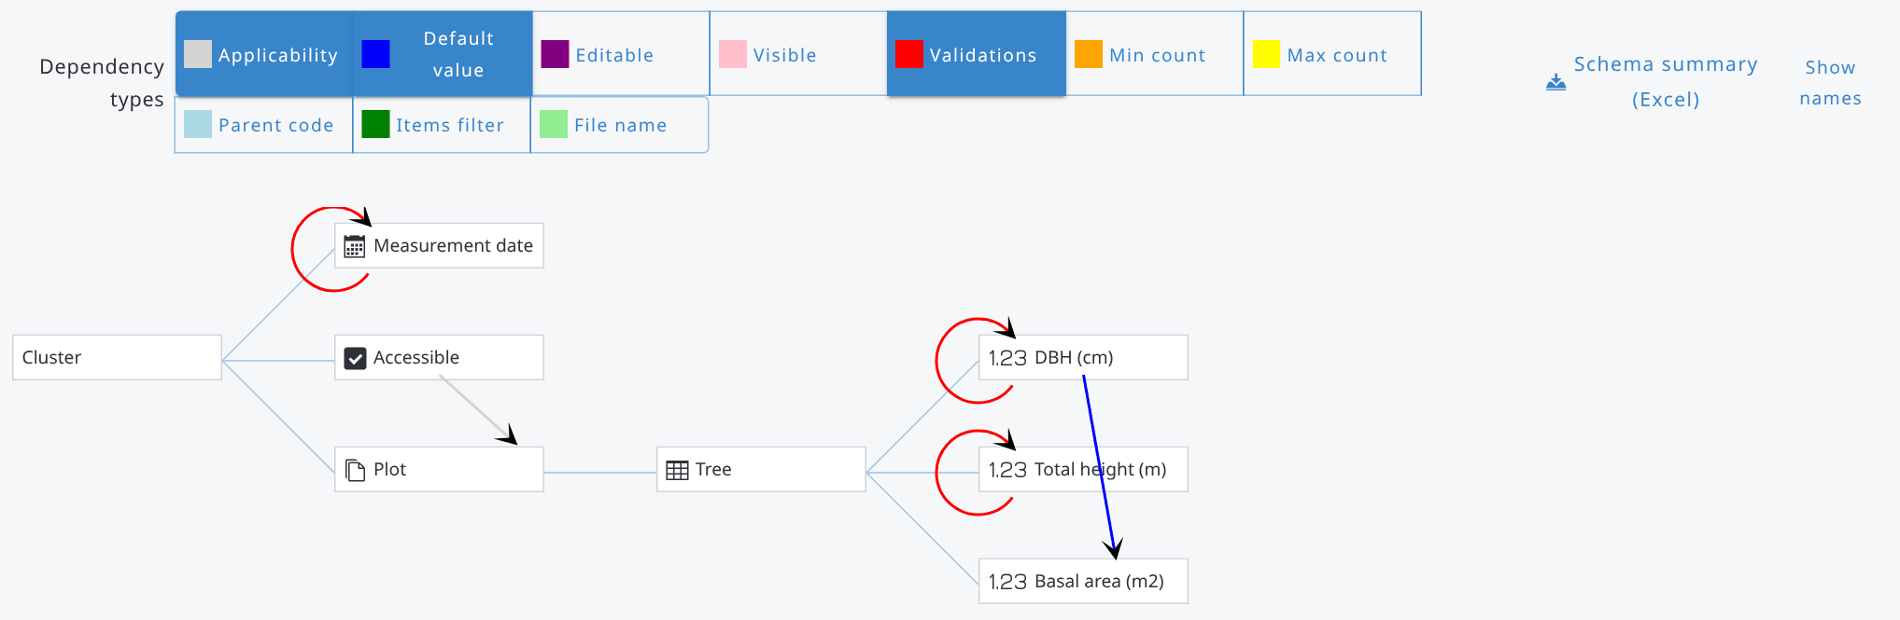
In the list of attributes of the Hierarchy page, when you hover over an attribute that has a description, the description is shown in a pop-up as follows:
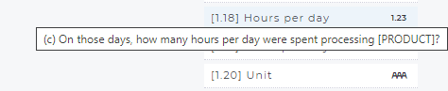

7.5. Categories

7.5.1. Working with categories
Categories define predefined lists of coded values that are used across the survey to provide consistent options for data entry, processing, and reporting. These fields are set up in accordance with pre-defined classification schemes. However, the Survey Administrator is free to add, remove or modify them. Code lists can be used to classify a wide range of attributes such as administrative levels, personnel, topographic elements, accessibility, land use classes, ownership and many more.
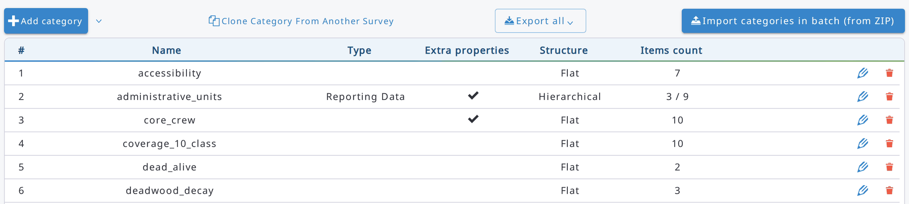
There can be two types of code lists: flat or hierarchical tables. A flat table contains only one level with two columns: code and label (or labels in all selected languages). A hierarchical code list can be used - for example - for storing data by administrative units (e.g., province, district, village).
Categories (and taxonomies) are shared across all cycles within a multi-cycle survey.
Command buttons
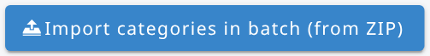 Import multiple category tables (UTF-8 CSV or Excel files)
via a zip file.
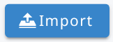 Import a table from a CSV/Excel file.
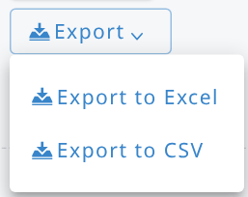 Export the selected table into an Excel or CSV file.

Templates are practical examples (as CSV/Excel files) of how to build a category table for Arena.
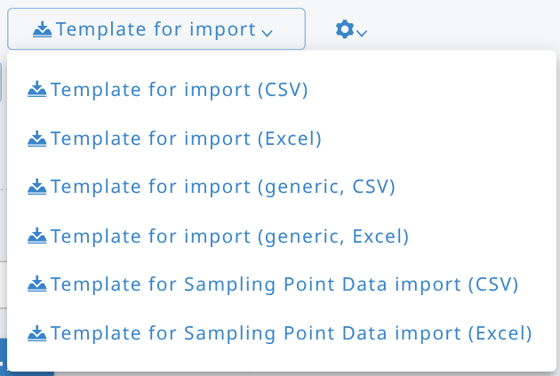
1. Export a flat template file (for later importing your data).
2. ‘Generic’: export a hierarchical template. This table contains fields for extra properties.
3. ‘Sampling Point Data’: export a Sampling Point Data template.
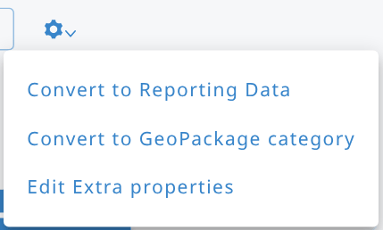

The settings (gear) menu lets you: convert the category into a Reporting Data category (see below); convert it into the Sampling Point Data category (if the survey does not have one yet) or into a GeoPackage category (see 7.5.6); convert it back to a simple category; edit the extra properties definitions (Edit Extra properties).
Adding a new category
New code lists can be added in two ways: "manually" or by importing a table in CSV/Excel format.
To add a new code list, click on the 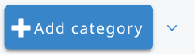button. Then type the Category name. The arrow next to the Add category button opens a menu to create a Sampling Point Data category or a category with geo capabilities (see 7.5.3 and 7.5.6).
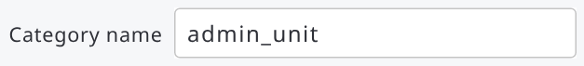
The category names should be unique. If the category name exists, there will be an error message, as follows.
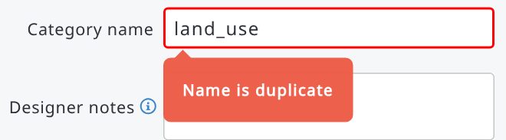
Code items are always text (upper-case letters are allowed). To start entering codes manually, click Add next to Items and fill in Code, Label and Description (optional). Items are shown as rows with index, code and label: click a row to expand it and edit the item, move it up or down, or delete it; click it again to collapse it.
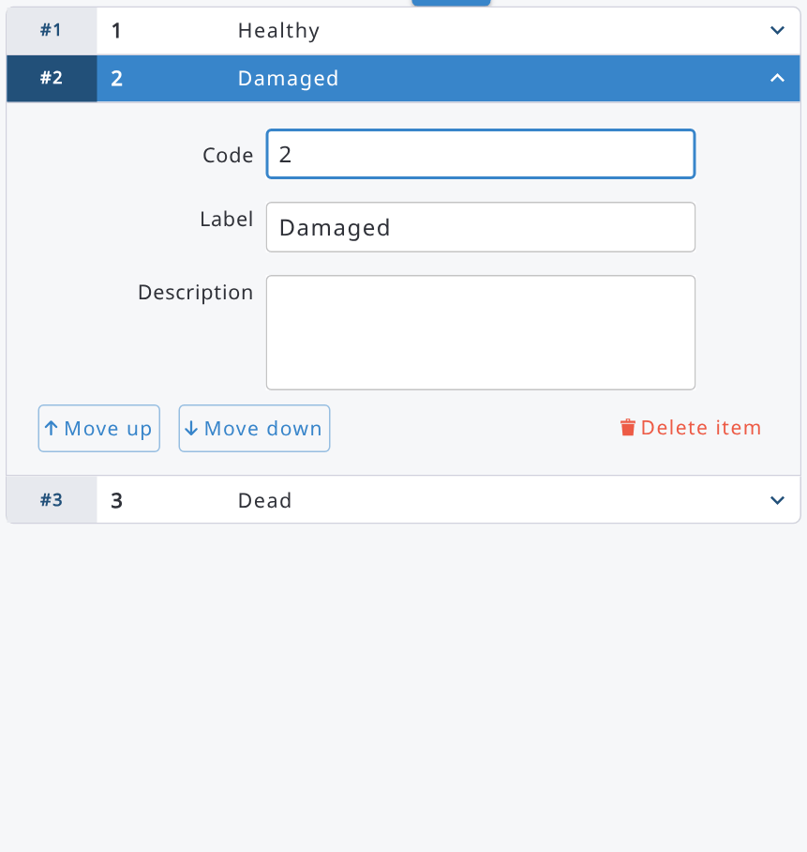
A quicker option to create a new code list is to import them using a CSV or Excel (.xlsx) file. The CSV file should be in Unicode (UTF-8) format.
This is the format for a flat table. If the survey contains just one language, then the file contains three columns: code, label_[language], description_[language]
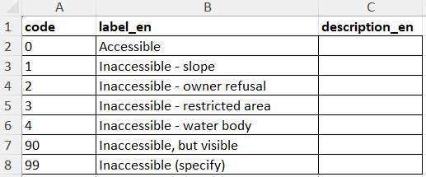
If the survey contains multiple languages, then the labels need to be given by the languages as follows.
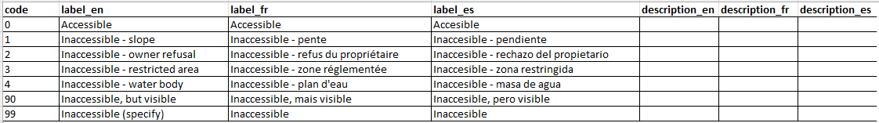
Names for the levels are only meaningful for hierarchical lists. This is an example of an administrative list with three levels: province, district, and llg (i.e., ’Local level government’).
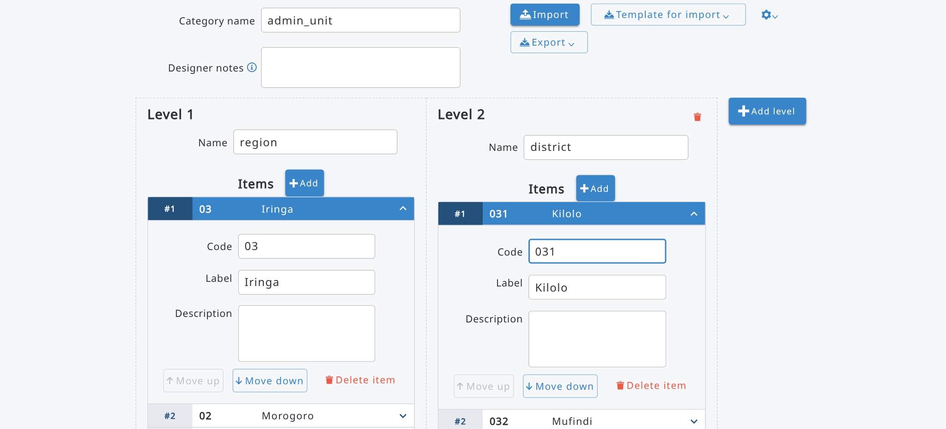

It is highly recommended to use CSV/Excel import when creating or updating a hierarchical list. The format of an input file is as follows.
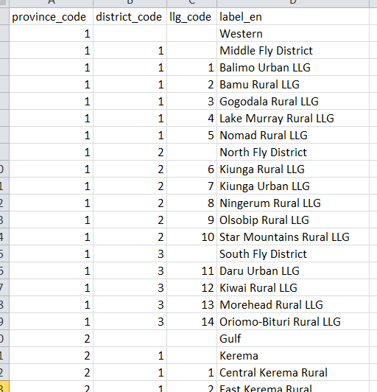
Once a code list has been created, click on 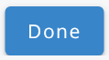button.
Note 1: In OF Collect there can be a Specify field joined to a category, but in OF Arena there needs to be an additional text attribute to store this extra data. This method can be used for example to specify unlisted value(s) in the data entry.
Note 2: Once the survey is published, you cannot edit or delete code, but you can edit labels and add new codes into a category’s list.

In order to keep a separate record of the code list, it is suggested to Export the code list by clicking the Export button. This will automatically generate and download a CSV/Excel file.
While the manual process for adding code lists is perfectly legitimate and can be used for simple lists, for more complex lists (e.g. lists that have many items or with a hierarchical structure) it is strongly recommended to prepare them in advance and upload them into Arena by clicking the Import button.

7.5.2. Extra properties
Category tables can contain extra information (i.e. Extra properties), and they can work as lookup tables. This ancillary data can be retrieved from other sources, for example from GIS.
Extra properties can be used for example in the "Items filter" expressions (Examples of expressions) and in data analysis with R.
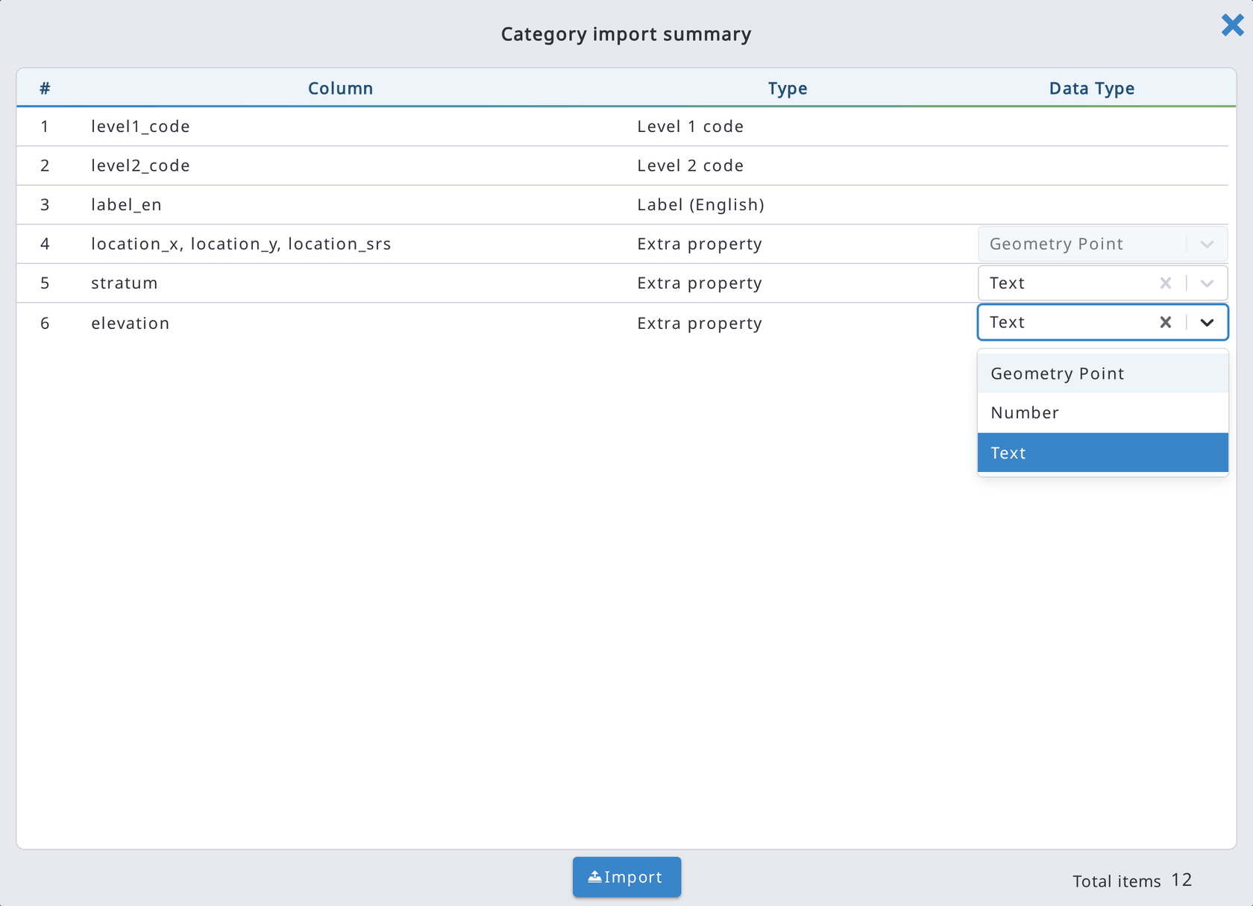
The next image shows hierarchical data in a CSV file. This can be used to import ancillary data for clusters (level1) and plots (level2).
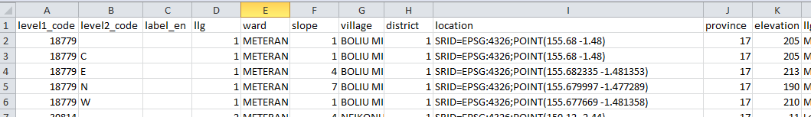
The extra properties can contain the following types of data: text, numeric or geometry point. In case of geometry point (i.e., coordinates), the spatial reference system (SRS) must be preset into the survey (see the Arena Dashboard section in this manual). A coordinate data split into three columns looks like this:
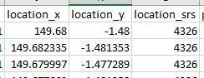
The best method of getting this type of ancillary data table into Arena is to create the table in MS Excel, Libre Calc (or equal), save it as a CSV (in UTF-8) or Excel (.xlsx) file and then import it. While importing, Arena asks to select data type for each column because the default data type is ‘text’.
In the data analysis with R, all categorical tables are accessible (as a list of data frames).

7.5.3. Sampling Point Data
Sampling Point Data (SPD) table is a special hierarchical code list with a fixed category name "sampling_point_data". It can be used to define the list of sampling points, and their properties such as coordinates of each sample’s location. Sampling point locations can be viewed on the Arena Map.

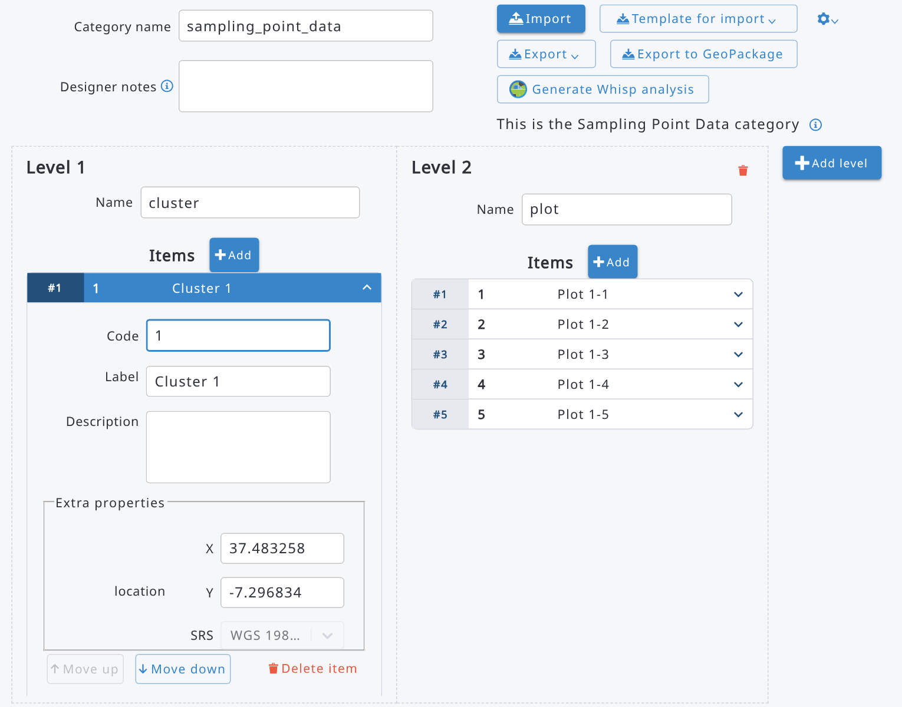

Here is an example of a Sampling Point Data for a forest inventory case:

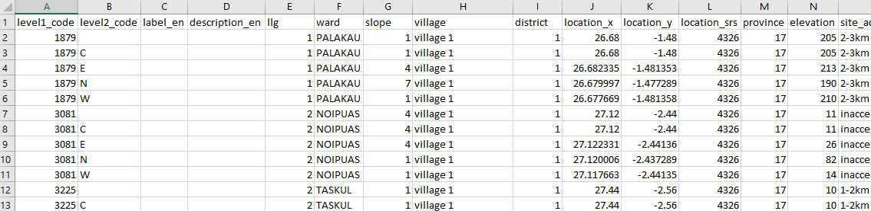

SPD can be created easily by importing a CSV or Excel file that should follow the formatting indicated below:
- levelX_code columns: 1 column for each level X (maximum 3 levels, e.g. if you have 2 levels, cluster and plot, you will have a column "level1_code" with cluster id value and a column "level2_code" for plot id value);
- label_LANGUAGECODE columns: labels that will be associated to each item on the list; e.g. label_en for English, label_fr for French;
- description_LANGUAGECODE column: not needed, you can leave this blank!
- location_x, location_y, location_srs columns: geometry point data as shown above;
- optional: extra properties.

A spatial sampling point grid can be made in any GIS application, or by using a Plot Grid Generator, see Annex 6 for more information.

See the chapter Examples of expressions how to use and call Sampling Point Data with the help of expressions in a survey.
To create the Sampling Point Data category, you can also use the arrow next to Add category and select Sampling Point Data category: the category is created with the name sampling_point_data and the location extra property, so you only need to import the file. In the category editor, the label This is the Sampling Point Data category identifies it. If the Sampling Point Data category has no location extra property (e.g. it was imported without the location columns), the category editor shows the warning The 'location' extra property is missing: without the location, the sampling points cannot be shown on the map, exported to GeoPackage or analysed with Whisp.
Reporting Data tables
Reporting data tables can be used within analysis with R/RStudio (read more in Chapter 10). This is a flat or a hierarchical table with the last column containing area information (in hectares or acres).
This is a simple table for feeding stratum areas into the data analysis:
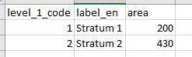
This is an hierarchical table for feeding in Province, District and Stratum areas into the data analysis:
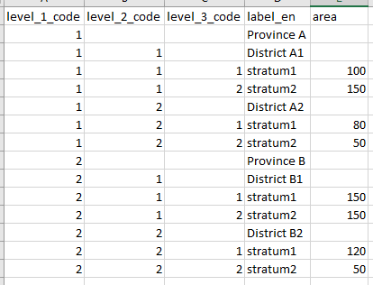

7.5.4. Clone a category from another survey
In Categories, use ‘Clone Category From Another Survey’ (next to Add category, Export all and Import categories in batch (from ZIP)). Pick a Source survey, then a Source category from that survey's category list, and confirm.
Arena checks the source category against the categories already in the current survey before cloning:
- If a category with the same internal ID already exists (i.e. this exact category was cloned into this survey before, even if since renamed), cloning is blocked with a message identifying it by its current name.
- If a different category already has the same name, cloning is blocked with a name-clash message.
- Otherwise, the category and its levels/items are copied into the current survey as a new, independent category.

7.5.5. Export all category tables
All categorical tables can be exported into a zip file with 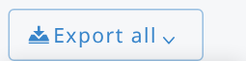 button.
Choose Export to Excel or Export to CSV: the export runs in the background and, when it is completed, click Download to get the ZIP file.

7.5.6. Categories with geo capabilities and GeoPackage export
A category whose items have a location (a geometry point extra property called location) has geo capabilities: the Sampling Point Data category is one of them. To create a category with geo capabilities, click the arrow next to Add category and select Category with geo capabilities; to add the location to an existing category, use Convert to GeoPackage category in the settings (gear) menu of the category editor. The location extra property of these categories is locked; use Convert to simple category in the same menu to unlock it.
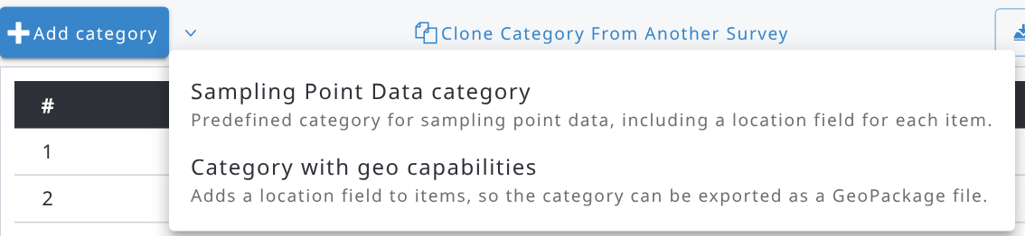
The categories list shows the type of each category (Reporting Data, Sampling Point Data, GeoPackage) in the Type column. In the category editor of a category with geo capabilities, the Export to GeoPackage button exports the items, with their locations, into a GeoPackage file that you can open in a GIS application (e.g. QGIS). The export runs in the background; when it is completed, click Download. Items without a valid location are skipped.
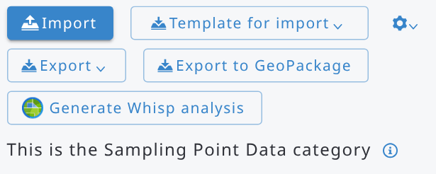

7.5.7. Whisp analysis of sampling point data
For the Sampling Point Data category (with locations), the Generate Whisp analysis button sends every sampling point with a location to Open Foris Whisp for the analysis. Confirm the message: the analysis runs in the background and it can take several minutes, depending on the number of sampling points. The results are combined with the sampling point data and stored in a new category called sampling_point_data_whisp (if this category already exists, its content is replaced).
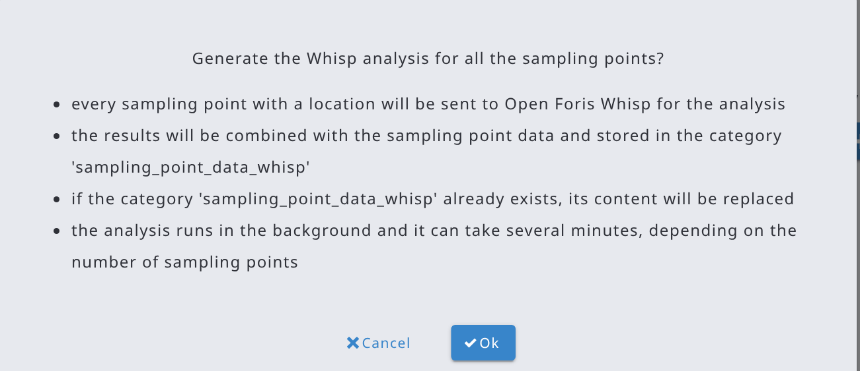

7.6. Taxonomies

7.6.1. Working with taxonomies
This section allows users to add one or more species lists by uploading a CSV (in UTF-8) or Excel (.xlsx) file. The list should contain all the taxonomic species that the user will select from during data entry. Species lists should be as comprehensive as possible and should be created using all resources available in the country: local or global databases, taxonomical books, experts’ knowledge etc. For security reasons it will not be possible to add species during data entry. Instead, additional species should be added to the CSV/Excel file (by a Survey Administrator) and the updated species list uploaded to Arena.
Taxonomies (and categories) are shared across all cycles within a multi-cycle survey.
Adding a Species list:
A species list table should be prepared in advance following the formatting requirements indicated below.
The columns are as follows:
- code (required): alphanumeric (i.e. letters and numerals) unique identifier code associated to the species,
- family (optional): family name of the species,
- genus (optional): genus of the species,
- scientific_name (required): latin name of the species (genus + [optionally] species name + [optionally] subspecies name e.g. Pinus spp. or Pinus radiata),
- lat (optional): synonym(s),
- vernacular_name (optional): such as local name or a timber trade name. The vernacular name column must be named with the ISO 639-2 language code of the corresponding language (e.g. eng for English, swa for Swahili, etc.). So, the column name in the imported file is just the language code.
Vernacular names can be accessed in expressions with the “taxonVernacularName” function.
- extra properties (optional): all columns not corresponding to the previous ones will be considered as extra properties; e.g. ‘wood_density’, ‘species_commercial_group’, ‘protection_class’, etc. Extra properties can be accessed in expressions with the “taxonProp” function or can be used in the "Items filter" expressions (Examples of expressions) and in data analysis with R.

An example of a valid (tree) species list:
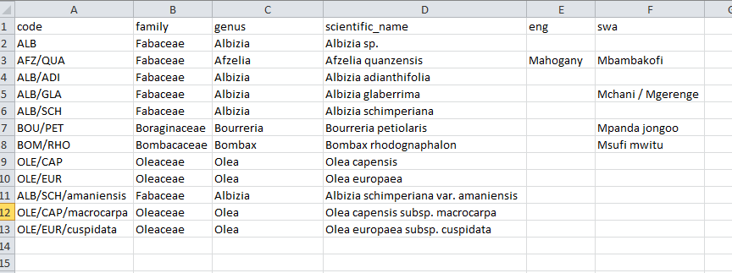

Optionally, the Survey Administrator can specify other columns, such as the vernacular names of the species using the language code (in 3 characters ISO-639-2 format, e.g. 'swa' for Swahili, 'eng' for English) as header of these columns. Multiple values are allowed for vernacular names, and they need to be separated with a slash ( / ) character.
Note: a species name (in the scientific_name column) can exist only once in the table. Similarly, each scientific name should have a unique species code.
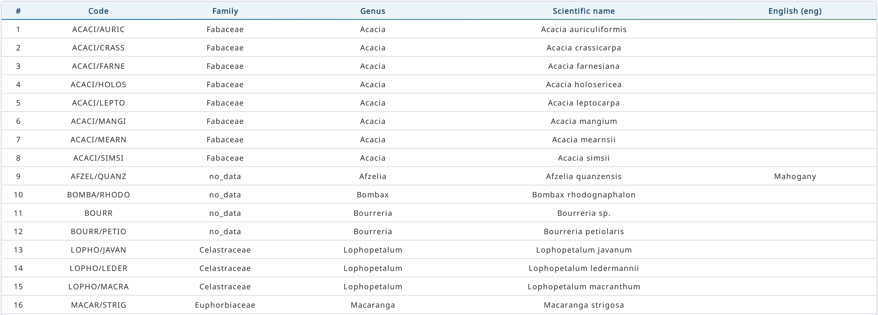
To add a new taxon list, specify first a name for the list in Arena. Then click Import, select the CSV/Excel file and click Back when ready. The screen will now show the records present in the species list. Species lists can also be renamed, deleted or exported. If needed, additional species lists can be created and uploaded in the same manner.
There are two species names automatically added to your list by the system: Unknown (UNK) and Unlisted (UNL). Avoid entering the same names and codes into the survey.
Taxonomic tables can contain extra properties associated with the species, e.g. dry wood density, timber price, minimum cutting diameter, etc. (see the previous figure with an example containing "wood_density" as an extra property). Extra property columns can be imported only via reading in a CSV or Excel file.
Note: If you need to apply an extra property as a numeric data somewhere in your forms within an expression, you need to set the data type for the extra property field. Do it as follows:
- Select 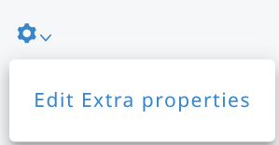
If your table does not contain any "extra property" column(s) yet, you will get this message:
If your table contains extra columns, you will see the "Extra properties" window. All extra properties are text by default.
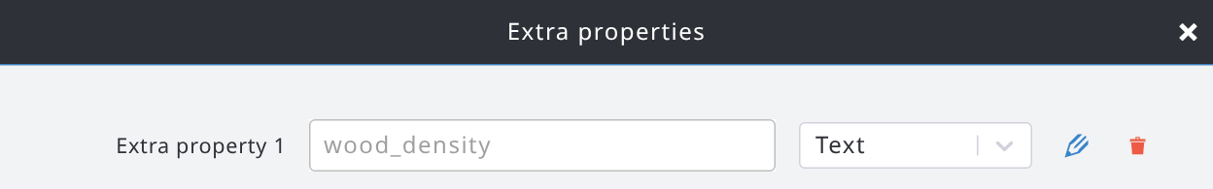
- click the Edit button 
- then change the data type 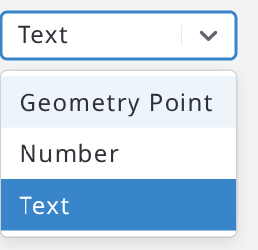 ===> 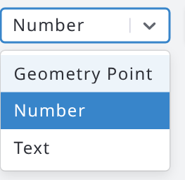
- click the Save button (next to the dropdown list; the X button next to it cancels the change)
- and you will see a warning, as follows:
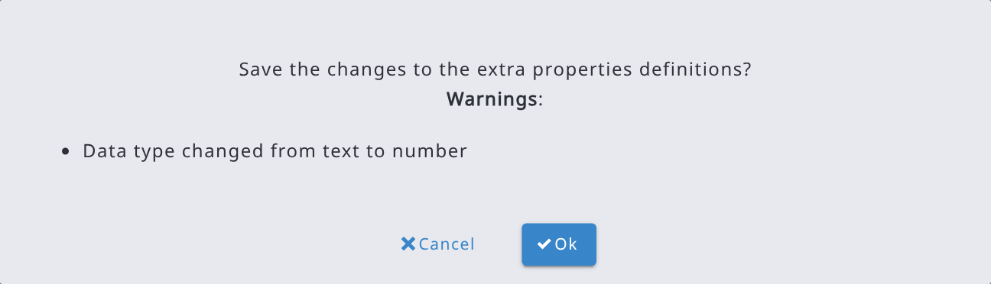
Click OK.
- close the editing window

Note: In R/RStudio, extra properties (as well as the species names) are all as text.

7.6.2. Clone a taxonomy from another survey
In Taxonomies, use ‘Clone Taxonomy From Another Survey’ (next to Add). The flow and the internal ID/name duplicate checks are the same as for categories, applied to taxonomies and their taxa.

7.6.3. Updating a taxonomy
To update a species list, click Import in the taxonomy editor and select the updated CSV/Excel file. If the survey is not published yet, the taxa of the file replace the existing ones. If the taxonomy is published:
- the taxa with the same code are updated and the new taxa are added;
- the taxa are sorted as in the imported file;
- published taxa that are not in the file cannot be deleted: they are left unchanged, after the imported ones, and a message lists their codes.
When importing Excel (.xlsx) files (taxonomies and categories), cells containing formulas, rich text or hyperlinks are read as plain values (the result of the formula, the text of the cell).

8. Templates

8.1. Using a template
Templates are surveys which can offer an easy way to start designing a new survey. They are tested surveys which will fit to specific purposes, such as for forest inventory or socio-economic survey data collecting.
More about the templates:
- Only users who can create surveys (Survey Managers and System Administrators) can create a survey from a template
- The idea of using templates is that it is easier to delete tables, forms and attributes than create them. Therefore, there are more entities and attributes in these templates than needed!
- Survey labels are already stored with multiple languages. All labels can be edited as needed, and new language(s) can be added.
There are the following templates available in Arena. Please see Annex 4 containing screenshots of these templates.
# | Name of template | Purpose | Language(s)
1 | template_forest_inventory_b | Typical forest attributes for a forest inventory case.  This is a template with the following structure:  cluster (or tract/transect)-plot-child entities (several) -'canopy_cover' is an assessment at the 'plot' level  -'stratum' can be a property of 'cluster' or 'plot' | English, French, Spanish
2 | template_forest_inventory_c | Typical forest attributes for a forest inventory case.  Template with the following structure:  cluster (or tract/transect)-plot-subplot (or stand/section)-child entities (several)  -'stratum' can be a property of 'cluster' or 'plot' | English, French, Spanish
3 | template_forest_inventory_d | Typical forest attributes for a forest inventory case.  Template structure:  plot-subplot (or stand/section)-child entities (several)  -'canopy_cover' is under 'plot' level  -'stratum' can be a property of 'cluster' or 'plot' | English, French, Spanish
4 | template_forest_inventory_e | Typical forest attributes for a forest inventory case.  This is a template with the following structure:  plot-child entities (several) | English, French, Spanish
5 | template_community_survey | FAO Forestry Paper 179 "National socioeconomic surveys in forestry". Community survey.  Handbooks:  -EN: https://www.fao.org/3/i6206e/i6206e.pdf  -FR: https://www.fao.org/publications/card/en/c/I6206FR/  -ES: https://www.fao.org/publications/card/es/c/I6206ES/  -EN forms: https://www.fao.org/forestry/forestry-modules/en/ | English, French, Spanish
6 | template_household_survey | as above.  Household survey. | English, French, Spanish
7 | template_nwfp | Non-wood Forest Products and Services  -Sampling based assessment, and  -Assessment of individual NWFP trees | English, French, Spanish
8 | Template_landslide_  assessment | Landslide data collection  - Point based data collection for risk assessment  - Database for developing a warning system | English, French, Spanish,  Indonesian
 | More templates will be frequently added.
When you need to create a new survey using a template, follow these steps:
- Click your profile picture at the upper-right corner and select New Survey. Select Clone, enter the name of the new survey and, under Clone from, keep Template selected and choose the template in the list (only published templates are listed), as follows:
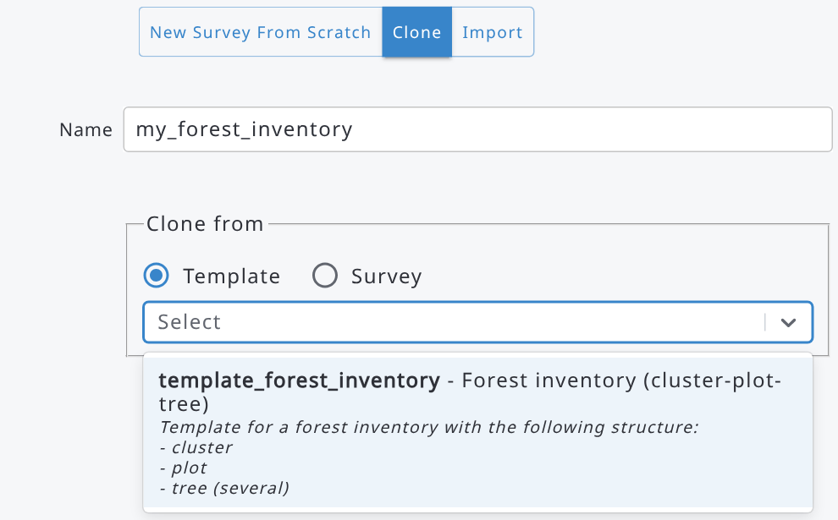
- Click the Create Survey button. The new survey is created and opened in the Dashboard.
- Select 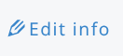in the Dashboard and edit the survey properties. You can still change the survey name here. You can
also delete all unneeded languages and add the required spatial reference systems into the survey.
- Go into the Form Designer, and edit the survey as needed. You can delete the unneeded entities (tables/forms) and attributes and add new ones into the pages.
Templates typically include more entities and attributes than are needed for a specific survey, as it is usually quicker to remove unnecessary elements than to add new ones.
- Test your survey with Preview.
- When ready, Publish the survey.
- Go to Users and invite users to get access to your survey (see more at the chapter "User roles and invitation to access a survey").

8.2. Getting a new template into Arena
Currently, only System Administrators can add new templates to Arena (see 8.3). If you are a Survey Administrator and would like to propose a new template or suggest improvements to an existing one, please contact the Arena development team at openforisinitiative@gmail.com. Include “Suggested survey to Arena template” in the email subject line.
A template is typically based on a published and tested survey and should be sufficiently generic to support a specific data collection purpose. As noted earlier, a well-designed template may include more attributes than are required for a particular survey, since removing unnecessary attributes is usually easier and faster than adding new ones in the Form Designer.

8.3. Creating and managing templates
System Administrators can create templates and manage them from the user menu (click your profile picture at the upper-right corner):
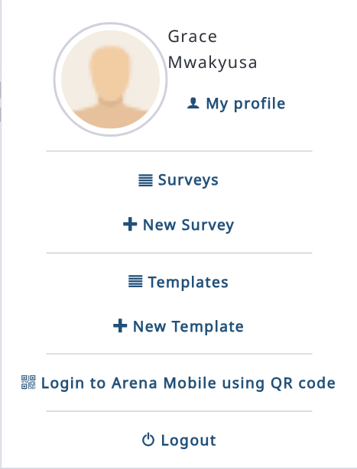
- Templates: lists the templates (select Only own surveys to see only yours). Select a template to open it: you can then edit it like any survey (Form Designer, categories, taxonomies, etc.).
- New Template: creates a new template, from scratch (New Template From Scratch) or by cloning an existing template or survey (Clone). Give it a name and click Create Template.
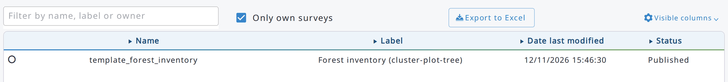
A template must be published before it can be used: only published templates are listed under Clone from > Template when creating a new survey. Write a clear label and a description in Edit info: they are shown in that list and help users choose the right template.
Processing chains can be cloned from templates too: when you clone a chain from another survey, the published templates that contain chains are listed in the Templates group (see chapter 10.6).

9. Data

9.1. What are the data entry stages?
Arena implements a workflow which divides data processing into three steps (or stages): 1) data entry, 2) data cleansing, and 3) data analysis.
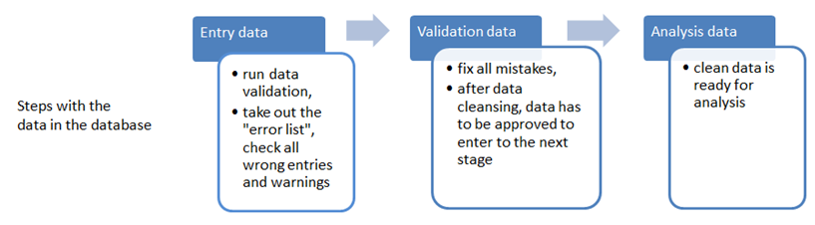
- Data entry stage 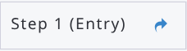
- Enter data exactly as recorded on the field forms.
- Data are neither interpreted nor corrected during this phase.
- Invalid values (those marked as "error") must be checked against the field forms. If the value was copied correctly, the value should be manually accepted. If it was copied incorrectly, the value should be entered as it appears on the field forms.
- Once all errors are either resolved or confirmed, the data entry clerk submits the record for data cleansing. Before entering the cleansing phase, a copy is made and marked read-only. No further changes may be made to this record by data entry staff (unless the record is returned by data cleansing staff).
- Data cleansing stage 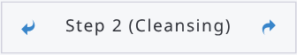
- Experts with knowledge of field conditions and data work with a copy of the data entered at step 1 to correct or remove invalid values.
Note: "Data entry" level users cannot edit the data which is at the cleansing stage.
- If the data cleansing expert deems that the data entry task was not completed or that the record contains too many errors, the record may be returned to phase 1 (entry) for additional changes.
- Once all data errors are resolved, the record may then be submitted for data analysis. This locks the record so that no further changes may be made.
- Data analysis stage 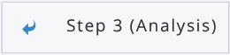
- Records are locked. They can be viewed but not edited.
- Records ready for analysis.
- If during analysis data are deemed incomplete or incorrect, the record may be rejected and sent back for further cleansing. Once updated and resubmitted, the record may once again be available for calculation and analysis.
In the record editor, the current step is shown at the upper-right corner (e.g. Step 1 (Entry)). Click the arrow on its right to submit the record to the next step, or the arrow on its left to send it back to the previous step. Arena asks you to confirm.

In the Data/Records view, selected records can also be promoted or demoted with the Update records step menu, as follows:
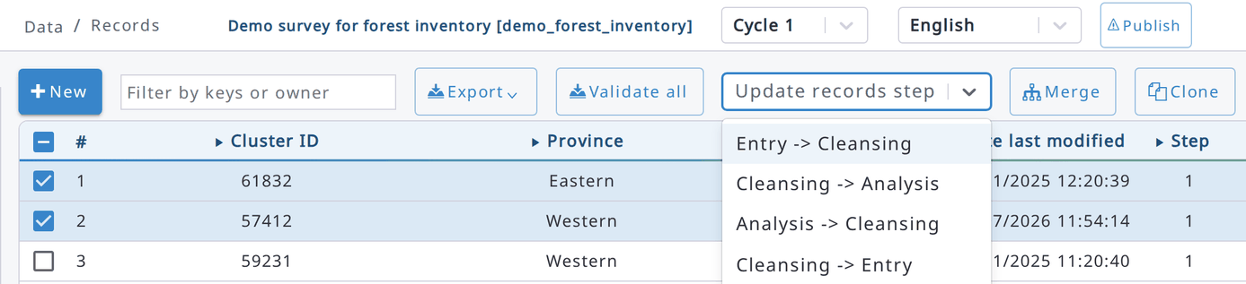

9.2. Adding, editing and viewing records
The Records section is used to enter, edit, view, and delete survey data. The main records view lists all root-level records and displays key metadata such as key field values, creation and modification dates, step, and the number of errors and warnings. Click a row to select it and double-click it to open the record.
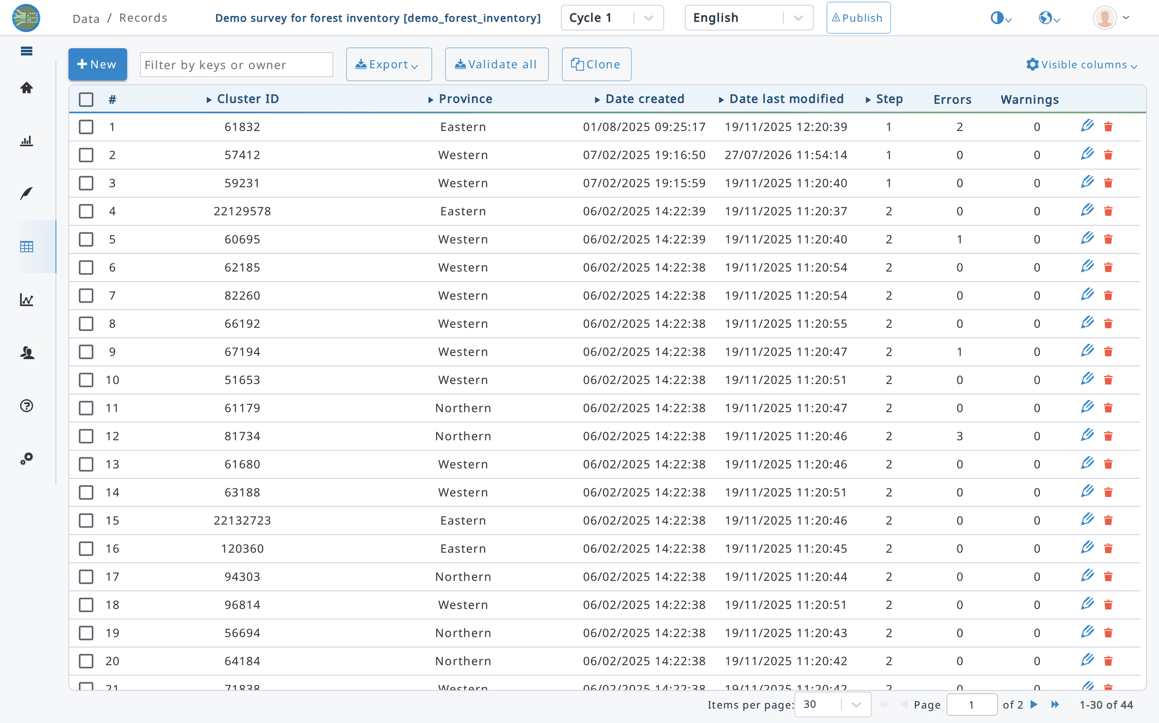
The steps (=stages) are coded as follows:
1: Data entry stage, 2: Data cleansing stage, 3: Data analysis stage.
The command buttons on the right side are as follows:
 Edit a record.  Delete a record.  View a locked record.
In the top left corner, the table has a checkbox to select all records in the view. If you have more than the currently set number of records in the view (i.e., 15, 30, 50 or 100), this method will just select the records of the current page (and not all your records).
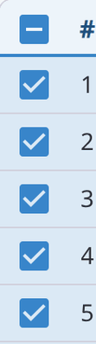
Records can be displayed either unsorted 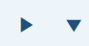or sorted 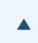, as follows:
Unsorted Descending order Ascending order

The user interface offers an input box for filtering the records, as follows:
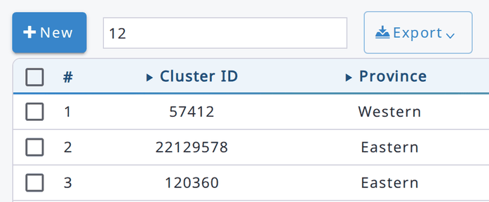
The list of records can be exported into an Excel file by clicking on the 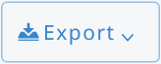button.
The Export button opens a menu with these options:
- Export list: the list of records, as shown in the table, as an Excel file.
- Export data: the data of the records as CSV files (see Data export).
- Export data summary: a summary of the data of each entity (for users who can analyse data).
- Export selected records (Arena format): available when records are selected. The selected records, with their files, are exported as a ZIP file in Arena format, that can be imported in Arena (see Import data from Arena/Arena Mobile file) or in Arena Mobile.
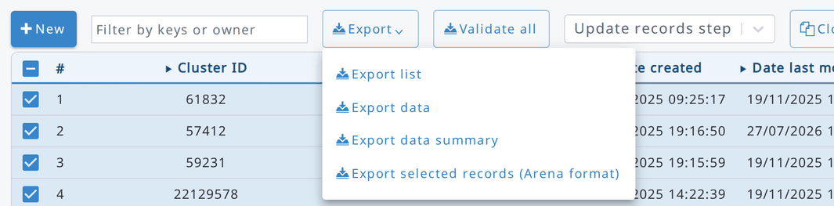
Selected records are kept when you move to another page of the list, so you can select records on several pages. The number of selected records is shown at the bottom left of the list. The selection is cleared when you change the filter or the number of records per page.
Dates and times (e.g. Date created and Date last modified) are shown in the time zone of your browser.

Data entry is straightforward. You will see all tables/forms at the left side panel, and data entry form in the main window at the right side. Start always entering data at the highest hierarchical level. For example, if you want to save forest inventory data where the structure is "cluster-plot-tree", input the cluster level data first, then the plot level etc. This helps ensure data consistency.
Arena does not lock the records (at data entry stages 1 and 2): users can work with the same data set, even edit the same record simultaneously. All records are locked only when data are submitted to stage 3 (Data Analysis). To avoid accidental changes, a record opened from the list is shown read-only: click Unlock at the top of the form to edit it (and Lock to go back to the read-only view). A new record opens ready for editing.
Start adding a new record by clicking  button. The program will open a data entry form. While entering the data, all data are automatically written into the database, i.e. there is no ADD-button!
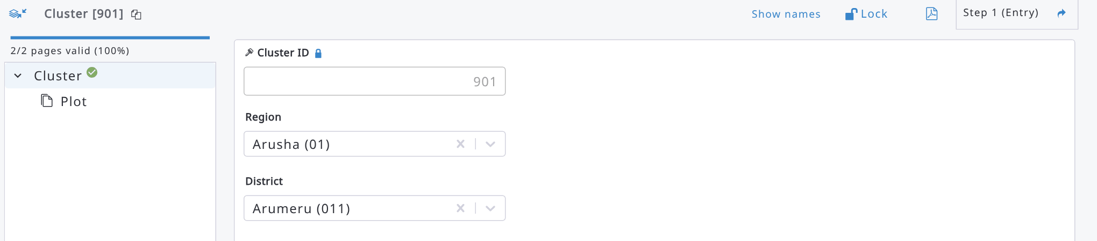
All items that are set as "required" are marked with a red symbol as long as the input field stays blank. The red label text and the red symbol can also indicate that there can be an error in the data item. In this case, Invalid record is shown at the top of the form: click it to open the validation report of the record.
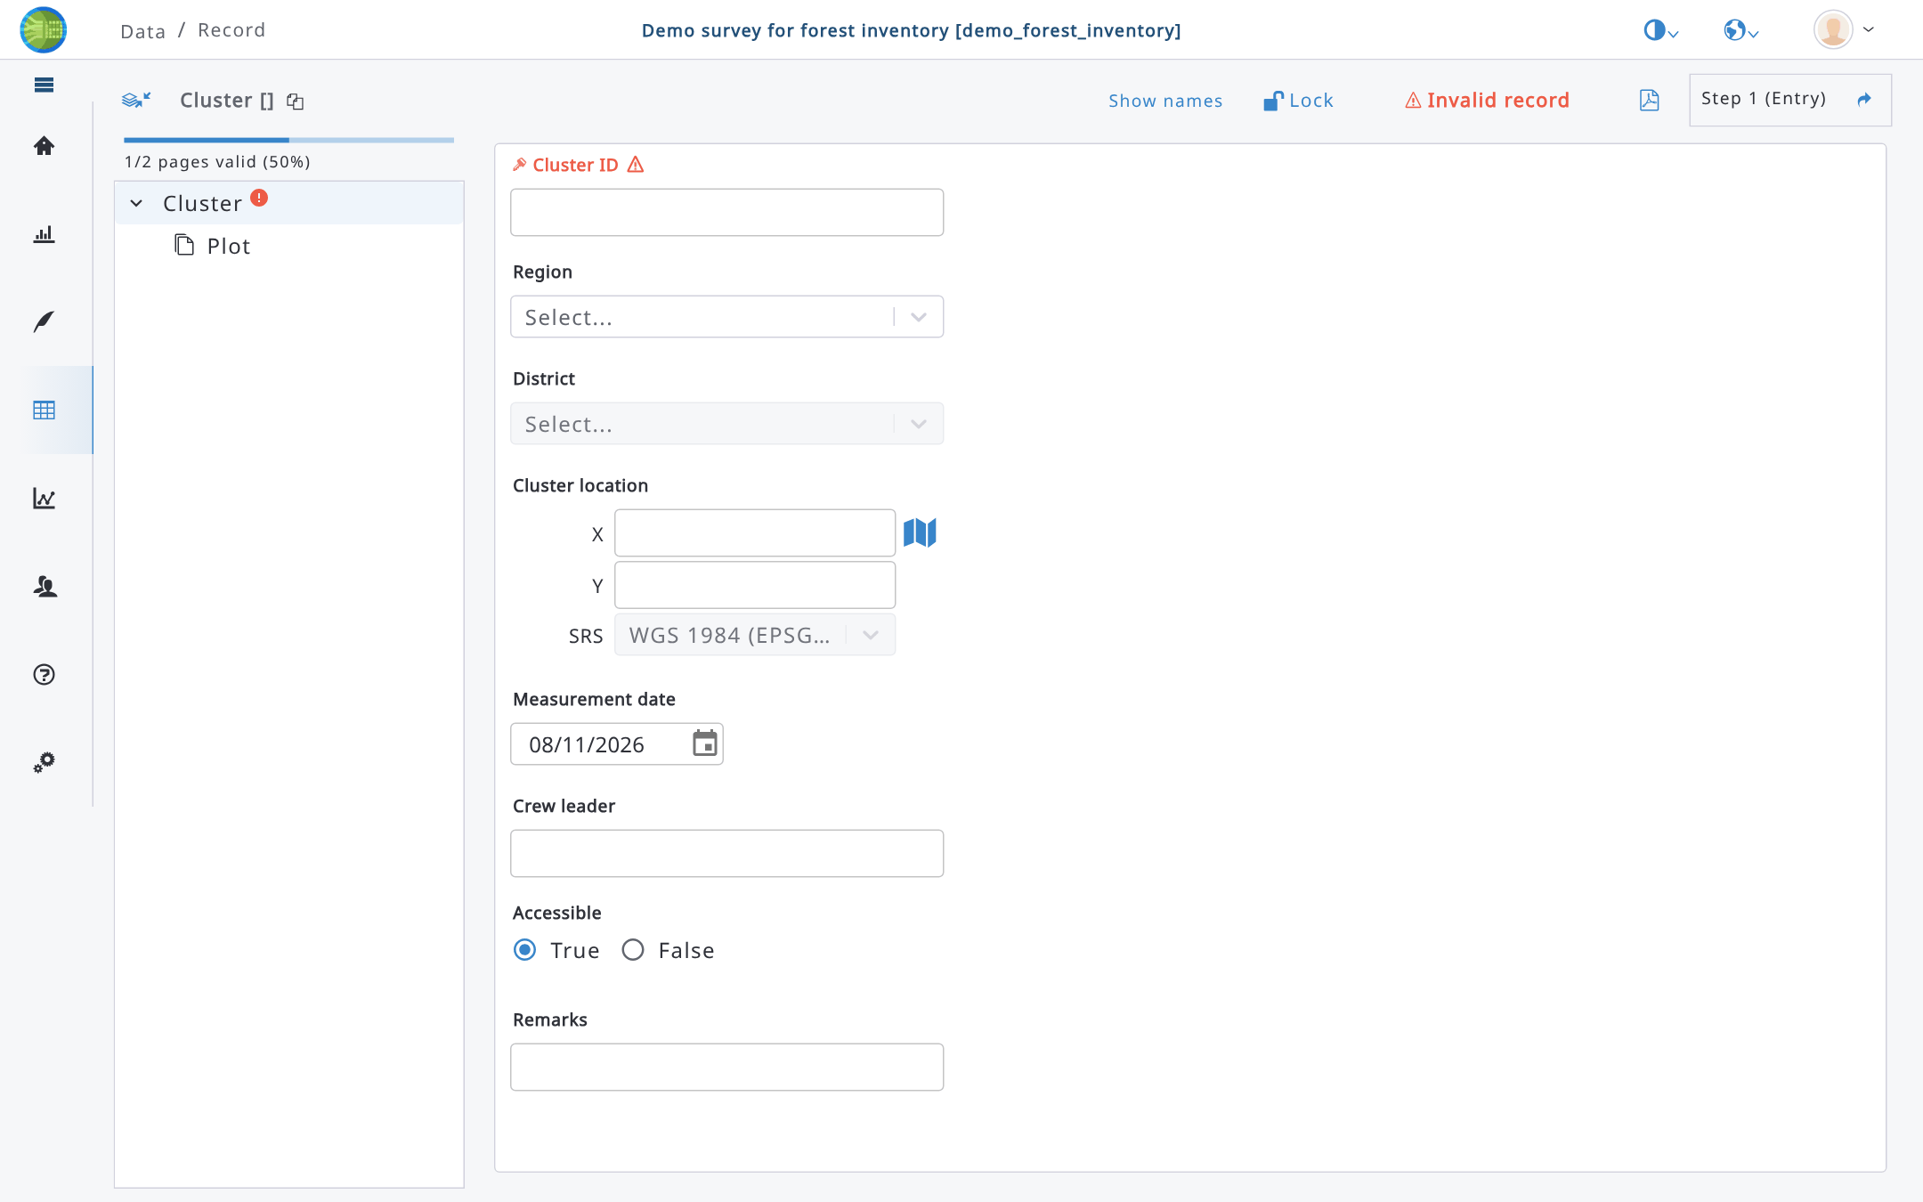
In case of a multiple-entry table/form, such as tree data, the new record can be added by clicking the button next to the table/form’s name. In tables, read-only values (e.g. calculated attributes) are shown as labels, and long values are cut with an ellipsis (…).
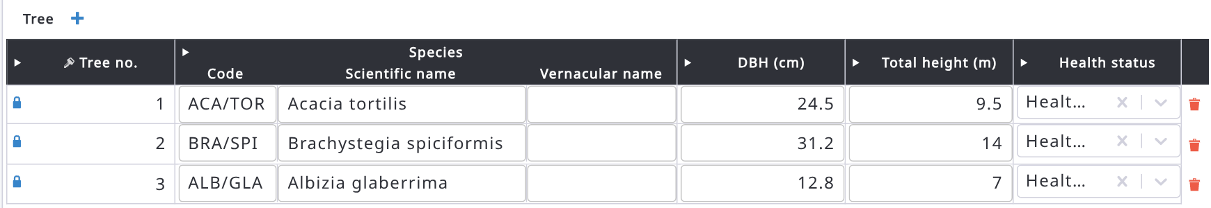
There are two ways how to see the entities and attribute identifiers:
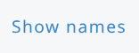 entity (table/form) or attribute name is shown,
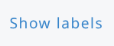 entity or attribute label is shown.

When working with forms that belong to lower-level entities, there is a text in the upper left corner showing the position of the record in the survey hierarchy (click the copy icon next to it to copy this path to the clipboard), as follows:
Species data entry can be handled so that you start typing in the first letters of the species name, or a code. Then a dropdown menu will emerge, and you can pick up the correct name as shown in the next image.
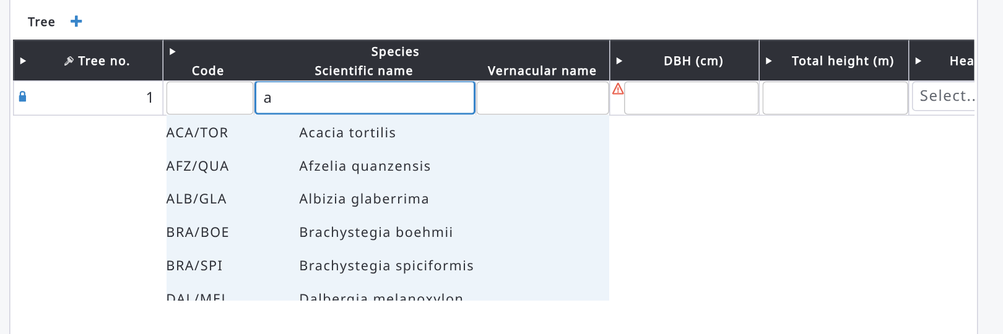
There are two species names automatically added by the system when a taxonomy is imported from a file: Unknown (UNK) and Unlisted (UNL). In order to enter one of these, type ‘un’ into the species name input box.
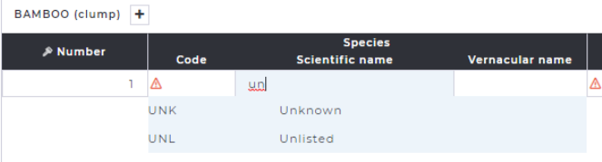

When attribute data type is ‘file’, the user interface looks as follows:
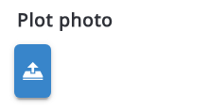 This is an upload button that can be used to upload a file into the Arena database.

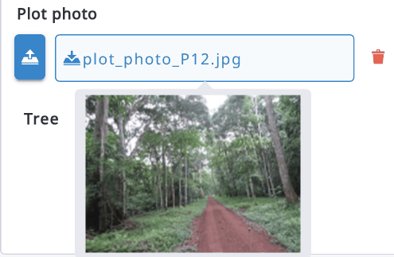
When a file has been uploaded, Arena shows the file name. When hovering over the name, a small snapshot view becomes visible, and when clicking the file name it can be downloaded into the local machine.
When a change makes some fields no longer relevant (their relevance condition is no longer met), Arena lists them and asks you to confirm that their values will be cleared. Click Ok to clear them, or Cancel to undo your change. If the values of non-relevant fields must be kept, a survey administrator can select Keep values of non-relevant attributes in Survey Info > Security.

9.3. Deleting a record
If you need to delete a record, go to the Records section and view the list of records. You can select one or more records and delete them by clicking the trash icon in their row or, after selecting them, the  button.
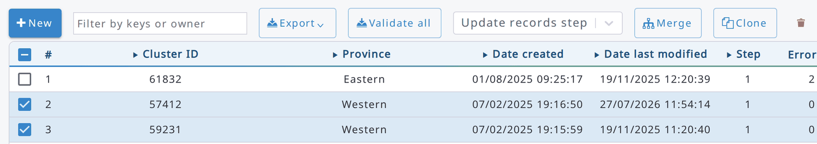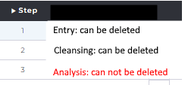
Look always at the step of your record: you can only delete a record that is on the Entry or Cleansing stage. After clicking on the Delete button, the following message box will appear.
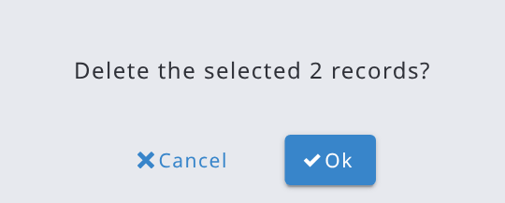

9.4. Deleting a row in a table
A row of a table can be deleted as follows: browse to the last column of a row. There you will see a trash box 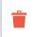 icon. Click that and message box will appear:

You can click Ok if you are sure. But be aware: there is no UNDO function in the system!

9.5. Cloning data
In the case of a multi-cycle survey, a Data Analyst (or a user with a higher role) can clone records from one cycle to another. The following conditions apply:
- The survey should contain more than 1 cycle;
- The survey must be published;
- Only data from older cycle can be cloned to newer, i.e. from Cycle 1 to 2, or from Cycle 2 to 3, but not backwards;
- Records cannot be overwritten in the target cycle; already existing records are skipped;
- Record key attribute definitions, defined on the Form Designer, must be the same in source and target cycle; if they have been modified, cloning will not work;
- The Clone-button is not shown on the last cycle’s record list;
When you want to clone data, do as follows:
- Select the source cycle in the cycle selector at the top of the page, e.g. 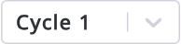
- Select the records to be cloned
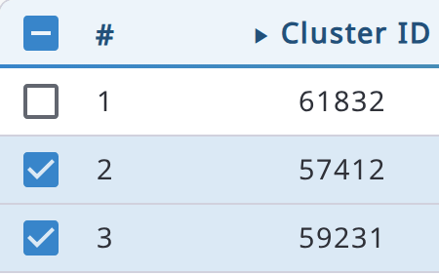
If you want to clone all records, you do not need to make any selection.
- Click on 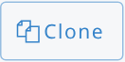
- Select the target cycle (To cycle); only later cycles can be selected,
- Select whether you want to clone all records or only the selected ones:
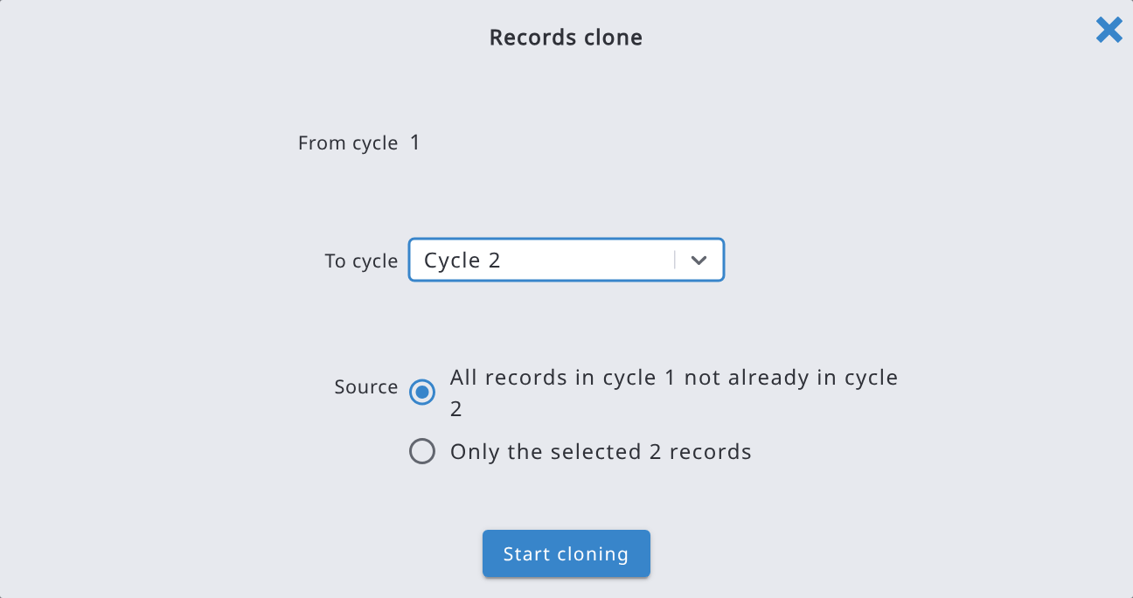
- Click on Start cloning and confirm. When cloning is complete, a message shows how many records were cloned.

9.6. Data Explorer and aggregating data
Data Explorer is a tool for viewing data in the tabular format. You can view both input data and (computed) result variables in the same table. You can view data in multiple ways (such as filtered and/or sorted), and it can be exported into a CSV or Excel file. In Raw mode, users who can edit the data can also turn on Edit and edit the data directly in this view.
Data Explorer can be used to aggregate data. This means that it can work as a reporting tool in "Aggregate Mode".

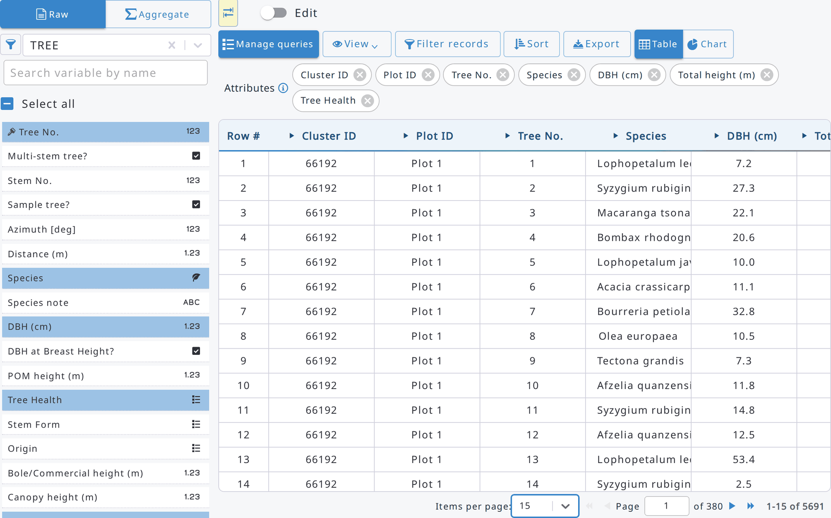
Letter "M" 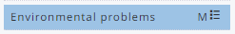indicates that this is a multiple-entry attribute.
All data in view can be exported into a CSV or Excel file with the Export button.
The main controls of Data Explorer are:
- Entity selector (left panel): select the entity (table) to view. The funnel button next to it filters the attributes by data type; Search variable by name filters them by name or label.
- Attributes list: click the attributes to add them as columns. They also appear as chips above the table, where you can remove them or drag them to change the order of the columns.
- Show/Hide Node Definitions Selector button: shows or hides the left panel.
- Mode: Raw (one row per entity) or Aggregate (see below). In Raw mode, the Edit switch lets you edit the data in the table.
- Filter records, Sort and Export: filter, sort and export the data in view. You can also sort quickly by clicking the arrow next to a column header.
- View: display options (Show names, Show codes, Show total and percentage).
- Manage queries: save the current query (entity, attributes, filter, sorting) and open the saved ones.
- Table / Chart: show the data as a table or as a chart.
The current version allows users to view and export the computed result variables in the Data Explorer view. Similarly, as imputed data attributes, computed result variables can be selected into the view, as below.
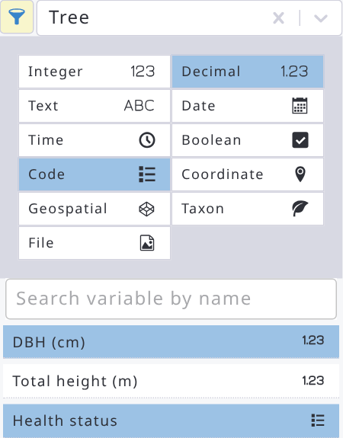
Data can be aggregated  to higher levels of the hierarchy. The aggregate mode contains two sections:
- Dimension. All categorical, boolean and key attributes of the selected entity and its parent entities. The list also contains computed categorical variables, and these are tagged with (C).
- Measure. All numeric attributes of the selected entity and its parent entities but excluding key attributes. The list also contains computed quantitative (i.e. numeric) result variables, and these are tagged with (C).
Multiple-entry attributes cannot be shown in the aggregate mode view.
For example, tree result variables, such as "number of trees per hectare" can be aggregated to a plot level, or any upper level.
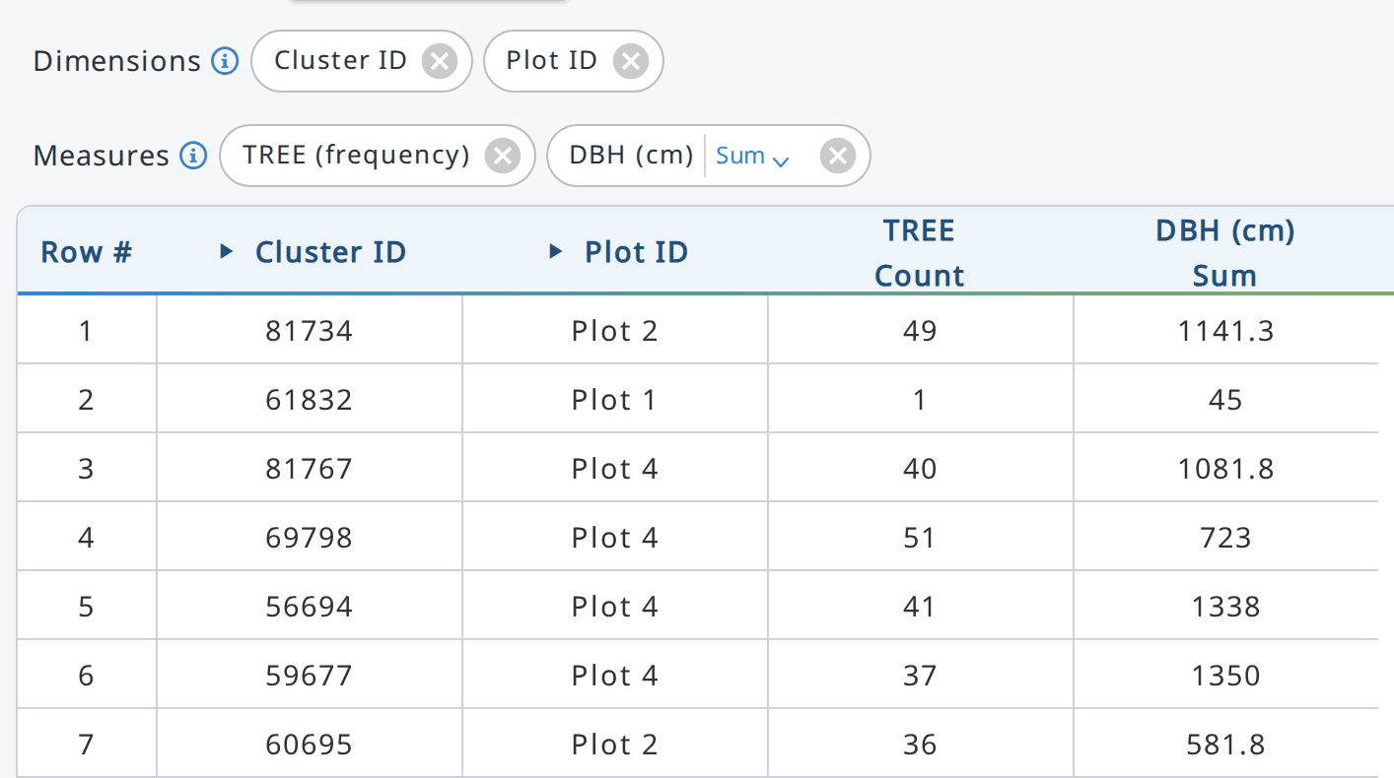
Follow the next steps to see the aggregates:
- Select the entity (table) to report in the entity selector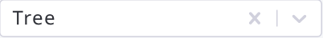
- Click Aggregate next to Mode.
- Select the Dimensions to be reported. In this case Cluster ID and Plot no. are selected:
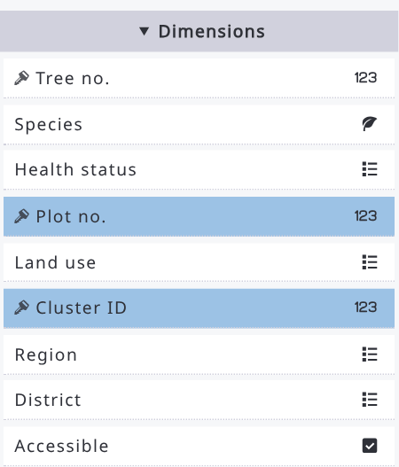
- Select the Measures to be reported.
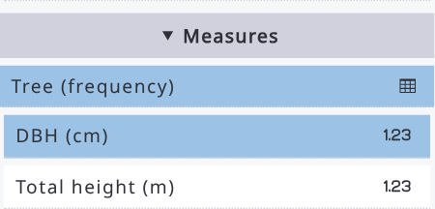
- In the table, Sum is the default function. To change it, click the gear icon in the column header at the icon and change the aggregate function.
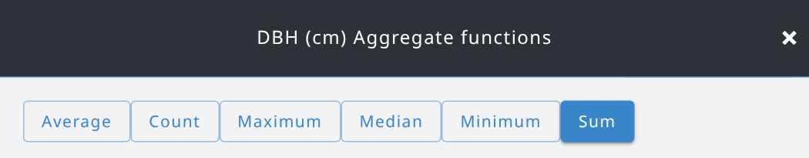
Deselect Sum and select Average and Count.
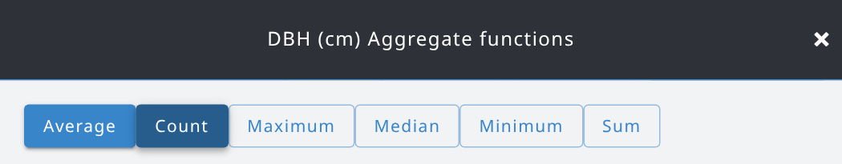
And then close the Aggregate function window by clicking button at the top-right corner (or Close at the bottom).
In the result view, the DBH statistics look as follows:
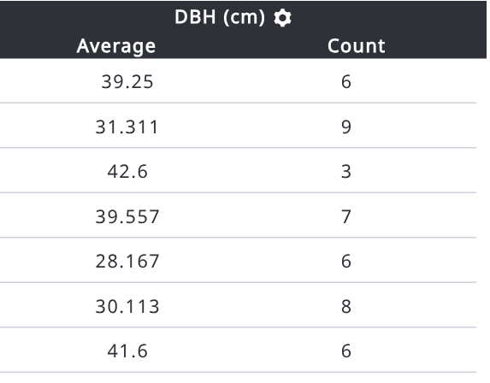
- More complex custom aggregate functions can be applied in the reporting, if needed. The aggregation uses the Structured Query Language (SQL) expressions which is the fastest method to run a database query on the Arena server. In the aggregate functions panel, click New under Custom aggregate functions, enter a name and an SQL expression using the column names of the entity (e.g. dbh), then click Save. The expression can contain only the column names of the entity, numbers, text in single quotes, arithmetic and comparison operators, CASE WHEN … THEN … ELSE … END, FILTER (WHERE …) and common functions (e.g. sum, avg, count, min, max, median, stddev, percentile_cont, coalesce, round): any other SQL (e.g. SELECT, semicolons or comments) is not accepted and the error is shown on the expression field.
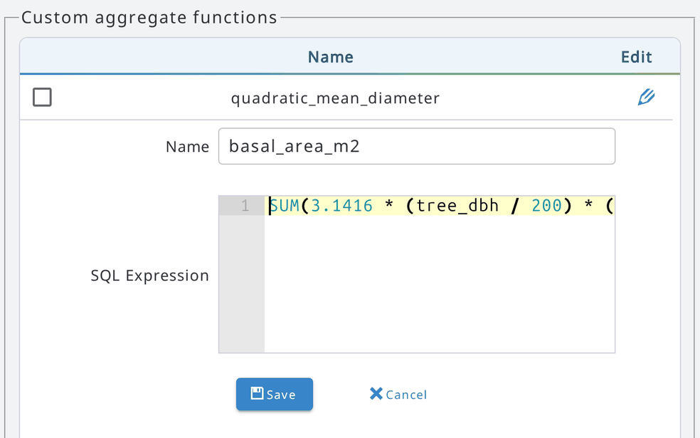
After clicking Save, we can see the list of custom aggregate functions as follows:
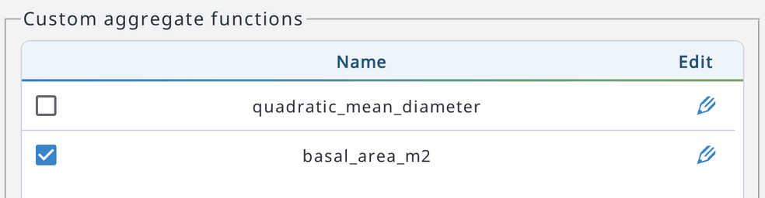
The reported custom aggregates need to be selected (checkbox) in order to see them in the report table.
- Click Close.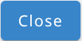
And the results will look as follows:
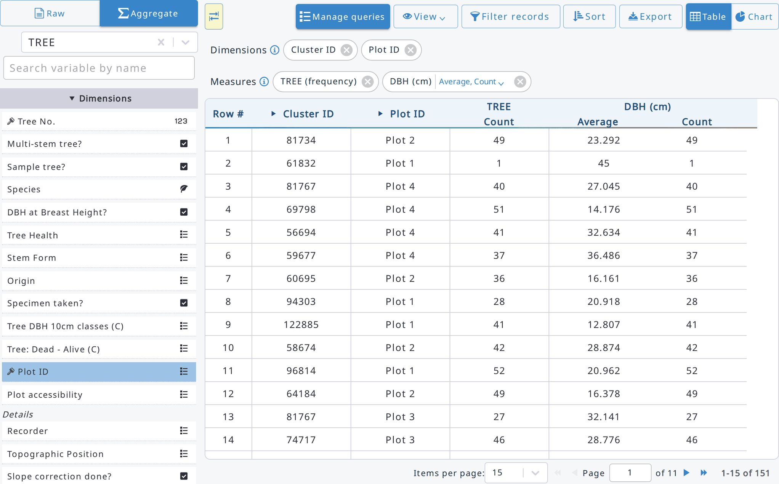
- Data can now be exported to a CSV or Excel file with the Export button 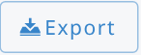 .

9.6.1. Filtering records and searching attributes
Click Filter records to show only the rows matching an expression. Build the expression with the basic editor (variable, operator, value, +AND, +OR), or click Advanced to write it. Expressions are written in JavaScript syntax, using the attribute names: e.g. dbh >= 40 && total_height > 20. Use && for AND, || for OR, == for equal and != for not equal.
To search text values, use text_attr.includes('abc'), text_attr.startsWith('abc') or text_attr.endsWith('abc'). Add .toLowerCase() before them to ignore the case, e.g. text_attr.toLowerCase().includes('abc'). Press Ctrl+Space to see the variables and functions you can use.
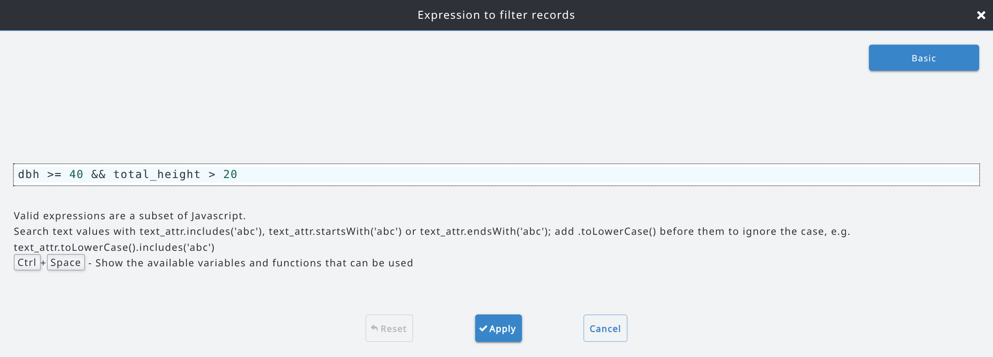
Click Apply to filter the data. While a filter is active, the Filter records button is highlighted. The same filter is used when you export the data.
To find an attribute quickly in a long list, type part of its name or label in Search variable by name, above the attributes list.

9.6.2. Totals and percentages
In aggregate mode, with a single measure, you can show the total of the measure and the percentage of every row. Open the View menu and select Show total and percentage: a % column is added next to each aggregate function and a Total row at the bottom of the table.
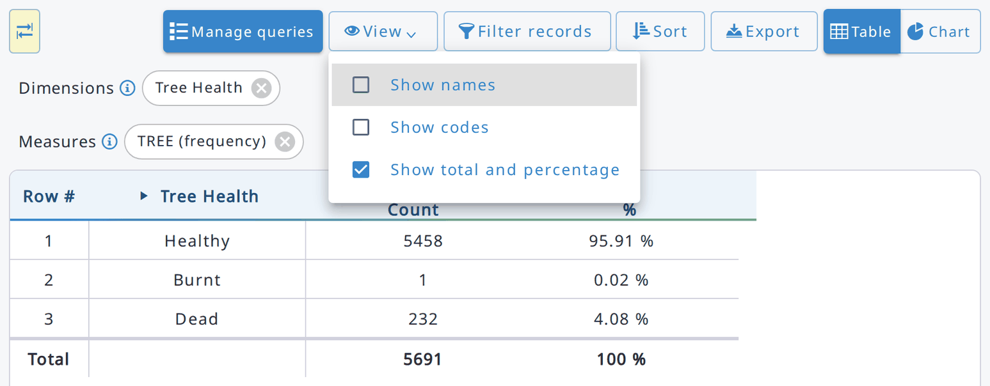
The View menu also contains:
- Show names: show the attribute names instead of their labels.
- Show codes: show the codes of the category items next to their labels (table view only).

9.6.3. Exporting data as a table or as a data matrix
Click Export to export the data in view. Choose the file format (Excel or CSV) and the options, and click Export. The options include Records modified after and Records modified before, to export only the records modified in a period.
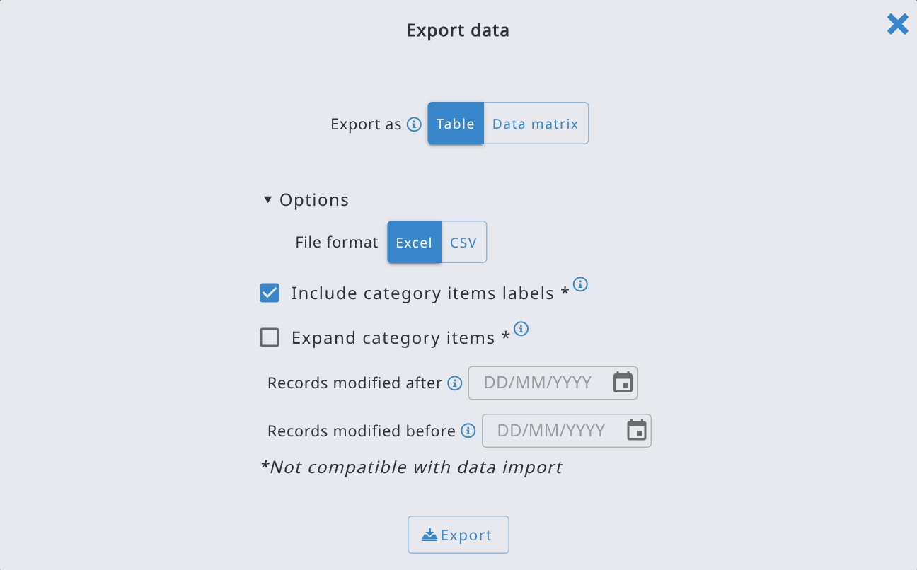
When the selected entity is a multiple entity (e.g. trees, or species of a vegetation plot) and you are in Raw mode, you can also export the data as a Data matrix: one row for each species (or other attribute) and one column for each record, as required by vegetation analysis tools such as Turboveg, Juice and Synbiosys. In Export as, select Data matrix, then choose:
- Rows: the attribute whose values become the rows (e.g. the species). Taxon attributes are exported with their scientific name.
- Second row attribute (optional): e.g. the layer, when the same species can appear more than once in a record.
- Key attributes used to name the record columns: each record becomes a column, named after the values of the selected key attributes (at least one).
- Values: the attribute shown in the cells (e.g. cover).
The Preview shows the structure of the exported table. If a filter is set in Data Explorer, only the matching data is exported. Click Start export to generate the file.
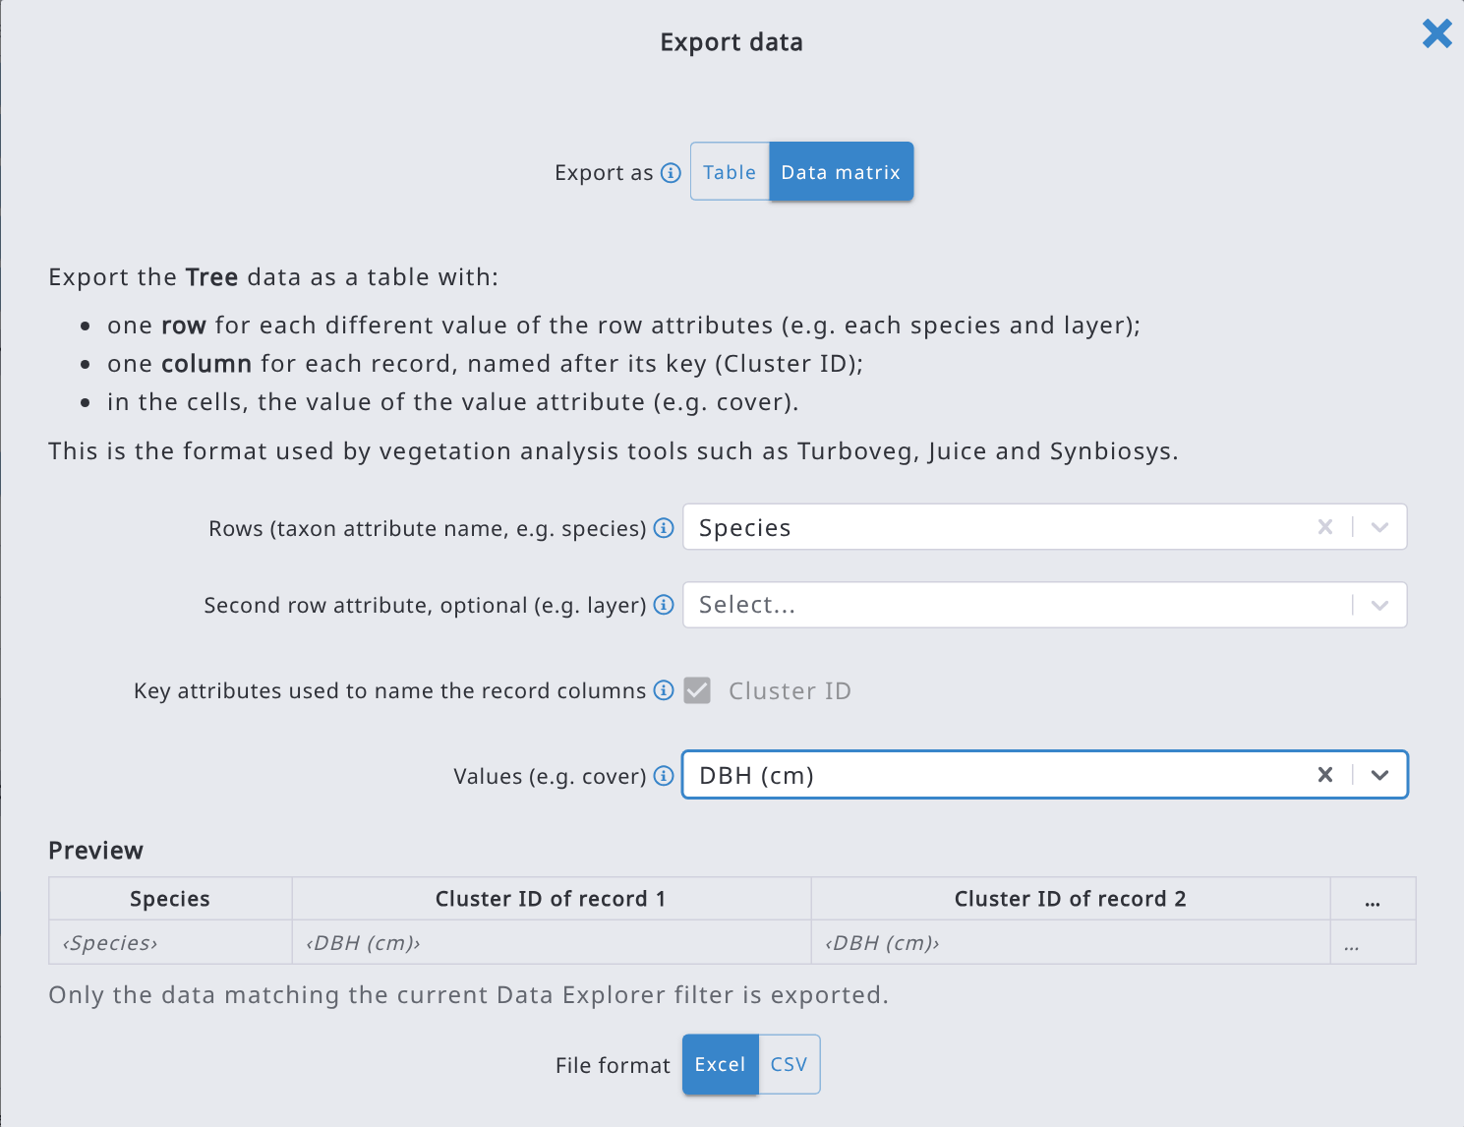

9.6.4. Charts
Click Chart to show the data as a chart (bar, pie, line, area or scatter chart). Charts also work with large data sets: when there are too many items, the chart shows a random sample of them that always includes the outliers, and a message tells how many items are shown out of the total.

9.6.5. Creating queries with AI
If the AI features are enabled on your Arena server by the administrator (and in the AI settings of your user profile), you can create a query by describing it in plain language. Click Ask AI, describe the data you want to see (e.g. average tree DBH and number of trees by species) and click Generate.
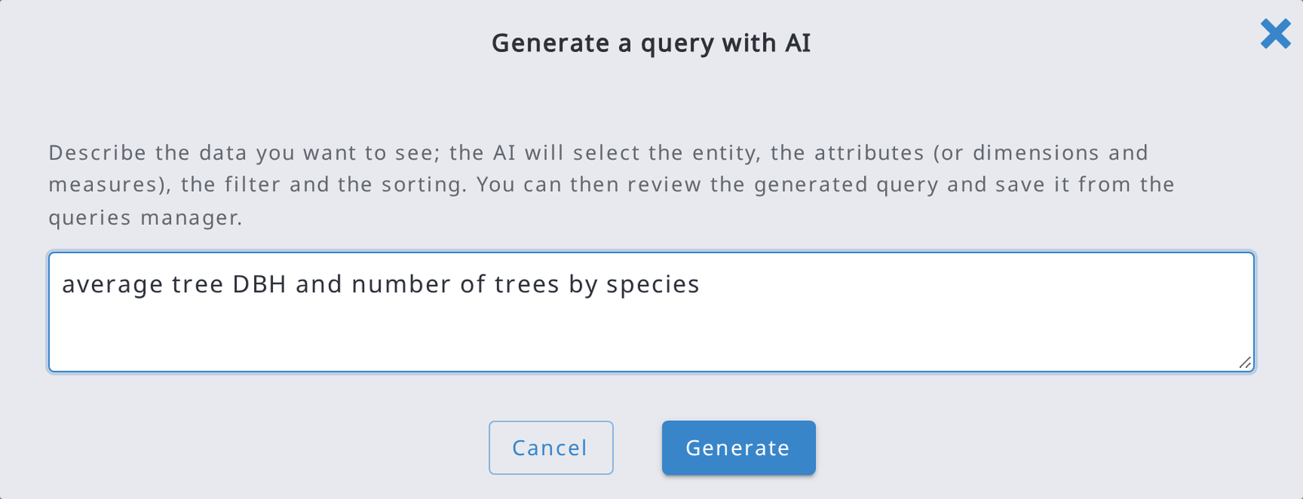
Arena selects the entity, the attributes (or dimensions and measures), the filter and the sorting, and shows the result. Check it and, if you want to keep it, save it from Manage queries.
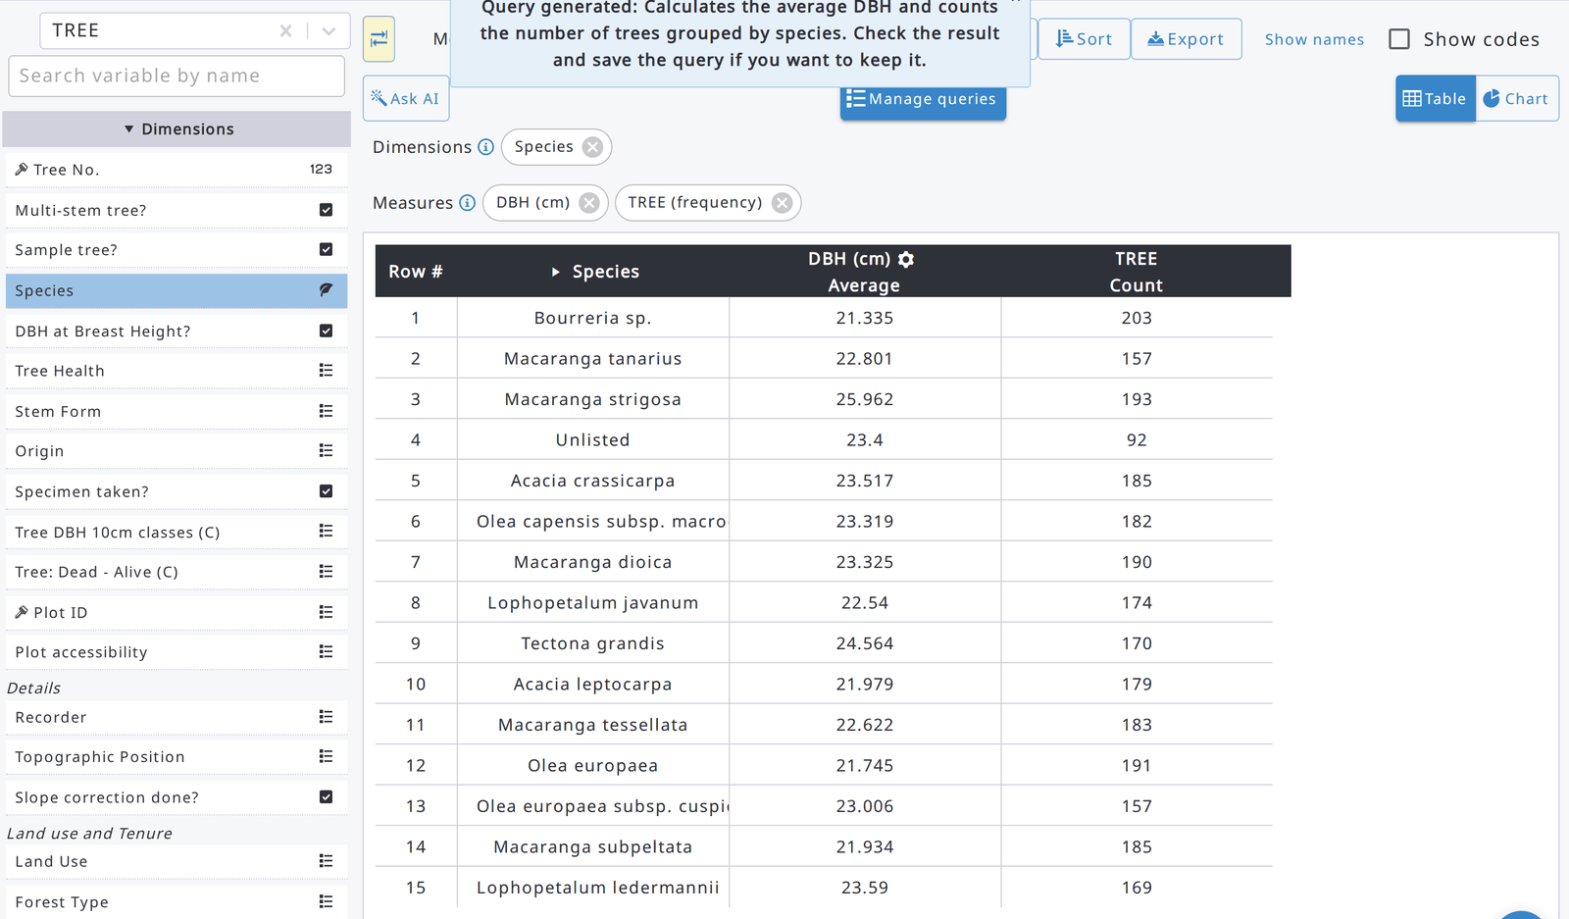
When saving a query in Manage queries, click Suggest name and description to let the AI propose the name, label and description of the query based on the current selections.

9.7. Map

9.7.1. Viewing map data
If a survey contains a Sampling Point Data table or coordinate data, the locations of the points can be viewed on a map in Data > Map. Point locations can also be recorded using the map view. Base map data can be only viewed but not exported from Arena.
The map opens in a workspace with the following parts:
- the top bar, with the Base map, Add data, Display and Tools menus, the Screenshot, Zoom to data and Full screen buttons, and a search box;
- the side panel, with the Layers, Records and Legend tabs (the arrow button collapses the panel);
- the status bar, at the bottom of the map.
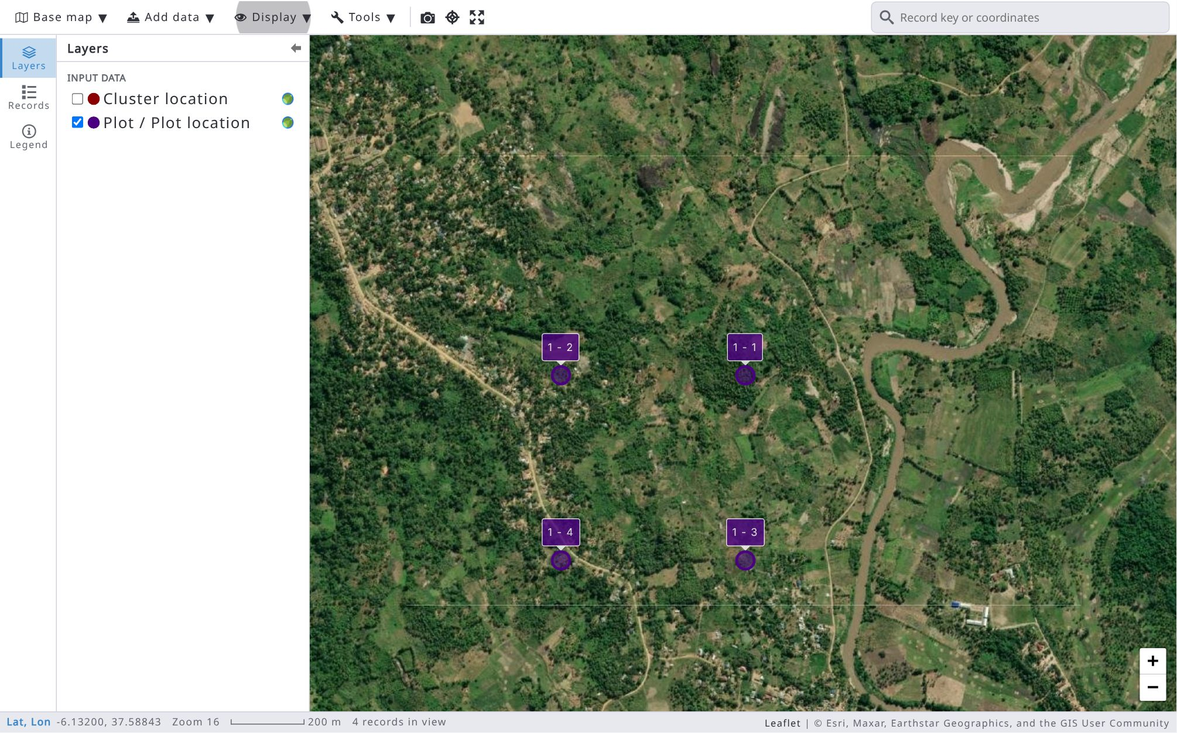
By clicking on a map marker, you open a pop-up window with the location of the point and the "Edit record" button, which opens the record in a floatable form window on top of the map view. The Previous / Next arrow buttons of the pop-up move to the previous / next record of the layer.
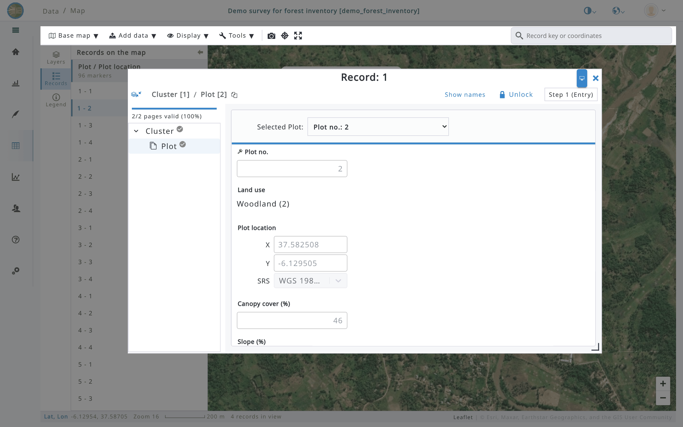
Markers in each layer have a different colour, assigned randomly: click the colour dot next to a layer in the Layers tab to change it. Use Display > Marker labels to show or hide the markers’ labels; Display > Location markers shows or hides the markers. The label contains the values of the key attributes separated by a hyphen (e.g., cluster_id - plot_no, 1 - 1 in the map view above).
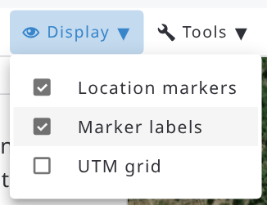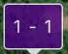
The markers (points) of the selected layers will be shown grouped in clusters. Each cluster of points is a circle with the number of grouped points. Clicking on the cluster or zooming sufficiently the actual locations will be visible as follows:
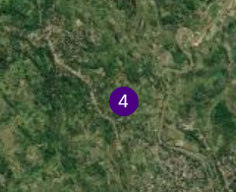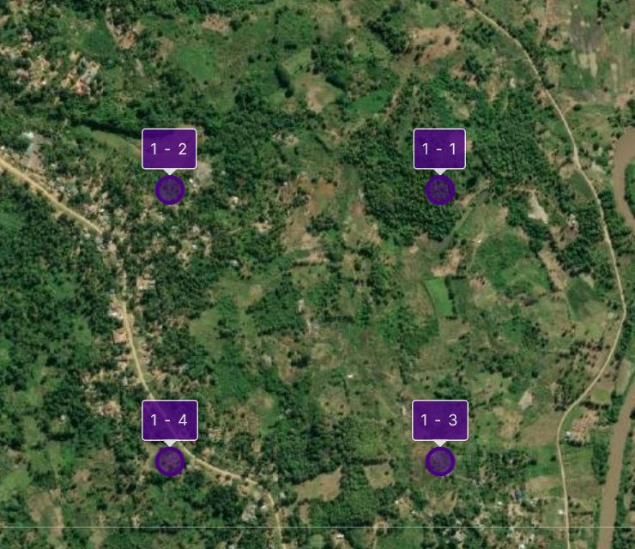
With the Base map menu, you can select the base map from several options (custom base maps added as WMS / WMTS services or XYZ tiles are listed there too, see 9.7.5). In the Layers tab, select the layer(s) to be shown: there is one layer for each coordinate attribute defined in the survey (Input data), one for each level of the Sampling Point Data and one for each area of interest of the survey (see 9.7.8).
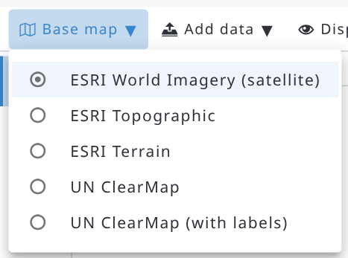
The maximum zoom levels are as follows: ‘ESRI World Imagery’ 17, ‘ESRI Topographic’ 16, ‘ESRI Terrain’ 9, ‘UN ClearMap’ 8, and ‘UN ClearMap with labels’ 6.
Use the search box in the top bar to move the map to a location or to a record. Type coordinates in decimal degrees (e.g., -6.1295, 37.587), in degrees, minutes and seconds (DMS) or in UTM (e.g., 37M 343814 9322016) and press Enter; or type the beginning of a record key (e.g., 1) and select the record in the list. The search finds the records of the layers shown on the map.
The Zoom to data button zooms the map to the data of the layers shown, and the Full screen button shows the map workspace on the whole screen (press Esc or click the button again to exit).
The Records tab lists the records of the layers shown on the map, grouped by layer, with the number of markers. Click a record to move the map to its location and open its pop-up; use Sort to sort the list by key. The selected record is highlighted in the list.
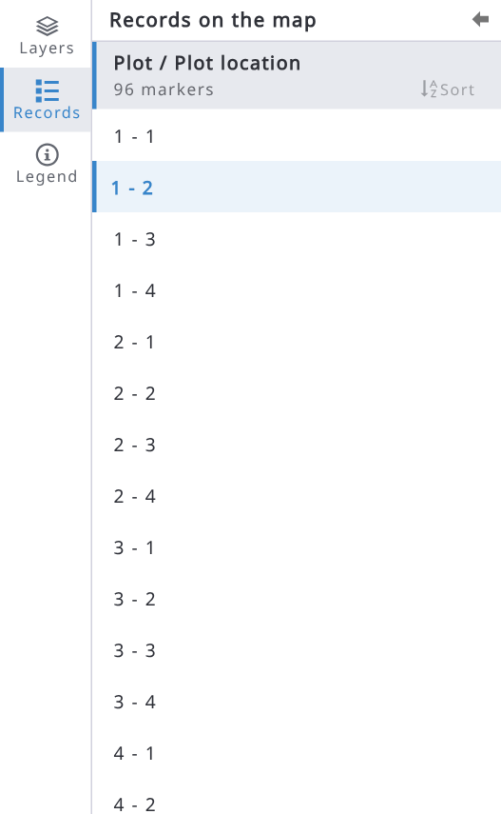
The Legend tab explains the symbols on the map: record locations, groups of nearby records, the sampling polygon and the UTM grid (when shown) and the added layers.
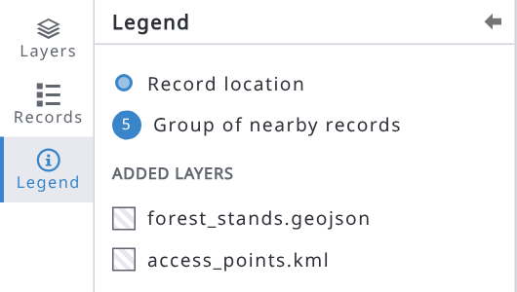
In the record editor, the map button next to a coordinate attribute opens the location in a smaller map, with the Base map and Display menus, the measure distance tool and a coordinates search box. Click the marker to see the coordinates and the elevation of the point; double click on the map or drag the marker to change the location (if the record can be edited), then click Save.
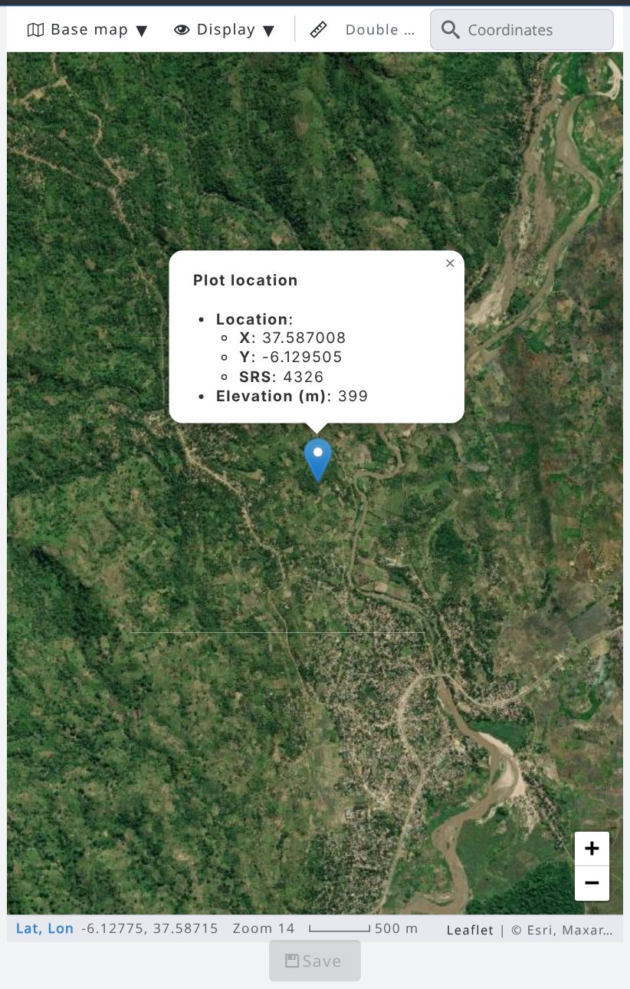

The status bar at the bottom of the map shows the coordinates of the mouse pointer (click the notation, e.g. Lat, Lon, to switch to DMS or UTM), the current zoom level, the scale and the number of records in view:

9.7.2. Sample-based image interpretation
The sample-based image interpretation allows users to visually collect data from map and satellite images using sampling polygons and a set of control points. The settings are in Survey info, Map tab (check Sample-based image interpretation enabled).
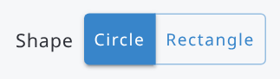 There are two shape options: rectangle and circle.
A rectangular sample plot. Note: Latitude is the Y axis, longitude is the X axis on a map.
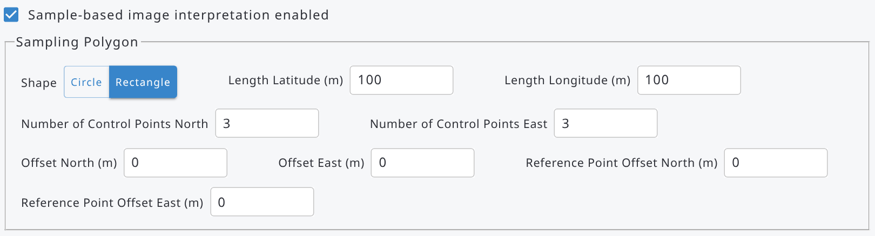
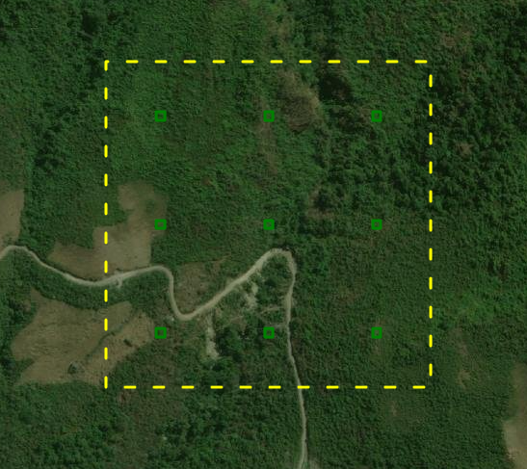 |   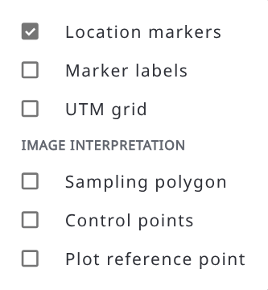
A circular sample plot:
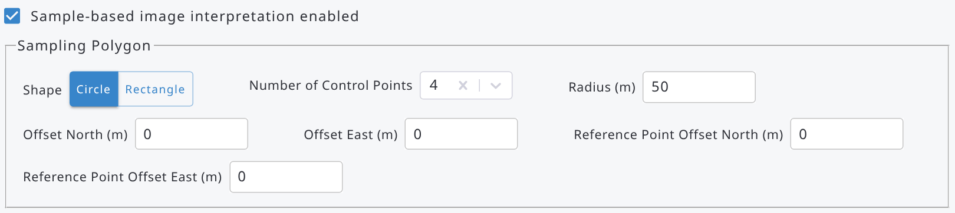
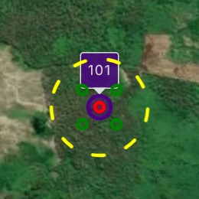 | 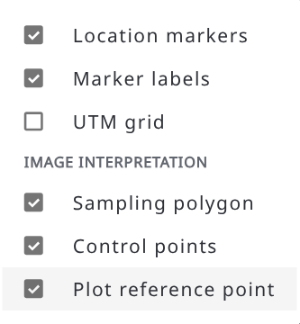
 | The UTM grid is displayed in the map view.

The control points are shown as small coloured polygons in a grid inside the sampling polygon. These are clickable: by clicking a point you can change its colour (with 5 colour options). The control points can be used to assess land or land cover features, such as proportions of land-use categories, forest coverage, etc.
In the map, use the Display menu to show or hide the Sampling polygon, the Control points and the Plot reference point (section Image interpretation, available when sample-based image interpretation is enabled), and the UTM grid.
Offset North/East moves the sampling polygon and the control points to the desired direction and distances. The "plot reference point" is an optional feature. This is a red point that can be used to mark for example a plot center point, if a grid is shifted with "offset" values.

There are two methods to collect the data: 1) using a Sampling Point Data table, or 2) imputed records with coordinate data.
When you click on the plot marker icon, Arena opens a pop-up window showing the following information.
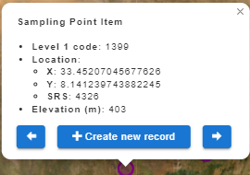 | Sampling Point item:  - Level code (in the Sampling Point Data),  - coordinates,  - elevation,  - ‘Create new record’ button (is available if the survey is published after the latest changes),  - Previous (<=) / Next (=>) buttons: move to the previous/next item in the Sampling Point Data table.
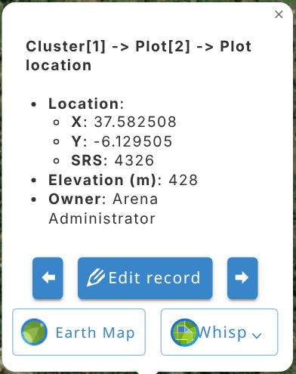 | A record with a coordinate data:  - record’s key attributes,  - coordinates (SRS as in imputed data),  - elevation,  - owner of the record,  - ‘Edit record’ button,  - Previous (<=) / Next (=>) buttons: move to the previous/next record on the record list.  - Buttons to access Open Foris Earth Map and Whisp
 | In the Edit Record view, this button opens a floatable browser window that can be moved (to be shown on a second monitor).

It can happen that the maximum zoom level is reached and the markers are still clustered, meaning that the points are very close to each other or overlapping. Then clicking on a clustered marker opens a pop-up showing a list of points in this cluster, and you can select the preferred item.
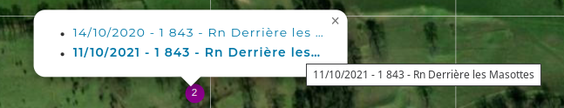

9.7.3. Google Earth Engine queries via Earth Map
Earth Map (EM) is a free Open Foris tool developed by FAO in the framework of the FAO – Google partnership. It allows users to easily visualize, process and analyze multi-temporal satellite imagery and global datasets on climate, vegetation, fires, biodiversity, geo-social and other topics, using the Google Earth Engine (GEE) data without coding. Users need no prior knowledge of remote sensing or Geographical Information Systems (GIS).
Currently, we can make a GEE query for a polygon in EM. The polygon submitted from Arena is the same as defined in the survey settings, see Sample-based image interpretation. This polygon is called Area of Interest (AOI) in Earth Map.
If sample-based image interpretation is not enabled in Survey info (Map tab), then Arena submits a polygon of 100m x 100m to Earth Map.
The following picture shows a circular sampling polygon in Arena’s Map view.
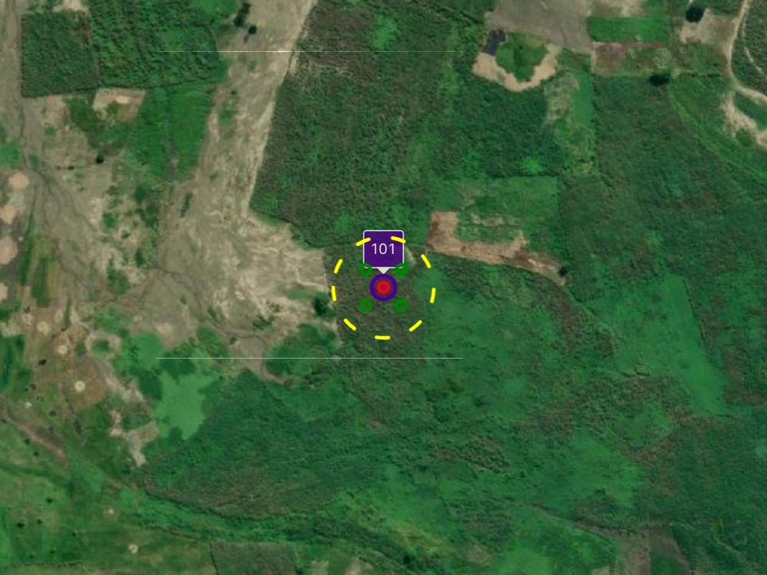
When clicking on a point marker on the map, you will get a pop-up with the 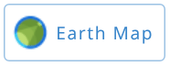button. By clicking on this button, Arena opens a new web page with connection to Earth Map. First, you need to sign in and there are the following options:
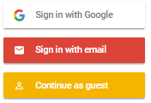With the last option, you can sign in without giving any information.
The same polygon submitted to EM looks as follows (with a query).
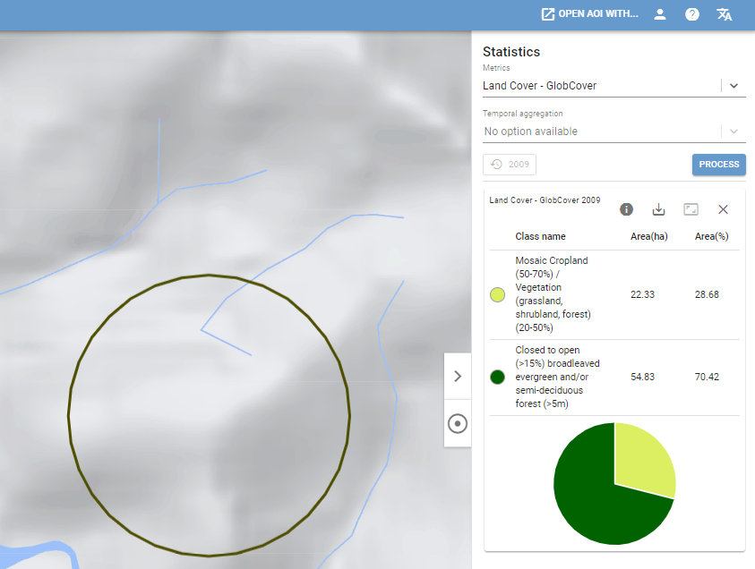

You can run GEE queries for your AOI by using the Statistics tools on the right side of the page.
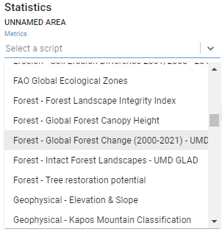

You can get multitemporal results as shown in the following picture.
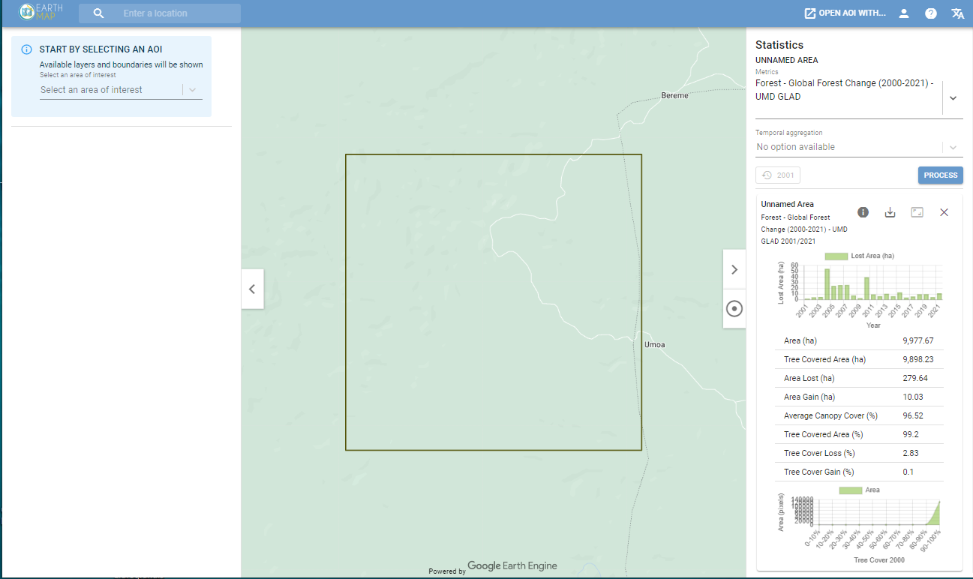

9.7.4. Polygon data on the map view
Users can upload polygon (or point and line) layers to the map view: open the Add data menu and choose Upload KML, KMZ or Shapefile…, then select the file.
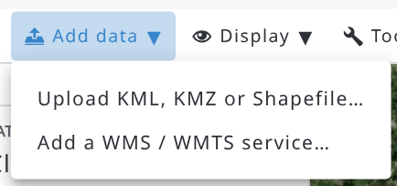
Arena’s map can show KML, KMZ, GeoJSON (.geojson or .json) or zipped Shapefile (.zip) files, up to 50 MB each, on top of the base map (or satellite image), as shown in the next images. After the upload, the map zooms to the content of the file. KML points without an icon style are shown with the default marker.
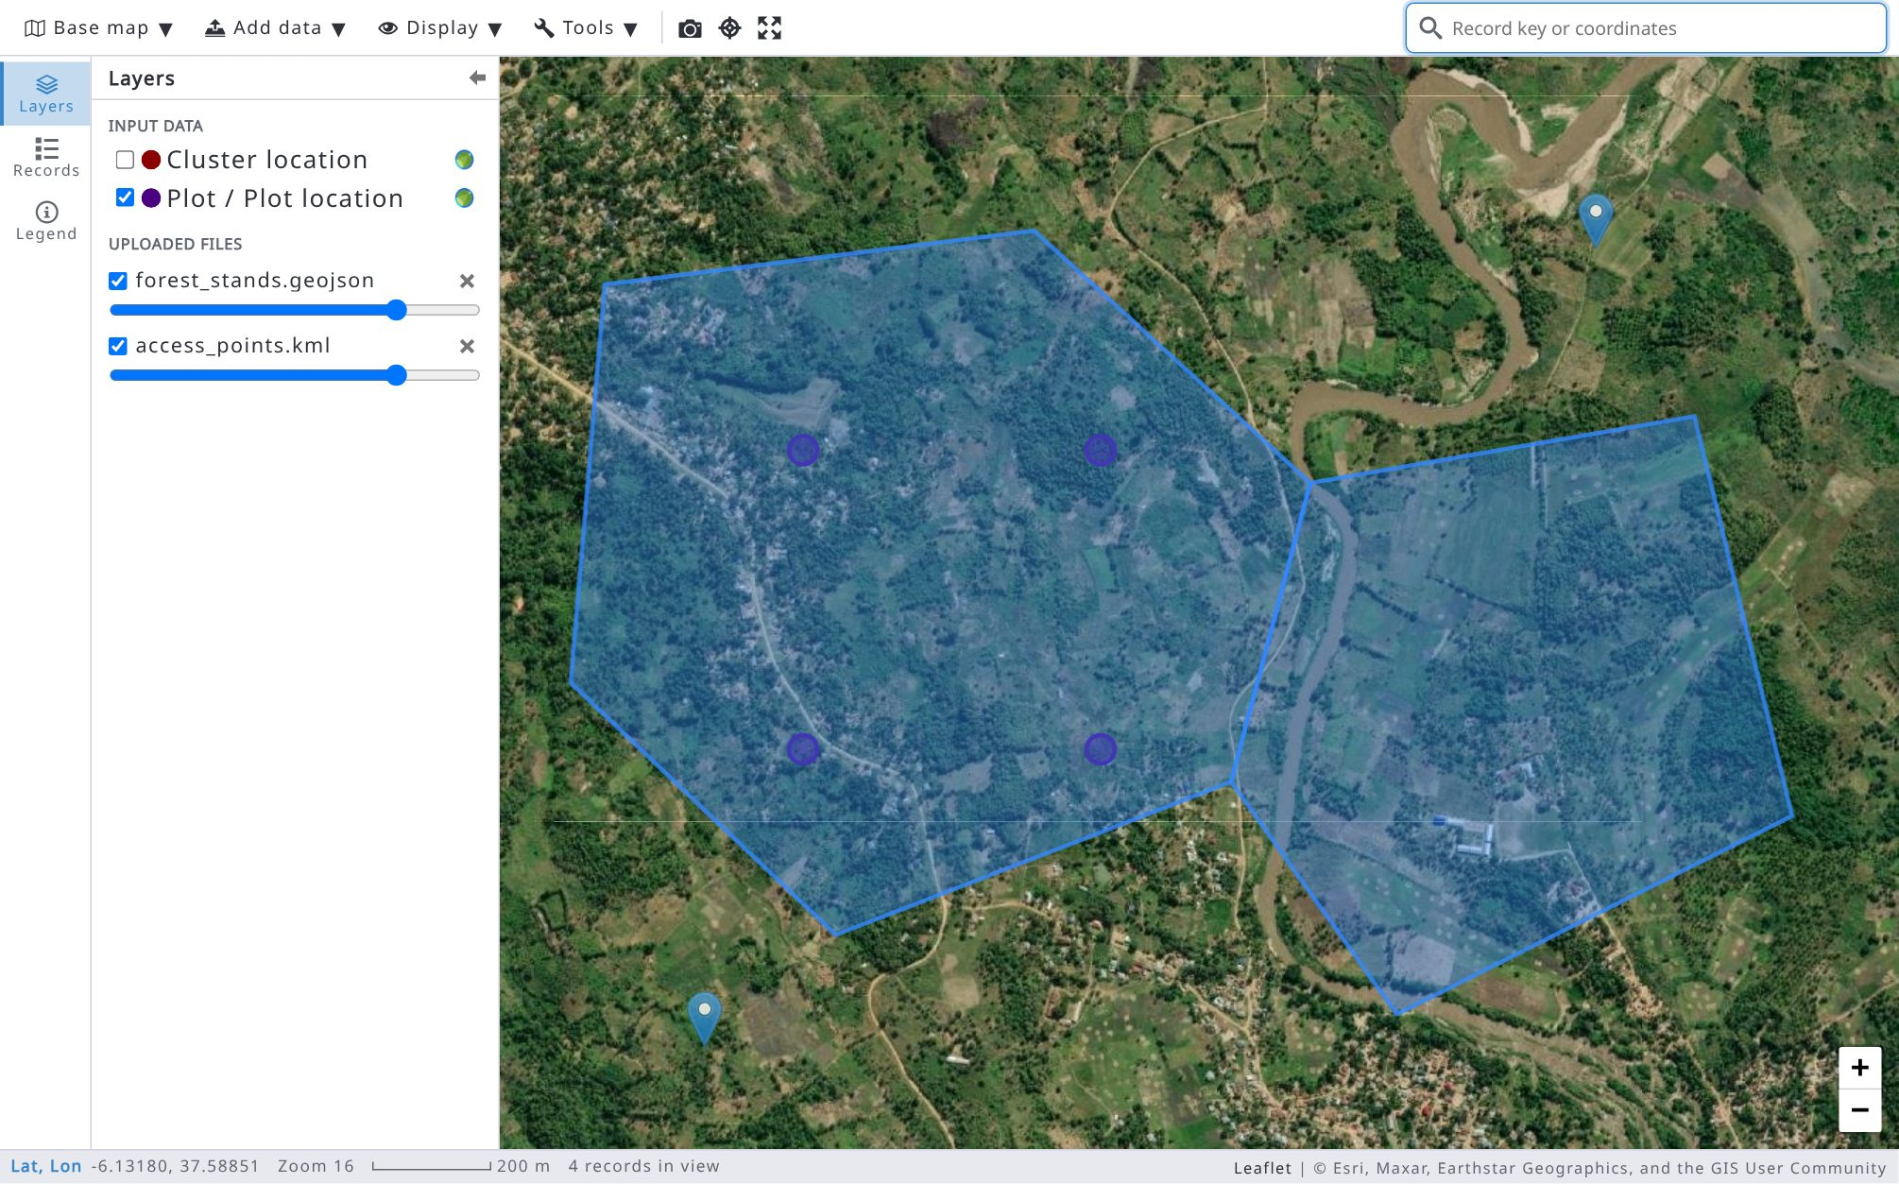
Uploaded files are listed in the Uploaded files group of the Layers tab: use the checkbox to show or hide a file, the slider below it to change its opacity and the × button to remove it. You can also upload several files into the Arena map view, if needed.
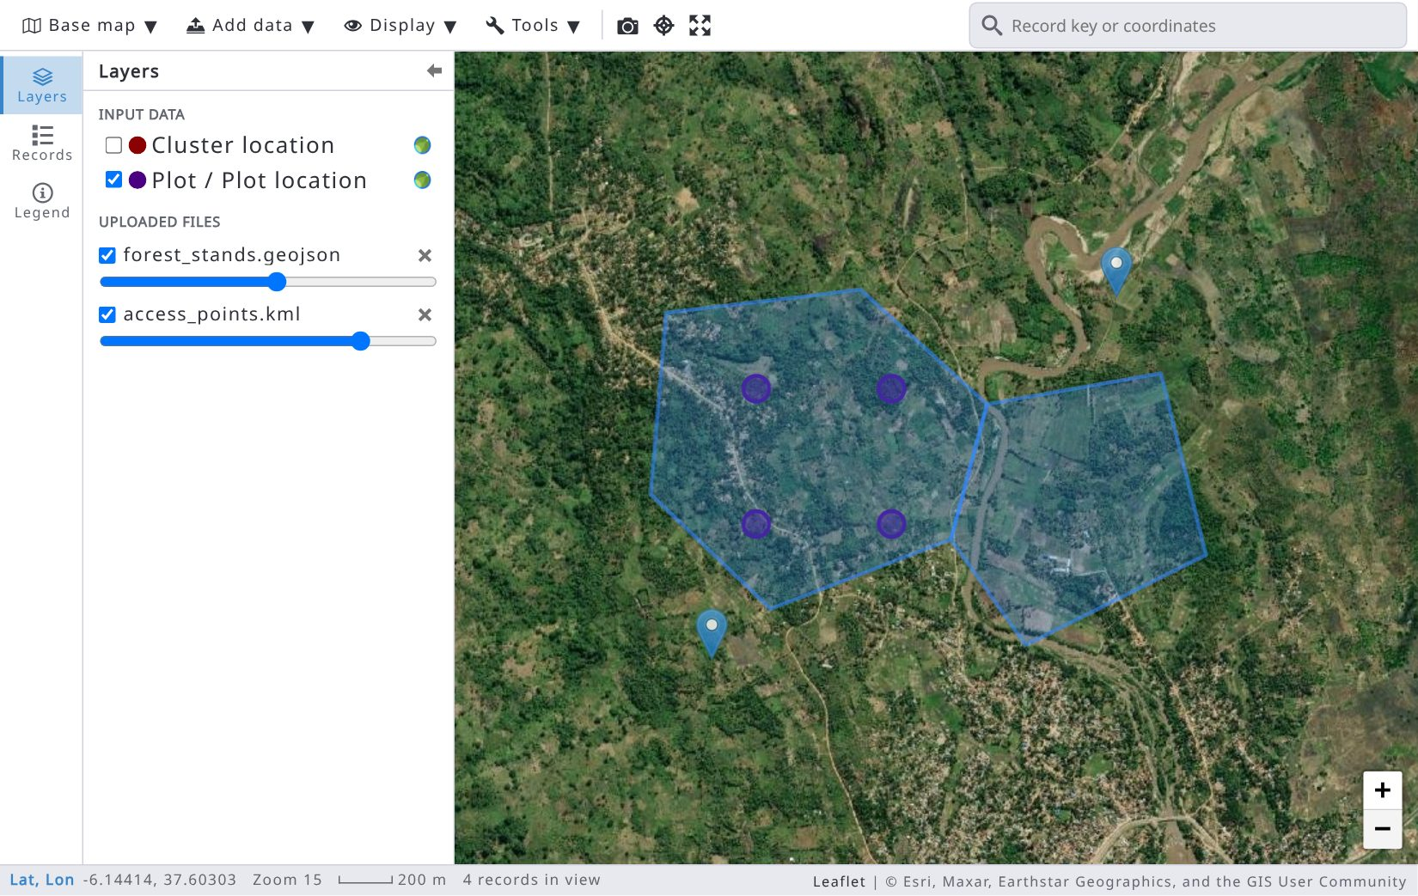
Note: the uploaded files are not stored anywhere. So, if you refresh the web browser window, all uploaded layers disappear. To share a map layer with the other users of the survey, add it as a WMS / WMTS service or XYZ tiles (see 9.7.5).

9.7.5. WMS / WMTS services and XYZ tiles
You can add layers published by map servers, for example national forest cover maps or recent satellite mosaics. Open the Add data menu and choose Add a WMS / WMTS service…:
- Service URL: the GetCapabilities URL of a WMS or WMTS service, or an XYZ tile template containing {z}/{x}/{y} (e.g., https://tiles.example.org/forest-cover/{z}/{x}/{y}.png). Click Load layers: for a WMS / WMTS service, select the layers to add in the list (only layers available in Web Mercator can be added); an XYZ template needs no capabilities;
- Add as: Overlay layer (shown over the base map, listed in the Layers tab, group Custom (WMS / WMTS)) or Base map (replaces the base map, listed in the Base map menu);
- Display name, Image format (PNG transparent or JPEG, when the service offers both), Opacity and Attribution;
- Who sees it: Everyone in this survey (the layer is saved in the survey and shown on the map of all its users; available to users who can edit the survey) or Only me (saved for you only).
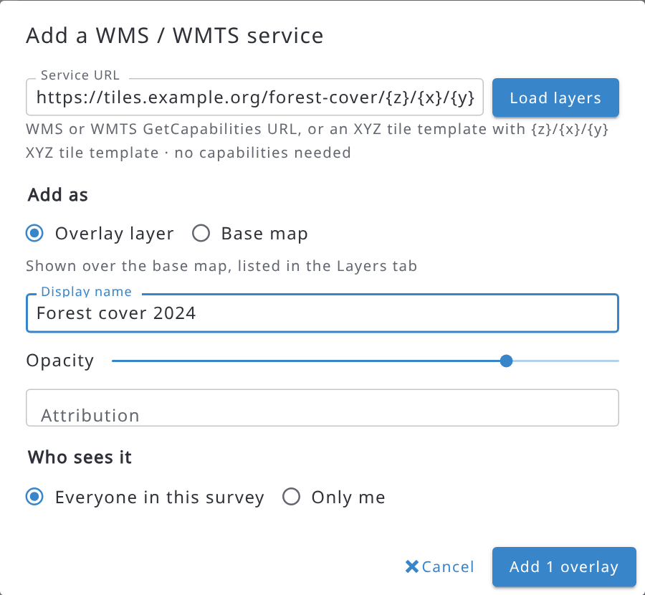
Click Add 1 overlay (or Add 1 base map). Unlike uploaded files, these layers are kept when you reopen the map. To remove an overlay, click the × button next to it in the Layers tab; to remove a custom base map, select it and use Remove selected custom base map in the Base map menu. Only users who can edit the survey can remove the layers shared with everyone: for other users the layer is hidden until the map is reopened.
Note: services that use http (not https) may be blocked by the browser.

9.7.6. Measuring distances and areas
Open the Tools menu and choose Measure distance or Measure area:
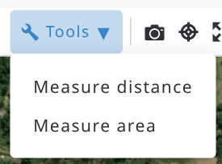
Click on the map to add points and double-click to finish. The measure bar at the top of the map shows the total distance (or the area and the perimeter); you can switch between Distance and Area and choose the Units (Automatic, meters, kilometers, square meters, hectares or square kilometers). Click Done (or press Esc) to end the measurement.
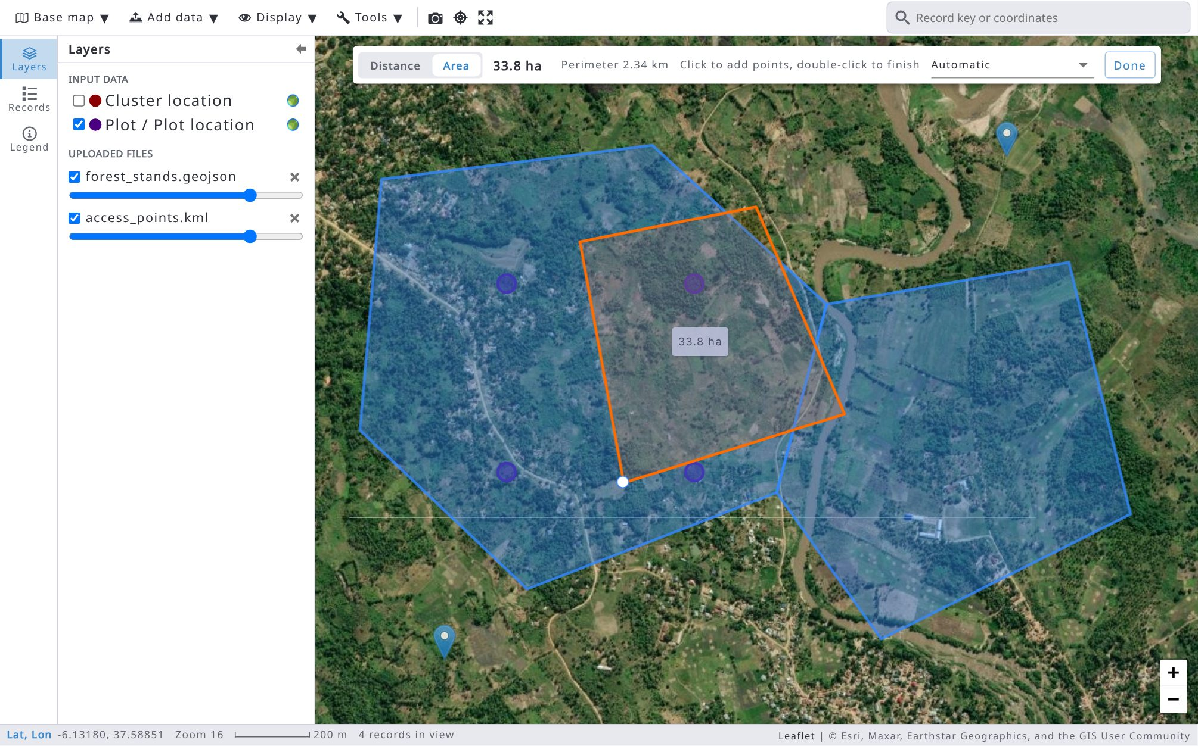

9.7.7. Map screenshots
Click the Screenshot button (camera icon) in the top bar to save an image of the map. The Map screenshot dialog shows a preview and the following options:
- Capture: Current view or Fit to plot (the map centred on the selected plot);
- Include: Markers and measurements, Scale bar and north arrow, and a stamp with Plot, date, coordinates, base map;
- Save to: Attach to a plot record (the image is saved in an image attribute of the plot: choose the Plot record, the Image attribute and the File name) or Download only (PNG file on this computer).
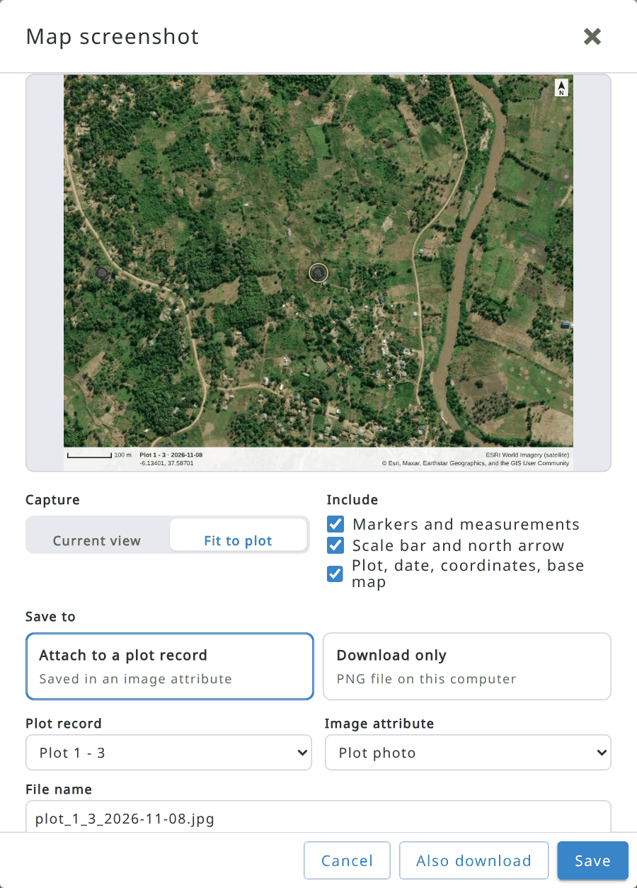
Click Save (or Also download to save it in the record and download it too). Images saved in a record are available to the field teams in Arena Mobile once they download the record. Only the image attributes of the plot that you can edit are listed. Base map tiles whose server does not allow it are left out of the screenshot.

9.7.8. Areas of interest on the map
The areas of interest defined in Survey info, Map tab (GeoJSON polygons used, for example, by the expression functions geoDistanceToAOIBoundary and geoAOIContaining) are available as layers in Data > Map, in the Areas of interest group of the Layers tab. Check an area to show it on the map, e.g., to see which plots fall inside it.
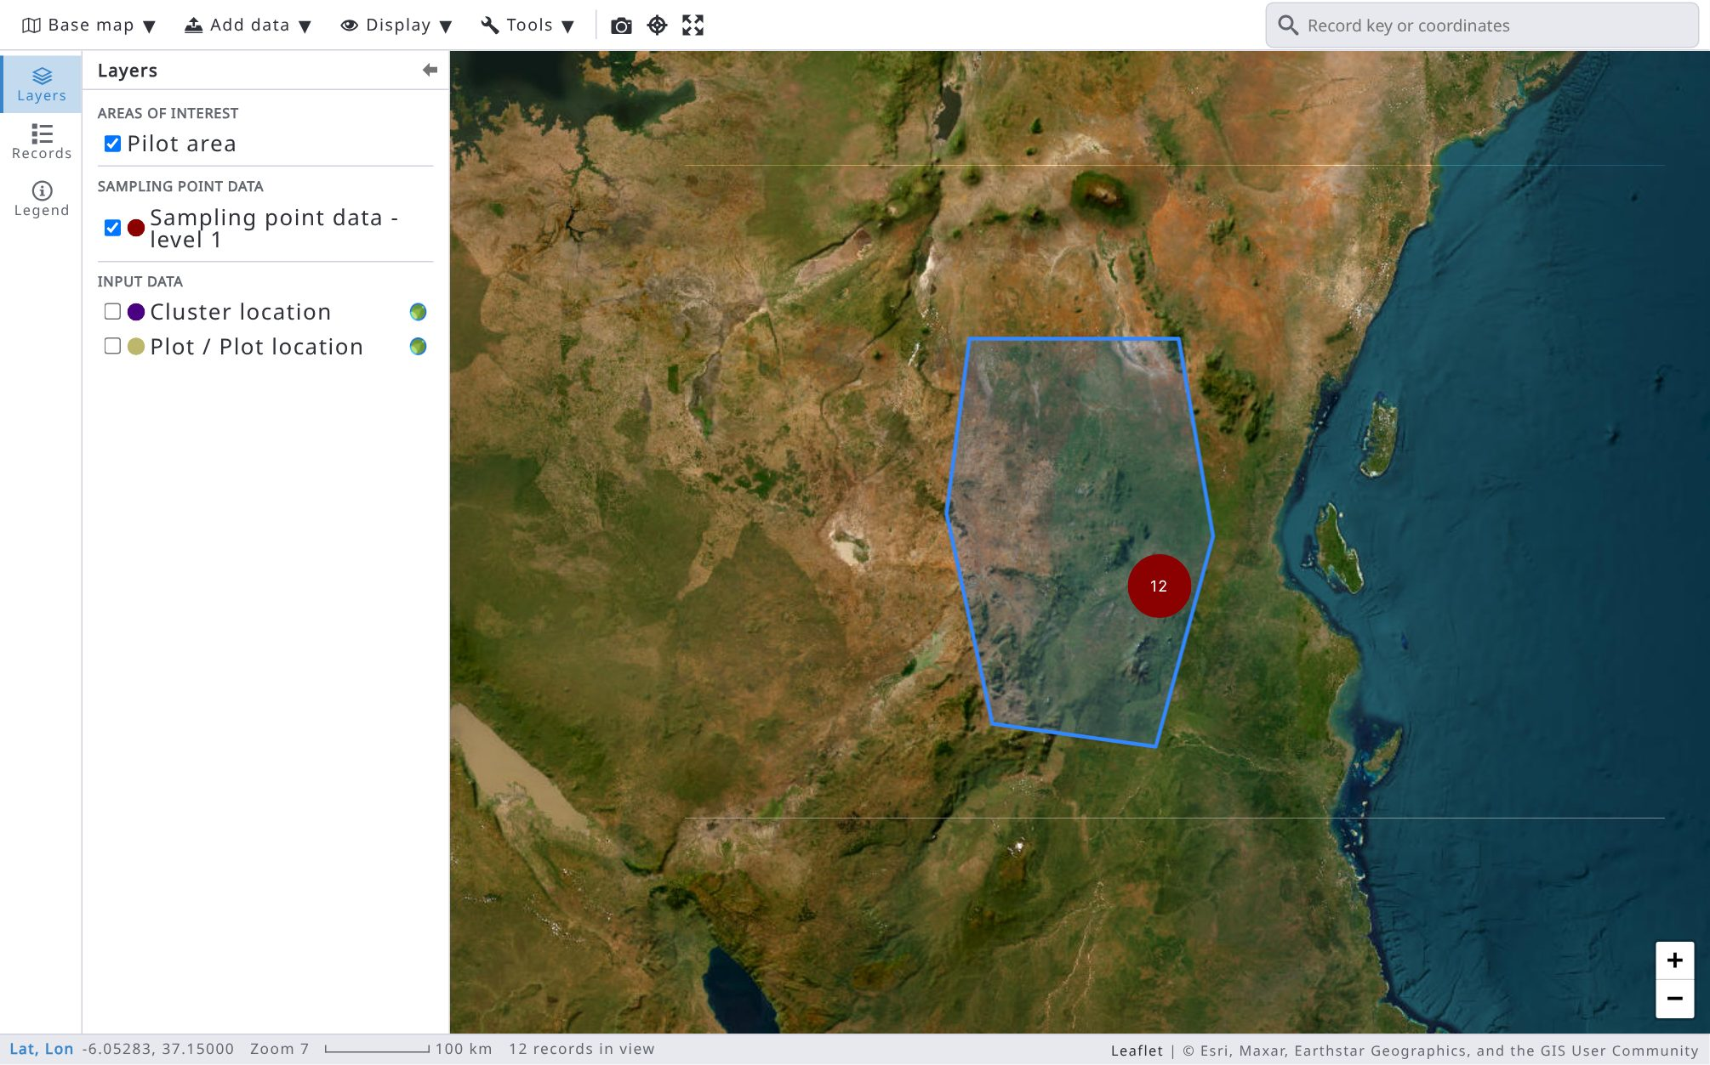

9.8. Data export
Data of the current survey can be exported into a zip file that contains several CSV or Excel files. In the case of multicycle data, the selected cycle’s data will be exported or there is an option to export all data.
The zip file contains all attributes grouped by entities. In the left side menu, select Data > Data Export. There are the following options for exporting data.
Options marked with an asterisk (*) are not compatible with data import: files exported with them cannot be imported back into Arena. Include result variables is shown only to users who can use the analysis, Include data from all cycles only in multi-cycle surveys and Include internal UUIDs only to system administrators.
You can also export data from Data Explorer (see 9.6.3) and the selected or filtered records from the records list.
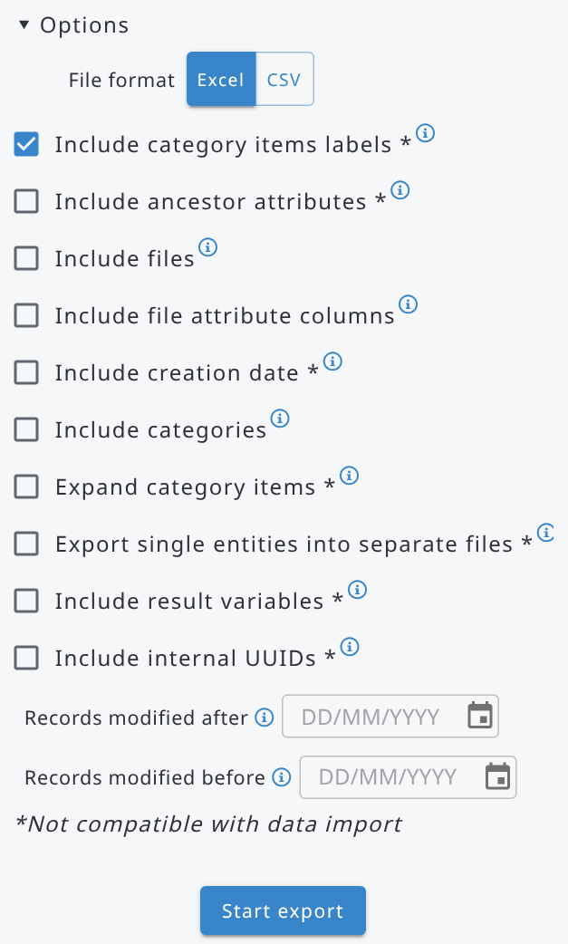 | Options:  File format: Excel (.xlsx) / CSV (.csv)  - Include category items labels: for categorical data, export both code and label (2 columns).  - Include ancestor attributes: include the attributes of the parent entities, up to the root entity.  - Include files: include all files (e.g. images, documents) in a subfolder called "files".  - Include file attribute columns: add the file identifier and file name columns of file attributes.  - Include creation date: add the creation date of every entity (row) in a column called "date_created".  - Include categories: export the categories into a subfolder called "categories".  - Expand category items: add a Boolean column for every category item.  - Export single entities into separate files: otherwise their attributes are included in the nearest multiple ancestor entity.  - Include result variables: include the computed result variables from RStudio processing.  - Include data from all cycles: in a multi-cycle survey, export the data of all cycles.  - Include internal UUIDs: add the internal (database) identifiers in columns ending with "_uuid".  - Records modified after / Records modified before: export only the records modified after and/or before the given dates.

The next image shows an exported file containing forest inventory data.
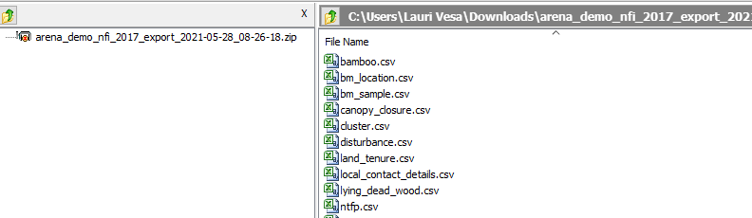
The first column in each table is showing the cycle (‘record_cycle’).
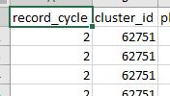

9.9. Data import
Always before using data import in Arena, take a backup of your survey with data. Read more here.
Arena can import external data from
- CSV or Excel files;
- Open Foris Collect / Collect Mobile files;
- Arena (backup) / Arena Mobile (export) files;
A survey should be published before a data import is possible.
If you are adding new information into the database using CSV or Excel files, import your data by following a top-down method! In the case of the survey structure described in the next chapter, first enter CLUSTER data as new records, then PLOT data with "update existing records", and then similarly "Reference objects", and so on. Data import template files are numbered to make data importing a bit easier.

9.9.1. Importing data from CSV or Excel file
Data to be imported must be provided as a .CSV (in Unicode, UTF-8; column separator is comma) or Excel file (.xlsx). Each file to be imported can contain data of one entity (or multiple attribute). In Excel files, cells with formulas, rich text or hyperlinks are read as plain values (the result of the formula, the text of the cell). The data import contains several steps.
STEP 1. Select the cycle
In case of a multicycle survey, the user has to select the target cycle (read more about cycles here).
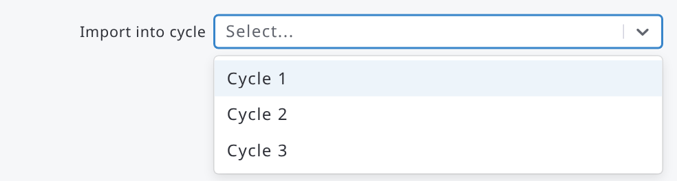

STEP 2. Select Import Type gives two options as follows:
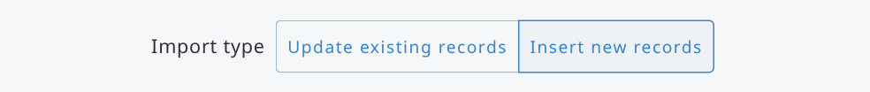

- Update existing records: select this method if the records are already entered and you can see them in the records list (Data → Records), but you need to add missing data under the root entity, or you need to update existing data.
- Insert new records: select this method if the survey is blank (i.e., no records yet), or the records to be imported are all new ones. Only the root level data can be imported as new records. All imported new records go into the Entry stage level.
For example, in the following survey "CLUSTER" is the root level entity, and a file to be imported should contain "cluster data" only.
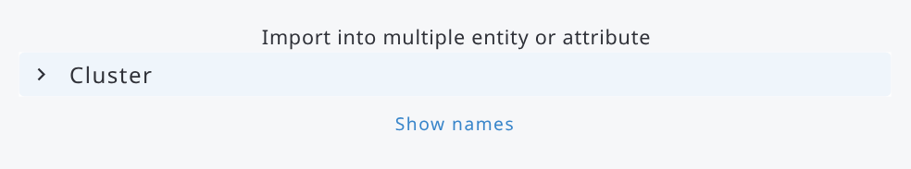
STEP 3. Select entity
Select the target entity (or multiple attribute) to be updated from the hierarchy view under Import into multiple entity or attribute, by clicking on its name. With Insert new records, the root entity is selected automatically.
Click the link below the hierarchy view (Show names, Show labels and names, Show labels) to switch between labels, names, or labels and names:
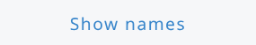 (Default view) 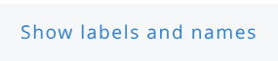 
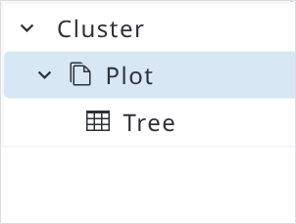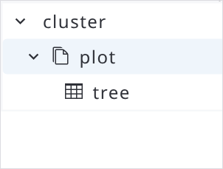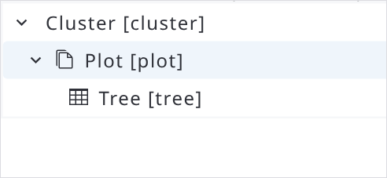

With Update existing records, click Options to show the following options:
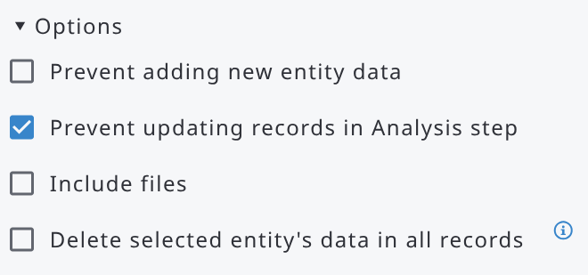 | 1) Allow/Prevent adding new entities, such as new sample plots into the database. [default: Allow]  2) Allow/Prevent updating records that are locked (i.e. in the Analysis stage). [default: Prevent] 3) Include files: import a .zip archive with the data file and the associated files (see Step 4b). 4) Delete selected entity's data in all records: all the instances of the selected entity, and their descendants, are deleted in all records before the new ones are inserted. Options 3 and 4 are available to system administrators only; option 4 is not available for the root entity.

STEP 4a. Select file
Click on this box to select a file to be imported, or drag and drop a file here:
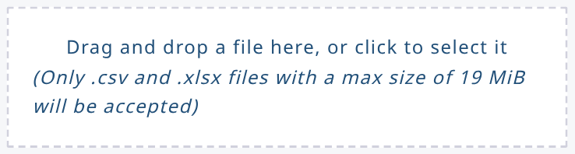
It is recommended to use the data import (CSV/Excel) templates. Select the entity in the hierarchy view, then click Download template and choose CSV or Excel. Download all templates gets the templates of all the entities in a single file. Do not add other columns: for example, the label columns (e.g. land_use_label) of a data export are reported as invalid columns.
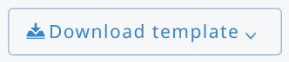
See in the next table information about data types to be imported:
Data type | Format
Numeric | Decimal separator is dot (.), for example 3.356
Integer
Text | CSV: A text that contains a comma should be in double quotes. E.g. "The plot falls into a lake, not accessed"
Boolean | true/false or 1/0
Categorical, Taxon | code (these are read in as texts). For key taxon attributes only the code column is required; the scientific and vernacular name columns are optional.  Note: a vernacular name is always imported, if that is given in the input file.
Date | YYYY-MM-DD, YYYY/MM/DD, YYYY.MM.DD, DD/MM/YYYY, DD.MM.YYYY, DD-MM-YYYY (e.g. 2025-03-20 or 20/03/2025)
Time | HH:MM (e.g. 10:35)
Coordinates | Use three columns:  -attribute_name_srs: EPSG:CODE, for example EPSG:4326,  or just an EPSG number  -attribute_name_x: numeric  -attribute_name_y: numeric
File | Use only one column:  - attribute_name_file_name: the file name of the associated file (e.g. photo.jpg), exactly matching a file provided in the “files” subfolder inside the archive uploaded in Step 5 below. Leave the cell blank if no file applies to that record.
Multiple entry attributes | Import these as separate CSV/Excel tables, after importing the parent entity table
After selecting a file, the file can be validated in order to detect possible incompatibles with the target entity in the survey. The validation process only checks that the file contains valid data according to the data type of each attribute. Hence, this validation will not for example check that a numeric value is matching the (input) validation rule set for an attribute.
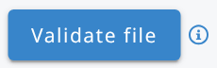
STEP 4b. Upload the associated files
If the entity being imported contains one or more file-type attributes (for example, a photo attached to a plot or tree record), the actual files are not embedded in the CSV/Excel file; the data file only carries the file name in the corresponding column, as shown in the Data Type table above.
To bring the files themselves into Arena together with the tabular data:
- Prepare a folder where you will put both the data file in tabular format (CSV/Excel file) and all the files referenced in the file-attribute column(s) of your data file;
- Copy the data file (.csv or .xlsx) inside the just prepared folder;
- Copy all the files referenced in the file-attribute column(s) of your CSV/Excel file into a subfolder called “files”; file names inside the archive must match exactly the file names listed in the CSV/Excel file (case-sensitive);
- Compress all the content of the folder (not the folder itself, but its content, that is the data file and the “files” subfolder) into a single .zip archive.
- In the import wizard, choose Update existing records, open Options and select Include files (system administrators only), then use the file upload box to select or drag and drop this .zip archive.

Arena stores each uploaded file against the correct record and file attribute automatically.
Previously imported files are replaced accordingly.
Tip
Keep the total size of the .zip archive and of each individual file within Arena's general upload limits.
For large photo sets, consider splitting the import into smaller batches by entity or by cycle.

Step 4c. Validate
After selecting the file, click Validate to detect possible incompatibilities with the target entity in the survey. The validation process checks that the file contains valid data according to the data type of each attribute, including, for file attributes, that every referenced file name is present in the uploaded archive.
It does not check, for example, that a numeric value satisfies the input validation rule set for that attribute.
When the validation finds errors, they are listed with the row number of the file and the error message. Click Export to download the list of errors.
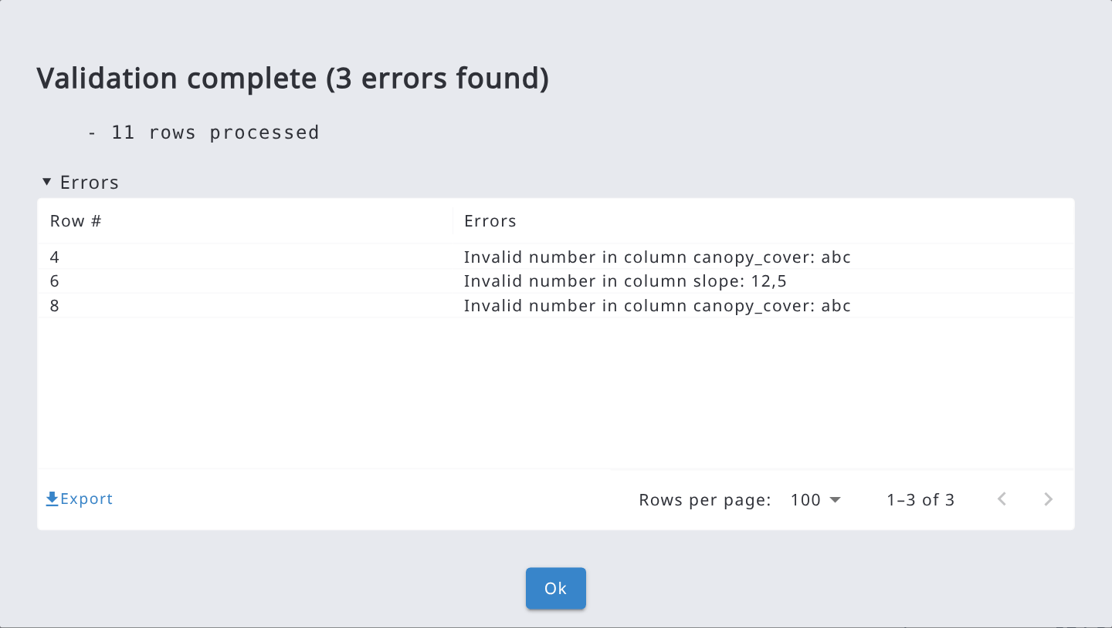

STEP 5. Start import
Click on the 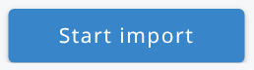 button.
Confirm with Ok: the import cannot be rolled back. A progress bar shows the rows being processed, with the elapsed and remaining time; click Details to see the progress of each step.
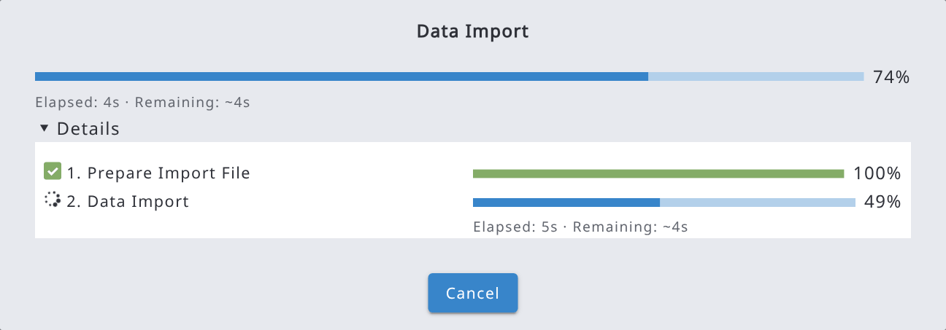
When the import is complete, a summary shows the number of rows processed, records created and updated, entities created and deleted and values updated. If the import completes with errors, the errors are listed in the same way as in the validation, and they can be exported.
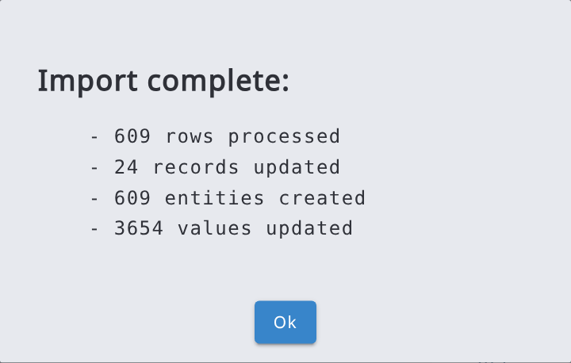

9.9.2. Import data from Collect/Collect Mobile file
Data to be imported must be in .collect-data or .collect-backup format.
If a survey is created in OF Collect, and this survey is imported into Arena and published, data can also be imported into the Arena (later). This enables collection of data using OF Collect Mobile in data collection.
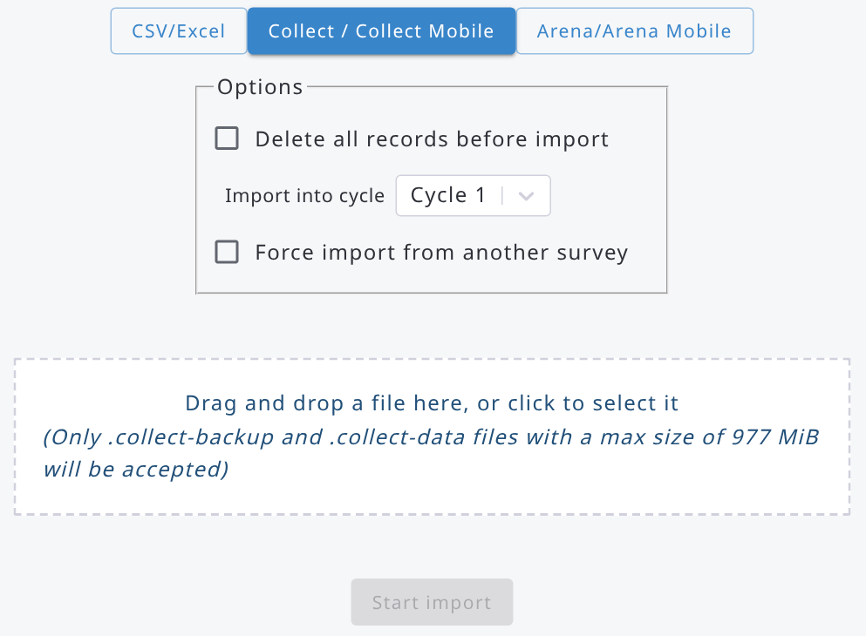

The checkbox "delete all records before import" means that all records (of the selected cycle) in the target survey will be deleted. Be cautious while using this selection!
Selection "Force import from another survey" allows users to import data from a collect-data file, which may have different survey name in Collect than in Arena, but the same schema (i.e. source and target schemas match).

9.9.3. Import data from Arena/Arena Mobile file
Data to be imported must be in .zip format and earlier exported from Arena or Arena Mobile (in Arena: Data → Records, select the records, then Export → Export selected records (Arena format)). The survey structures must match between the target survey and in the file to be imported.
The conflict resolution strategy means that the user needs to decide what to do in a case where the same record, or a record with the same key attributes, is already in the database.
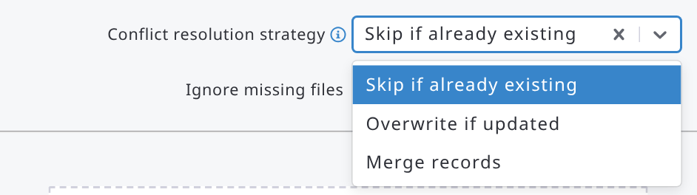
It contains three options:
- Skip if already existing: the record is skipped if it already exists in the database;
- Overwrite if updated: the existing record is overwritten with the imported data, if the imported record was modified more recently;
- Merge records: the data from the imported file will be attached to the existing record (see Merging data). By this means, for example a missing tree (entity) data can be imported into the records.
A record in the file matches an existing record when it has the same UUID or the same key attribute values, also when the keys are codes of large categories or taxonomies: in that case the records are merged (or skipped, or overwritten) instead of being duplicated. Merging records with the same keys but different UUIDs (e.g. records created with different Arena Mobile devices) can be disabled in the survey security settings (see Merging data).
The other options are:
- Ignore missing files: import the records even if some of the files they reference are not in the .zip file. Files already stored on the server do not need to be in the file again: Arena Mobile, for example, does not upload the files that the server already has.
- File upload chunk size: size of the parts in which the file is uploaded; use a smaller size with slow or unstable connections.
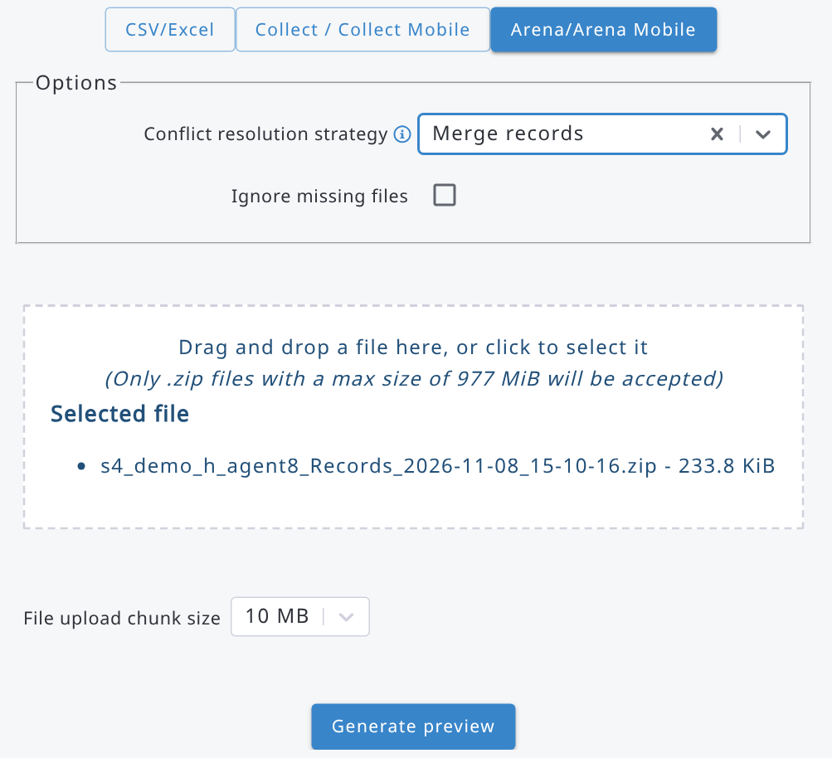
Select the file and click Generate preview. The Import preview shows, for each record in the file, its key attributes, the cycle, whether it already exists, the action that will be applied (Insert, Overwrite, Merge or Skip) and the modification dates of the existing and the imported record. Unselect the records you do not want to import, then click Import selected records and confirm. Records marked as Skip cannot be selected.
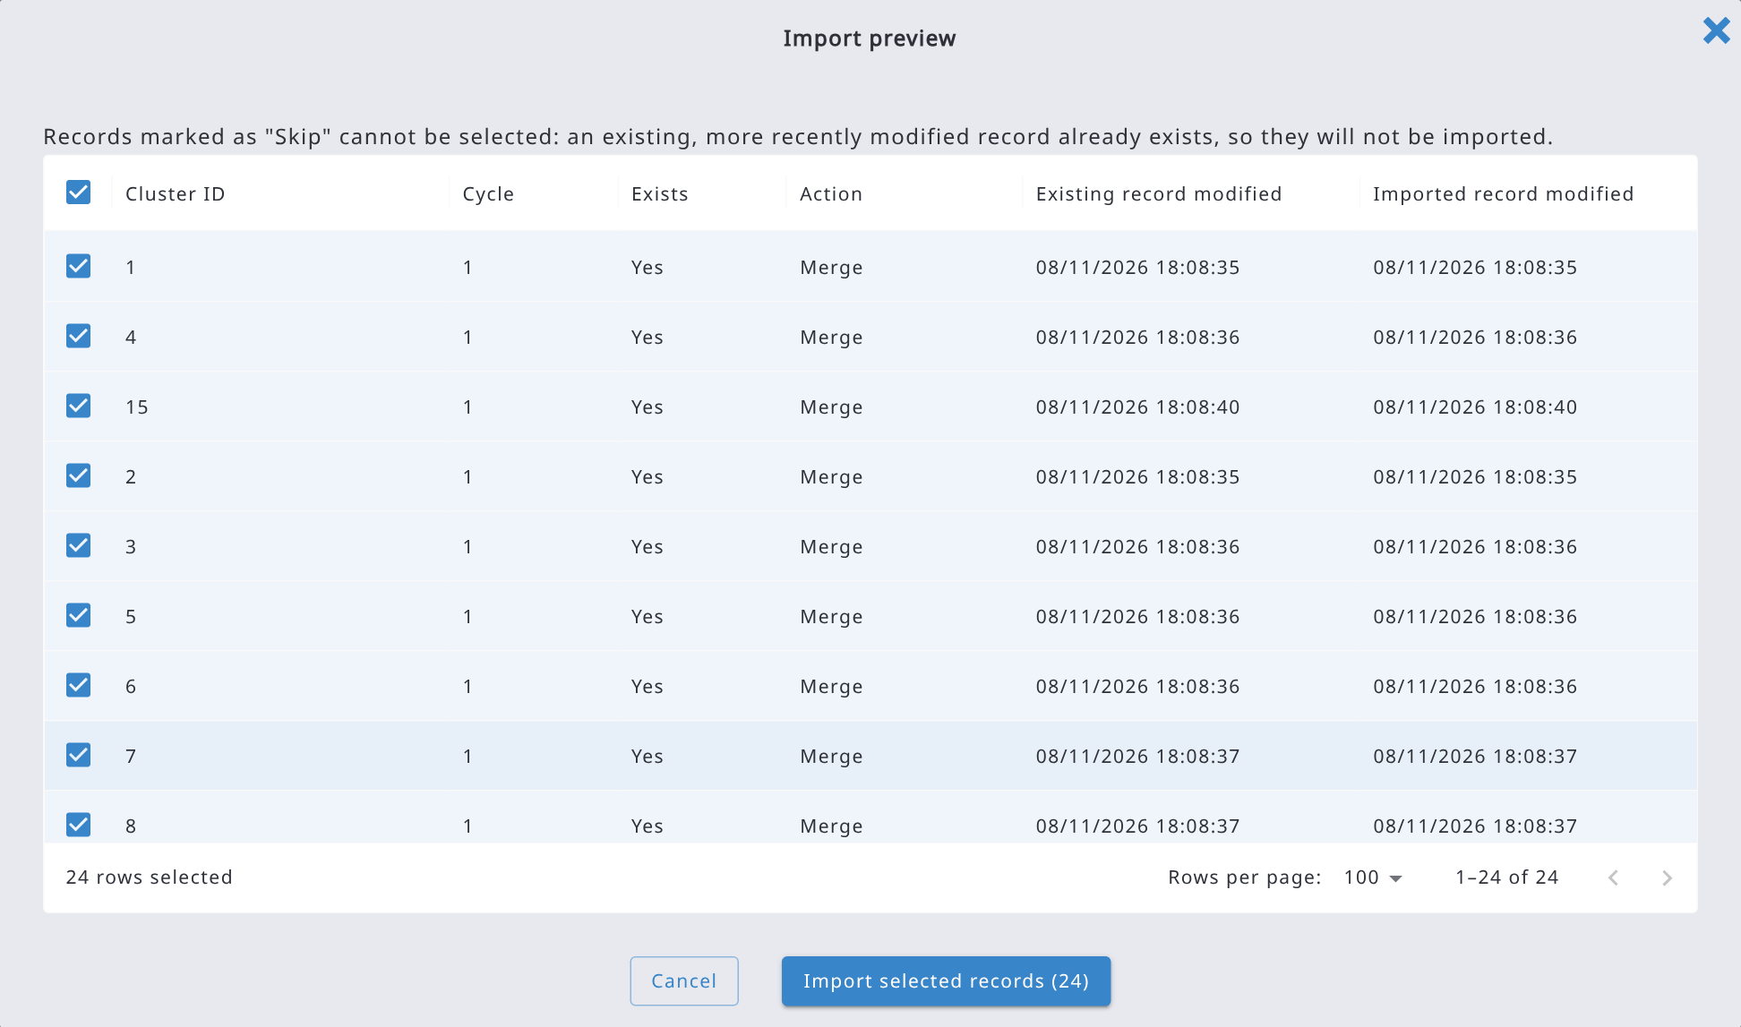
If you cancel the import while it is running, it stops after the record being processed. At the end, a summary shows the number of records processed, created, updated and skipped. Files with large records are imported quickly.

9.10. Validation report
Errors in data can be detected by several means. While editing the data in Data Records, there can be an error message indicating that there is something wrong in the data. However, there is no easy way to find the erroneous data in the Data Records. So, for searching and browsing the erroneous data, we should use the Validation Report tool.
The data validation report is a table that is created by running through all data validation checks in the survey. It is essential to run this report and fix all errors in the data before the data enters the Analysis phase. Note: if your data are already at the Analysis step 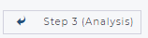, you cannot edit the records. You need to submit the record back to Step 2.
In case of a multi-cycle dataset, the validation is executed for the selected cycle’s data only.
The validation report can look as follows:
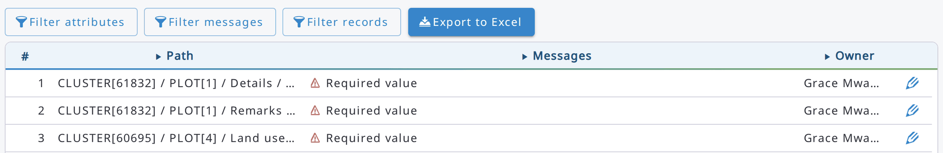
The validation report shows all records that have issues, either ‘Warning’ or ‘Error’. The Error message will be automatically generated, if the custom "Error Message" is left blank in the survey designing phase.
The erroneous records can be directly accessed and edited from the Validation Report view.
Click a row (or its edit icon) to open the record. Click the arrows next to Path, Messages and Owner to sort the report. Use the buttons above the table to show only part of the messages:
- Filter attributes: show only the messages of the selected attributes.
- Filter messages: show only the selected message types (Required value, Invalid value, Duplicate value, Duplicate entity key, Duplicate record key, Node count, Custom validation).
- Filter records: show only the records matching an expression, written in JavaScript syntax as in Data Explorer (see 9.6.1), e.g. cluster_id <= 5.
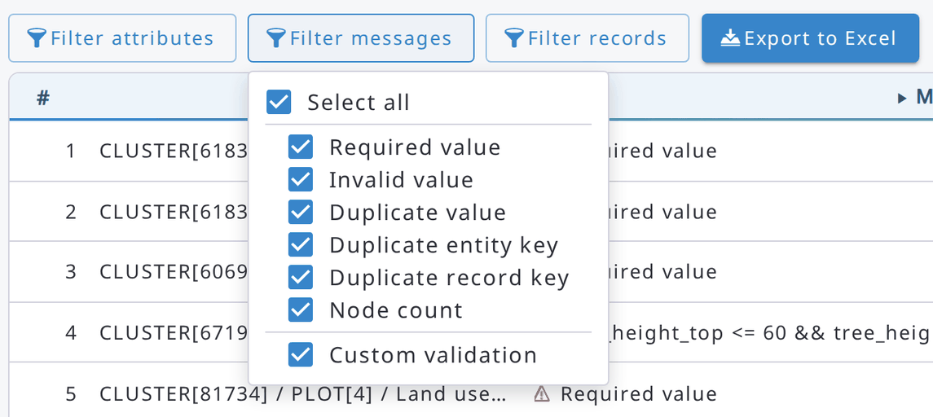
The filters are also applied when exporting the report.
The validation report can be exported into an Excel file by clicking on the 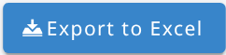button. The report contains more information than the screen view, and it looks in MS Excel as follows.
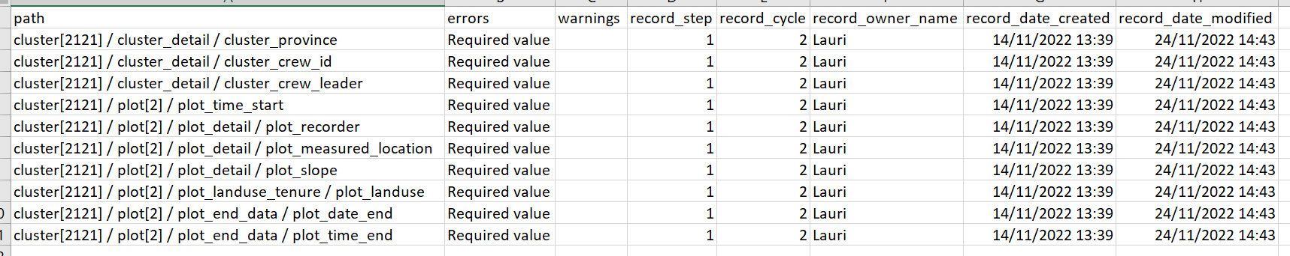

9.11. Merging data
Records can be merged into one. This feature works only when it's applied to 2 records at a time.
Select the 2 records to merge in the records list (Data → Records), then press the Merge button on the top bar.
Merging data can be quite useful when, for example, data on the same site is collected using different devices; Arena and Arena Mobile don't allow creating records with the same identifiers (keys), but to make the data collection in the field faster, users can work on the same site (cluster) with different devices and combine the data later on. (e.g. when you have a survey with a structure cluster -> plot -> tree, users in the same cluster can collect tree data in different sample plots).
The survey must be prepared in a way that makes merging records easier.
During the merge process, the newer record will be considered as "source", while the older one as "target", so that values in the source record will go into the target record.
The merging process goes through every "entity" in the record, starting from the root.
- entities with the same key attribute values will be "merged";
- entities in the source record but not in the target one will be added;
- entities on the target record but not on the source one will be kept;
- attributes with values in the target record will not be replaced by values of the source record;
- empty attributes in the target record will be replaced with the ones in the source record;
A simple way to allow merging records is to start collecting data with one device, then on another device only the key attributes of the entities could be filled, and other attributes can be skipped/left blank. Here is an example of how 2 records will be merged; in this case, the survey has a quite simple structure such as cluster -> plot -> tree; the target record has 1 plot with 2 trees, the source record has a plot with the same ID as the target record and 1 tree with an ID different from the ones of the trees in the target record plot; the expected result is to have the "new" tree inside the target record plot, like this:
Target record | Source record | Merged record
Cluster:  Cluster ID: 1a  Region: R1  District: R1a  Plot [1]:  Plot ID: 1  Tree [1]:  Tree ID: 1  Tree species: S1  Tree [2]:  Tree ID: 2  Tree species: S2 | Cluster:  Cluster ID: 1b  Region:  District:  Plot [1]:  Plot ID: 1  Tree [1]:  Tree ID: 3  Tree species: S3 | Cluster:  Cluster ID: 1a  Region: R1  District: R1a  Plot [1]:  Plot ID: 1  Tree [1]:  Tree ID: 1  Tree species: S1  Tree [2]:  Tree ID: 2  Tree species: S2  Tree [3]:  Tree ID: 3  Tree species: S3
In case the source record contains another plot, with an ID different from the one of the plots already in the target record, also the "new" plot will be added to the target record, like in this example:
Target record | Source record | Merged record
Cluster:  Cluster ID: 1a  Region: R1  District: R1a  Plot [1]:  Plot ID: 1  Tree [1]:  Tree ID: 1  Tree species: S1  Tree [2]:  Tree ID: 2  Tree species: S2 | Cluster:  Cluster ID: 1b  Region:  District:  Plot [1]:  Plot ID: 1  Tree [1]:  Tree ID: 3  Tree species: S3  Plot [2]:  Plot ID: 2  Tree [1]:  Tree ID: 1  Tree species: S2  Tree [2]:  Tree ID: 2  Tree species: S4 | Cluster:  Cluster ID: 1a  Region: R1  District: R1a  Plot [1]:  Plot ID: 1  Tree [1]:  Tree ID: 1  Tree species: S1  Tree [2]:  Tree ID: 2  Tree species: S2  Tree [3]:  Tree ID: 3  Tree species: S3  Plot [2]:  Plot ID: 2  Tree [1]:  Tree ID: 1  Tree species: S2  Tree [2]:  Tree ID: 2  Tree species: S4

Before applying for the merge, a preview of the results will be shown and the user will have to confirm the merge; once confirmed, the "source" record will be deleted and will no longer be accessible, while the target record will be modified, adding value from the source record.
When 2 records have too many differences from each other, a warning message will be shown to the user; in that case, the user could have selected 2 records that are not compatible for the merge.
Merging records with the same keys
Records with the same key attribute values can come from different Arena Mobile devices, or from Arena files imported with the Merge records conflict resolution strategy. When they are uploaded or imported with the merge option, they are merged into the existing record instead of being duplicated (merging follows the rules described above).
This is allowed by default. To prevent it, go to Home → Survey Info → Security, unselect Allow merging records with same keys (e.g. records created in different Arena Mobile devices) and click Save. When the option is not selected, importing a record with the same keys as an existing one stops with an error.
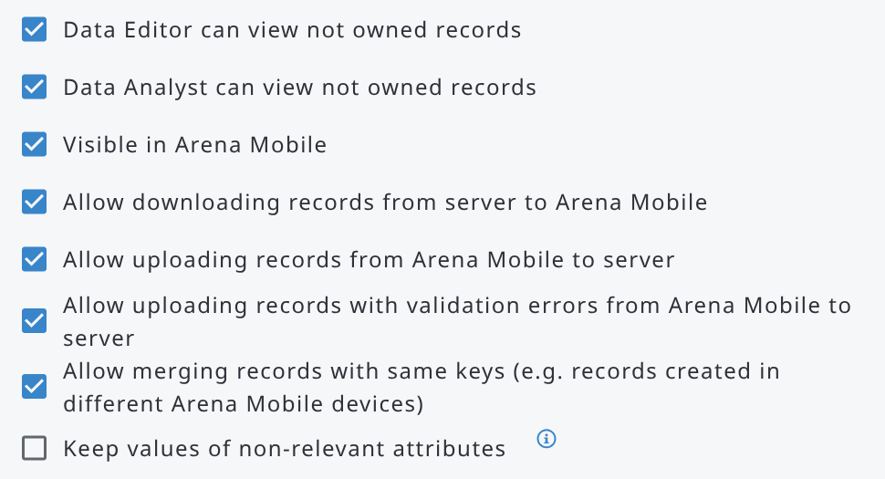

9.12. Creating printable record documents

9.12.1. Exporting a printable document
To export a printable document of a record, follow the next steps:
- Open a record in Data → Records.
- Navigate to the page you want to print. This is only needed when printing the current page.
- Click the PDF icon (Export Document) in the record header bar.
- In the "Export printable document" dialog, select the options and click Download.
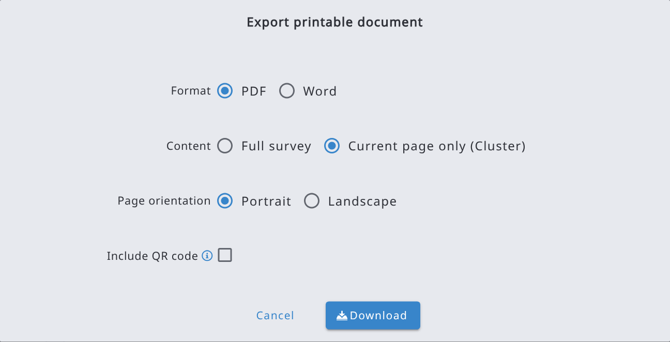
Option | Explanation
Format | PDF or Word (.docx). The Word file can be edited further before printing.
Content | Full survey: the whole record, with the survey label and description as the title. Current page only: only the entity instance currently shown in the form (e.g. the plot or tree you are viewing), with the entity label as the title. Its subpages are not included.
Include QR code | Adds a QR code to the first page. Available only with "Current page only".
Page orientation | Portrait or Landscape. The selection will be the document default. Entities with their own orientation set in the Print tab override it.
The document is generated in the language currently selected in the form's language selector, and for the cycle of the record. The downloaded file is named after the survey, the cycle and, for "Current page only", the entity label.
Note: "Current page only" requires a specific entity instance to be open. If the current page belongs to a multiple entity and no row or form is selected, the dialog shows a message. In that case, navigate to a specific instance or export the full survey.
What is included in the document
- The layout follows the Form Designer. Attributes are placed according to the form grid (columns and positions). Multiple entities displayed as tables are printed as tables. Multiple entities displayed as forms are printed once per instance, each under its own heading.
- Entities on their own page, and multiple entities at the upper levels of the hierarchy, start on a new page.
- Code attributes show the item label. Taxon attributes show the scientific name followed by the code.
- Boolean attributes use the label value set in the attribute (Yes/No or True/False).
- Image file attributes are printed as pictures. Other file types show the file name.
- Attributes set as Hide in entry form, and nodes that are not relevant or not visible in the record, are not printed.
- Calculated result attributes from processing chains are not included.
Example of a printed page (current page only, with QR code):
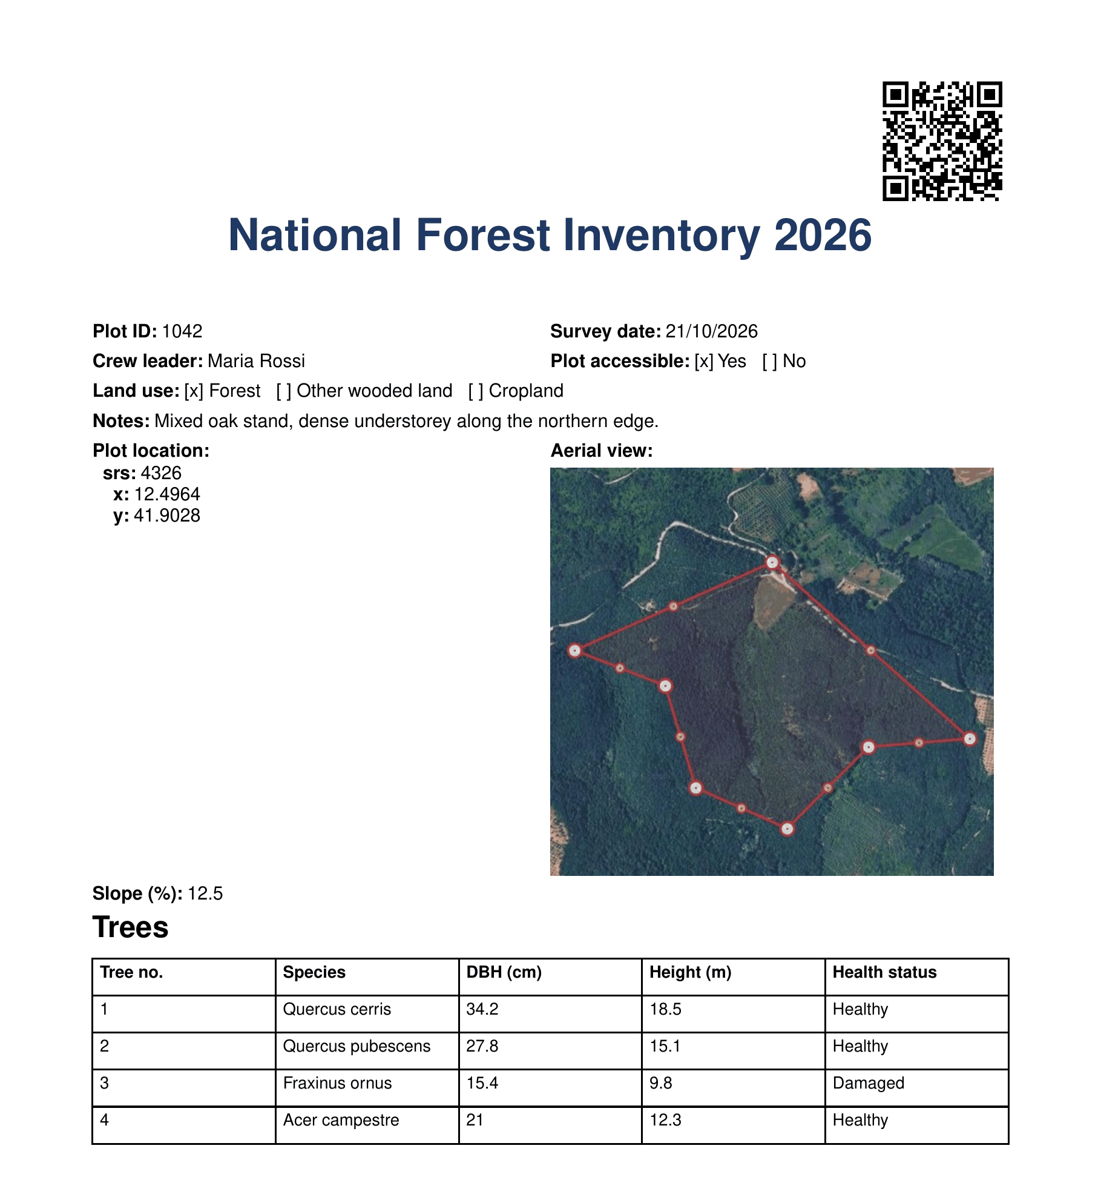

9.12.2. QR code
When the "Include QR code" option is enabled, Arena stores a read-only PDF copy of the exported page on the server and prints a QR code in the top-right corner of the first page. Scanning the QR code with any smartphone opens the stored PDF.
- The link is valid for one year.
- Exporting the same page again with the QR code option updates the stored PDF with the current data and extends the validity by another year. The QR code and its link remain unchanged, ensuring that previously printed copies continue to work.
- The QR link can be accessed without logging in to Arena. Anyone who has the printed document can view that page's data. Therefore, carefully consider whether to use this feature for records containing personal, confidential, or otherwise sensitive information.

10. Analysis

10.1. Creating a processing chain
Data processing in Arena is implemented using R scripts. Each survey has its own set of scripts, which can be created and modified by the Survey Administrator or Data Analyst. The processing can be executed either in a cloud-based RStudio environment or locally using R and RStudio installed on a personal computer, which is the recommended approach.
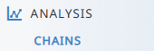
Data processing is carried out through a calculation chain consisting of the result variables to be calculated. Each computation within the chain is referred to in this manual as a calculation step. While a survey can contain several calculation chains, only one chain can be designated for applying the Sampling Design and Statistical Analysis methods.
Advantages of the processing chain
- Automated calculation result attributes (e.g., tree volume, biomass, carbon),
- One script – it is transparent and easy to repeat,
- R provides powerful statistical engine,
- Efficiency and reproducibility of inventory workflows by standardizing processing steps,
- Provides a foundation for reporting and documentation.
The concept of using a data processing chain in sampling-based assessment is illustrated in the following chart.
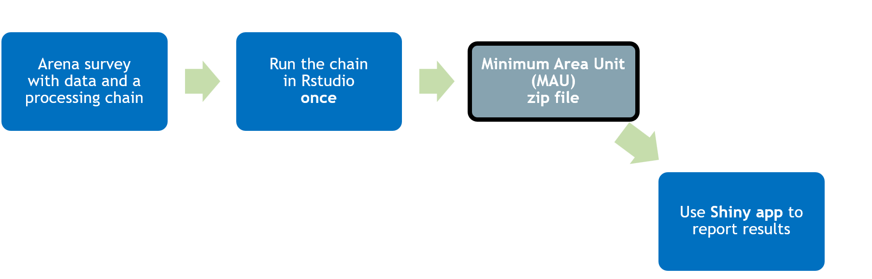

Chains are common across all cycles. If the user needs to apply different data processing rules by cycles, this needs to be taken into account inside the R scripts.
Start creating a new calculation chain by clicking 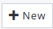 button.
Then give the calculation chain information.
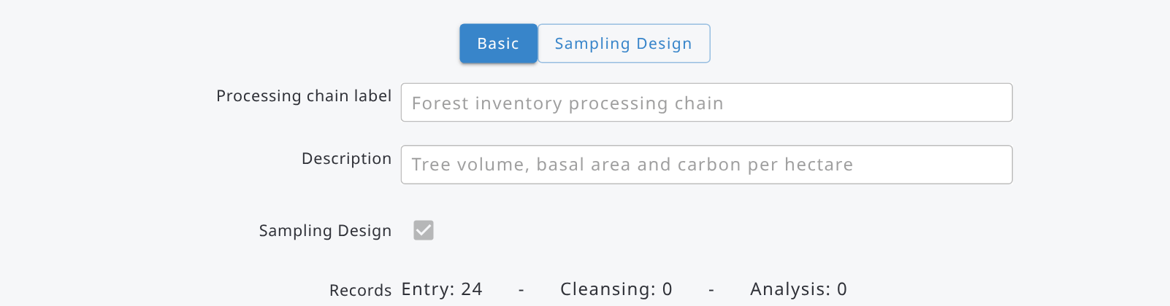
Input fields
- Processing chain label * name for the chain (required),
- Description * descriptive text about the chain (optional),
- Sampling Design * enable if you have sampling-based data (only one chain per survey); the Sampling Design tab is then shown,
- Records * number of records on different steps (of the selected cycle)
By default, the form of an existing processing chain is locked (a chain you have just created stays unlocked). Use these two buttons to unlock/lock the form.
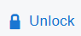 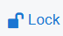

RStudio options (expand the RStudio panel of the Basic tab)
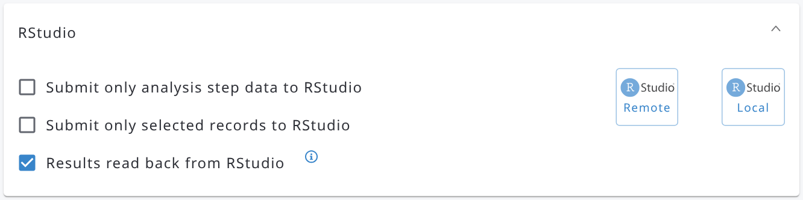 | 1) If enabled, only the analysis stage data will be copied to the RStudio session.  2) Only selected records’ data are submitted to the RStudio session.  3) Enable this option if the result variables are read back into the Arena server from the RStudio session with  [system/persist-results.R]

A chain must contain at least one calculation step, represented by a result variable. You can add either a quantitative (numeric) variable or a categorical (coded) variable.
For example, tree stem volume is a quantitative variable.
First, click the 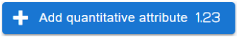button.
Then, select the entity name from the dropdown list.
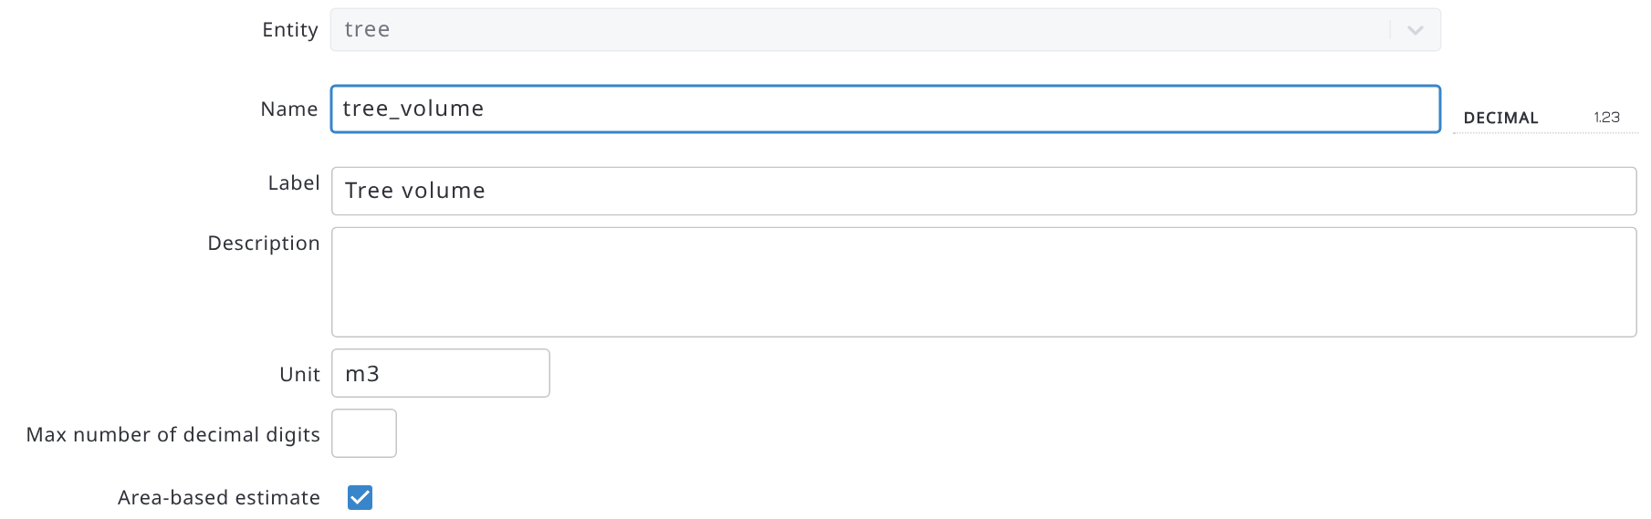
Then fill in the variable’s name, label (optional), unit (optional), and number of decimal digits (optional, used in Data Explorer only). The variable names must be unique in a survey.
Select if you want to compute area-based results for the given variable, such as "volume per hectare" or "number of trees per hectare".
In the Statistical Analysis with a Shiny app, we can only report the area-based variables.

IMPORTANT: Follow these steps while renaming an area-based result variable
1) disable "area-based estimate" and approve to delete the node,
2) rename your result variable, and
3) enable 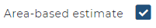back active again

R scripts can only be created and edited in RStudio. In Arena, they can be viewed but not modified. Click Save & Back to return to the previous screen.
You will see the list of results variables as follows.
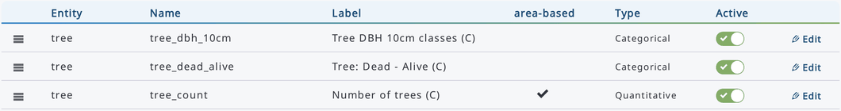
Note 1: In the label text, the suffix (C) means that this is a calculated (chain) attribute.
Note 2: After saving a result variable, its properties can be edited but the parent entity cannot be changed.
Note 3: When you edit an existing result variable, use the arrow buttons at the bottom of the page to move to the previous or next result variable of the chain, Back to return to the chain, and Delete to delete the variable.

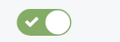ACTIVE/DEACTIVATE variable button: This method allows users to include or exclude a result variable in the data processing in R.
Note: if you have earlier processed your results with an "area-based" result variable that you want to deactivate, the results per hectare ("_ha") will still emerge in the Data Explorer and in the CSV/Excel export data. If you want to remove this "per hectare" attribute, first deselect "area-based estimate" in the attribute’s properties page, and then deactivate that attribute. Then run the analysis chain one more time in RStudio.
Categorical result variables are used for data aggregation and reporting. Click the  button to add a new categorical result variable.
Select the entity, then fill in the name and label (optional). The categorical variable needs to be linked with an existing (flat) category: select it in the Category dropdown list, as in the example below. Next to the list:
- Add creates a new category and links it to the variable,
- Edit opens the selected category,
- Manage opens the list of the categories of the survey.
Then click Save & Back.
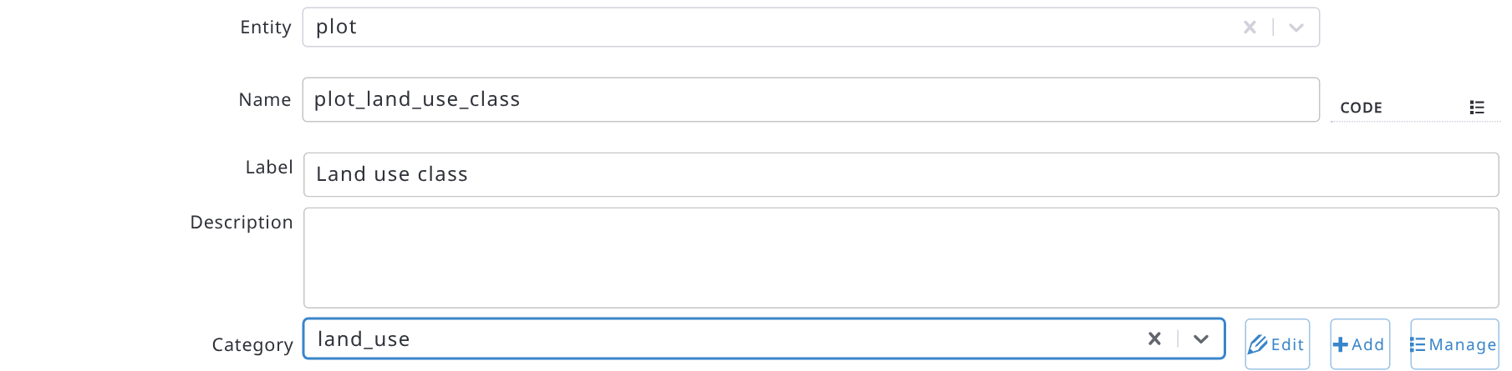
IMPORTANT: When using a computed categorical attribute, ensure that the R script does not return NA values from RStudio to the Arena server, as this may cause issues when reading JSON data. To avoid this, create a default category, such as "No Data" or "Other", and assign all missing values to that category (for example, code 0).
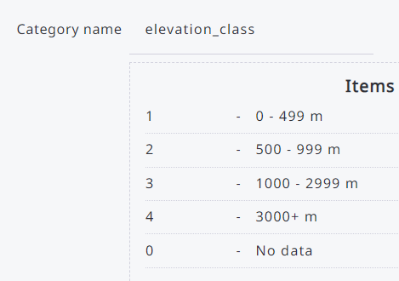 e.g. plot$plot_elevation_class[ is.na( plot$plot_elevation_class)] <- ‘0’

The calculation chain now looks as follows.
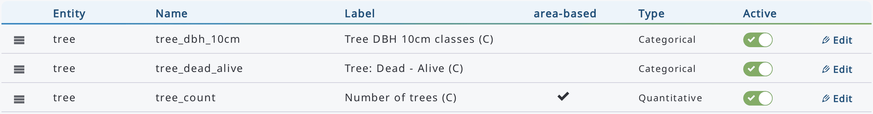
Note: Some computed variables may depend on the results of previous calculations. For example, above-ground biomass must be computed before below-ground biomass. The order of variables can be adjusted by clicking and dragging the handle icon next to the variable name and dropping it in the desired location.
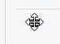
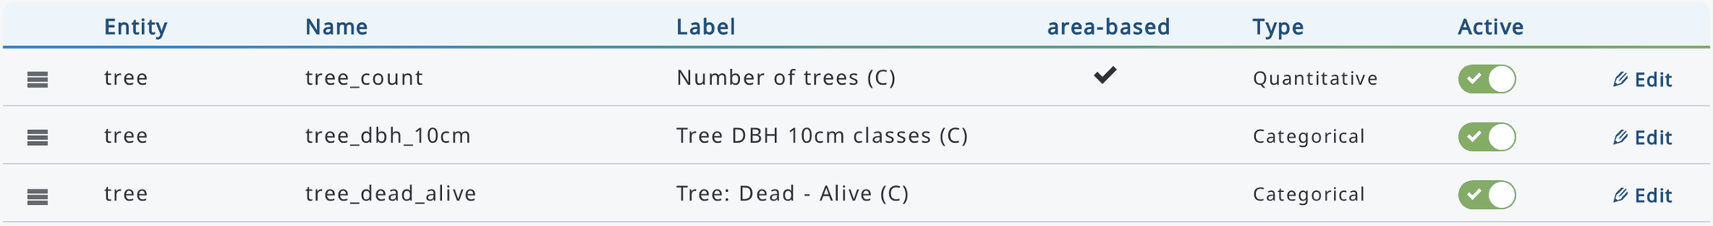
Note: If the window gets "frozen" while moving the variables (as below), refresh your browser.
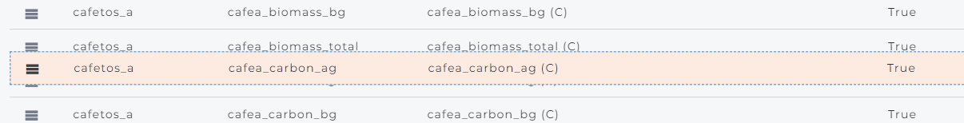
If an entity contains a result variable but no associated data, it will not be included in the processing performed in RStudio. In such cases, a warning icon will be displayed, as shown in the image below.
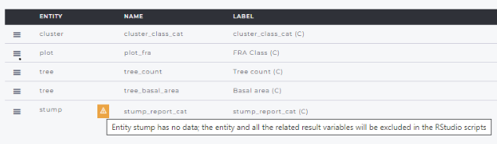
After all result variables have been added, the survey must be published before they can be used.
Click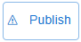.

10.2. RStudio in programming and data processing
R scripts can be created, debugged, and run in RStudio. An overview of the entire processing chain is provided in the following figure.
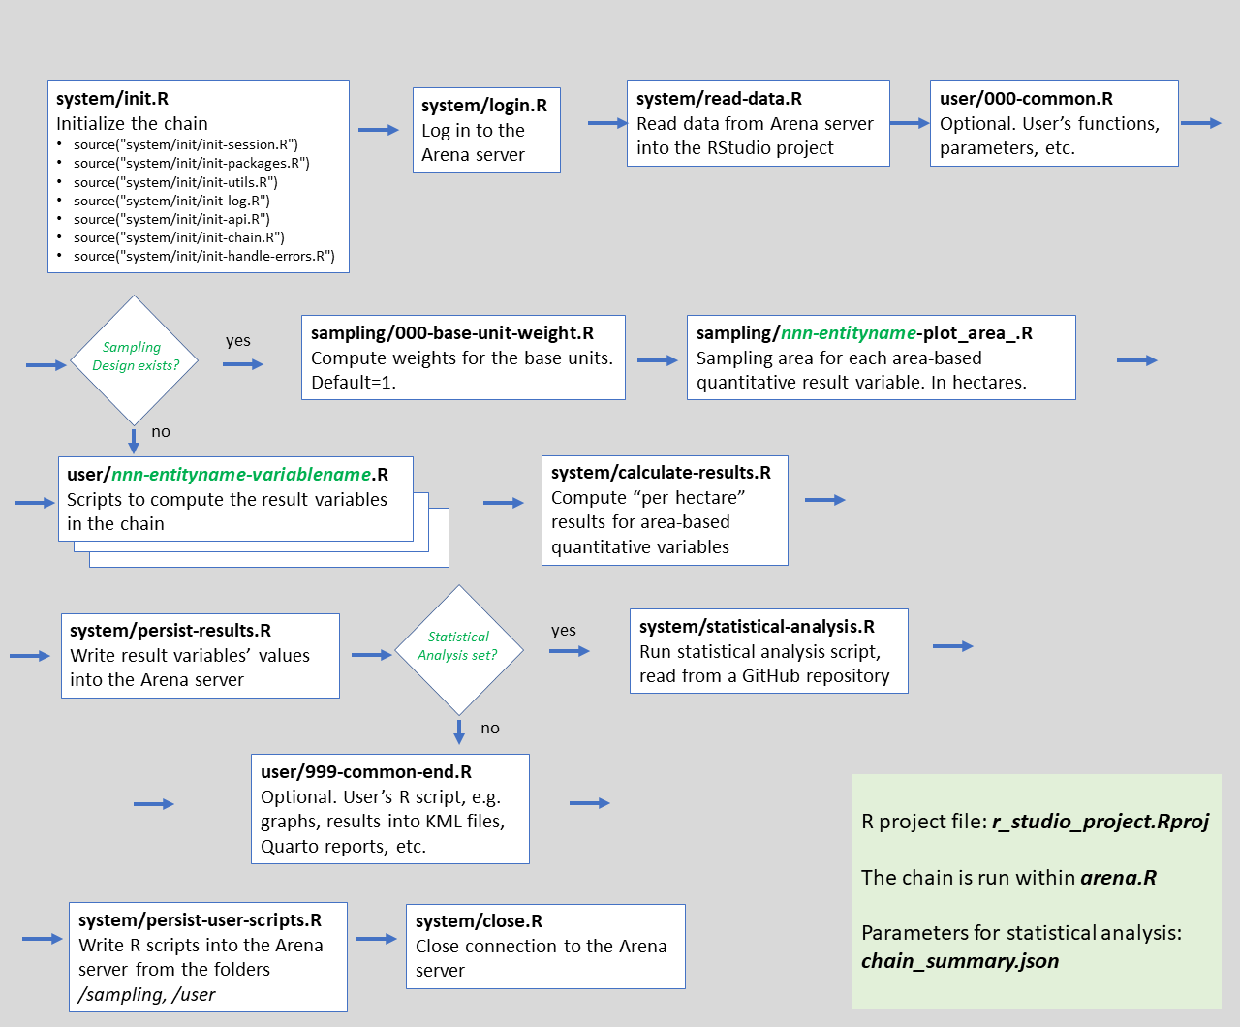

The following two options are available for using RStudio with Arena:
- 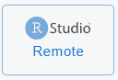Use RStudio Server in the cloud, or
- 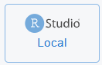 Use locally installed RStudio (in your machine).

To run RStudio locally, ensure that:
- R version 4.1.3 or newer is installed.
- The rstudioapi package is installed.
- An active internet connection is available.
- You start a new RStudio session.

The workflow for both RStudio options is as follows:
- Publish the survey. This step is required whenever changes have been made to the survey structure, survey data, or calculation chain.
- Select whether you want to submit all data or only analysis step data to RStudio.
Note: For multi-cycle surveys, only the data from the currently selected cycle will be submitted to RStudio.

- Click the RStudio Remote (RStudio Server) or RStudio Local button in the RStudio panel to start the process.
Note: The RStudio process cannot be started if no data are available for submission (i.e. all record counts are zero).
- The following message will be displayed. The message differs slightly depending on whether you are using the server-based or local RStudio environment:
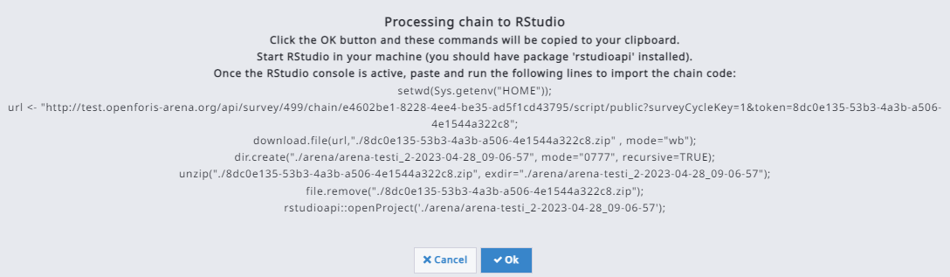
Click OK to continue.
Arena will automatically copy the initialization script to your clipboard .
- RStudio Server: RStudio will open automatically.
Local RStudio: Start RStudio on your computer.

- Paste the copied script into the RStudio Console (Ctrl+V) and execute it. This step uploads all survey scripts from Arena's PostgreSQL database to RStudio.
- In the Files pane, the following structure will be available
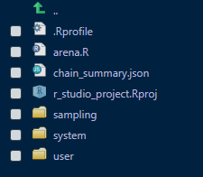
arena.R = Main program file (do not edit!).
system/ = Directory containing system-generated files (do not edit!).
sampling/ = Directory containing scripts for base-unit weights and plot areas (can be edited).
user/ = Directory containing scripts for result variables, one file per variable numbered in chain order, e.g. user/001-tree-tree_volume.R (can be edited).
- The startup script automatically opens the arena.R file. Run the first two lines of the script to initialize the session.
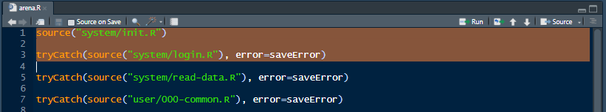
The file system/init.R contains system initialization commands, including database connection and configuration settings. When using RStudio Server, the initialization process installs a large number of R packages required by Arena into the current RStudio session. In Local RStudio, only a small set of essential packages is installed, and only if they are not already available .

The complete list of packages used by Arena can be found in: system/init/init-packages.R

Initialization typically takes a few seconds when a new RStudio session is started. Subsequent executions within the same environment are usually faster because the required packages and settings have already been configured.

If there is this error in the R Console:
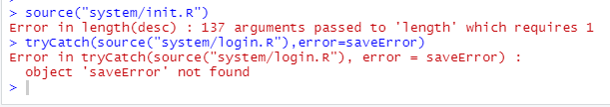
or some package is not loaded, as in the following case
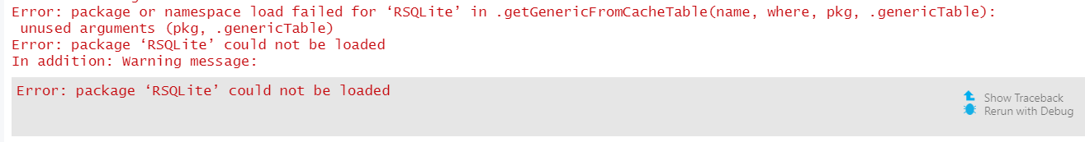
simply run system/init.R again! This error is caused by R or RStudio.

system/login.R displays two input dialogs to authenticate access to the Arena database. First, enter your Arena username (email address), and then enter your password. For security reasons, the password is masked and displayed as asterisks.
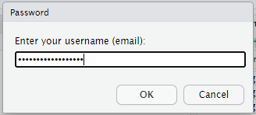
After a successful login, a confirmation message similar to the following will appear in the R Console: "User myusername@x.org successfully logged in"

- Run the third line of the script:.
source('system/read-data.R')
This script initializes the survey data objects as R data frames and downloads the data from Arena. The loaded objects can be viewed in the Environment pane in RStudio.
The following data will be added into the R project:
- Data from all entities included in the calculation chain.
- Data from the Base Unit and Clustering entities.
- All categorical and taxonomic tables, stored as lists of data frames.
- The schema summary table (arena.schemaSummary).
- The chain summary object (arena.chainSummary), which contains information about the structure and content of the calculation chain.
- Once the data have been loaded successfully, open the user/ folder to access the scripts associated with the survey's result variables.
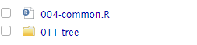
This folder contains the common file for adding R scripts (as functions) that are common for all calculation steps following file 000-common.R
Important: about using R packages
- Whenever possible, load all your required packages in 000-common.R, as this provides a single location for managing package dependencies and simplifies script maintenance.
- Note that RStudio Server runs on a Linux environment. As a result, some R packages that are available on other operating systems may not work on the server.
- When using additional packages, avoid loading them with the library() function. Instead, use the usePackage() function, for example:
usePackage("lmfor")
The usePackage() function checks whether the specified package is already installed. If the package is not available, it is installed automatically. The function is defined in the system file init-packages.R:
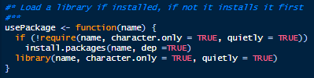
- Since a large number of packages may be loaded during an RStudio session, it is recommended to explicitly qualify function names with their package names to avoid conflicts. For example:
dplyr::select(), dplyr::filter()
This practice improves code readability and helps ensure that the intended function is used when multiple packages provide functions with the same name.

- The scripts located in the user/ and sampling/ folders are the primary files that require user-developed code.

Within the RStudio project, survey data are organized into data frames corresponding to each entity. In addition, two lists of data frames are available: categories and taxonomies.
For example, if the survey includes a code list named land_use, it can be accessed as categories$land_use.
Taxonomic tables may also contain additional attributes, such as species-specific wood density values. Since these attributes are stored as character fields in Arena, they must be converted to numeric data types before being used in calculations.

- Once all scripts have been tested, saved, and executed without errors, run the main program by opening arena.R and clicking the Source button.
This process uploads all updated R scripts and writes the computed results back to the Arena database. If the calculation chain includes Sampling Design and Statistical Analysis settings, the resulting output tables will also be exported as CSV files (see Chapter 10.4.4 for details).
- RStudio Server users: After the processing has completed successfully, close your RStudio session by returning to Arena and selecting the option to terminate the RStudio connection from the main side panel.
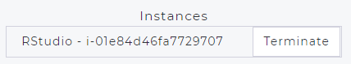
Terminating the connection frees server resources and makes them available to other users of the cloud-based RStudio service.

If RStudio Server does not start
If you encounter an error message like the one shown below in your web browser, it indicates that the RStudio Server instance is currently unable to start.
In such cases, please wait 5 to 10 minutes and try again. This issue may occur when many users are attempting to access the system simultaneously, resulting in limited server resources.
Working with external files (e.g. CSVs and image files)
If you are using RStudio Server and need to create or save files during your session, such as CSV files, images, or other outputs, please refer to Annex 3 for detailed instructions.
Error handling
In arena.R, each module invocation within the processing chain includes an argument for capturing and handling errors, as illustrated in the example below.
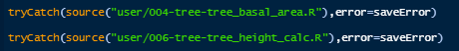
All errors encountered during script execution are collected in a global error log. This log is evaluated by the script system/persist-user-scripts.R when user-developed R scripts are saved back to the Arena server. If any errors are present in the log, execution of the calculation chain is halted and a warning message is displayed in the R Console. All reported errors must be resolved before the chain can be executed successfully.
After fixing the erroneous R code, the error log must be cleared before rerunning the scripts. There are three ways to do this:
- Restart the chain from system/init.R.
This clears the error log automatically. However, the survey data needs to be reloaded from the Arena server into RStudio, which may take considerable time for large datasets.
- Run cleanGlobalErrors() in the R Console.
After clearing the error log, rerun the chain starting from the corrected script or module.
- Add cleanGlobalErrors() to 000-common.R.
By including this command in 000-common.R, the error log will be cleared automatically when you rerun the chain from that point.
Choosing the second or third option is often more efficient, as it avoids reloading data from the server and reduces processing time during script development and testing.
Problems with system/persist-results.R
IIn some cases, computed results cannot be written back to the Arena database. One common cause is the presence of one or more data frame columns that contain only NA values. When this occurs, error messages similar to the examples below may be displayed.
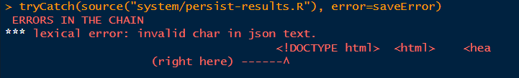
Or the error message is this one:
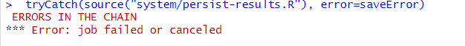
The first step is to inspect the result variables and verify whether any of them contain only NA values. If all result variables appear valid, the issue may originate from the input data retrieved from Arena.
A practical solution is to remove any columns that consist entirely of missing values before rerunning the result persistence process. For example, if the error occurs in the tree data frame, the following command removes all columns whose values are exclusively NA:
tree[sapply(tree, function(x) all(is.na(x)))] <- NULL
After removing the affected columns, rerun the system/persist-results.R script to write the results back to the Arena database.
Viewing updated scripts in Arena
User scripts are saved back to the Arena database by the system/persist-user-scripts.R script.
If an updated script is not immediately visible in the Arena script editor, refresh your web browser to reload the latest version from the database.

10.3. About computing area-based variables
In most forest inventory projects, results are typically reported by area units. In contrast, area-based estimates are generally not required for activities such as interviews and socio-economic surveys.
When you create a result variable and enable the Area-based estimate option, Arena automatically creates a corresponding variable in the database (for example, tree_volume becomes tree_volume_ha).
In Arena, all variables generated by the processing chain can be displayed by enabling .
In the RStudio project, a new sampling folder is created containing additional files used for sampling-based estimation, as described in the following sections.
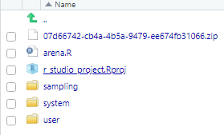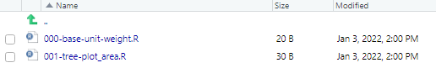
The sampling/ folder contains scripts for calculating base-unit weights and the sampling areas required for area-based result variables.
Depending on the survey design, base-unit weights can be defined in different ways. For example, all sample plots may be assigned equal weights, while inaccessible plots can be assigned a weight of zero and excluded from the estimation process.
All plots get equal weights: Inaccessible plots get no weights:
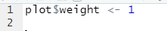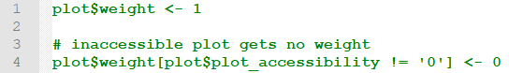
For nested circular sample plots, the sampling area for records in the tree entity can be calculated using the corresponding sampling script.
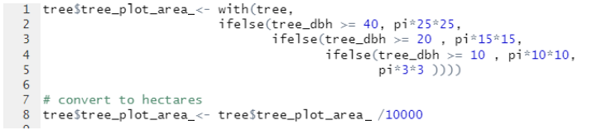
Note: The name of a plot-area variable always includes a prefix derived from the entity name, such as tree_plot_area_ or bamboo_plot_area_.
Arena automatically generates additional code in system/calculate-results.R to convert area-based measurements into per-hectare (or per-acre) results:
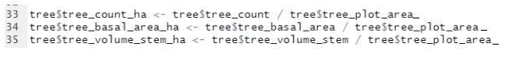
After the full processing chain has been executed successfully in RStudio, all user-developed scripts are saved back to the Arena server. If the “Results Read Back from RStudio” option is enabled, the computed result variables are also written back to the Arena database.
These result variables can then be viewed, explored, and aggregated using the Arena Explorer tool. The figure below illustrates how area-based result variables are displayed in both the Explorer view and the Hierarchy view.
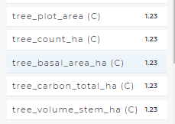
Variables marked with (C) are computed variables, indicating that their values are generated through the calculation chain rather than entered directly by users’ input data.
Weight and plot area attributes
When the chain has a base unit (see the Sampling Design tab), Arena creates the following sampling attributes every time you publish the survey:
- weight, in the base unit entity (default script: plot$weight <- 1);
- <entity>_plot_area_ (e.g. tree_plot_area_), in every entity with an active area-based result variable of the chain (default script: tree$tree_plot_area_ <- NA: replace NA with the plot area formula).
These decimal attributes are not shown in the data entry forms and cannot be deactivated. Arena deletes them when they are no longer needed, for example when the base unit changes or an entity has no active area-based result variables anymore. Their scripts are in the sampling/ folder of the RStudio project (the weight first). To see them in the list of result variables, select Show sampling attributes:
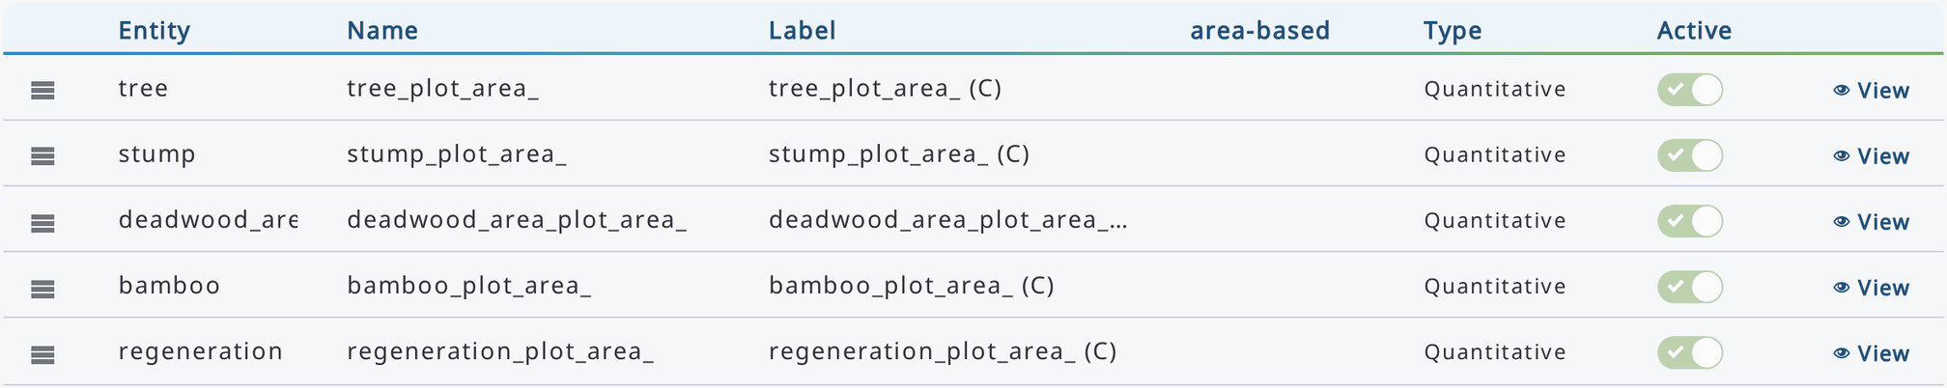

10.4. Sampling design and statistical analytics

10.4.1. Sampling strategy
This section will cover defining a sample strategy in Arena. A sample strategy is the combination of sample design along with an estimator (formula) from which is calculated an estimate for a parameter of interest. For many strategies the sample design and formula are so closely associated that the term "design" is used when "strategy" is meant, we will follow this convention.
Arena supports the following sampling strategies: 1) simple random sampling and systematic sampling;
2) stratified sampling; and 3) single stage or cluster sampling. In addition, the script can compute area estimates for 4) two-phase sampling (UNDER DEVELOPMENT, non-clustered, or clustered).

Definitions and Background
Most forest inventory measurement protocols use a set of circles or rectangles; the set is arranged geometrically around the sample point for the set, see figure below.
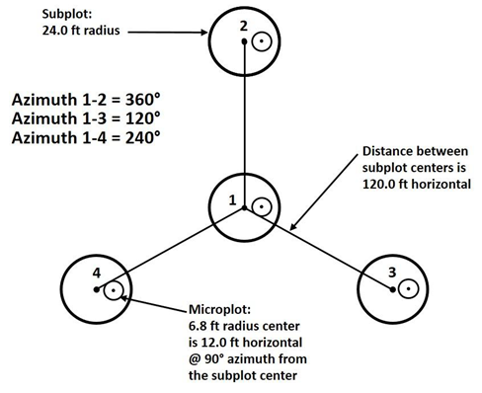
In a majority of inventories, the set is referred to as a cluster and individual elements are referred to as plots. One exception is the Forest Inventory and Analysis (FIA) program of the United States Forest Service, which refers to the set as a plot and individual elements as subplots. To avoid confusion between the two uses of "plot" we will refer to the FIA set as the FIA-plot.
In Open Foris Calc, the smallest unit of measured area is called a base unit, and it is assumed that the base unit is of a single stand type. For many inventories the plot is the base unit. Although in some inventories the plot can be mapped into different stand types. One example of this is FIA, which has the field crews divide the subplots into different stands if there is a stand boundary which can be repeatable mapped.

Typically, trees are measured on clusters of plots, where the plots may vary in size and/or number depending on the diameter class of the tree. Therefore, each entity that contains "area-based" variable(s) gets a new result attribute automatically in a processing chain, for example "tree" gets attribute "tree_plot_area_".

10.4.2. Settings for sampling design
The Sampling Design tab, shown once the Sampling Design option is selected in the Basic tab, contains a form for a description of the survey strategy. The form looks as follows:
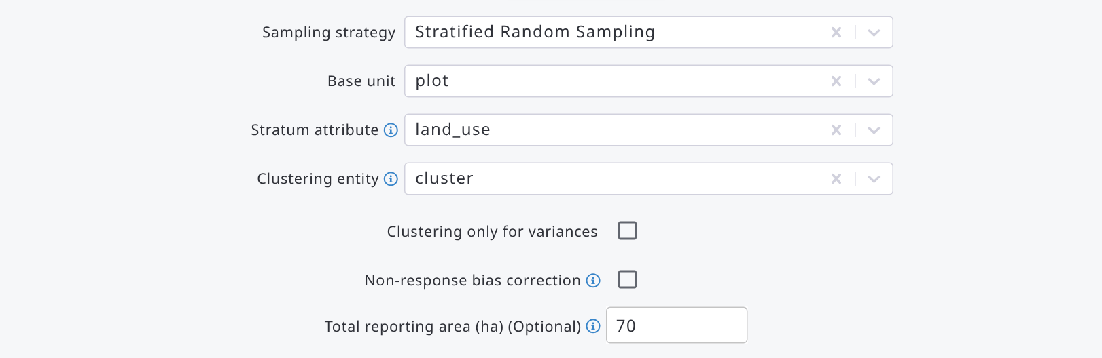
The content is as follows:
Line | Required? | Explanation
Sampling strategy | Optional  If NONE, statistical analysis is not executed | Options:  0. none  1. random sampling  2. systematic sampling  3. stratified random sampling  4. stratified systematic sampling  5. two-phase sampling
Base unit | Yes | The smallest unit of measured area
Stratum attribute | Yes, if stratified sampling strategy | Select a categorical attribute (base unit or its parent level).  Only one attribute can be selected.  This can also be a categorical result attribute.  Areas of strata should be given in.
Clustering entity  (within cluster sampling) | Optional | Set the clustering entity.  In cluster sampling, results are aggregated first at the base unit level, then at the cluster level, and then at the domain level (strata / reporting unit).  if blank: a single stage survey.
Clustering only for variances? | Optional | As a single stage survey: A clustering entity is set, but clusters are only applied for computing variances, but not for means.
Non-response bias correction? | Optional | If enabled, calculation requires a category table 'sampling_units_plan' containing the sampling design (i.e. planned number of samples, and clusters if clustered sampling).  See more information below.
Total reporting area (ha) | Optional | Non-stratified sampling case.  Area of interest for reporting "totals".

The two-phase sampling strategy contains more selections, as follows.
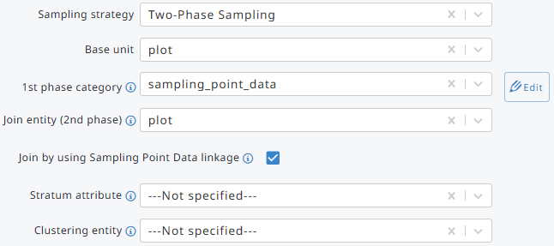
Base unit, Stratum attribute, and Clustering entity are explained in the previous table. In two-phase sampling, the stratum attribute is used to sub-stratify the first-phase sample: only attributes whose name is also a column of the 1st phase category are listed. The additional required information is as follows.
1st phase category | Category table name, that contains the 1st phase samples.
Join entity (2nd phase) | 2nd phase entity (table) to be joined with 1st phase table.
Join by using Sampling Point Data linkage? | YES: 2nd phase entity (‘plot’ in the image above) is getting its key attribute values from the 1st phase category table (sampling_point_data).  NO: 2nd phase entity (‘plot’ in the image above) is not linked with the 1st phase category table.  The following two questions will arise.
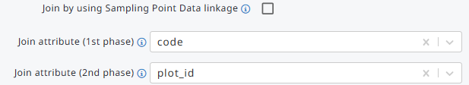
Join attribute (1st phase) | Column name in the 1st phase category table
Join attribute (2nd phase) | Attribute name in the 2nd phase entity (table).  This can be categorical or text data type only.
All selections in the "Sampling Design" will be submitted as a JSON file into the R project, and they will be available as a named list arena.chainSummary in RStudio.
The JSON chain summary file can be downloaded from the Advanced functions menu of the chain with the 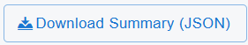command.
Read more about the Arena JSON file in Annex 5.

Areas of strata
Stratified sampling requires computation of inclusion probabilities by stratum. In Arena, inclusion probabilities are expressed as "expansion factors" (which are equal to the inverse of inclusion probability).
There are two methods in Arena script to compute expansion factor for a base unit:
- Computation with the help of sample weights in stratum, i.e.
Exp_factor = [base unit weight in stratum] / (sum([base unit weights in stratum])
- Areas of stratum is known, i.e.
Exp_factor = [area in stratum] / (sum([base unit weights in stratum])
Method A does not allow you to compute "Totals" (such as total volume, biomass) correctly. However, per hectare results can be computed.
In case B, sampling areas must be provided. These are given via the category table of the stratification entity, in a column named "area". All areas are given in hectares (or acres).
The total inventory area is the sum of the column "area". The content of the ‘reporting table’ is described next.
Case 1. Stratified sampling. Areas of strata as a CSV/Excel file in the "Categories" section for attribute "stratum":
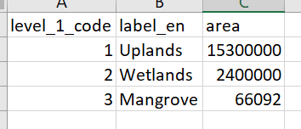

10.4.3. Statistical analysis
A new Shiny app can execute a statistical analysis for all area-based (active) quantitative result variables. These are highlighted below.
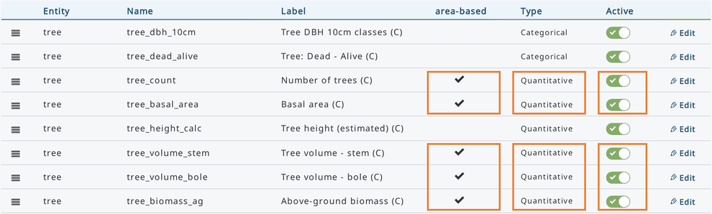
The following conditions should be filled in order run the analysis with Arena Shiny app:
- BASIC: The entity to be reported contains active area-based quantitative result variables in the chain,
- BASIC: ‘Sampling Design’ checkbox is enabled,
- SAMPLING DESIGN: Sampling strategy is selected. Certain sampling strategies may require additional options to be specified.
- SAMPLING DESIGN: Base unit entity is given.

10.4.4. Area for statistical analysis
If the extent of samples is known (such as sampling plot areas in forest inventories), Arena’s script can always compute results per hectare basis, such as tree volume per hectare. For computing the "total" results for a given area of interest (AOI), such as total tree volume, the user must give in the area. The method of giving the AOI (extent) depends on the sampling strategy, as follows:
- Non-stratified sampling.
In the Sampling Design tab, enter the area in the Total reporting area (ha) field:
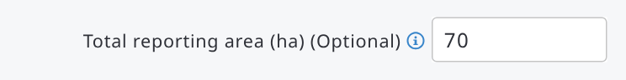
- Stratified sampling, total AOI is known but the areas of strata are not known in advance:
Same as in Case #1. Areas of strata are computed according to proportion of strata (i.e. sum of weights in stratum divided by the total sum of weights across all strata).
- Stratified sampling, the areas of strata are known in advance:
Areas (ha) are given within the attribute’s category table as an "extra property", as follows:
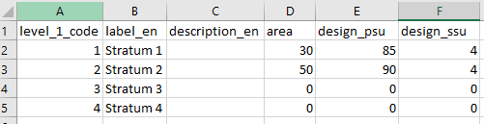
- AOI (extent) is not known, or it is not relevant: the script assumes the reporting area is equal to 100 ha.

10.4.5. Non-response bias corrections
A problem common to nearly all sample-based surveys is partial or complete non-response from some of the selected sample units. Arena script can apply the Weighting Class Adjustment method and compute weight adjustment factors based on data about the planned number of sampling units. In this case, missing observations are ignored and an adjustment factor is incorporated into a sample weight to compensate for non-response or situations where all or part of a sample (plot) falls outside the population.
The weight adjustment requires information about the planned number of Primary Sampling Units (PSUs) and Secondary Sampling Units (SSUs).
In a forest inventory, Primary Sampling Units can be sample plots or clusters, by strata in case of stratified sampling. Secondary Sampling Units can be sample plots.
In stratified sampling, the number of PSUs and SSUs are given within the stratum attribute’s category table, as follows:
In the example above, the area of Stratum 1 is 30 ha, and the initial number of clusters (PSUs) is 85, and the number of sample plots in a cluster is 4.
In the next example, the non-response bias correction is not computed for missing clusters, but only for missing sample plots (SSUs):
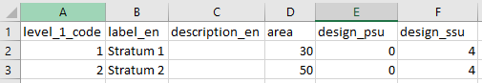
And in the next example, the non-response bias correction is computed only for missing clusters (PSUs) in strata, but not for sample plots (SSUs):
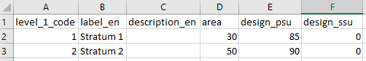
If this lookup table is missing or its format is incorrect, Arena’s R script cannot compute corrections.
Stratified sampling case:
level_1_code: stratified, give the stratum attributes’ codes (text)
label_en: Label (text)
area: stratum area (in hectares. Optional)
design_psu: planned number of primary samples (such as clusters) in strata (numeric)
design_ssu: planned number of samples (such as plots) in clusters (numeric)

NOTE: This part of the Arena platform and R scripts will be further developed by the OF Arena Team and changes will be documented in this manual and the GitHub repository.

10.5. Arenalytics - R package for statistical analysis and reporting
Arenalytics is an analytical dashboard developed for reporting and exploring data collected and processed with Open Foris Arena. It was designed to address one of the main challenges of sample-based assessments: generating reliable statistics, tables, and figures from large and complex survey datasets without requiring users to predefine all reporting outputs in advance. The dashboard was developed particularly for forest inventories and other sample-based assessments where users need to produce estimates such as biomass, tree density, volume, carbon stocks, or other indicators across multiple reporting domains. The dashboard allows users to dynamically analyse survey results by selecting measures, dimensions, and filters, producing estimates, totals, means, and reliability statistics on demand.
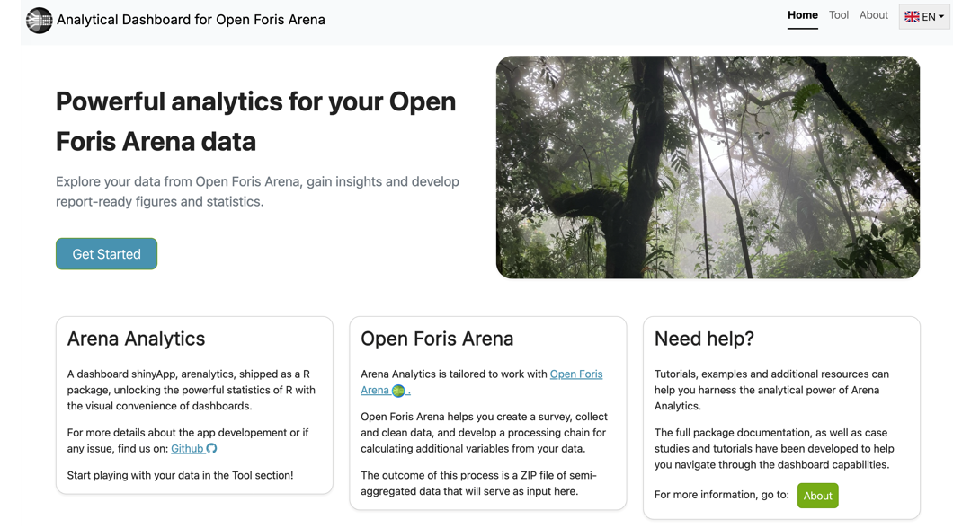
The Arenalytics workflow begins in Open Foris Arena, where survey data are collected and processed using a calculation chain. Once the processing chain has been executed in RStudio, Arena automatically generates Minimum Area Unit (MAU) files that contain pre-computed result variables and supporting attributes required for reporting. These files are packaged into a ZIP archive and loaded into Arenalytics for analysis.
After loading a MAU zip file, Arenalytics performs automatic validation checks and provides a survey summary to help users verify that the uploaded data are ready for analysis. Users can then select an entity, choose one or more measures to analyse, and define dimensions and filters that determine how results will be aggregated and presented. Dimensions can originate from either the original survey data or from the processing chain, enabling flexible reporting across administrative units, forest types, diameter classes, species groups, and many other categories. The resulting tables are generated instantly and updated whenever the settings in the ‘Cross outputs settings’ section change.
Workflow Summary:
Arena Survey with Data and Processing Chain
→ Run Chain in RStudio
→ Generate MAU ZIP file
→ Load data into Arenalytics
→ Select Entity and Dimensions
→ Click Run analysis
→ Select Measures and Filters
→ Review & Export results
→ Create figures
→ Generate reports
The dashboard can be accessed through a web application or installed locally from its open-source R package, making it suitable for both online and offline environments:
- Use the online version. Open the hosted dashboard in your web browser: https://openforis-shiny.shinyapps.io/arenalytics/
- RECOMMENDED: Install and run locally in a Rstudio instance with
if (!require(remotes)) install.packages("remotes")
if (!require(arenalytics)) remotes::install_github("openforis/arenalytics", upgrade="never")
arenalytics::shiny_run_arenalytics()

The internal showcase presentation also notes that a demo dataset is available in the About section of the application. A step-by-step guideline to Arenalytics is available here.
The outcome of the Arena processing chain is a ZIP file of semi-aggregated data that will serve as input for Arenalytics, a Minimum Area Unit (MAU) file. The MAU file contains data aggregated to the Minimum Area Unit level, which is defined as the smallest homogeneous land unit in the survey area. In the Arena processing chain, the MAU is equivalent to the base unit used for statistical estimation.
Examples:
- If a plot is completely homogeneous (single land use or vegetation type), the plot itself is the MAU.
- If a plot is divided into several land-use or vegetation sections, then each homogeneous section becomes a separate MAU unit. Estimation variables are first computed for these sections and then aggregated to higher reporting levels.
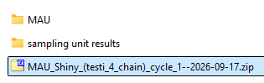
The MAU file is automatically generated by an Arena system script as a ZIP file. It contains:
- Result estimates for each base unit (MAU).
- All relevant dimensions derived from categorical, taxonomic, and Boolean attributes.
- Pre-computed measures that Arenalytics can subsequently aggregate into tables, charts, means, totals, and sampling-error estimates for any user-selected combination of dimensions.
Arenalytics reads measures at the MAU level and dynamically aggregates them to any reporting level (forest type, species, administrative region, diameter class, etc.) requested by the user. For a typical forest inventory case, where plots may be split into land-use strata or forest types, you can think of the MAU file as a dataset where each record represents one homogeneous plot section together with all its computed area-based variables and reporting dimensions.
The generated MAU ZIP file can be stored on the Arena server to facilitate archiving and future retrieval. Follow these steps:
- Unlock the chain
- Click Advanced functions and then Upload MAU.zip
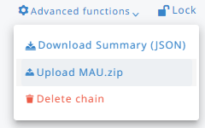
- Once the file is uploaded, you will see an option to download or delete this file:
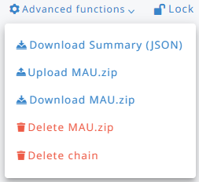
The MAU.zip file is linked to the cycle selected in the header: if the survey has more than one cycle, Arena asks you to confirm the cycle before uploading the file, and Download MAU.zip and Delete MAU.zip work on the file of the current cycle.
Only .zip files are accepted. If a MAU.zip file has already been uploaded for the chain, Arena asks you to confirm before replacing it. Upload MAU.zip and Delete MAU.zip are available only when the chain is unlocked, Download MAU.zip also when it is locked.

10.6. Duplicate or clone a chain from another survey
This chapter explains how to copy an existing processing chain with R scripts from one survey into another without rebuilding a new chain step by step.

10.6.1. Overview
The ‘Clone chain from another survey’ feature lets a Survey Administrator or Data Analyst copy a complete chain from a survey they have access to into the survey they are currently working on. The clone operation copies:
- the chain's properties (name, labels, and description);
- all R scripts;
- the calculated result variables (analysis attributes) defined in the chain, re-created under the matching entities of the destination survey;
- the categories and taxonomies referenced by those calculated variables, so that coded results keep working after the clone.
The cloned chain is created as a new, independent chain in the destination survey - the source chain is left untouched, and the two chains are not kept in sync after cloning.

10.6.2. Prerequisites
- You must have Survey Administrator or Data Analyst permissions in the destination survey (the one you want to copy the chain into).
- You must also have access to the source survey (the one the chain is copied from). Only surveys you can access, and that already contain at least one chain, are offered as a source.
- The destination survey should already contain the entities that the source chain's calculated variables refer to (for example, plot or tree), using the same entity names. Arena checks this for you before the clone runs; if the entities do not exist in the target survey, the analysis variables associated to those entities won’t be cloned.

10.6.3. Step-by-step: cloning a chain
- Open the destination survey (the survey you want the chain copied into) and go to Analysis → Chains.
- In the Chains panel, click the button “Clone from another survey”.
- In the Clone chain from another survey dialog, select the Source survey (or template) from the dropdown list. Only surveys and templates you have access to, and that contain at least one chain, appear here.
- Select the Source chain you want to copy from the list of chains available in that survey.
- Arena automatically runs a compatibility check, comparing the entities used by the source chain's calculation steps with the entities available in the destination survey.
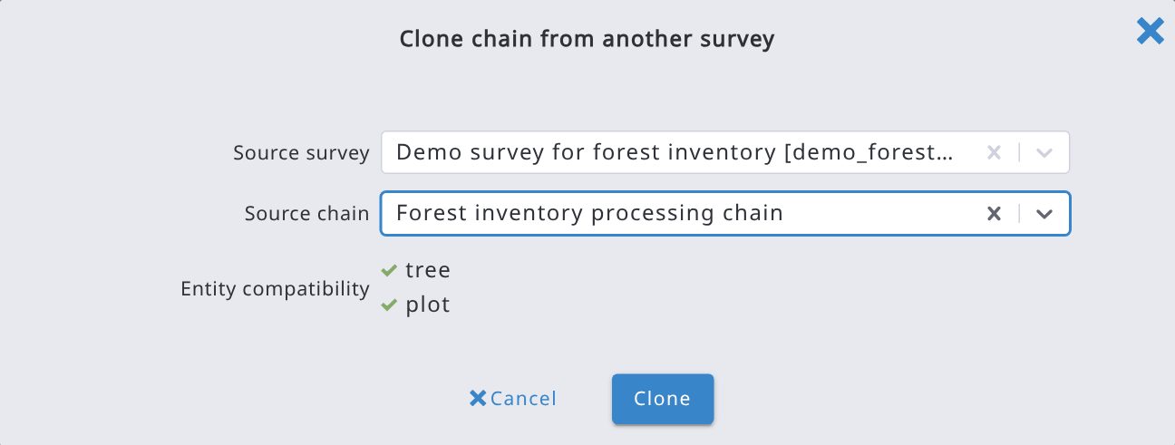
- Review the compatibility results. If everything is compatible, confirm the clone by clicking Clone. Entities that do not exist in the destination survey are marked as missing in target survey: select Skip analysis attributes for entities missing in the target survey to clone the chain without their analysis attributes (otherwise Clone stays disabled).
- Arena creates the new chain in the destination survey, copies the scripts and calculated variables, and then opens the newly created chain automatically so you can review it.

10.6.4. What happens after cloning
- A new chain is created in the destination survey with a new, unique identifier, it is entirely separate from the source chain.
- All R scripts from the source chain are copied over as-is; you can edit them afterwards like any other chain script.
- Calculated variables are re-created under the matching entities of the destination survey, together with any categories or taxonomies they depend on.
- The new chain is validated automatically once created, and any issues (for example, an expression referencing an attribute that does not exist in the destination survey) are flagged for you to resolve, the same way validation works for a chain you build manually.
- You are taken directly to the newly created chain, ready for review, adjustment, and publishing.

10.6.5. Notes and limitations
- Cloning copies the chain definition and scripts; it does not copy previously computed results or published data — you still need to run the chain in RStudio to generate results in the destination survey.
- Only chains you can access (i.e., chains belonging to surveys you are a member of, or to published templates) can be used as a source.
- If the source and destination surveys use different names for otherwise equivalent entities, rename the entity in one of the two surveys first so the compatibility check can match them.
- A survey can contain more than one chain; cloning adds a new chain alongside any chains that already exist in the destination survey; it does not replace them.
- When you clone a whole survey (Clone in the new survey page), its chains are cloned too.

10.7. Deleting a chain
A calculation chain can be deleted from the Advanced functions menu. Unlock the form and click Delete chain.
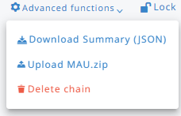
This action cannot be canceled.

11. User roles and invitation to access a survey

11.1. User roles
Each survey is hosted by one or more Survey Administrators. A Survey Administrator can invite new users by sending an email invitation from Arena.
A Survey Manager status is a user privilege and not a role: this user can create a new survey and become a Survey Administrator for that new survey.
To become a Survey Manager and start creating a new survey, please go to www.openforis-arena.org and click on the Request Access link:

Note: User roles like- “Data Analyst”, “Data Cleanser” and “Data Editor” can be provided only when the survey is published. During the survey designing phase only “Survey Administrator” role can be provided to another Arena user. Unpublishing an already published survey does not remove the assigned user roles from the survey. Field crews or field data collectors are generally provided access with the “Data Editor” role in the survey.
Fill in the form. It is recommended to start using a template, read more about them in this Annex. Then send the request and wait for approval. You will receive an email with the details on how to access Arena.
The users are divided into the following roles, each of them having different access rights to the tools, surveys and data.

Permission |  | Survey Administrator | Data Analyst | Data Cleanser | Data Editor | Guest
Dashboard | Data dashboard | X | X | X
Survey | Create a new survey | "Survey Manager" status
Survey | Edit own surveys | X
Survey | Delete own surveys | X
Survey | Publish / Unpublish survey | X
Survey | View hierarchy | X | X | X | X | X
Survey | View dependency tree | X
Survey | View categories and taxonomies | X | X | X | X | X
Survey | Export (Arena) schema | X
Survey | Export (Arena) schema + data  (backup) | X
Survey | View Collect Import Report (for schema import) | X
Survey | View and export schema summary | X | X | X | X | X
Data | View records (own surveys) | X | X | X | X | X
Data | Add new records (own surveys) | X | X | X | X
Data | Edit all records (own surveys) | X | X | X
Data | Edit own records (own surveys) | X | X | X | X
Data | Submit record to Cleansing | X | X | X | X
Data | Submit record to Analysis | X | X | X
Data | Demote/Promote all records | X | X
Data | Clone data | X | X
Data | Use map | X | X
Data | Export (data to CSV/Excel) | X | X | X | X (only own records) | X
Data | Import (CSC/Excel/Arena/Collect) | X | X | X | X
Data | Validation report | X | X | X
Analysis | Access to analysis tools | X | X
Analysis | View result variables in Data Explorer and Hierarchy views | X | X
Users | Invite users to own surveys | X
Users | Edit users of own surveys | X

If a user is removed from a survey, all user’s records are assigned to the Survey Administrator.
Notes on the table above:
- The Dashboard, the Data Explorer and the Validation report are available to Survey Administrators, Data Analysts and Data Cleansers. They are not available to Data Editors.
- The Map is available to Survey Administrators and Data Analysts.
- Data import is possible only in published surveys.
- System administrators have all the permissions in all the surveys of the server.
- Guest: can view and export the records of the survey, also in Arena Mobile, but cannot add, edit, delete or submit them. Like the other data roles, it can be assigned only when the survey is published. Add the guest to a user group with qualifiers to show only the records of that group (see 11.3).

11.2. Invitation to survey

A Survey Administrator can invite new users to get access to the current published survey.
To send an invitation to a new survey user or a group of users, go to the 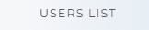 section and click the 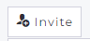button. The following form will appear.
The invitation is sent to all set email addresses. Fill in first the email addresses (type each address and press Add), then select a Role, and type an additional message, if needed. The Permissions of the selected role are shown below it. Only system administrators see the System administrator checkbox, used to invite other system administrators.
This is an example of email that the client will get:
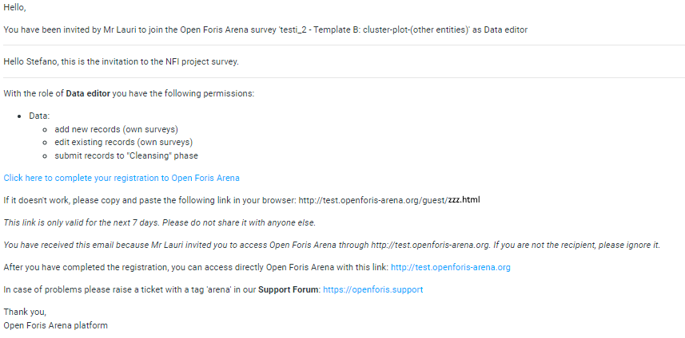
The text of the message is shorter if the invited person (i.e. email) is already a registered Arena user.
If a recipient does not get an email, the message might be blocked by a strict firewall filter on the recipient’s end. Ask the recipient to check their spam, junk, and clutter folder for the invitation message. A user invitation will be deleted if it is not accepted in 1 month.
If the invited user is currently logged in the Arena platform, then this user might need to log out and log in again in order to see the survey properly.

11.3. User Grouping

11.3.1. Overview
A Survey Administrator can organize the people who collect data for a survey into named groups (e.g., by region, team, or organization). A group can optionally carry one or more qualifiers (key/value pairs that automatically restrict and pre-fill the data that its members collect) so that each group only can see and edit the records that belong to them.
User Groups are useful when:
- Several field teams share the same survey but should not see or edit each other’s records.
- Records must be automatically tagged with a region, project, or organization code as soon as they are created, based on who is entering the data.
- You want to get a quick overview of which users are assigned to which team, and a method to reassign them.

11.3.2. Accessing User Groups
Only users with a Survey Administrator role in the current survey can create, edit, delete groups, or manage members.
User Groups are managed per survey, via the Users section of the survey menu:
- Select the survey and go to Users on the left-hand side menu.
- Select the User Groups tab.
The User Groups page has up to three tabs, depending on your permissions:
Tab | What it shows
User Groups | A simple list of the groups defined in the survey.
Group Assignments | A Kanban-style board with one column per group (plus an "Unassigned" column) and one card per user; drag and drop a user’s card to change their group.
Members Report | A flat table with one row per group member, listing the group’s name, label and qualifiers alongside the member’s name, email, survey role and account status.

11.3.3. Creating and Editing a User Group
- On the User Groups tab, click New Group.
- Enter a Name for the group. The name is normalized automatically (no spaces or special characters) and it must be unique within the survey.
- Enter a Label for each survey language – this is the friendly name shown to users throughout Arena.
- Optionally add one or more Qualifiers (see 11.3.4) and select in Can view the records of the groups whose records the members can view (see 11.3.8).
- Click Save. Once the group is saved, a Members panel appears at the bottom of the page (see 11.3.5).

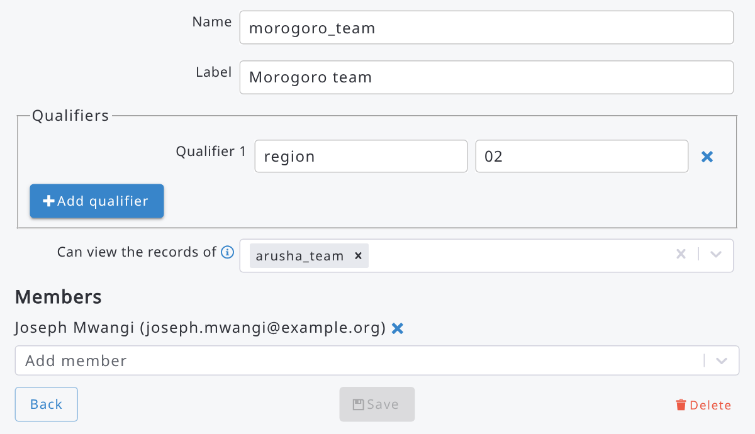
To edit an existing group, open it from the User Groups list and change any field, then click Save again. To remove a group, open it and click Delete; in this case the members are not deleted, they simply become unassigned.

11.3.4. Qualifiers: Linking a Group to Survey Data
A qualifier is a key/value pair attached to a group. The key must match the name of a survey attribute that has been marked as a qualifier attribute in the Form Designer (see 11.3.4.1). When this is done, Arena uses the pair to automatically fill in and restrict data for members of that group.

11.3.4.1. Marking an attribute as a Qualifier
Only single-value Text or Code attributes placed directly under the root entity of the form can be used as qualifiers. To enable one, do next:
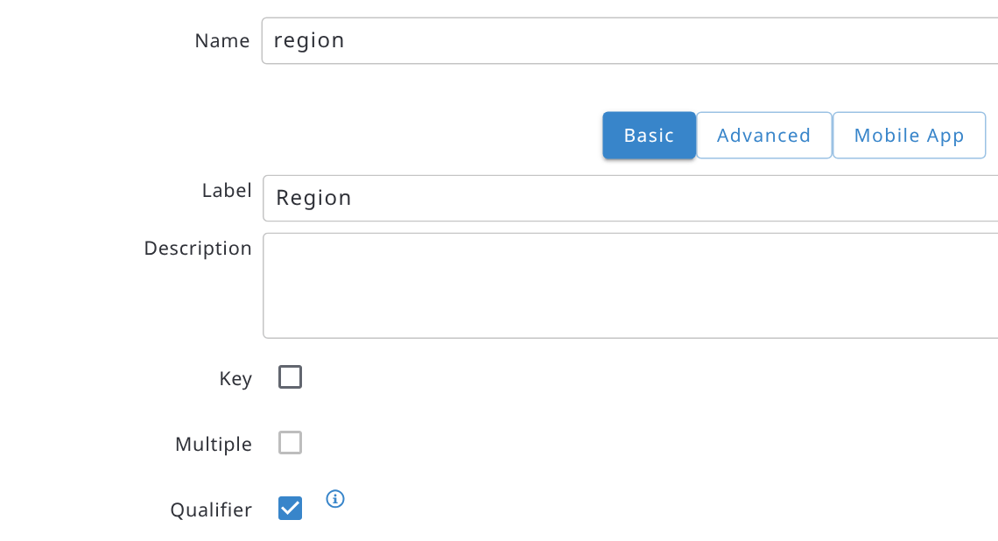
- Open the Form Designer and select the text or code attribute (it must be defined inside the root level entity) that will hold the group value (for example, "region" or "project_code").
- In the attribute’s Basic Properties panel, enable the Qualifier checkbox. This option only appears once when at least one User Group exists in the survey.
What "Qualifier" does: When a new record is created by a user belonging to a group, this attribute is automatically filled with the value specified for it among that group’s qualifiers. Users will only be able to see and modify records belonging to their own group if they belong to one.

11.3.4.2. Adding qualifier values to a group
Back on the group’s edit page, in the Qualifiers panel:
- Click Add qualifier.
- Under Key, enter the exact name of the qualifier attribute defined on the form (e.g. "region").
- Under Value, enter the value that should apply to this group (e.g. "North"; for a Code attribute, enter the item’s code).
- Repeat for additional qualifier attributes, and then click Save.
A group can have several qualifiers if the form defines several qualifier attributes. Each qualifier key must be unique within the group, and it cannot be left blank.

11.3.4.3. Effect on data entry and data access
- New record: the qualifier attribute(s) are filled in automatically as soon as a member of the group starts collecting a new record, using the value(s) set on their group.
- Existing records: a user can only view and edit records whose qualifier attribute value matches their own group’s qualifier value. Attempts to open or edit a record outside their group are rejected.
- Unassigned users, or groups without a matching qualifier, are not restricted by this mechanism.
- Guests: the members of the group with the Guest role can view the records of their group (and of the groups selected in Can view the records of, see 11.3.8), also in Arena Mobile, but they cannot edit them, nor add new records.
- A user is considered to belong to at most one group per survey; only that group’s qualifiers are applied.

11.3.5. Managing Group Members
There are two ways to assign survey users to a group. These are explained next.

11.3.5.1. Method 1. From the group’s edit page
- Open the group and scroll to the Members panel.
- Use the Add member dropdown to pick up a survey user by name and email.
- If the chosen user already belongs to a different group, Arena asks for confirmation before moving them (a user can only be a member of one group at a time).
- To remove a member, click the ✕ icon next to their name. They become unassigned, not deleted from the survey.

11.3.5.2. Method 2. From the Group Assignments board (drag and drop)
The Group Assignments tab (visible only to users who can manage groups) shows every survey user as a card on a Kanban-style board, with one column per group plus a leading Unassigned column.
- Go to Users > User Groups > Group Assignments.
- Drag a user’s card from its current column into the column of the group you want to assign them to (or into Unassigned to remove them from any group).
The new status is saved immediately; there is no separate Save step for this view.
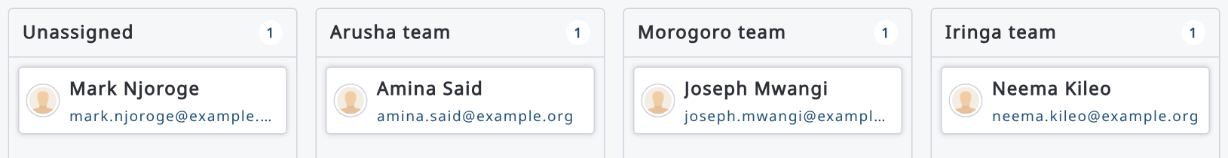

11.3.6. Members Report
The Members Report tab gives a flat, exportable-style view for auditing group membership: one row per group/member pair, showing the group’s name, label and qualifiers next to the member’s name, email, survey role and account status (Invited, Accepted, or Password change required). Groups with no members still appear, with a single empty-member row, so no group is missed.
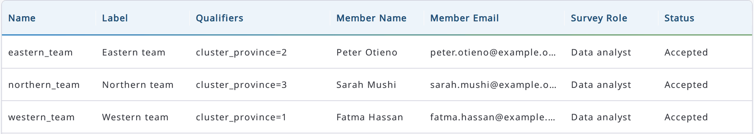

11.3.7. Frequently Asked Questions
- Can a user belong to more than one group?
No. Adding a user to a group who already belongs to a different group moves them to the new group after a confirmation prompt.
- What happens to a group’s members if the group is deleted?
They are not removed from the survey; they simply become unassigned and lose any qualifier restriction that the group applied.
- Can I use a multiple-choice or nested attribute as a qualifier?
No. Only single-value Text or Code attributes placed directly under the root entity of the form can be marked as qualifiers.

11.3.8. Read-only access to the records of other groups
The members of a group with qualifiers can see and edit only the records of their own group. To let them also view the records of other groups (e.g. a supervisors' team), open the group and select those groups in Can view the records of, then click Save.
The members of the group can then view, export and download (also in Arena Mobile) the records of the selected groups, but they cannot edit them. In the example of section 11.3.3, the members of the Morogoro team can view the records of the Arusha team.
Record files, data exports and the records uploaded from Arena Mobile are also restricted to the records that the user group can access.

12. Examples of expressions
Arena uses Javascript programming language for expressions. Because some users may be familiar with XPath language expressions used in OF Collect, the tables (use the link below) represent expressions with both these languages.
The filters of the Data Explorer and of the Validation report also use JavaScript syntax only. To search text values use includes, startsWith or endsWith, e.g. remarks.includes('dead'); add .toLowerCase() before them to ignore the case, e.g. remarks.toLowerCase().includes('dead').
Note: In JavaScript, a string is a sequence of characters enclosed in single (‘) or double (") quotes. The choice of quoting style is up to the programmer.
Operands (see more here):
AND: && OR : || NOT: !
Equal to: == not equal: != Less than: <, <= Greater than: >, >=
Multiplication: * , Division: / , Modulo: % , Exponentiation: **
All examples of expressions you can find in this online document. It contains the following topics:
12.1. "Relevant if" and "Apply if" rules
12.2. Methods and functions
12.3. Data validation
12.4. Functions using current user
12.5. Functions using current record
12.6. Examples
12.7. Items filter expressions
How to avoid performance issues with Arena / Arena Mobile
If you encounter slowness while editing a large number of entities in a multiple entity (table), you should check the expressions set in for every attribute (default values, validation rules, etc.), because, depending on the way they are defined, they can be evaluated by Arena and Arena Mobile too many times. This can happen when you record a new entity or delete an existing one.
Please follow these rules:
- when you have a default value with an expression that depends on the "index" of the entity, like index($context) + 1, mark it with "Default value evaluated only one time", otherwise the expression will be evaluated repeatedly every time you insert a new entity;
- when you have a validation rule that checks the value of an attribute, please prefer the use of "this" instead of the name of the variable; e.g.
this > 10 instead of attribute_name > 10 or parent_entity_name.attribute_name > 10
- When you point at another attribute (e.g. this < tree_height_top), make sure that the attribute (tree_height_top) precedes in the data structure.

13. Changing or resetting password
Change your password
- Log in to Open Foris Arena
- Click on your profile picture in the top-right corner, select "My profile" and click on "Change password" at the bottom of the page
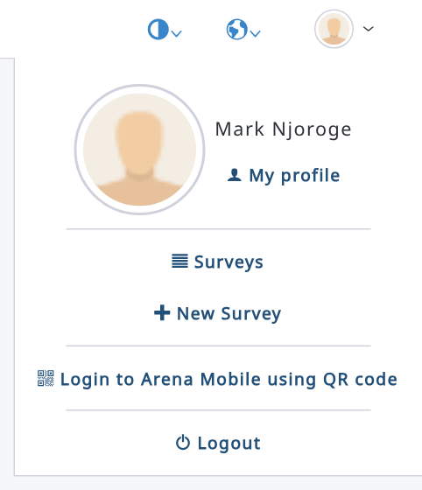
- Type your old password and the new password, and confirm the new one. The new password must pass all the Password strength checks; then click on "Change password".
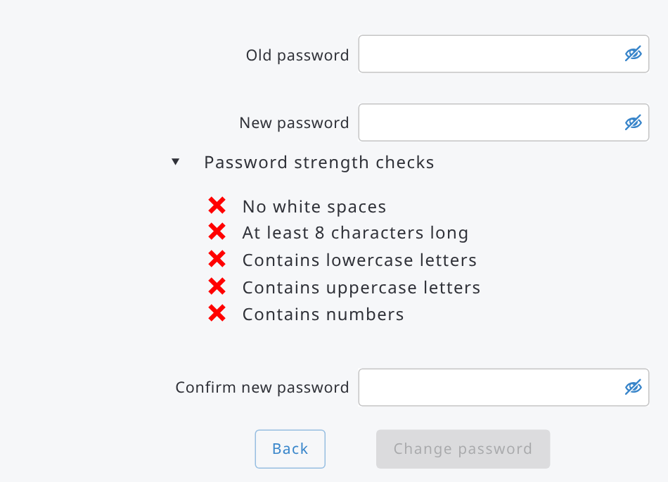

Reset your password
- Go to the Open Foris Arena login page
- Click on the "Forgot password?" link
- Type your login (email) address and click on "Send password reset email"
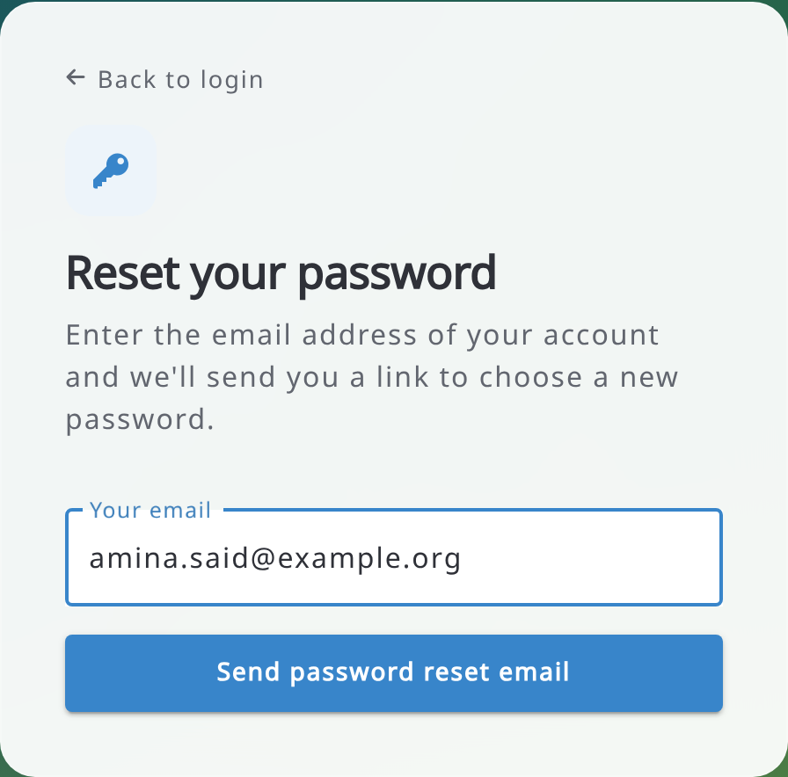
And you will get the following message:
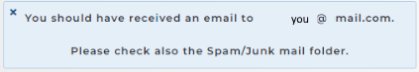
- Open the email. It looks like this:
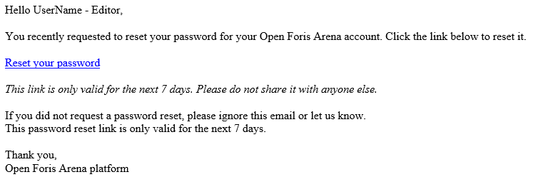
- Click on the link in the email, and you will get the following form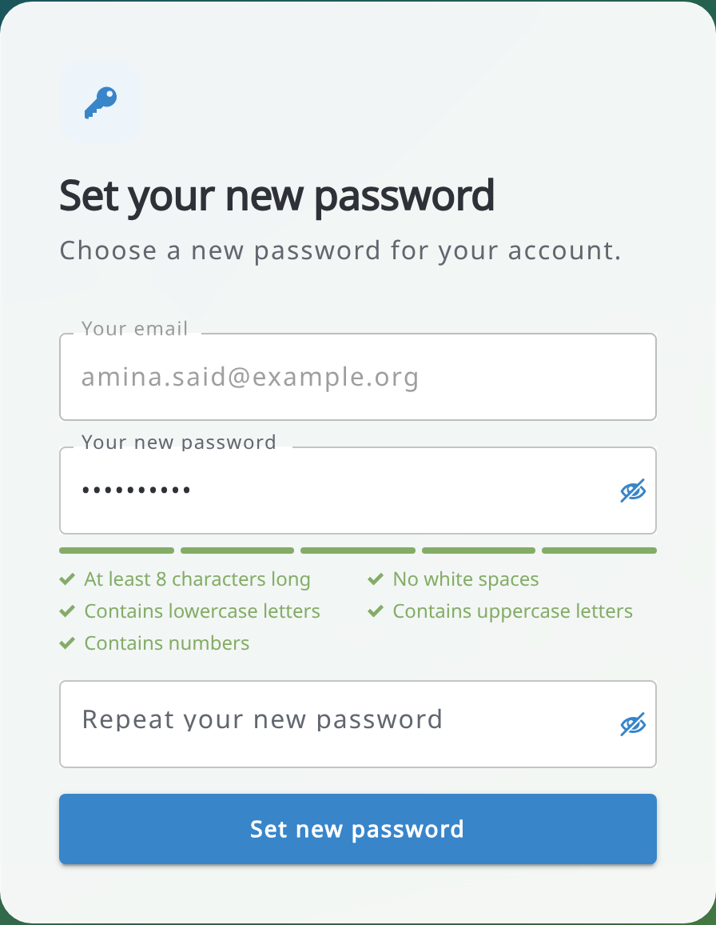
- After resetting the password, log in to Arena.

14. System administration
Users with the System administrator privilege see the System Administration menu at the bottom of the sidebar. It is not linked to the current survey and contains the following items:
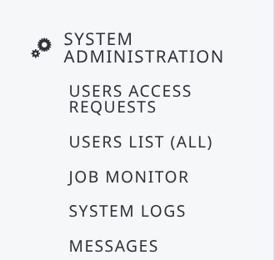
- Users access requests: requests sent with the Request access link of the login page (shown only when access requests are enabled on the server);
- Users list (all): all the users of the server, with Export to Excel, Backup / Restore and New User;
- Job monitor: the background jobs (imports, exports, publishing...) of all users; select Active jobs only to see the running jobs, and cancel a job if needed;
- System Logs: the server log, live;
- Messages: messages sent to the users by email or as in-app notifications.
System administrators also see the Changelog in the Help menu.

14.1. Backup and restore users
You can copy the users from one Arena server to another one. In Users list (all), click Backup / Restore:
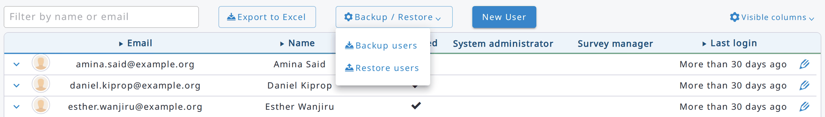
- Backup users exports all the users with their survey roles and user groups (2FA devices are not exported). Select Include passwords to include the password hashes: in this case keep the backup file in a safe place and delete it after use.
- Restore users reads a backup file in the other server. Users are matched by email; survey roles and user groups are matched by survey name and group name, and the roles of surveys not existing in the server are ignored. For each user you can choose the action: Add (new users), Skip, Update survey roles or Update survey roles and details, and whether to restore the Password stored in the backup. If the passwords are not included in the backup, new users will have to reset their password.

14.2. Messages
In Messages, click New to write a message:
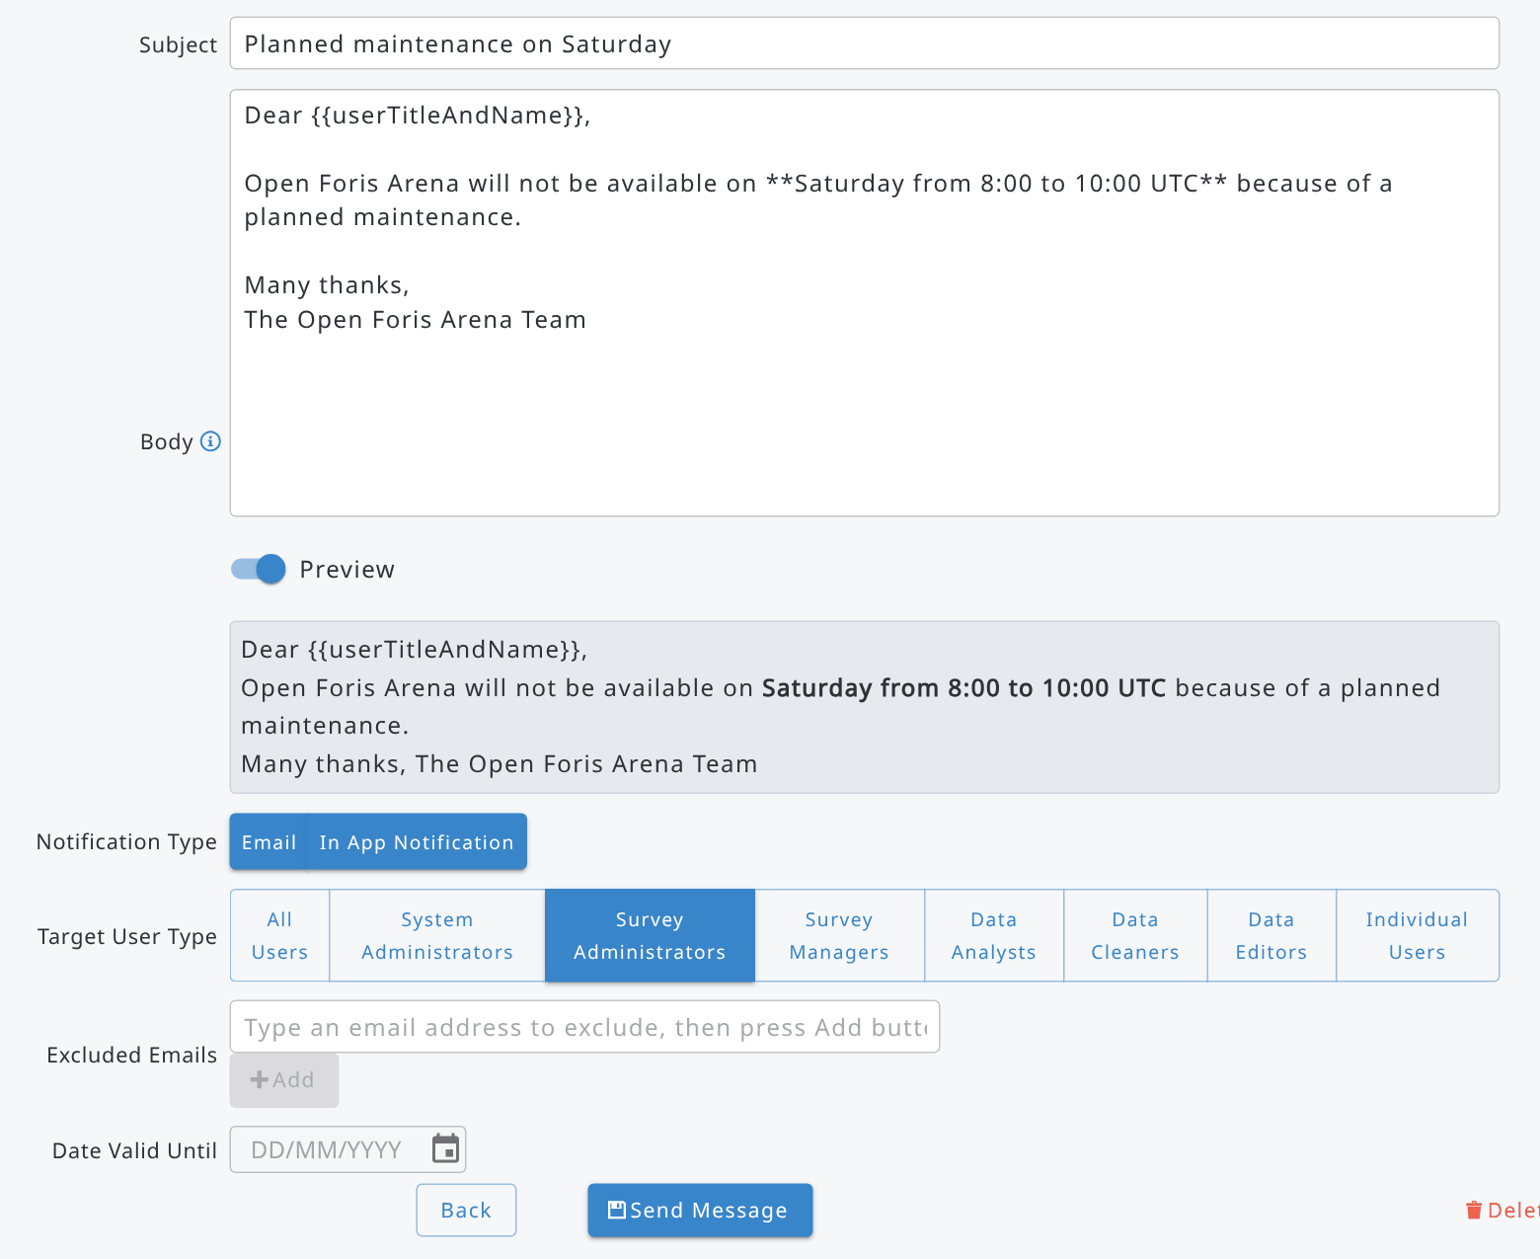
- Subject and Body: the body can be formatted with Markdown and can contain the placeholders {{userTitleAndName}} and {{userName}}; switch on Preview to see the result;
- Notification Type: Email, In App Notification or both;
- Target User Type: All Users, or only some types of users, e.g. Survey Administrators (to write only to the administrators of the surveys) or Individual Users (type their email addresses in Included Emails); use Excluded Emails to leave out some users;
- Date Valid Until: until when the in-app notification is shown.
Click Send Message. The message is sent in the background and a progress dialog is shown: you can cancel the sending from it. Messages already sent are not recalled.

14.3. System Logs
System Logs shows the log of the server live (Live in the top-right corner). You can filter the lines by text and by level (Error, Warn, Info, Debug), show or hide the HTTP requests, set the Max lines shown, Pause the view, Export the loaded lines to a text file or Clear the view. If the server runs on more instances, select the instance in Instances.
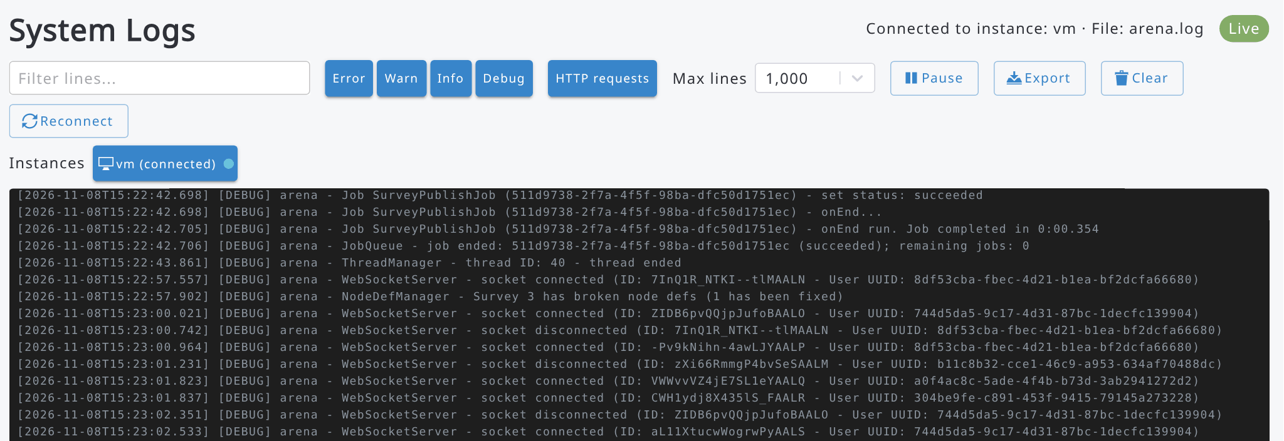

Acknowledgements


The Open Foris Arena platform has been built with the support of
- The Government of Norway and the UN-REDD Programme through the Food and Agriculture Organization of the United Nations (FAO),
- The Ministry for Foreign Affairs, Finland, and
- The Government of the United Kingdom of Great Britain and Northern Ireland (Aim4Forests Programme).
The deepest thanks to the developers of the system: Lauri Vesa, Stefano Ricci, Cosimo Togna, Ramiro Blazquez-Gonzalez, Jose Serafini Gauto, Diego Perez Sastre, Miró Sorja, Stefano Giaccio, Daniel Koch and Elias Kunnas. The other contributors in the development and documentation have been Falgoonee Kumar, Javier Garcia Perez, Anibal Cuchetti, Jimena Saucedo Miranda, Victoria O'Brien, Maria Valbuena Perez, Ann Rotich, Rebecca Tavani, Gael Sola, Julian Fox and Anssi Pekkarinen.

Annex 1. System architecture
OF Arena is built with JavaScript programming language and the system is based on the following components:
- Static front-end in React.js
- Back-end in Node.js
- Database Management System: PostgreSQL
- Amazon Web Services (AWS),
- Leaflet JavaScript library for interactive maps,
- System front-end and back-end will communicate via Web Socket connection, and the OF Arena authentication system uses local user storage. OF Arena sends notifications via email.
- External data: users can upload files into the system,
- OF Arena integrates with RStudio server,
- Local off-line installation and usage via docker.
OF Arena uses cookies, so they should be allowed in the web browser. The system is tested with the following web browsers: Google Chrome (recommended), Windows Edge and Opera.

Annex 2. Abbreviations and acronyms

AOI | Area of Interest
AWS | Amazon Web Services
CSV | Comma Separated File
DBH, dbh | Diameter at the breast height (1.3m) (of a tree)
EM | Earth Map (https://www.openforis.org/earth-map/)
EPSG | EPSG Geodetic Parameter Dataset (also EPSG registry)
FAO | Food and Agriculture Organization of the United Nations
GEE | Google Earth Engine
ID, id | Identifier
JS | Javascript
JSON | JavaScript Object Notation
NA | Not Available (missing data)
OF | Open Foris
R | Programming language ‘R’
SQL | Structured Query Language
SRS | Spatial reference system
UTF-8 | Unicode Transformation Format – 8-bit
UUID | Universally unique identifier
Whisp | “What is in that plot”, an open-source query tool at here

Annex 3. RStudio Server: writing and downloading files created during run-time
Because RStudio Server works on a remote server, getting files, such as CSV files or graphic files, created by the R scripts from the server to the user’s machine requires special methods. Here we go through how to do this.

- Write this script into 000-common.R:
# define a folder for output files
user_file_path <- './user_output/'

# create a folder for files to be exported
if (!dir.exists( user_file_path )) dir.create( user_file_path, showWarnings = FALSE )

cat( normalizePath(user_file_path) )

Optionally, you can also use a function to add all "user’s files" into a zip file (arena_R_export.zip) which can be downloaded (after running the project files). Add also this script into 000-common.R (after the script above):

zip_user_files <- function(tFolder) {
#delete zip if it exists (i.e., file to be downloaded)
fn <- paste0( tFolder, "arena_R_export.zip ")
if (file.exists(fn)) {
#Delete file if it exists
file.remove(fn)
}

# check if any files to be zipped
f <- list.files(tFolder, all.files=TRUE, recursive=TRUE, full.names=FALSE)
if (length(f) > 0) {
zip::zip("arena_R_export.zip", f, recurse=TRUE , root=tFolder, include_directories = TRUE,
mode = "mirror")
}
}

Note: add script
zip_user_files( user_file_path )
into the very last calculation step.

- in the part where you need to write something into a CSV file, use this type of command line

write.csv(my_DF, paste0( user_file_path, "test.csv" ), row.names = FALSE)

- To download the files from the server, there are two methods:
a) using RStudio’s EXPORT tool (this is easier),
b) or by R coding.
a) RStudio’s EXPORT tool:
In the Files pane, More menu, there is an Export… option:
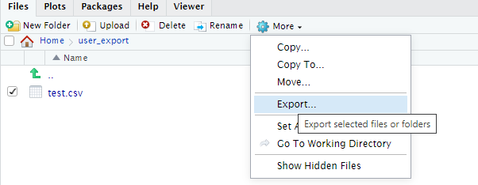

b) Coding method to export the files from the server:
file_list = list.files(path=user_file_path, pattern="*.csv")
for (i in seq_along(file_list)) {
export_filename = file_list[[i]]

# create a path for file to export
my_export_file_path <- paste0(user_file_path, export_filename)

# make a pause before exporting the next file, otherwise there can be a pop-up warning
if (i > 1) {
cat('*** PRESS ENTER HERE')
readLines(stdin(), 1)
}

# export to local disk using browser's capabilities
browseURL(my_export_file_path)
}

Annex 4. Templates for Arena

The following tables screenshots of templates in OF Collect and Arena.
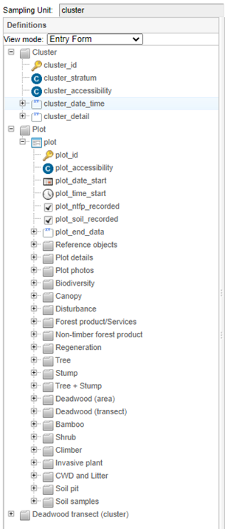 | 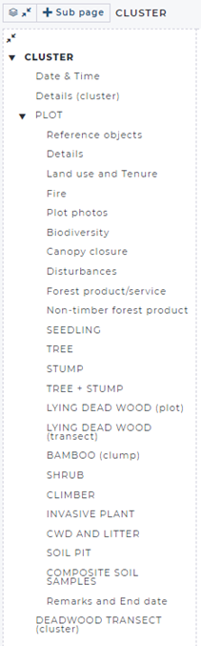 | template_forest_inventory_b  Template B:  cluster – plot – several entities  Purpose: Forest inventory case where data will be collected in sampling units that are clustered.  Languages: English, French, Spanish

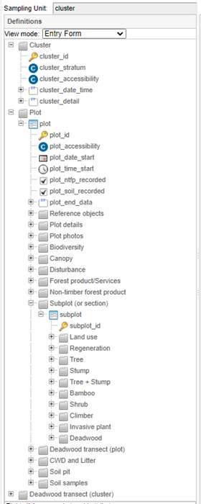 | 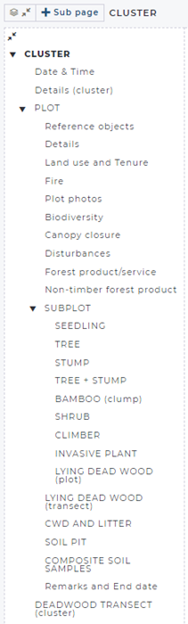 | template_forest_inventory_c  Template C:  cluster – plot – subplot – several entities  Purpose: Forest inventory case where data will be collected in sampling units that are clustered.  A typical case: sample plots can be split into subplots or sections.  Languages: English, French, Spanish

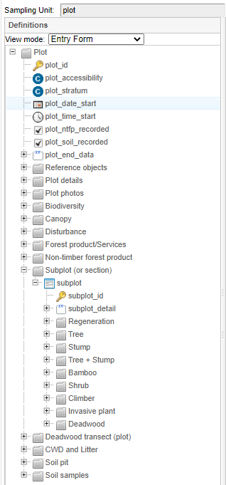 | 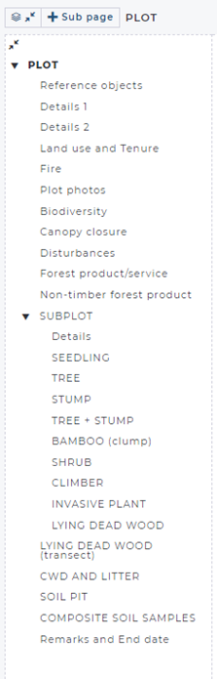 | template_forest_inventory_d  Template D:  plot – subplot –several entities  Purpose: Forest inventory case where data will be collected in (independent) sampling units.  A typical case: sample plots contain subplots or sections.  Languages: English, French, Spanish

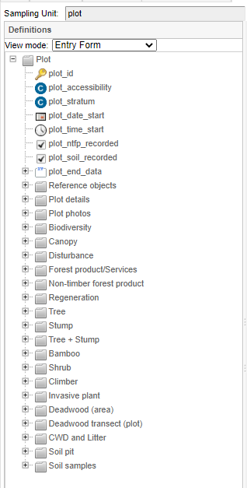 | 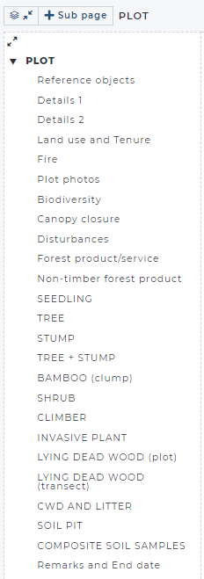 | template_forest_inventory_e  Template E:  plot – several entities  Purpose: Forest inventory case where data will be collected in sampling units.  Languages: English, French, Spanish
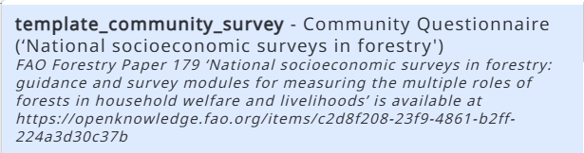  Languages: English, French, Spanish | 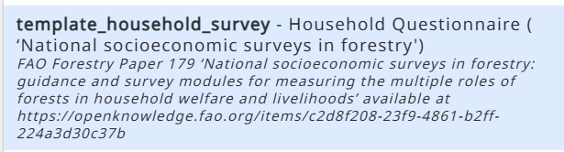  Languages: English, French, Spanish | Templates for the FAO Forestry Paper 179 "National socioeconomic surveys in forestry"  Handbooks:  - English: https://openknowledge.fao.org/items/c2d8f208-23f9-4861-b2ff-224a3d30c37b  - French: https://openknowledge.fao.org/items/4daa62ed-86d6-4163-997e-312cb5707d61  - Spanish: https://openknowledge.fao.org/items/50469569-d42c-4ece-a3c4-c3c3417b835d
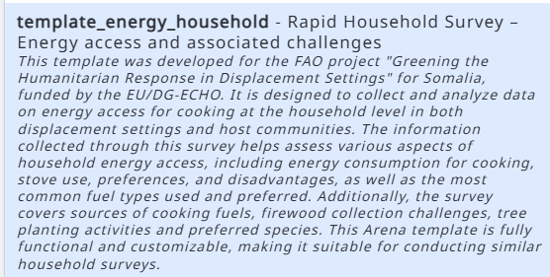  Languages: English, Somali | 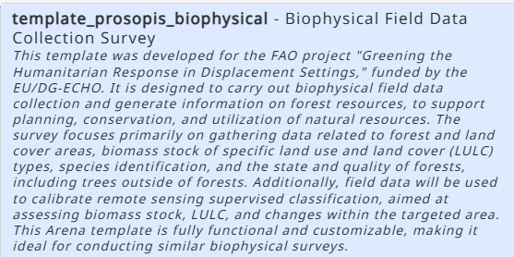  Languages: English
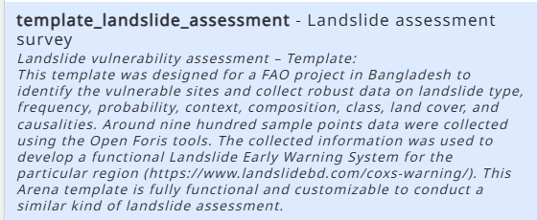 | 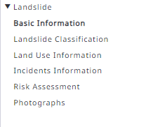 | Landslide vulnerability assessment – Template  (in English)  Project:  https://www.landslidebd.com/coxs-warning/  This Arena template is customizable to conduct a similar kind of landslide assessment.
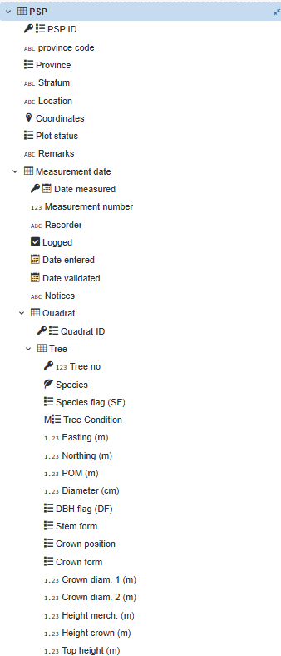 |  | Permanent Sample Plot (PSP) Template  (in English)  This template was designed for the Papua New Guinea Forest Research Institute in November 2024, for collecting and hosting the Permanent Sample Plot data collected from 1-ha sample plots. The plots were divided into 25 quadrats (20m x 20m each).  This Arena template is customizable, and it can be applied in similar types of assessments.  Languages: English

Annex 5. JSON file in data processing
In the Chains section in Arena, all selections in the "Sampling Design" will be submitted as a JavaScript Object Notation (JSON) file ‘chain_summary.json’ into the R project. The chain section also contains a command to export the chain information as a JSON file. Because a JSON file is a text file, you can open it with any text editor.
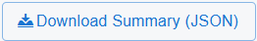
Some tools to view the content of this file:
- open the file in NotePad, copy the text and paste it into an online json parser (search for a free tool), or
- use NotePad++, install the plugin "JSON Viewer", and use this plugin (Plugins > JSON Viewer > Format JSON).
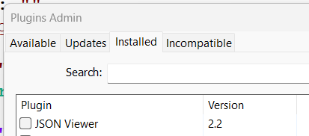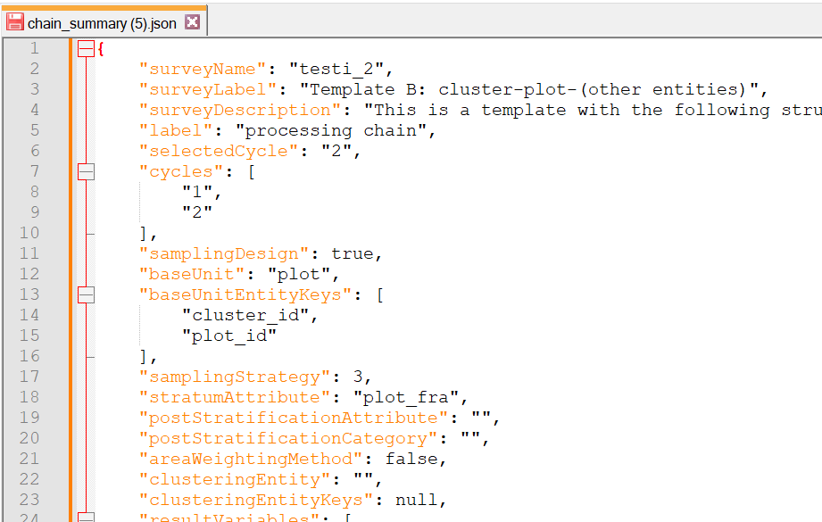

Annex 6. Plot Grid Generator in making spatial Sampling Point Data
The Sampling Point Data is a lookup table that can be used to retrieve data into forms and tables. It can contain for example the predefined list of sampling points, such as clusters and sample plots numbers. It can also contain properties of these points, such as location (coordinates) and data derived from GIS or other ancillary sources.
One handy method to generate a spatial grid for Arena is to use the Plot Grid Generator tool, that is available via https://openforis.org/materials/ and Handy Shiny apps section.
This tool contains an User’s Guide.
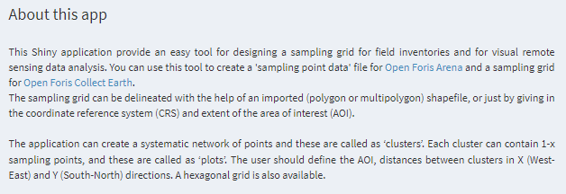
Once the grid has been successfully generated, it can be exported as CSV files. The application writes a zip file, that contains the following files:
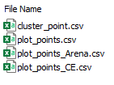
The file "plot_points_Arena.csv" can look as follows:
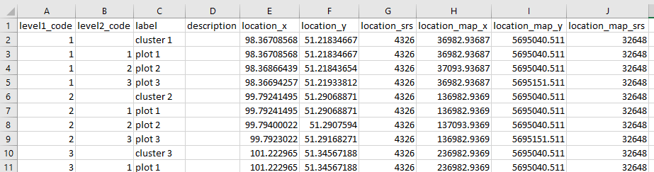
This is a hierarchical category table that can be imported into Arena’s categories. Because "label" and "description" do not contain any language codes, these fields will be written into the survey’s default language, i.e. to the first language in the survey (properties).
* location_x, location_y, location_srs : point coordinates in EPSG:4326 (latitude-longitude)
* location_map_x, location_map_y, location_map_srs: point coordinates in imported map’s Spatial
Reference System (SRS)
This CSV file can be imported into Arena as a new category with the name "sampling_point_data", and Arena will show the following Category Import Summary on the screen:
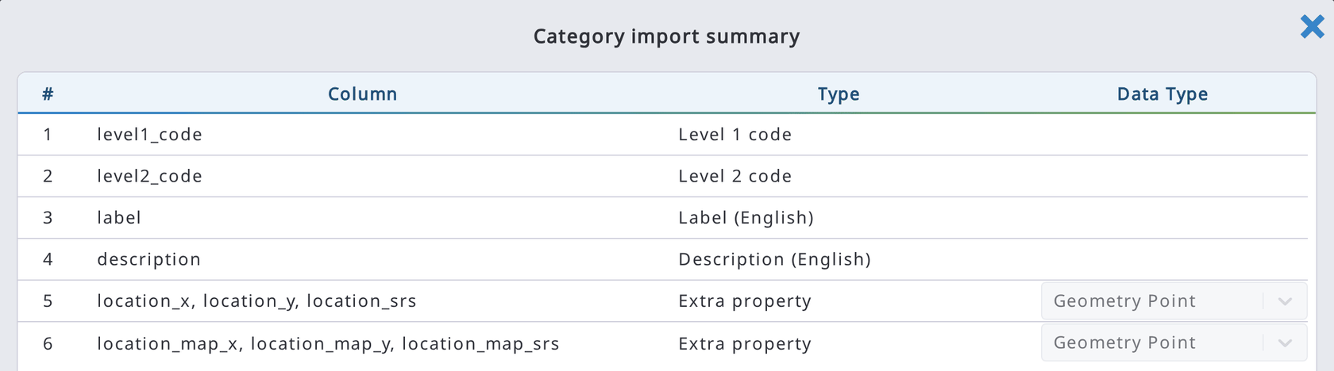
Note: to import map coordinates, that SRS should be given for the survey, otherwise there will be this error message:
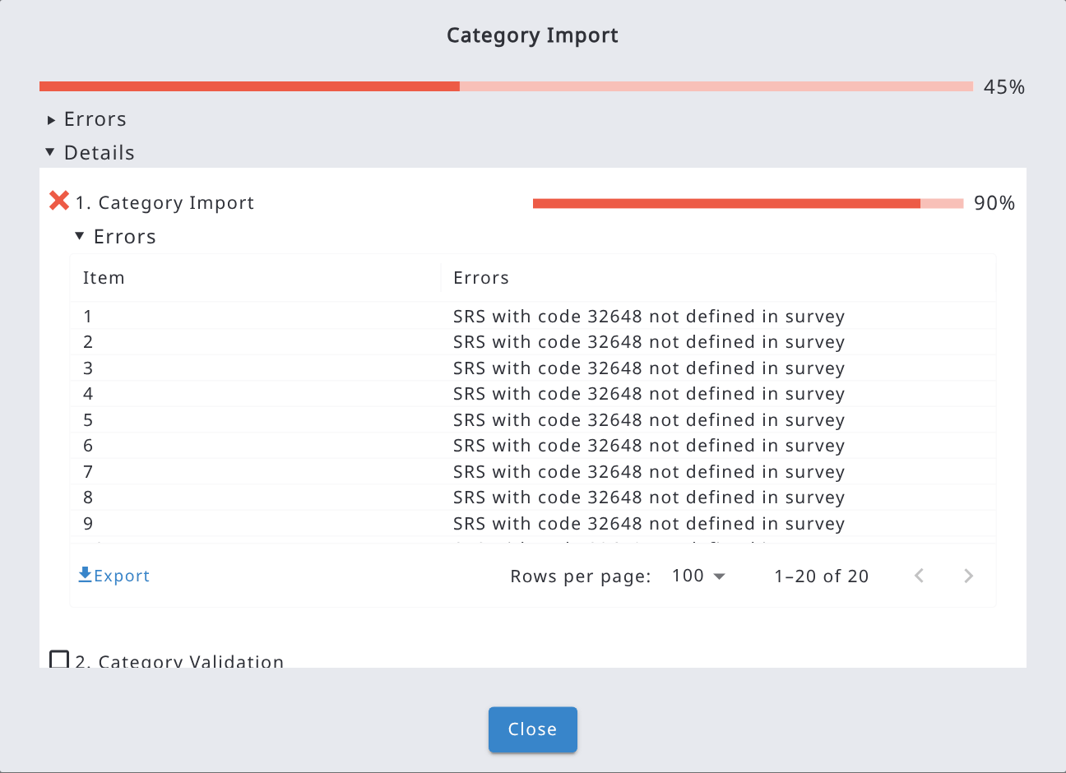
In this case, SRS should contain EPSG:32648, as follows:

Annex 7. Installing Open Foris Arena on a Custom Server
This section explains how to install and run Open Foris Arena on your own server (on-premises or cloud VM) using Docker, instead of using the hosted openforis-arena.org platform. It is intended for system administrators who will maintain the server.
1. Overview
Arena is distributed as a set of Docker images: the Arena application itself, a PostgreSQL/PostGIS database, and, optionally, an RStudio Server container used for running custom R scripts on collected data. Running Arena on a custom server therefore requires Docker and, unless you already have one, a PostgreSQL database.
2. Prerequisites
- A server (Linux is recommended) with a public or reachable IP address, if the server must be accessed outside the local network.
- Docker installed. Download and install it from docker.com if it is not already present.
- Sufficient disk space for the database, uploaded files, and analysis output directories.
- Network access from the server to the internet, to pull Docker images (or a local copy of the images if the server is offline).
- Optional: an SMTP or SendGrid/Office365/Amazon SES account, if Arena should send emails (e.g., password resets, survey invitations).
3. Install and configure PostgreSQL
If you do not already have a PostgreSQL database available, run one as a Docker container. The following command creates a database named "arena" and a user "arena" with password "arena", listening on port 5444:
docker run -d --name arena-db -p 5444:5432 \
-e POSTGRES_DB=arena \
-e POSTGRES_PASSWORD=arena \
-e POSTGRES_USER=arena \
postgis/postgis:17-3.5
Note: Change the database name, user, password, and port to suit your environment and security requirements. Arena can also be pointed at an already-existing PostgreSQL/PostGIS instance instead of a dedicated container.
4. Create the configuration file (arena.env)
Create a text file named arena.env containing the parameters Arena needs at startup. The most commonly used variables are listed below; the full list is available in the Arena GitHub repository.
Variable | Purpose | Example
ARENA_PORT | Port the web application listens on | 9090
PGHOST / PGPORT / PGDATABASE / PGUSER / PGPASSWORD | PostgreSQL connection parameters (or use DATABASE_URL) | localhost / 5444 / arena / arena / arena
TEMP_FOLDER | Folder for temporary uploaded files | /home/your_user/openforis/arena/upload
FILE_STORAGE_PATH | File-system folder for stored files (omit to use DB or S3) | /home/your_user/openforis/arena/files
ANALYSIS_OUTPUT_DIR | Folder shared with RStudio Server for analysis output | /home/your_user/openforis/arena/analysis
USE_HTTPS | Set to true if requests are forwarded to HTTPS by a reverse proxy | false
ADMIN_EMAIL / ADMIN_PASSWORD | Credentials for the first system administrator account | admin@example.org / temporary-password

A minimal working arena.env looks like this:
ARENA_PORT=9090
PGHOST=localhost
PGPORT=5444
PGDATABASE=arena
PGUSER=arena
PGPASSWORD=arena
TEMP_FOLDER=/home/your_user/openforis/arena/upload
FILE_STORAGE_PATH=/home/your_user/openforis/arena/files
ANALYSIS_OUTPUT_DIR=/home/your_user/openforis/arena/analysis
USER_AUTH_TOKEN_SECRET=replace-with-a-long-random-string
USE_HTTPS=false
ADMIN_EMAIL=admin@example.org
ADMIN_PASSWORD=replace-with-a-temporary-password
Security: ADMIN_PASSWORD is used only to create the first system administrator account. Change this password from within Arena immediately after the first login, and consider removing it from the file afterward.

5. Install and run Arena
From the folder containing arena.env, run:
docker run --env-file ./arena.env --network="host" openforis/arena:latest
This pulls the official Arena image and starts the container, exposing the web application on the port defined by ARENA_PORT (9090 by default). Use the same command to restart Arena after it has been stopped.
6. Open Arena in the browser
Once the container is running, open:
http://localhost:9090
(replace localhost with the server's hostname or IP address if connecting remotely). The Arena login form should appear. On first startup, Arena automatically creates a system administrator account using ADMIN_EMAIL and ADMIN_PASSWORD from arena.env. Log in with those credentials and change the password using the Change Password function inside Arena.
7. Optional: run RStudio Server for statistical analysis
To enable custom R scripts and calculation chains, run RStudio Server as a separate container, sharing the ANALYSIS_OUTPUT_DIR folder defined in arena.env:
docker run -d --name arena-rstudio --network=host \
-v ANALYSIS_OUTPUT_DIR:/home/rstudio \
-e DISABLE_AUTH=true \
rocker/rstudio
Replace ANALYSIS_OUTPUT_DIR with the actual path used in arena.env. RStudio Server will be available at:
http://localhost:8787
To restart RStudio Server after a reboot or stop:
docker container restart arena-rstudio
Alternatively, an already-existing external RStudio Server (or RStudio Server Pro pool) can be connected by setting RSTUDIO_SERVER_URL (and related RSTUDIO_* variables) in arena.env instead of running a local container.
8. Recommended next steps
- Configure HTTPS via a reverse proxy (e.g., Nginx or Traefik) in front of Arena, and set USE_HTTPS=true in arena.env.
- Set up an email service (SendGrid, Office365, or Amazon SES) so Arena can send account and survey-invitation emails.
- Schedule regular backups of the PostgreSQL database and the file-storage / analysis directories.
- Review the ALLOW_USER_ACCESS_REQUEST, FILE_UPLOAD_LIMIT, and JOB_QUEUE_CONCURRENCY settings to match your organization's needs.

Annex 8. Privacy Policy
Effective date: May 1, 2021
Food and Agriculture Organization of the United Nations ("FAO", "us", "we", or "our") operates the Open Foris Arena website (the "Service").
This page informs you of our policies regarding the collection, use, and disclosure of personal data when you use our Service and the choices you have associated with that data. This Privacy Policy is powered by FreePrivacyPolicy.com.
We use your data to provide and improve the Service. By using the Service, you agree to the collection and use of information in accordance with this policy. Unless otherwise defined in this Privacy Policy, terms used in this Privacy Policy have the same meanings as in our Terms and Conditions, accessible from https://www.openforis-arena.org/
Use it under your own responsibility
The designations employed and the presentation of material in this information product do not imply the expression of any opinion whatsoever on the part of the Food and Agriculture Organization of the United Nations (FAO) concerning the legal or development status of any country, territory, city or area or of its authorities, or concerning the delimitation of its frontiers or boundaries.
The mention of specific companies or products of manufacturers, whether or not these have been patented, does not imply that these have been endorsed or recommended by FAO in preference to others of a similar nature that are not mentioned.
The views expressed in this information product are those of the author(s) and do not necessarily reflect the views or policies of FAO.
Information Collection and Use
We collect several different types of information for various purposes to provide and improve our Service to you.
Types of Data Collected
Personal Data
While using our Service, we may ask you to provide us with certain personally identifiable information that can be used to contact or identify you ("Personal Data"). Personally identifiable information may include, but is not limited to:
- Email address,
- First name and last name,
- Associated organization,
- Title,
- Country,
- Cookies and Usage Data.

Usage Data
We may also collect information on how the Service is accessed and used ("Usage Data"). This Usage Data may include information such as your computer's Internet Protocol address (e.g. IP address), browser type, browser version, the pages of our Service that you visit, the time and date of your visit, the time spent on those pages, unique device identifiers and other diagnostic data.
Tracking & Cookies Data
We use cookies and similar tracking technologies to track the activity on our Service and hold certain information.
Cookies are files with a small amount of data which may include an anonymous unique identifier. Cookies are sent to your browser from a website and stored on your device. Tracking technologies also used are beacons, tags, and scripts to collect and track information and to improve and analyze our Service.
You can instruct your browser to refuse all cookies or to indicate when a cookie is being sent. However, if you do not accept cookies, you may not be able to use some portions of our Service.
Examples of Cookies we use:
- Session Cookies. We use Session Cookies to operate our Service.
- Preference Cookies. We use Preference Cookies to remember your preferences and various settings.
- Security Cookies. We use Security Cookies for security purposes.
Use of Data
We use the collected data for various purposes:
- To provide and maintain the Service
- To notify you about changes to our Service
- To allow you to participate in interactive features of our Service when you choose to do so
- To provide customer care and support
- To provide analysis or valuable information so that we can improve the Service
- To monitor the usage of the Service
- To detect, prevent and address technical issues
Transfer of Data
Your information, including Personal Data, may be transferred to and maintained on computers located outside of your state, province, country or other governmental jurisdiction where the data protection laws may differ from those of your jurisdiction.
Your consent to this Privacy Policy followed by your submission of such information represents your agreement to that transfer.
We will take all steps reasonably necessary to ensure that your data is treated securely and in accordance with this Privacy Policy and no transfer of your Personal Data will take place to an organization or a country unless there are adequate controls in place including the security of your data and other personal information.
Disclosure of Data
Legal Requirements
We may disclose your Personal Data in the good faith belief that such action is necessary to:
- To comply with a legal obligation
- To protect and defend the rights or property of FAO
- To prevent or investigate possible wrongdoing in connection with the Service
- To protect the personal safety of users of the Service or the public
- To protect against legal liability
Security of Data
The security of your data is important to us, but remember that no method of transmission over the Internet, or method of electronic storage is 100% secure. While we strive to use commercially acceptable means to protect your data, we cannot guarantee its absolute security.
Service Providers
We may employ third party companies and individuals to facilitate our Service ("Service Providers"), to provide the Service on our behalf, to perform Service-related services or to assist us in analyzing how our Service is used.
These third parties have access to your Personal Data only to perform these tasks on our behalf and are obligated not to disclose or use it for any other purpose.
Analytics
We use third-party Service Providers to monitor and analyze the use of our Service.
- Google Analytics
Google Analytics is a web analytics service offered by Google that tracks and reports website traffic. Google uses the data collected to track and monitor the use of our Service. This data is shared with other Google services. Google may use the collected data to contextualize and personalize the ads of its own advertising network.
You can opt-out of having made your activity on the Service available to Google Analytics by installing the Google Analytics opt-out browser add-on. The add-on prevents Google Analytics JavaScript (ga.js, analytics.js, and dc.js) from sharing information with Google Analytics about visits activity.
For more information on the privacy practices of Google, please visit the Google Privacy & Terms web page: https://policies.google.com/privacy?hl=en
Links to Other Sites
Our Service may contain links to other sites that are not operated by us. If you click on a third party link, you will be directed to that third party's site. We strongly advise you to review the Privacy Policy of every site you visit.
We have no control over and assume no responsibility for the content, privacy policies or practices of any third-party sites or services.
Maps
The designations employed and the presentation of material in the map(s) do not imply the expression of any opinion whatsoever on the part of FAO concerning the legal or constitutional status of any country, territory or sea area, or concerning the delimitation of frontiers.
Electronic products
FAO declines all responsibility for errors or deficiencies in the database or software or in the documentation accompanying it, for program maintenance and upgrading as well as for any damage that may arise from them. FAO also declines any responsibility for updating the data and assumes no responsibility for errors and omissions in the data provided. Users are, however, kindly asked to report any errors or deficiencies in this product to FAO.
Children's Privacy
Our Service does not address anyone under the age of 18 ("Children").
We do not knowingly collect personally identifiable information from anyone under the age of 18. If you are a parent or guardian and you are aware that your Children have provided us with Personal Data, please contact us. If we become aware that we have collected Personal Data from children without verification of parental consent, we take steps to remove that information from our servers.
Changes to this Privacy Policy
We may update our Privacy Policy from time to time. We will notify you of any changes by posting the new Privacy Policy on this page.
We will let you know via email and/or a prominent notice on our Service, prior to the change becoming effective and update the "effective date" at the top of this Privacy Policy.
You are advised to review this Privacy Policy periodically for any changes. Changes to this Privacy Policy are effective when they are posted on this page.
Contact Us
If you have any questions about this Privacy Policy, please contact us by email: openforisinitiative@gmail.com
Open Foris Arena is developed and hosted by the Forestry Division, FAO

RStudio requires R (https://cran.r-project.org/). RStudio is available at https://posit.co/download/rstudio-desktop/ Read more about requirements for R version and RStudio in this chapter.
A Survey Manager is not a user role, but a user’s privilege. A role is always related to a survey. Any user can get Survey Manager rights, but predefined access rights to a specific survey.
https://en.wikipedia.org/wiki/Node_(computer_science)
In the Opera web browser, you may need to configure the shortcut ctrl+space in Settings. By default, Opera opens/closes the Instant Search.
https://stackoverflow.com/questions/43307776/how-to-open-a-text-file-with-excel-in-utf-8-encoding
Language code can also be missing. In that case, ‘label’ and ‘description’ are read into the default language of the survey, i.e. to the first language of the survey.
In an imported OF Collect survey, column "synonym" is shown as ‘lat’ in Arena.
See https://www.postgresql.org/docs/9.5/functions-aggregate.html
see e.g. https://developers.arcgis.com/documentation/mapping-apis-and-services/reference/zoom-levels-and-scale/
Elevation is retrieved from Open Topo Data.
Earth Map uses GeoJSON geometries and there is no circle geometry. Therefore Arena "simulates" a circle with a multi-vertex polygon in Earth Map.
If you are working with forest inventory data, please see the recommended naming approach in "Naming of entities & attributes: Recommendations" under “Arena” at https://www.openforis.org/support-and-resources/
The reason for doing this is that when you disable the checkbox, the system will delete an internal "variablename_ha" attribute from the database. When you enable it, the system will create a new attribute "newname_ha" into the database.
The initialization script is valid for 60 minutes, and after that it will expire.
When using local RStudio in a Windows machine, the files are downloaded into the following folder: C:\Users\USERNAME\Documents\arena
The list of required R packages can be found at /system/init/init-packages.R
You need to PUBLISH the survey in order to enable this button.
This method will be developed by the end of 2026.

